**CSCI 4333 Section 2  
8/31/2020**

Self-Annotation

Engineer logbook

Toyu.accdb:

Relational db is a collection of tables: each table stores many rows representing entities. Columns are properties of the entity represented by the row.

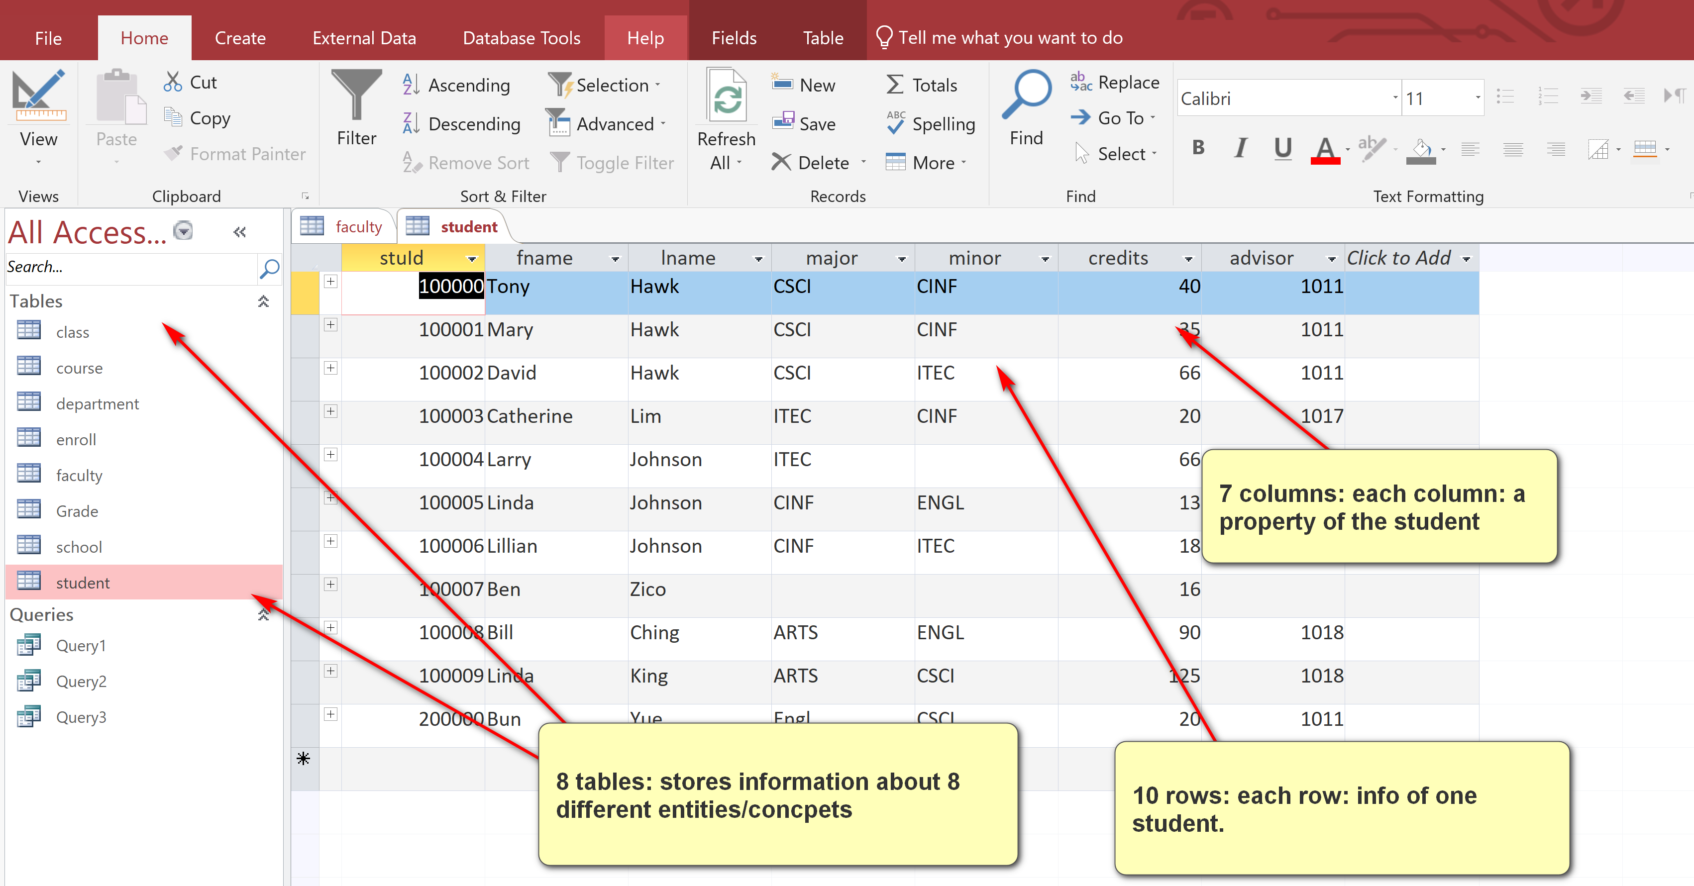

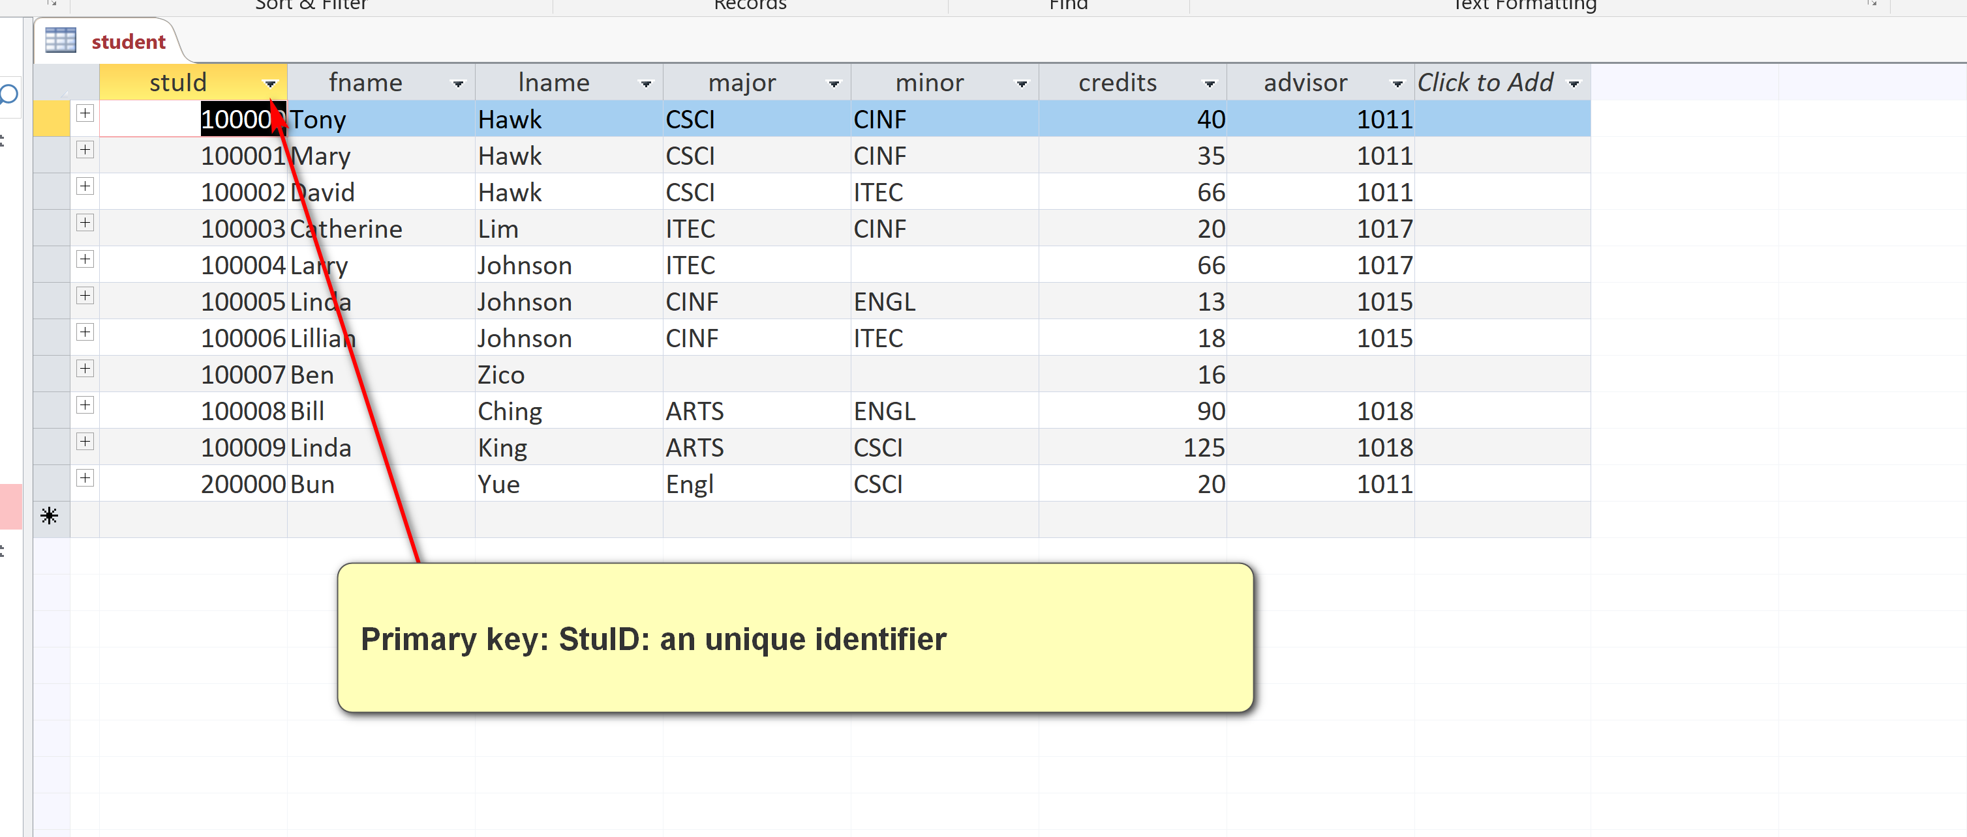

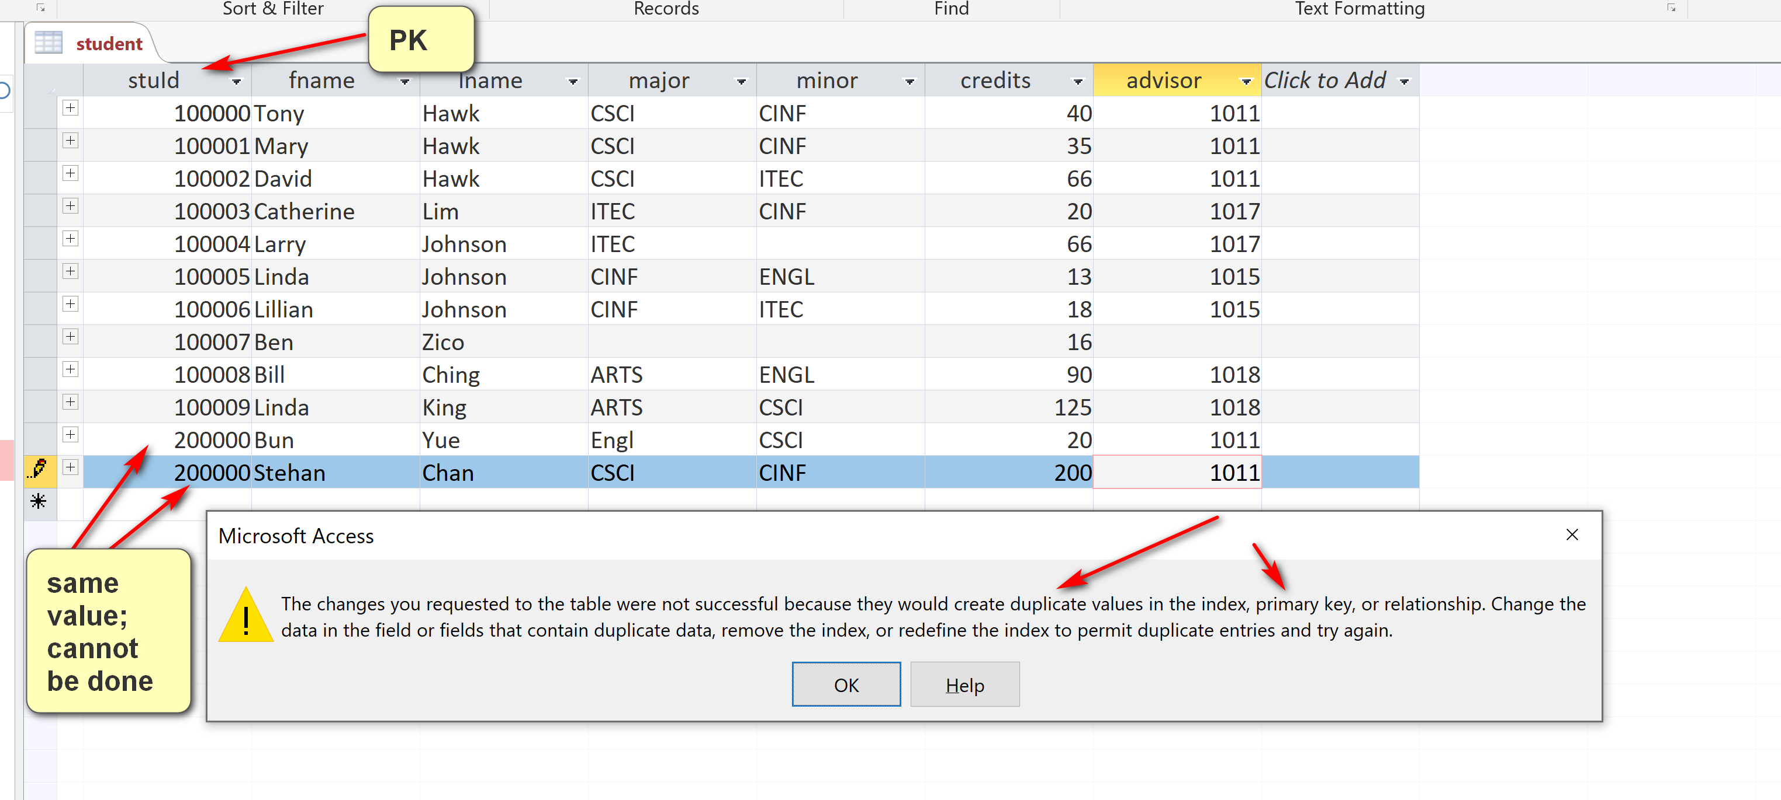

stuId is a simple PK of student (simple: 1 column).

Every table has one and only one PK.

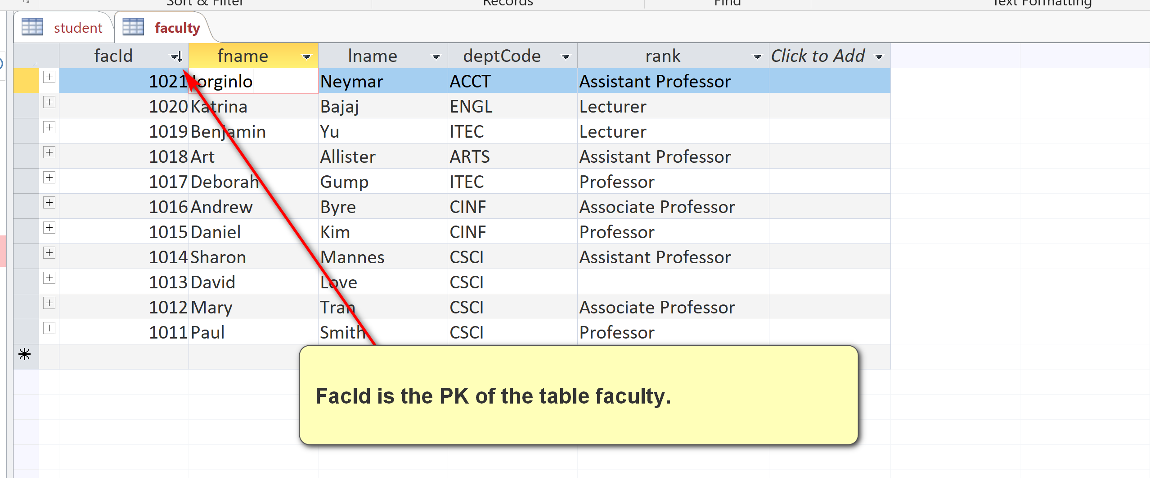

Student(advisor) = Faculty(facId) = 1011

Advisor is a foreign key (FK) of student referencing facId (PK) in the table Faculty (parent table)

Student(major: FK) references Department(deptCode: PK).

Student(minor: FK) references Department(deptCode: PK).

Student has 3 FK.

What is PK of the enroll table?

StuID? No

ClassId? No

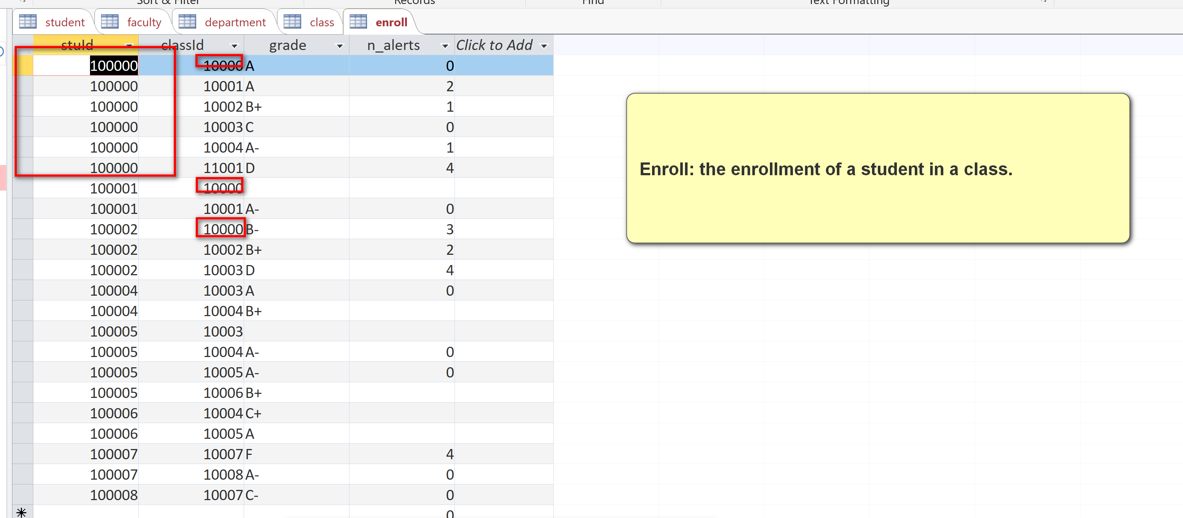

No PK? No.

PK: {stuId, ClassId}: composite: more than one columns.

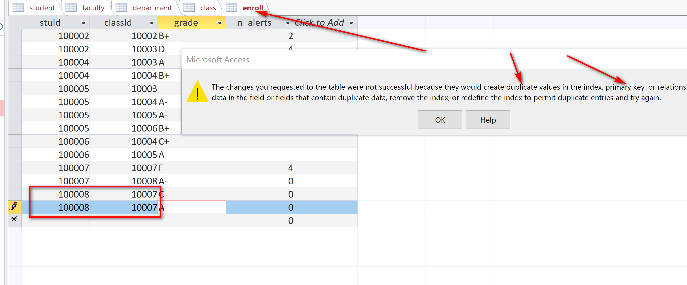

A class is an offering of a course (e.g. CSCI 4333) in a semester taught a faculty.

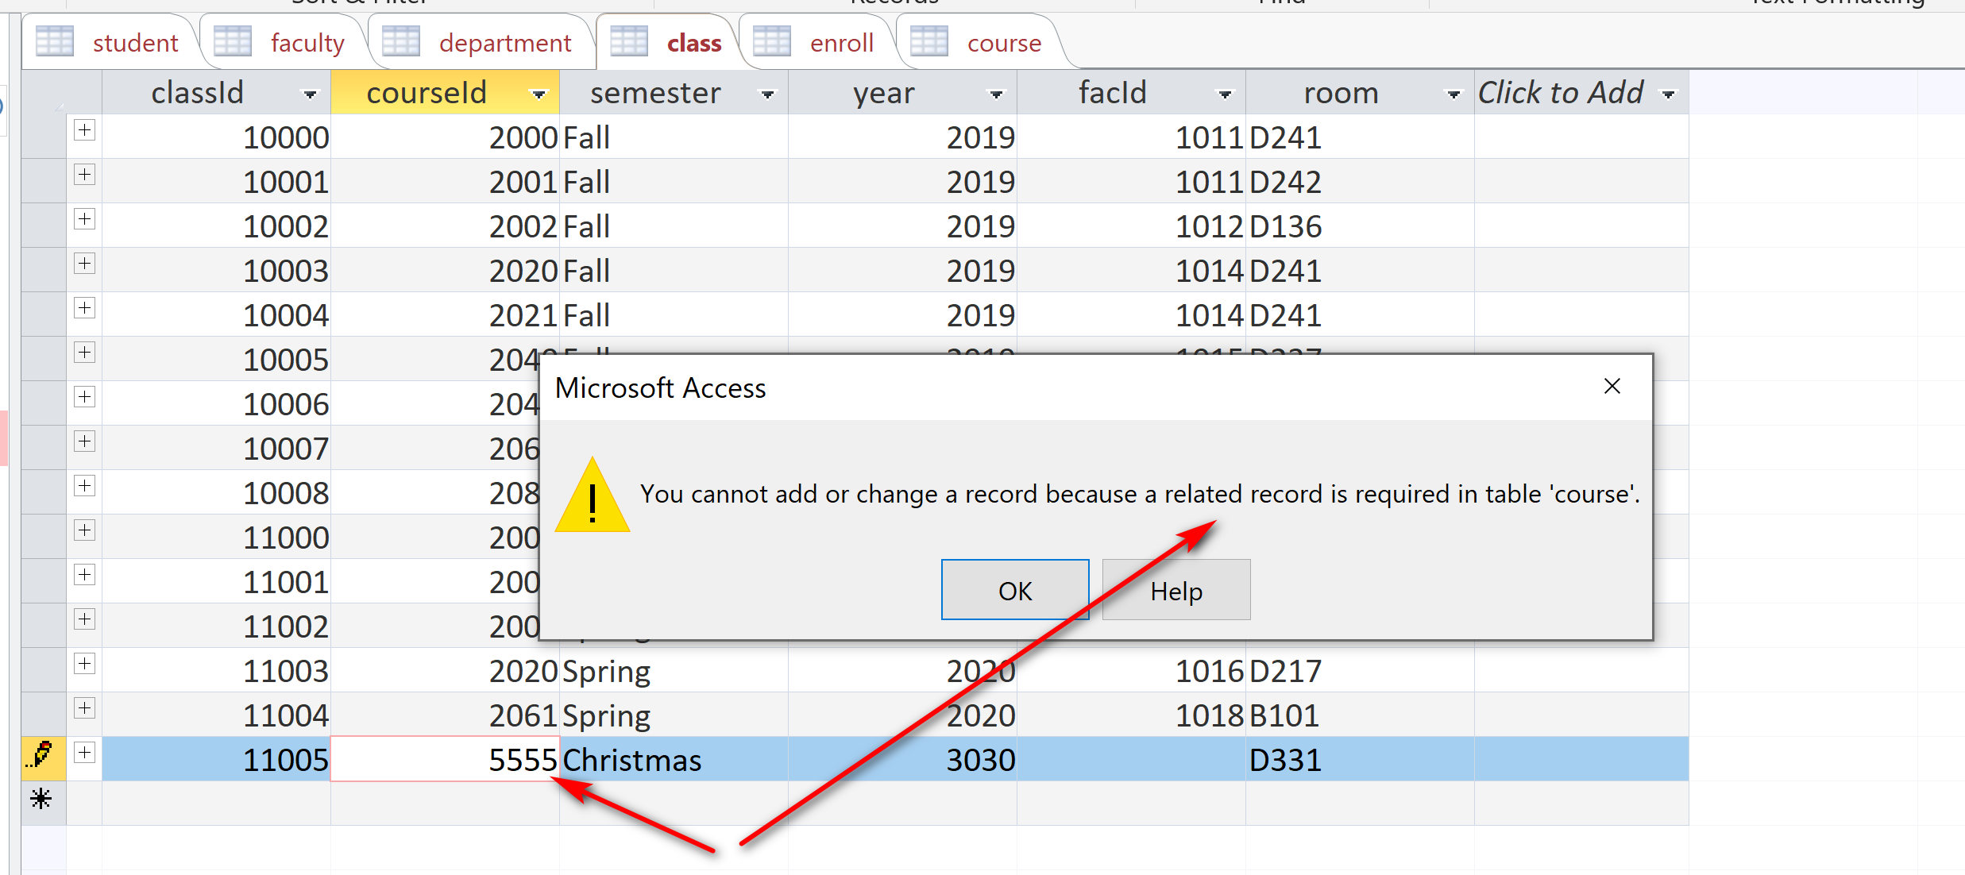

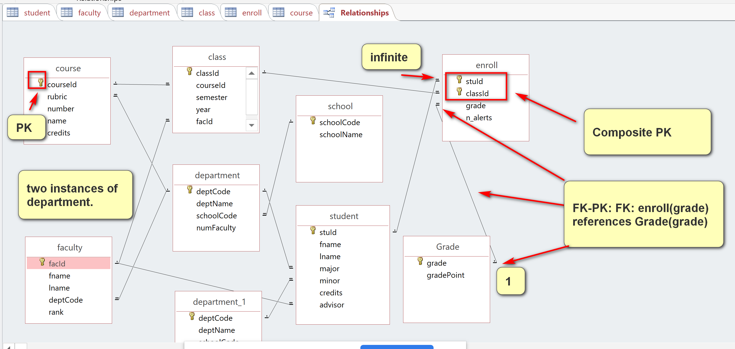

Summer 2020:

(a) Show the classId and grade of all classes taken by Tony Hawk. The result:

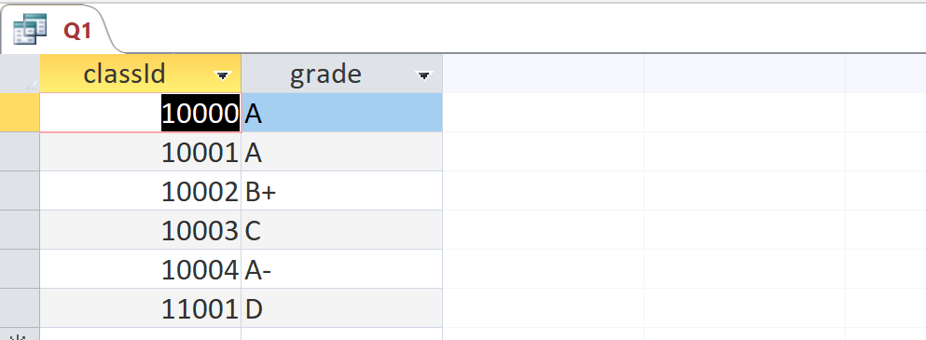

Analysis:

[1] Output:

1. classId: Enroll
2. grade: Enroll

[2] Data sources

1. Enroll
2. Student

[3] Conditions:

1. Problem conditions: taken by Tony Hawk:
   1. Student: fname = ‘Tony’ and lname = ‘Hawk’
2. Join conditions (linking tables):
   1. Enroll.stuId (FK) = Student.stud (PK)

