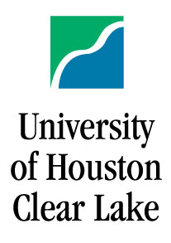
UHCL NSF Scholar Orientation Day
October 13, 2006
Delta 236
Agenda

Theme: Undergraduate Research

12:30 Lunch

12:50 Welcome from Dr. Sadegh Davari, Chair of the Division of Computing and Mathematics, Acting Dean of the School of Science and Computer Engineering

12:55 Introduction
Future changes
Maintaining eligibility
by Drs. Sharon Hall and Bun Yue

1:10 Undergraduate Research

Presentations by:

- Dr. Bun Yue (introduction: 5 – 10 minutes)
- Dr. Sharon Hall
- Dr. Sadegh Davari
- Dr. Dan Kim
- Dr. Andrew Yang
- Ms. Wei Ding
- Questions and Discussion

1:50 Promoting the scholarship

2:05 NSF Scholar Organization: election and activities

2:30 Tour of the computer security laboratory by Dr. Andrew Yang.

2:40 Adjourn.

