**All Graduate CS and CIS Students – New and Returning**

**CS/CIS 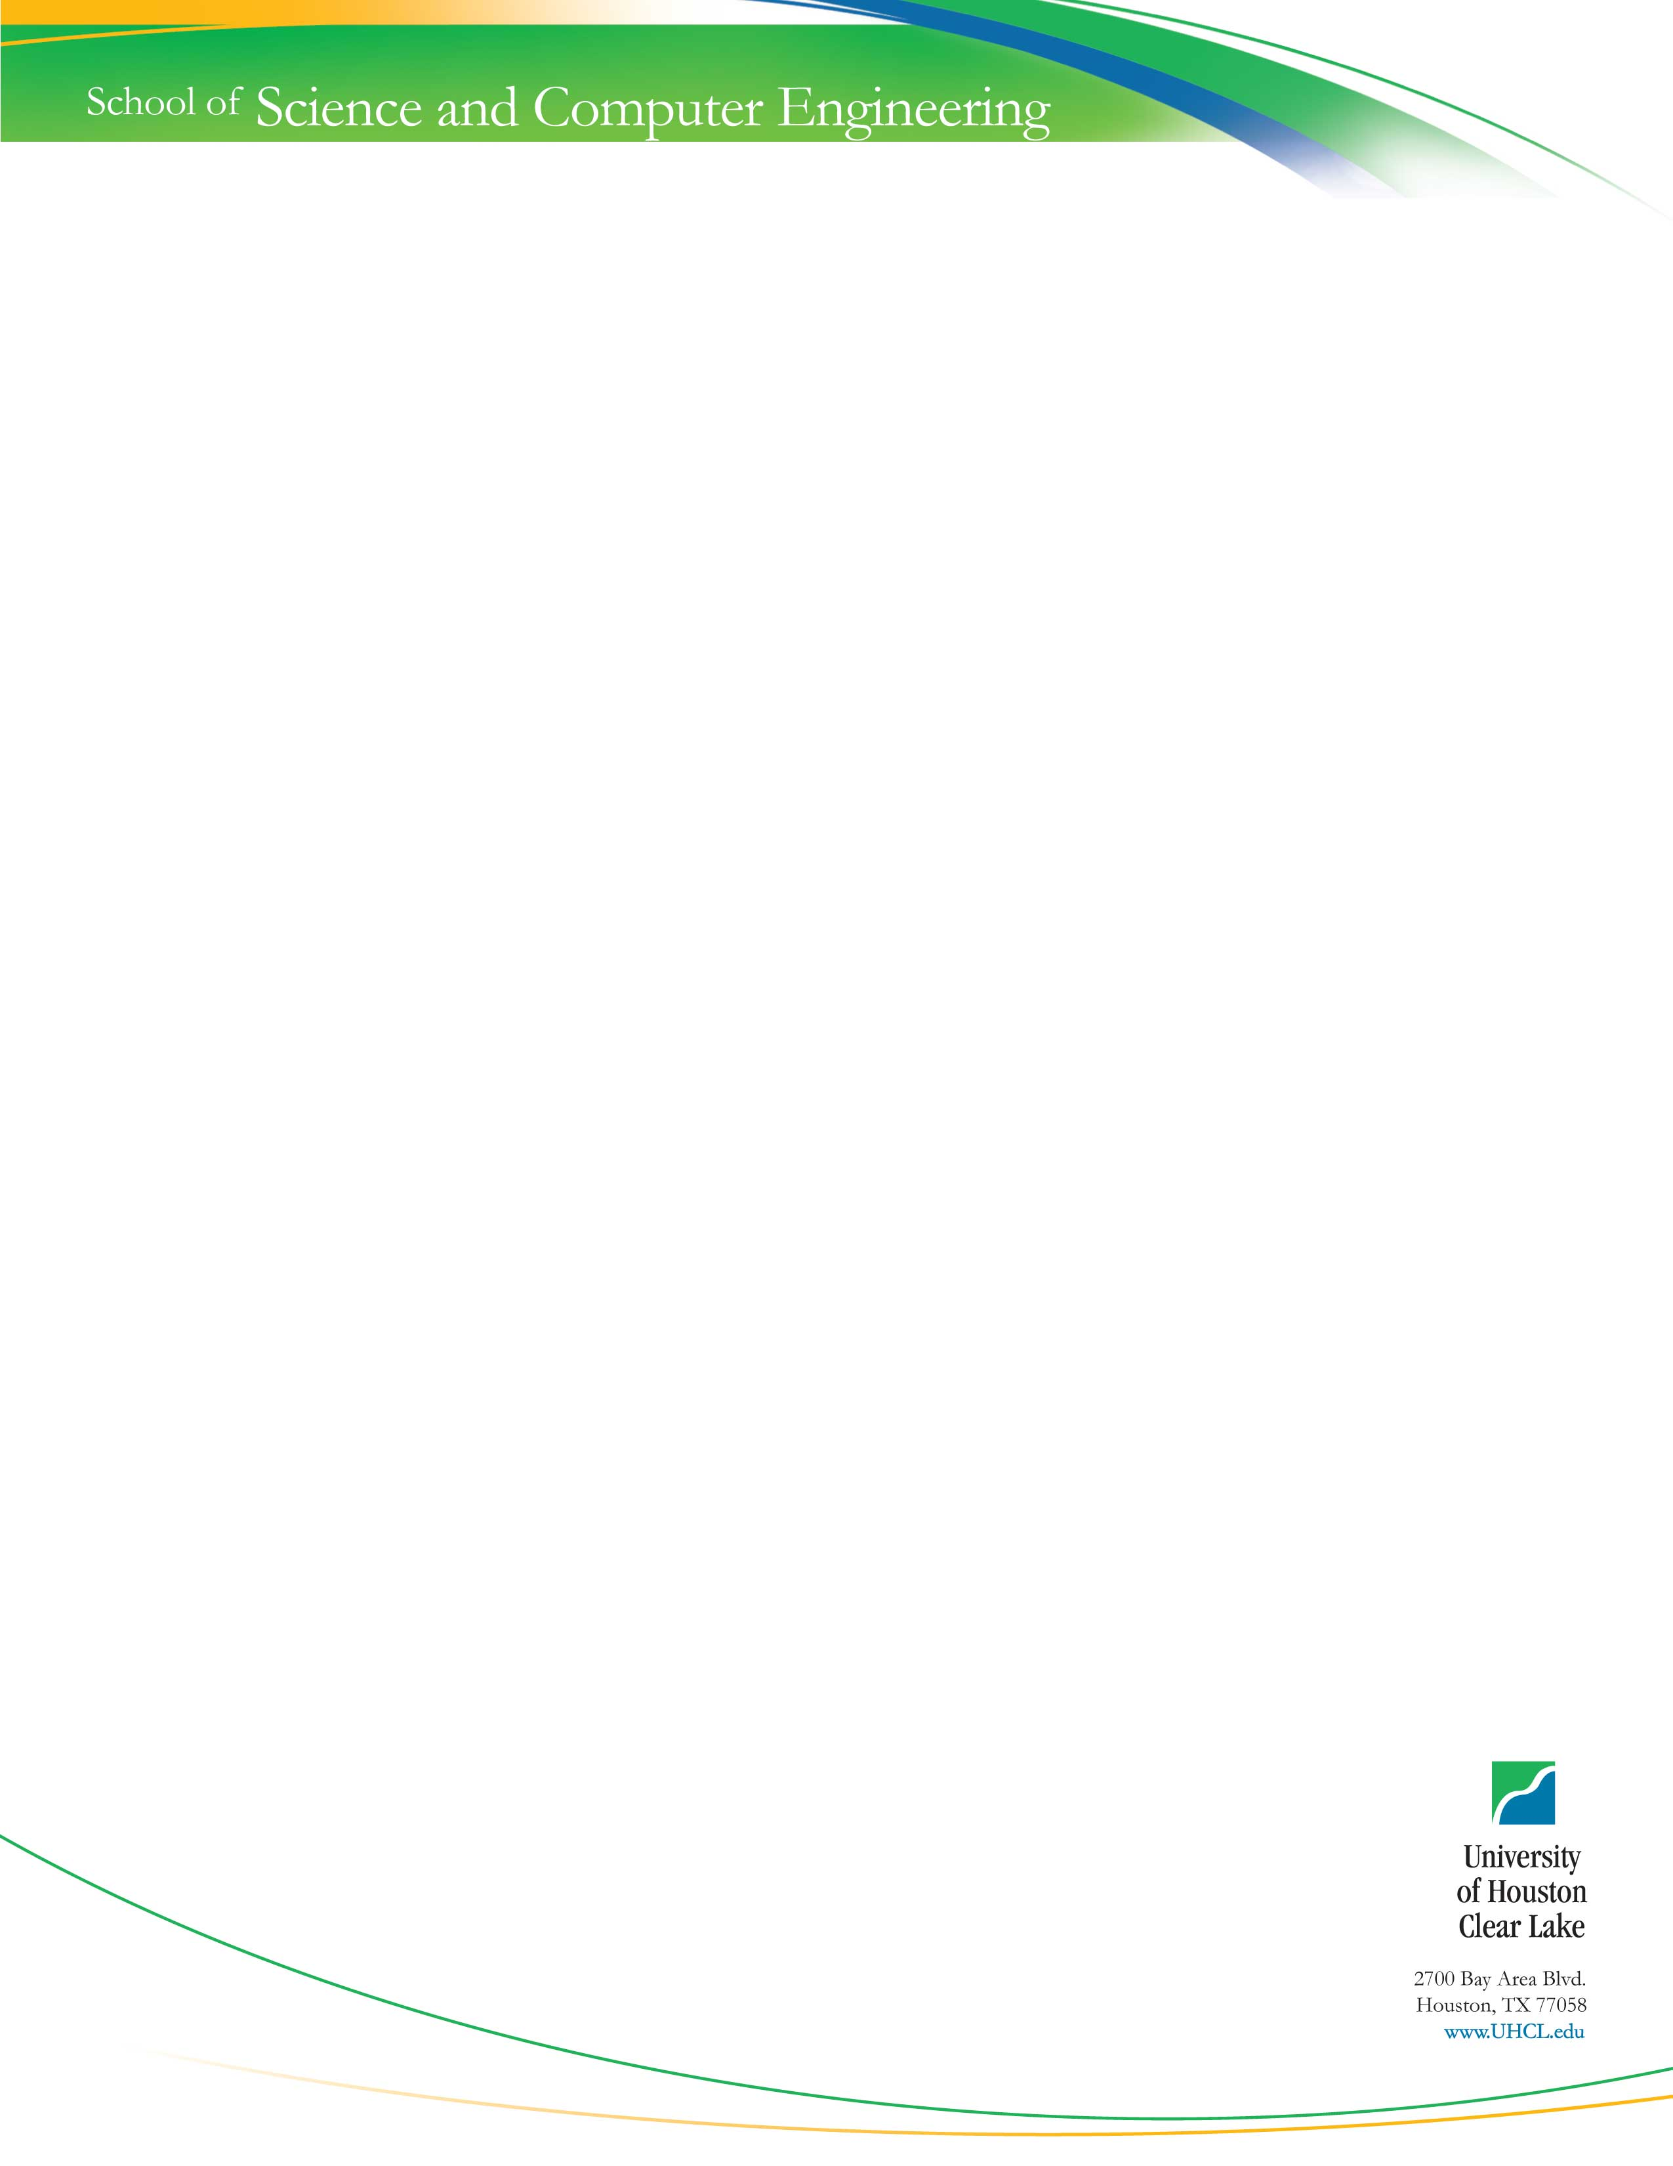Graduate Student Orientation**

**Date: September 3rd (Thursday) 2:30-4:00pm**

**Place: D241**

**Agenda:**

* Welcome: Dean of School of Science and Computer Engineering Dr. Zbigniew Czajkiewicz.
* Introduce the CS/CIS faculty members
* Presentations
  + Introduction: Dr. Yue
  + Foundation courses, Advising and CPS, and planning: Dr. Hisham Al-Mubaid
  + Controlled courses: Dr. Terry Feagin
  + Research: Dr. Gary Boetticher
  + Capstone Projects: Dr. Yue
  + Academic Honesty: Dr. Hall
  + Scholarship and financial aid: Dr. Gary Boetticher
  + Resources: Dr. Yue
  + TA & RA: Dr. Yue
  + Q & A: Dr. Kim
* Drawings and social time