MiniCheck-OCR, Inc. **Invoicing and receipt archive**

Confidential Project Details

Capstone Spring 2011

MiniCheck ID™/DL Utility

**Tracking Invoices and Receipts** for purchases made throughout the year can often be a difficult task, especially for the food service industry. Restaurant managers and employees often make last minute purchases of equipment and supplies necessary to run their day to day operations. Most of the time, sales tax on these types of transactions is paid at the time of purchase. The restaurant is required to maintain a record of the sales tax having been paid on transactions of this type. In the event of an audit, documented proof of payment is required in order to avoid paying the sales tax again. Sufficient proof includes a copy of the sales receipt and corresponding invoice.

In most cases, sales receipts are printed on thermal paper which has a tendency to fade quickly. Once faded, the information printed on the receipt is unreadable and thereby useless.

The restaurant cannot verify that the sales tax was ever paid or the details of the transaction.

Often, the restaurant will pay sales tax on these transactions again.

**Project Scope: Web based invoicing and receipt archive**

**MiniCheck Invoicing and Receipt Tracking System™**

To develop a web based invoice and receipt archive tracking system providing real-time access to expense records, invoices and receipts for purchases made. The MiniCheck Invoicing and Receipt Tracking System™ will reside on a secure webserver.

Access to the system will be controlled by a unique user name and password for every user.

Admin level credentials for each client/restaurant location will be assigned to management allowing them to setup and delete users from the system. Admin level users will be able to determine each user’s assigned level of access.

Each transaction record will be automatically assigned a unique ID number. Each item associated with a particular record will be tied to that record by assigning the item a derivative unique ID number.

Users will be able to add notes to each record they create and subsequently access. However, once notes are added to a record, they cannot be deleted.

Integrating a reliable web-Twain component is essential for enabling users to seamlessly access and use the system. Support for Twain compliant scanners will provide a cost effective, flexible and standardized solution.

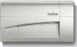 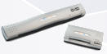 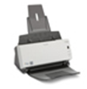 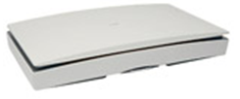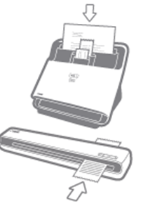

**Document format options should include** PDF and Tif formats for archiving invoices and receipts.

**Creation of product user guide and training wizard** for the system developed should show detailed screen shots of all product features including the customer login screen, user interface, sample transaction logs, activity reports and all administrative functions. Use animated wizards to enhance the effectiveness of the product user guide and tutorials.

**Comments or questions:**

**Bruce Brenner, President**

**MiniCheck-OCR, Inc.**

**713-446-6676**

**Bruce@MiniCheckOCR.com**