Capstone Project – Spring 2011
Sponsored by Tietronix Software Inc.
Mentor: Craig Russell
International Space Station Lite app on the iPad

Overview:
Tietronix has developed the ISS Lite app for Android platform. The application provides the following features:
- Learn about the different elements of the Space Station
- Learn about the multiple expedition crews that have been working onboard the space station since its beginning
- View the video of the space station assembly sequence
- Compute the next viewing opportunity of the space station depending on the location of the user.
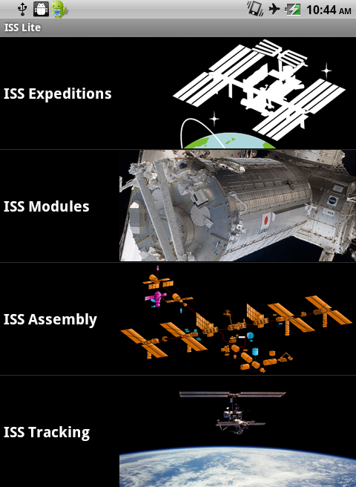

Another application developed by Tietronix, using the Unity Game Engine is the Glovebox, in which users learn about experience on combustion and flames in Zero g.

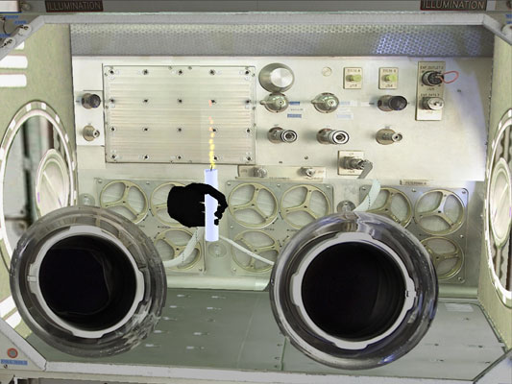

Project Objectives:
The goal of this project is to port and integrate these two applications to the iPad platform.
Port the current ISS Lite app to the iPad platform, customizing it to the mobile device technical specs. Add a few additional functions to extend and improve the app. Port the Glovebox application on the iPad and integrate it with the ISS Lite app.

Requirements:
- The application will be working on the iPad and the iPhone
- The application will provide the same features as the ISS Lite app currently available on the Android platform
- The application will provide a way to learn about the multiple Shuttle, Soyouz and other vehicles that have docked with the Space Station.
- The application will provide a way to learn about the current Earth views from the Space Station.
- The system will allow to access the Glovebox application from the ISS Lite main menu.

