Capstone Project – spring 2010
Sponsored by Tietronix Software Inc.

Title: Tietronix Metrics Collection and Analytics Tool

Background: Software Metrics are measurements of different aspects of a software project that help us determine whether or not we are progressing toward the goal of that project. They are used extensively as management tools to provide some calculated, observable basis for making decisions. Some common metrics for projects include schedule deviation, remaining budget and expenditure rate, presence or absence of specific types of problems, and milestones achieved. An important part of software engineering is to provide a metrics program that supports the development of quality software. Capturing and storing metrics in a repository allows an organization to improve its planning estimates, its benchmarking, and its processes based on objectives measurements.

Description: The intent of this project is to develop a web based tool that allows the end users to define, collect, store and report on a set of custom metrics.

Requirements:
- User Requirements
  - See appendix A
- System Requirements
  - The system will be JEE (Java enterprise Edition) web based application
  - The system will be designed to be compatible with leading database management systems (MS SQL, Oracle, and MySQL). For purpose of this capstone the team will use MySQL 5.x as the backend database.
  - The web application will be compliant to at least XHTML Transitional DTD

Project Deliverables:
The project team will provide the following deliverable in three phases:
- Phase 1: Design
The project team will create a design document to elaborate on how the system will be built
- Phase 2: Build Beta
The project team will implement the design
- Phase 3: Test and Deliver GA
The project team will test the beta version, fix any issues and deliver the system along with source code, test scripts, deployment instructions and final report.

Required Skills
A good understanding of following technologies/concepts
- Java
- Web technologies (XHTML, CSS)
- Object Oriented Design and Programming
- Databases

Mentor Information
Abbasi Dhilawala
Software Engineer, Tietronix Software Inc
abbasi.dhilawala@tietronix.com
http://www.tietronix.com
281-404-7243

Appendix A: User Requirements
- System shall support multiple users
  - Each user shall have a userid, user name, first name, last name and email address
  - Userid shall be system generated unique identifier
  - User name shall be used for login and shall be user specifiable
  - User name shall be unique

- System shall support multiple projects
  - Each project shall have a unique name
  - Each project shall have one or more project member
  - Each project shall have one or more project administrator
    - Project administrator shall be a project member
    - Project administrator shall be able to assign users as members for their project
    - Project administrator shall be able to assign other members as project administrator of their project

- System shall support one or more administrator
  - System administrator shall be able to create projects
  - System administrator shall be able to create users
  - System administrator shall be able to edit users
  - System administrator shall be able to delete users
  - System administrator shall be able to assign project members and administrator
  - System administrator shall be able to define global metrics that are applicable to each project
  - System administrator shall be able to make other user system administrator

- Project administrator shall be able to define metrics for their project at any time
  - Metrics shall have a name
  - Metrics name shall be unique for that scope (project or global)
  - Metrics shall have a type (primitive or derived)
  - Primitive metrics shall have a data type (number, date, text)
  - For derived metrics the system shall support the following functions
    - Add: Allow adding 2 or more primitive metrics with the data type of number
    - Subtract: Allow subtracting 2 primitive metrics with data type of number or date (for date data type the result is number of days)
    - Product: Allow multiplication of 2 or more primitive metrics with the data type of number
    - Divide: Allow dividing 2 primitive metrics with data type of number
  - The data type of derived metric shall be number

- Project administrator shall be able to define one or more metric collection instances
  - Metric collection instance shall have a name
  - Metric collection instance shall have a date

- For each metric collection instance the project administrator shall be able to specify values for the global and project defined primitive metrics.
  - The system shall validate the metrics value to make sure it matches the data type of the metrics
  - Metric value shall not be required

- The system shall support metric reports
  - Project members shall be able to run reports on projects they are part of
  - System administrators shall be able to run reports on all projects in the system
  - System shall support reporting raw values for all metrics for a project across many collection instances (see example 1)
  - System shall support comparison reports for metrics with data type number and date for a project across many collection instances (see example 2)
  - System shall support reporting for one or more projects at a time (see example 3)
  - System shall support both textual and graphical formats for comparison reports
  - All reports shall be print friendly
Example 1: Raw value report for a single project
My Project has 3 metrics. Two primitive: Lines of Code (number) and Defects (number). One derived: Defects / Line of Code (number). Has 5 collection cycles

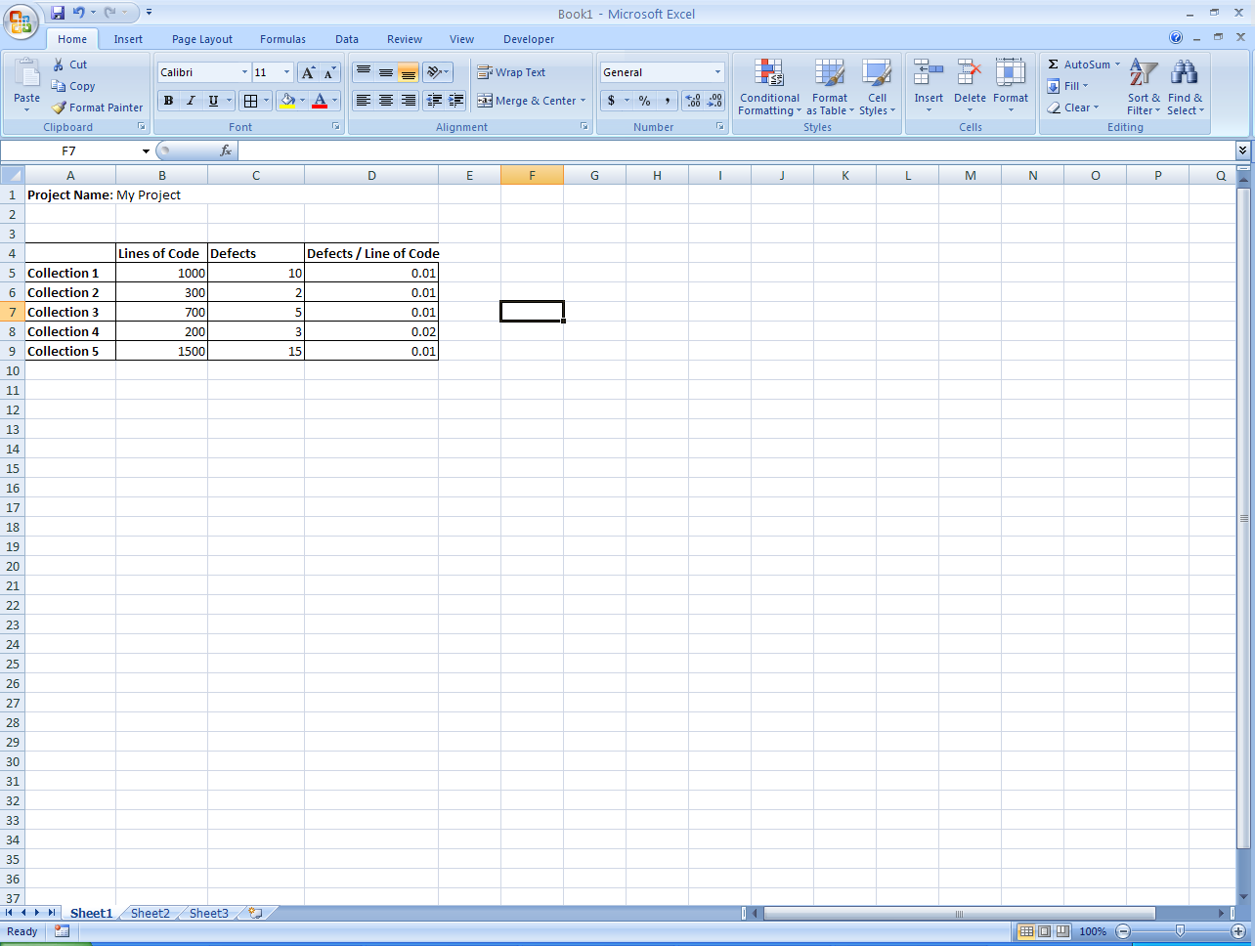

Second Project has 3 metrics. Two primitive: Planned Milestone date (date) and Actual Milestone date (date). One derived: Delay in days(number). Has 4 collection cycles

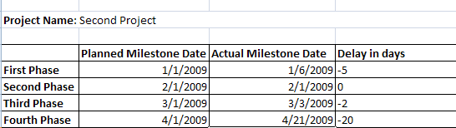
Example 2: Textual and Graphical Comparison Report
Comparison of two metrics Lines of Code (number) and Defects (number) in textual format

Comparison of two metrics Lines of Code (number) and Defects (number) in graphical format

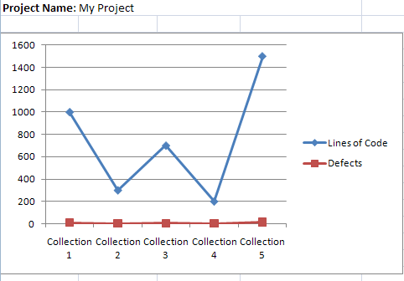
Example 3: Reports for multiple projects at a time (textual and graphical)
In first project comparison of Lines of Code (number) and Defects (number)
In second project comparison of Planned Milestone date (date) and Actual Milestone date (date)

