Capstone Project – Spring 2010
Sponsored by Tietronix Software Inc.

Spacecraft Solar Arrays Shading Visualization

Background:
A spacecraft such as the International Space Station is in a simplified Earth orbit. As the spacecraft circles the Earth its orientation relative to the Sun continuously changes. The structure of the spacecraft casts continuously varying shadows upon the solar arrays.

Objective:
Graphically model the shading of sunlight on the solar panels of an orbiting spacecraft. Analytically determine the area of the solar panels exposed to sunlight and the resulting incident radiant energy.

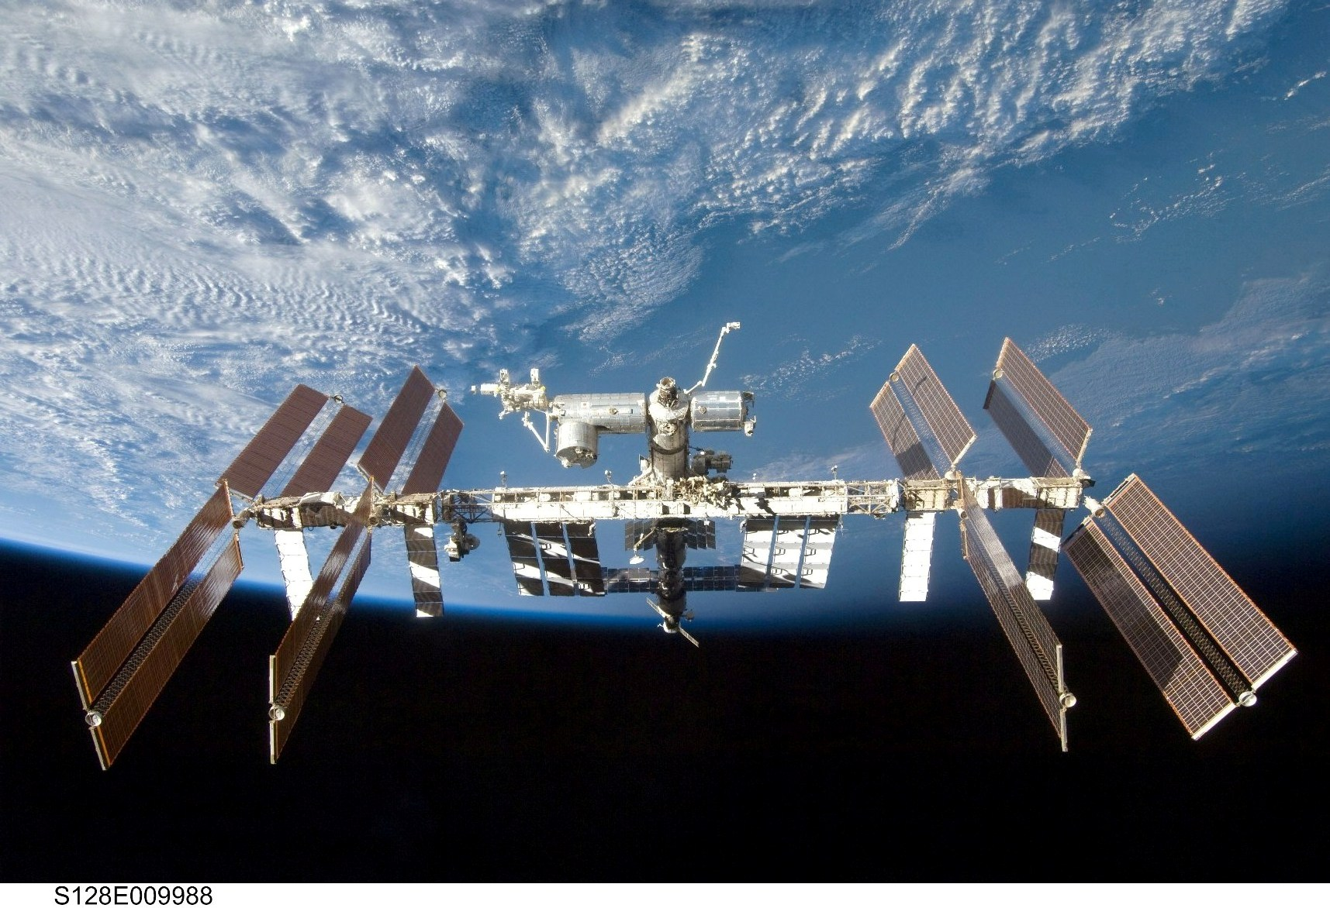

Project:
The proposed application will determine the area of the solar arrays exposed to direct sunlight and the amount of power deposited by the sunlight onto the arrays. The application will also compute the optimal pitch, yaw, and roll angles that will maximize the sunlight reaching the solar arrays. The application will provide a 3D visualization of the orbiting spacecraft and accurately show the relationship of the sun and shadows upon the structure of the spacecraft. A 3D game engine, Unity, will be used to render the visualization of the spacecraft. Unity is available on multiple platforms, including the iPhone/iPod Touch. Models of the spacecraft will be provided.

REFERENCES:
1. http://unity3d.com/unity/features/iphone-publishing

TECHNOLOGY AREAS: Unity, 3D graphics, Orbital Mechanics

Mentor Information: Peter Armstrong

