Capstone Project – Spring 2010
Sponsored by Tietronix Software Inc.

Solar Thermal Plant Design and Operation Suite of Tools

Computation using OpenCL

Background:
Solar Thermal power plants are generating electricity from the energy of the sun. They use a field of a few thousand mirrors to reflect the sun rays onto a receiver located at the top of a tower. In the receiver a fluid is being heated by the concentrated sunlight and then water vapor is generated and sent into a regular turbine. These power plants have been studied extensively in the 70’s and 80’s. There is a strong renewed interest in the technology, and for the past years a number of new projects have been started that need updated software tools for their design and operation.

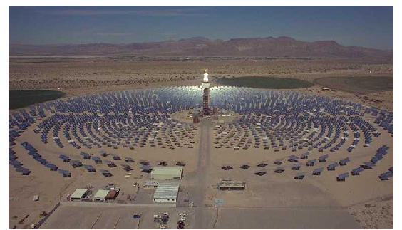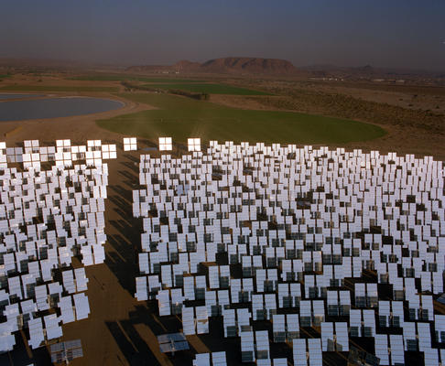

Project:

The proposed project is a part of the overall development of a suite of software that can support the solar plant designers as well as the plant operators. This semester’s project will focus on the development of a massively parallel program in OpenCL that computes the shading and blocking of a field of heliostats in real time.
OpenCL (Open Computing Language) is the first open, royalty-free standard for general-purpose parallel programming of heterogeneous systems. OpenCL provides a uniform programming environment for software developers to write efficient, portable code for high-performance compute servers, desktop computer systems and handheld devices using a diverse mix of multi-core CPUs, GPUs, Cell-type architectures and other parallel processors such as DSPs.
Several thousand heliostats are positioned around a central receiving tower. Throughout the day, their facets are continuously oriented to reflect sunlight onto the tower. However, some heliostats cast shadows onto neighboring heliostats, and other heliostats partially block the reflected light from neighboring heliostats. This application will compute the area of the shaded and blocked portions of each heliostat at least once per second and produce a continuously updated 2D color contour map that represents the efficiency of the heliostat field. Controls will be provided to allow the simulation clock to be paused, to run in real time, or to be manually set to any time. The application will provide a data snapshot of each heliostat's shading, blocking, and cosine effect to a .csv file upon user request.

REFERENCES:
http://www.khronos.org/opencl/
http://www.khronos.org/developers/library/overview/opencl_overview.pdf

TECHNOLOGY AREAS: Solar Power, OpenCL, Parallel GPU-based Computing

Mentor Information: Peter Armstrong

