MiniCheck-OCR, Inc FIGHT IDENTITY FRAUD
Confidential Project Details
Capstone Spring 2010
MiniCheck ID Pro+™

Fighting Identity Fraud is a major concern in our society. Financial institutions, Insurance companies, Automobile dealers, Retailers, Employers, Pharmacies, Credit card companies, Mortgage companies, Apartment complexes and the Healthcare industry are just some examples where verifying a customer’s identity is very important.
MiniCheck ID™ and MiniCheck DL Utility™ is designed to effectively fight Identity Fraud and enhance the capture of important customer data. REAL WORLD IMPLICATIONS

This project will incorporate some of the work done in the previous semesters and extend the capabilities of the MiniCheck ID DL Utility we have developed which should really be fun. The features developed this semester will have real world implications! Our goal is to provide an excellent “hands on” learning experience and have fun doing it!

This project offers a great “end-to-end” opportunity to develop a real world application with far reaching implications. Once the application is built and tested, the team will receive hands-on-experience working directly with one of the leading software protection solutions in the world.

MiniCheck-OCR, Inc
MiniCheck-OCR, Inc has developed a suite of applications known as the *MiniCheck MGR™, MiniCheck ID™ and MiniCheck ID Pro™. The *MiniCheck MGR™ is a revolutionary new front-end application for electronically processing checks; MiniCheck ID™ and MiniCheck ID Pro™ are used for validating IDs at the point-of-sale or any situation where ID Validation or Age Verification are important. MiniCheck ID™ incorporates advanced identity management by allowing the user to connect to third party databases in order to verify a customer’s identity by verifying the authenticity of a social security number or postal address. All functions executed through the MiniCheck ID™ user interface. At the point-of-sale, MiniCheck ID™ provides the ability to validate a photo ID such as a driver’s license or state issued ID card in order to prevent losses due to fraud. This ID validation happens using a combination of advanced algorithms to read and decipher the electronically encoded data in either the magnetic strip or barcode located on the ID itself. The user has an option to capture an image of a photo ID at the point-of-sale and store it within the record archive maintained on the local PC by the user in the Access database.
MiniCheck ID Pro™ adds to MiniCheck ID™ the ability to process credit card transactions.

Project scope: FIGHT IDENTITY FRAUD

MiniCheck ID Pro™
To enhance and improve upon the existing architecture and functionality of the MiniCheck ID DL Utility application.
The name of the newly modified application is MiniCheck ID Pro+™ V1.4 and will continue to use the flexible C#/.NET Framework in addition to Flex technology.
The team will review the previous Capstone team’s source code to review for consistency and to look for integration points between this code and the MiniCheck DL Utility. All features and functionality should be checked thoroughly to ensure they work reliably with both Windows XP, Vista and Windows 7.

*The project this semester will include adding support for reading CREDIT CARDS and Reading Military ID cards.

*In order to support credit card processing, MiniCheck ID Pro+™ (Developed by previous Capstone teams) has previously been integrated to Authorize Net, a leading credit card processing gateway. NOTE: MiniCheck DL Utility has NOT yet been integrated to Authorize Net. All integration and support API documents can be found at www.Authorize.Net. Authorize Net provides toll-free technical support to developers wishing to integrate applications to Authorize Net’s platform. The team will modify MiniCheck DL Utility to fully support reading Credit Cards with the intention of processing them through Authorize Net. Confirm that MiniCheck DL Utility works reliably with Authorize Net as well. Required enhancement will be an automatic comparison between any common information contained on a credit card to the corresponding information contained in the magnetic stripe or barcode on a driver’s license. This will reduce the likely hood of accepting a fraudulent Credit Card. Integration with Military ID cards the same, compare common denominators on Military ID to Credit Card.

MiniCheck ID Pro+™ FIGHT IDENTITY FRAUD

Additional required enhancements:
*Review data base functionality for generating targeted client statistic lists using a variety of search criteria and setting up user-defined product ID names, codes or descriptions.
*The team will modify the user interface and data base so that when choosing the option to process a credit card transaction, other “OPTIONAL” fields become available so that the USER can enter and easily capture VALUABLE customer demographic information regarding the transaction that will be useful for generating targeted customer profile lists later on.

Age calculation with ALERTS regarding age based restrictions
*Add functionality for automatic Age Calculation: Automatic alerts generated for the user based on the age calculation results.
Example:
*Under 21, NOT authorized consumption or purchase of alcoholic beverages
*Under 18, NOT authorized to purchase ANY tobacco-related products
*Under 18, NOT authorized to purchase or posses fireworks
*Over 60 eligible for senior discounts

MiniCheck ID Pro+™
*Last semester’s team integrated the application to E-VERIFY which is the information data base through Homeland Security for verifying an employee’s right to work in the US. The value add is that MiniCheck ID Pro+ combined robust ID Validation using a variety of popular POS devices with the ability to verify and confirm the true identity of the employee. MiniCheck ID Pro+ supports reading, parsing and displaying the electronically encoded information in the magnetic stripes and barcodes found on drivers’ licenses and state issued ID cards.
Some refinement of the E-Verify integration still needs to be optimized this semester as a part of this project, then testing and certifying all functionality is reliable and working will be done.
The team will review code, look for integration points or for portions of the code that can be integrated to MiniCheck DL Utility.

Important Detailed Information regarding MiniCheck ID™
The current version of MiniCheck ID Pro+™ is a PC based application created in C# (.NET Framework) designed to perform the following functions:
Read, capture, identify and parse the information that is contained in the magnetic stripe or barcode (2D PDF 417) on a driver’s license or state issued ID card.
The results then displayed on the users’ desktop within the MiniCheck ID user Interface on the user’s desktop allowing the user the ability to quickly and accurately verify that the information printed on the front of the ID card matches the information that is electronically encoded in the magnetic stripe or barcode.
MiniCheck DL Utility uses .NET Framework and Flex Technology
Most magnetic stripe readers work in a similar way (basically); they read the data from the magnetic stripe and output this data in its RAW format. There are different brands of magnetic stripe readers on the market; examples of this are evident in almost every retail location in the country. Different interface options are HID (Human Interface) or Keyboard Emulation.
*Many drivers’ licenses and state issued ID cards have magnetic stripes and/or barcodes on them which contain important personal information. Using the reference materials available, the previous student team has fully integrated the ability to identify the basic fields of information in the magnetic stripes and 2D barcodes then parse the specific fields of information from that RAW Data. The user has the option to store the parsed data automatically in the database of the MiniCheck ID Pro+™ application.
*The information contained in the magnetic stripes or barcodes found on ID cards vary depending on the state of issue.
IMPORTANT Note: The previous Capstone teams developed the MiniCheck ID™ application to support all drivers’ licenses and state issued ID cards that follow the AAMVA standards that are the recommended industry standards for formatting and encoding the information contained on drivers’ licenses and state issued ID cards. With MiniCheck DL Utility, we now have an updated parser that supports drivers’ licenses and state issued ID cards that do NOT follow the AAMVA standards as well as those that do.

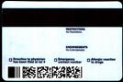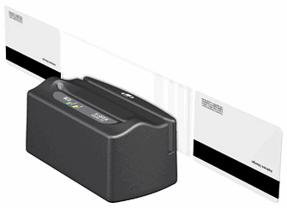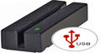

MINICHECK ID™

Additional Background and history

When a user swipes an ID card through the magnetic stripe reader, the raw data electronically encoded on the card is parsed and converted into meaningful information, it is then displayed in the user interface. This allows the user to verify that the information displayed on the card is same as the information that is electronically encoded in the magnetic stripe thereby reducing the likelihood of accepting a potentially fraudulent transaction.
We want to enhance the existing standalone application by improving the user interface and making it more powerful than before in terms of functionality. Consider changing the user interface to make it more user friendly and have a professional graphically appealing appearance. The MiniCheck ID™ application has been successfully integrated to a variety of POS hardware by previous teams including the Mini USB 3-Track MSR (Magtek), CardScan business card scanner, DocketPort 667, MICR Image (Magtek), Excella STX (Magtek). Mini USB 3-Track MSR, MICR Image, RDM 7000, VIVOTECH contactless payments terminal, E-SEEK M250 and Excella STX scanners read Magnetic stripes, CardScan, DocketPort 667 and Excella STX scanners capture an image of an ID Card, MiniCheck ID Pro+ reads and parses the information contained in Barcodes from the images of the barcode located on the ID. They used the Software Development Kit from Atalasoft which is used for converting barcodes from images to RAW Data. This technology allows MiniCheck ID™ to read the information contained in a barcode from an image of a barcode without the use of a physical barcode reader.
Last semester’s team re-engineered the application code and did NOT fully integrate all POS hardware devices. This semester’s team will complete integration of all remaining hardware devices.
- A variety of third-party service providers offer databases so that users can actually verify someone's identity to a higher level like a social security number previous address etc., as opposed to just a local validation of an ID. It requires a login with username and password, the user then chooses another option to "Verify Identity" from the MiniCheck ID™ user interface. The user interface changes to adapt to the available options within the 3rd party service provider’s online database for verification. Everything still appears to take place within the MiniCheck ID™ user interface. We want to add this ability to integrate to different service providers. This semester’s team will research different service providers and the integration options offered. WE will then choose at least two providers to integrate to this semester. Example, check out the following companies: VERIS, USA Info Search, PUBLIC DATA.com and others you can find.

This project will be fun while providing an excellent learning experience for each team member. This project combines multiple technologies to produce a powerful real-world solution. Thank you for choosing this project and I look forward to working with you.

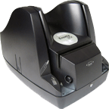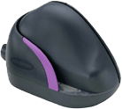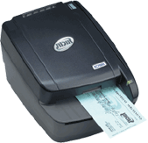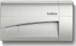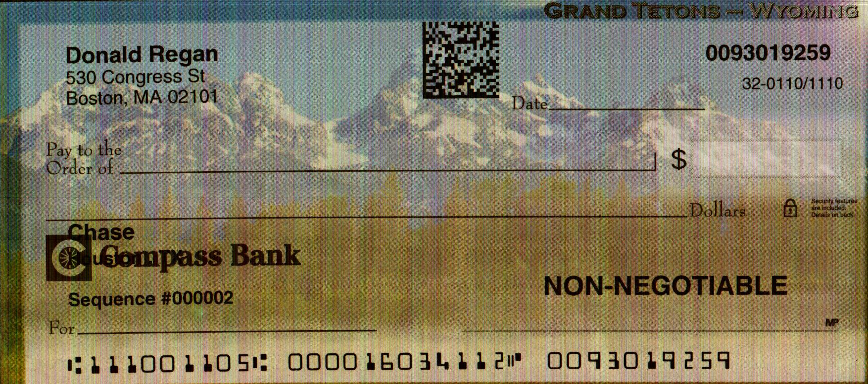

SPECIAL Opportunity:
The team will have the opportunity to work with PC Guard, a leading product for protecting software applications from unauthorized use. This will be an excellent “hands on” experience in learning how to protect developed software applications which is often a required skill in today’s software development environment.
Comments or questions:

Bruce Brenner, President
MiniCheck-OCR, Inc
713-446-6676
Bruce@MiniCheckOCR.com

