Mobile Medical Image Visualization
Using iPhone/iPod Touch

Soft Imaging, LLC.

Introduction

Rich internet applications (RIA) have changed the way many software developers and end-users utilize the internet. They led to the development and evolution of the web as an interactive application platform rather than a HTML document retrieving interface.
In recent years, an increasing number of RIAs have been developed and deployed for various applications as client-server and data center technologies become more commonly used. Concurrently, the field of medical imaging has also experienced historical transition from analog film-based technology to digital counterpart. The hypermedia nature of the internet makes it possible and convenient to communicate and archive digital content beyond the limitation of geographical location. The advancement in RIA and rapid adoption of digital medical information bring forth great opportunities to create effective solutions and products that address the needs of emerging healthcare applications such as telemedicine and electronic health records. Furthermore, the advent and affordability of high performance mobile computing devices such as iPhone and iPod Touch help facilitate the development of efficient technologies that provide healthcare providers with the ability to access critical clinical information from anywhere and at anytime.

Project Definition and Requirements

The goal of this project is to develop a RIA on iPhone and iPod Touch for mobile medical image computing and visualization. Such an application will enable users to have secured access to medical images on a server at a remote location, and perform required computing and visualization functions for interpretation of these images on the mobile devices. The envisioned software system will be composed of a rendering engine on the client (i.e., iPhone/iPod Touch), an application gateway, and an application and a database on the server. Via a Wi-Fi network, users will be able to log onto the server and start the application. The users can then access the database and query for particular cases of medical images for required visualization and interpretation. The results of the case study can be archived on the server or be exported. An illustration of medical image rendering on a iPhone/iPod Touch is shown in Figure 1.

The initial scope and requirements of the work proposed for this capstone project are specified below:

- Development of the iPhone application for mobile medical image rendering and visualization using iPhone SDK (Objective-C) and Cocoa-AMF on a Mac.
- Development of software using Java services and BlazeDS for the client to interface with the server for database access and image retrieval, and for image processing and 3D reconstruction on the server using VTK (either on a Mac or a PC).
- The anticipated deliverables are functional software that reads a sample image set, process the image set and reconstruct its 3D volume or surface on the server, and then display the rendered results on the iPhone/iPod Touch based on user interaction.

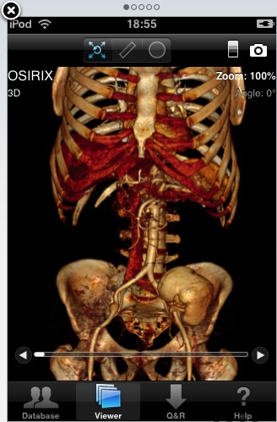
To ensure the quality of resulting software, source code should be commented using easy-to-understand comments, and follow Soft Imaging’s coding style guidelines. Example code will be provided as needed. As a recommended practice, the code should be written in a structured and modular fashion so that one would be able to maintain the code and reuse portions of the code in other applications with minimal effort and modification.
Figure 1. An illustration of medical image rendering on an iPhone/iPod Touch.

Contact Information

The names, email addresses and phone number of the contact persons for this project are:

Qiang Wu
Qiang.wu@softimagingllc.com
(281) 488- 5050

and

Steve Clarner
Steve.clarner@softimagingllc.com
(281) 488-5050

