Capstone Project Proposal:

Solar Thermal Plant Design and Operation Suite of Tools

Tietronix Software

Background

Concentrating solar power plants produce electricity by reflecting sunlight onto a central receiver, where the energy is used to heat a medium which ultimately drives electrical generators. Sunlight is reflected toward the receiver by mirrored devices called heliostats. Heliostats, sometimes numbering in the tens of thousands, are organized into fields around a tower holding the receiver at the appropriate height above the ground.

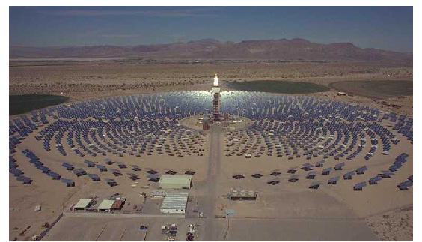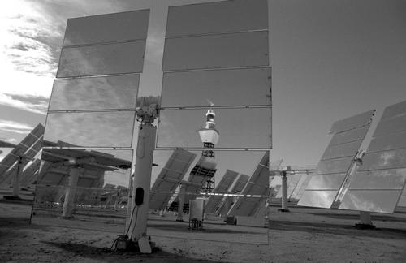

In the design of solar power plants, many parameters must be optimized. One such parameter is the location of each heliostat in the field. Heliostats are positioned in such a way that, as they track the motion of the sun across the sky, the degree to which any given heliostat casts a shadow upon neighboring heliostats is kept within an acceptable limit. The degree to which any given heliostat blocks the view of the receiver from a neighboring heliostat is also a factor in the optimization process. These two factors, shadowing (shading) and blocking, are computed for a given field layout by a Tietronix software program called SolarComputation.

A single run of the program SolarComputation produces, for a given field layout, a snapshot of the shading and blocking of each heliostat in that field at a moment in time. Since real world solar power plants will operate continuously around the year, the design process must include analyses of the field’s layout at times and dates (and, by extension, sun angles) that are representative of the annual incident sunlight.

A particular stage in the design of a solar power plant might require dozens or even hundreds of executions of the SolarComputation program. The technique, process, and tools required to store, manage, and recall the information it creates is required.

Project:
The proposed project is a part of the overall development of a suite of software that can support the solar plant designers as well as the plant operators. This semester’s project will focus on the development of a a computer software program that stores, in a database, the output of the SolarComputation program in such a way that data for a given field configuration can be retrieved by various keys (e.g., date, time of day, location, sun angle, heliostat identifier, etc). The program will manage the shading and blocking data for multiple field configurations at multiple dates and times. It will allow for the addition as well as deletion of records. The program will be delivered as a standalone executable operated via a simple graphical user interface. Accompanying documentation shall include a detailed design and a user’s guide.

