Capstone Project Proposal:

Using CUDA for Solar Thermal Plant Computation

Tietronix Software

Background

NVIDIA® CUDA™ is a general purpose parallel computing architecture that leverages the parallel compute engine in NVIDIA graphics processing units (GPUs) to solve many complex computational problems in a fraction of the time required on a CPU. It includes the CUDA Instruction Set Architecture (ISA) and the parallel compute engine in the GPU. To program to the CUDA™ architecture, developers can, today, use C, programming languages, which can then be run at great performance on a CUDA™ enabled processor. (see http://www.nvidia.com/object/cuda_home.html#)

Concentrating solar power plants produce electricity by reflecting sunlight onto a central receiver, where the energy is used to heat a medium which ultimately drives electrical generators. Sunlight is reflected toward the receiver by mirrored devices called heliostats. Heliostats, sometimes numbering in the tens of thousands, are organized into fields around a tower holding the receiver at the appropriate height above the ground.

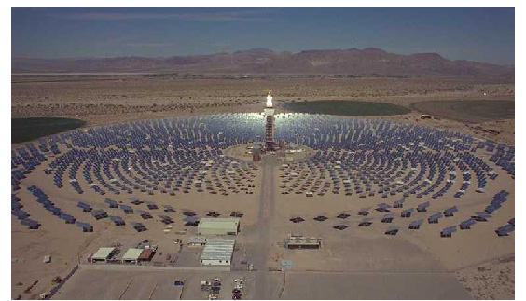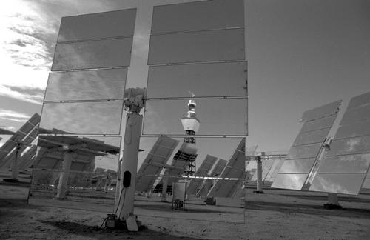

In the design of solar power plants, many parameters must be optimized. One such parameter is the location of each heliostat in the field. Heliostats are positioned in such a way that, as they track the motion of the sun across the sky, the degree to which any given heliostat casts a shadow upon neighboring heliostats is kept within an acceptable limit. The degree to which any given heliostat blocks the view of the receiver from a neighboring heliostat is also a factor in the optimization process. These two factors, shadowing (shading) and blocking, are computed for a given field layout by a Tietronix software program called SolarComputation. For tens of thousands of heliostats, this computation can take a significant amount of time.

Project:
The proposed project is a part of the overall development of a suite of software that can support the solar plant designers as well as the plant operators. This semester’s project will focus on the development of a computer software program that uses the power of the CUDA technology to perform the same computation as our current software program. The main effort will be in adapting our known algorithms to the CUDA instruction set. Shading and Blocking involve the computation of vectors projections and polygon clipping. Performance metrics will be collected to allow the comparison between the original software and the CUDA-based software. The program will be delivered as a standalone executable operated via a simple graphical user interface. Accompanying documentation shall include a detailed design and a user’s guide.

