Capstone Project 3 – Spring 2008
Sponsored by AtLink Communications Inc & Tietronix Inc.

These projects are designed to emphasize the innovation use of advanced software technologies and pragmatic application of software engineering best practices. Each project should be undertaken by a software development team of at least four MSCS students.

Building a Rich Internet Application (RIA) as an alternative UI for the existing “PerformWork” tab of TieSPA.

Description: This Project uses an Open Source Rich Internet Application (RIA) development environment Flex (www.flex.org ) to build the next generation UI to replace the “Perform Work” tab of TieSPA (http://www.tietronixproducts.com/SDA.htm). The “Perform Work” tab of TieSPA is meant to be a work panel for a day to day user of TieSPA. Currently it has a portal based interface as shown below.

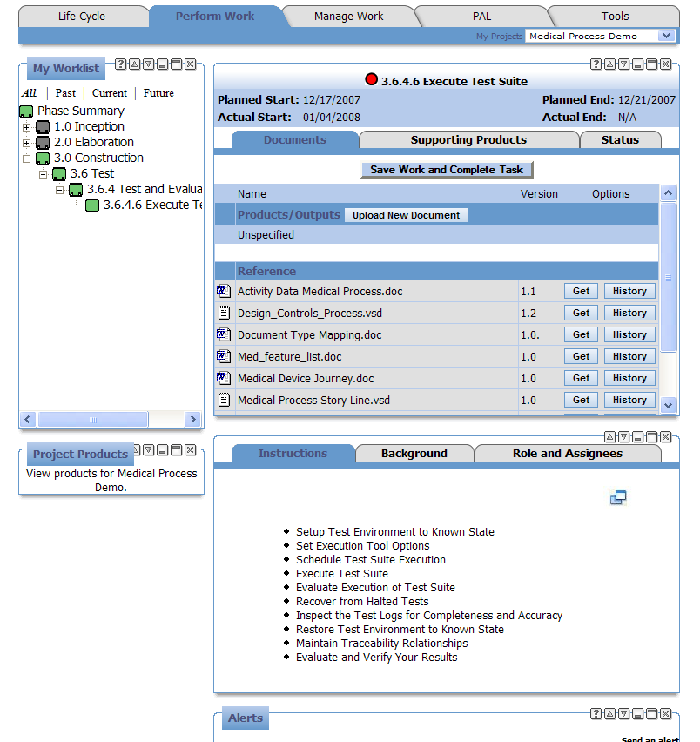

Requirements:
TieSPA is an engineering process automation tool that already has built in support for medical device manufacturing. The tool provides a personalized view of the work that needs to be done by an individual member of the team using the “Perform Work” tab. The Requirement is to implement a RIA interface that can be more productive, sexy and easy to use than the current version.

- Project Requirements
  - The team will identify the set of information that should be presented in the “Perform Work” RIA.
  - The team will then create the best UI to visualize each one of that information.
  - The team will then design the best layout for the Perform Work.
  - The team will then design the best navigational capabilities to provide the detail information to the user.
  - The team will then implement the RIA UI.

Design/Implementation Constraints:
The project team will design and build the RIA using the following open source development tools:
  - The system shall Flex (www.flex.org )
  - The system will also use the TieSPA database to collect relevant information for the new perform work RIA.
  - Visio UML tool for analysis & design specifications

Project Deliverables:
The project team will provide the following deliverable in three phases:
- Phase 1: Analyze and Prototype
The project team will provide the following:
Software Requirement Specification draft that includes a UML 2.0 use case, analysis and Sequence models. Prototypes and mock-up of the RIA interface and the set of information that is relevant on the perform work RIA.
- Phase 2: Design and Build Beta
The project team will provide the following deliverables:
Software Design Specification final that includes a UML 2.0 design model and if necessary a data model. The beta version of the RIA interface.
- Phase 3: Test and Deliver GA
Product Tests specified using UML 2.0 Sequence Diagrams supporting the Software Requirements Specification. Final and working version of the Flex based RIA for the project and a project report.

