UHCL
Fitness Center
Database Application

Instructor:
Dr. Kwok-Bun Yue

Mentor:

Ms. Denise B. Cazes

Project Team Members:

Hala Annab
Mark B. Jones
Wei (Lawrence) Liu
Jacqueline Matekwa Mbata

Report Date: May 1st, 2007

Spring 2007

This page
Intentionally
Left blank
Abstract
The UHCL Fitness Center (also known as the Fitness Zone) runs several programs and services for students, faculty, staff, alumni, and family of faculty and staff. The Fitness Center needs an application to track Fitness Zone facility usage, 100 Mile Club program participation, and use of services. This application needs to be scaleable to support future programs similar to the 100 Mile Club, additional membership groups, and direct access by members.
To accommodate the immediate and future requirements an application was implemented as a Web application and run locally in the Fitness Zone. Designing the application on a Web-based architecture will allow it to be moved to a public Web server at some point in the future to support direct access by members. Implementing the application locally satisfies the immediate access requirements while minimizing the need for support from University Computing and Telecommunications (UCT).
The system was implemented as a three tier Web application using ASP.NET for the presentation layer, C# for the business logic, and Microsoft Access for the database. Any Computer Science Student Assistant should be familiar with these technologies which should facilitate support for the application. Microsoft Access should require little maintenance and is easy to backup. This should also simplify support for the application.
Eventually the application can be moved to a public Web server so that functionality can be added for members to access the system directly to apply for membership, update their own 100 Mile Club activity logs, and perhaps other services. This should reduce the work load for the Fitness Zone manager and staff as well as adding services and convenience for Fitness Zone members. The system has been designed with the future in mind such that the application will scale as usage increases, and additional functionality can be added easily.
This page
Intentionally
Left blank
Table of Contents
1 Introduction and Background 6
2 Design and Implementation 8
2.1 System Architecture 8
2.2 Relation Schema 8
2.3 Class Diagram 9
2.4 Main Functions 9
2.5 Technologies Used 9
2.6 Software Development Model 10
2.7 Implementation Issues 10
2.8 Other Solutions Considered 11
3 Evaluation of Solution 11
3.1 Prototype Evaluation 11
3.2 Lessons learned 12
4 Conclusions 12
5 References 13
6 Appendices 14
6.1 Appendix A – Project Management and Team Information 14
6.1.1 Team Roles and role assignments 14
6.1.2 Schedule 16
6.2 Appendix B – Major tasks and contributions 17
6.3 Appendix C – Manager/Admin Use Case Diagram 20
6.4 Appendix D – Student Worker Use Case Diagram 21
6.5 Appendix E – UML Class Diagram 22
6.6 Appendix F – Database Relation Schema Diagram 23
6.7 Appendix G – Requirements Document 24
6.8 Appendix H – Data Definition Document 24
6.9 Appendix I – Design Document 24
6.10 Appendix J – Coding Standards Document 24
6.11 Appendix K – Test Plan Document 24
6.12 Appendix L – Technical Guide 24
6.13 Appendix M – User guide 24
6.14 Appendix N – Future Development Feature List 24

Introduction and Background
The UHCL Fitness Zone is a facility on campus that offers various workout machines and equipment. It is available to students, faculty, staff, alumni, and family of faculty and staff. In addition to the workout facility the Fitness Zone organizes different programs like yoga classes and the 100 Mile Club; and it also offers services such as locker rental and body fat testing.
The Director of the Fitness Zone is interested in an application that will store Fitness Zone Membership Information, track member usage of the Fitness Zone facility, manage locker rentals, and help organize program participation for the 100 Mile Club with the possibility of expanding to more programs in the future. One of the challenges is that the Fitness Zone does not have any technical staff and will not have support for this application from University Computing and Telecommunications (UCT). Therefore, the application needs to be easy to administer and use by the manager and staff. The application also needs to be easy to maintain. The intention is that the Fitness Zone will hire a student assistant who is a Computer Science graduate student to fix bugs and add features.
This project is a continuation of a previous capstone project. The existing application is a windows application that runs on a MS Windows operating system. It was coded using C# and uses MS Access to store its data. There were several issues with the existing application that prompted the second capstone project. The cited issues were that some modules were not executing, the application was not useable from multiple machines, and the project documentation was not sufficient. It was also determined that the user interface had usability problems and was not sufficiently intuitive. The reports were not working on the client’s machine due to a missing DLL. Finally, the database design was not normalized and did not sufficiently support the functionality that was implemented or allow for future development. As a result this application was never actually used.
When developing our requirements we started with the previous group’s requirements document and analyzed the existing application. After discussing the existing application and requirements document with the Manager of the Fitness Zone it was clear that in general the existing application addressed the features she was interested in, but the terminology used seemed to mean more to the developers than to the Fitness Zone and the existing work flows in the Fitness Zone did not seem to be well considered. For example the developers used the term ‘Operator’ in the documentation and application. The Fitness Zone manager and employees refer to this role as ‘Student Worker’. And the application relied on members and student workers knowing a system generated ID when looking up members in the database which is not an intuitive method for looking up member data. We used terminology more familiar to the management and employees of the Fitness Zone, and tailored our forms and page navigation to imitate the Fitness Zone’s existing paper based procedures.
To accommodate the immediate and future requirements we decided to start over and implement a Web application. The immediate needs only require that the application be accessible by Fitness Zone employees from the two computers in the Fitness Zone, but designing the application on a Web-based architecture will allow it to be moved to a public Web server at some point in the future to support direct access by members. But to minimize the need for support from UCT the application will be implemented initially on one of the computers in the Fitness Zone which will not be accessible from the Internet. The application could then be accessed through the UHCL network from the second Fitness Zone computer using a Web browser.

Design and Implementation

System Architecture
The system has been implemented as a three-tier Web application. The Web server and database will reside on the desktop computer at the front desk of the Fitness Zone.
That computer and the computer at the manager’s desk will access the system using a Web browser via the UHCL network. The diagram in figure 1 gives a picture of the design.
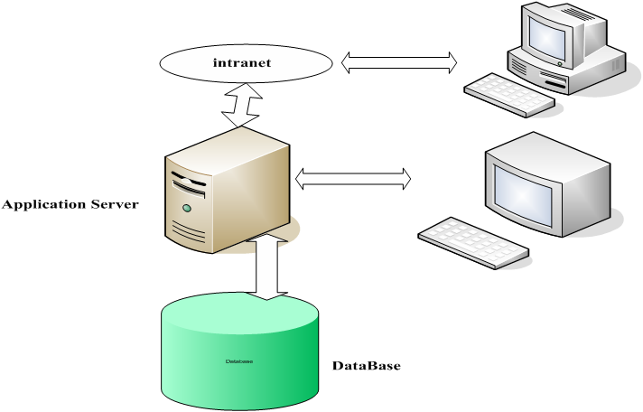
Figure 1: System Architecture
Security may be a mild concern going forward since the application will be accessible via the UHCL network. Currently the application is using HTTP. Especially if the application is moved to a public web server a ‘secure’ server should be considered where the application can run using HTTPS. This will prevent system passwords from crossing the network as clear text and protect any data that may be sensitive. Also, the application has not been tested to see if it is vulnerable to attacks such as ‘cross site scripting’ or evaluated in any other way from a security perspective.

Relation Schema
The Database includes fourteen tables. There are two main groups of tables: one group that holds information related to the people that are tracked by the system and one group that holds information relating to membership and program participation. The ‘Persons’ table is actually central to both groups and ties the schema together. The information relating to people includes name, identifiers, telephone number, home address, emergency contact information, birth, and gender information. The second group of tables tracks Fitness Zone membership, locker rental, and program participation. A complete diagram of the database relations is available in Appendix C.

Class Diagram
A complete class diagram is included as Appendix D.

Main Functions
The main tasks to be implemented were:
- A mechanism to enter Fitness Zone Applications into the database
- A mechanism for approving Fitness Zone Applications
- A mechanism for entering 100 Mile Club registrations, distance log submissions, and participation reports
- A mechanism for tracking locker rentals
- A mechanism for tracking the Fitness Zone Facility usage and generating reports

Technologies Used
The system was implemented as a three tier Web application using ASP.NET for the presentation layer, C# for the business logic, and Microsoft Access for the database. We also used a third party charting tool called WebChart to create the required graphical reports. WebChart is a library of web controls that can be used to generate several different styles of graphical charts [Mares].

Software Development Model
We used an iterative approach to development in concert with rapid prototyping. After collecting requirements we started by developing an HTML mockup (or façade) for the application. This gave our client a quick idea of what the application would look like and also helped us to refine the requirements by communicating in terms of the proposed user interface. As different parts of the user interface were agreed upon the functionality was added to the prototype. As we received feedback from the client we were able to anticipate her reactions to development of subsequent features.

Implementation Issues
The main obstacle we encountered was regarding the initial choice of the system architecture. We wanted to switch from the windows-application architecture used by the previous group to a Web-application architecture. This quickly became an issue when trying to identify a place to run the production system.
In order to run the application such that it was accessible via the internet we would need University Computing and Telecommunications to host the application on one of their Web servers. As it turns out, it is against their policy to host applications they will not be supporting.
So with that option unavailable we decided that we could run the application locally on one of the Fitness Zone desktops. This will not satisfy all of the future requirements of the system but it does satisfy the immediate requirements while allowing for the possibility of moving to a public Web server in the future. This is where we ran into more obstacles. In order to run a Web application we needed a Web server. The Fitness Zone computers did not have a Web server installed and it was against UCT policy to allow a Web server to be installed on desktops. In the end we were able to negotiate with UCT and they agreed to install the software we needed.

Other Solutions Considered
When the project began we were considering three possible solutions: fix the existing windows application, re-write a windows application, or re-write the system as a Web Application. The existing windows application had several shortcomings including a lack of internal and external documentation, a poor database design, and a user interface that was not intuitive. After deciding to re-write the application, we looked at the immediate requirements and our clients ‘wish list’ for the future, and determined that a Web-application architecture would be the most flexible and allow for future development to satisfy the client’s future vision.

Evaluation of Solution

Prototype Evaluation
Arguably, the biggest problem with the existing application developed, by the previous group, is that it is not being used. We have focused on developing a system that is flexible, easy to maintain, and (most important) that will be used and add value to the Fitness Zone. This means that in some cases we had to work hard to focus the scope to sets of related features that provide complete, useable solutions to specific problems. As a result some of the features that were included in the existing application have not been translated into our application. In this way we are gauging our success on the features that will be used in our application vs. features that were actually used in the previous application. And in terms of our original problem statement we are delivering a useful application that is well documented and easy to maintain.
A big measure of the quality of our application is in the work we did redesigning the database and in the usability of the user interface. We spent a great deal of time analyzing the data we needed to capture, what reports we needed from the data, and how best to express the data in a well designed, normalized database schema. We also spent many hours walking through the pages of the user interface working on minimizing the amount of data entry required and optimizing the page flow and information displayed to the user.
Judging by the feedback from our mentor we expect to see our application not only used but continue to evolve as others continue to add features.

Lessons learned
We were fortunate to get a good early start on our project because as we would discover there were circumstances beyond our control that slowed our progress. The biggest lesson would be to expect delays and to be prepared to narrow the scope of the project in order to complete what you have in the time allotted. This not only makes it possible to finish on time but it improves the quality of the work completed.

Conclusions
We are proud of the work we have done and consider our project to be successful. There are features that we would have liked to implement and features for which interest was expressed by our mentor that could not be implemented in the time allotted. But in terms of our original charge, which was “to deliver a working application with sufficient documentation and user guidelines so it can be maintained by the fitness center in the future” [Yue], we have delivered.
We have designed a flexible, scalable, and maintainable system with a well thought out database design and a user interface designed to be intuitive and to fit the existing work flows at the Fitness Zone. The code is well documented and detailed technical and user guides have been supplied. We feel confident that the Fitness Zone will use and benefit from our application which is our strongest measure of success.

References
- Yue, Kwok-Bun. “UHCL Fitness Center Database Application” 2006. CSCI 6838 Capstone Projects. 2007
<http://dcm.cl.uh.edu/yue/courses/csci6838/Spring2007/fitness.html>
- Zafar, Sohail; Zhu, Hongbing; Satewar, Rajesh. “PROJECT NO. 3 Fitness Center Tracking Application” 2006. CAPSTON PROJECT SUMMER 2006. 2007
< http://dcm.cl.uh.edu/c6838su06gp3/>
- UHCL. “Student Life Fitness Zone” 2004. Fitness Zone. 2007
< http://dcm.cl.uh.edu/c6838su06gp3/>
- Mares, Carlos Aguilar. “WebChart Control for ASP.NET” 2006. CarlosAg.net. 2007 < http://www.carlosag.net/Tools/WebChart/Default.aspx>

Appendices

Appendix A – Project Management and Team Information

Team Roles and role assignments
Team Leader (Mark)
The Team Leader is responsible for organizing team efforts and ensuring that the team is satisfying the professor's Policies and Requirements document.

Webmaster (Mark, Jacqueline)
The Webmaster is responsible for maintaining the Project Web site as well as ensuring that the Web site conforms to the professor's Guidelines for Project Web page document.

DBA (Jacqueline, Hala)
The DBA is responsible for designing, documenting, implementing, and maintaining the project database. The DBA is responsible for ensuring the project conforms to the professor's Guidelines for Database Design and Documentation document.

Lead Programmer (Lawrence, Hala)
The Lead Programmer is responsible for designing the structure of the application modules, establishing a coding standard for the project, and guiding the coding efforts of other team members.

System Administrator (Hala, Lawrence)
The System Administrator is responsible for evaluating the computers in the Fitness center as well as installing and configuring any software that the project may require on the Fitness Center Computers.

Technical Writer (Mark, Hala)
The Technical Writer is responsible for editing the documents produced by the team and ensuring that the final report conforms to the professor's Guidelines for Final Reports document.

Schedule
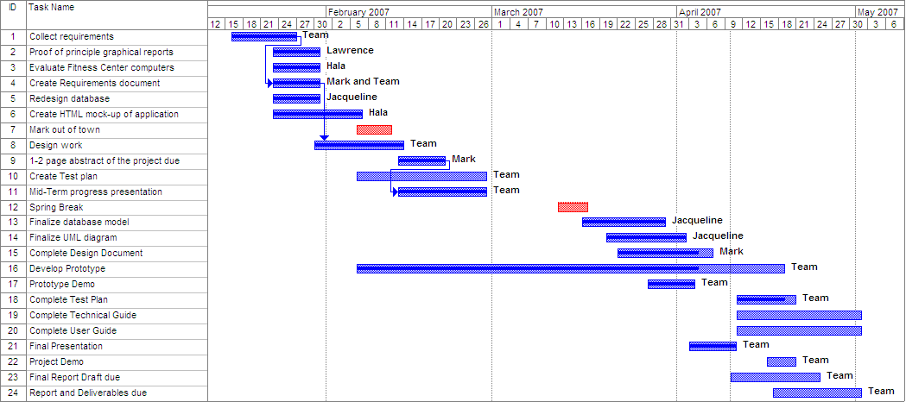

Appendix B – Major tasks and contributions
Team Leadership
- Hala Annab (10%) – Meeting discussion, meeting minutes
- Mark B. Jones (70%) – Meeting scheduling, meeting agendas, meeting minutes, task assignment coordination, coordinated communication with mentor and professor, communicated with UCT
- Wei (Lawrence) Liu (10%) – Meeting discussion, meeting minutes
- Jacqueline M. Metekwa Mbata (10%) – Meeting discussion, meeting minutes
Website creation and Maintenance
- Hala Annab (5%) – Edited content
- Mark B. Jones (75%) – Created and maintained Web site
- Wei (Lawrence) Liu (5%) – Edited content
- Jacqueline M. Metekwa Mbata (15%) – Edited content
Database Design and Implementation
- Hala Annab (10%) – contributed to database design decisions
- Mark B. Jones (5%) – contributed to database design decisions
- Wei (Lawrence) Liu (10%) – contributed to database design decisions
- Jacqueline M. Metekwa Mbata (75%) – Drafted database design, ER Diagram, UML Class Diagram, Data Definition Document, implemented database

Prototype Design and Implementation
- Hala Annab (70%) – prototype design, HTML mockup, system architecture diagram, coding: fitness zone registration, employee registration, search engine, email password, change password, login screen, 100 Mile Club registration, yoga registration, approve membership, renew membership, feedback modifications, testing
- Mark B. Jones (5%) – prototype design, HTML mockup
- Wei (Lawrence) Liu (20%) – Graphical Reports proof-of-principle, prototype design, coding: check-in/checkout, usage reports
- Jacqueline M. Metekwa Mbata (5%) – Use Case Diagrams, HTML mockup, prototype design
Documentation
- Hala Annab (15%) – Drafted Coding Standards document, Presentation Slides, Drafted User Guide
- Mark B. Jones (60%) – Drafted Requirements document, Drafted Abstract, Drafted Test Plan, Drafted mid-term and final presentation, Drafted Technical Guide, Drafted Final Report
- Wei (Lawrence) Liu (10%) – Edited Technical Guide, Presentation Slides
- Jacqueline M. Metekwa Mbata (15%) – Drafted Design Document, Presentation Slides, Completed User Guide

System Installation
- Hala Annab (50%) – Evaluated Fitness Zone Computers, Installed application in the Fitness Zone, Trouble shoot configuration, user training
- Mark B. Jones (10%) – Evaluated Fitness Zone Computers, Trouble shoot configuration
- Wei (Lawrence) Liu (40%) – Trouble shoot configuration
- Jacqueline M. Metekwa Mbata (0%) –

Appendix C – Manager/Admin Use Case Diagram
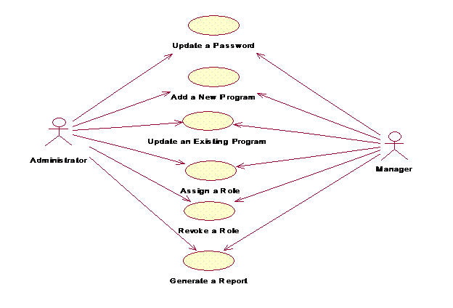

Appendix D – Student Worker Use Case Diagram
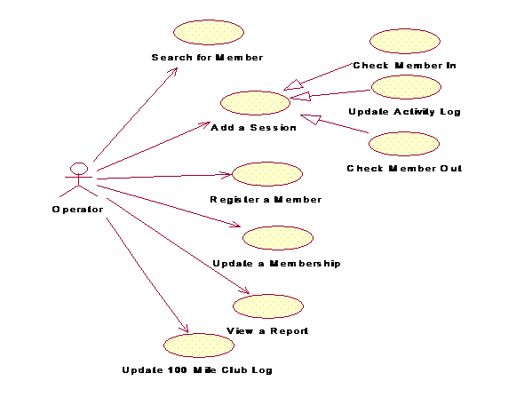

Appendix E – UML Class Diagram

Appendix F – Database Relation Schema Diagram
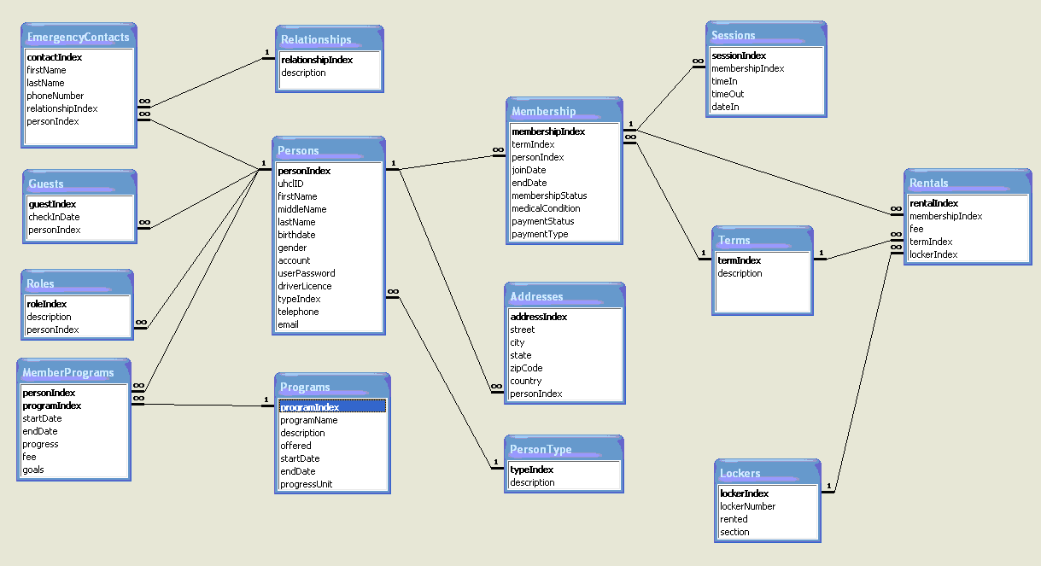

Appendix G – Requirements Document
Attached …

Appendix H – Data Definition Document
Attached …

Appendix I – Design Document
Attached …

Appendix J – Coding Standards Document
Attached …

Appendix K – Test Plan Document
Attached …

Appendix L – Technical Guide
Attached …

Appendix M – User guide
Attached …

Appendix N – Future Development Feature List
The following is a list of features that could not be completed by the original project deadline or are ‘wish list’ items for the Fitness Zone.
- Move the application to a public Web server.
- Allow non-members to complete Fitness Zone membership applications on-line
- Add a link to the ‘Approve FZ Application’ page to view member information
- List all 100 Mile Club members
- List all Yoga members
- Prevent multiple simultaneous check-in by one member

