MiniCheck-OCR, Inc FIGHT IDENTITY FRAUD
Confidential Project Details
Capstone Fall 2011
MiniCheck ID™

Fighting Identity Fraud is a major concern in our society. Financial institutions, Insurance companies, Automobile dealers, Retailers, Employers, Pharmacies, Credit card companies, Mortgage companies, Apartment complexes and the Healthcare industry are just some examples where verifying a customer’s identity is very important.
MiniCheck ID™ is designed to effectively fight Identity Fraud and enhance the capture of important customer data. This has timely REAL WORLD IMPLICATIONS

This project will incorporate some of the work done in the previous semesters and extend the capabilities of the MiniCheck ID DL Utility we have developed in previous versions which should really be fun. The features developed this semester will have real world implications! Our goal is to provide an excellent “hands on” learning experience and have fun doing it!
This project offers a great “end-to-end” opportunity to develop a real world application with far reaching implications.

MiniCheck-OCR, Inc
MiniCheck-OCR, Inc has developed a suite of applications known as MiniCheck ID™, MiniCheck ID Pro™, MiniCheck ID Pro+™ and MiniCheck DL Utility. These applications are used for validating IDs at the point-of-sale, Mobile environment or any situation where ID Validation, Age Verification or Electronically Capturing the information contained on ID cards is important. Previous versions of MiniCheck ID™ incorporated multi-level authentication by allowing the user to connect to third party databases in order to verify a customer’s identity by verifying the authenticity of a social security number, postal address or legal right to work status. All functions executed through the MiniCheck ID™ user interface. At the point-of-sale, MiniCheck ID™ provides the ability to validate a photo ID such as a driver’s license or state issued ID card in order to prevent losses due to fraud. This ID validation happens using a combination of advanced algorithms to read and decipher the electronically encoded data in either the magnetic strip or barcode located on the ID itself. The user has an option to capture an image of a photo ID at the point-of-sale and store it within the record archive maintained on the local PC by the user in the Access database.
MiniCheck ID Pro™ adds to MiniCheck ID™ the ability to process credit card transactions.

Project scope: FIGHT IDENTITY FRAUD

MiniCheck ID Pro™
To enhance and improve upon the previous architecture and functionality of the MiniCheck ID application and re-architect the UI and application itself.
The name of the new application will be MiniCheck ID with E-Verify and should be based on a platform offering the most flexibility for hardware options and future modifications. Technologies considered include .NET, FLEX and JAVA.
The team will be able to review past project details and source code of previous teams to review methodologies previously used to integrate to E-Verify and different pieces of Hardware. This may be helpful in determining improvement points.
*The application developed for this project should support windows 7 and Windows XP.

Features developed will include:

*Reading, decoding and parsing the electronically encoded data contained on government issued ID cards from either the magnetic stripe or 2D Barcode (PDF 417) located on the ID card.
*Age calculation option alerting user if customer under 21 for age controlled products.
*The ability to pass the data captured from ID cards to third party applications in flexible formats including XML making it possible to automatically populate databases, form fields etc…
*Ability to “auto-compare” common denominators contained on an ID card and a Credit Card such as name.
*Support for E-VERIFY. E-Verify provides a database available to employers in order to verify an employee’s legal right to work status in the US. Fighting identity fraud has been a very big problem for E-Verify. It is estimated close to 50% of E-Verify’s positive matches are incorrect due to identity fraud. This MiniCheck ID application needs to be integrated to E-Verify. Excellent support and integration materials for E-Verify web services are available.

FIGHT IDENTITY FRAUD

Age calculation with ALERTS regarding age based restrictions
*Add functionality for automatic Age Calculation: Automatic alerts generated for the user based on the age calculation results.
Example:
*Under 21, NOT authorized consumption or purchase of alcoholic beverages
*Under 18, NOT authorized to purchase ANY tobacco-related products

MiniCheck ID Pro+™V2
*Previous Capstone teams have integrated to E-VERIFY which is the information data base through Homeland Security for verifying an employee’s right to work in the US. The value add is that MiniCheck ID Pro+V2 will combined robust ID Validation and reading with the ability to verify and confirm the true identity of the employee. This application will support reading, parsing and displaying the electronically encoded information in the magnetic stripes and barcodes found on drivers’ licenses and state issued ID cards.
The information contained on the ID card will be passed electronically into the E-Verify online system. This will eliminate errors due to manual data entry, speed the data entry process and reduce the risk of identity fraud.

Flow:
Read, capture, identify and parse the information that is contained in the magnetic stripe or barcode (2D PDF 417) on a driver’s license or state issued ID card.
The results then displayed on the users’ desktop within the MiniCheck ID user Interface on the user’s desktop allowing the user the ability to quickly and accurately verify that the information printed on the front of the ID card matches the information that is electronically encoded in the magnetic stripe or barcode.

MiniCheck ID™
Most magnetic stripe readers work in a similar way (basically); they read the data from the magnetic stripe and output this data in its RAW format. There are different brands of magnetic stripe readers on the market; examples of this are evident in almost every retail location in the country. Different interface options are HID (Human Interface) or Keyboard Emulation.
*Many drivers’ licenses and state issued ID cards have magnetic stripes and/or 2D barcodes on them which contain important personal information. Using the reference materials available, the previous student team has fully integrated the ability to identify the basic fields of information in the magnetic stripes and 2D barcodes then parse the specific fields of information from that RAW Data. The user has the option to store the parsed data automatically in the database of the MiniCheck ID Pro+™ application.
*The information contained in the magnetic stripes or barcodes found on ID cards vary depending on the state of issue.
IMPORTANT Note: Previous Capstone teams developed the MiniCheck ID™ applications to support all drivers’ licenses and state issued ID cards that follow the AAMVA standards that are the recommended industry standards for formatting and encoding the information contained on drivers’ licenses and state issued ID cards. With MiniCheck ID™, we now have an updated parser that supports drivers’ licenses and state issued ID cards that do NOT follow the AAMVA standards as well as those that do.

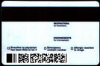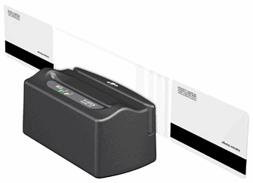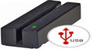

MINICHECK ID™

Additional Background and history

When a user swipes an ID card through the magnetic stripe reader, the raw data electronically encoded on the card is parsed and converted into meaningful information, it is then displayed in the user interface. This allows the user to verify that the information displayed on the card is same as the information that is electronically encoded in the magnetic stripe thereby reducing the likelihood of accepting a potentially fraudulent transaction.
Previous Capstone Teams enhanced the existing standalone application by improving the user interface and making it more powerful than before in terms of functionality. They changed the user interface to make it user friendly. The MiniCheck ID™ application was successfully integrated to a variety of POS hardware. Previous versions of MiniCheck ID™ read and parsed the information contained in Barcodes from the images of the barcode located on the ID. They used the Software Development Kit from Atalasoft which is used for converting barcodes from images to RAW Data. This technology allows MiniCheck ID™ to read the information contained in a barcode from an image of a barcode without the use of a physical barcode reader.

This project will be fun while providing an excellent learning experience for each team member. This project combines multiple technologies to produce a powerful real-world solution.
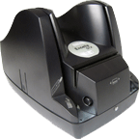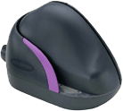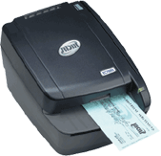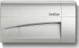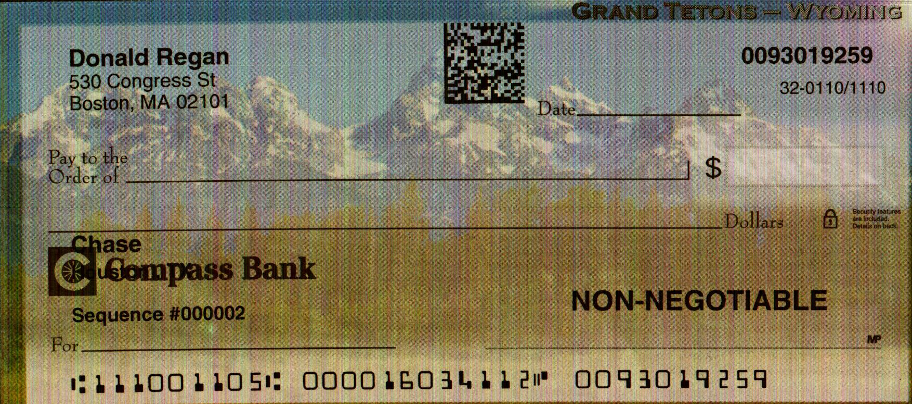

SPECIAL Opportunity:
The team will have the opportunity to work with PC Guard, a leading product for protecting software applications from unauthorized use. This will be an excellent “hands on” experience in learning how to protect developed software applications which is often a required skill in today’s software development environment.
Comments or questions:

Bruce Brenner, President
MiniCheck-OCR, Inc
832-545-2888
Bruce@DetectIDFraud.com

