Capstone Project – Fall 2010
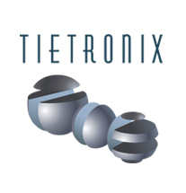
Sponsored by Tietronix Software Inc.

Solar Thermal Plant Design and Operation Suite of Tools

Modelica model of a Solar Thermal plant

Background:
Solar Thermal power plants are generating electricity from the energy of the sun. They use a field of a few thousand mirrors to reflect the sun rays onto a receiver located at the top of a tower. In the receiver a fluid is being heated by the concentrated sunlight and then water vapor is generated and sent into a regular turbine. These power plants have been studied extensively in the 70’s and 80’s. There is a strong renewed interest in the technology, and for the past years a number of new projects have been started that need updated software tools for their design and operation.

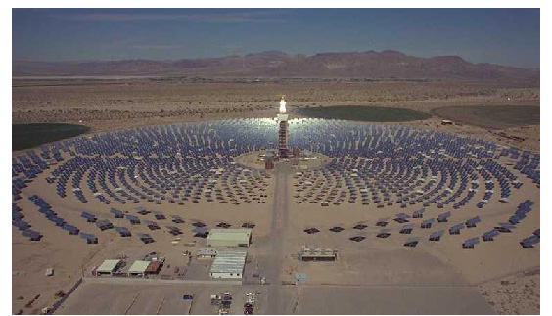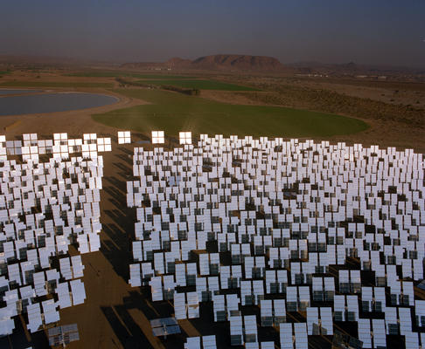

Project:

The proposed project is a part of the overall development of a suite of software that can support the solar plant designers as well as the plant operators. This semester’s project will focus on the development of a simulation software of the thermal systems of a concentrating solar thermal power plant’s receiver, using Modelica.

Modelica is a non-proprietary, object-oriented, equation based language to conveniently model complex physical systems containing, e.g., mechanical, electrical, electronic, hydraulic, thermal, control, electric power or process-oriented subcomponents.

Several thousand heliostats are positioned around a central receiving tower. Throughout the day, their facets are continuously oriented to reflect sunlight onto the tower. As the reflected light hits the receiver the thermal energy is absorbed into a fluid (e.g. water, oil, or molten salt) which then transports the energy to a heat exchanger where the energy is transferred to water, creating steam which drives a regular steam turbine. The application will take a set of input values which will then be used to simulate the thermal process from absorption to electricity output. Output will be in the form of graphs rendered using MathModelica’s simulator module.

REFERENCES:
- http://www.modelica.org/
- http://www.mathcore.com/products/mathmodelica/

TECHNOLOGY AREAS: Solar Power, Modelica, Systems Modeling, Electricity Generation

Mentor Information: Claus Nilsson

