Capstone Project – Fall 2009
Sponsored by Tietronix Software Inc.

Solar Thermal Plant Design and Operation Suite of Tools

Real Time Simulation/Visualization Component

Background:
Solar Thermal power plants are generating electricity from the energy of the sun. They use a field of a few thousand mirrors to reflect the sun rays onto a receiver located at the top of a tower. In the receiver a fluid is being heated by the concentrated sunlight and then water vapor is generated and sent into a regular turbine. These power plants have been studied extensively in the 70’s and 80’s. There is a strong renewed interest in the technology, and for the past years a number of new projects have been started that need updated software tools for their design and operation.

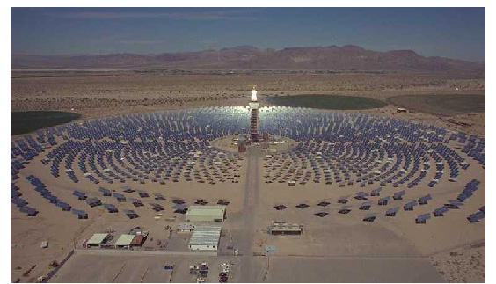

NVIDIA® CUDA™ is a general purpose parallel computing architecture that leverages the parallel compute engine in NVIDIA graphics processing units (GPUs) to solve many complex computational problems in a fraction of the time required on a CPU. It includes the CUDA Instruction Set Architecture (ISA) and the parallel compute engine in the GPU. To program to the CUDA™ architecture, developers can, today, use C, programming languages, which can then be run at great performance on a CUDA™ enabled processor.

Project:

OBJECTIVE: Develop a photo-realistic 3D simulation of a concentrating solar power plant, viewable from any perspective, that accurately models the motion of the sun and heliostats, and which can be updated in faster than real time.

DESCRIPTION: One thousand or more heliostats are arranged in a pattern around a central tower. The heliostats track the movement of the sun throughout the day and reflect the sun’s rays to a collector at the top of the tower. The traditional method of simulating this with computer graphics is too slow for real time animation. What is needed is a new approach that combines the computational power of CUDA with the inherent 3D rendering abilities of modern graphics hardware. The goal is the ability to graphically model the motion and interaction of the heliostats, the sun, reflected sunlight, and the collector as the sun follows its arc across the sky, while controlling the speed and direction of the movement of time. Shadows will be cast in a realistic manner. The 3D environment will allow the camera or viewpoint to be dynamically repositioned.

Design and implement a photo-realistic 3D simulation of a solar power plant, using a simplified one-facet heliostat model, that accurately tracks the movement of the sun, and which is able to sustain a minimum of 20 frames per second graphics update rate, while allowing the user to control the simulation date and time, as well as the rate of change of time, and the camera or viewpoint position.

REFERENCES:
1. http://www.nvidia.com/object/cuda_home.html

2. http://en.wikipedia.org/wiki/The_Solar_Project

KEYWORDS: Concentrating solar power plants, heliostats, computational mathematics, celestial mechanics, computer graphics, CUDA, OpenGL, GLSL

TECHNOLOGY AREAS: Computer Graphics, Ray Tracing, CUDA, OpenGL, GLSL

