Capstone Project – Fall 2009
Sponsored by Tietronix Software Inc.

Solar Thermal Plant Design and Operation Suite of Tools

Simplified Solar Power Plant Visualization for the iPhone

Background:
Solar Thermal power plants are generating electricity from the energy of the sun. They use a field of a few thousand mirrors to reflect the sun rays onto a receiver located at the top of a tower. In the receiver a fluid is being heated by the concentrated sunlight and then water vapor is generated and sent into a regular turbine. These power plants have been studied extensively in the 70’s and 80’s. There is a strong renewed interest in the technology, and for the past years a number of new projects have been started that need updated software tools for their design and operation.

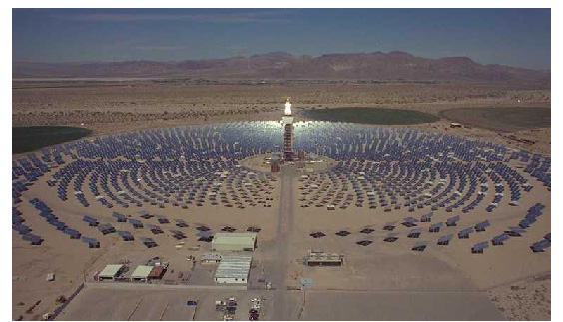

Project:

The proposed project is a part of the overall development of a suite of software that can support the solar plant designers as well as the plant operators. This semester’s project will focus on the development of an iPhone (and/or iPod Touch) computer software program which visualizes the heliostats and central tower of a simplified solar power plant at a user-specified location, time and date.
Heliostats are arranged in a pattern around a central tower. The heliostats are oriented to reflect the sun’s rays onto a collector based on the position of the sun at a given time. The heliostat position and orientation data are provided to the iPhone application. The application renders the heliostat field and models the light emitted by the sun, which is reflected by the heliostats onto the collector. The interaction of heliostats with one another is modeled to the extent that they can cast shadows and block the view of the collector. The touch interface allows the user to view the field from any perspective and at varying degrees of magnification. A 3D game engine (Unity) will be used for rendering the graphics.

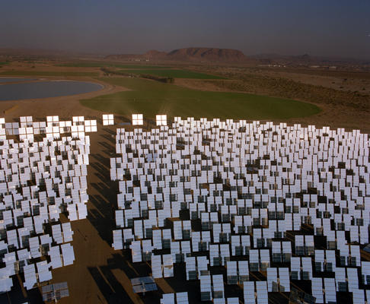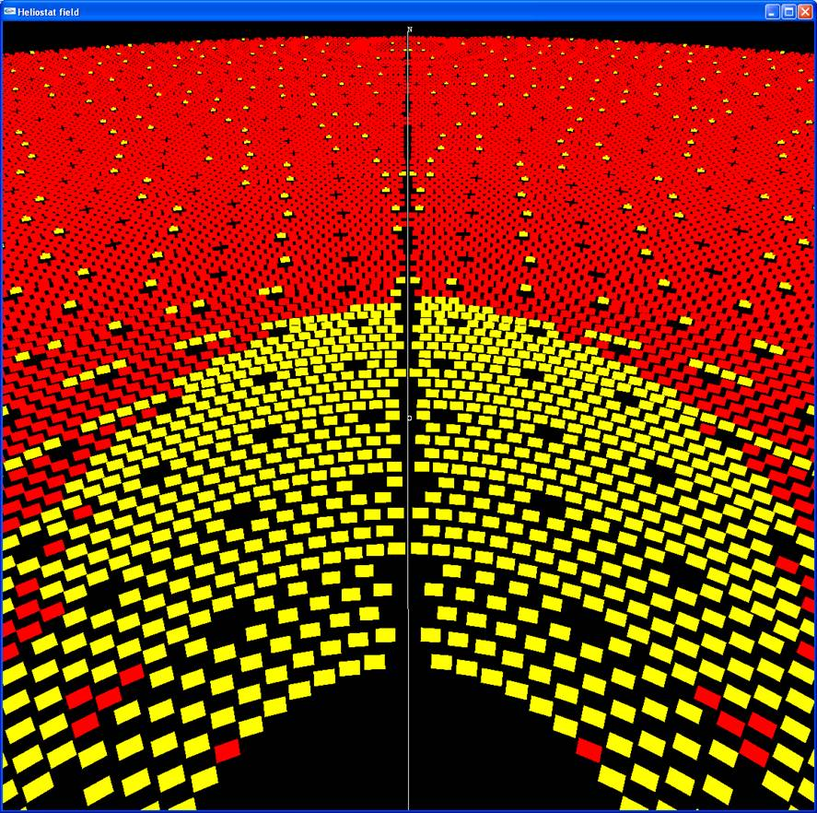

REFERENCES:
1. http://unity3d.com/unity/features/iphone-publishing

2. http://en.wikipedia.org/wiki/The_Solar_Project

TECHNOLOGY AREAS: Mobile Computing, Game Development, iPhone

KEYWORDS: Concentrating solar power plants, heliostats, iPhone, Unity, mobile computing

