Capstone Project – Fall 2008
Sponsored by Tietronix Software Inc.

Solar Thermal Plant Design and Operation Suite of Tools - Simulation Component

Background:
Solar Thermal power plants are generating electricity from the energy of the sun. They use a field of a few thousand mirrors to reflect the sun rays onto a receiver located at the top of a tower. In the receiver a fluid is being heated by the concentrated sunlight and then water vapor is generated and sent into a regular turbine. These power plants have been studied extensively in the 70’s and 80’s. There is a strong renewed interest in the technology, and for the past year a number of new projects have been started that need updated software tools for their design and operation.

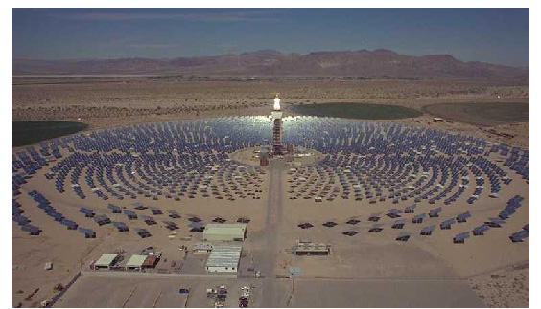

Project:
The proposed project is a part of the overall development of a suite of software that can support the solar plant designers as well as the plant operators. Their needs include the capability to compute many different data such as Shading, Blocking in the mirrors field, flux reflected from the mirrors to the receiver, and performance for a given time and day. These computations need to take into account multiple parameters such as the time of the day, location of the mirror and geometry of the receiver. This project will focus on the development of a simulation software that will use the results from other components/software and simulate the overall yearly performance of the Solar Power Plant. The software will be designed using an object oriented method, UML, and can be written either in Java or in C++. It should strive to use existing simulation toolkit such as JavaSim, Ptolemy II, SimJava, DESMO-J, D-SOL, … . This is a follow-up of capstone projects done over the past 3 semesters.

