Capstone Project Proposal:

Solar Thermal Plant Design and Operation Suite of Tools

Background:
Solar Thermal power plants are generating electricity from the energy of the sun. They use a field of a few thousand mirrors to reflect the sun rays onto a receiver located at the top of a tower. In the receiver a fluid is being heated by the concentrated sunlight and then water vapor is generated and sent into a regular turbine. These power plants have been studied extensively in the 70’s and 80’s. There is a strong renewed interest in the technology, and for the past year a number of new projects have been started that need updated software tools for their design and operation.

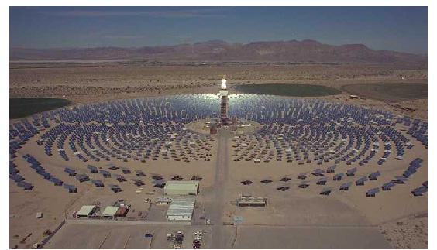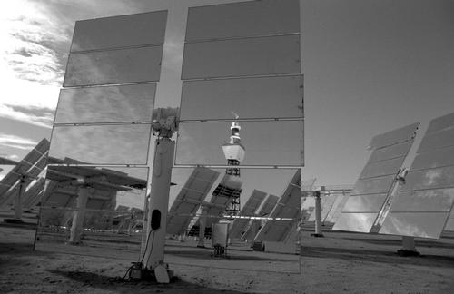

Project:
The proposed project is the development of a suite of software that can support the solar plant designers as well as the plant operators. Their needs include the capability to compute the flux reflected by one/set/all mirrors in the field toward the receiver located at the top of the tower. These computations need to take into account multiple parameters such as the time of the day, location of the mirror and geometry of the receiver. Additionally, visualization software of the field of mirror can help the operators quickly understanding the status of the mirrors. Different software modules can be reused from other projects and integrated within the suite of tools to be developed. The software will be designed using an object oriented method, UML, and can be written either in Java or in C++. Configuration files capturing the data will be using XML.
This is a follow-up of a successful capstone project done last semester.

