TieFlow Workflow Toolkit
Process Definition Verification

Capstone Project Final Report

Member:
Ying Xu
Jianlan Peng
Weiqin Yan
Xiangchun Zhang

Instructor:
Sadegh Davari

Mentor:
Scott Hetherington
Chad Keeton
Sohan Fernando

University of Houston at Clear Lake - UHCL
May 1, 2002

Table of Content

- Introduction 4
- Project Management 4
  - Roles and Tasks 4
  - Project Web Site 5
  - Project Time Line 6
- Technical Issues 6
  - Petri-Net-Based Workflow Technique 6
    - Basic Concepts of Petri-Net Workflow 6
    - Definition of Petri-net 7
    - Properties of Workflow Net 8
  - Reduction Graph Algorithm 9
    - Introduction 9
    - Process Modeling Structure 10
    - Structure Conflicts in Process Model 11
    - Reduction Rules 12
    - Apply Reduction Rules 14
- Overall Design 15
  - Architecture 15
  - Application Design 16
  - Research 17
- Responsibilities and Results 17
  - Ying Xu’s Responsibilities and Results 18
    - Contribution 18
    - Accomplishment 18
  - Jianlan Peng’s Responsibilities and Results 18
    - Contribution 18
    - Accomplishment 19
  - Weiqin Yan’s Responsibilities and Results 19
    - Contribution 19
    - Accomplishment 19
  - Xiangchun Zhang’s Responsibilities and Results 20
    - Contribution 20
    - Accomplishment 20
- Problems encountered & fixed 20
  - Problems Encountered 21
  - Problems Fixed 21
- Java API Documentation 22
- Lessons Learned 23
- Conclusion 24
- Acknowledgment 24
- Reference 24
Appendix A User’s Guide 25
Appendix B Design Document 25
Appendix C Source Code 25

Introduction

TieFlow Workflow Toolkit is a web-based electronic workflow system used to automate manual, form-based processes. These processes are specified in XML according to a DTD(Document Type Definitions) created for the workflow engine. Our project requires us to implement a process verifier. The process verifier can parse a XML document from both command line and JSP by using XML parser and insure that the process is valid according to DTD, insure that the process is valid and complete.

Our team consists of Ying Xu, Jianlan Peng, Weiqin Yan, Xiangchun Zhang. We designed the process definition verifier and insured that the processes are valid and complete in addition to being properly specified according to the DTD. In our project,
We use Petri-Net-Based techniques to help us define verifier rules, and use Graph Reduction Techniques to implement some rules. Finally, our project facilitates increased productivity and interoperation. We provide a standard-alone program.

Our team developed necessary documentation in an effort to keep handy way to access the project and increase productivity and efficiency. These documents will help enable other developers to expand and, if necessary, debug our product.

Included with this report, you will find the user guide (Appendix A), design document (Appendix B), and source code (Appendix C).

Project Management

Our group placed great effort into maintaining a well-tough project plan, and creating all necessary documentation. We set up tasks for group members, managed time line for each task and divided project in areas to meet project requirement, to develop code, to verify and test code

2.1 Roles and Tasks

In order to develop the project we used a well-defined set of tasks. Table 2-1 describes responsibility of each task.

Table 2-1 Roles and Tasks Table

Team Leader | Creates and maintains Project Plan with input from team members
Team Leader | Creates meeting agendas with input from team members
Team Leader | Creates and maintains a requirement matrix with input from team members
Team Leader | Controls team meeting agenda
Design | Updates and maintains Design Document -new version- with input from team members (Capstone requirement)
Requirements | Updates and maintains Requirement Matrix with input from team members (Capstone requirement)
Tasks | Creates and maintains requirements for task (Capstone requirement)
Tasks | Describes how it should behave (Capstone requirement)
Tasks | Provides and maintains Documentation/status (Capstone requirement)
Tasks | Problem encountered and how to fix.
Final Report | Creates and maintains Final Report with input from team members (Capstone requirement)
Webmaster | Create and maintain project web site, Create discussion board.
Test plan | Create and maintain test plan for each phase of the project
Presentation | Prepare and present the each progress presentation in class.
Final presentation | Prepare and present the group final presentation in class.

2.2 Project Web Site

We created a web site for communication with our members and publish our progress. The web site also allows our mentors and faculty advisor easily to access the project and provide the information of our current status.
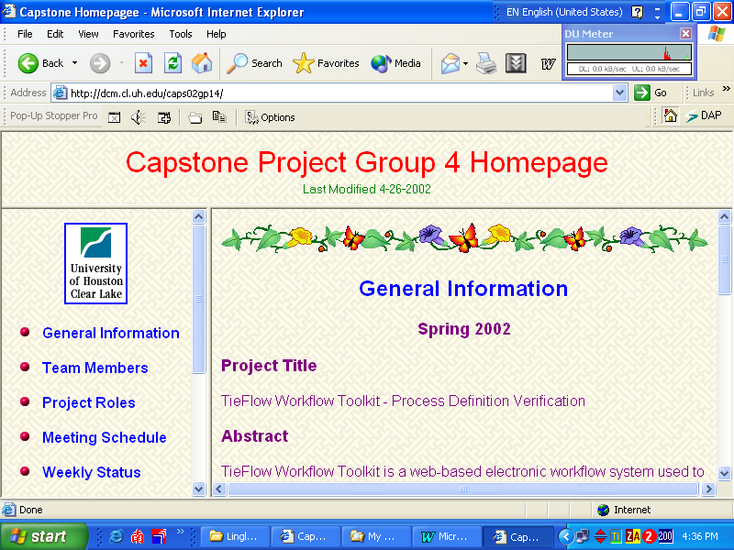

Figure 2.1 Capstone Project Home Page
  - Project Timeline

We created a well-thought plan in order to manage our time and increase our productivity. The project was divided in areas in order to meet the project requirements, develop and verify the code.

Phases & Milestones | Starting Date | Ending Date
Phase I: Preliminary Investigation & Analysis
Set up Group Project Home Page | 01/15/02 | 01/30/02
Define Each Member’s Role | 01/15/02 | 01/30/02
Analyze Objectives Constraints & Requirements | 01/30/02 | 02/20/02
Choose Hardware and Software Platforms | 01/30/02 | 02/20/02
Phase II: Design & Module
Overall Design | 02/20/02 | 03/13/02
UML Modeling | 03/13/02 | 04/3/02
Coding | 03/01/02 | 04/24/02
Phase III: Integration & Testing
Preliminary Testing | 04/17/02 | 04/19/02
Refine & Debug | 04/19/02 | 04/22/02
Execute Integration | 04/22/02 | 04/24/02
Phase IV: Documentation
Final Report | 04/24/02 | 05/01/02

Table 2.2. Time Line for the Project

Technical Issues

3.1 Petri-Net-Based Workflow Technique

3.1.1 Basic Concepts of Petri-Net workflow

Workflow Management Systems are marked by three dimensions: Control-flow dimension, the resource dimension and the case dimension. But we just focus on control-flow dimension: it specifies which tasks need to be executed and in what order. Petri-net is a directed bipartite graph with two node types called place and transition. The nodes are connected via directed arcs. Connections between two nodes of the same type are not allowed [1].

Formally, a Petri-net is defined as 5-tuple (P, T, F, W, M) (see figure 3-1). P is a finite set of places, use circle to represent it. Every place contains zero or more than zero tasks. T is a finite set of transitions, use rectangle to represent it; F is a set of arcs, use arrow line to represent it. W is a weight function; M is the state; we show two ways in the figure 2 to specify a Petri-net [2].

In a Petri-net, a transition t is said to be enabled iff each input place p of t contains at least one token. An enabled transition may fire.

In the graph part, t1 (transition1) needs two tasks in place part to enable, but there is only one task in that place. So t1 can’t be enabled. t2 can be enabled because it just needs one task.

Mathematical Notation

P={p1,p2,p3,p4}
T={t1,t2}
F={(p1,t1),(p2,t2),(p3,t2), (t1,p4), (t2,p4)}
W(p1,t1)=2
W(p2,t2)=W(p3,t2)=
W (t1,p4)=W(t2,p4) = 1
M0=[1 1 1 0]

2
p1
t1
p4

p2

t2
Graphical Notation
p3

Figure 3-1 Petri-Net Graph

3.1.2 Definition of Petri-net [3] [4]

Now we introduce the important definitions of Petri-Net and Workflow Net.

Definition1(Live): A Petri net is live iff, for every reachable state M’ and every transition t there is a state M’’ reachable from M’ which enables t.

Definition 2(Bounded, safe): A Petri net is bounded iff, for each place p there is a natural number n such that for every reachable state the number of tokens in p is less than n. The net is safe iff for each place the maximum number of tokens does not exceed 1.

Definition 3 (Well-formed): A Petri net is well-formed iff there is a state M such that Petri net is live and bounded.

Definition 4 (Free-choice): A Petri net is Free-choice Iff for every two transitions t1 and t2, they have the same input place.

Definition 5(State machine): A Petri net is State machine Iff for each transition has exactly one input and one output place.

Definition 6(Strongly connected): A Petri net is Strongly connected Iff for every pair of nodes x and y, there is a path leading from x to y.
3.1.3 Properties of Workflow net [5] [6]

Workflow net (WF-Net) is a Petri net which models the control-flow dimension of a workflow. A WF-Net specifies the dynamic behavior of a single case in isolation case.
It has following properties:

Soundness of WF-Nets:
- For every state M reachable from state i, there exists a firing sequence leading from state M to state o.
- State o is only state reachable from state i with at least one token in place o.
- There are no dead transitions in (PN, i )

Free-choice WF-Nets:
A process definition composed of AND-splits, AND-joins, OR-splits, OR-joins is free-choice. A good workflow is to balance AND/OR-splits and AND/OR-joins.

Parallel Routing:

A parallel routing has two kinds of routing, one is AND-splits, the other one is AND-join. Figure 3-2 specifies this routing. When a transition is split to more than one place, it is called AND-splits. When more than one place join to one transition, it is called AND-joins.

AND-splits

t

t

AND-joins

Figure 3-2 AND-splits and AND-joins

Sequential Routing:
t2
t1

Figure 3-3 Sequential Petri-Net Workflow

Iteration:
t1

t2

Figure 3-4 Iteration Petri-Net Wokflow

Conditional Routing:

One place is split into more than one transition, it is called OR-splits; more than one transitions join to one place, it is called OR-joins.
t1

OR-splits

t2

t1

OR-joins

t2

Figure 3-5 Conditional Routing Petri-Net Workflow

We can use those definitions and properties to define our verifier rules.

3.2 Graph Reduction Algorithm [7]

3.2.1 Introduction
The workflow technology provides a flexible and appropriate environment to develop and maintain next generation of component-oriented enterprise-wide information systems. The production workflows, a subclass of workflows, support well-defined procedures for repetitive processes and provide a means for automated coordination of activities that may span over several heterogeneous and mission-critical information systems of an organization. Production workflow applications are built upon business processes that are generally quite complex and involve a large number of activities and associated coordination constraints.
The objective of process modeling is to provide high-level specification of processes that are independent of the target workflow management system. It is essential that a process model is properly defined, analyzed, verified, and refined before being deployed in a workflows management system.

3.2.2 Process Modeling Structure

To be able to present graph reduction techniques for process model analysis, introduce a basic process modeling language - the process models are modeled using two types of objects: node and transition. Node is classified into two subclasses: task and choice/merge coordinator. Figure 3.6 shows graphical representation of modeling objects.

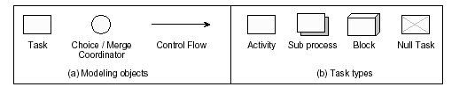
Fig 3-6 Project Modeling Object and Task Type

Task represents the work to be done to achieve some objectives. It is also used to implicitly build sequence, fork, and synchronizer structures.

Activity is an atomic piece of work coordinated by the workflow management system. The modeling and

Choice/Merge Coordinator is graphically represented by a circle, is used to explicitly build choice and merge structures.

Transition links two nodes in the graph and is graphically represented by a directed edge. It shows the execution order and flow between its tail and head nodes.

Sequence is the most basic modeling structure and defines the ordering of task execution. It is constructed by connecting at the most one incoming and one outgoing transition to a task.

Fork (and-split) structure is used to represent concurrent paths within a workflow graph and is modeled by connecting two or more outgoing transitions to a task. A fork does not enforce concurrent execution of the nodes that follow its outgoing transitions. At run-time, the forked nodes are triggered at the same time but they may be performed later any time independent from each other.

Synchronizer (and-join) structure, represented by attaching more than one incoming transition to a task, is applied to synchronize such concurrent paths. A task waits until all the incoming transitions have been triggered.
    - Structural Conflicts in Process Model
There are two structural conflicts in process:

- Deadlock - Joining exclusive choice paths with a synchronizer results into a deadlock conflict. A deadlock at a synchronizer structure blocks the continuation of a workflow path since one or more of the preceding transitions of the synchronizer are not triggered.
- Lack of Synchronization - Joining fork concurrent paths with a merge structure introduces lack of synchronization conflict in the process model. A lack of synchronization at a merge structure results into unintentional multiple activation of nodes that follow the merge node.

All paths introduces after the begin node through split structures are properly joined through join structures before reaching the end node. The synchronizer structures are applied to join fork paths and merge structures to join choice paths.

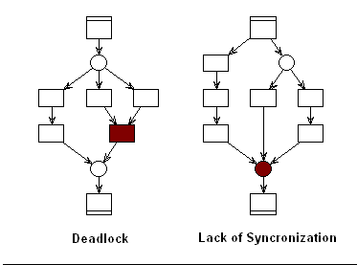

Fig 3-7 Process Model with Structure Conflicts
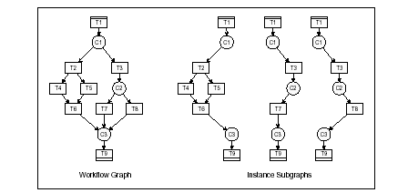

Fig 3-8 Process Model with No Structure Conflicts

Using graph notations to represent workflow models called workflow graphs. Represent a formal notation of the workflow graphs that will be used in the verification algorithm that follows. The notion of workflow graphs to be discussed here is based on the generic class of workflow modeling languages that we have introduced in section 3.2.2.

A process model based on this modeling language conforms to the following basic properties:

- It uses only core modeling structures, namely, sequence, choice, merge, fork, synchronization, begin/end, nesting, and iteration; it does not have any cycles and the iteration structure is supported only through blocked iteration; and, it has exactly a single begin and a single end task.
- Each object (node and transition) of the workflow graph has some associated attributes. These attributes could be singular values or sets of other values or objects. We will use these attributes to define modeling structures and associated correctness criteria in graph notation. Later on these attributes will also be used in the specification of verification algorithms.

    - Reduction Rules

The reduction process makes use of five reduction rules - terminal, sequential, adjacent, closed, and overlapped - as long as they are able to reduce the graph. We apply these reduction rules by visiting all nodes of the graph and checking if a reduction rule can be applied. We will call the node being visited as the current node while describing the reduction rules. We also assume that when a node is removed from the graph, all transitions attached to it are automatically removed.

Terminal Reduction Rule
The terminal reduction rule removes begin and end nodes from workflow graph only if they are not part of fork, choice, synchronizer, or merge structures. We remove the current node from the graph if the number of transitions attached to it is less than or equal to one.

Sequential Reduction Rule

If the current node being visited is forming a sequential structure, i.e., it has exactly one incoming and one outgoing flow, we change the toNode of its incoming transition to the toNode of its outgoing transition and remove the current node from the graph.

Closed Reduction Rule

The application of sequential and adjacent reduction rules generally introduces closed components in workflow graphs. A closed component comprises two nodes of the same type that have more than one transition between them. The closed reduction rule deletes all but one transition between such nodes

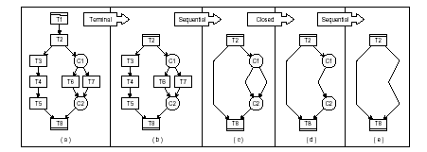

Fig 3-9 Applying Terminal Sequential and Closed Reduction Rules

Adjacent Reduction Rule

The adjacent reduction rule targets two types of components. If the current node is not removed by terminal and sequential reduction rule, it means that it is forming either a split or join structure since it would either have out degree or in degree or both that is more than one. In this case, we check if the current node has a single incoming transition and is introducing a split structure by having more than one outgoing transition. If the type of the current node is same as its preceding node, we move outgoing transitions of the current node to the preceding node and remove the current node.

Overlapped Reduction Rule

The overlapped reduction rule targets a specific class of components in workflow graphs that has an infrequent occurrence. Therefore, we invoke it only if the adjacent and closed reduction rules are unable to reduce the graph. An overlapped component of a workflow graph meets several properties that ensure non-existence of structural conflicts in it. Such a component has four levels.

The source of the component at level 1 is always a choice / merge and sink at level 4 is always a task. It has only task objects at level 2 and only choice / merge objects at level 3. Each of the task nodes at level 2 has outgoing transitions to each of the choice / merge nodes at level 3 and has exactly one incoming transition from the source at level 1. Each of the choice / merge node at level 3 has incoming transitions only from each of the task nodes at level 2 and has exactly one outgoing transition to the sink at level 4. The nodes at level 3 and 4 do not have any other transitions attached to them than the ones mentioned above. The overlapped reduction rule identifies components that meet all these properties and reduces them to a single transition between source and sink of the component.

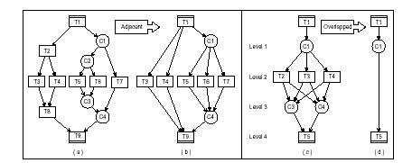

Fig 3-10 Applying Adjacent and Overlapped Reduction Rules

    - Apply Reduction Rules

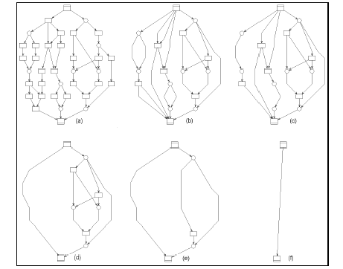

Fig 3-11 Reducing Workflow Graph without Structure Conflicts

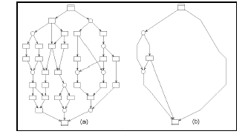

Fig 3-12 Reducing Workflow Graph with Structure Conflicts

Overall Design

4.1 Architecture

Our program has following architecture styles, in which program is divided into smaller pieces in an object-oriented way (see Figure 4-1).

XML

Verifier
DTDChecker

Node
Node
ErrorA

Report

WarningA
Node
Result
DOM Tree
Result

XML

.
.
Figure 4-1 Component Architectures

The overall design phase is a very important stage on our project development. The program is broke down into the smaller pieces in an object-oriented way.

RulePQR

<<interface>>
Rule

Verifier
RuleResultSet
RuleA
RuleB
…...
DTDChecker
RuleResult

Figure 4-2Verifier Class Diagram

4.2 Application Design

The application design contains two kinds of design, one is software design, and the other one is GUI design:

- Software Design - it increases the software’s maintainability and extensibility, and it is very flexible. Each component of the software can be easily modified according to future need and still work with the rest of the unchanged components. For example, when a rule is not required for the verification, that rule class can be easily removed without modifying any source code.

- GUI Design - On the left side of the window, every node and its attributes are shown. On the right side, it displays the output information of error type, description and location on the XML file. You can check the tree of nodes and find the errors indicated.

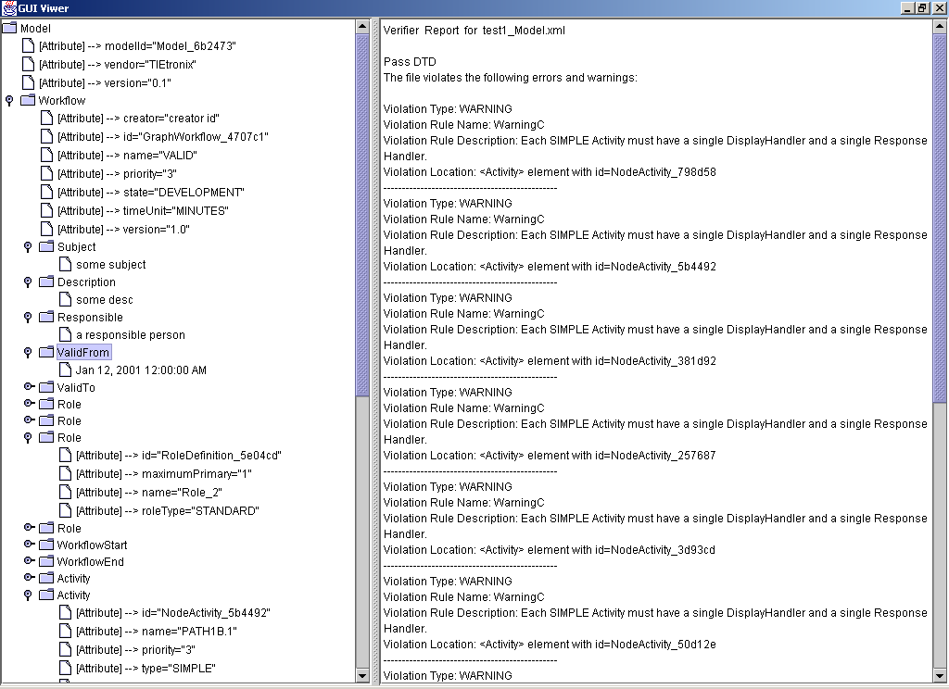

Figure 4-3 Output Results for the Verifier

4.3 Research

Although it’s not easily shown through the final application, without the excellent research effort by the whole development team, this project is impossible to reach the current state. Through research we clarified the requirements; through research we had a deeper understanding of concepts for Petri-Net workflow; through research we solved the problems that we met. It’s also through research, we decided on which algorithm is used by the team. Research is the backbone of this project. The team spent half of the available time for the research and was rewarded with great results. The current application can do a superb job for our project.

Responsibilities and Results

Each team member successfully accomplished her tasks. Our approach took on consideration that in order to develop a good product, members of our team have to be separate as developers and integrators. In our opinion, maintaining this separation will enable the development and debugging of the product in a professional manner since the integrators would be able to find any error overlooked by the developer.

5.1 Ying Xu’s Responsibilities and Results

5.1.1 Contribution

As team Coordinator:

Maintained timely project status.

Maintained the project’s plan and its execution.

Schedule the meetings and agenda.

Motivated and checked each member development and accomplishments.

As programmer:
- Research for algorithms that can apply to our project.
- Develop GUI interface for output.
- More convenient for viewing the result.
- Try to convert workflow model to the graph reduction model.
- Implement DTDChecker for DTD validation.
- Implement Verifier main class, and error handler for DTDCheckerErrorHandler.

5.1.2 Accomplishment

- As team leader:
- Ensured that our project’s goals are meet.
- Supervised the development of the project.
- Organized the final presentation and final report.
- Successfully made several presentations about project status.
- As developer:
- Import right algorithms for deploy.
- Display Tree viewer of XML file using javax.swing.Jtree.
- Give the direction for converting the model from workflow to graph reduction model.
- Successfully implement DTDChecker , Verifier class, and DTDCheckerErrorHandler.

  - Jianlan Peng’s Responsibilities and Results

    - Contribution

- As webmaster:
- Create the web site for our capstone project.
- Set up a discussion board for communication
of the group members.
- Take notes for each meeting and prepare weekly report.
- Schedule project plan and write the timeline.
- Update the web site weekly or as needed.

- As developer:
- Implement Error Rule A - G.
- Research on Graph Reduction Algorithms.
- Do presentation #4.
- Prepare documentations and test case.
- Research on Javadoc Generator.
- Generate Java API Documentation for all packages and classes.

    - Accomplishment

- As webmaster:
- Design and develop the project homepage.
- Ensure the web site is up-to-date.
- Post the project progress weekly.
- Link research papers and useful documents to the homepage.
- Modify Power Point slides and post them to the web before every presentation.

- As developer:
- Successfully implement the Error Rule (A–G).
- Help in UML Modeling.
- Write the requirement documents and the test plan.
- Test the program with different XML documents.
- Help on code debugging and integration.
- Generate the Java API documentation for the project.

  - Weiqin Yan’s Responsibilities and Results

    - Contribution

- As project designer
- Design part of the framework for the verifier project.
- Draw sequence diagram.
- Search research papers and algorithms.
- Research on Graph Reduction Algorithms.

- As developer
- Part coding for the verifier project.
- Code Integration
- Test and debug the code

    - Accomplishment

- Involve in project overall design.
- Allows addition or modification of individual rules without redesign or major modification code.
- Through a lot of efforts, fortunately found the graph reduction algorithm, which is used, in implementing rule (P-R) from the Internet.
- Coding rules (P, Q, R).
- Do the presentation #2.
- Keep in touch with other group member, reporting the coding progress to them
- Debug code.
- Doing part of testing.

5.4 Xiangchun Zhang’s Responsibilities and Results

5.4.1 Contribution

- Implemented Error Rules (H-O)
- Implemented Warning Rules (A-C).
- Designed and drew UML class diagram for Rules.
- Contributed to the documentation and helped during integration.
- Spent plenty of time researching and testing code written for our project.
- Search for Petri-Net and understanding the concepts.

5.4.2 Accomplishment

- Do the presentation #3.
- Designed UML class diagram for rules, coded error rules (H-O) and warning rules.
- Find errors, inconsistencies in the process definition.
- Allows addition or modification of individual rules without redesign or major modification code.
- Verify process definition XML documents containing sub-processes.
- Tested application.
- Helped integration.
- Documented application.
- Downloaded Xerces (version 2_0_0) XML parser for any required XML processing.
- Learned DOM and knew how to use classes in the DOM API.
- Be familiar with XML.
- Found proper articles for Petr-net-based workflow management.
- Learned information that mentors gave us.
- Participated in weekly meeting with mentors and group regularly.
- Helped on website maintenance and discussion board.

6 Problem Encountered & Fixed

6.1 Problems Encountered
During this project, we met a lot of problems. The mainly problems are
- How to implement the Rules P-R

We talked about Graph Reduction Algorithm. It can provide us a way to solve this problem. But Graph Reduction Algorithm cannot be directly used in our Workflow Model. Because in Graph Reduction Algorithm, the node can only be one of two types:

- Task (also called and-join or and-split)
- Choice/Merger (also called or-join or or-split)

But in workflow model, the node may have more than one type in the same time.

- How to treat iteration problem when we implemented the Rules P-R

Graph Reduction Algorithm can’t solve the workflow that contains iteration routing. So we need find a way to solve it.

6.2 Problems fixed

To implement the Rules P-R by using Graph Reduction Algorithm, we converted node with more than one type into separated node, each with just one type and with different node ID. We made a node called Node1_1 and a transition 4 to fit for the Graph Reduction Algorithm model (see figure 5-1). Then we can use Graph Reduction Algorithm to implement the Rules P-R.

Node1
Node1
Convert to
4
3

2
3
1
Node1_1

1
2

Figure 6-1 Convert Model

In order to implement the Rules P-R, first we should check if there is any iteration routing in a workflow. If the workflow contains iteration routing, we should delete some nodes between starting iteration node and ending iteration to convert this workflow into no iteration workflow. Unfortunately, we have no time to solve this problem.
- Java API Documentation

We used the coding standards on the development of our project. We included the
JavaDoc comment structure in our code. Java API Documentation can be
automatically extracted from the code using Javadoc.

- Documentation comments (doc comments) are the special comments in the Java source code that are delimited by the /** ... */ delimiters. A doc comment is made up of two parts - a description followed by zero or more tags, with a blank line (containing a single asterisk "*") between these two sections:

/**
* This is the description part of a doc comment
*
* @tag Comment for the tag
*/

Javadoc is the JDK tool that generates API documentation from documentation comments. It parses the declarations and documentation comments in a set of Java source files and produces a corresponding set of HTML pages describing the public and protected classes, interfaces, constructors, methods, and fields.

SYNOPSIS: javadoc [options ] [ packagenames ] [ sourcefiles ] [ @files ]

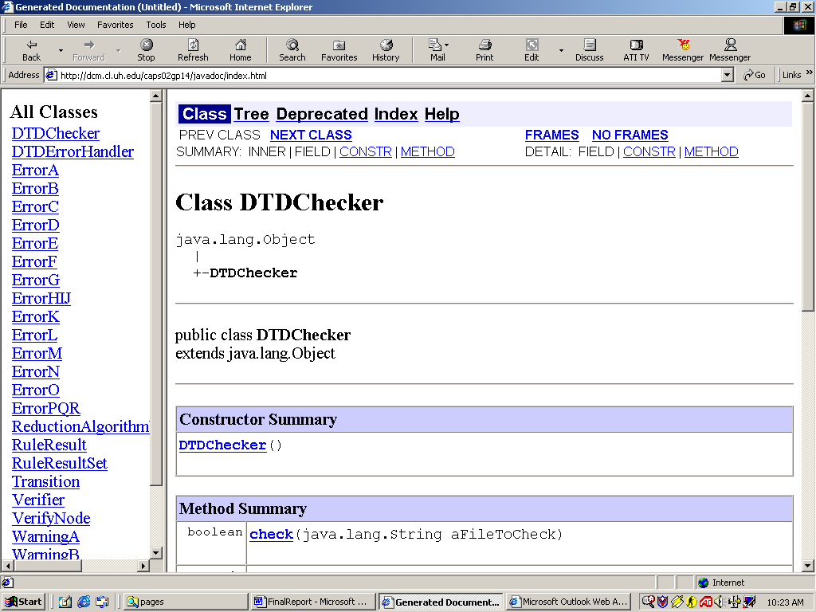

Figure 7-1 Javadoc of Verifier Classes

Lesson Learned

We learned a lot from this course. In order to meet the project’s goals, it is necessary to maintain good communication between each member. Tools, like web site, discussion board, publish of our weekly status, and logbook enabled us to gain a better understanding of the project and tasks. In addition, our project plan enabled us to set achieving goals and increase our team productivity and time management. We accomplished this since each teammate was able to concentrate on a specific area, but allowing them to learn from the achievements and mistakes of the other members.

The lessons we learned from this course are the followings:
- New technologies:
- Workflow systems
- XML parser
- Petri-Net
- Graph Reduction Techniques
- Team works:
- Cooperate each other.
- This experience provides us a good background for our future job.
- Good communication:
- A project is not isolate.
- A good communication with related people can help a lot.
- Do research:
- Deeper understand our project and make a correct direction.
- We did a lot of research work by ourselves without the mentor’s instruction.
- Follow the project plan and specify the roles:
- Ensure to finish the project on time.
- Know your next steps.
- Efficiency.
- Well understand user requirements:
- Save time.
- Make a good design that is key to success.
- Adequate documentation:
- Helps lot during design, development and testing.
- Save time on the final report.

Conclusion

The project is dominated by researches; probably at least half of the time was spent doing researches. From the great wealth of information and long requirement debates, the program was coded and integrated in fairly short time period compared to the time doing researches. The team felt that the project was a success given the time frame of one semester. Through research, the team went from not having a clear understanding of the project object to gaining substantial knowledge in Petri-net analysis and related fields. Further, the team came up with a reasonable requirement for one semester time and completed the full cycle of development, from design to implement and testing.

Now we come to this conclusion in view of the fact that we did in this semester:
- Found information about Petri-Net workflow and algorithms for this project.
- Designed application.
- Drew UML classes diagram.
- Implemented our project
- Tested program in different XML file versions.
- Documented each step of the design.
  - Project plan
  - Web site
  - Requirement Design specification
  - Code inspection
  - User Guide
  - Document

  - Final Report

- Acknowledgment

We would like to thanks Dr. Davari, Mr. Scott Hetherington, Mr. Chad Keeton, and Mr. Sohan Fernando for their remarks and direction that allowed us effectively achieve our capstone project.

- References

- http://www.ento.vt.edu/~sharov/PopEcol/lec1/petrinet.html, Petri-net.
- http://www.ida.liu.se/labs/eslab/publications/pap/db/ISSS00.pdf, Verification if Embedded Systems by using a Petri Net based Representation, Luis Alejandro Cortes, Petru Else and Zebo Peng
- http://wwwis.win.tue.nl/~wsinwa/jcsc/node4.html, Classical Petri net.
- http://www.fjeld.ch/pub/CSAPC97paper.pdf, Paralled or event-driven goal setting mechanism in Petri net based models of expert decision, behaviour M. Rauterberg, M.Fjeld, and S. Schluep.
- http://lsdis.cs.uga.edu/activities/NSF-workflow/wfm.html, Petri-net-based Workflow Management Software, W.M.P. van der Aalst.
- http://www.ecs.soton.ac.uk/~mal/vcl2000/narboni.pdf, Verification Petri net properties in CLP Guy A. Narboni.
- http://www.dstc.edu.au/praxis/publications/wsadiq_isj_2000.pdf, Applying Graph Reduction Techniques for identifying Structure Conflicts in Process Models, W.Sadiq, M. E. Orlowska.
- Verification of Workflow Task Structures: a Petri-net-based Approach, W.M.P. Van der Aalst, A.H.M. ter Hofstede.
- The Application of Petri Nets to Workflow Management, W.M.P. Van der Aalst.
- Woflan: A Petri-net-based Workflow Analyzer, W.M.P. Van der Aalst.
- Diagnosing Workflow Process using Woflan, H.M.W. Verbeek, T. Basten, W.M.P. Van der Aalst.
- Modeling and Analysis of Workflow Processes, C. Karamanolis,D,Giannakopoulou, J.Magee,S.Wheater.
- XRL/Woflan:Verification and Extensibility of an XML/Petri-net based language for inter-organizational workflows, W.M.P. Van der Aalst, H.M.W. Verbeek,A.Kumar.
- Workflow Verification: Finding Control-Flow Errors Using Petri-Net-Based Techniques, W.M.P. Van der Aalst.
- Waflan 2.0 A Petri-net-based Workflow Diagnosis Tool, , W.M.P. Van der Aalst, H.M.W. Verbeek.

Appendix A. User’s Guide
I. Software Requirement
II. Hardware Requirement
III. Path set up
IV. How to run the code

Appendix B. Design Document
I. & II.UML Class Diagram
III. UML Sequence Diagram

Appendix. C Source Code

