Capstone Project Proposal

Ad Hoc Report Generator

Problem Statement

Background
Most applications built today have reporting requirements that are crucial for business needs such as analysis, feedback and general metrics of data. There are many products out there that can be used as an aid to build such reports. Some of these products are Crystal Reports and the upcoming Microsoft Reporting services. To build a reporting feature in any application, one requires knowledge of what kind reports are required, the queries that need to be used to generate the report, the look and feel of the report, knowledge of the reporting product itself and a developer to tie in things together. Such reports, in general, are limited in number and satisfy the requirement of most software, which is to supply useful related application information to people who are interested in such data only. Such people are called information consumers and they usually know what reports they want. On the other end of the spectrum, we have people who really don’t know what kind of data they are looking for in their application but want to make some business decisions based on certain trends they see in the data. These people are called data analysts and they use a reporting tool called a decision support system usually implemented by using one or more of the various OLAP technologies. Here reports are generated dynamically based on what the analyst has specified. OLAP databases fit well with applications on an Enterprise scale and are built keeping a broad scope in mind of the data they are meant to represent. Simple generalized reports on the other hand are targeted reports meant for the everyday user of the system usually aimed to help people maintain and support the users of the application. Both these types of reporting services require extensive knowledge of the application and all the relationships between the data in the database. Reports usually can only be built knowing these interdependencies between data – which is what makes the data actually useful and thus report building more difficult.

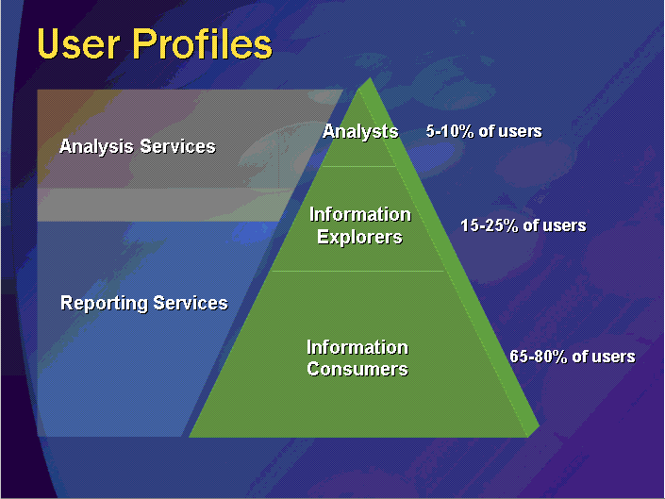

Problem
There are a few applications we built (small to midsize range) that we have seen that require some unique reporting requirements that cannot be handled using the general reporting tools out in the market today. These requirements include database schemas that are dynamic per deployment of the same application and/or applications that do not require the over head of decision support systems, but do need certain features to be implemented in the reporting services such as dynamic report creation. The main question is how can one define such a reporting tool where-in you can point to an existing database and let the tool analyze interrelationships and represent the data to consumers in an intuitive and easy to use way that can benefit not only the consumer, but also alleviate developer resources and thus benefit the application provider. What are the rules that govern the behavior of the reporting engine? Can such a reporting tool be even built? The scope of this capstone project is to build on the research, implementation and groundwork already laid out by previous capstone groups. The intent is to verify and expand the scope of the current implementation and make it as attractive, if not more against current emerging tools being built by competitors.

Overall Requirements:

- Verify the validity of current framework.
- Research on Data Mining technologies for performance improvements.
- Research on caching technologies for performance improvements.
- Improve on existing features such as
  - Fact Table analysis algorithm.
- Implement new features such as
  - Filtering support in reporting engine.
  - Sorting support in reporting engine.
  - Lookup table
  - Comprehensive web GUI for report input gathering.
  - Report output generator and formatter.
  - Report Exporter.
  - Static (canned) reports.
- Implement integration tool with workflow TieFlow.

Technologies to be used:

- Java
- JSP / STRUTS / JavaServer Faces.
- XML
- Refactoring methods.
- SQL Server 2000 / SQL Server 2005 Beta 2

Capstone Project Scope #2

- Verify the validity of current framework.
- All research topics.
- All improvements required for current framework
- Implementing and Verify new features to engine such as Filtering and Sorting.
- Implementation of integration tool with TieFlow.

The overall Ad Hoc reporting requirements were built on the basis of the following TieFlow reporting requirements discussed in the following pages.
TieFlow Workflow Toolkit

Problem Statement

Background
The TieFlow Workflow Toolkit is a web-based electronic workflow system used to automate manual, form-based processes. The Toolkit utilizes multiple databases to manage the process and content information related to the definition and execution of the electronic processes. The workflow engine uses the process database to store the process definitions and to track the current status of each process instance. The process database has a set of known tables with fixed schemas. The workflow engine uses the content database to store all of the inputs made to the electronic form by users in the process. The content database contains a variable number of tables with variable schemas. These tables and schemas are directly dependent upon the form data required for the process. Thus, it is possible that each process has a different set of content tables. The only guarantee with the content database tables is that their primary key contains the same columns as the process database tables. Currently, the key of the content database tables is identical to the ProcessInstance table. However, the content database key may migrate to include additional columns to allow content data to be tracked down to the WorkItem level.

Problem
Some pre-defined, hard-coded reports are provided for each process. However, users of the TieFlow Workflow Toolkit need the ability to define and execute ad-hoc reports so that they can find exactly the information they need when they need it. Ideally, they would be able to view the available tables and fields, select the fields to display on the report, define the report filtering criteria and sort order, and specify the report output type and format. Additionally, users would have the ability to save ad-hoc report templates (to rerun the same defined report at later dates without having to regenerate all of the report parameters each time) and modify ad-hoc report templates (to create new ad-hoc report templates based on existing templates). Since many of the users of this system will not have programming skills or be familiar with databases, the interface must be intuitive and easy to operate.

High-Level Requirements

Code / Architecture
- Report Generator Interface shall be web-based and shall operate in standard web-browsers.
- Report Generator shall be compatible with the J2EE 1.3.1 architecture in which the workflow toolkit executes. The Report Generator may be JSPs and EJBs or a Java applet with remote database access or another implementation with prior approval.
- Report Generator shall use the Java JDK version 1.4 for any required Java code.
- Report Generator shall use the Xalan/Xerces (version 2_3_1) XML parser for any required XML processing.
- Report Generator shall have the capability to interface with a relational database or an XML database. The content database may be relational or XML. The process database is currently a relational database, but may eventually become an XML database.
- Reporting services shall be built on the framework implemented by SQL Server 2000 Analysis Services.

General Requirements
- Report Generator shall provide the capability to generate reports on process information from the process database tables.
- Report Generator shall provide the capability to generate reports on content information from the content database tables.
- Report Generator shall provide the capability to generate reports requiring database joins between two or more tables. The tables and fields may be from the process database, content database, or both.
- Report Generator shall have no dependencies on the number of content database tables or their schema definitions. Ideally, the Report Generator should also have no dependencies on the process database tables and schemas so that future updates and modifications of the process database does not also require modification of the Report Generator.

Authentication and Permissions
- Report Generator shall provide the ability to authenticate users.
- Report Generator shall require authentication of the user in order to access ad-hoc reports.
- Report Generator shall provide access to only the content database tables and fields and the process data that the authenticated user has permissions. Once authenticated, the user’s identity and roles may be used to determine the processes and data to which he may have access.
- Report Generator shall require authentication of the user in order to access saved report templates that have restricted access.
- Report Generator shall provide the ability to allow anonymous users to access saved report templates with no restrictions.

Ad-Hoc Report Generation
- Report Generator shall restrict the user’s view of content tables to the tables appropriate for the specified process.
- Report Generator shall provide the capability for the user to specify one or more fields from the available databases to be displayed as part of the report output.
- Report Generator shall provide the capability for the user to specify the order of output for the selected display fields.
- Report Generator shall provide the capability for the user to specify a descriptive label for each of the selected display fields. This label, if specified, shall appear on the report output in place of the database table and column name.
- Report Generator shall provide the capability for the user to specify one or more fields from the available databases to be used as filtering criteria for generating the report. The fields used for filtering are independent of the fields used for display. In other words, the list of displayed fields may have no fields, some fields, or all fields in common with the list of filtering fields.
- Report Generator shall provide the capability for the user to specify the filtering criteria for each of the selected filtering fields. The criteria will be dependent upon the data type of each field, but should generally include null, !null, = [value], != [value], > [value], >= [value], < [value], <= [value]. Combinations of these types would also be useful to have the ability to specify valid ranges of data, invalid ranges of data, or exclusions. For example, X (date field) where X is greater than 11/30/2001 and X is less or equal to 12/31/2001 and X != 12/25/2001.
- Report Generator shall provide the capability for the user to specify the Boolean relationships between each of the filtering fields (AND, OR, NOT).
- Report Generator shall provide the capability for the user to specify the sort order of the display fields to be used in the generation of the initial report output.
- Report Generator shall provide the capability to generate statistical information for specified display fields, based on the data included in the report output. For example: count, sum, average, median, max, min, and standard deviation.
- Report Generator shall provide the capability for the user to specify the report output destination, including screen [default], file, and email. Additional output destinations should not be precluded.
- Report Generator shall provide the capability for the user to specify the report output format, including the following formats:
  - Delimited – (with a user-specified delimiter) for import into another application such as Excel or SQL. This output format would not include any HTML tags in the data set.
  - Table – formatted column output using HTML tags.
  - Graph – graphical representation of the data in the form of a plotted graph (applicable for only certain report data)
  - Bar chart – graphical representation of the data in the form of a bar chart (applicable for only certain report data)
  - Pie chart – graphical representation of the data in the form of a pie chart (applicable for only certain report data)
Additional output formats should not be precluded.

Dynamic Report Output Modification
- Report Generator shall provide the capability to allow the user to dynamically sort the report output (for Table formatted output) by the selected column from the report output display. Dynamic editing of the column labels and ordering of the columns on the report output page would be nice.
- Report Generator shall provide the capability to allow the user to dynamically change the report output format from the report output display. Valid output formats are dependent upon the report display data.
- Report Generator shall provide the capability to allow the user to send the completed report output to a file or to email the completed report output from the report output display.

Report Templates
- Report Generator shall provide the capability to allow the user to save report output (on the server) from the report output display. Thus, if a saved report output is redisplayed, the same report output would be displayed every time. When report output is saved, a link (or some other interface method) to redisplay this report output must be added to the Report Generator interface to allow users to display this saved report output again.
- Report Generator shall provide the capability to allow the user to save report templates(on the server) from the report output display. The report template is the query used to generate the report output – not the output results themselves. Thus, if that template is executed again after changes to the database, different report output would be displayed. When a report template is saved, a link (or some other interface method) to re-execute this report must be added to the Report Generator interface to allow users to run the report again.
- Report Generator shall provide the capability to save report templates in one of two different configurations:
  - Configuration 1 – Filter criteria specified for each of the filtering fields in the template is identical to the original values specified at the creation or modification of the template. Thus, the exact same query is executed each time this report template is run.
  - Configuration 2 – Filter criteria specified for each of the filtering fields in the template may be modified on each execution of the report template. The filtering fields and their Boolean relationships are fixed, but their values and/or ranges may be specified when the report template is executed.
- Report Generator shall provide the capability to save report output and report templates with specified access levels, including anonymous, public, and private at a minimum. Anonymous report output and templates are available to all internet users without requiring authentication. Public report output and templates are available to all authenticated users. Private report output and templates are available only to the creator of the report output or template. The access level specifications should not preclude the addition of new access levels in the future. It is likely that access levels for groups, roles, or specified individual users will be added at some point.
- Report Generator shall provide the capability to modify report templates. The modified templates must be saved under a new name and cannot overwrite or replace the source report template. This capability provides a method for users to generate ad-hoc reports with simple changes to a saved report template rather than having to completely redefine the entire report.
- Report Generator shall provide the capability to delete report templates. Deletion of report templates should only be allowed by the creator of the report template.

