CSCI 5931A
Advanced Database Development
Fall 1998
Final Examination

Name: _____________________________

Number: ___________________________

Time allowed: one hour and 20 minutes

Attempt all questions. Turn in both question and answer sheets separately.

- Consider the following definition:

create or replace type t2_EmployeeType as object (
ID Number(9),
FName VARCHAR2(30),
LName VARCHAR2(30),
SupervisorRef REF t2_employeeType,

member function FullName return VARCHAR2,
pragma restrict_references(FullName, RNDS, WNDS, RNPS, WNPS),
);

create or replace type body t2_EmployeeType as
member function FullName return VARCHAR2 IS
begin
return self.FName || ' ' || self.LName;
end FullName;
end;

create table t2_Employees of t2_EmployeeType;

Write the PL/SQL code to insert three employees into the object table t2_Employees:

Employee #1: ID: 10000, FNAME: 'To', LANME: 'Yuen', no supervisor.

Employee #2: ID: 10001, FNAME: 'Bun', LNAME: 'Yue', supervisor: employee #1 (To Yuen).

Employee #3: ID: 10001, FNAME: 'Kathy', LNAME: 'Chan', supervisor: employee #2 (Bun Yue).
- Consider the relation t2_emp, a simple employee relation storing names and supervisor, created by the following SQL statements:

drop table t2_emp;
create table t2_emp (
EmpID NUMBER(5) primary key,
EmpName VARCHAR2(30),
SupervisorID NUMBER(5),
Foreign key (SupervisorID) references t2_emp(EmpID)
);

insert into t2_emp values (100, 'Joe', NULL);
insert into t2_emp values (101, 'Mary', NULL);
insert into t2_emp values (102, 'Jack', 101);
insert into t2_emp values (103, 'Jick', 102);
insert into t2_emp values (104, 'Mike', 103);
insert into t2_emp values (105, 'Susan', 103);
insert into t2_emp values (106, 'Peter', 102);
insert into t2_emp values (107, 'Paul', 100);
insert into t2_emp values (108, 'Art', 106);
insert into t2_emp values (109, 'Russell', 105);

Write a Java JDBC program to connect to the Oracle database to list all supervisors of a user-specified employee names. In the following sample session, user input is in a different font:

userid : student1
password: abcdef
This program find all supervisor names of an employee.
Enter employee number.

EmpID/Exit>101
Employee with ID 101, Mary, has no supervisor.
EmpID/Exit>103
The supervisor of Emp # 103, Jick:
EmpID 102, Jack.
EmpID 101, Mary.
EmpID/Exit>105
The supervisor of Emp # 105, Susan:
EmpID 103, Jick.
EmpID 102, Jack.
EmpID 101, Mary.
EmpID/Exit>120
Employee with ID 120 is not in the database.
EmpID/Exit>exit
Thank you and bye.

(P.T.O.)
The following Java skeleton has been prepared for you. Fill in the blank parts.

import java.sql.*;
import java.io.*;
class FindSupervisors {
public static void main (String args [])
throws SQLException, IOException {

DriverManager.registerDriver (new oracle.jdbc.driver.OracleDriver());

String user, pass, sql, key;
user = readEntry("userid : ");
pass = readEntry("password: ");
Connection conn = DriverManager.getConnection
("jdbc:oracle:oci8:@addb", user, pass);

System.out.println("This program finds all supervisor names of an employee.");
System.out.println("Enter employee number.\n");

PreparedStatement stmt = conn.prepareStatement
("select * from t2_emp where EmpId = ?");
do {

String Emp = readEntry("EmpID/Exit> ");

if (Emp.equals("exit"))
break;
int EmpId = Integer.parseInt(Emp);

stmt.setInt(1, EmpId);
ResultSet rset = stmt.executeQuery ();

if (! rset.next()) {
System.out.println("Employee with ID " + EmpId + " is not in the database.");
continue;
}

// Add your code here...

} while (true);
conn.close();
System.out.println("Thank you and bye.");
}

//readEntry function -- to read input string
...
}

- Using the relations in question (2), write a PHP program, InsertEmployee.php3, to allow user to insert a new employee to t2_emp. Initially, the program should display:

A listing of all existing employee numbers should be included as the options of the supervisor. When the insertion is submitted, the following screen appears:
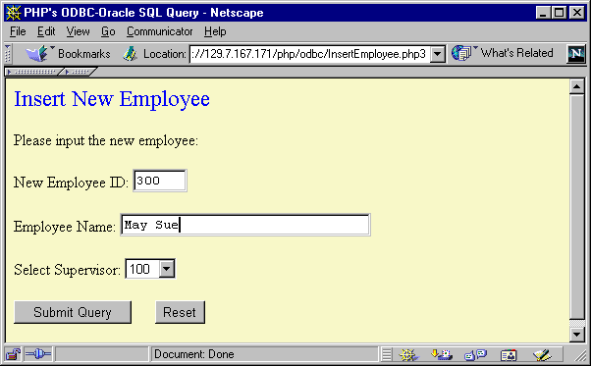
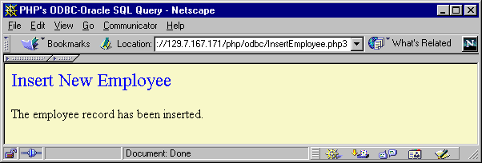
Fill in the skeleton provided by you in the next page.

(P.T.O.)

<HTML>
<HEAD><TITLE>PHP's ODBC-Oracle SQL Query</TITLE></HEAD>
<BODY BGCOLOR=#FFFFCC>
<FONT COLOR="#0000FF" SIZE=+2>Insert New Employee</FONT>
<P>

<? // Open ODBC connection.
$my_db = odbc_connect("ora_addb", "student1", "fish8498");

if (! strcmp($EmpId, "")) { /* Display form for inserting employees */
echo "<FONT COLOR=BLUE SIZe=+2 ALIGN=CENTER></FONT>
<P>
<FORM method=post>
Please input the new employee:
<P>
New Employee ID:
<INPUT Type=TEXT NAME=EmpId size=5>
<P>
Employee Name:
<INPUT Type=TEXT NAME=EmpName size=30>
<P>
Select Supervisor:
<SELECT NAME=SupervisorID>
";

// Add your code here: part (1)

echo "</SELECT>
<P>
<INPUT TYPE=SUBMIT>&nbsp;&nbsp;&nbsp;&nbsp;&nbsp;<INPUT TYPE=RESET>
</FORM>";
} /* end if */
else { /* Insert the employee record. */

// Add your code here: part 2.

}
?>
</BODY>
</HTML>
CSCI 5931A
Advanced Database Development
Fall 1998
Suggested Solution to Final Examination

- For example:

declare
Emp t2_EmployeeType :=
t2_EmployeeType (10000, 'To', 'Yuen', NULL);
EmpRef REF t2_EmployeeType;
begin
insert into t2_Employees values(Emp);

select REF(t2_Emp) into EmpRef
from t2_Employees t2_Emp
where t2_Emp.ID = 10000;

Emp := t2_EmployeeType(10001, 'Bun', 'Yue', EmpRef);
insert into t2_Employees values(Emp);

select REF(t2_Emp) into EmpRef
from t2_Employees t2_Emp
where t2_Emp.ID = 20000;

Emp := t2_EmployeeType(10002, 'Kathy', 'Chan', EmpRef);
insert into t2_Employees values(Emp);
end;
/

- For example:

import java.sql.*;
import java.io.*;

class FindSupervisors {
public static void main (String args [])
throws SQLException, IOException {

DriverManager.registerDriver (new oracle.jdbc.driver.OracleDriver());

String user, pass, sql, key;
user = readEntry("userid : ");
pass = readEntry("password: ");
Connection conn = DriverManager.getConnection
("jdbc:oracle:oci8:@addb", user, pass);

System.out.println("This program find all supervisor names of an employee.");
System.out.println("Enter employee number.\n");

PreparedStatement stmt = conn.prepareStatement("select * from t2_emp where EmpId = ?");

do {

String Emp = readEntry("EmpID/Exit> ");

if (Emp.equals("exit"))
break;
int EmpId = Integer.parseInt(Emp);

stmt.setInt(1, EmpId);
ResultSet rset = stmt.executeQuery ();

if (! rset.next()) {
System.out.println("Employee with ID " + EmpId + " is not in the database.");
continue;
}

int SupervisorId = rset.getInt("SupervisorId");
if (rset.wasNull()) {
System.out.println(" Employee with ID " + EmpId + ", " + rset.getString("EmpName") + ", has no supervisor.");
continue;
}

System.out.println("The supervisor of Emp # " + EmpId + ", " + rset.getString("EmpName") + ": ");
do {
stmt.setInt(1, SupervisorId);
rset = stmt.executeQuery ();
rset.next();
System.out.println(" EmpID " + SupervisorId + ", " + rset.getString("EmpName") + ".");
SupervisorId = rset.getInt("SupervisorId");
if (rset.wasNull())
break;
} while (true);
} while (true);

conn.close();
System.out.println("Thank you and bye.");
}

//readEntry function -- to read input string
static String readEntry(String prompt) {
try {
StringBuffer buffer = new StringBuffer();
System.out.print(prompt);
System.out.flush();
int c = System.in.read();
while(c != '\n' && c != -1) {
buffer.append((char)c);
c = System.in.read();
}
return buffer.toString().trim();
} catch (IOException e) {
return "";
}
}
}

- For example,

<HTML>
<HEAD><TITLE>PHP's ODBC-Oracle SQL Query</TITLE></HEAD>

<BODY BGCOLOR=#FFFFCC>

<FONT COLOR="#0000FF" SIZE=+2>Insert New Employee</FONT>
<P>

<?
// Open ODBC connection.
$my_db = odbc_connect("ora_addb", "student1", "fish8498");

if (! strcmp($EmpId, "")) { /* Display form for entering questions. */
echo "<FONT COLOR=BLUE SIZe=+2 ALIGN=CENTER></FONT>
<P>
<FORM method=post>
Please input the new employee:
<P>
New Employee ID:
<INPUT Type=TEXT NAME=EmpId size=5>
<P>
Employee Name:
<INPUT Type=TEXT NAME=EmpName size=30>
<P>
Select Supervisor:
<SELECT NAME=SupervisorID>
";
$stmt = "select distinct EmpID from t2_emp";
$result = odbc_exec($my_db, $stmt);
while (odbc_fetch_row($result)) {
echo "<option value=";
echo(odbc_result($result, "EmpId"));
echo ">";
echo(odbc_result($result, "EmpId"));
};
echo "</SELECT>

<P>
<INPUT TYPE=SUBMIT>&nbsp;&nbsp;&nbsp;&nbsp;&nbsp;
<INPUT TYPE=RESET>
</FORM>";
} /* end if */
else {
$insert_stmt = "insert into t2_emp (EmpId, EmpName, SupervisorID) values (" . $EmpId . ", '" . $EmpName . "'," . $SupervisorID . ")";
$result = odbc_exec($my_db, $insert_stmt);
if (! $result) {
echo "The employee record cannot be inserted.";
}
else if (odbc_num_rows($result) > 0) {
echo "The employee record has been inserted.";
}
else {
echo "The employee record cannot be inserted.";
}
odbc_commit($my_db);
}
?>
</BODY>
</HTML>

