**CSCI 5333.4 DBMS  
Fall 2011  
Suggested Solution to Mid-Term Examination**

(1) For example: Date added to the class Consignment Transaction.

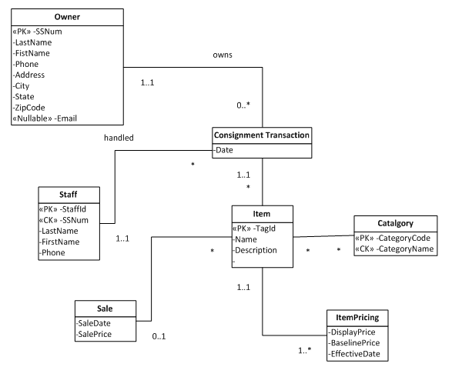

(2) For example:

A(P, Q, CID)

* CK: P
* FK: CID references CID in C
* Known to be not nullable: P, CID

B(BID, M, N, CID, Lead_BID)

* CK: BID
* FK: (1) CID references CID in C, and (2) Lead_BID references BID in B.
* Known to be not nullable: BID

C(CID, K)

* CK: CID
* FK: none
* Known to be not nullable: none.

AR(ARID, P, R)

* CK: (1) ARID, (2) {P, R}
* FK: P references P in A
* Known to be not nullable: ARID, P and R.

AB(ABID, P, BID)

* CK: (1) ABID, (2) {P, BID}
* FK: (1) P references P in A, (2) BID references BID in B.
* Known to be not nullable: ABID, P and BID.

(3) No, this is because the following two scenarios will both satisfy the three conditions.

1. One candidate key: A, and
2. Two candidate keys: AB and AC.

(4)

(a)

PROJECT [PNUM] (SELECT [SCity = 'Houston'] (SUPPLIER JOIN SUPPLY))  
MINUS  
PROJECT [PNUM] (SELECT [SCity = 'Dallas'] (SUPPLIER JOIN SUPPLY));

(b)

PROJECT [SNAME] ((SELECT [STATUS >= 5] (SUPPLIER)) JOIN (SELECT [COLOR = 'Green'] (SUPPLY JOIN PART)));

(c)

-- If Divide were supported.  
(PROJECT [SNUM, PNUM] (Supply)) Divide (PROJECT [PNUM] (SELECT [COLOR='Green'] (Part));

(PROJECT [SNUM] (SUPPLIER))  
MINUS  
(PROJECT [SNUM]  
 (((PROJECT [SNUM] (SUPPLIER))  
 JOIN   
 PROJECT [PNUM] (SELECT [COLOR='Green'] (Part)))  
 MINUS  
 (PROJECT [SNUM, PNUM] (Supply))));

(5)

(a)

{pnum | Supply(snum, pnum, _), Supplier(snum, _, ‘Houston’, _), not Supplier(snum,_,’Dallas’,_)}

(b)

{sname | Supplier(snum, sname, _, status), status >=10, Supply(snum, pnum,_), Part(pnum, _, ‘Green’,_)}

(c) {snum | Supplier(snum), forall (pnum) (not Part(pnum, _, ‘Green’, _) or Supply(snum, pnum, _)}

(6)

SELECT DISTINCT PNum  
FROM Supplier, Supply  
WHERE Supplier.SNum = Supply.SNum  
AND Supplier.SCity = 'Houston'  
AND PNUM NOT IN   
 (SELECT DISTINCT PNum  
 FROM Supplier, Supply  
 WHERE Supplier.SNum = Supply.SNum  
 AND Supplier.SCity = 'Dallas');

(b)

SELECT DISTINCT SNAME  
FROM Supplier, Supply, Part  
WHERE Supplier.SNum = Supply.SNum  
AND Supply.PNUM = Part.PNum  
AND Status >= 10  
AND Color = 'Green';

(c)

SELECT DISTINCT SNum  
FROM Supplier  
WHERE NOT EXISTS   
 (SELECT DISTINCT P1.PNum  
 FROM Part P1  
 WHERE Color = 'Green'  
 AND NOT EXISTS  
 (SELECT *  
 FROM Supply S  
 WHERE Supplier.SNum = S.SNum  
 AND P1.PNum = S.PNum));

(d)

SELECT PName AS 'Part', COUNT(*) AS 'Number of Suppliers', SUM(Quantity) As 'Total'  
FROM Supply, Part  
WHERE Supply.PNum = Part.PNum  
GROUP BY PName  
ORDER BY PName;