CSCI 4333.1 Classroom Notes and Demonstrations
8/27/2025
1.2 The Relational Model: an introduction
- The basic relational data model in layman terms:
  - A database is composed of a collection of tables (relations).
  - A table contains many rows (tuples) and columns (attributes/fields).
  - Each row contains many column values.
  - Every row of a table has the same set of columns.
  - Values of the same column have the same data type.
  - Keys are sets of columns/attributes.
  - A candidate key of a table is a minimal unique identifier of a row in the table.
  - A primary key is a selected candidate key (for storing the table).
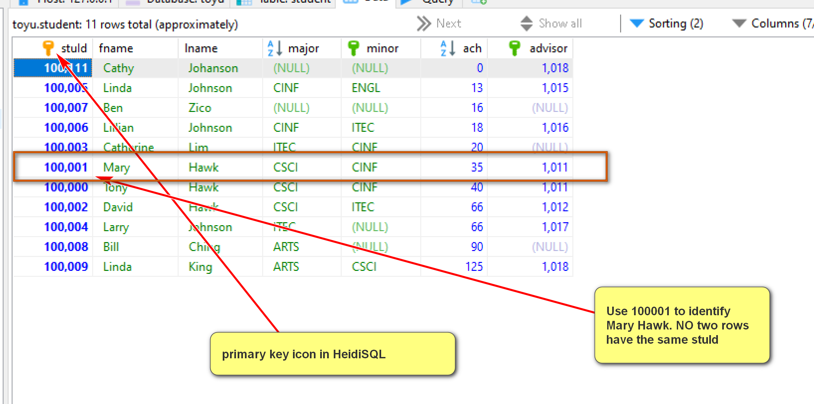
Table schema/structure: stuId is the primary key of the table student.
CREATE TABLE IF NOT EXISTS Student (
stuId INT NOT NULL,
fname VARCHAR(30) NOT NULL,
lname VARCHAR(30) NOT NULL,
major CHAR(4) NULL,
minor CHAR(4) NULL,
-- ach: accumulated credit hours, including transferred credits.
ach INTEGER(3) UNSIGNED NULL DEFAULT 0,
advisor INT NULL,
CONSTRAINT Student_stuId_pk PRIMARY KEY(stuId),
-- an artificial example of a CHECK constraint.
CONSTRAINT Student_ach_cc CHECK ((ach>=0) AND (ach < 250)),
CONSTRAINT Student_major_fk FOREIGN KEY (major)
REFERENCES Department(deptCode) ON DELETE CASCADE,
CONSTRAINT Student_minor_fk FOREIGN KEY (minor)
REFERENCES Department(deptCode) ON DELETE CASCADE,
CONSTRAINT Student_advisor_fk FOREIGN KEY (advisor)
REFERENCES Faculty(facId)
);

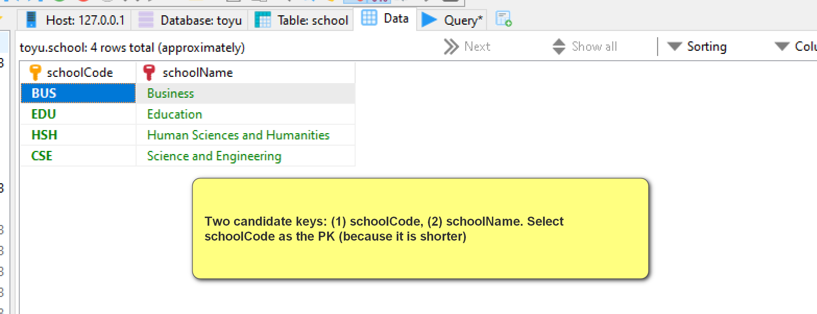
  - Alternative/secondary keys are candidate keys not selected as the primary key. (schoolName (i.e., {schoolName} is an alternative key of the table School in toyu)
Enroll table:
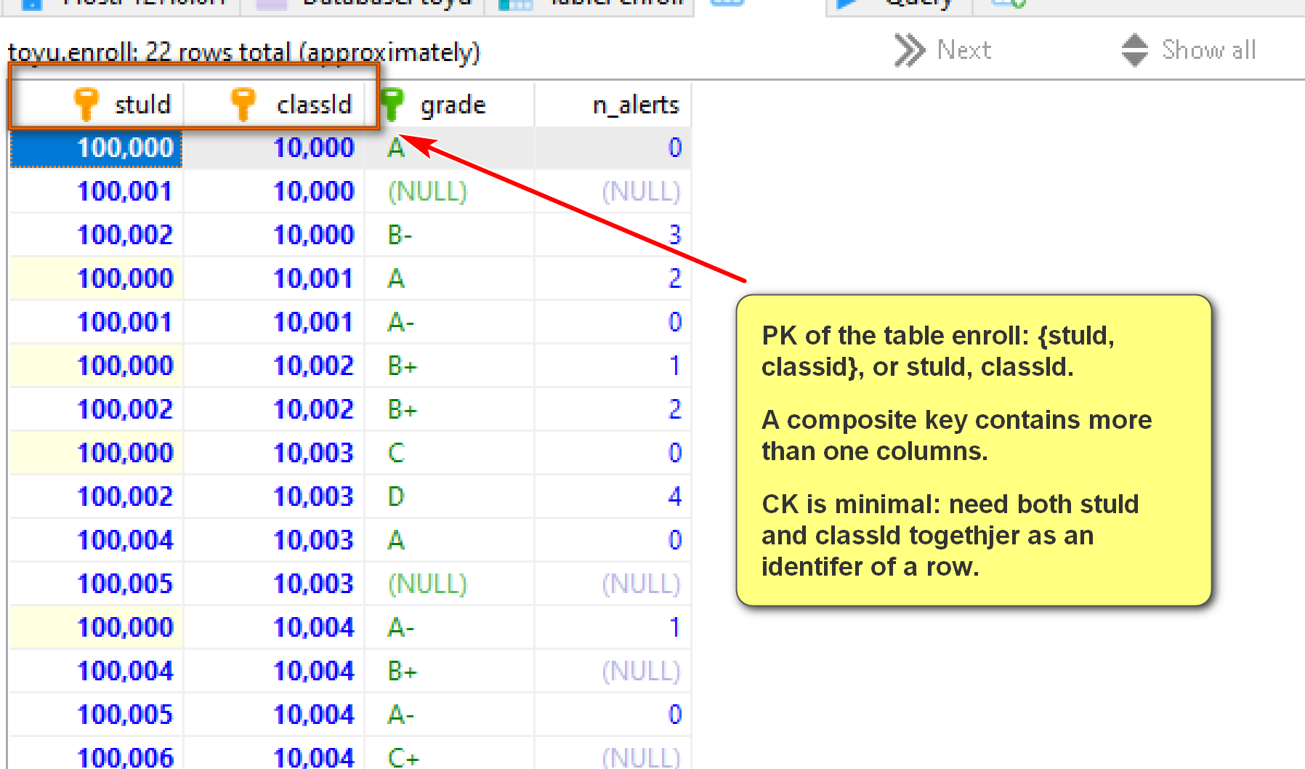
CREATE TABLE IF NOT EXISTS Enroll(
stuId INT NOT NULL,
classId INT NOT NULL,
grade VARCHAR(2) NULL,
n_alerts INT NULL,
CONSTRAINT Enroll_classId_stuId_pk PRIMARY KEY (classId, stuId),
CONSTRAINT Enroll_classNumber_fk FOREIGN KEY (classId)
REFERENCES Class(classId) ON DELETE CASCADE,
CONSTRAINT Enroll_stuId_fk FOREIGN KEY (stuId)
REFERENCES Student (stuId) ON DELETE CASCADE,
CONSTRAINT Enroll_grade_fk FOREIGN KEY (grade)
REFERENCES Grade (grade) ON DELETE CASCADE
);

  - A foreign key of a relation references a primary key of another relation (known as the parent or referenced table).
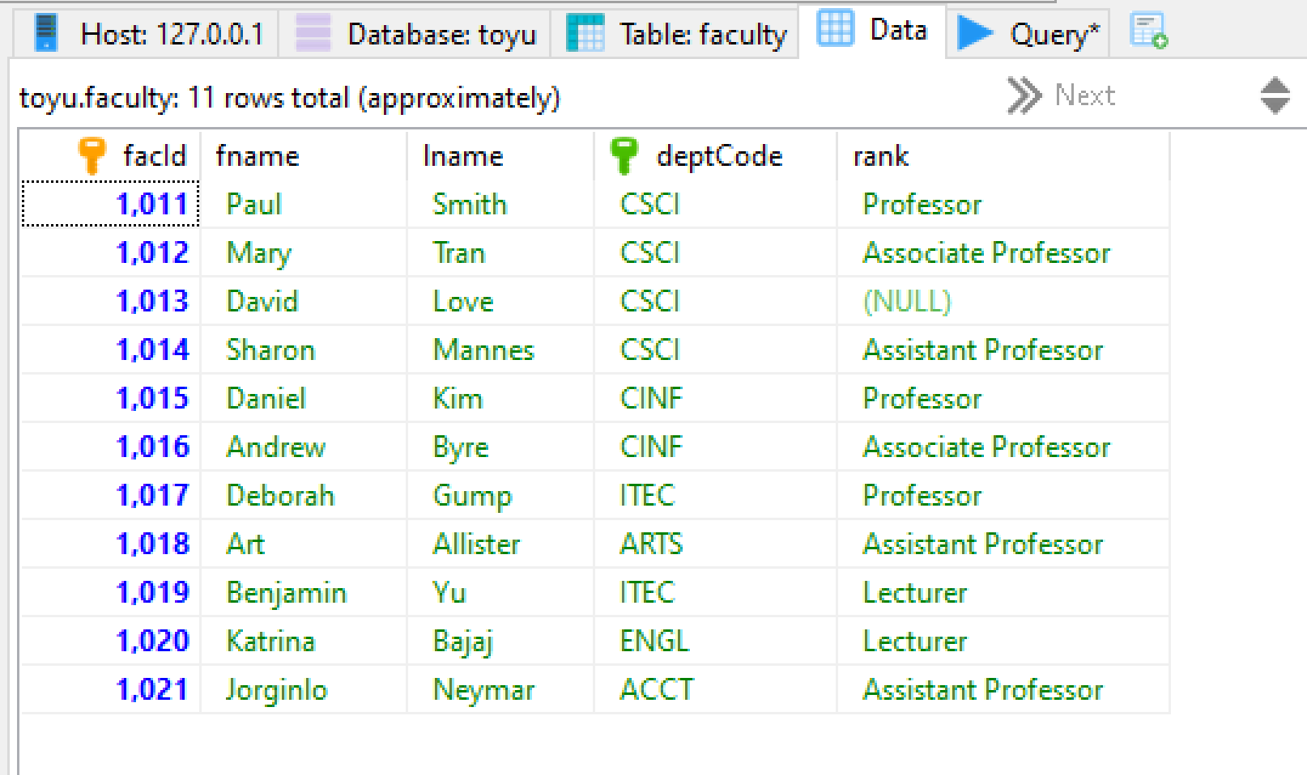
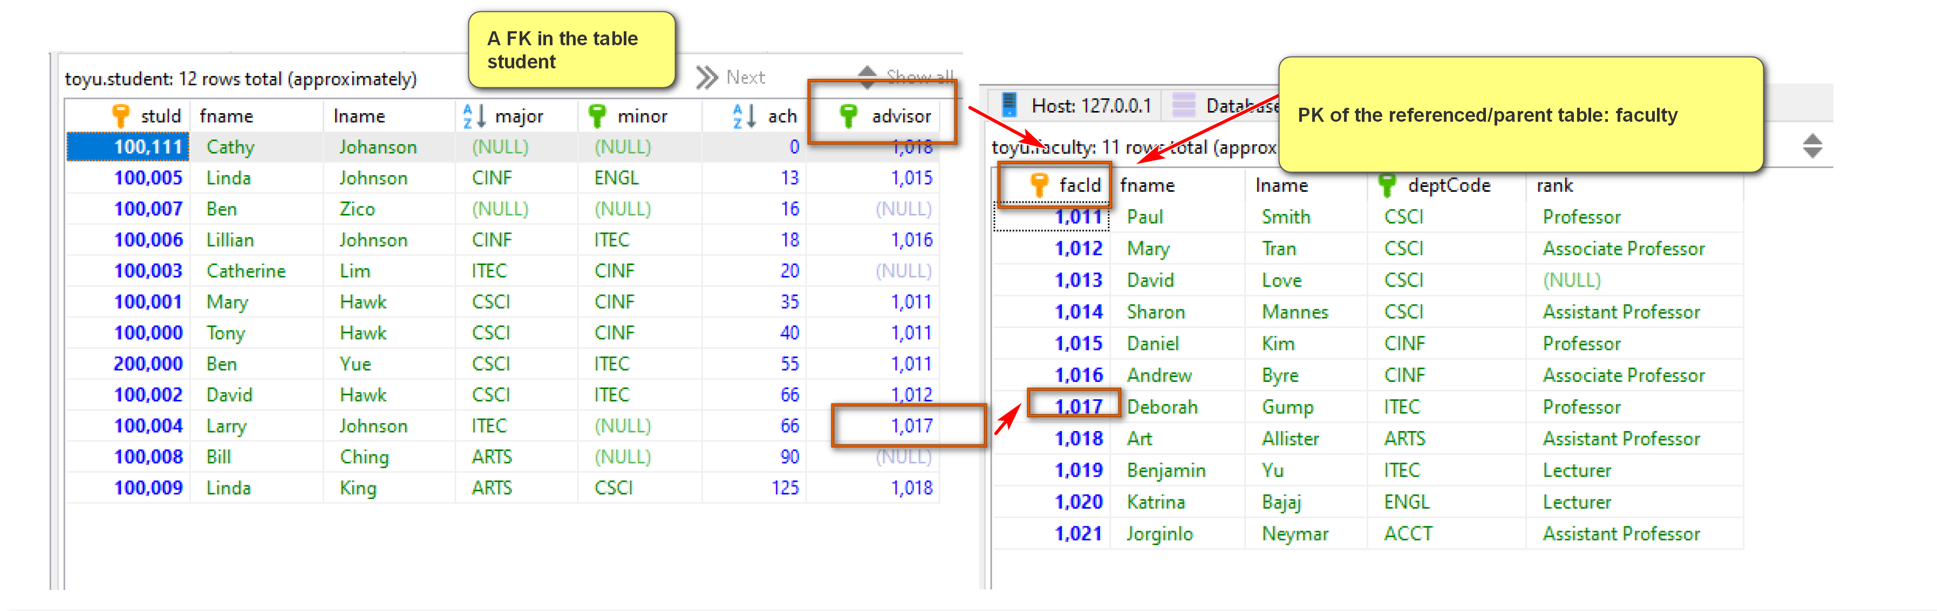
CREATE TABLE IF NOT EXISTS Student (
stuId INT NOT NULL,
fname VARCHAR(30) NOT NULL,
lname VARCHAR(30) NOT NULL,
major CHAR(4) NULL,
minor CHAR(4) NULL,
-- ach: accumulated credit hours, including transferred credits.
ach INTEGER(3) UNSIGNED NULL DEFAULT 0,
advisor INT NULL,
CONSTRAINT Student_stuId_pk PRIMARY KEY(stuId),
-- an artificial example of a CHECK constraint.
CONSTRAINT Student_ach_cc CHECK ((ach>=0) AND (ach < 250)),
CONSTRAINT Student_major_fk FOREIGN KEY (major)
REFERENCES Department(deptCode) ON DELETE CASCADE,
CONSTRAINT Student_minor_fk FOREIGN KEY (minor)
REFERENCES Department(deptCode) ON DELETE CASCADE,
CONSTRAINT Student_advisor_fk FOREIGN KEY (advisor)
REFERENCES Faculty(facId)
);

More theoretically:
- The (theoretical) relational model is based on the concept of a relation.
- It is a set-theoretic model: the definitions are based on mathematical sets.
- If you are not familar with set theory, read about it. This is a basic, short, good, and good-enough introduction: https://www.ucl.ac.uk/~ucahmto/0005_2021/Ch2.S1.html (note that in the set builder form, the author used ":" to represent "such that". We usually use "|" instead.)
- Note that practical DBMS do not implement the pure relational model.
- In the theoretical relational model:
  - An attribute (column/field) is a name.
  - A domain is a set of values an attribute can take.
    - It is the set of values of the data type of the attribute.
    - The value of an attribute should be atomic (cannot be divided into smaller components with individual meanings):
      - If all attributes of a relation are atomic, the relation is said to be in First Normal Form.
    - Null may or may not be an acceptable value for an attribute. It depends on problem requirements.
  - A relation schema, R, is a set of attributes A₁, A₂,…,A_{n} with their domains D₁, D₂,…, D_{n}.
  - A tuple (row) is a set of mapping of a set of attributes to a set of values: A_{i} -> d_{i} where d_{i} ∈ D_{i}, for i = 1 to n (∈: belongs to)
  - A relation (instance) is a set of tuples.
  - The degree (or arity) of a relation is the number of attributes in its schema.
- Some advantages of the relational model and relational DBMS (as compared to other databases):
  - Strong mathematical foundation
  - Simple
  - Strong design theory
  - Strong support of data integrity and consistency
  - Strong support of transactions
  - Strong industrial support and community
  - High popularity
- Some disadvantages of the relational model and relational DBMS:
  - The data model may not match the problem requirements well.
  - Impedance mismatch with object-oriented models.
  - Do not scale well.
  - Structured data may be too restrictive for specific problems.

