CSCI 4333.2
Annotation
2/4/26
Introduction to UML
by K. Yue
1. Introduction to UML
- UML: A set of graphical notations for object-oriented modeling.
- Wikipedia: "The Unified Modeling Language (UML) offers a way to visualize a system's architectural blueprints in a diagram."
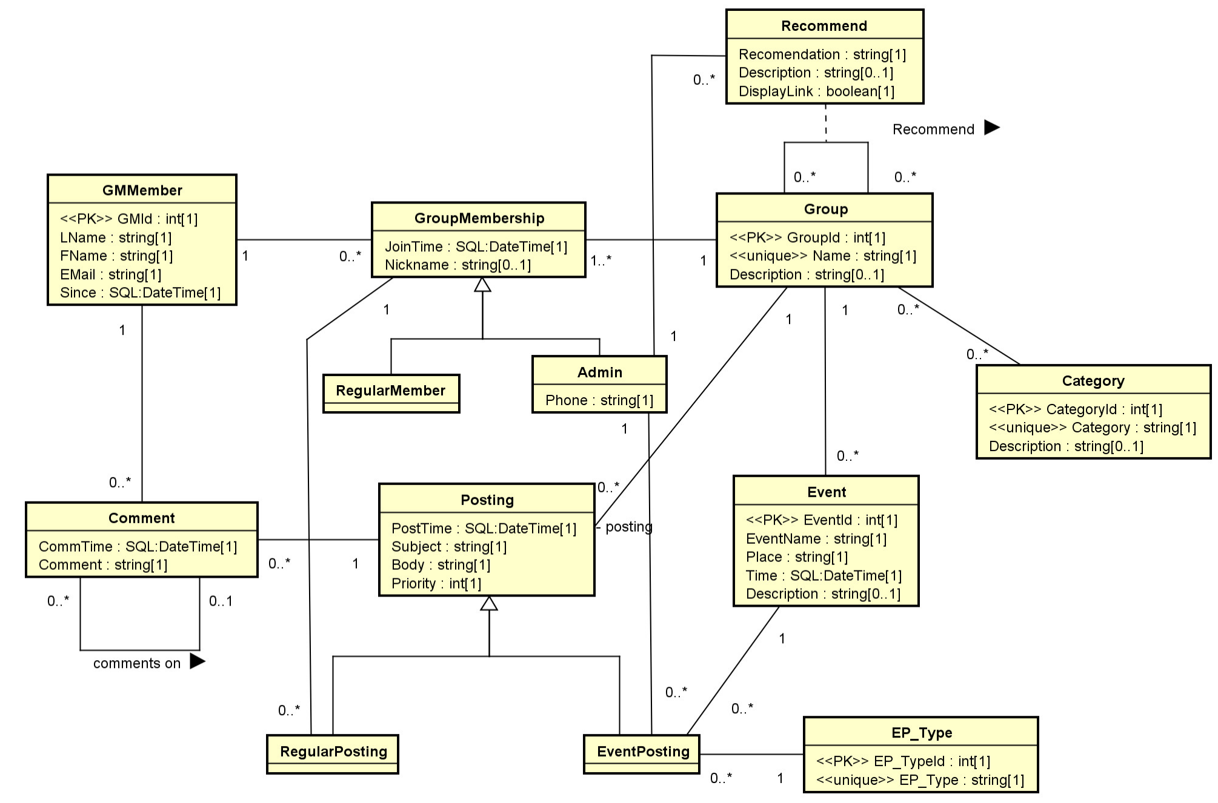

- A standard maintained by OMG: OMG's UML page.
- Two major versions:
  - Version 1.4.2: international standard released in 2005.
  - Version 2.5.1: released in 2017, added nested classifiers and improved behavior models. Specification: https://www.omg.org/spec/UML
- Two main types of diagrams:
  - Structure diagrams: model static structures.
  - Behavior diagrams: model dynamic behaviors.
- Version 2.5 has 15 diagrams: 7 structure diagrams and 8 behavior diagrams.
- Some Resources:
  - OMG UML Resource
  - SPARX UML Tutorial.
- We will focus on the class diagram only.
Class Diagram of UML 2.2 diagram (from Wikipedia):
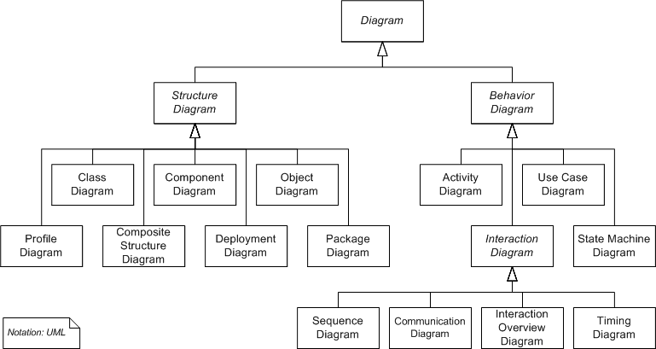

Data modeling focus on class diagram and object diagram.
2. Class Diagrams (Emphasis on DB applications)
2.1 Introduction:
- A static structure diagram in UML.
- "Describes the structure of a system by showing the system's classes, their attributes, operations (or methods), and the relationships among the classes." -- from Wikipedia.
- Read "class diagram" from Wikipedia: http://en.wikipedia.org/wiki/Class_diagram.
- For a significantly better introduction by IBM: http://www.ibm.com/developerworks/rational/library/content/RationalEdge/sep04/bell/.
- Two kinds of tools for drawing UML diagrams:
  - Graphical tools: main purposes are drawing diagrams (e.g., MS Visio, draw io, etc.)
  - Computer-Aided Software Engineering (CASE) tools: for software development with some understanding of the semantics of diagram elements (e.g., MagicDraw, IBM Rational Rhapsody, Visual Paradigm, Astah, etc.)
- We use Astah UML Editor
  - We will use community version in classroom demonstration, which is now deprecated.
  - Students can use the more powerful student version for free: search "astah student license".
- One may also use UML object diagrams to show objects and their associations of a snapshot of the system.
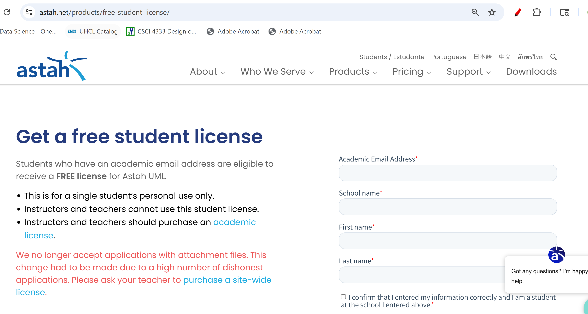
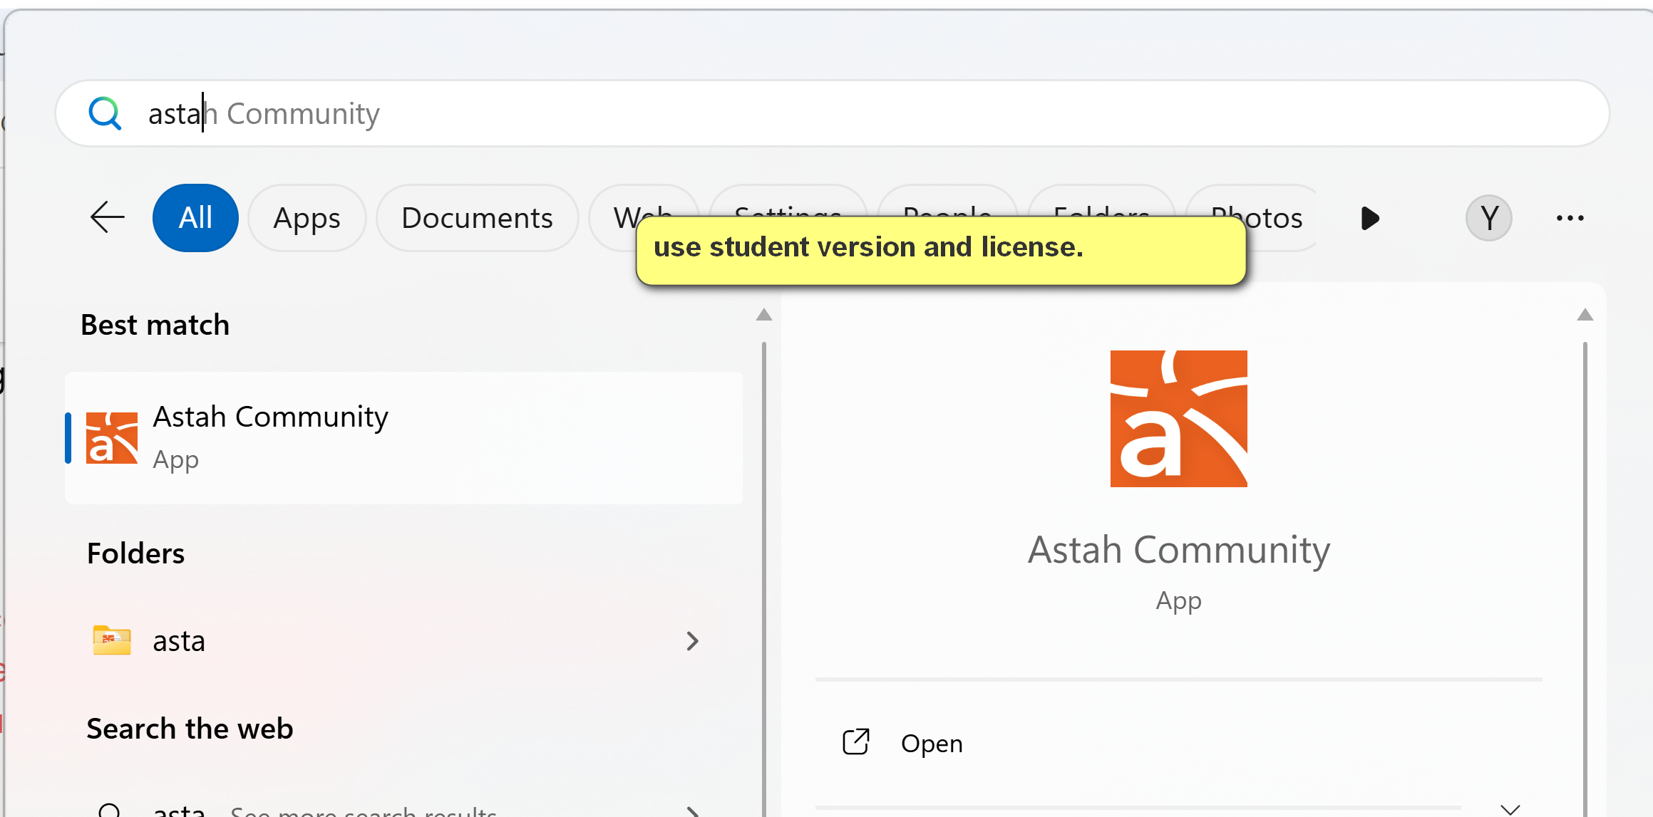
Create a new class diagram
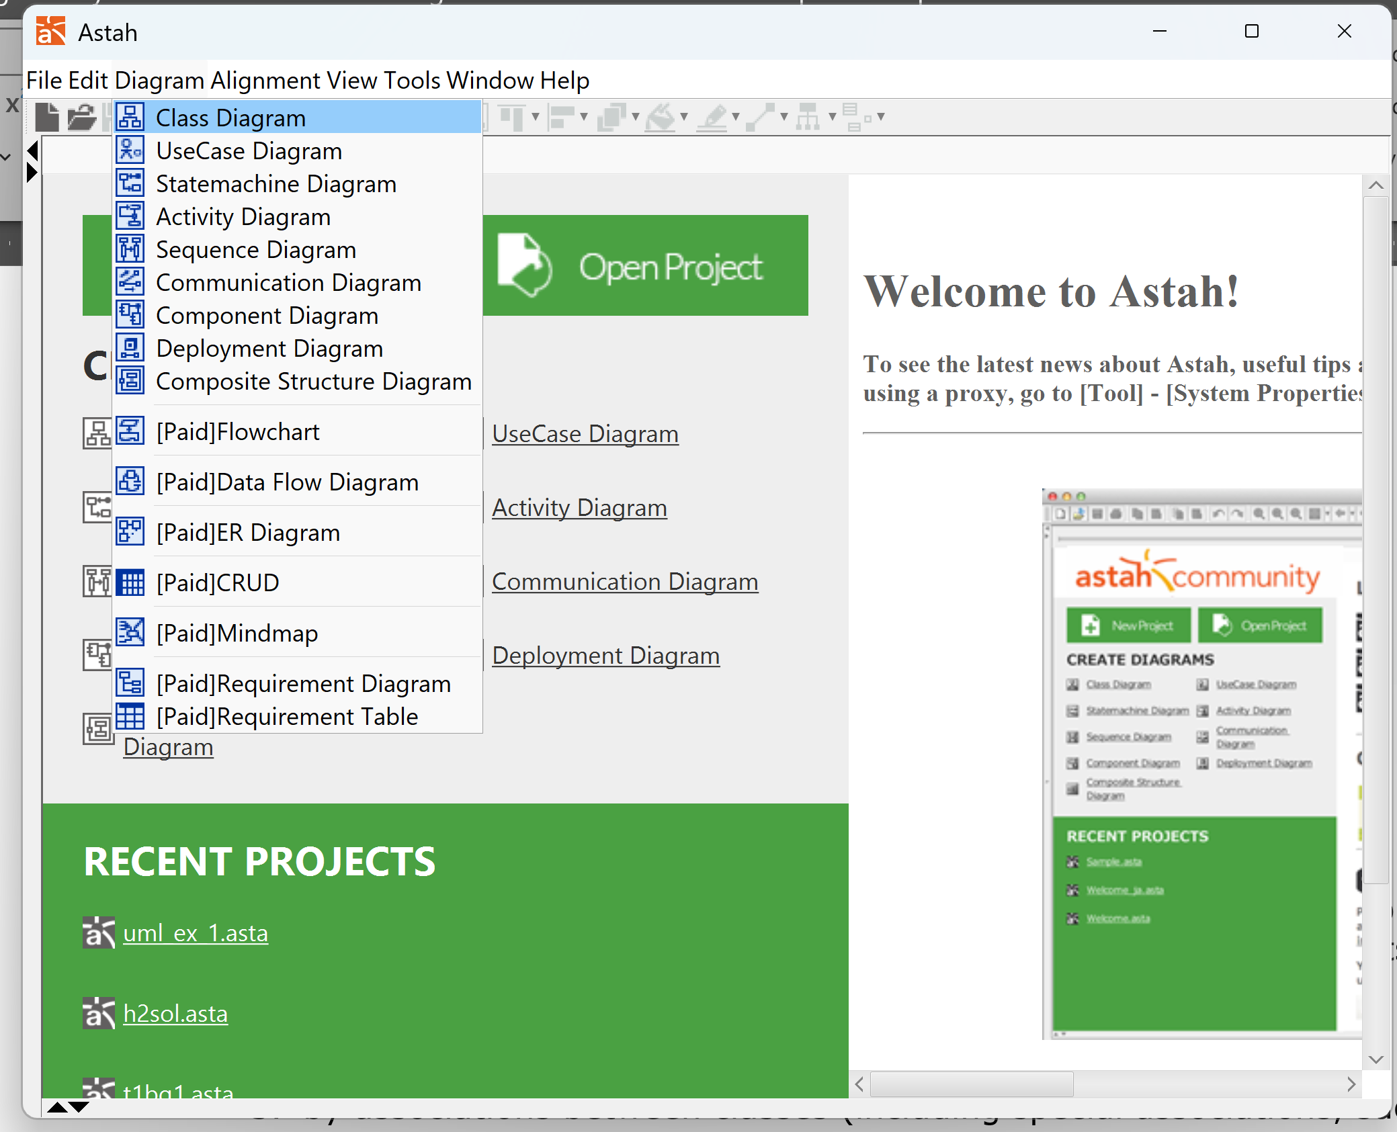
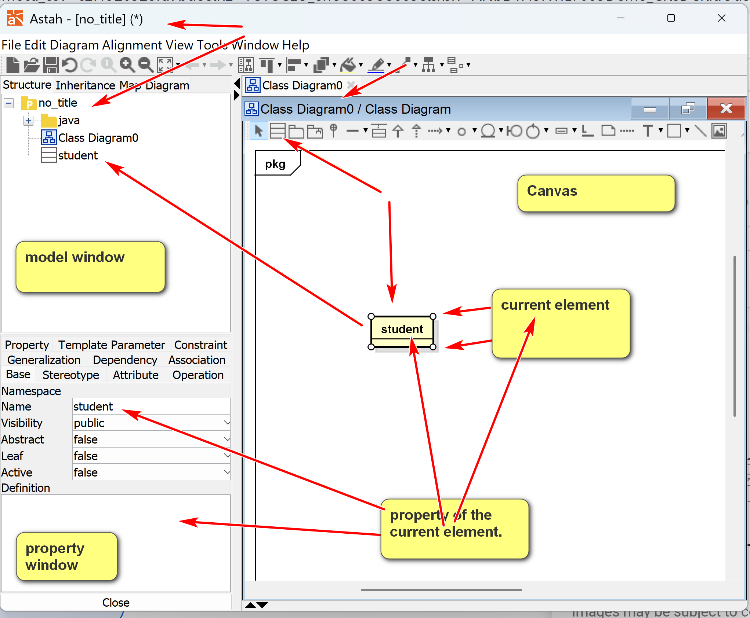
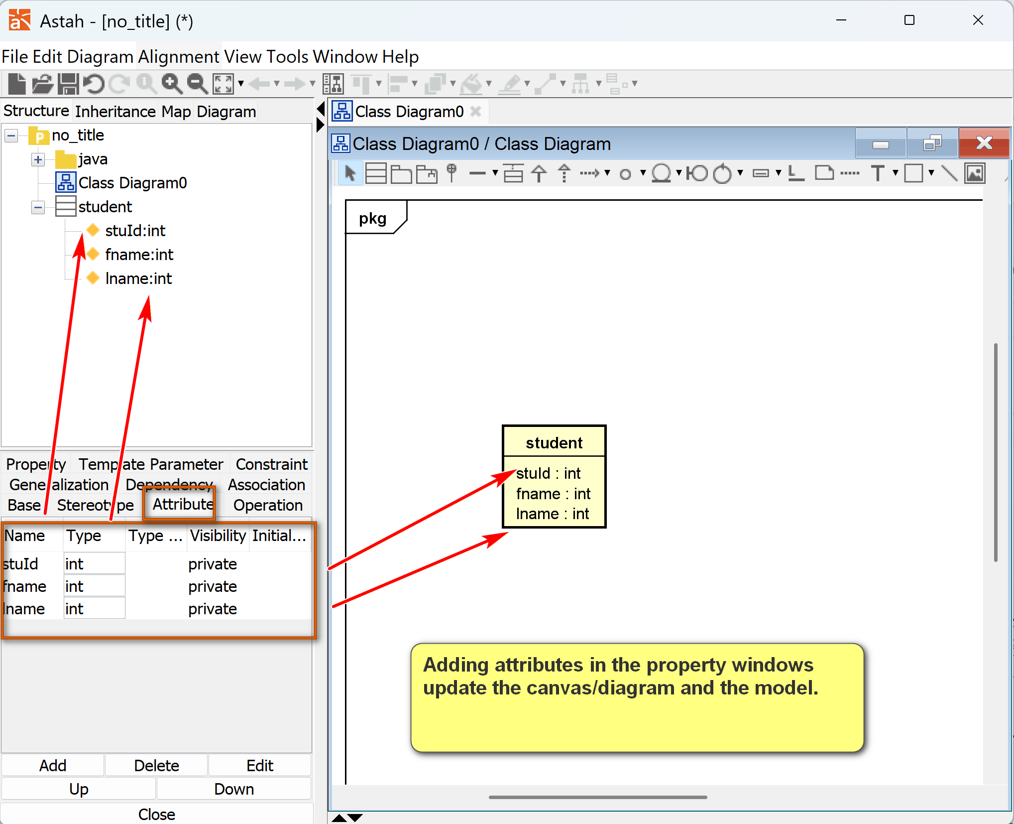
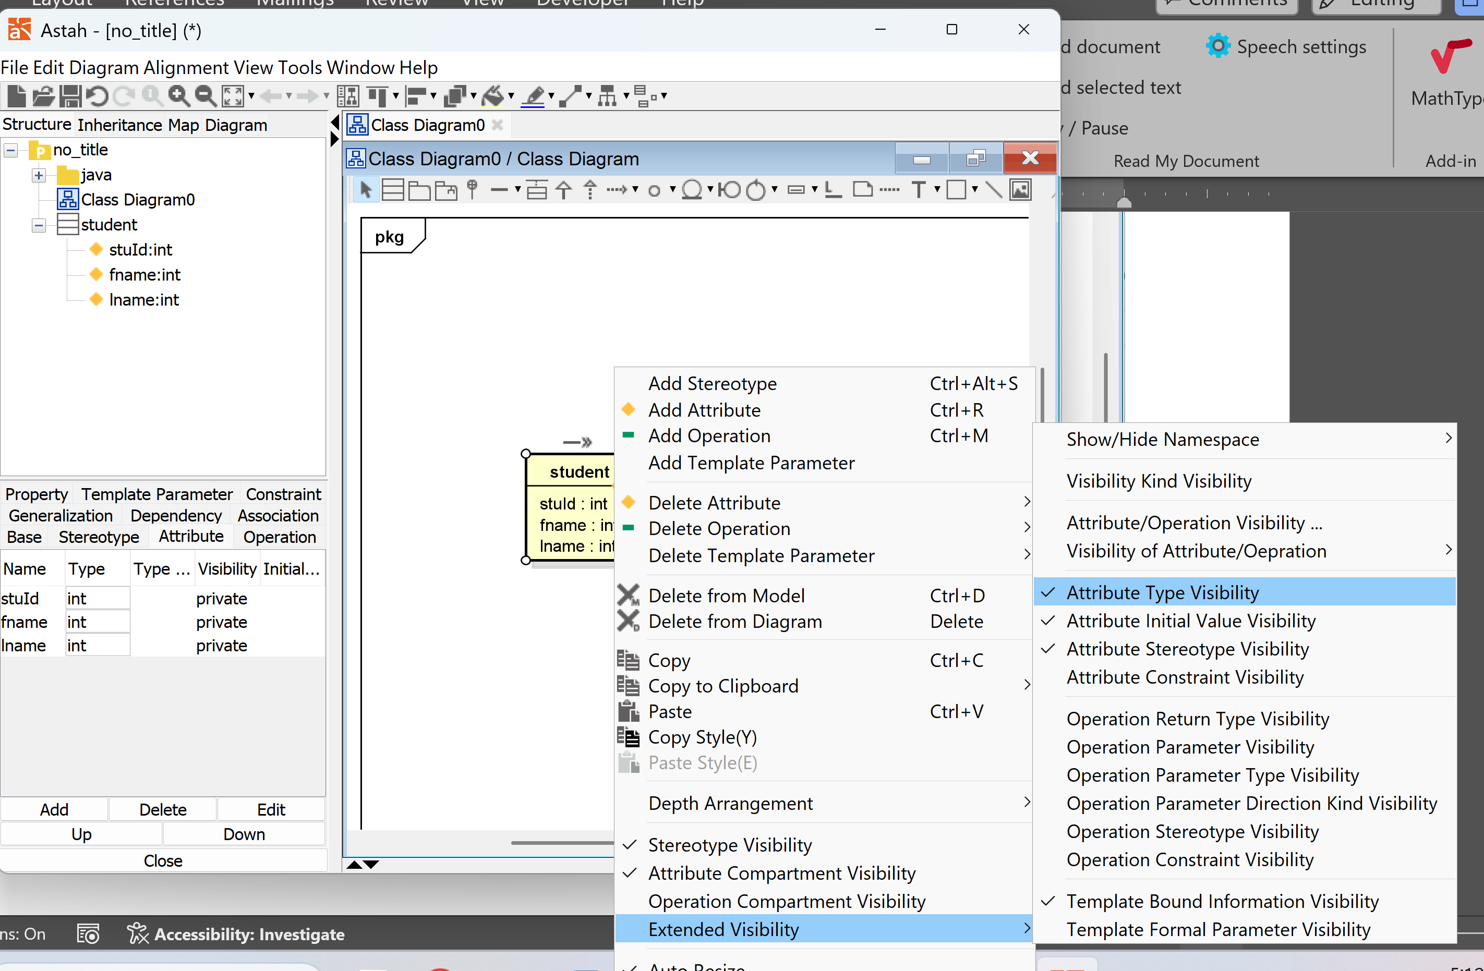

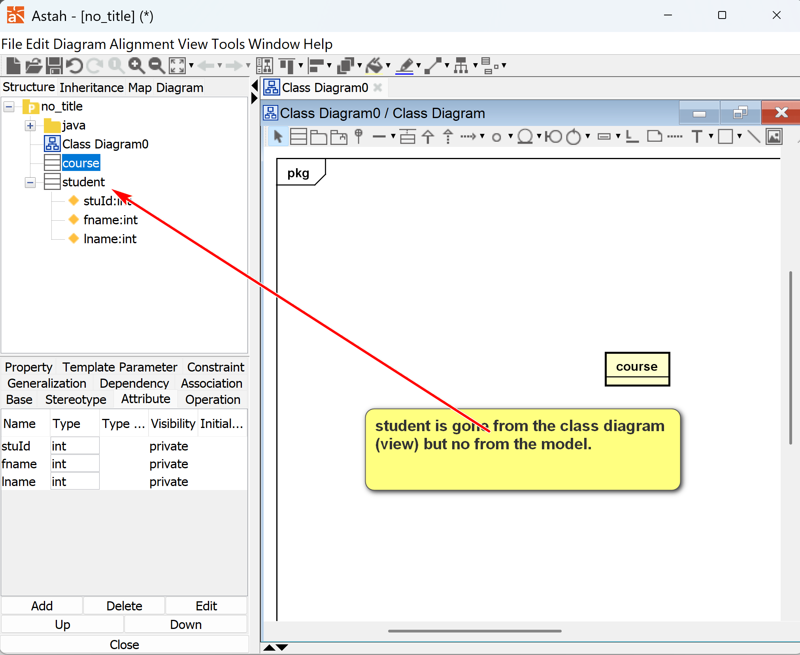
2.2 A Simple Conceptual Modeling Process (OO Modeling)
- Study application requirements to gain a very good understanding of the problem.
- Conduct an analysis to extract concepts that may have data requirements.
- For each concept, decide how should it be modeled? Major options are:
  - by attributes
  - by a class
  - by associations between classes (including special associations, such as composition, aggregation, generalization, etc.)
  - no need to model (as it does not represent any data requirement)
These steps are repeated until the model reaches the necessary fidelity, accuracy, and precision.
[1] Class: Concept A: A by itself.
- Have attributes
- Have associations
- Flexible
- More complexity
- Exists by themselves (object standalone by themselves)
[2] Attributes: Concept A: A of X. A is a property of X (object or association)
- No sub-attribute.
- Cannot form association
- Only have values
- Simple
- Dependency on other elements (such objects, associations)
- Property of something.

[3] Associations: Concept A: X (subject: OO’s object) – A (verb) – Y (object)
- May have attributes
- Cannot form association with other elements
[4] No la: no data requirements.
Example:
Problem. A used car dealership application's subsystem: information about cars and their manufacturers.
Specification description: A car manufacturer has a unique id and name. A car maker may make many cars. For example, Honda, which may have a manufacturer id of 10001, makes Civic and Accord.
Concepts:
[1] Car manufacturers (i.e., Car maker): class
[] Car: class
[] Vin number: uniquely identify a car.
A car's model refers to the specific name or design of a vehicle within a manufacturer's lineup (the make, like Toyota), distinguishing it by features, size, and style (e.g., Camry, Corolla) from other products of the same brand, with different trims and options.
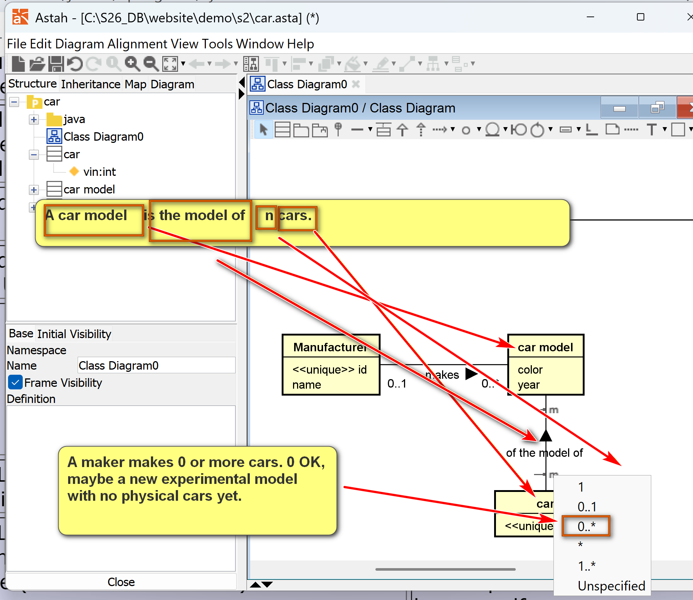
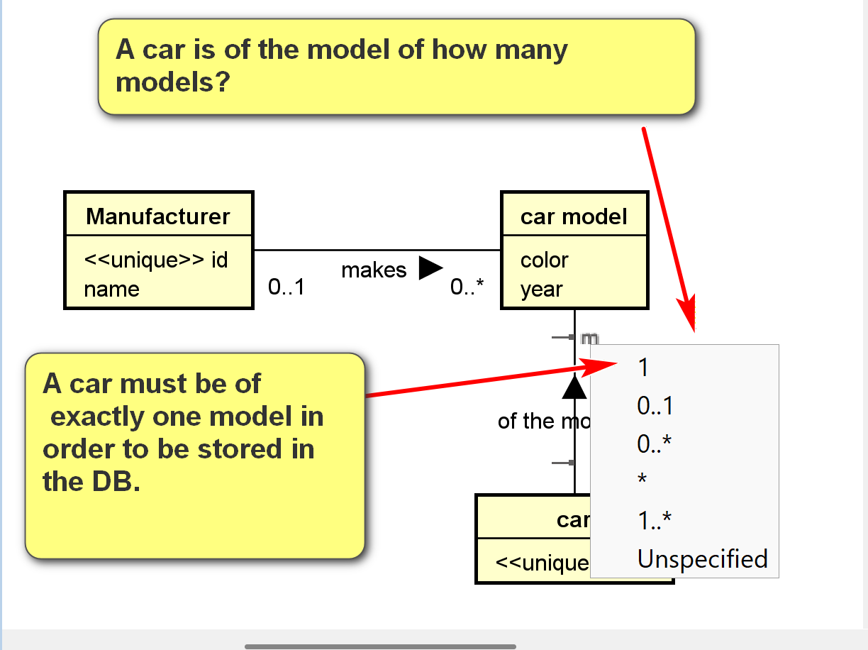

[] unique id (A) of car manufacturer (X): E.g. 10011 is the id of Honda: attribute of what element?
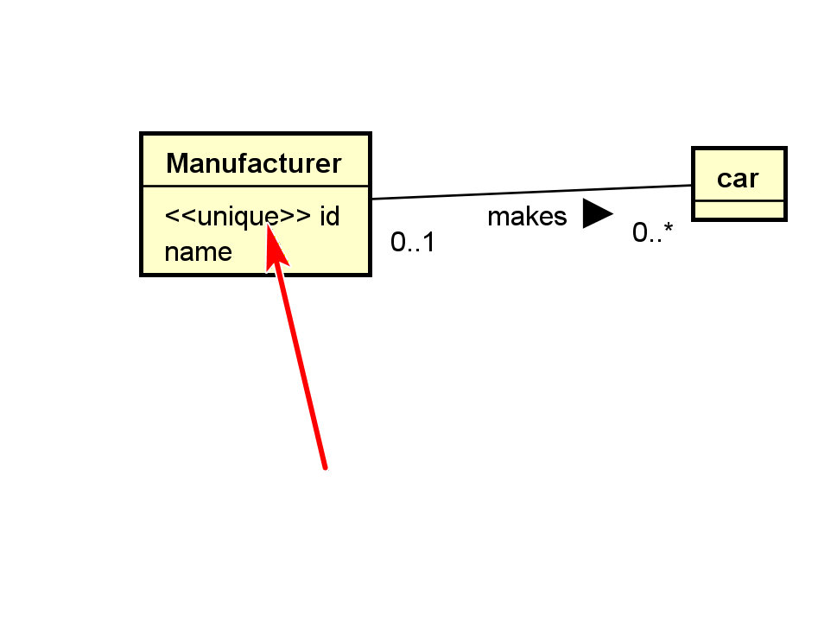
UML general-purpose, extensible modeling language: stereotype (tag, property added on UML elements), <<unique>>
[] Year
“A car manufacturer has a unique id and name. “
[] name (A) of the car car manufacturer (X): attributes
[] may make many:
Sentence: subject: X verb: A object: Y
“A car maker (X) may make (A) many cars (Y).
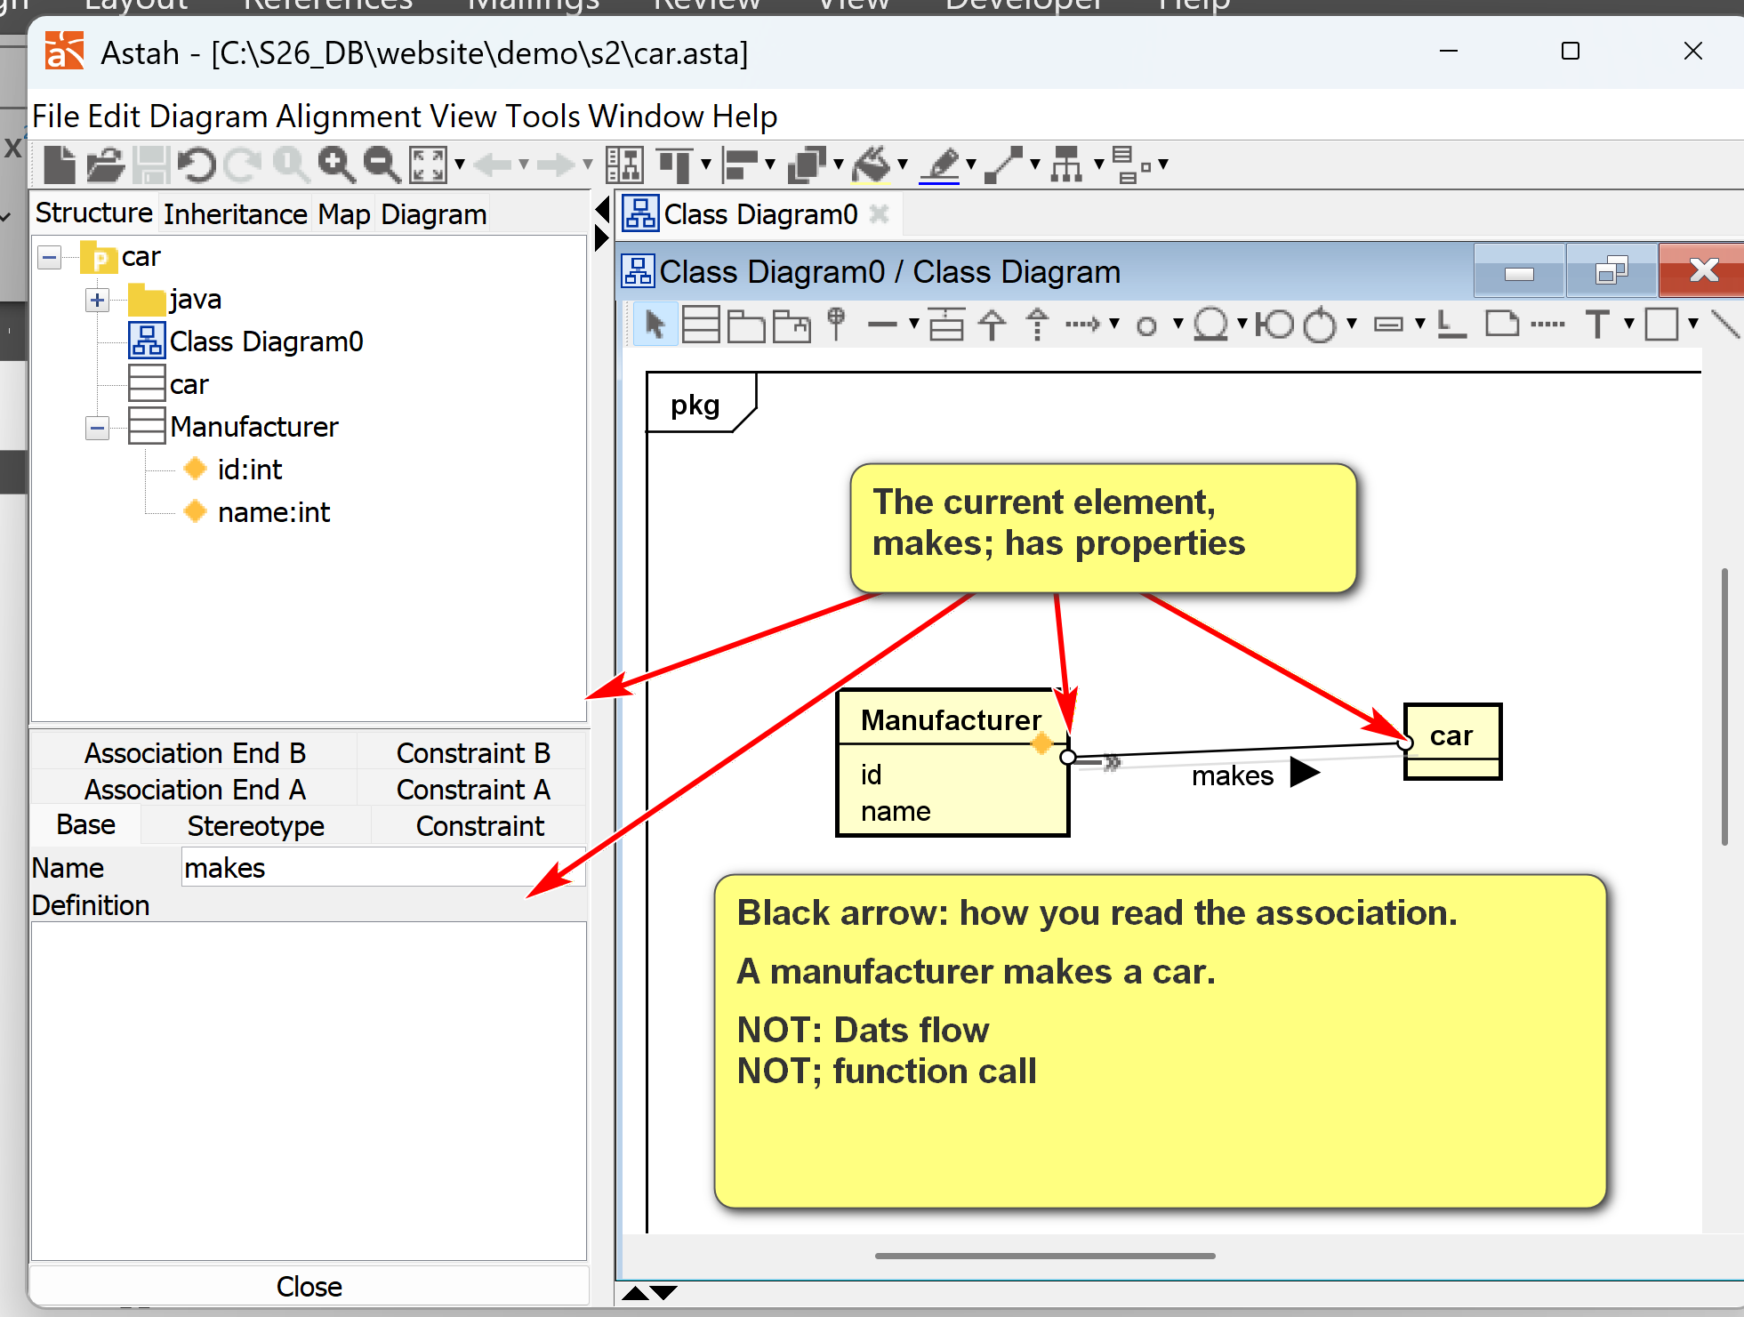
Multiplicity/Cardinality: # of objects involved in the association.
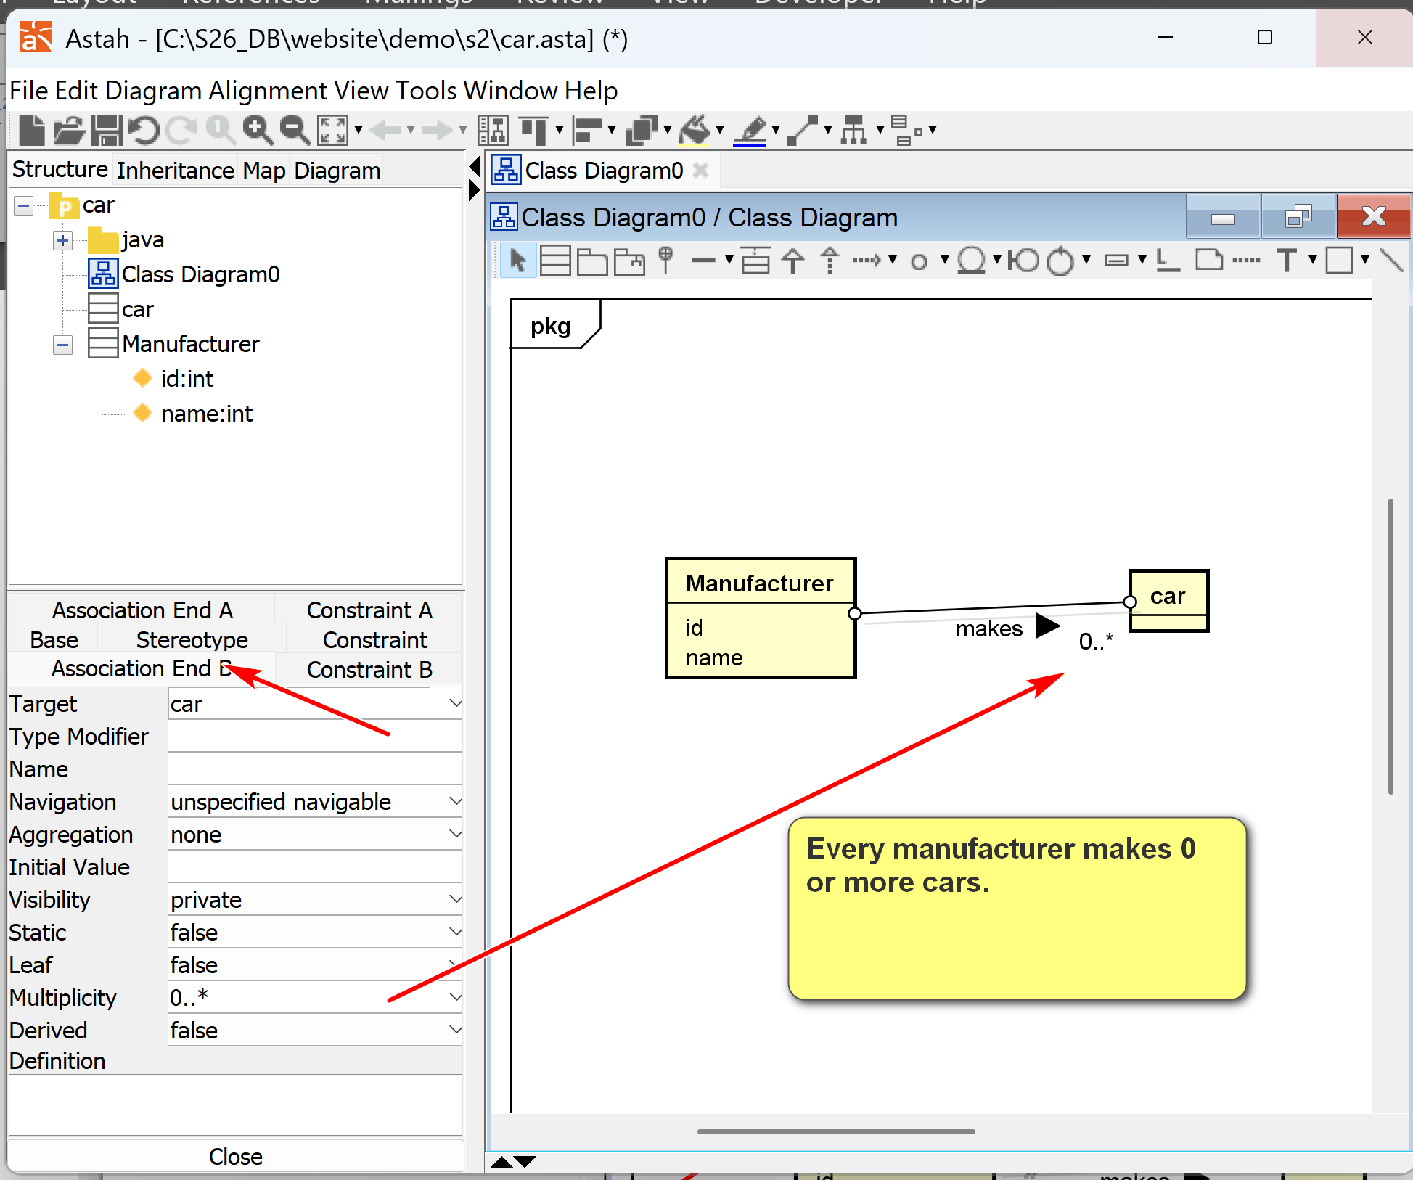
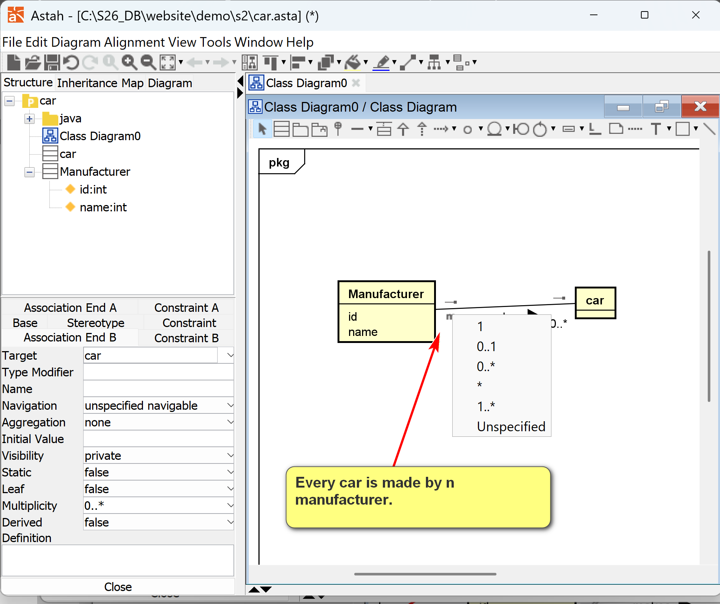
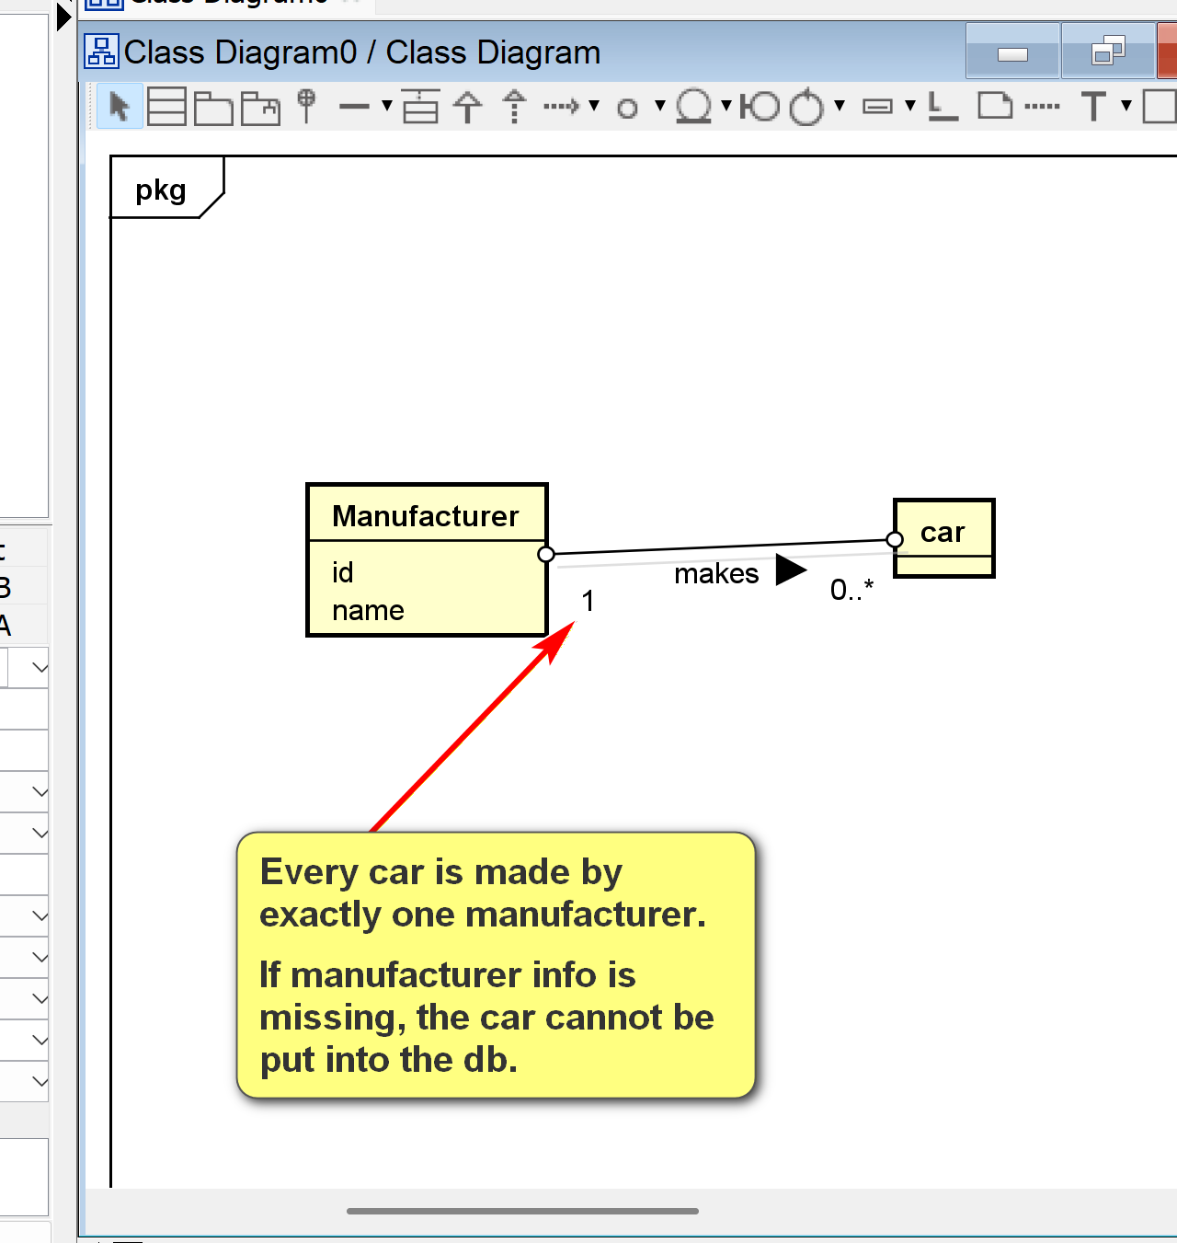
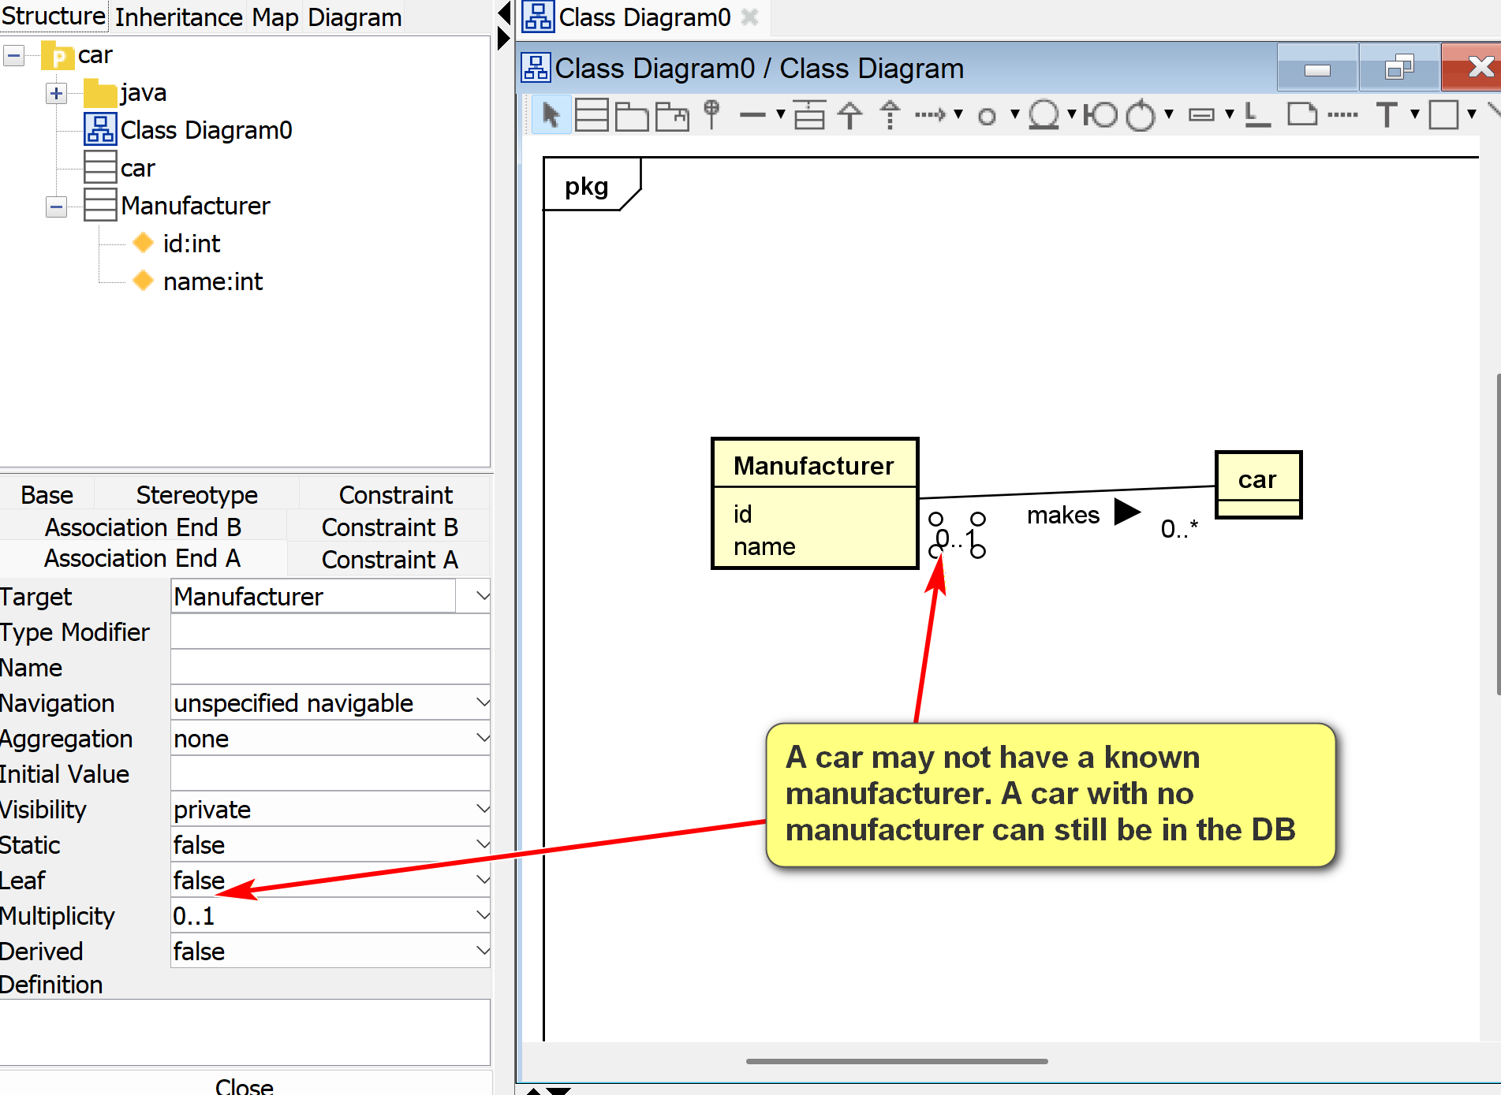

[] Convertible
[] Honda: the value of the name of a manufacturer. No need to model, just an example
Name of a manufacturer: attribute name:, value: Honda
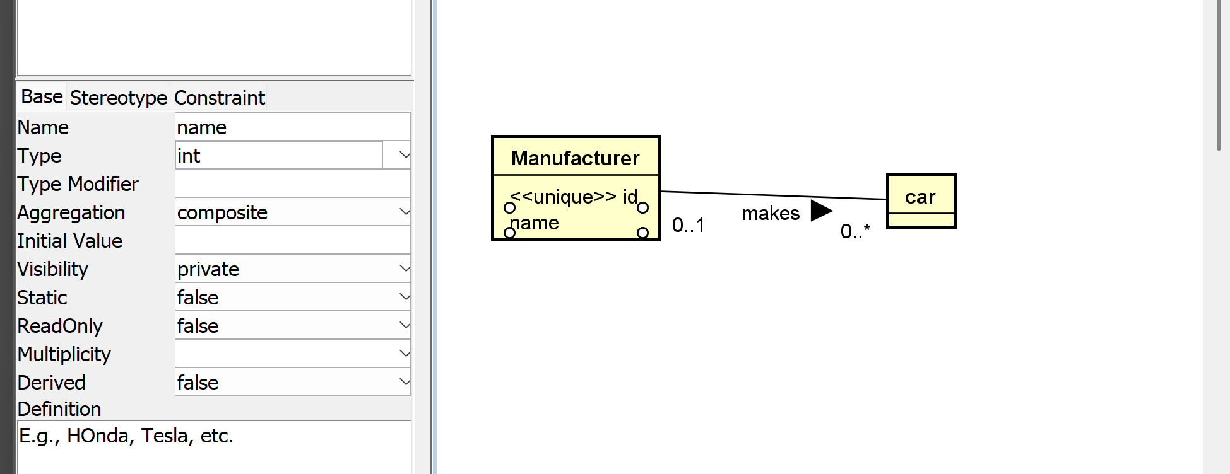
[] 10001: value of the id attribute of a manufacturer.
[] Civic: object; no need to model in a class model.
[] Accord: objects; no need to model

: A car manufacturer has a unique id and name. A car maker may make many cars. For example, Honda, which may have a manufacturer id of 10001, makes Civic and Accord.

Analysis and Design
Some observations:
- Manufacturer: a class (template) that can be used to initiate many manufacturer objects (instances).
- Honda: an object of the class Manufacturer.
- Resolve ambiguous terms: e.g., the term "manufacturer" may refer to the manufacturer class, or a particular manufacturer (i.e., a manufacturer object such as Honda).
- Define synonym: manufacturer, car manufacturer and car maker may be the same. Different terms can refer to the same concept.
- "Unique id": may be modeled as an attribute (name), a property of the manufacturer class.
- Make additional assumptions: E.g., every manufacturer object must have an unique id.
- 10001: attribute (value) of the id of a manufacturer object.
- Name: a property of a manufacturer.
- Another additional assumption: Every manufacturer object must have a name.
- Car: a class, as there may be many brands of cars.
- Prepare questions: E.g., do we need to introduce the concept model (e.g., Coupe, Sedan, Si Coupe)?
- Civic and Accord: object instances of Car.
- Additional assumption: Every car must have a name as its attribute.
- Make, or manufacture: a relationship between a manufacturer (object) and a car (object). A manufactor (object) makes (verb: possible asspication) a car (object).
Class Diagram:
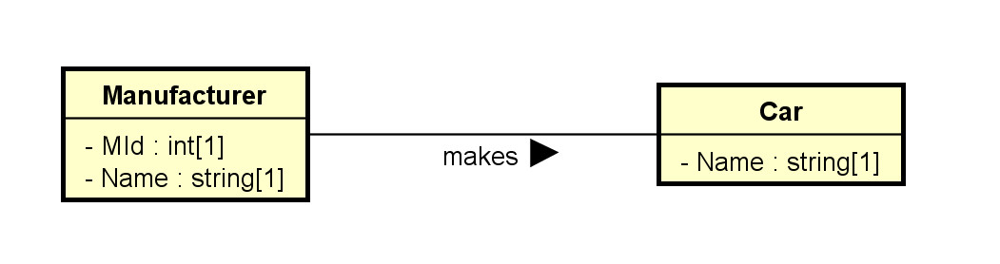
Object Diagram:
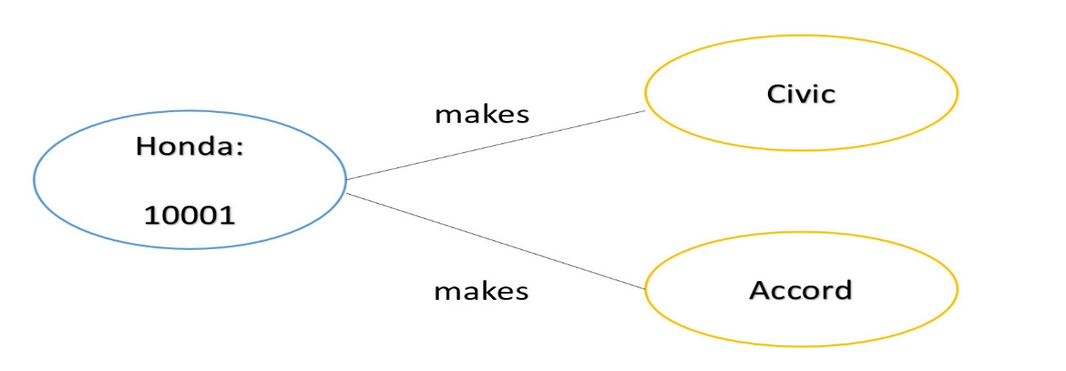
2.3 Classes
2.3.1 Basics
- Drawn as a rectangular box.
- The class names, attributes, and operations may be specified, with selected details in the name, attribute, and operation compartments respectively.
- Attribute and operation compartments are optional.
- For DB modeling,
  - The attribute compartment will eventually need to be clearly modeled.
  - The operation compartment may not be needed.
- The levels of details depend on the phases of modeling. It is a common mistake to specify too much detail in the early modeling phases.
- As modeling proceeds, more details are added, updated, and refined.
Note that software application modeling and database modeling have different foci.
- Software modeling: focus on operations (methods, especially public methods).
- Database modeling: focus on attributes (data).
Example: The following sequence of diagrams of how the modeling of the used car dealership application may proceed.
Initial version: v0.0.1.0:
- Only some major classes, associations, and attributes.
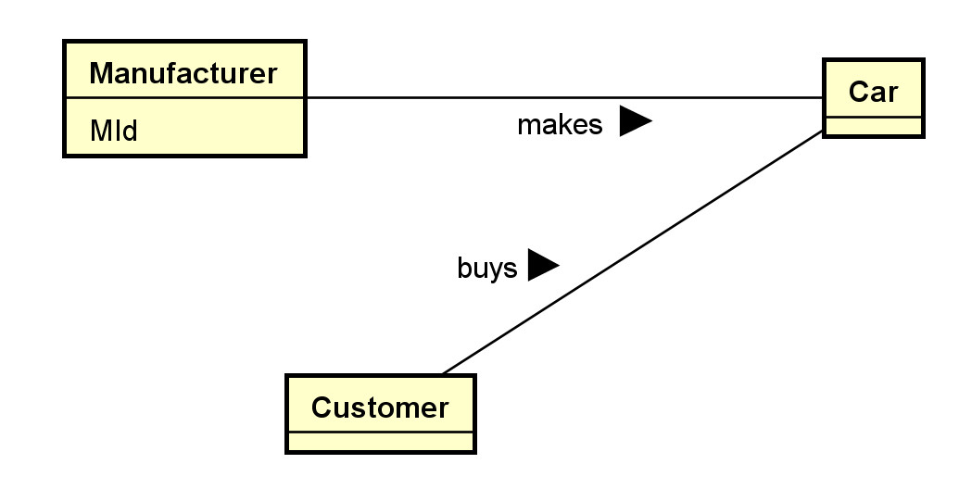
Version v0.0.1.1:
- Add a payment class and some attributes.
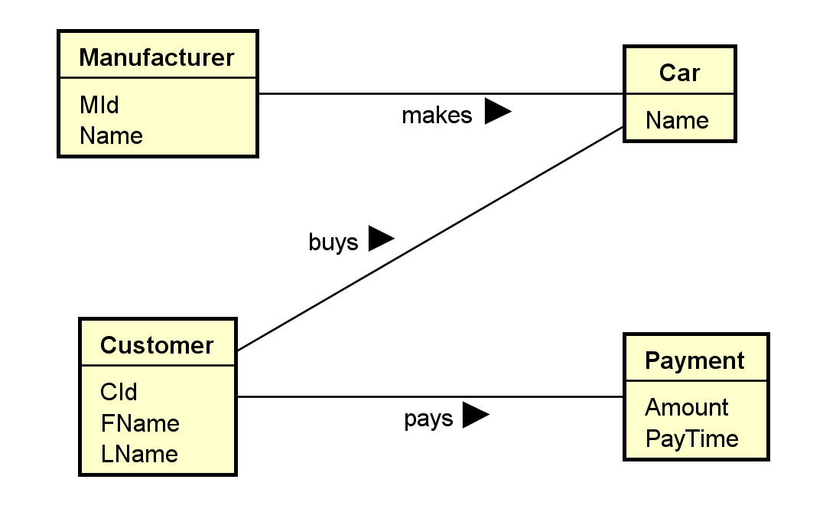
Version v0.0.1.2:
- Decided to split the concept 'car' into two concepts 'car model' and 'car'. Adjust associations.
- Add some type information.
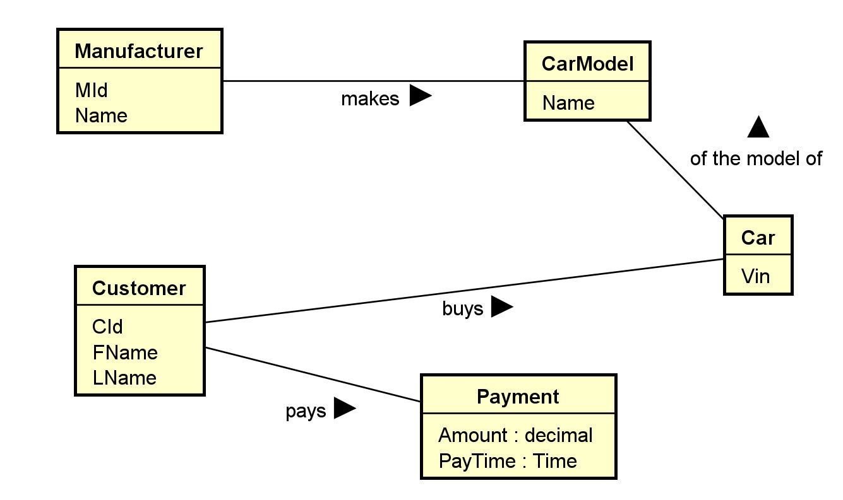
Version v0.0.1.3:
- Add an association between Payment and Car.
- Add multiplicity of the association "of the model of":
  - A car must be made of one car model.
  - There may be many cars made of the same model.
- Add multiplicity of 1 to the attributes Amount and PayTime of the class Payment. They are mandatory.
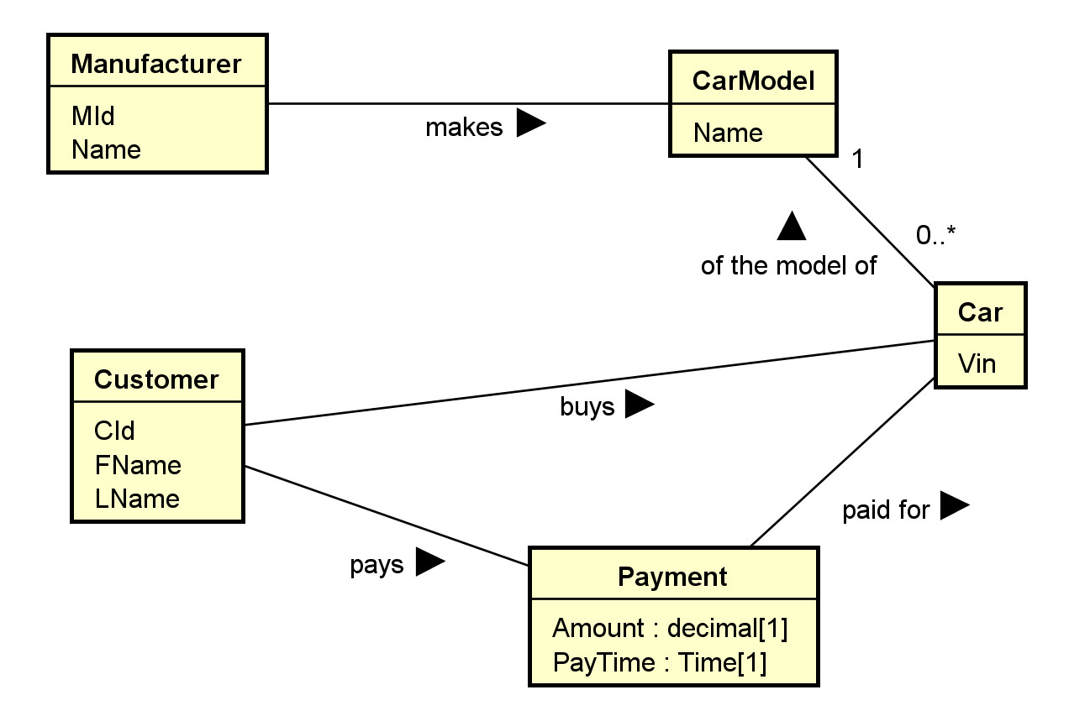
- For example, one may focus on the main classes and their associations in the first model, without worrying about the attribute or operation compartments.
- Most UML editors allow controlling visibility of different elements. For example, in Astah:
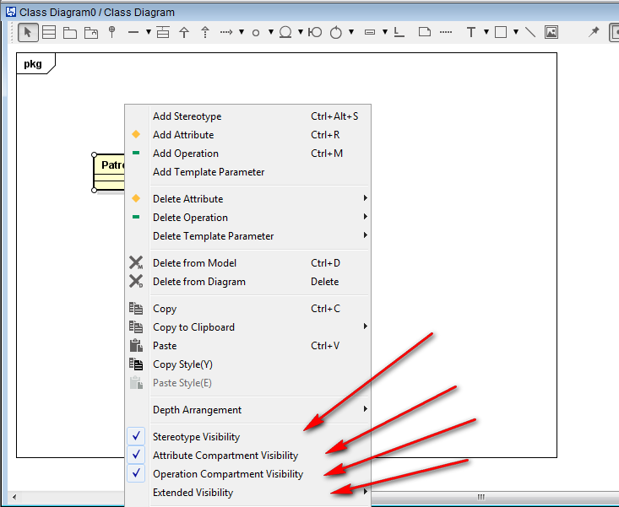
- A stereotype (specifying the kind of entities) and a property list with tagged values can be added to any compartment.
- Their flexibility allows for customization and extensibility to fit specific applications.
- Additional properties on data members may be specified, such as:
  - Visibility: + (public: +, protected: #, private: -, etc.)
  - data types
  - abstract (in italic) or concrete (as constraints)
  - class members (underscored) or instance members
  - default values
Example: for software modeling:
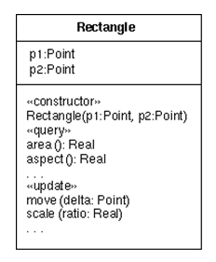
Example: for database modeling.
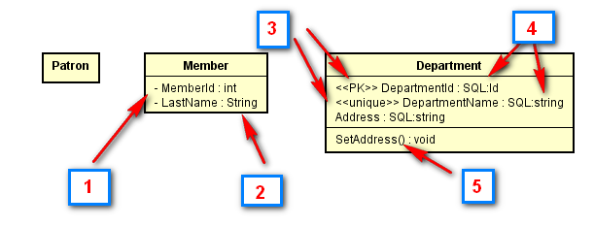
The classes Patron, Member and Department with some attributes may be modeled in the first draft of the UML class diagram. Boxes in the diagram above:
- In a subsequent iteration, attributes may be added using settings of the UML tool showing visibility of the attribute members.
- Data types may be included using predefined data types provided by the tool.
- In a further iteration, stereotype may be added, such as to identify the primary key <<PK>> and simple candidate key <<unique>>.
- More specific user-defined types (or implementation types) may be used.
- Operation members may be added. They are in general less important than data members in data modeling.
- Multiplicity should eventually be added, as shown in the diagram for Patron below.
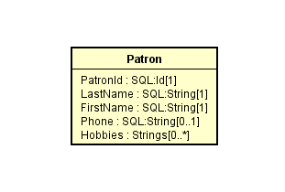
- Note that multiplicity can be used to depict nullable and multi-valued attributes. In this example, PatronId is not nullable ([1]), Phone is nullable ([0..1]) and Hobbies can have multiple values ([0..*]).
Check out the introductions to class diagrams from agile modeling and wikipedia.
- Some possible relational database extensions on attributes may include:
  - Multi-valued: * or by using multiplicity.
  - Multiplicity can also be used to indicate whether an attribute is nullable.
  - Derived: <<derived>> using stereotype, \, or using other specific notations
  - Primary key: <<PK>> as stereotype.
  - Candidate keys: <<CK>> as stereotype.
  - Unique field: <<unique>> as stereotype.
  - Nullability: <<nullable>> or by using multiplicity.
  - User-defined or system defined SQL data types.
  - Indexing: <<index>> as stereotype.
- Check with your organizations for UML guidelines on a specific project.
- An example of a database profile for UML: http://www.agiledata.org/essays/umlDataModelingProfile.html
  - may be adapted for uses in later phase of modeling.
2.3.2 More Properties of Classes
- A class is a 'first-class citizen.'
  - It has attributes.
  - It can form associations with other classes.
  - It can have operations.
  - Objects of a class can exist by themselves.
  - It has more structures for modeling data requirements.
- As a comparison, an attribute is not a first-class citizen.
  - It does not have sub-attributes.
  - It cannot form associations with other elements.
  - The existence of an attribute depends on the object..
- Objects can be instantiated from classes.
Example:
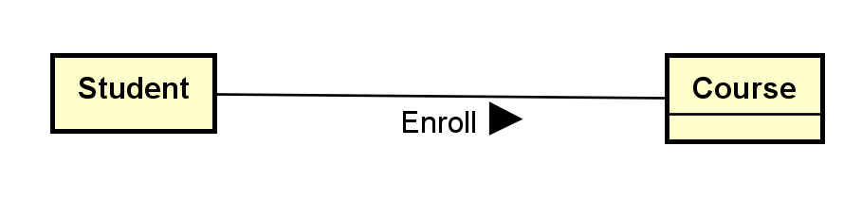
We may have four objects of the student class: S1, S2, S3 and S4. Each student object represents an individual student in a database application.
We may have three objects of the course class: C1, C2, and C3. Each course object represents an individual course in the database application.
2.4 Associations
- Binary associations are represented by solid lines.
- Important options include:
  - Association names with directional arrows (for reading).
  - Association roles: the role of an object participating in an association.
  - Multiplicities: the allowed number of associated objects.
  - Association attributes can usually stored by promoting an association to an association classes.
  - Qualifiers: association attributes to partition the targeted classes.
  - Navigational requirement: specified by arrows. Usually not used in data modeling.
  - Dependency constraints: by dotted lines.
- Some modeling questions and decisions:
  - Should we model something as a class or as an association?
  - Should we model something as a class or as an attribute?
  - What kind of association should I use? Binary association, association class, n-ary association?
Example: Note that no attribute is shown in this initial phase.
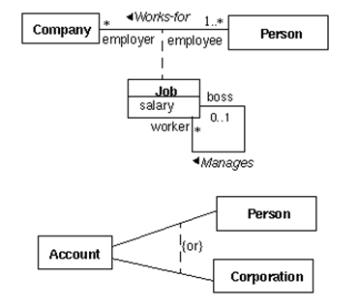
Note:
- Job is an association class.
- The arrow in the association "works-for" shows the direction of the association.
- The association "manages" is between two job objects.
- The {or} designation specifies the partition of the account class into two classes: person (account) and corporate (account).
Example: For:
The association Enroll describes the association 'type'. An association is actually between two objects (a student object and a course object). Examples:
S1 -- C1: meaning student S1 is enrolled in course C1.
S1 -- C3: (The associations S1--C2 and S1-C4 do not exist. This means the student S1 has not enrolled in the C2 or C4.)
S2 -- C1
S2 -- C2
S2 -- C4
S3 -- C3
S4 -- C1
S4 -- C4
2.5 Multiplicity
- Multiplicity can be specified by a number, the symbol * (many), a range, or a set. Some example:
  - 0..1: zero or 1
  - 1..1: only 1
  - 1: may be 0..1 or 1..1; usually interpreted as 1..1
  - 0..*: zero or many
  - 1..*: 1 or many
  - *: many; may be 0..* or 1..*
  - 1..4: 1 to 4
  - {1, 2, 6}: 1, 2 or 6
  - {1, 3:5, 7:9}: 1, 3, 4, 5, 7, 8, 9
- Multiplicity is a very common source of errors. Please refer to the explanation in the following diagram until you are very clear about it.
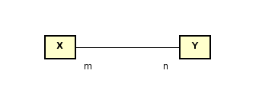
- Meaning:
  - Every X object must be associated with n Y objects.
  - Every Y object must be associated with m X objects.
Example
What do you think about these class diagrams?
(a)
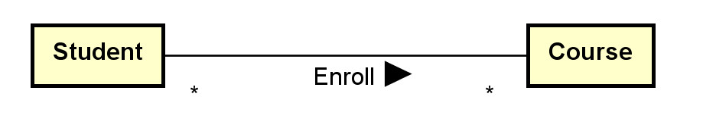
Assumptions made:
- A student may take many courses.
- Not sure whether a student is allowed to take zero course since * (instead of 0..* or 1..* is used).
- A course may have many students enrolled.
- Not sure whether a course has no student enrolled since * (instead of 0..* or 1..* is used).
(b)
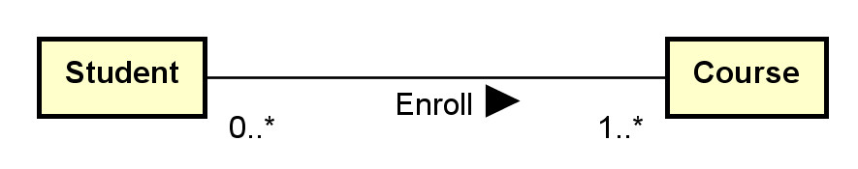
Assumptions made:
- A student must be enrolled in one or more courses (may not be a reasonable assumption).
- A course may have 0 or more students enrolled.
(c)
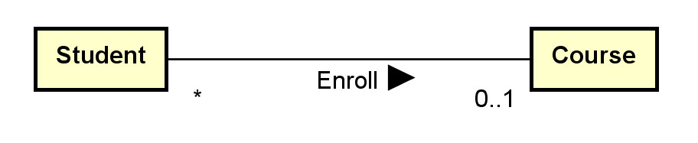
Assumptions made:
- A student can only be enrolled in 0 or 1 course only (sound not reasonable).
- A course may have many students enrolled.
- Not sure whether a course has no student enrolled since * (instead of 0..* or 1..* is used).
Aggregation indicator
- aggregation (hollow diamond) and composition indicator (solid diamond):
- Aggregation models the ‘a-part-of’ relationship (whole-part). E.g., car-wheel.
- Composition is a strong form of aggregation: the part's lifecycle is dependent on the whole's lifecycle; e.g. university-department, building-room.
- They can also be represented by using multiplicity.
Example: Aggregation and Composition
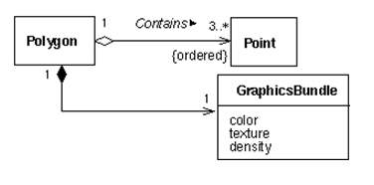
What do you think about this composition and aggregation examples in: http://en.wikipedia.org/wiki/File:Congregationalism?
Ternary Associations
- N-ary associations are represented using a diamond connecting to participating classes.
  - Not so common.
  - May be modeled as a class instead.
- A ternary association involves three participating objects.
An example from a tutorial:
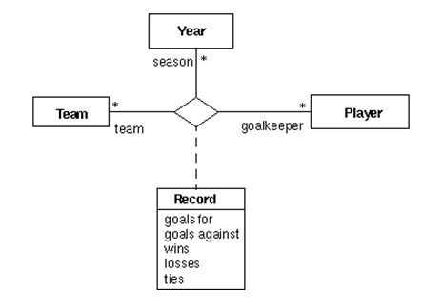
Notes:
- In modeling, a ternary association can reasonably be replaced by promoting it to a class and add three binary associations.
- Don't use n-ary associations where n>=3 unless you are sure.
Generalization and Specialization
- Generalization is represented by a hollow triangle at the superclass.
  - Generalization models the 'a-kind-of’ association.
  - It is mainly used to
    - manage classes with common data members and methods by putting these common members into their superclass.
    - provide inheritance.
    - avoid multiple copies of member definition.
- Some options of generalization include:
  - discriminator (the name of the partition),
  - powertype (a class in which an instance of it is a subclass of the superclass),
  - constraints (overlapping, disjoint, complete, incomplete and user defined constraints).
Example:
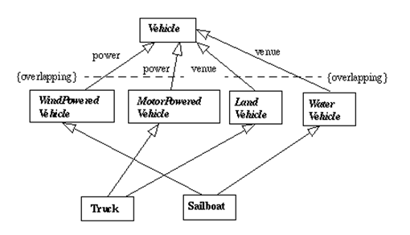
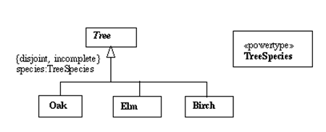
- There are many possible options and extensions.
Constructing class diagrams: some tips
- There are many methodologies and best practice tips to construct effective class diagrams.
- There are many possible modeling options: e.g., classes versus attributes, classes versus associations, multiplicity, etc.
- Need to fully understand the assumptions and implications when making modeling decisions.
- Do not model implementation details in earlier modeling phases.
3. Example: toyu
A reasonable conceptual model of the toyu database in UML:
