CSCI 4333.2
2/18/2026
An example of an association class:

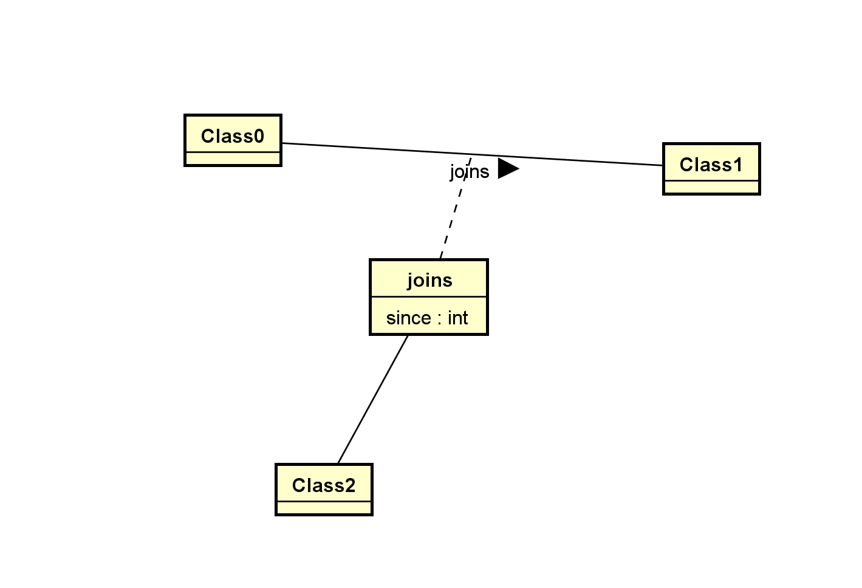
Tuple(Row) Relational Calculus (TRC): s: tuple; variable: tuple (row)
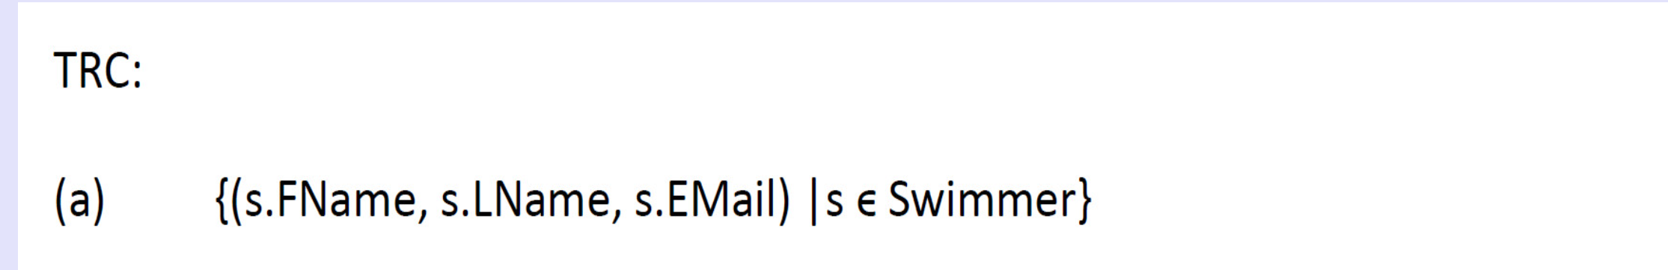
{}: set builder form: define sets.
(): tuple builder form.
SELECT s.FName, s.LName, s.Email; -- s: a row in the table
FROM Swimmer AS s; -- Swimmer: table
-- no alias
SELECT Swimmer.FName, Swimmer.LName, Swimmer.Email -- Swimmer: a tuple/row
FROM Swimmer; -- swimmer: table

The Relational Model
by K. Yue
1. Introduction
1.1 Data Model
- There are many data models used by database systems.
- The data models of database systems define how data is organized, structured, connected, processed, and queried in the databases.
- It is important to recognize the basic data structures used by these models.
- Examples:
  - Relational model: set-theoretic relation/table
{1,2} = {2,1} = {1,1,1,2,2}
Set: unordered, no duplicate elements
  - Excel: table, and to be more exact, a two-dimensional array
Ordered (have indices), allow duplicates:
[1,2,1] <> [1,2] <> [2,1]
  - Object-oriented model: directed graphs (e.g. Neo4J: graphical db)

  - XML: trees with many different types of nodes, plus sets of attributes.
  - Cassandra: columnar or wild column model
  - MongoDB: document model
  - Neo4J: graph model
1.2 The Relational Model: an introduction
- The basic relational data model in layman terms:
  - A database is composed of a collection of tables (relations).
  - A table contains many rows (tuples) and columns (attributes/fields).
  - Each row contains many column values.
  - Every row of a table has the same set of columns.
  - Values of the same column have the same data type.
  - Keys are sets of columns.
  - A candidate key of a table is a minimal unique identifier of a row in the table.
  - A primary key is a selected candidate key (for storing the table).
  - Alternative/secondary keys are candidate keys not selected as the primary key.
  - A foreign key of a relation references a primary key of another relation (known as the parent or referenced table).
More theoretically:
- The (theoretical) relational model is based on the concept of a relation.
- It is a set-theoretic model: the definitions are based on mathematical sets.
- If you are not familar with set theory, read about it. This is a basic, short, good, and good-enough introduction: https://www.ucl.ac.uk/~ucahmto/0005_2021/Ch2.S1.html (note that in the set builder form, the author used ":" to represent "such that". We usually use "|" instead.)
- Note that practical DBMS do not implement the pure relational model.
- In the theoretical relational model:
  - An attribute (column/field) is a name.
  - A domain is a set of values an attribute can take.

    - It is the set of values of the data type of the attribute.
    - The value of an attribute should be atomic (cannot be divided into smaller components with individual meanings):
      - If all attributes of a relation are atomic, the relation is said to be in First Normal Form.
    - Null may or may not be an acceptable value for an attribute. It depends on problem requirements.
  - A relation schema, R, is a set of attributes A₁, A₂,…,A_{n} with their domains D₁, D₂,…, D_{n}.
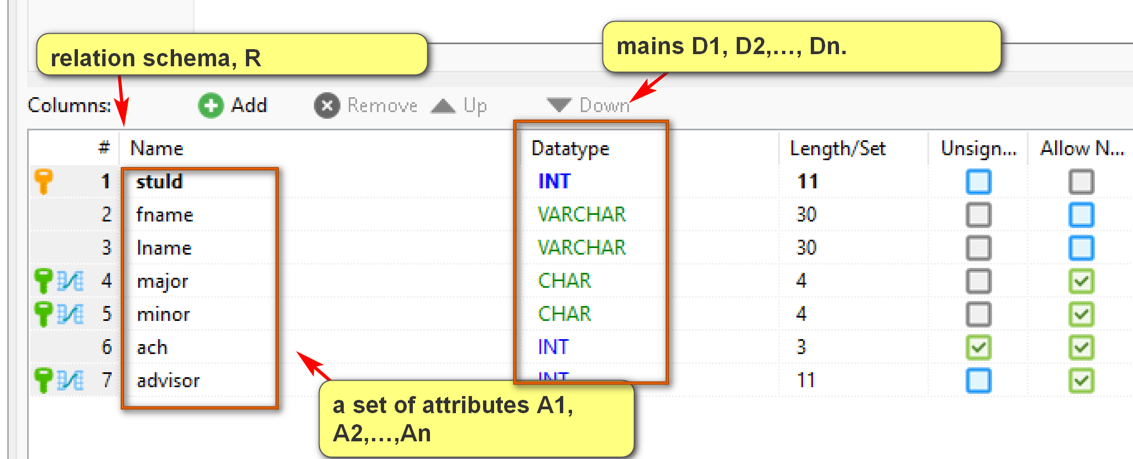

  - A tuple (row) is a set of mapping of a set of attributes to a set of values: A_{i} -> d_{i} where d_{i} ∈ D_{i}, for i = 1 to n (∈: belongs to)
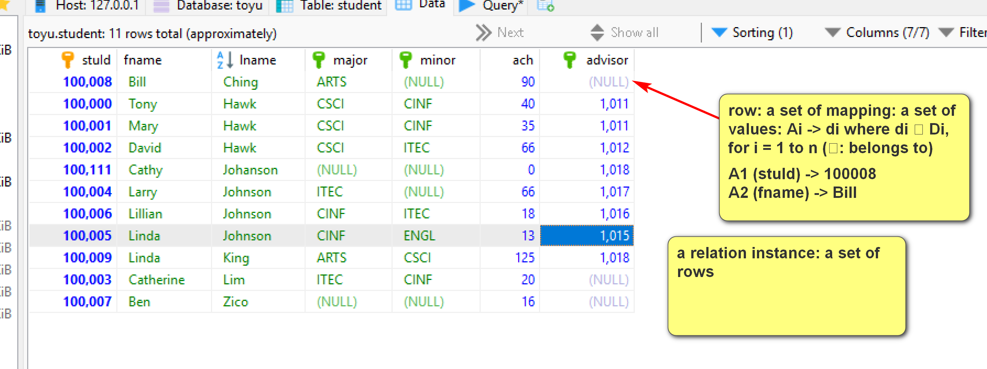
  - A relation (instance) is a set of tuples.
  - The degree (or arity) of a relation is the number of attributes in its schema.
- Some advantages of the relational model and relational DBMS (as compared to other databases): structured data high reliable, high consistent data.
  - Strong mathematical foundation
  - Simple
  - Strong design theory: normalization theory.
  - Strong support of data integrity and consistency
  - Strong support of transactions
  - Strong industrial support and community
  - High popularity
- Some disadvantages of the relational model and relational DBMS:
  - The data model may not match the problem requirements well.
  - Impedance mismatch with object-oriented models.
  - Do not scale well.
- “. In practical, real-world applications, single-instance databases in the tens to hundreds of terabytes (TB) are common, with some reaching over a petabyte using sharding techniques.”
  - Structured data may be too restrictive for specific problems.
1.3 Toyu Example
Toyu: A drastically simplified university
SQL statement: SELECT * FROM class;
Select every column from the table class.
MariaDB [toyu]> SELECT * FROM class;
+---------+----------+----------+------+-------+------+
| classId | courseId | semester | year | facId | room |
+---------+----------+----------+------+-------+------+
| 10000 | 2000 | Fall | 2019 | 1011 | D241 |
| 10001 | 2001 | Fall | 2019 | 1011 | D242 |
| 10002 | 2002 | Fall | 2019 | 1012 | D136 |
| 10003 | 2020 | Fall | 2019 | 1014 | D241 |
| 10004 | 2021 | Fall | 2019 | 1014 | D241 |
| 10005 | 2040 | Fall | 2019 | 1015 | D237 |
| 10006 | 2041 | Fall | 2019 | 1019 | D217 |
| 10007 | 2060 | Fall | 2019 | 1020 | B101 |
| 10008 | 2080 | Fall | 2019 | 1018 | D241 |
| 11000 | 2000 | Spring | 2020 | 1011 | D241 |
| 11001 | 2001 | Spring | 2020 | 1012 | D242 |
| 11002 | 2002 | Spring | 2020 | 1013 | D136 |
| 11003 | 2020 | Spring | 2020 | 1016 | D217 |
| 11004 | 2061 | Spring | 2020 | 1018 | B101 |
+---------+----------+----------+------+-------+------+
14 rows in set (0.005 sec)
A tuple/row: {classId: 10004, courseId: 2021, semester: 'Fall', year: 2019, facId: 1014, room: 'D241'}. Note that it is a set of mappings from attribute names to attribute values.
It can also be represented as:
{classId: 10004, facId: 1014, room: 'D241', semester: 'Fall', year: 2019, courseId: 2021}
or
{10004, 2021, 'Fall', 2019, 1014, 'D241'} if the attribute names are assumed in be in the right order.
or using a more computer science-style notation.
(10004, 2021, 'Fall', 2019, 1014, 'D241')
Identify some examples of the database terms in the class table above as much as possible.
- Some important properties of a relation:
  - There is no duplicate tuple.
    - Because a relation is a set.
    - Consequence: the relational model does not support 'object identity' directly.
  - The relational model is known to be 'value-oriented':
    - A row is a set of attribute values.
    - Two rows with the same values in all attributes are the same row.
    - Cannot store two duplicate rows in a table.
  - The terms tables and relations are not exactly the same. "Table" is a more generic term.
- Tuples within a relation are unordered.
  - Changing the order of displaying the tuples does not change (the meaning of) the relation.
- Attributes within a relation schema are unordered.
  - Changing the order of the attributes within a relation schema does not change the information stored in the relation.
Example:
+---------+----------+----------+------+-------+------+
| classId | courseId | semester | year | facId | room |
+---------+----------+----------+------+-------+------+
| 10000 | 2000 | Fall | 2019 | 1011 | D241 |
| 10001 | 2001 | Fall | 2019 | 1011 | D242 |
| 10002 | 2002 | Fall | 2019 | 1012 | D136 |
| 10003 | 2020 | Fall | 2019 | 1014 | D241 |
| 10004 | 2021 | Fall | 2019 | 1014 | D241 |
| 10005 | 2040 | Fall | 2019 | 1015 | D237 |
| 10006 | 2041 | Fall | 2019 | 1019 | D217 |
| 10007 | 2060 | Fall | 2019 | 1020 | B101 |
| 10008 | 2080 | Fall | 2019 | 1018 | D241 |
| 11000 | 2000 | Spring | 2020 | 1011 | D241 |
| 11001 | 2001 | Spring | 2020 | 1013 | D242 |
| 11002 | 2002 | Spring | 2020 | 1013 | D136 |
| 11003 | 2020 | Spring | 2020 | 1016 | D217 |
| 11004 | 2061 | Spring | 2020 | 1018 | B101 |
+---------+----------+----------+------+-------+------+
and
+---------+------+----------+----------+------+-------+
| classId | year | semester | courseId | room | facId |
+---------+------+----------+----------+------+-------+
| 11004 | 2020 | Spring | 2061 | B101 | 1018 |
| 10007 | 2019 | Fall | 2060 | B101 | 1020 |
| 10002 | 2019 | Fall | 2002 | D136 | 1012 |
| 11002 | 2020 | Spring | 2002 | D136 | 1013 |
| 11003 | 2020 | Spring | 2020 | D217 | 1016 |
| 10006 | 2019 | Fall | 2041 | D217 | 1019 |
| 10005 | 2019 | Fall | 2040 | D237 | 1015 |
| 10000 | 2019 | Fall | 2000 | D241 | 1011 |
| 11000 | 2020 | Spring | 2000 | D241 | 1011 |
| 10003 | 2019 | Fall | 2020 | D241 | 1014 |
| 10004 | 2019 | Fall | 2021 | D241 | 1014 |
| 10008 | 2019 | Fall | 2080 | D241 | 1018 |
| 10001 | 2019 | Fall | 2001 | D242 | 1011 |
| 11001 | 2020 | Spring | 2001 | D242 | 1013 |
+---------+------+----------+----------+------+-------+
store the same information.
The second table can be obtained in SQL by:
SELECT classId, year, semester, courseId, room, facId
FROM class
ORDER BY room, facId;
2. Keys
- A set of attributes K is a candidate key (CK) of a relation R if it minimally identifies a tuple at any time:
  - Uniqueness: No two tuples of R have the same value of K.
  - Minimality: No proper subset of K has the uniqueness property.
- A candidate key is a property of the semantic (meaning) of a relation.
- In other words, being a candidate key is the result of the requirements of an application.
- A relation always has at least one candidate keys. Why?
  - Because a relation instance r is a set of rows, no two rows will have the exact same values.
  - Thus, the relation schema R by itself satisfies the uniqueness property.
  - R or one of its proper subsets will satisfy the minimal property as extraneous attributes are removed.
- A set of attributes may be a candidate key of a relation R but not a candidate key of another relation S.
- For any relation instance, the candidate key of a tuple must have an unique value.
- A primary key is a selected candidate key for a relation in the DBMS. It is used for practical purpose (of how the relation is stored physically) and does not have a special meaning in the theory of the relational model.
- Some criteria for selecting a primary key:
  - Stable and relative immutable.
  - Simple: contains one attribute
  - Concise: short storage space and faster comparison.
- An alternate/secondary key is a candidate key that is not the primary key.
- Questions people may ask:
  - What is the key of the database toyu? Wrong question.
  - What is the primary key of the database toyu? more precise but still wrong question.
  - What is the key of the school table of the toyu database? good question but a bit ambiguous. Answer: schoolCode.
  - What is the primary key of the school table of the toyu database? schoolCode.
  - What are the candidate keys of the school table of the toyu database? [1] schoolCode, [2] schoolName.
  - What are the secondary/alternative keys of the school table of the toyu database? schoolName.
Example:
Consider:
MariaDB [toyu]> SELECT * FROM faculty;
+-------+----------+----------+----------+---------------------+
| facId | fname | lname | deptCode | rank |
+-------+----------+----------+----------+---------------------+
| 1011 | Paul | Smith | CSCI | Professor |
| 1012 | Mary | Tran | CSCI | Associate Professor |
| 1013 | David | Love | CSCI | NULL |
| 1014 | Sharon | Mannes | CSCI | Assistant Professor |
| 1015 | Daniel | Kim | CINF | Professor |
| 1016 | Andrew | Byre | CINF | Associate Professor |
| 1017 | Deborah | Gump | ITEC | Professor |
| 1018 | Art | Allister | ARTS | Assistant Professor |
| 1019 | Benjamin | Yu | ITEC | Lecturer |
| 1020 | Katrina | Bajaj | ENGL | Lecturer |
| 1021 | Jorginlo | Neymar | ACCT | Assistant Professor |
+-------+----------+----------+----------+---------------------+
11 rows in set (0.001 sec)
MariaDB [toyu]> SELECT * FROM department;
+----------+------------------------------+------------+----------+
| deptCode | deptName | schoolCode | numStaff |
+----------+------------------------------+------------+----------+
| ACCT | Accounting | BUS | 10 |
| ARTS | Arts | HSH | 5 |
| CINF | Computer Information Systems | CSE | 5 |
| CSCI | Computer Science | CSE | 12 |
| ENGL | English | HSH | 12 |
| ITEC | Information Technology | CSE | 4 |
| MATH | Mathematics | CSE | 7 |
+----------+------------------------------+------------+----------+
7 rows in set (0.001 sec)
- deptCode is a candidate key of the relation department. Assumptions made:
  - Each tuple in the department relation represents an unique department.
  - Each department has an unique code. No two departments can have the same code.
- deptName is also a candidate key of the relation department. Assumptions made:
  - Each tuple in the department relation represents an unique department.
  - Each department has an unique name. No two departments can have the same name.
- deptCode is selected as the primary key of the relation department since it is concise and more stable.
- deptCode is not a candidate key of the relation faculty. Assumptions made:
  - Each tuple in the faculty relation represents a faculty member.
  - Each faculty serves only one department.
  - A department may have many faculty members.
Consider the tables student and enroll:
- stuid is a candidate key of the relation student. Assumptions made:
  - Each tuple in the student relation represents an unique student.
  - Each student has an unique student id, or no two students can have the same stuid.
- stuid is not a candidate key of the relation enroll. Assumptions made:
  - Each tuple in the Enroll relation represents the enrollment of a student in a class, ending up with a grade.
  - A student can take many classes.
  - A class can have many students.
- Note again that a candidate key is a property of a relation.
2.1 More about keys:
- A key is simple if it has only one attribute.
- A key is a composite key if it has more than one attributes.
- A key is a compound key if it is a composite and each attribute in the key is a foreign key.
- Every relation has at least one candidate key.
- A foreign key of a relation is a set of attributes that is a candidate key in another relation. The other relation is sometimes called the parent (or referenced) table of the foreign key.
- A foreign key may or may not have null value. It depends on the problem requirements.
- For uses in normalization theory:
  - An attribute that appears in one or more candidate keys is a prime attribute (or key attribute).
  - An attribute that does not appears in any candidate key is a non-prime (non-key) attribute.
  - A superkey of a relation is a set of attributes that uniquely identify a row (uniqueness). It may not be minimal. (A Superkey may have extraneous attributes not needed for unique identification.)
Consider the example above. The attribute deptCode is a foreign key in the relation faculty, referencing department(deptCode)
- A deptCode in the department relation must be referring to a department in the database, identified by deptCode in the relation department (referential integrity).
- In relational DB, rows (data) from different tables are linked together using foreign keys.
- A foreign key of a child table links to a primary key of the parent table.
Likewise, stuid is a foreign key in the relation Enroll: stuid references student(stuid)
Note that the student table has three foreign keys.
Example: In the department table in toyu:
Department(deptCode, deptName, schoolCode, numStaff)
Candidate keys:
- deptCode (i.e. {deptCode})
- deptName
Primary key: deptCode
Alternate key:
- deptName
Prime attributes:
- deptCode
- deptName
Non-prime attributes:
- schoolCode
- numStaff
Superkeys:
- deptCode
- deptName
- deptCode, deptName (i.e. {deptCode, deptName})
- deptCode, schoolCode
- deptCode, numStaff
- deptCode, deptName, SchoolCode
- deptCode, deptName, numStaff
- deptCode, SchoolCode, numStaff
- deptCode, deptName, SchoolCode, numStaff
- deptName, SchoolCode
- deptName, numStaff
- deptName, SchoolCode, numStaff
Example:
Study the list of all foreign keys in toyu:
- The INNER JOIN operation can be used to join tables through foreign keys.
Example:
-- INNER JOIN
SELECT * FROM faculty;
SELECT * FROM department;
SELECT s.fname, s.lname, s.advisor, f.`rank`
FROM student AS s INNER JOIN faculty AS f
ON (s.advisor = f.facId);
Result:
MariaDB [toyu]> SELECT * FROM faculty;
+-------+----------+----------+----------+---------------------+
| facId | fname | lname | deptCode | rank |
+-------+----------+----------+----------+---------------------+
| 1011 | Paul | Smith | CSCI | Professor |
| 1012 | Mary | Tran | CSCI | Associate Professor |
| 1013 | David | Love | CSCI | NULL |
| 1014 | Sharon | Mannes | CSCI | Assistant Professor |
| 1015 | Daniel | Kim | CINF | Professor |
| 1016 | Andrew | Byre | CINF | Associate Professor |
| 1017 | Deborah | Gump | ITEC | Professor |
| 1018 | Art | Allister | ARTS | Assistant Professor |
| 1019 | Benjamin | Yu | ITEC | Lecturer |
| 1020 | Katrina | Bajaj | ENGL | Lecturer |
| 1021 | Jorginlo | Neymar | ACCT | Assistant Professor |
+-------+----------+----------+----------+---------------------+
11 rows in set (0.000 sec)
MariaDB [toyu]> SELECT * FROM department;
+----------+------------------------------+------------+----------+
| deptCode | deptName | schoolCode | numStaff |
+----------+------------------------------+------------+----------+
| ACCT | Accounting | BUS | 10 |
| ARTS | Arts | HSH | 5 |
| CINF | Computer Information Systems | CSE | 5 |
| CSCI | Computer Science | CSE | 12 |
| ENGL | English | HSH | 12 |
| ITEC | Information Technology | CSE | 4 |
| MATH | Mathematics | CSE | 7 |
+----------+------------------------------+------------+----------+
7 rows in set (0.000 sec)
MariaDB [toyu]> SELECT s.fname, s.lname, s.advisor, f.`rank`
-> FROM student AS s INNER JOIN faculty AS f
-> ON (s.advisor = f.facId);
+---------+----------+---------+---------------------+
| fname | lname | advisor | rank |
+---------+----------+---------+---------------------+
| Tony | Hawk | 1011 | Professor |
| Mary | Hawk | 1011 | Professor |
| David | Hawk | 1012 | Associate Professor |
| Larry | Johnson | 1017 | Professor |
| Linda | Johnson | 1015 | Professor |
| Lillian | Johnson | 1016 | Associate Professor |
| Linda | King | 1018 | Assistant Professor |
| Cathy | Johanson | 1018 | Assistant Professor |
+---------+----------+---------+---------------------+
8 rows in set (0.000 sec)
Classroom Exercise:
(1) Give a realistic example of a relation with two candidate keys. State the assumptions you have made.
(2) A relation R has an arity of 4. What are the possible minimum and maximum number of superkeys of R? What are the possible minimum and maximum number of candidate keys of R?
What about the general case?

Null Values in SQL DB
by K. Yue
1. Null values
- Generally used for representing missing information.
- SQL DBMS provide a method to test whether a value is null or not (IS NULL and IS NOT NULL).
Example:
-- students with no advisor
SELECT s.*
FROM student AS s
WHERE s.advisor IS NULL; -- unary function: 1 argument/operand/parameter
-- Show all students with a declared minor.
SELECT DISTINCT s.*
FROM student AS s
WHERE s.minor IS NOT NULL;
-- Show enrollment without a n_alerts value.
SELECT e.*
FROM enroll AS e
WHERE e.n_alerts IS NULL;
Result:
MariaDB [toyu]> -- students with no advisor
MariaDB [toyu]> SELECT s.*
-> FROM student AS s
-> WHERE s.advisor IS NULL;
+--------+-----------+-------+-------+-------+------+---------+
| stuId | fname | lname | major | minor | ach | advisor |
+--------+-----------+-------+-------+-------+------+---------+
| 100003 | Catherine | Lim | ITEC | CINF | 20 | NULL |
| 100007 | Ben | Zico | NULL | NULL | 16 | NULL |
| 100008 | Bill | Ching | ARTS | NULL | 90 | NULL |
+--------+-----------+-------+-------+-------+------+---------+
3 rows in set (0.000 sec)
MariaDB [toyu]>
MariaDB [toyu]> -- Show all students with a declared minor.
MariaDB [toyu]> SELECT DISTINCT s.*
-> FROM student AS s
-> WHERE s.minor IS NOT NULL;
+--------+-----------+---------+-------+-------+------+---------+
| stuId | fname | lname | major | minor | ach | advisor |
+--------+-----------+---------+-------+-------+------+---------+
| 100000 | Tony | Hawk | CSCI | CINF | 40 | 1011 |
| 100001 | Mary | Hawk | CSCI | CINF | 35 | 1011 |
| 100002 | David | Hawk | CSCI | ITEC | 66 | 1012 |
| 100003 | Catherine | Lim | ITEC | CINF | 20 | NULL |
| 100005 | Linda | Johnson | CINF | ENGL | 13 | 1015 |
| 100006 | Lillian | Johnson | CINF | ITEC | 18 | 1016 |
| 100009 | Linda | King | ARTS | CSCI | 125 | 1018 |
+--------+-----------+---------+-------+-------+------+---------+
7 rows in set (0.000 sec)
MariaDB [toyu]>
MariaDB [toyu]> -- Show enrollment without a n_alerts value.
MariaDB [toyu]> SELECT e.*
-> FROM enroll AS e
-> WHERE e.n_alerts IS NULL;
+--------+---------+-------+----------+
| stuId | classId | grade | n_alerts |
+--------+---------+-------+----------+
| 100001 | 10000 | NULL | NULL |
| 100005 | 10003 | NULL | NULL |
| 100004 | 10004 | B+ | NULL |
| 100006 | 10004 | C+ | NULL |
| 100006 | 10005 | A | NULL |
| 100005 | 10006 | B+ | NULL |
+--------+---------+-------+----------+
6 rows in set (0.000 sec)
2. Null and Boolean Expressions
- MySQL does not have a Boolean data type. A Boolean value is converted to TINYINT: 0 as FALSE, otherwise TRUE.
- Java: 2-valued logic: F or T
- SQL: T, F, and null
- If a Boolean value is expected, null is implicitly type converted to FALSE.
- However, NULL is a special value different with 0 or empty string.
- Comparing null to other values return false.
Example:
-- 1. Boolean values are TINYINT. FALSE is 0.
SELECT FALSE,
TRUE;
SELECT *
FROM student
WHERE 0;
SELECT *
FROM student
WHERE 1;
SELECT *
FROM student
WHERE 2697;
SELECT *
FROM student
WHERE '0';
SELECT *
FROM student
WHERE '145';
-- warning: '' cannot be converted to a number.
-- "Warning 1292 Truncated incorrect DOUBLE value: ''"
SELECT *
FROM student
WHERE '';
-- warning: '' cannot be converted to a number.
-- "Warning 1292 Truncated incorrect DOUBLE value: ''"
SELECT *
FROM student
WHERE 'Hello world';
SELECT *
FROM student
WHERE 1.49;
Result:
MariaDB [toyu]> SELECT FALSE,
-> TRUE;
+-------+------+
| FALSE | TRUE |
+-------+------+
| 0 | 1 |
+-------+------+
1 row in set (0.001 sec)

-- A Boolean value is converted to TINYINT:
MariaDB [toyu]>
MariaDB [toyu]> SELECT *
-> FROM student
-> WHERE 0;
Empty set (0.000 sec)
MariaDB [toyu]>
MariaDB [toyu]> SELECT * -- [3] prepare the column
-> FROM student – [1] create an intermediate contains all data
-> WHERE 1; -- [2] prepare rows: keep those that satisfy the condition.
+--------+-----------+----------+-------+-------+------+---------+
| stuId | fname | lname | major | minor | ach | advisor |
+--------+-----------+----------+-------+-------+------+---------+
| 100000 | Tony | Hawk | CSCI | CINF | 40 | 1011 |
| 100001 | Mary | Hawk | CSCI | CINF | 35 | 1011 |
| 100002 | David | Hawk | CSCI | ITEC | 66 | 1012 |
| 100003 | Catherine | Lim | ITEC | CINF | 20 | NULL |
| 100004 | Larry | Johnson | ITEC | NULL | 66 | 1017 |
| 100005 | Linda | Johnson | CINF | ENGL | 13 | 1015 |
| 100006 | Lillian | Johnson | CINF | ITEC | 18 | 1016 |
| 100007 | Ben | Zico | NULL | NULL | 16 | NULL |
| 100008 | Bill | Ching | ARTS | NULL | 90 | NULL |
| 100009 | Linda | King | ARTS | CSCI | 125 | 1018 |
| 100111 | Cathy | Johanson | NULL | NULL | 0 | 1018 |
+--------+-----------+----------+-------+-------+------+---------+
11 rows in set (0.000 sec)
MariaDB [toyu]>
MariaDB [toyu]> SELECT *
-> FROM student
-> WHERE 2697;
+--------+-----------+----------+-------+-------+------+---------+
| stuId | fname | lname | major | minor | ach | advisor |
+--------+-----------+----------+-------+-------+------+---------+
| 100000 | Tony | Hawk | CSCI | CINF | 40 | 1011 |
| 100001 | Mary | Hawk | CSCI | CINF | 35 | 1011 |
| 100002 | David | Hawk | CSCI | ITEC | 66 | 1012 |
| 100003 | Catherine | Lim | ITEC | CINF | 20 | NULL |
| 100004 | Larry | Johnson | ITEC | NULL | 66 | 1017 |
| 100005 | Linda | Johnson | CINF | ENGL | 13 | 1015 |
| 100006 | Lillian | Johnson | CINF | ITEC | 18 | 1016 |
| 100007 | Ben | Zico | NULL | NULL | 16 | NULL |
| 100008 | Bill | Ching | ARTS | NULL | 90 | NULL |
| 100009 | Linda | King | ARTS | CSCI | 125 | 1018 |
| 100111 | Cathy | Johanson | NULL | NULL | 0 | 1018 |
+--------+-----------+----------+-------+-------+------+---------+
11 rows in set (0.001 sec)
MariaDB [toyu]>
MariaDB [toyu]> SELECT *
-> FROM student
-> WHERE '0';
-- implicit type conversion: ‘0’ -> 0 interpreted as FALSE.
Empty set (0.000 sec)
MariaDB [toyu]>
MariaDB [toyu]> SELECT *
-> FROM student
-> WHERE '145';
+--------+-----------+----------+-------+-------+------+---------+
| stuId | fname | lname | major | minor | ach | advisor |
+--------+-----------+----------+-------+-------+------+---------+
| 100000 | Tony | Hawk | CSCI | CINF | 40 | 1011 |
| 100001 | Mary | Hawk | CSCI | CINF | 35 | 1011 |
| 100002 | David | Hawk | CSCI | ITEC | 66 | 1012 |
| 100003 | Catherine | Lim | ITEC | CINF | 20 | NULL |
| 100004 | Larry | Johnson | ITEC | NULL | 66 | 1017 |
| 100005 | Linda | Johnson | CINF | ENGL | 13 | 1015 |
| 100006 | Lillian | Johnson | CINF | ITEC | 18 | 1016 |
| 100007 | Ben | Zico | NULL | NULL | 16 | NULL |
| 100008 | Bill | Ching | ARTS | NULL | 90 | NULL |
| 100009 | Linda | King | ARTS | CSCI | 125 | 1018 |
| 100111 | Cathy | Johanson | NULL | NULL | 0 | 1018 |
+--------+-----------+----------+-------+-------+------+---------+
11 rows in set (0.001 sec)
MariaDB [toyu]>
MariaDB [toyu]> -- warning: '' cannot be converted to a number.
MariaDB [toyu]> -- "Warning 1292 Truncated incorrect DOUBLE value: ''"
MariaDB [toyu]> SELECT *
-> FROM student
-> WHERE '';
Empty set, 1 warning (0.000 sec)
MariaDB [toyu]>
MariaDB [toyu]> -- warning: '' cannot be converted to a number.
MariaDB [toyu]> -- "Warning 1292 Truncated incorrect DOUBLE value: ''"
MariaDB [toyu]> SELECT *
-> FROM student
-> WHERE 'Hello world';
Empty set, 1 warning (0.000 sec)
MariaDB [toyu]>
MariaDB [toyu]> SELECT *
-> FROM student
-> WHERE 1.49;
+--------+-----------+----------+-------+-------+------+---------+
| stuId | fname | lname | major | minor | ach | advisor |
+--------+-----------+----------+-------+-------+------+---------+
| 100000 | Tony | Hawk | CSCI | CINF | 40 | 1011 |
| 100001 | Mary | Hawk | CSCI | CINF | 35 | 1011 |
| 100002 | David | Hawk | CSCI | ITEC | 66 | 1012 |
| 100003 | Catherine | Lim | ITEC | CINF | 20 | NULL |
| 100004 | Larry | Johnson | ITEC | NULL | 66 | 1017 |
| 100005 | Linda | Johnson | CINF | ENGL | 13 | 1015 |
| 100006 | Lillian | Johnson | CINF | ITEC | 18 | 1016 |
| 100007 | Ben | Zico | NULL | NULL | 16 | NULL |
| 100008 | Bill | Ching | ARTS | NULL | 90 | NULL |
| 100009 | Linda | King | ARTS | CSCI | 125 | 1018 |
| 100111 | Cathy | Johanson | NULL | NULL | 0 | 1018 |
+--------+-----------+----------+-------+-------+------+---------+
11 rows in set (0.000 sec)
Example:
-- 2. If a Boolean value is expected, null is implicitly type-converted to FALSE.
SELECT e.*
FROM enroll AS e
WHERE e.n_alerts;
Result:
MariaDB [toyu]> SELECT e.*
-> FROM enroll AS e
-> WHERE e.n_alerts;
+--------+---------+-------+----------+
| stuId | classId | grade | n_alerts |
+--------+---------+-------+----------+
| 100002 | 10000 | B- | 3 |
| 100000 | 10001 | A | 2 |
| 100000 | 10002 | B+ | 1 |
| 100002 | 10002 | B+ | 2 |
| 100002 | 10003 | D | 4 |
| 100000 | 10004 | A- | 1 |
| 100007 | 10007 | F | 4 |
| 100000 | 11001 | D | 4 |
+--------+---------+-------+----------+
8 rows in set (0.000 sec)
Example:
-- 3. null is a special value different with 0 or empty string.
SELECT FALSE IS NULL,
TRUE IS NULL,
0 IS NULL,
1 IS NULL,
"" IS NULL,
"Hey" IS NULL,
NULL IS NULL,
NULL IS NOT NULL;
Result:
MariaDB [toyu]> SELECT FALSE IS NULL,
-> TRUE IS NULL,
-> 0 IS NULL,
-> 1 IS NULL,
-> "" IS NULL,
-> "Hey" IS NULL,
-> NULL IS NULL,
-> NULL IS NOT NULL;
+---------------+--------------+-----------+-----------+------------+---------------+--------------+------------------+
| FALSE IS NULL | TRUE IS NULL | 0 IS NULL | 1 IS NULL | "" IS NULL | "Hey" IS NULL | NULL IS NULL | NULL IS NOT NULL |
+---------------+--------------+-----------+-----------+------------+---------------+--------------+------------------+
| 0 | 0 | 0 | 0 | 0 | 0 | 1 | 0 |
+---------------+--------------+-----------+-----------+------------+---------------+--------------+------------------+
1 row in set (0.000 sec)
Example:
-- 4. Comparing null to other values return null, which is converted to false.
SELECT NULL > 3,
NULL <= 3,
5 >= NULL,
5 < NULL,
NULL > NULL,
NULL <= NULL;
SELECT *
FROM student
WHERE NULL > 3;
-- Comparisons must be mindful of null.
SELECT e.*
FROM enroll AS e
WHERE e.n_alerts >= 2;

If e.n_alerts is null -> (e.n_alerts >= 2) results: null -> false
SELECT e.*
FROM enroll AS e
WHERE e.n_alerts < 2;
SELECT e.*
FROM enroll AS e;
-- Q. List all enrollment records without 2 or more n_alerts.
-- Naive solution
SELECT e.*
FROM enroll AS e
WHERE e.n_alerts < 2;
-- Q. List all enrollment records without 2 or more n_alerts.
-- More likely solution
SELECT e.*
FROM enroll AS e
WHERE e.n_alerts IS NULL
OR e.n_alerts < 2;
-- Q. List all enrollment records without a value in n_alerts.
-- incorrect answer.
SELECT e.*
FROM enroll AS e
WHERE e.n_alerts <> NULL;
-- Q. List all enrollment records without a value in n_alerts.
-- correct answer.
SELECT e.*
FROM enroll AS e
WHERE e.n_alerts IS NOT NULL;
Result:
MariaDB [toyu]> -- 4. Comparing null to other values return null, which is converted to false.
MariaDB [toyu]> SELECT NULL > 3,
-> NULL <= 3,
-> 5 >= NULL,
-> 5 < NULL,
-> NULL > NULL,
-> NULL <= NULL;
+----------+-----------+-----------+----------+-------------+--------------+
| NULL > 3 | NULL <= 3 | 5 >= NULL | 5 < NULL | NULL > NULL | NULL <= NULL |
+----------+-----------+-----------+----------+-------------+--------------+
| NULL | NULL | NULL | NULL | NULL | NULL |
+----------+-----------+-----------+----------+-------------+--------------+
1 row in set (0.000 sec)
MariaDB [toyu]>
MariaDB [toyu]> SELECT *
-> FROM student
-> WHERE NULL > 3;
Empty set (0.000 sec)
MariaDB [toyu]>
MariaDB [toyu]> -- Comparisons must be mindful of null.
MariaDB [toyu]> SELECT e.*
-> FROM enroll AS e
-> WHERE e.n_alerts >= 2;
+--------+---------+-------+----------+
| stuId | classId | grade | n_alerts |
+--------+---------+-------+----------+
| 100002 | 10000 | B- | 3 |
| 100000 | 10001 | A | 2 |
| 100002 | 10002 | B+ | 2 |
| 100002 | 10003 | D | 4 |
| 100007 | 10007 | F | 4 |
| 100000 | 11001 | D | 4 |
+--------+---------+-------+----------+
6 rows in set (0.000 sec)
MariaDB [toyu]>
MariaDB [toyu]> SELECT e.*
-> FROM enroll AS e
-> WHERE e.n_alerts < 2;
+--------+---------+-------+----------+
| stuId | classId | grade | n_alerts |
+--------+---------+-------+----------+
| 100000 | 10000 | A | 0 |
| 100001 | 10001 | A- | 0 |
| 100000 | 10002 | B+ | 1 |
| 100000 | 10003 | C | 0 |
| 100004 | 10003 | A | 0 |
| 100000 | 10004 | A- | 1 |
| 100005 | 10004 | A- | 0 |
| 100005 | 10005 | A- | 0 |
| 100008 | 10007 | C- | 0 |
| 100007 | 10008 | A- | 0 |
+--------+---------+-------+----------+
10 rows in set (0.000 sec)
MariaDB [toyu]>
MariaDB [toyu]> SELECT e.*
-> FROM enroll AS e;
+--------+---------+-------+----------+
| stuId | classId | grade | n_alerts |
+--------+---------+-------+----------+
| 100000 | 10000 | A | 0 |
| 100001 | 10000 | NULL | NULL |
| 100002 | 10000 | B- | 3 |
| 100000 | 10001 | A | 2 |
| 100001 | 10001 | A- | 0 |
| 100000 | 10002 | B+ | 1 |
| 100002 | 10002 | B+ | 2 |
| 100000 | 10003 | C | 0 |
| 100002 | 10003 | D | 4 |
| 100004 | 10003 | A | 0 |
| 100005 | 10003 | NULL | NULL |
| 100000 | 10004 | A- | 1 |
| 100004 | 10004 | B+ | NULL |
| 100005 | 10004 | A- | 0 |
| 100006 | 10004 | C+ | NULL |
| 100005 | 10005 | A- | 0 |
| 100006 | 10005 | A | NULL |
| 100005 | 10006 | B+ | NULL |
| 100007 | 10007 | F | 4 |
| 100008 | 10007 | C- | 0 |
| 100007 | 10008 | A- | 0 |
| 100000 | 11001 | D | 4 |
+--------+---------+-------+----------+
22 rows in set (0.000 sec)
MariaDB [toyu]>
MariaDB [toyu]> -- Q. List all enrollment records without 2 or more n_alerts.
MariaDB [toyu]> -- Naive solution
MariaDB [toyu]> SELECT e.*
-> FROM enroll AS e
-> WHERE e.n_alerts < 2;
+--------+---------+-------+----------+
| stuId | classId | grade | n_alerts |
+--------+---------+-------+----------+
| 100000 | 10000 | A | 0 |
| 100001 | 10001 | A- | 0 |
| 100000 | 10002 | B+ | 1 |
| 100000 | 10003 | C | 0 |
| 100004 | 10003 | A | 0 |
| 100000 | 10004 | A- | 1 |
| 100005 | 10004 | A- | 0 |
| 100005 | 10005 | A- | 0 |
| 100008 | 10007 | C- | 0 |
| 100007 | 10008 | A- | 0 |
+--------+---------+-------+----------+
10 rows in set (0.000 sec)
MariaDB [toyu]>
MariaDB [toyu]> -- Q. List all enrollment records without 2 or more n_alerts.
MariaDB [toyu]> -- More likely solution
MariaDB [toyu]> SELECT e.*
-> FROM enroll AS e
-> WHERE e.n_alerts IS NULL
-> OR e.n_alerts < 2;
+--------+---------+-------+----------+
| stuId | classId | grade | n_alerts |
+--------+---------+-------+----------+
| 100000 | 10000 | A | 0 |
| 100001 | 10000 | NULL | NULL |
| 100001 | 10001 | A- | 0 |
| 100000 | 10002 | B+ | 1 |
| 100000 | 10003 | C | 0 |
| 100004 | 10003 | A | 0 |
| 100005 | 10003 | NULL | NULL |
| 100000 | 10004 | A- | 1 |
| 100004 | 10004 | B+ | NULL |
| 100005 | 10004 | A- | 0 |
| 100006 | 10004 | C+ | NULL |
| 100005 | 10005 | A- | 0 |
| 100006 | 10005 | A | NULL |
| 100005 | 10006 | B+ | NULL |
| 100008 | 10007 | C- | 0 |
| 100007 | 10008 | A- | 0 |
+--------+---------+-------+----------+
16 rows in set (0.000 sec) MariaDB [toyu]> -- Q. List all enrollment records without a value in n_alerts.
MariaDB [toyu]> -- incorrect answer.
MariaDB [toyu]> SELECT e.*
-> FROM enroll AS e
-> WHERE e.n_alerts <> NULL;
Empty set (0.000 sec)
MariaDB [toyu]>
MariaDB [toyu]> -- Q. List all enrollment records without a value in n_alerts.
MariaDB [toyu]> -- correct answer.
MariaDB [toyu]> SELECT e.*
-> FROM enroll AS e
-> WHERE e.n_alerts IS NOT NULL;
+--------+---------+-------+----------+
| stuId | classId | grade | n_alerts |
+--------+---------+-------+----------+
| 100000 | 10000 | A | 0 |
| 100002 | 10000 | B- | 3 |
| 100000 | 10001 | A | 2 |
| 100001 | 10001 | A- | 0 |
| 100000 | 10002 | B+ | 1 |
| 100002 | 10002 | B+ | 2 |
| 100000 | 10003 | C | 0 |
| 100002 | 10003 | D | 4 |
| 100004 | 10003 | A | 0 |
| 100000 | 10004 | A- | 1 |
| 100005 | 10004 | A- | 0 |
| 100005 | 10005 | A- | 0 |
| 100007 | 10007 | F | 4 |
| 100008 | 10007 | C- | 0 |
| 100007 | 10008 | A- | 0 |
| 100000 | 11001 | D | 4 |
+--------+---------+-------+----------+
16 rows in set (0.000 sec)
3. Interpretation of null values
- Three possible interpretations of NULL:
  - Not applicable.
  - Missing value.
  - No information at all.
Example:
Consider the attribute SpouseName. A Null value may mean:
- not applicable: the person is not married.
- missing information: the person is married but we do not have the name of the spouse.
- no information at all: we do not know whether the person is married or not.
How do we distinguish between the three meanings of the null value in this case?
By using an extra attribute, such as MaritalStatus.
... | SpouseName | MaritalStatus | ...
 | Null | Married
 | Null | Not married
 | Null | Null

