CSCI 4333.2
2/16/2026
(annotation)
Transforming UML Class Diagrams to Relational Models
by K. Yue
1. Transforming OO Model to the Relational Model
- Once a conceptual OO data model is constructed, it needs to be mapped for implementation in the selected logical database model. See IntroDataModeling.html.
- If a relational DB is used, the mapping will be from OO (classes, attributes, associations, etc.) to relational schema (relations, attributes, keys, etc.)
- Note that the relational model and the OO model are very different, even though diagrams representing the two models look similar (there are only a finite number of common suitable shapes).
- Computer-Aided Software Engineering (CASE) tools or DB modeling tools may provide varying degrees of facilities for automatic generating relational schema and corresponding SQL statements.
- However, it is important to understand the mechanism that a tool uses to generate the relational schema and make adjustment if needed.
1.1 Model Transformation
The problem is: Source Model --> Target Model.
- Source Model: UML
  - Basic/primary/elmentary elements:
    - Class
    - Attribute: can be multi-valued.
    - Association
Example:
Multi-valued attributes: consider the class Member with the following attributes:
- Member_Id: <<PK>>
- Screen_Name <<unique>>
- Hobbies[0..*]
- Medals[0..*]
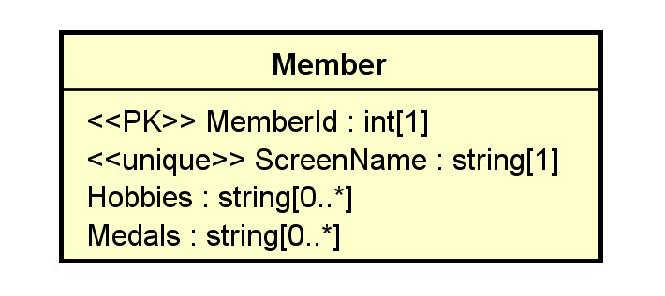

  - Secondary elements:
    - Object
    - Multiplicity
    - Data type
    - Default value
    - Constraint
    - Stereotype for RDB extensions: e.g., candidate keys, primary keys, unique, derived, nullability, etc.
    - ...
- Target Model: Relational Model
  - Basic elements:
    - Relation/table
    - Attribute (column/field): It should be single-valued (atomic: cannot be broken into smaller units of individual meaning). Otherwise, first normal form (1NF) is not satisfied.
  - Secondary elements:
    - Row (tuple)
    - Data type
    - Nullability
    - Constraint
    - Candidate key
    - Primary key
    - Foreign key
    - Index
    - ...
- There are only two basic elements in the targeted model to consider. Data in the relational model can be stored only in two ways:
  - relation:
    - more flexible,
    - can hold attributes to store a collection of logically related data
    - more complex.
  - attribute:
    - should be single-valued (if good design, i.e., the first normal form, is to be assured.)
    - Simple and may have better performance.
    - Thus, if attributes are sufficient in model transformation, they are preferred.
- Different RDBMS provide different features.
    - Thus, the targeted RDB model is not universal.
    - It is necessary to define vendor-specific transformation rules.
2. Transformation Rules
- We present a set of mapping rules below. It is not meant to be complete or universal.
- Examples of comparable transformation rules:
  - A relative simple one: http://web.fe.up.pt/~ssn/2010/lbaw/slides/lbaw-uml2rel.eng.pdf a
  - A more elaborated one based on agile methodology: http://www.agiledata.org/essays/mappingObjects.html.
- Do not mechanically follow these rules. Instead, understand the rationale behind the rules and adapt.
- All OO model details should be implemented in the targeted model in some ways.
  - database level: preferred.
  - middle layer level
  - application level
2.1 Classes
C1. A class C is mapped or transformed to a relation RC.
- Relations may later be merged and/or reorganized in design refinement and performance tuning.
- The relation may use the same name as the class.
- As a result, all infomration of an object of class C is stored as a row in RC.
Rationale:
- A class is a logical unit for encapsulating related data and a relation has the same property.
Toyu:
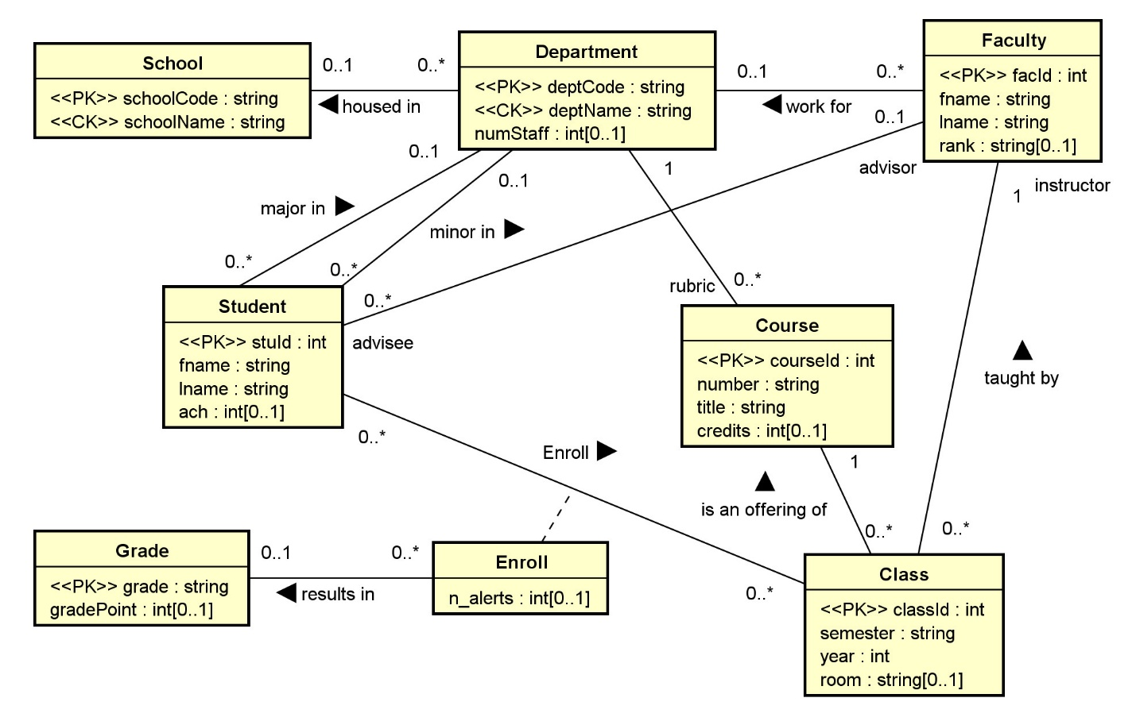
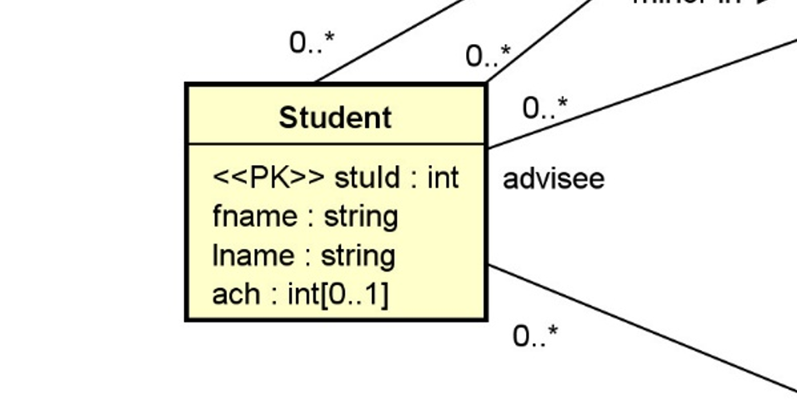:
Fname: string[1..1]
Default multiplicity: 1..1 (simplification)
every toyu UML class -> table (e.g. student, department, enoll, etc.)
2.2 Attributes
Basic:
ATT1. Single-Valued Attributes. Map all single-valued attributes (with simple data types) of a class C as attributes of RC, the relation for the class C.

Toyu: all attributes are single value in the UML model -> single value attributes in the table.
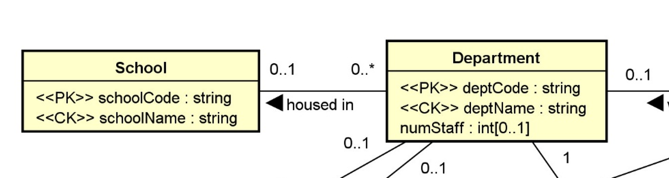
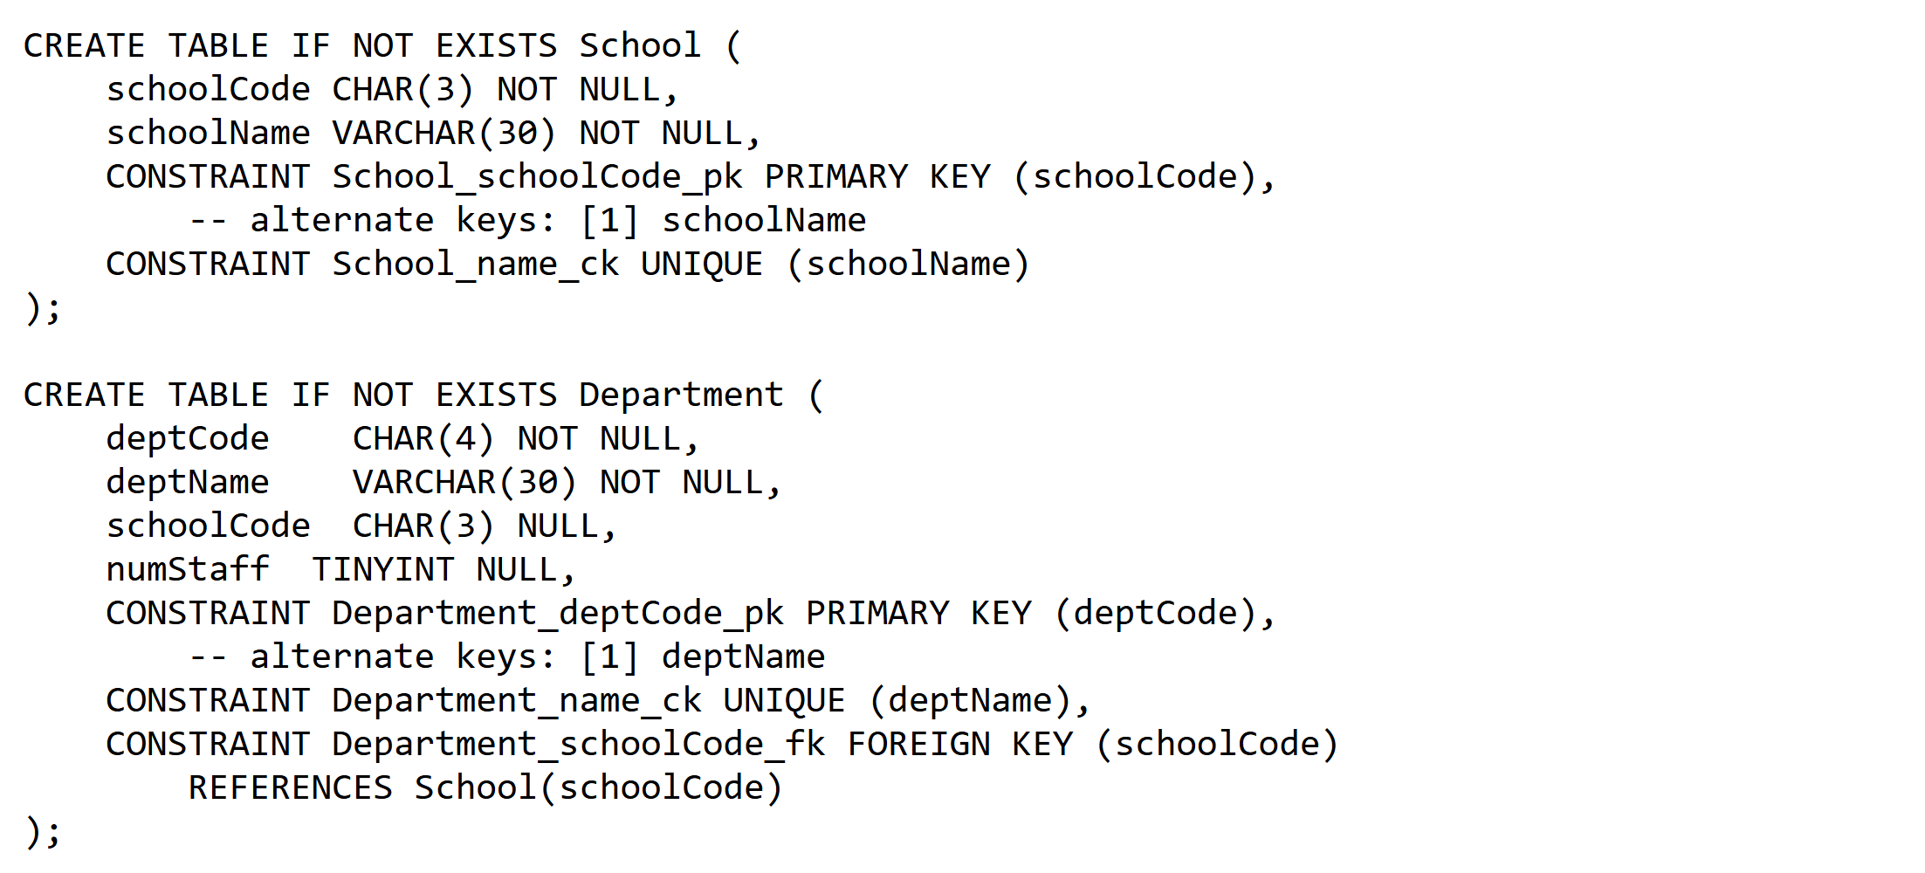
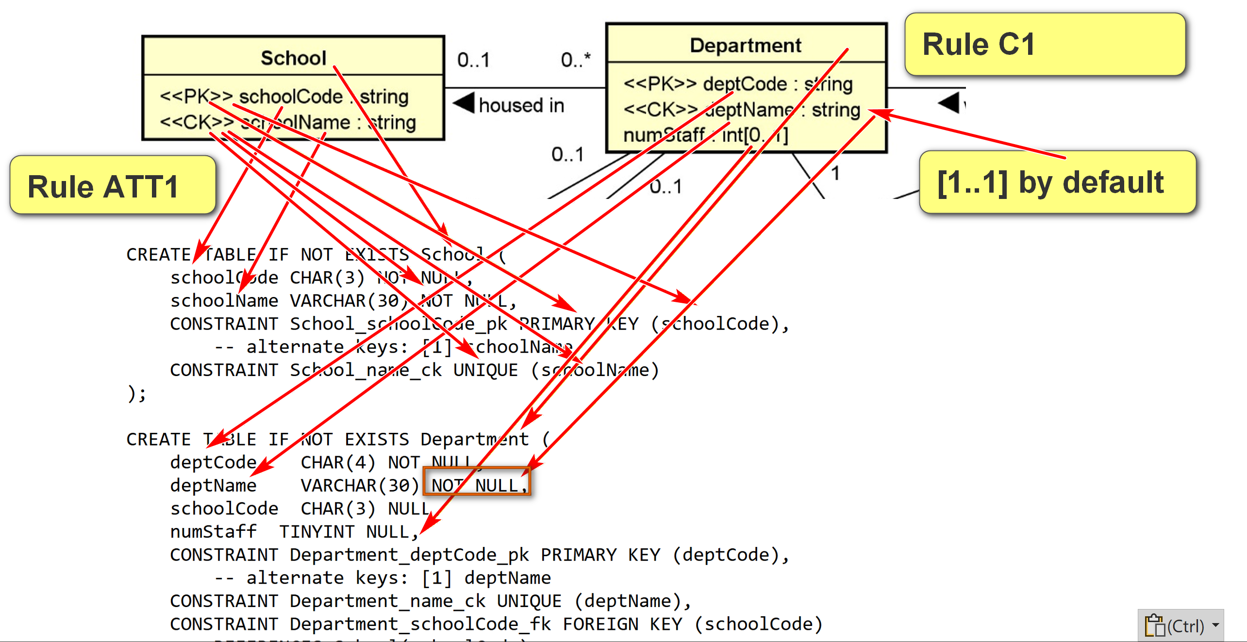
ATT2. Multi-Valued Attributes. For each multi-valued attribute A of the class C, create a new relation RCA containing the attribute A and the primary key, RCId, of the relation RC (which implements the class C).
- (RCId: MemberId, A: Hobby) is a composite (more than 1 attribute) candidate key.
- RCId (MemberId) is a foreign key referencing RC(RCId): Member(MemberId)
- A surrogate key, such as RCA_Id (HobbyId), may be created to serve as the simple primary key.
- The name of RCA should be meaningfully selected (to be the table Hobby).
Multi-valued attributes: consider the class Member with the following attributes:
- Member_Id: <<PK>>
- Screen_Name <<unique>>
- Hobbies[0..*]
- Medals[0..*]
E.g. object
- Member_Id: <<PK>>: M1
- Screen_Name <<unique>>: Joe
- Hobbies[0..*]: eat, drink, sleep
- Medals[0..*]: IEEE, fishing, ACM
hobby1, hobby2, hobby3: good Hobbies[0..3]
Member(MemberId, ScreenName, …)
MemberId (PK) | SN | Hobbies? N (not atomic) | Hobby1 | Hobby2 | Hobby3
M1 | Joe | Eat, dring, sleep

Hobby
MemberId (FK) | Hobby | HobbyId (auto increment): simple PK
M1 | Eat | 1
M1 | Drink | 2
M1 | Sleep | 3
M3 | Sleep | 4

Reasonable relation schema: three relations used
- Member(MemberId, ScreenName):
  - CK: [1] MemberId, [2] ScreenName
- Hobby(HobbyId, MemberId, Hobby):
  - CK: [1] HobbyId, [2] MemberId, Hobby
  - FK: [1] MemberId references Member(MemberId)
  - A surrogate key, HobbyId, is created as the primary key.
- Medal(MedalId, MemberId, Medal):
  - CK: [1] MedalId, [2] MemberId, Medal.
  - FK: [1] MemberId references Member(MemberId)
  - A surrogate key, MedalId, is created as the primary key.
All columns in the tables above are not nullable.
Secondary:
ATT3. Zero in Multiplicity. If the multiplicity of an attribute is specified, to handle the case of 0:
- If 0 is allowed in the UML model (e.g., 0..1, 0..* in the UML class diagram), the attribute is nullable. Add the NULL specifier in the column definition in the RDBMS. (NULL is usually the default)
- If 0 is not allowed, add the NOT NULL specifier in the column definition.
ATT4. Default Values. The default value of an attribute can be directly implemented in SQL DDL. Example, in MySQL:
CREATE TABLE table_name (
column1 data_type,
column2 data_type DEFAULT default_value,
...
);
ATT5. Data Types. Data type mapping should be handled adequately, effectively, and consistently.
- In later modeling phases, one may use SQL data types of the targeted DBMS in the class diagram.
- If available, consider using user-defined data types in the targeted DBMS.
UML: int
Oracle: need to consider
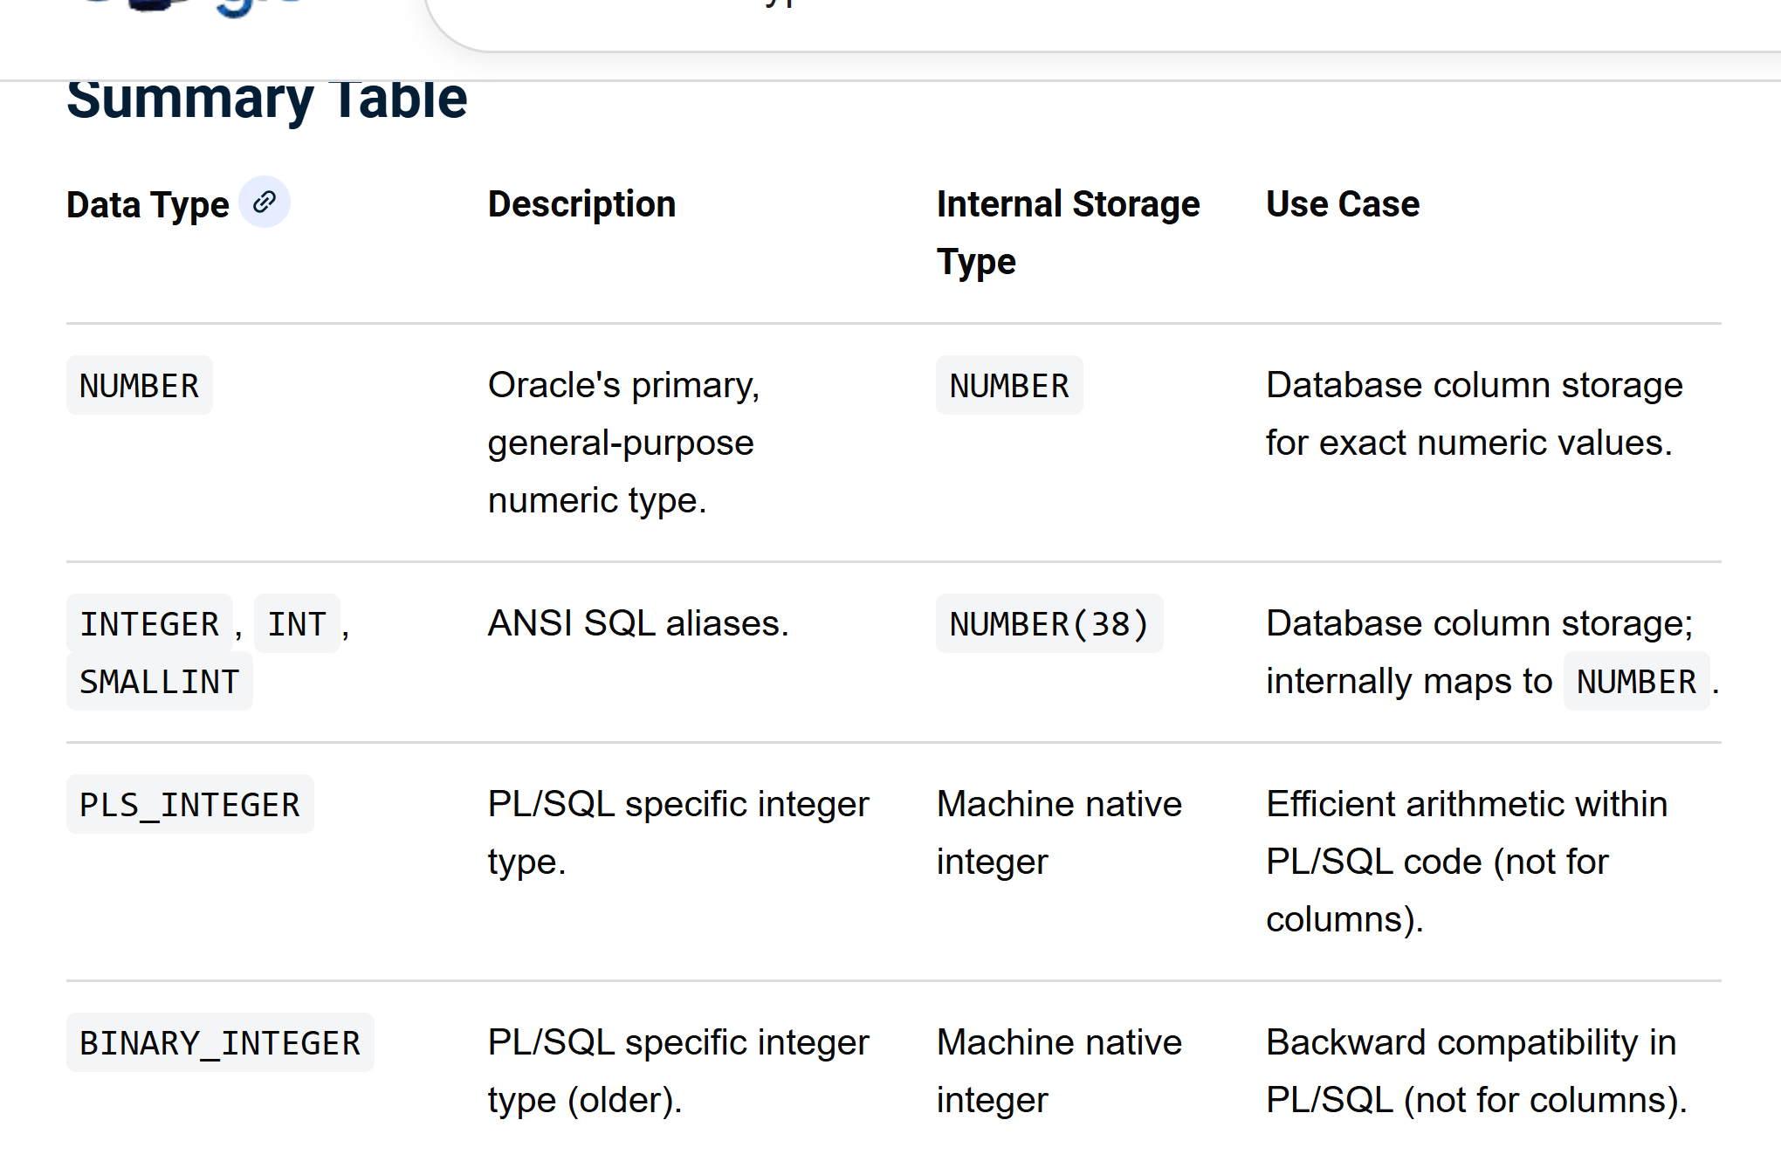
Example:
UML for toyu.student:
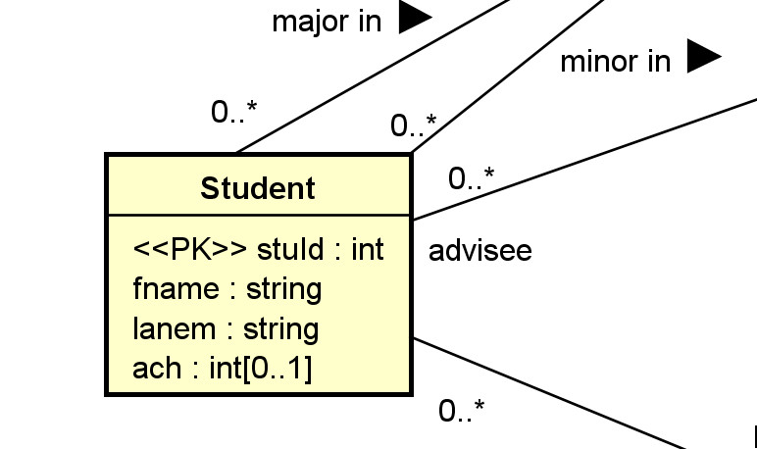
Relational schema (in HW assignment format):
Relation | Student(StuId, fname, lname, major, minor, ach, advisor)
Candidate Keys | [1] StuId
Foreign Keys | [1] major references department(deptCode), [2] minor references department(deptCode), [3] advisor references faculty(facId)
Nullable Attributes | major, minor, advisor, ach
Non-nullable Attributes | stuId, fname, lname
Notes
Relational schema in SQL (with more implementation details):
CREATE TABLE IF NOT EXISTS Student (
stuId INT NOT NULL,
fname VARCHAR(30) NOT NULL,
lname VARCHAR(30) NOT NULL,
major CHAR(4) NULL,
minor CHAR(4) NULL,
-- ach: accumulated credit hours, including transferred credits.
ach INTEGER(3) NULL DEFAULT 0,
advisor INT NULL,
CONSTRAINT Student_stuId_pk PRIMARY KEY(stuId),
-- an artificial example of a CHECK constraint.
CONSTRAINT Student_ach_cc CHECK ((ach>=0) AND (ach < 250)),
CONSTRAINT Student_major_fk FOREIGN KEY (major)
REFERENCES Department(deptCode) ON DELETE CASCADE,
CONSTRAINT Student_minor_fk FOREIGN KEY (minor)
REFERENCES Department(deptCode) ON DELETE CASCADE,
CONSTRAINT Student_advisor_fk FOREIGN KEY (advisor)
REFERENCES Faculty(facId)
);
Example:
Multi-valued attributes: consider the class Member with the following attributes:
- Member_Id: <<PK>>
- Screen_Name <<unique>>
- Hobbies[0..*]
- Medals[0..*]
Reasonable relation schema: three relations used
- Member(MemberId, ScreenName):
  - CK: [1] MemberId, [2] ScreenName
- Hobby(HobbyId, MemberId, Hobby):
  - CK: [1] HobbyId, [2] MemberId, Hobby
  - FK: [1] MemberId references Member(MemberId)
  - A surrogate key, HobbyId, is created as the primary key.
- Medal(MedalId, MemberId, Medal):
  - CK: [1] MedalId, [2] MemberId, Medal.
  - FK: [1] MemberId references Member(MemberId)
  - A surrogate key, MedalId, is created as the primary key.
All columns in the tables above are not nullable.
ATT6. Single-Valued Composite Data Types. A single-valued attribute of a composite data type (such as set, list, array, JSON) can be mapped in various ways.
- If there is a comparable composite data type in the targeted DBMS, it can be implemented as an attribute of that data type in the relation.
  - The relation will no longer be in the first normal form.
  - Care should be taken in handling the difference in data type mapping.
- Otherwise, regard the attribute as a multi-valued attribute and apply rule ATT2.
ATT7. Derived Attributes. For a derived attribute A, computed from other data, not independent. E.g. Aga computed from DoB. E.g., GPA:
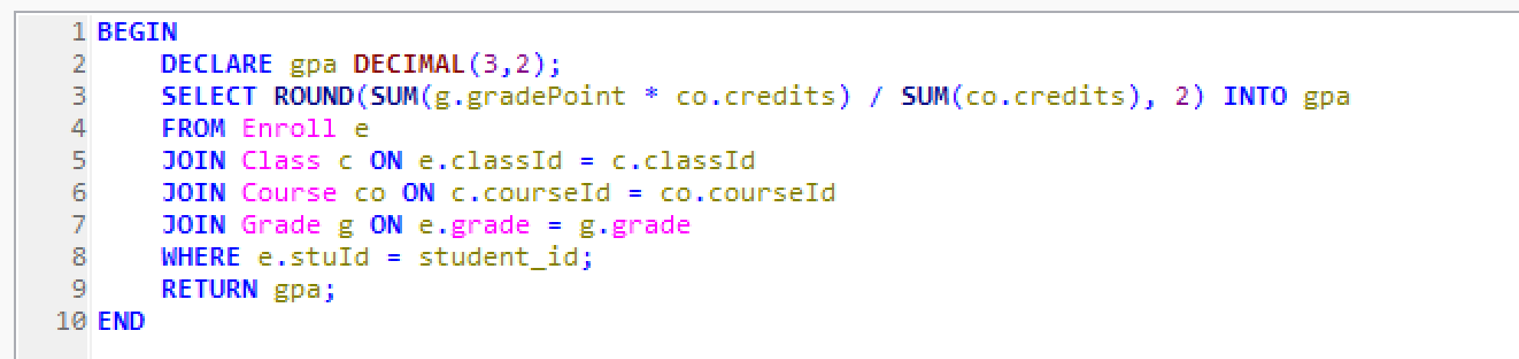
- It can be implemented and stored as a ‘physical’ attribute of the relation.
  - Mechanisms, such as triggers or stored procedures, should be used to ensure data consistency. The derived column should be consistent with the data that derives its value.
  - Advantages: performance: good for derived attributes that are hard to compute and read/write ration is high to very high.
- It may not be stored as a column directly in any relation.
  - Mechanisms, such as virtual columns, views or stored functions, may be used to provide standard access to the derived attributes.
Example:
A class Rectangle has three attributes:
- Length
- Width
- \Area or <<derived>>: derived.
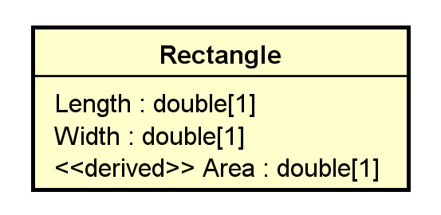
What may the relational schema look like?
One solution:
Rectangle(RectangleId, Length, Width)
with a view Rect define as
SELECT DISTINCT RectangleId, Length, Width, Length * Width as Area
FROM Rectangle;
Alternatively, use virtual columns: a column that is computed in real-time by an expression and not stored. (the definition is stored)
CREATE or replace TABLE rectangle (
width DOUBLE,
height DOUBLE,
area DOUBLE AS (width * height) virtual -- area is always correct.
);
CREATE or replace TABLE rectangle (
width DOUBLE,
height DOUBLE,
area DOUBLE – storing it as an actual column. Programmer responsible for data integriry
);

2.3 Keys and Constraints
KC1. Primary Key Identified. If a relation R implements a class C or an association (class) AC, and C or AC has identified the PK, set it as the primary key of R.
KC2. Candidate Keys. If a relation R implements a class C or an association (class) AC, and C or AC has candidate keys K's, set all K's as candidate keys of R.
- If no primary key has been identified, select a CK to serve as the primary key, and apply KC1.
- A candidate key can be implemented by using the 'unique' and non-null constraint together in SQL.
KC3. No Primary Key Identified. If a relation R implements a class C or an association (class) A, and C or AC has no candidate key, create a surrogate primary key K for R.
- This is needed as every relation must have at least one candidate key.

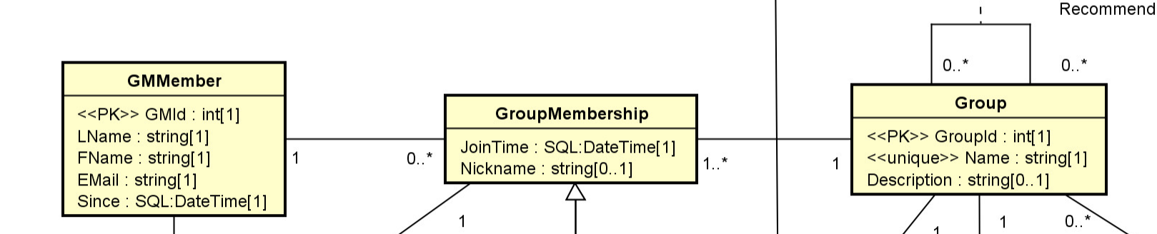
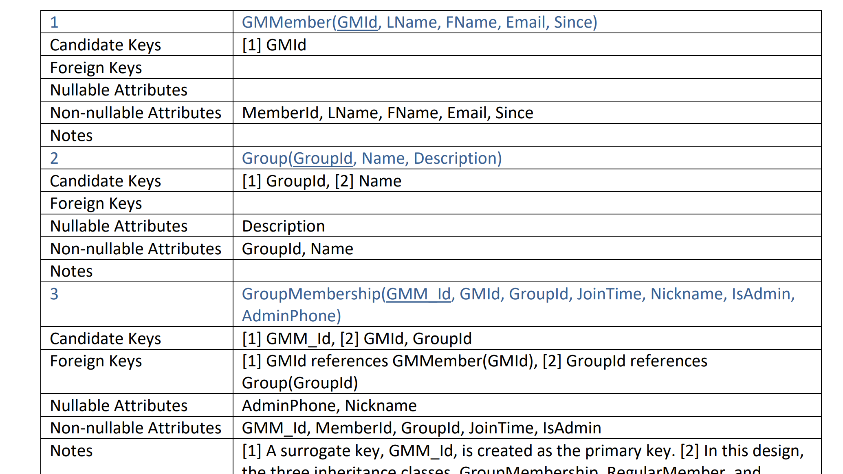
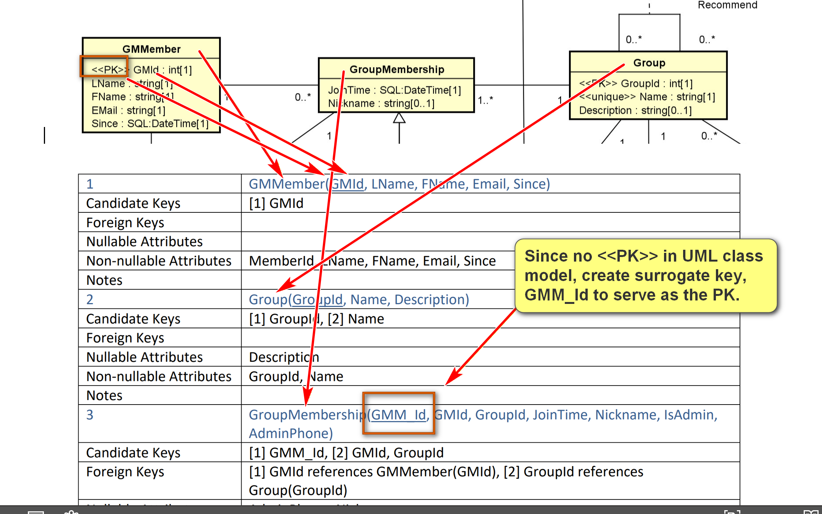
Example:
for the class Department in toyu:
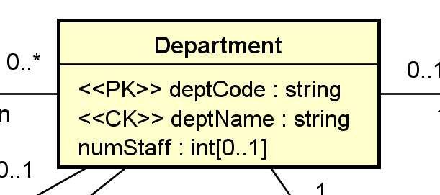
Relational schema (in HW assignment format):
3 | Department(deptCode, deptName, schoolCode, numStaff)
Candidate Keys | [1] deptCode, [2] deptName
Foreign Keys | [1] schoolCode references School(schoolCode)
Nullable Attributes | schoolCode, numStaff
Non-nullable Attributes | deptCode, deptName
Notes
Relational schema in SQL (with more implementation details):
CREATE TABLE IF NOT EXISTS Department (
deptCode CHAR(4) NOT NULL,
deptName VARCHAR(30) NOT NULL,
schoolCode CHAR(3) NULL,
numStaff TINYINT NULL,
CONSTRAINT Department_deptCode_pk PRIMARY KEY (deptCode),
-- alternate keys: [1] deptName
CONSTRAINT Department_name_ck UNIQUE (deptName),
CONSTRAINT Department_schoolCode_fk FOREIGN KEY (schoolCode)
REFERENCES School(schoolCode)
);
KC4. For a stereotype:
- Some may be directly implemented in SQL DDL, e.g., PK, CK, unique, etc.
- Otherwise, it is necessary to consider where and how it is implemented.
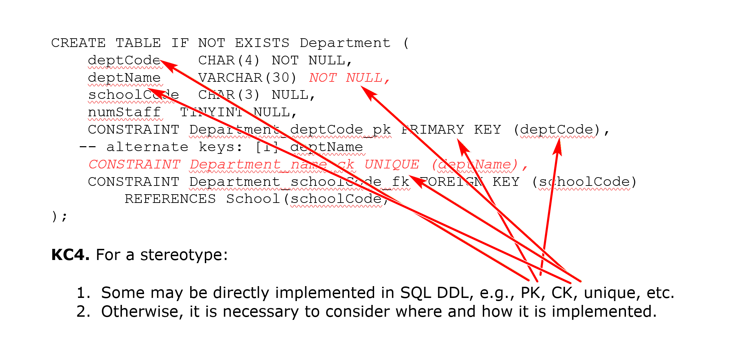
2.4 Associations
A1. Many-to-one Association. For a many to one association A between C1 (the class with the one multiplicity) and Cm, add a column R1_Id into the relation Rm (which implements Cm).
- Assume that R1_Id is the primary key of the relation R1 (which implements C1).
- R1_Id is a foreign key in Rm referencing R1(R1_Id).
- The name R1_Id may be renamed.
- R1_Id is not null in Rm iff (if and only if) 0 is not allowed (i.e., 1..1) for C1.
- Any single-valued attribute of the association is mapped to a column in Rm.
- If the association A is an association class, single-valued attributes of A can be stored as attributes of R1.
- If you have composite or multi-valued attributes of the relationship, you should consider promoting the association to a regular class in your UML class diagram.
Example:
For:
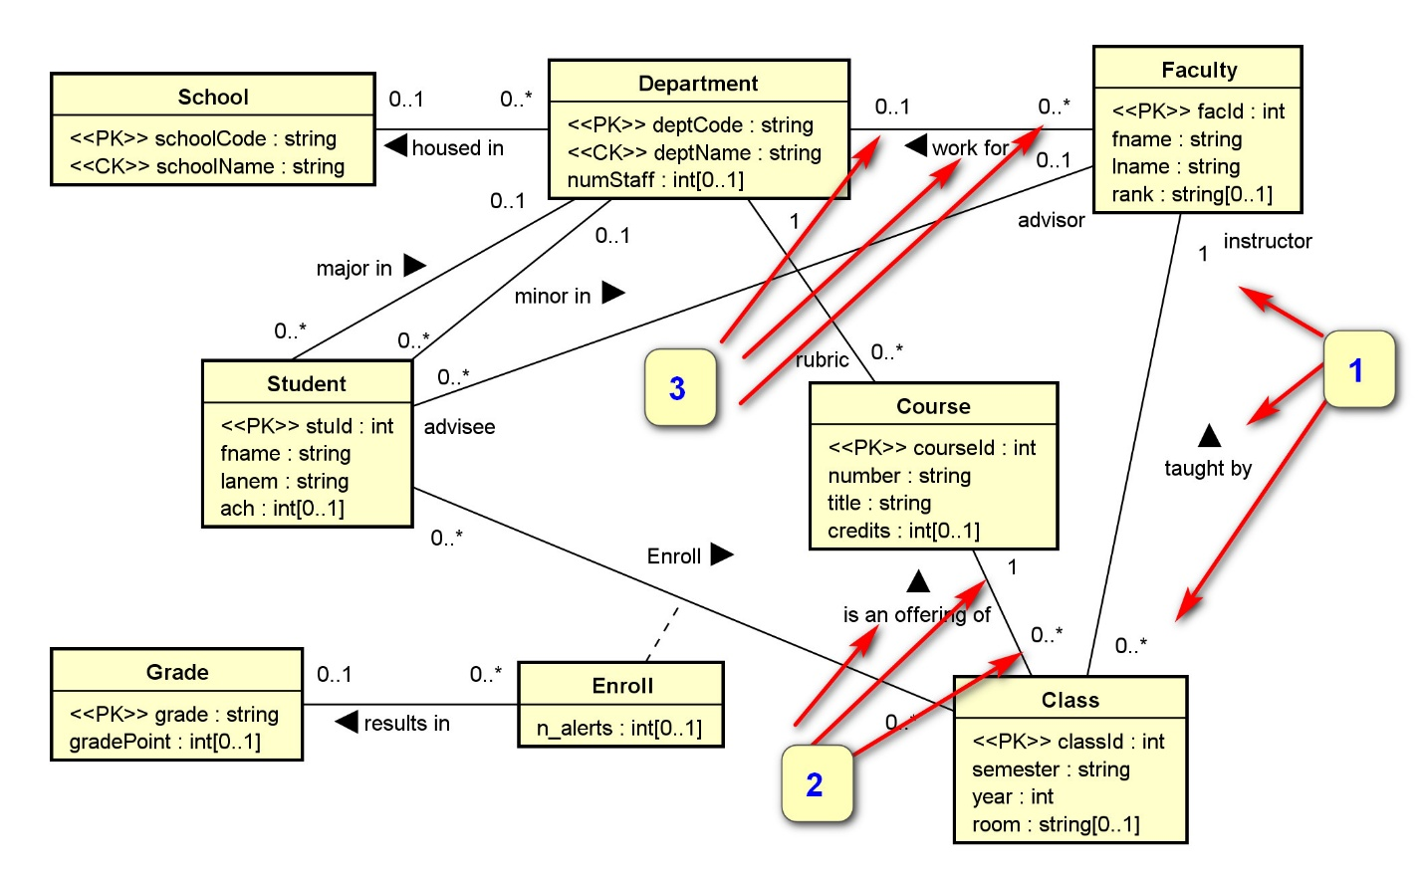
We have the three numbered associations implemented by the three foreign keys below.
4 | Faculty(facId, fname, lname, deptCode, rank)
Candidate Keys | [1] facId
Foreign Keys | [1] deptCode references Department(deptCode)
Nullable Attributes | rank, deptCode
Non-nullable Attributes | facId, fname, lname
Notes
6 | Class(classId, courseId, semester, year, facId, room)
Candidate Keys | [1] classId
Foreign Keys | [1] courseId references Course(courseId), [2] facId references Faculty(facId)
Nullable Attributes | room
Non-nullable Attributes | classId, courseId, semester, year, facId
Notes
Eg.
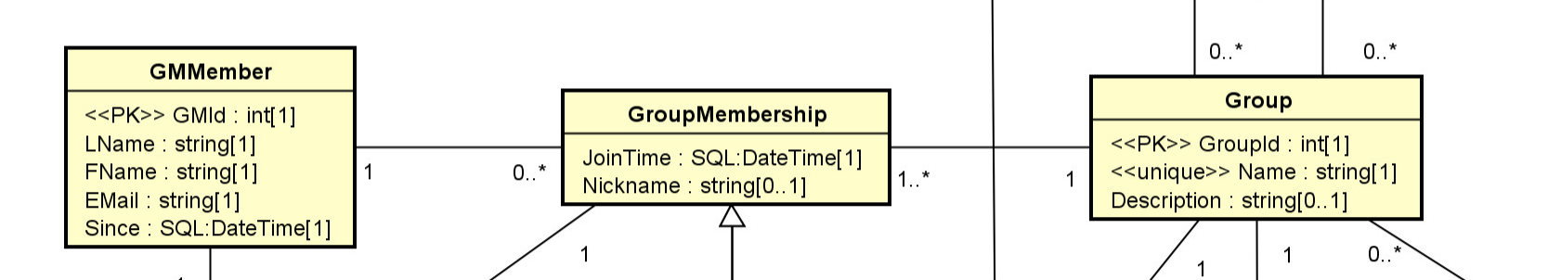
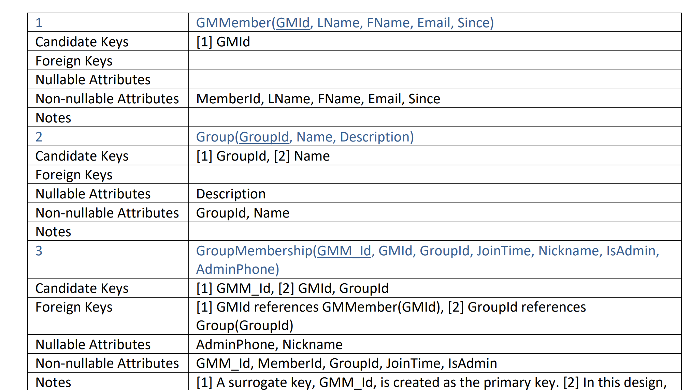
Two Membership instances: Member M1 join the groups G1, G2
Another M2 joins G2, G3
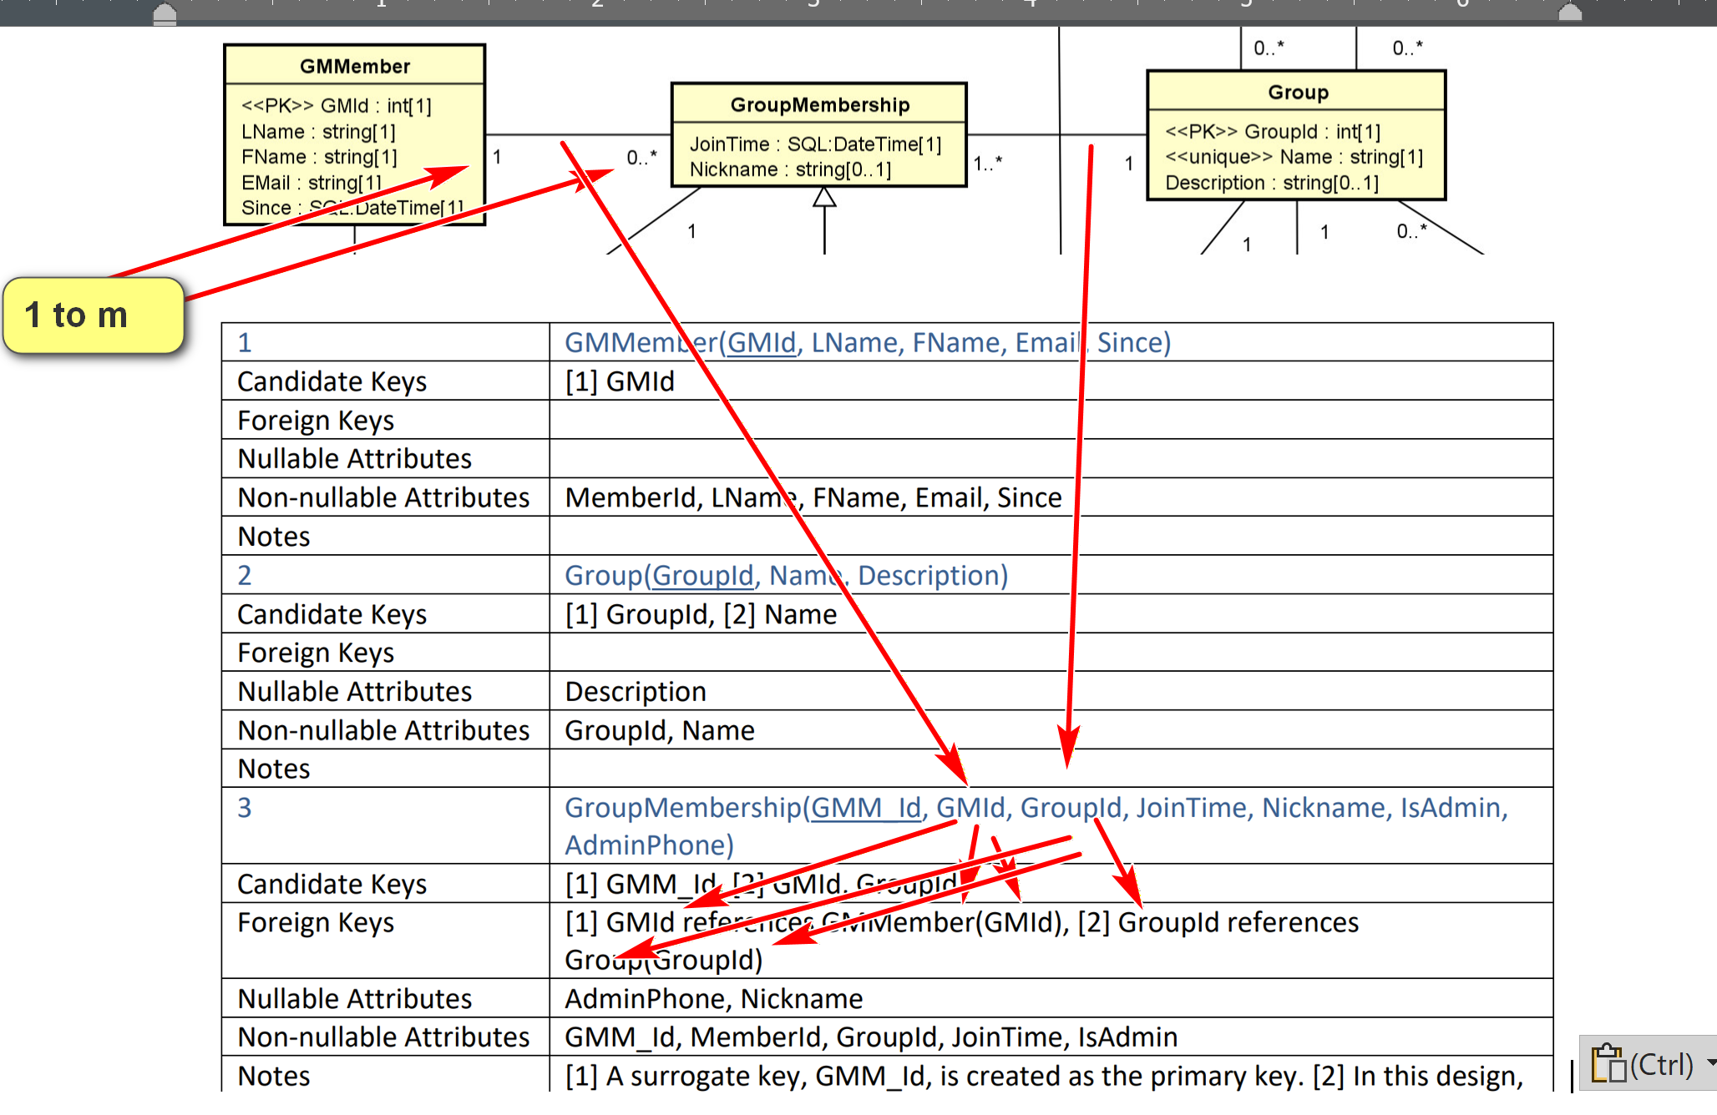
Many to one between GroupMembership (*) and GMMember (1)
A1. Many-to-one Association. For a many to one association A between C1: GMMEmber (the class with the one multiplicity) and Cm, add a column R1_Id (GMId) (GMinto the relation Rm: GroupMembership (which implements Cm: GroupMembership).
- Assume that R1_Id (GMId) is the primary key of the relation R1: GMMember (which implements C1).
- R1_Id (GMId) is a foreign key in Rm referencing R1(R1_Id): GMMember(GMId)
- The name R1_Id may be renamed.
- R1_Id is not null in Rm iff (if and only if) 0 is not allowed (i.e., 1..1) for C1.
- Any single-valued attribute of the association is mapped to a column in Rm.
- If the association A is an association class, single-valued attributes of A can be stored as attributes of R1.

A2. Many-to-many Association. For a many-to-many association (including association classes) between classes CA and CB, create a new relation RAB(RA_Id, RB_Id).
- (RA_Id, RB_Id) is a candidate key.
- RA_Id references RA(RA_Id) as a foreign key.
- RB_Id references RB(RB_Id) as a foreign key.
- An additional surrogate key, such as RAB_Id, can be created.
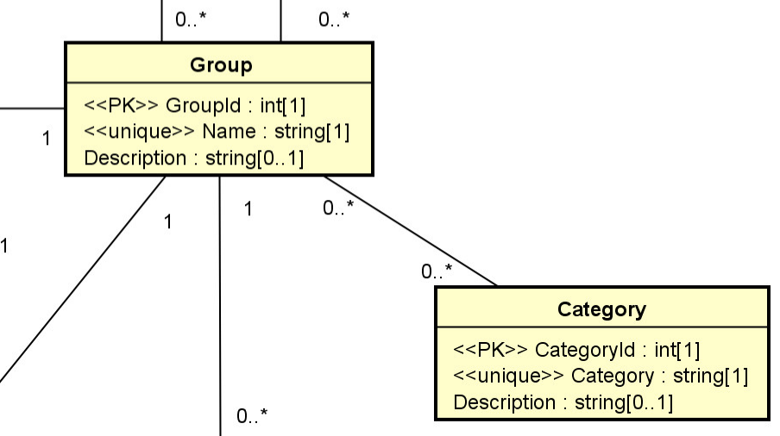
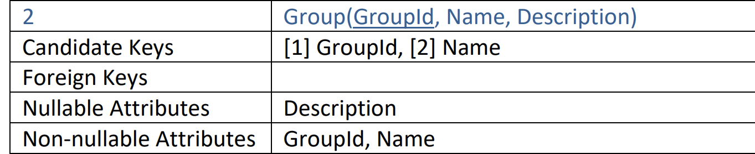
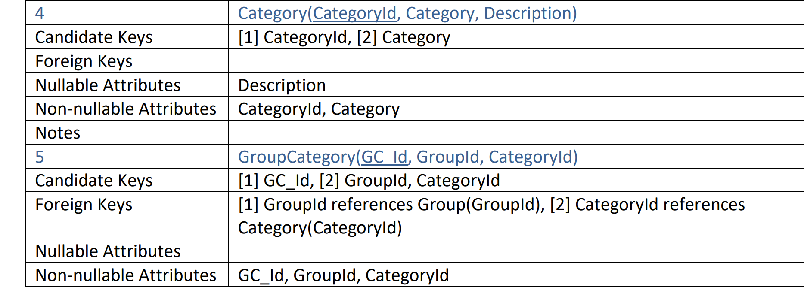
G1: categories C1 and C2
G2: C2 and C3
G3: no category.

Example:
For:
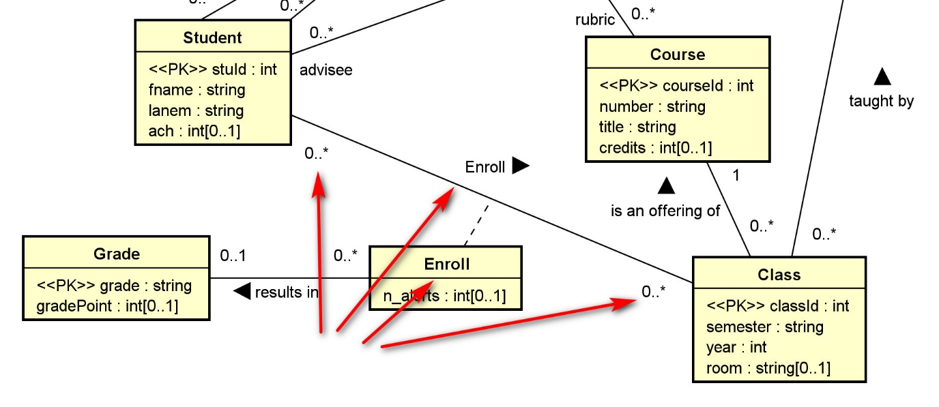
We have:
8 | Enroll(stuId, classId, grade, n_alerts)
Candidate Keys | [1] stuId, classId
Foreign Keys | [1] stuId references Student(stuId), [2] classId references Class(classId), [3] grade references Grade(grade)
Nullable Attributes | grade, n_alerts
Non-nullable Attributes | stuId, classId
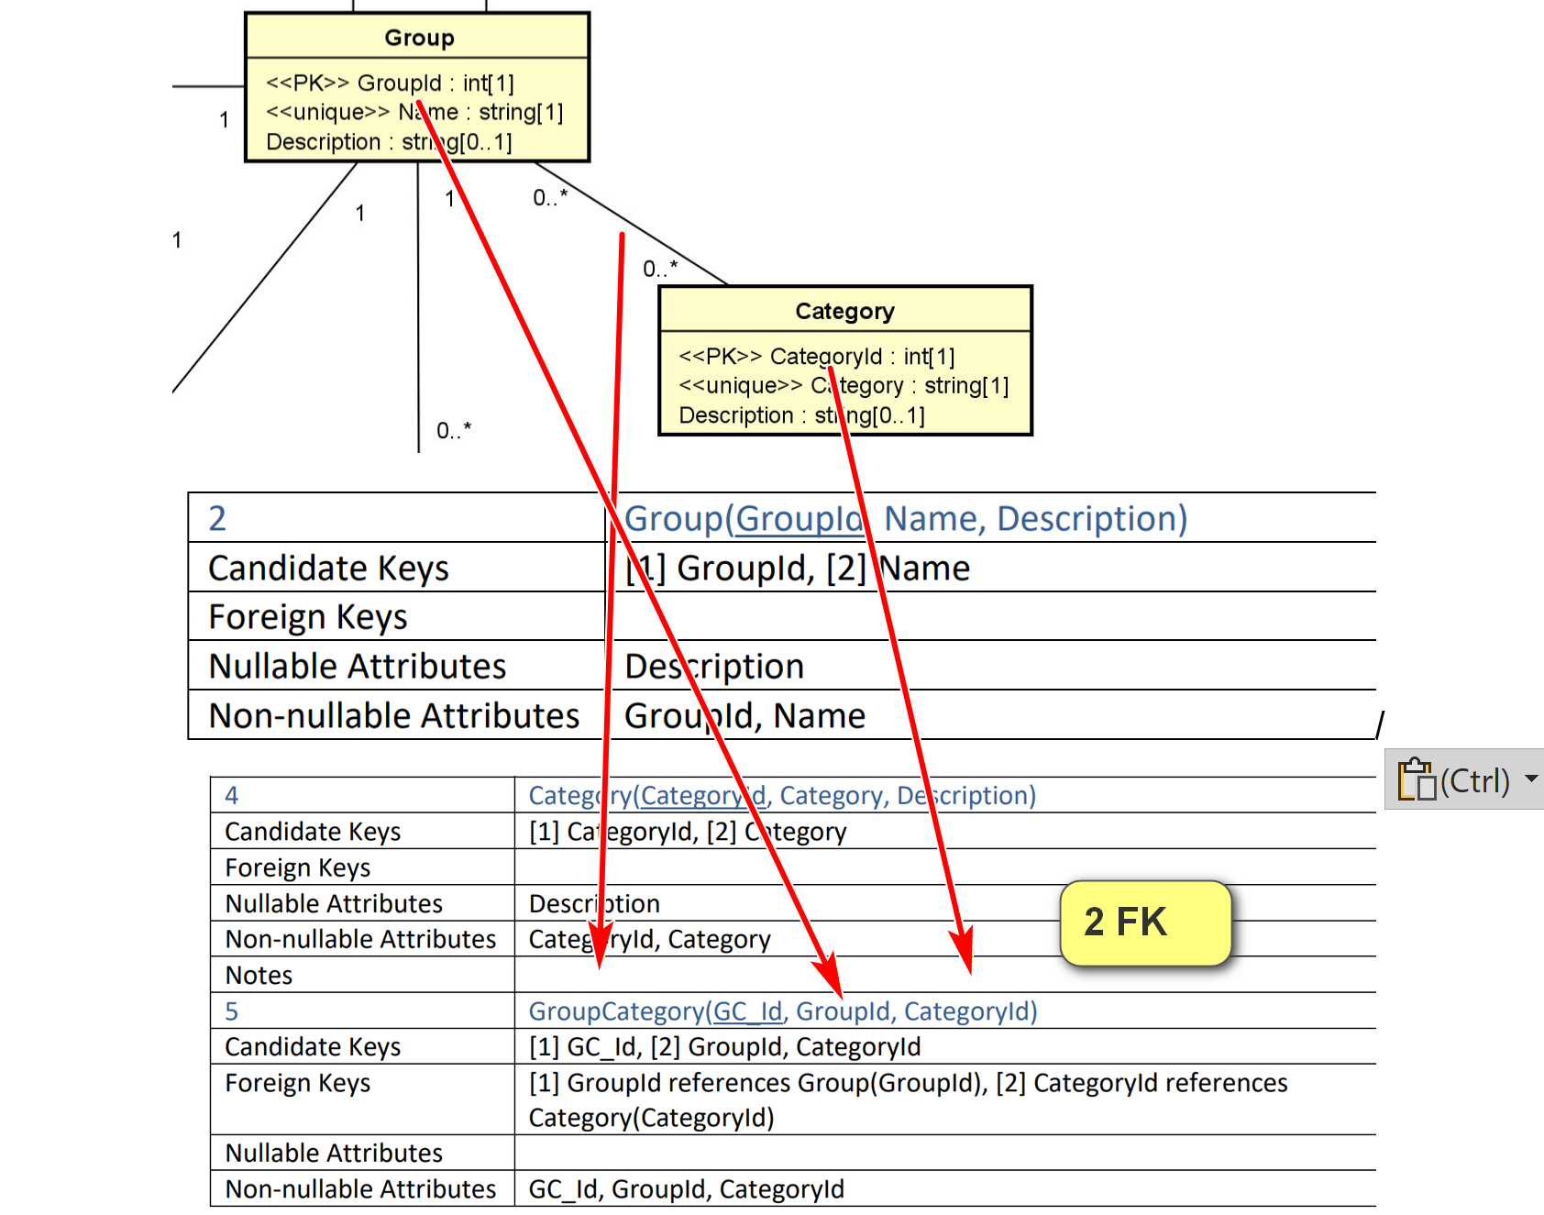
A3. One-to-one Association. For a one to one association between classes CA and CB, there are several options: (special case of m to 1)
- Treat CA as C1 and CB as Cm and apply A1.
- Treat CA as Cm and CB as C1 and apply A1.
- Merge the two relations RA and RB into one. (In this case, you may want to refactor the class diagram.)
A4. N-ary Associations. For any n-ary association (n>2), a new relation is needed. (do not easily user them).
- You should consider using binary associations instead.
- A ternary association can be modeled as a regular class with three binary associations with the participating classes in the ternary association.
Example:
Consider the ternary association between the classes Supplier, Part, and Warehouse with an association attribute quantity.
It can reasonably be replaced by a new class and three binary associations.
Supplier s1 supplied 5 part P1 to warehouse w1. (n-ary association; n = 3; tenary)

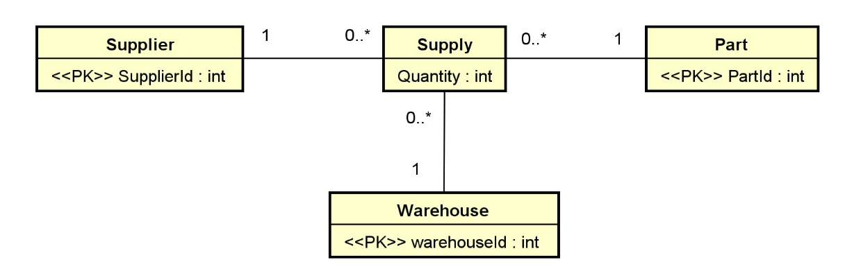
Supply(SupplyId, SupplierId, PartId, WarehouseId, Quantity):
- CK: [1] SupplyId, [2] SupplierId, PartId, WarehouseId
- FK: [1] SupplierId references Supplier(SupplierId), [2] PartId references Part(PartId), [3] WarehouseId references Warehouse(WarehouseId).
- All attributes in Supply is not nullable.
Example:
Checkout the UML diagram and relation schema for toyu and swim.

