CSCI 4333.2
Annotation
1/21/26

Previously:
5. A Simple Introduction to the Relational Model
- Relational databases are the most popular databases: https://db-engines.com/en/ranking. It is based on the relational model.
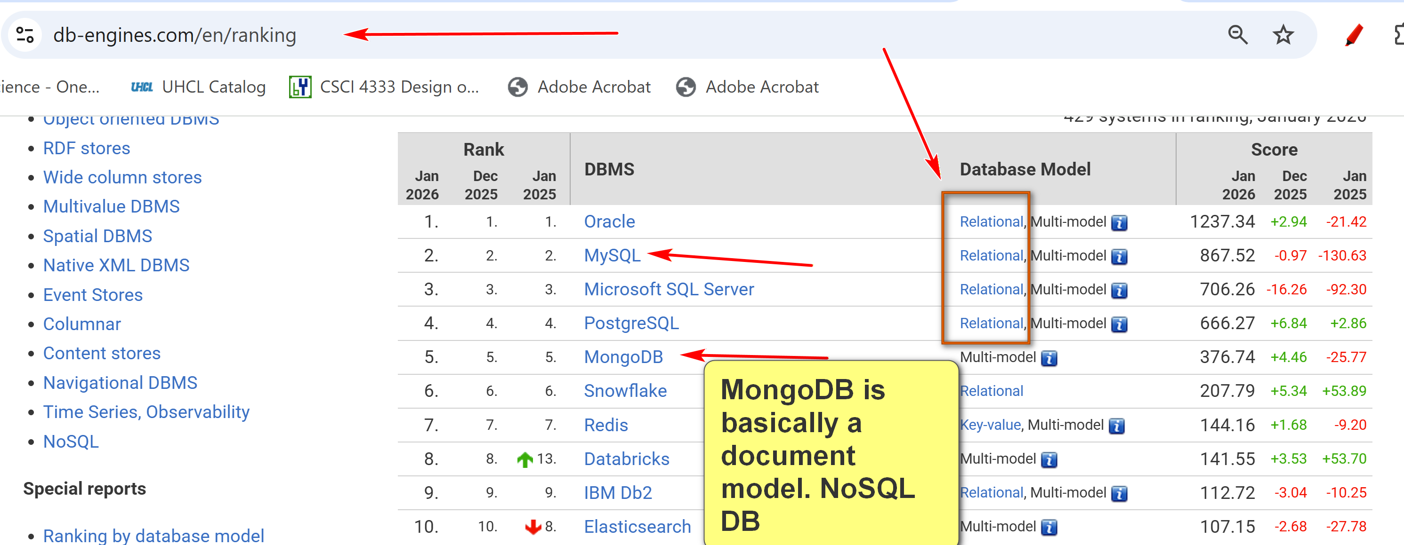
- There are many other data models: e.g. document model, key-value, wide-column, …

- In layman's term: A table (relation) is the basic unit of a relational database.
  - A relational DB contains a collection of tables.
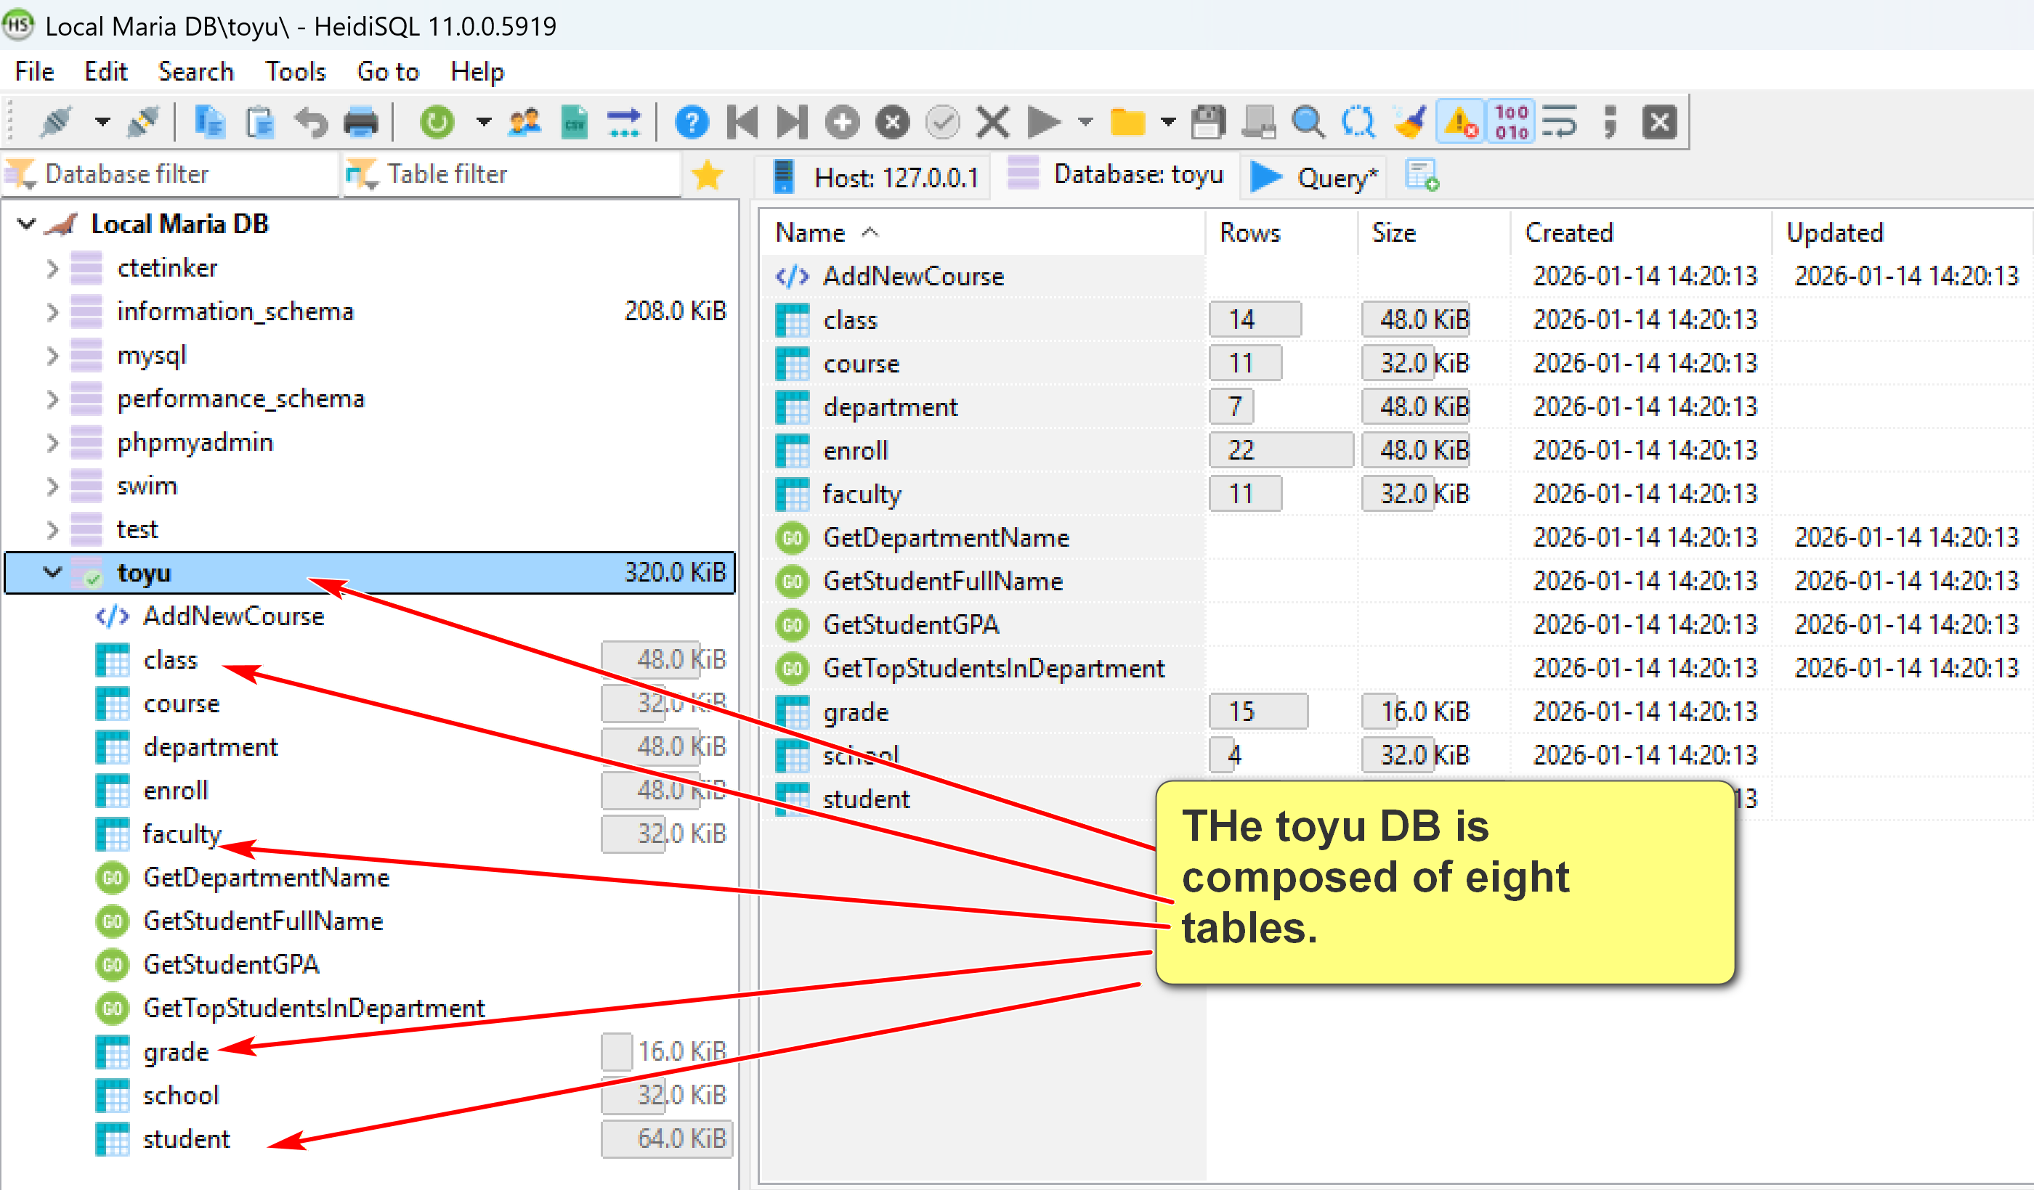
- A table is composed of many rows (tuples).
  - Each row stores information about an object, entity, concept, …
- Each row has many column (attribute) values.
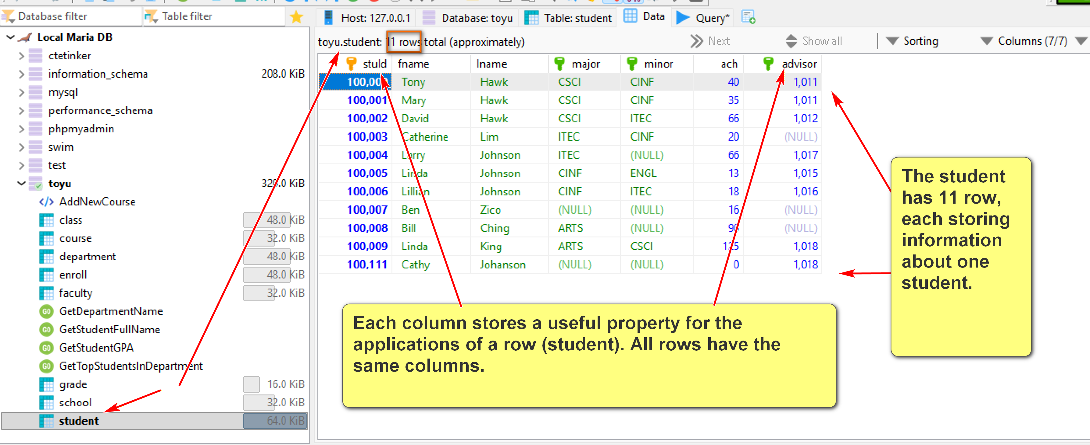
IN toyu:
A class is an offering of a course (identified by courseId) in a semester taught by a faculty (identified by facId) in a room.
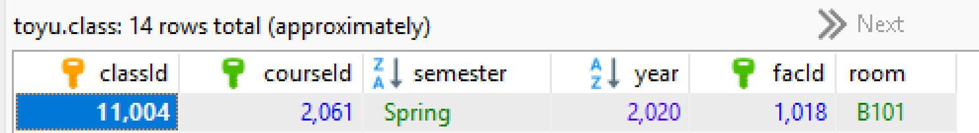
A row in the enroll captures the data of an enrollment: a student (identified by stuId) enrolled in a class (identified by classId) with a grade and a n_alerts.
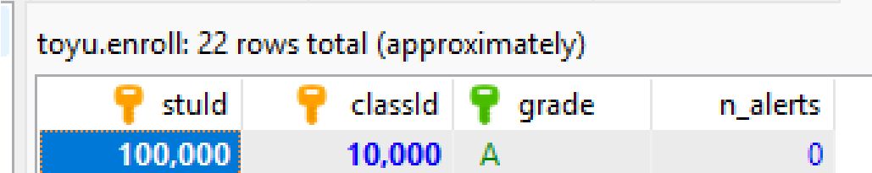
- A primary key is roughly a minimal set of columns in a table that uniquely identify a row.
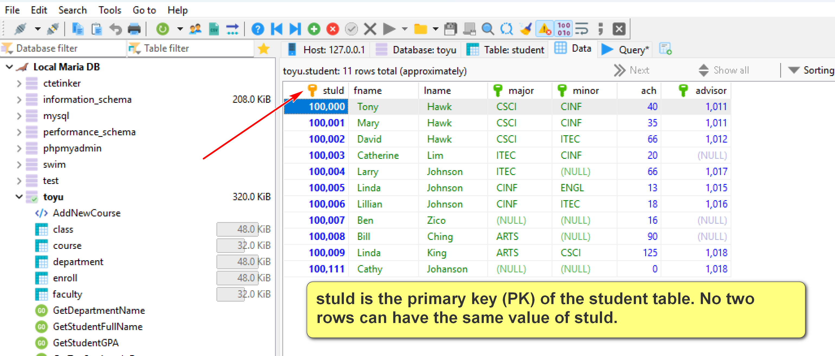

- Two tables can be related to each other by foreign keys. A foreign key is roughly a column in a table in which its value must be equal to the referenced value of the primary key in another table (called the paren or referenced table).
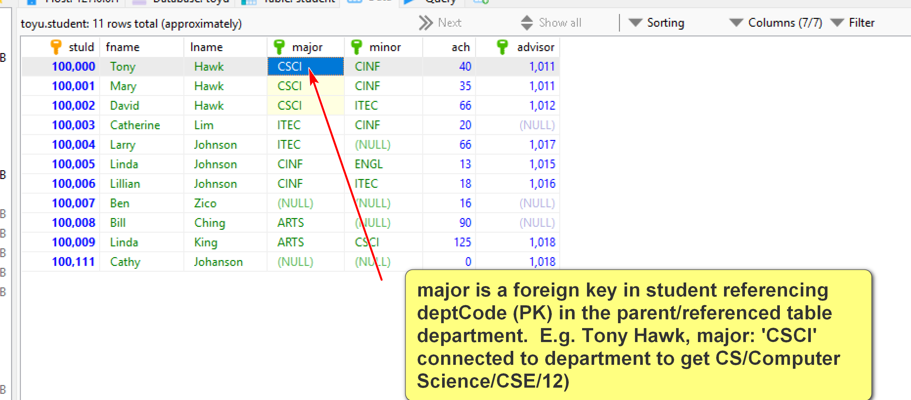

In student, advisor is FK referencing faculty(facId):
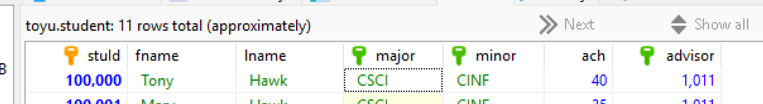
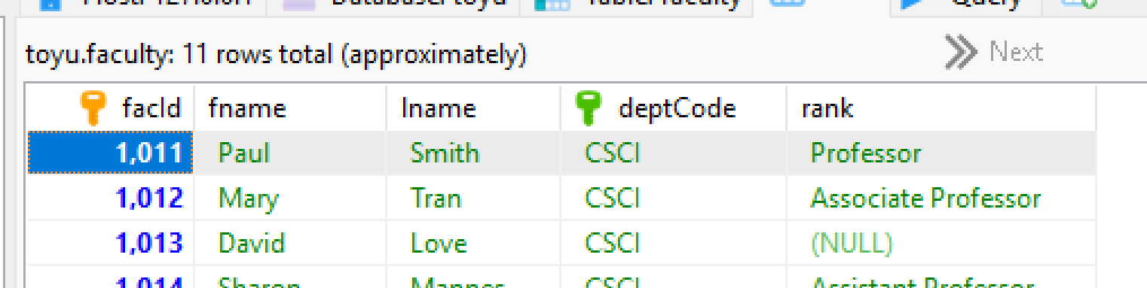
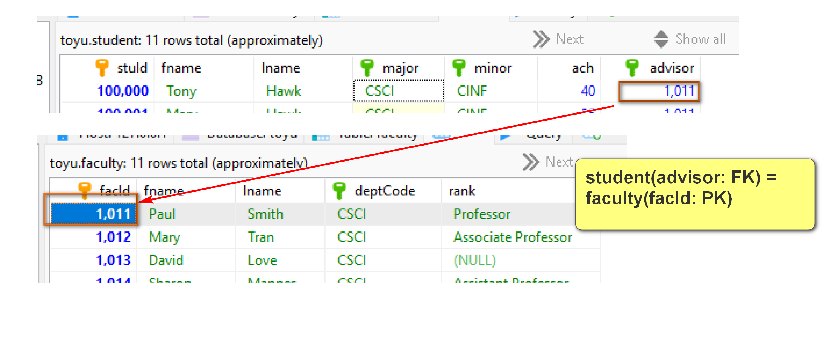
2.2 Simple schema and keys
Relations/tables (primary key underscored):
Grade(grade, gradePoint)
School(schoolCode, schoolName)
Department(deptCode, deptName, schoolCode, numStaff)
Faculty(facId, fname, lname, deptCode, rank)
Course(courseId, rubric, number, title, credits)
Class(classId, courseId, semester, year, facId, room)
Student(StuId, fname, lname, major, minor, ach, advisor)
Enroll(stuId, classId, grade, n_alerts)
Foreign keys:
1. Student(advisor) references Faculty(facId)
2. Student(major) references Department(deptCode)
3. Student(minor) references Department(deptCode)
4. Faculty(deptCode) references Department(deptCode)
5. Department(schoolCode) references School(schoolCode)
6. Enroll(stuId) references Student(stuId)
7. Enroll(classId) references Class(classId)
8. Enroll(grade) references Grade(grade)
9. Class(courseId) references Course(courseId)
10. Class(facId) references Faculty(facId)
11. Course(Rubric) references Department(deptCode)

- Relational DBMS is the most popular DBMS. Examples:
  - DB-engine ranking: https://db-engines.com/en/ranking
  - Top 10 DBMS in Data Science: https://towardsdatascience.com/top-10-databases-to-use-in-2021-d7e6a85402ba
- SQL is the 'glue' in many DB systems.
Classroom discussion
Please ask questions about the toy University DB (toyu)

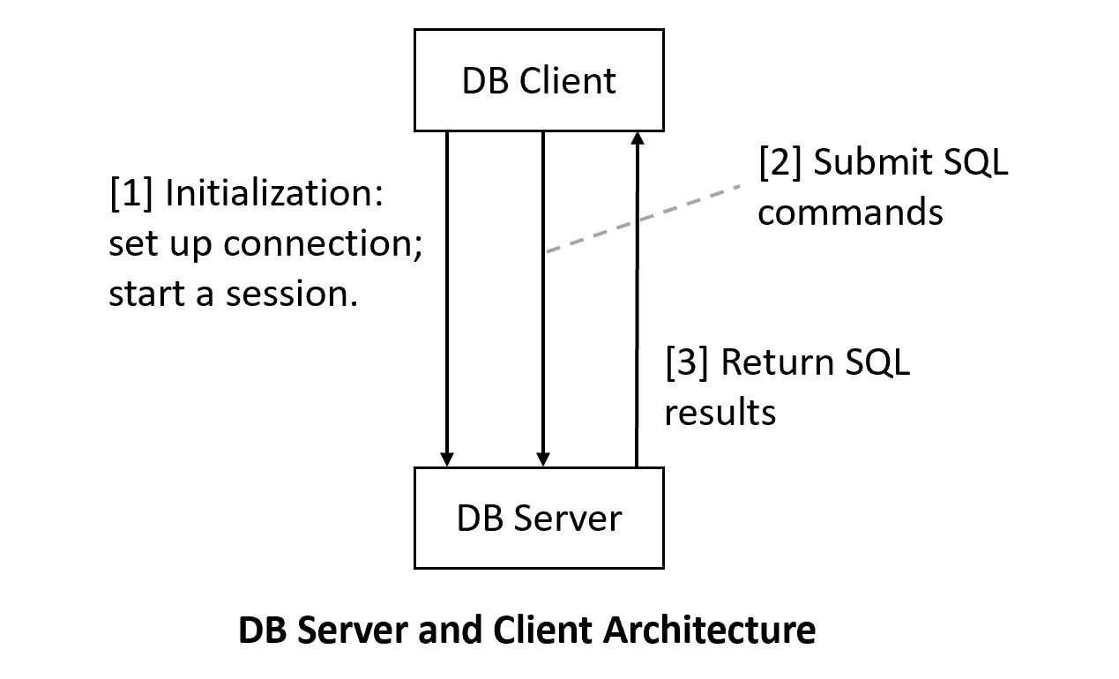
XAMPP/Maria DB: DB server:
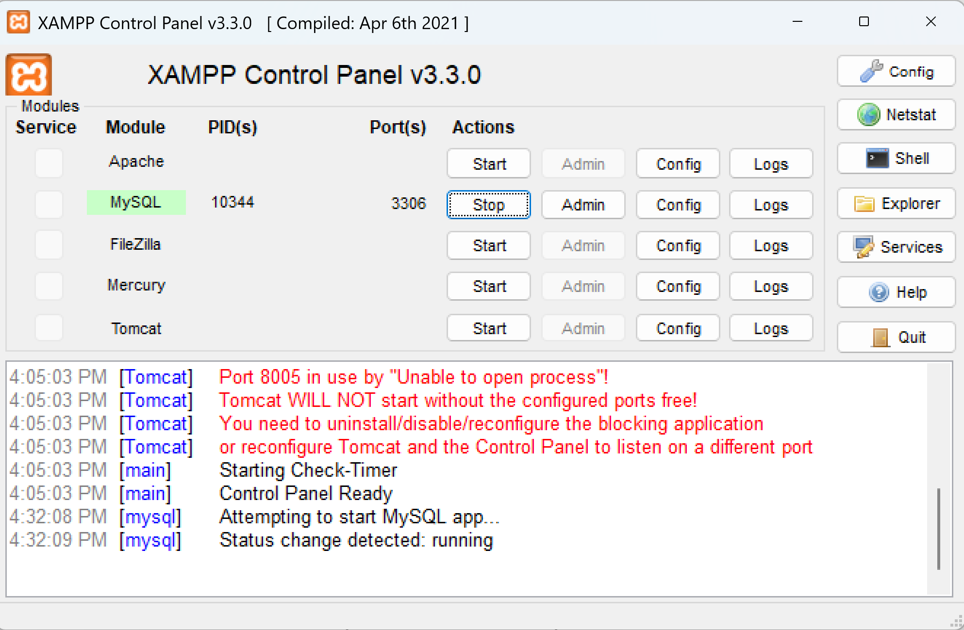
Client: HeidiSQL
2nd Client: MySQL prompt command line client

3.1 MySQL Server Setup
We will use MariaDB that is a part of XAMPP. Do not recommend installing standalone MySQL.
[1] Install XAMPP, which contains many server software configured to work together for development purposes. For XAMPP, we will use MySQL/Maria DB and Apache (Web server).
- Recommended to install XAMPP in the top level: c:\xampp (likely the default).
- Set up development accounts immediately using phpMyAdmin after installation.
- Change the root password (optional but recommended): a secure step that requires tinkering.
- To ensure that PHPMyAdmin will work on a new admin account (optional):
  - Use PHPMyAdmin to create a new admin account, e.g., "frog_ad", with the password "a_new_prince" for both hostname '%' and 'localhost'
  - PhpMyAdmin uses the default root account (with no initial password) via localhost.
  - Thus, you will need to supply the new username and password to start up PhpMyAdmin by editing the file c:\xampp\phpMyAdmin\config.inc.php, search change the line to, for example:
    - $cfg['Servers'][$i]['user'] = 'frog_ad';
    - $cfg['Servers'][$i]['password'] = 'a_new_prince';
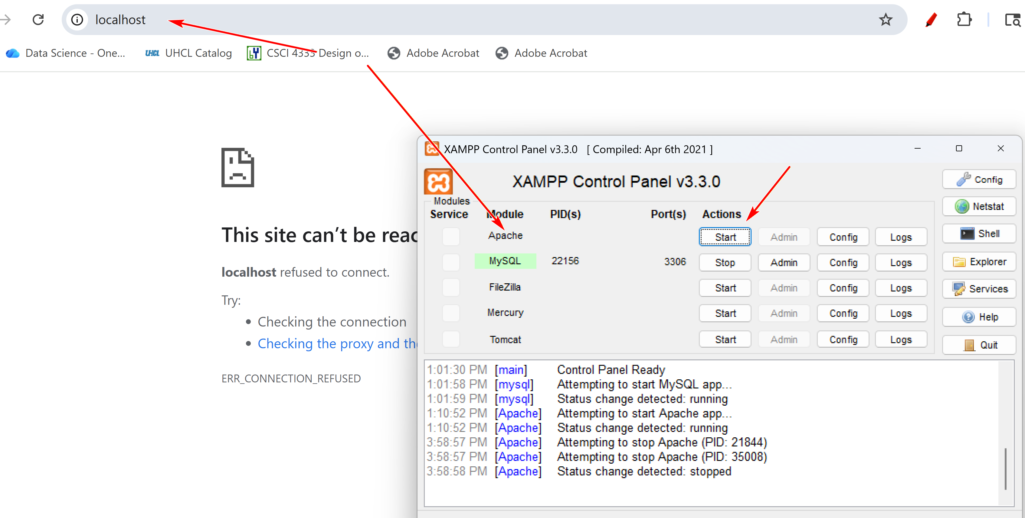

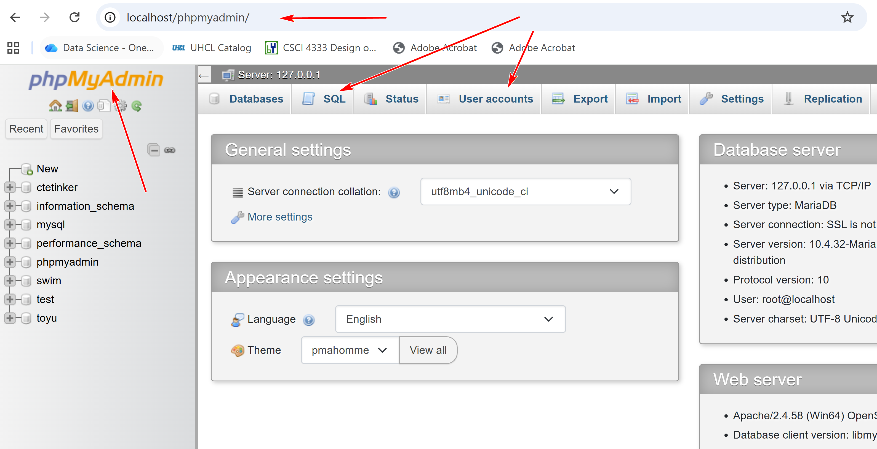
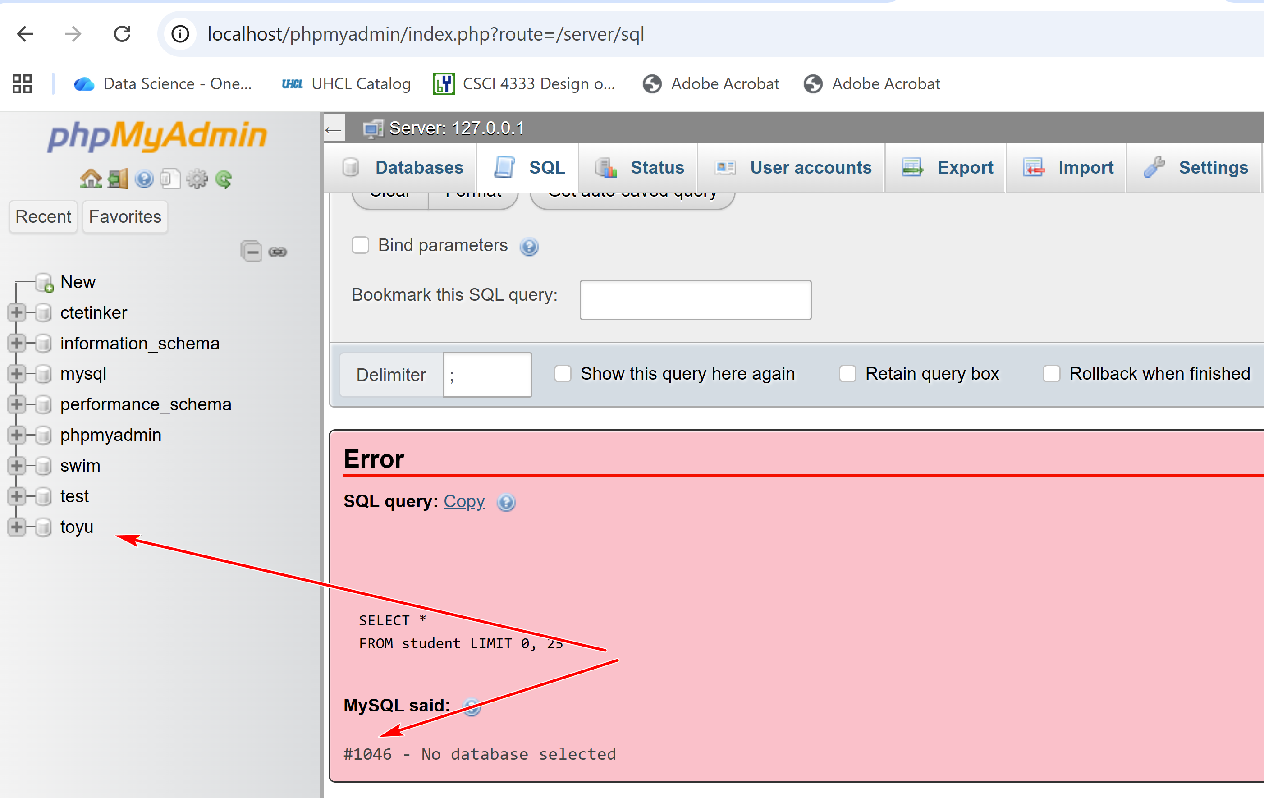

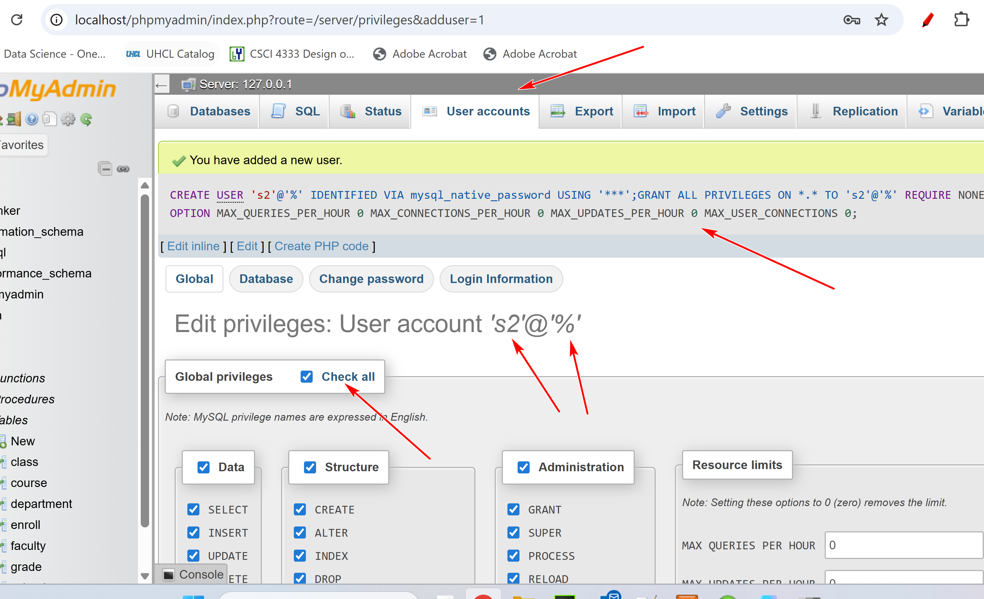
Two accounts:
S2@%: username@hostname (% matches any IP address)
s2@localhost: on top of ip.

F25 HW #1
[1] Show the stuId, name, major, and minor of all students who are majoring in
CSCI, CINF or ITEC.
+--------+-----------------+-------+-------+
| stuId | name | major | minor |
+--------+-----------------+-------+-------+
| 100000 | Tony Hawk | CSCI | CINF |
| 100001 | Mary Hawk | CSCI | CINF |
| 100002 | David Hawk | CSCI | ITEC |
| 100003 | Catherine Lim | ITEC | CINF |
| 100004 | Larry Johnson | ITEC | NULL |
| 100005 | Linda Johnson | CINF | ENGL |
| 100006 | Lillian Johnson | CINF | ITEC |
+--------+-----------------+-------+-------+
7 rows in set

