CSCI 4333.2
Annotation
Introduction to the course
CSCI 4333
by K. Yue

Python
Javascript
SQL: MySQL
XAMPP: Server Software Package: Development, not production
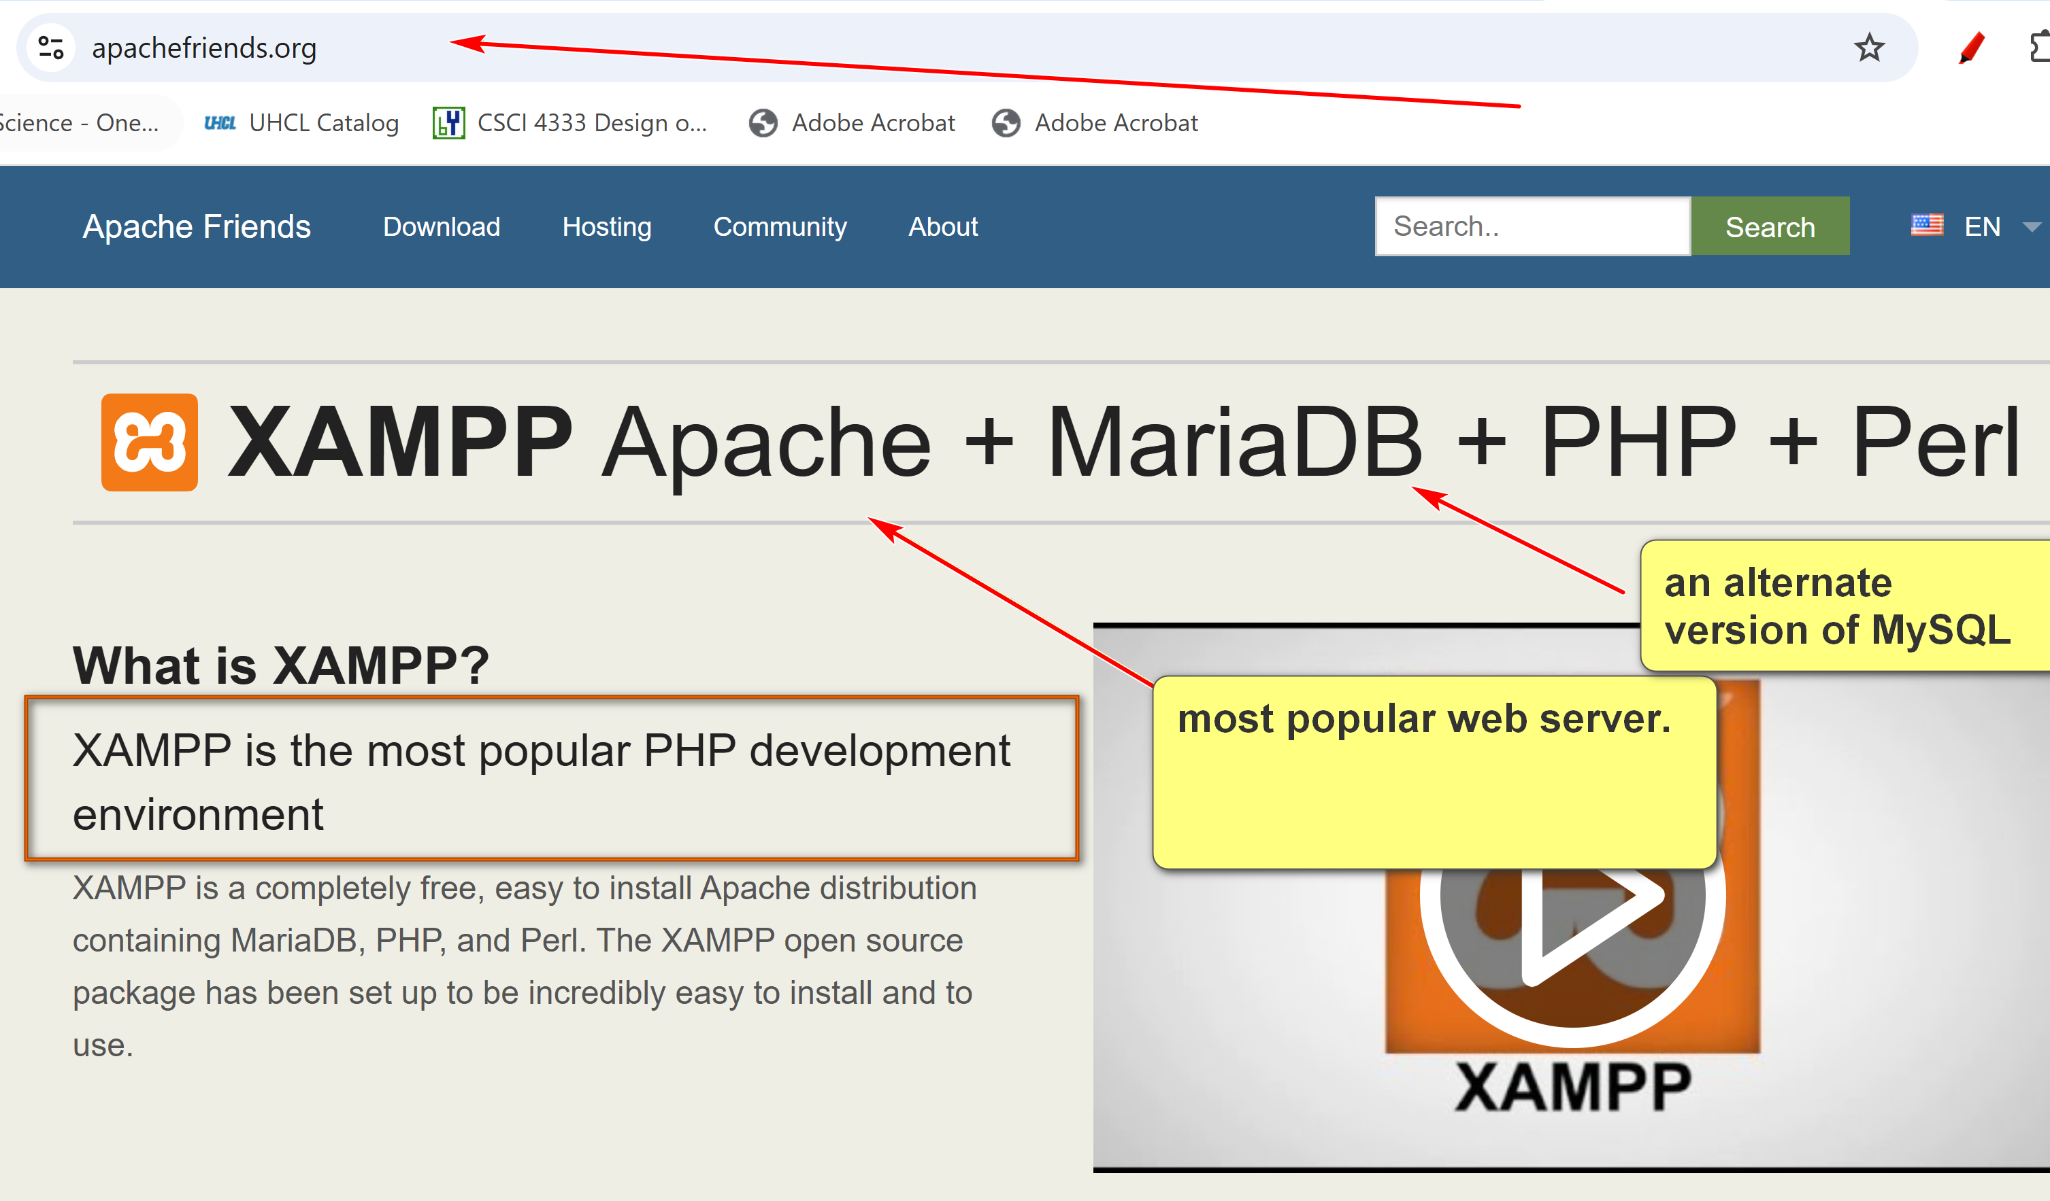

1. Promotion
- This course is (hopefully) one of the more useful CS/DS courses for students.
- World data is estimated to double every two years.
  - Q: what is source?
  - Q: Implications?
    - 10 years -> 32
    - 20 years -> 1,024 times.
    - Current data is 0.1% of the data of 20 years later.
2. How to be successful in the course
General Course Suggestions:
- Course expectation is demanding.
- Please consider forming the habit of listening carefully and asking a lot of questions.
General Professionalism:
- Attitude
- Be considerate.
- Be helpful and useful to others.
- Be a good listener.
- Be responsive.
- Hardworking
- Attention to details.
- Focus: uni-tasking.
Some general tips:
- Engagement: Participate. Ask questions, a lot of them. Help others. Plan ahead.
- Preparation: start as early as possible and do not fall behind.
- Don’t copy and paste. Instead, copy, integrate, and apply.
- SEE-I: State, Elaborate, Exemplify and illustrate. To gauge one’s understanding.
  - State: the primary concept in your words.
  - Elaborate: supporting concepts and ideas in your words.
  - Exemplify: construct concrete exampes.
- Form good habits.
Some good traits of Computer and Data Scientists:
- Habits of trying to make sense of stuff.
- Intellectual curiosity.
- Tinkering and experimentation.
- Open-minded, not dogmatic.
- A large tool set.
3. Resources
- Companion materials of our textbook: please consult the course page in Canvas for additional resources related to the textbook.
- Contents of the course will be based mostly on
  - Lecture notes posted in the course website: ../../index.html.
  - Classroom demonstrations.
  - Assignments.
- Please read the appropriate pages in the textbook and lecture notes in this site before coming to the class.
- Document your learning. Bring a notebook to the class. Otherwise, it may be a good idea to print out the notes and bring them to the class so you can make notes during the class.
4. Introduction
- Persistent data is the backbone of many applications.
- Three main choices of storing persistent data:
  - Files
  - Databases: focus of this course.
  - Cloud-based storage and database.
- Some advantages of DBMS (according to Ricardo, the optional textbook of this class):
  - Sharing of data
  - Control of redundancy
  - Data consistency
  - Improved data standards: common format to easy development and communications.
    - File Systems: file type is a data format
    - DB: few data standards; SQL Ansi standard.
  - Better data security
  - Improved data integrity
  - Balance of conflicting requirements
  - Faster development of new applications
  - Better data accessibility
  - Economy of scale
  - More control over concurrency:
    - State: allow a good number of concurrent processes should work correctly together.
    - Elaborate: Concurrent access can be controlled by locking.
    - Example: many tasks in Windows (coarse concurrent control); a program may lock a file so other programs cannot access. DB can allow many tasks to access the same DB.
  - Better backup and recovery procedures
- How do we make sense of these 12 different advantages?
  - Different textbooks may have different collections of the advantages of DBMS because of different classifications.
  - No need to memorize them.
  - Better to assimilate them and construct your own list.
  - Make your own notes. Use SEE-I (In your own words, state, elaborate, and exemplify with examples, and illustrate the concept.)
    - However, do not overuse metaphors.
  - Learning through documentation, communications, and teaching.
- What are some disadvantages of DBMS?
  - Complexity
  - Cost
  - Learning curve
  - Possible single points of failure and bottleneck

5. A Simple Introduction to the Relational Model
- Relational databases are the most popular databases: https://db-engines.com/en/ranking. It is based on the relational model.
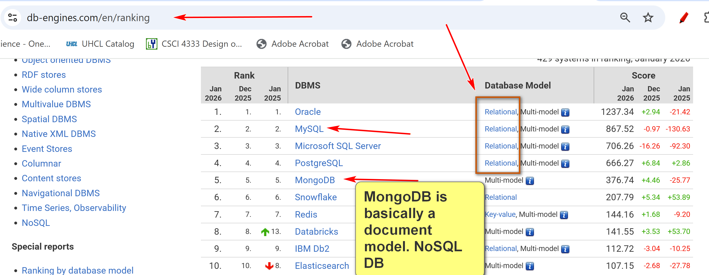
- There are many other data models: e.g. document model, key-value, wide-column, …

- In layman's term: A table (relation) is the basic unit of a relational database.
  - A relational DB contains a collection of tables.
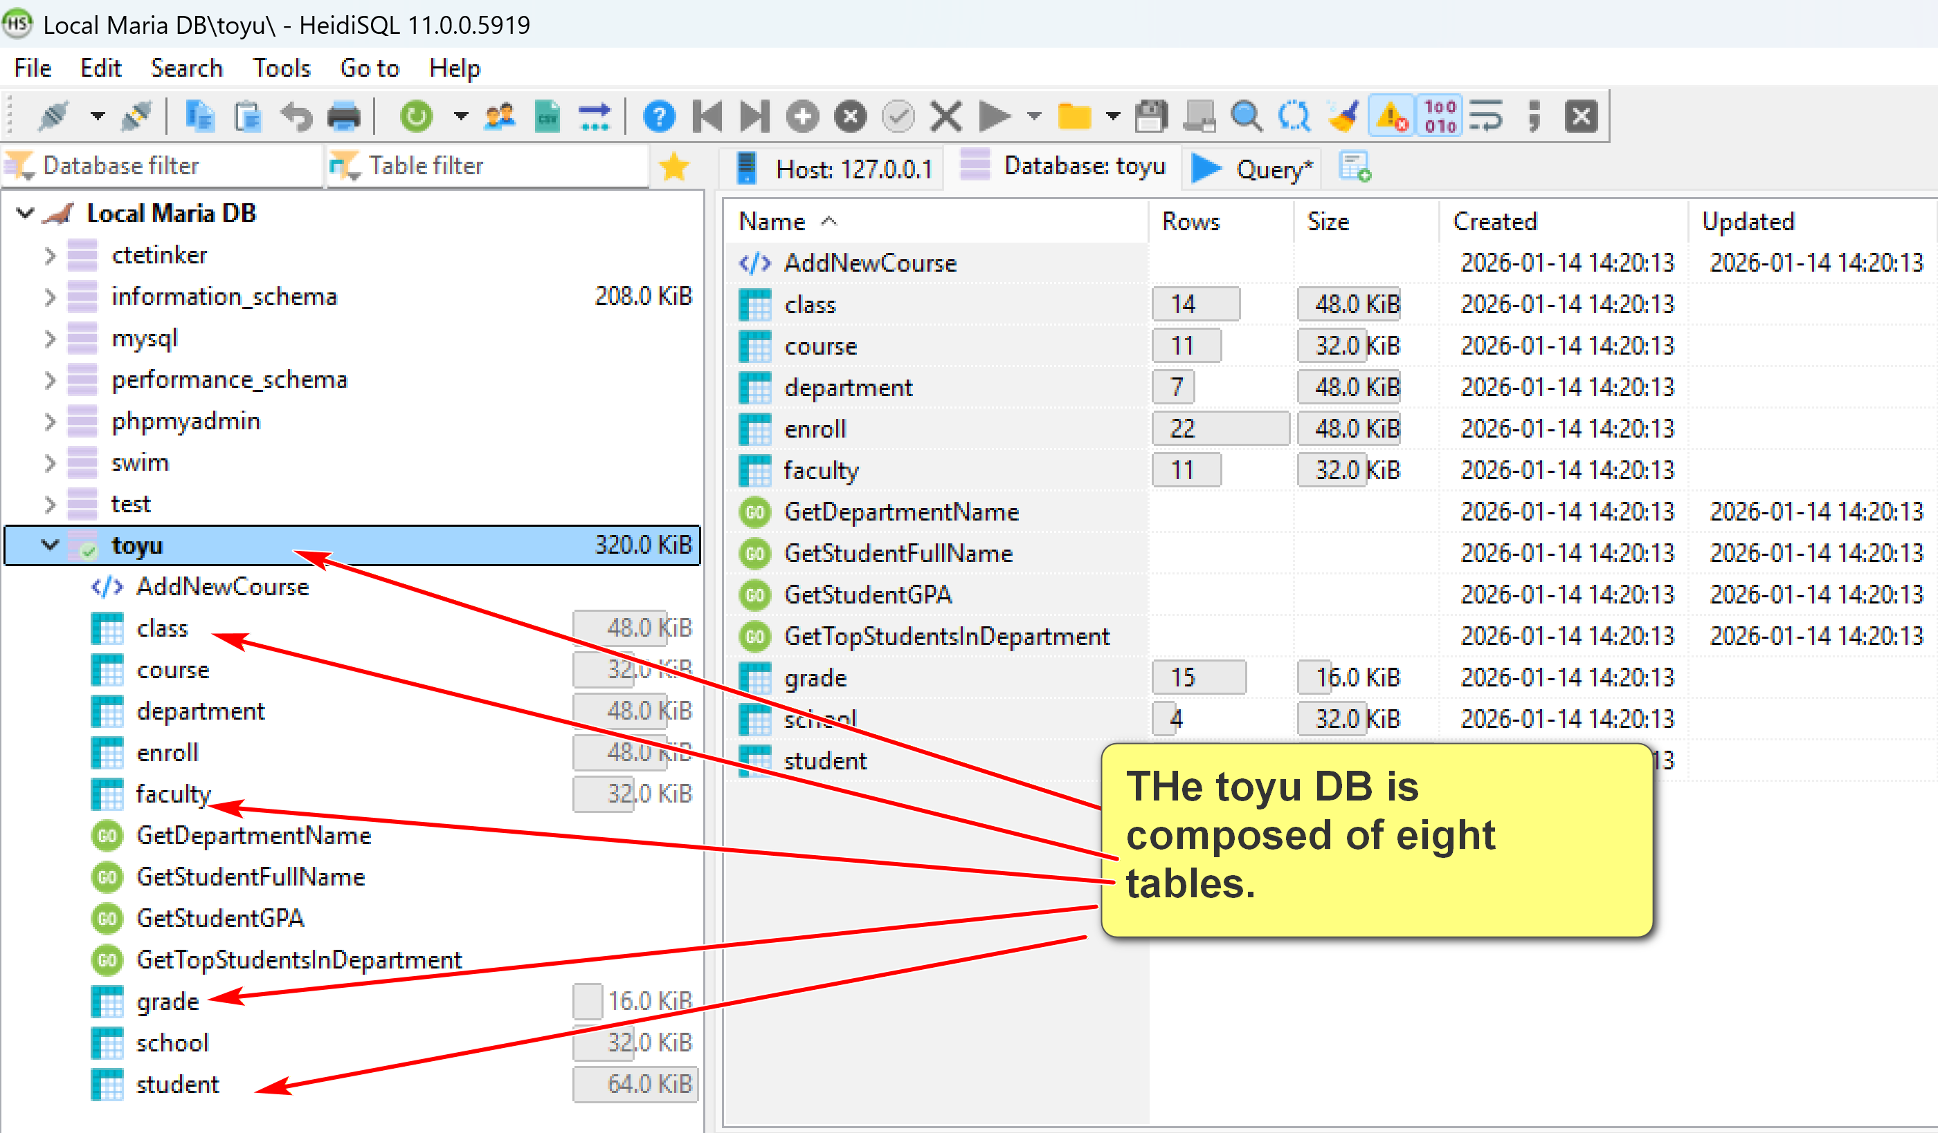
- A table is composed of many rows (tuples).
  - Each row stores information about an object, entity, concept, …
- Each row has many column (attribute) values.
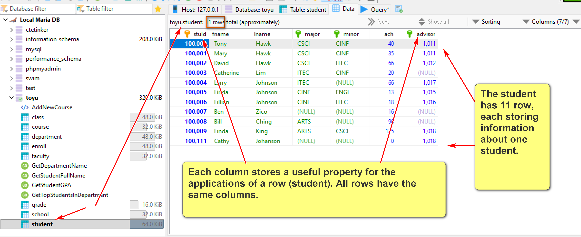
IN toyu:
A class is an offering of a course (identified by courseId) in a semester taught by a faculty (identified by facId) in a room.
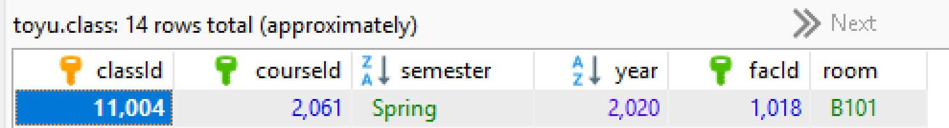
A row in the enroll captures the data of an enrollment: a student (identified by stuId) enrolled in a class (identified by classId) with a grade and a n_alerts.
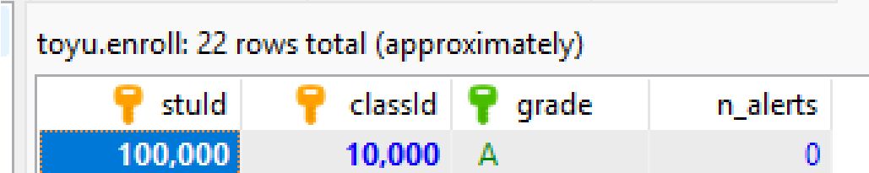
- A primary key is roughly a minimal set of columns in a table that uniquely identify a row.
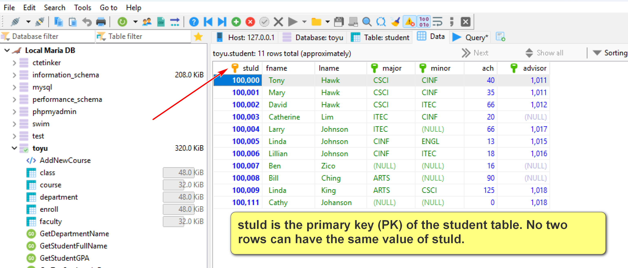

- Two tables can be related to each other by foreign keys. A foreign key is roughly a column in a table in which its value must be equal to the referenced value of the primary key in another table (called the paren or referenced table).
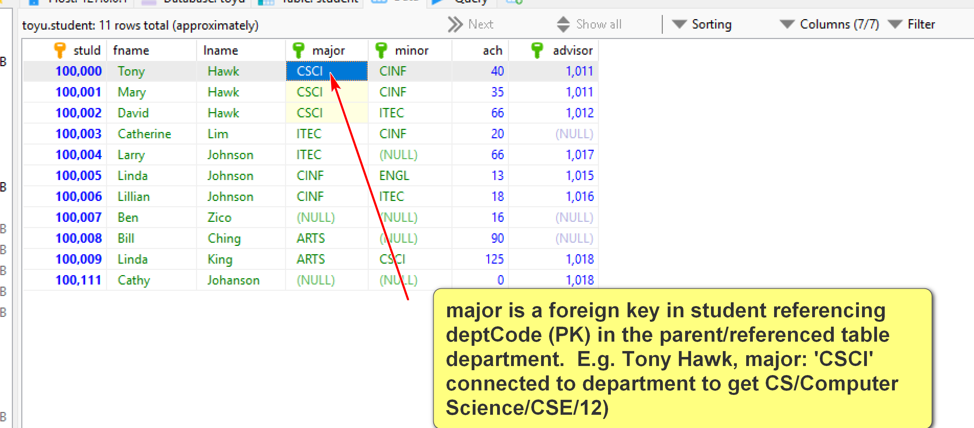

In student, advisor is FK referencing faculty(facId):
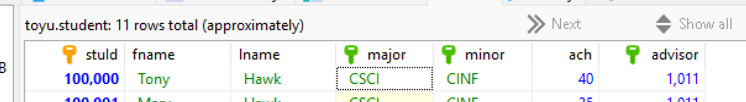
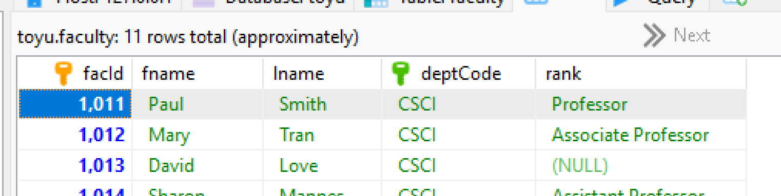
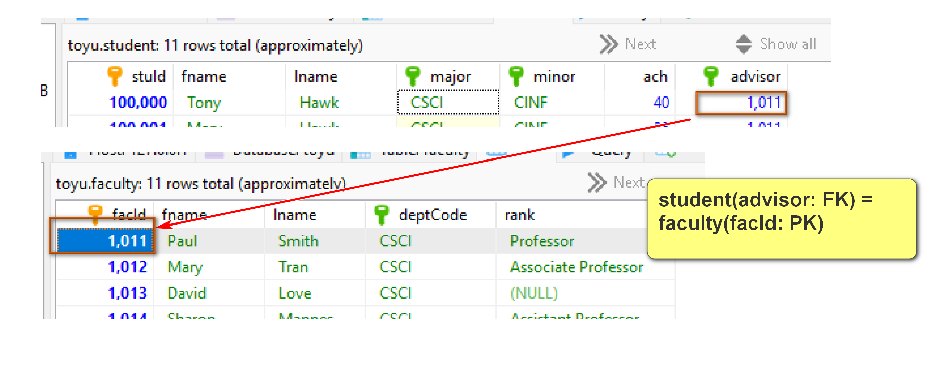
2.2 Simple schema and keys
Relations/tables (primary key underscored):
Grade(grade, gradePoint)
School(schoolCode, schoolName)
Department(deptCode, deptName, schoolCode, numStaff)
Faculty(facId, fname, lname, deptCode, rank)
Course(courseId, rubric, number, title, credits)
Class(classId, courseId, semester, year, facId, room)
Student(StuId, fname, lname, major, minor, ach, advisor)
Enroll(stuId, classId, grade, n_alerts)
Foreign keys:
1. Student(advisor) references Faculty(facId)
2. Student(major) references Department(deptCode)
3. Student(minor) references Department(deptCode)
4. Faculty(deptCode) references Department(deptCode)
5. Department(schoolCode) references School(schoolCode)
6. Enroll(stuId) references Student(stuId)
7. Enroll(classId) references Class(classId)
8. Enroll(grade) references Grade(grade)
9. Class(courseId) references Course(courseId)
10. Class(facId) references Faculty(facId)
11. Course(Rubric) references Department(deptCode)

- Relational DBMS is the most popular DBMS. Examples:
  - DB-engine ranking: https://db-engines.com/en/ranking
  - Top 10 DBMS in Data Science: https://towardsdatascience.com/top-10-databases-to-use-in-2021-d7e6a85402ba
- SQL is the 'glue' in many DB systems.
Classroom discussion
Please ask questions about the toy University DB (toyu)

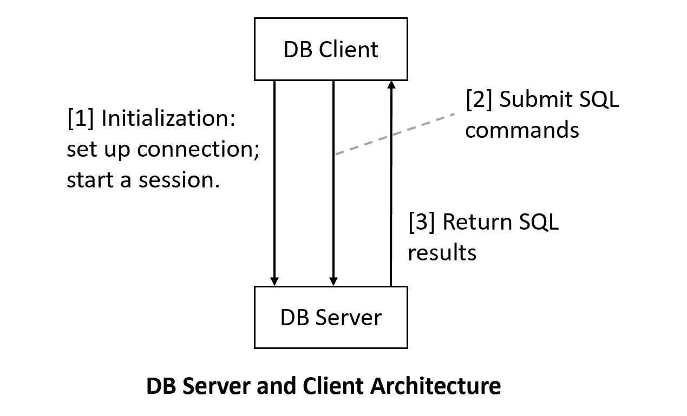
XAMPP/Maria DB: DB server:
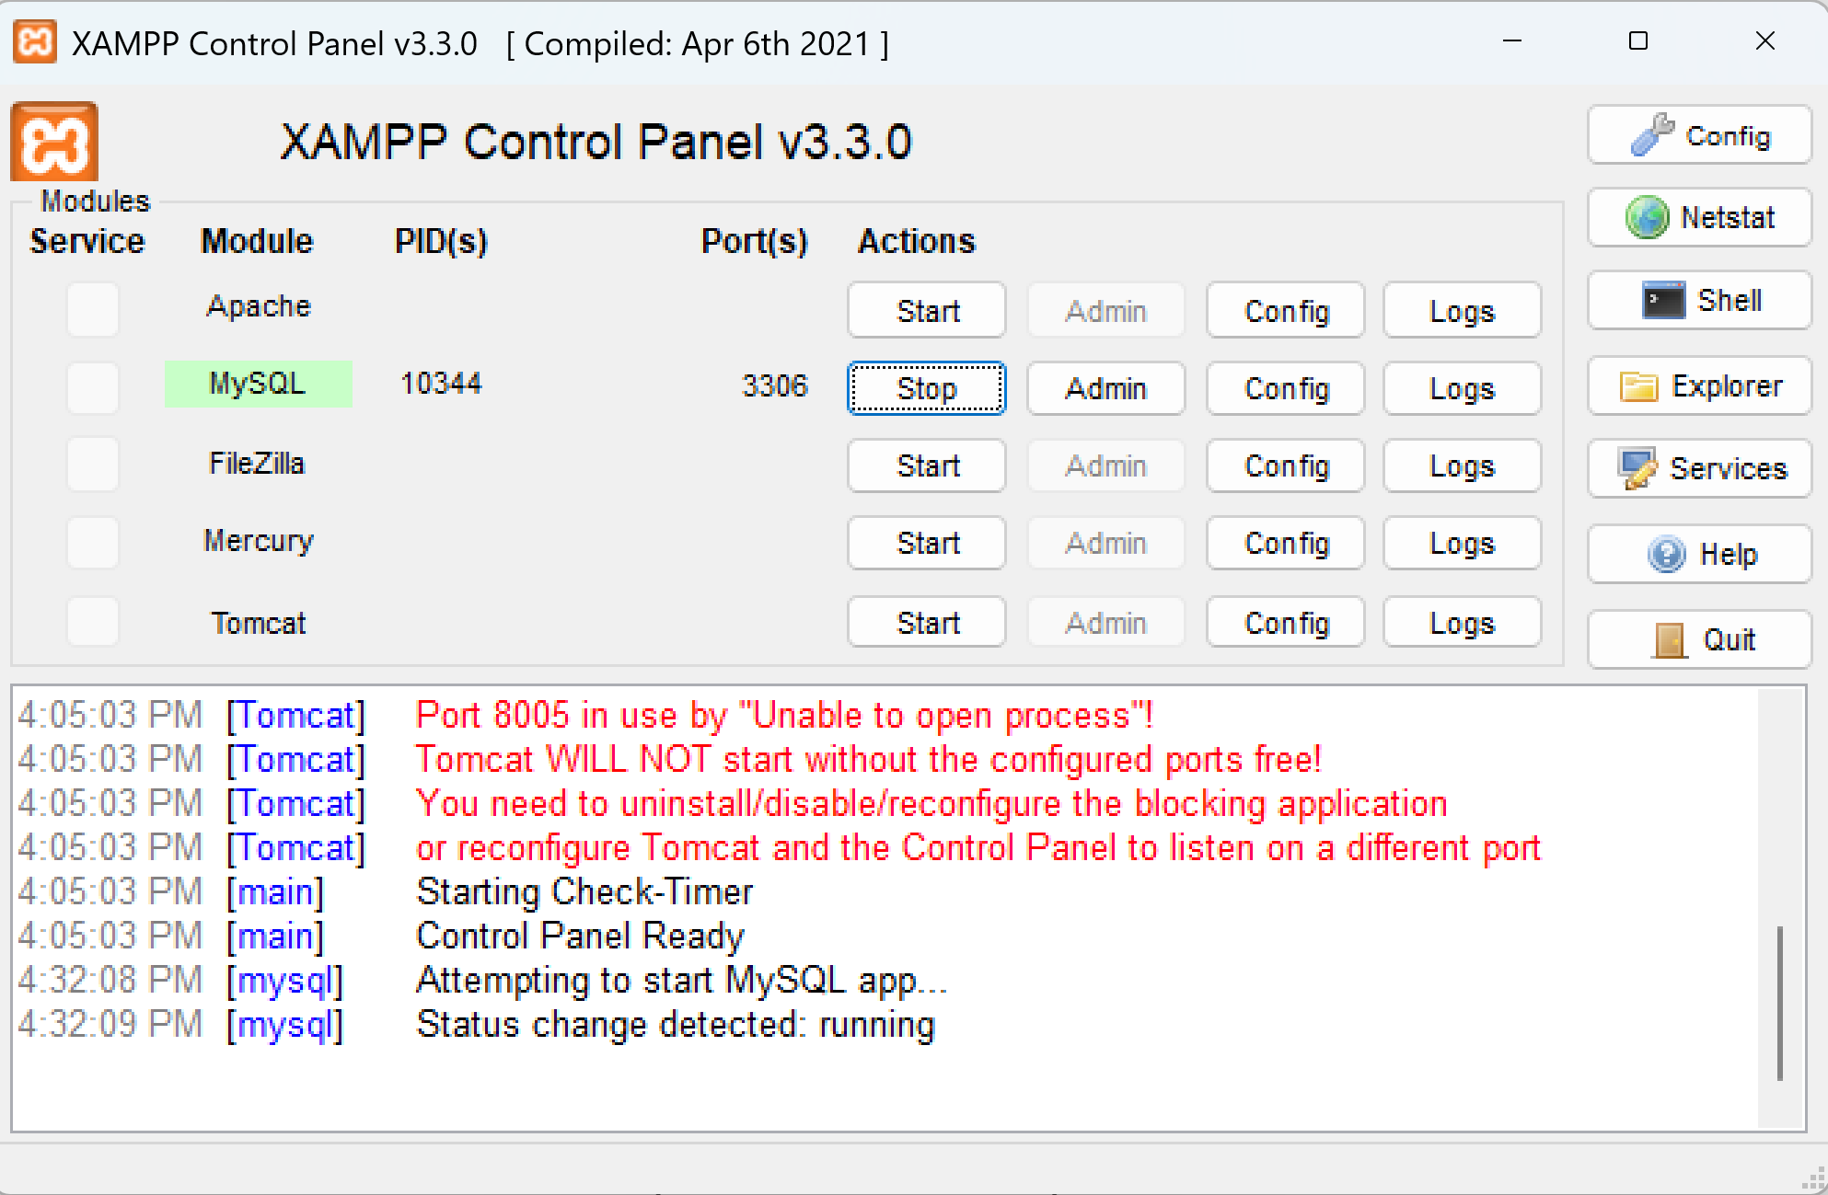
Client: HeidiSQL
2nd Client: MySQL prompt command line client

