Database Systems
Fall 2025
Homework #2 UML Modeling
Download and install the student version of Astah's UML Editor: http://astah.net/download. Astah provides it free for students. This is one of the best free UML editors available. It has some restrictions but should be more than sufficient for our class. Another good alternative is to use Visual Paradigm’s community version. This is free but may leave a watermark when you export your model diagram to images or PDF. Thus, you may just take a screenshot of the model instead.
The homework assignment is to model a drastically simplified database application described below.
Multiplicities for attributes and associations should be as specific as possible. You may or may not explicitly specify the attribute multiplicity of 1..1 (or just 1), which is assumed to be the default. Documenting attribute and association are optional, but they are encouraged when not trivial. For example, the roles or the names of associations may be displayed when appropriate. Operations for classes are not necessary. You may create user-defined types, such as SQL::Id, SQL::DateTime, SQL::Boolean, etc.
Save your files as h2.asta (Astah's file format) and h2_documentation.docx (optional; for additional information if needed). You may also include a PDF version of your class diagram: h2.pdf, especially if you are not using Astah.
Submit your homework through Canvas, including the ASTA and/or PDF files. If you are not using Astah, you must submit a PDF file.

Group Meet
Create a data model using an UML class diagram to support a portion of a drastically simplified Meetup-type social media network: Group Meet (GM). It only supports a very limited set of functions with drastic simplifications. Make additional reasonable assumptions if necessary.

GM allows members to form groups for gathering events. A GM Member must have a name and an email address to join GM.
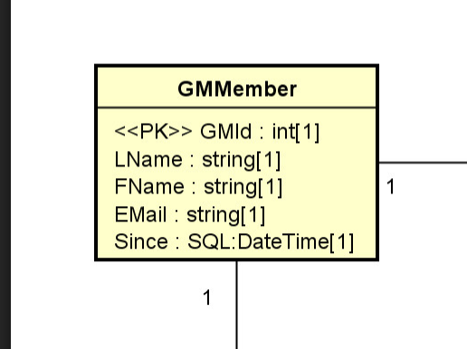

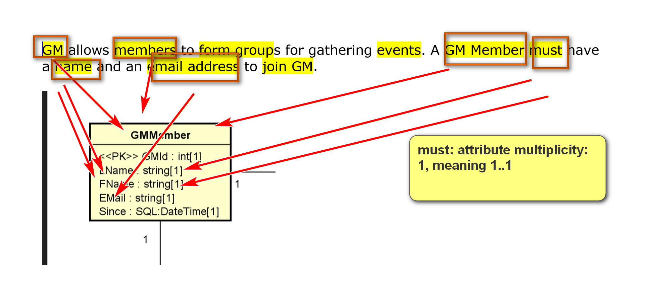
GM allows members to form groups for gathering events. A GM Member must have a name and an email address to join GM.
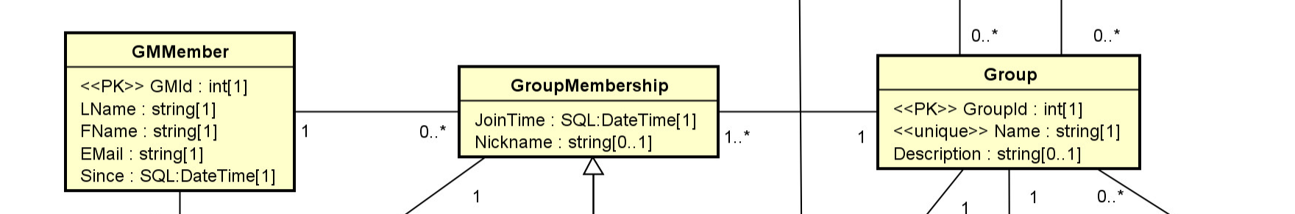
E.g.
GMMembers: M1, M2, M3, M4
Groups: G1, G2, G3, …
Membership: roin/form, … (association between a GMMber object and a group object)
M1 joins G1, G2
M2 joins G1, G3<
M3 joins G1
M4: no group
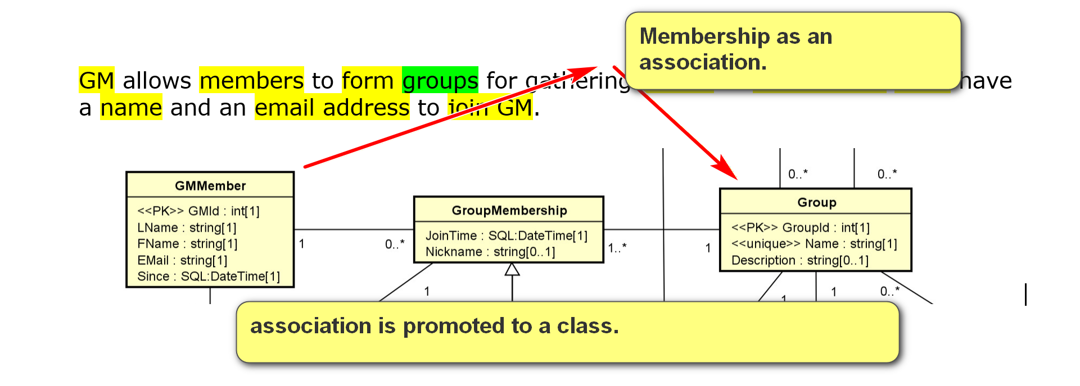
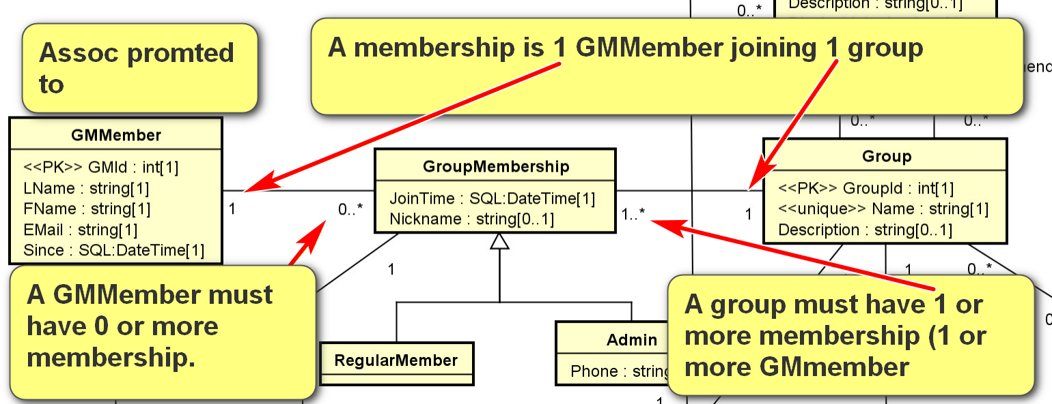
A unique member GMId is created automatically for a new member, and the join time is recorded.
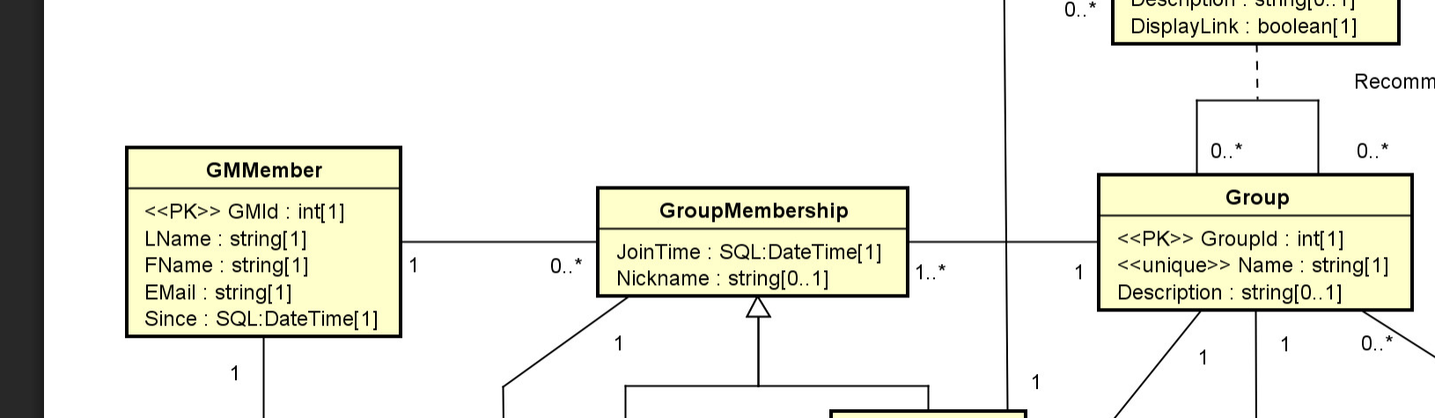
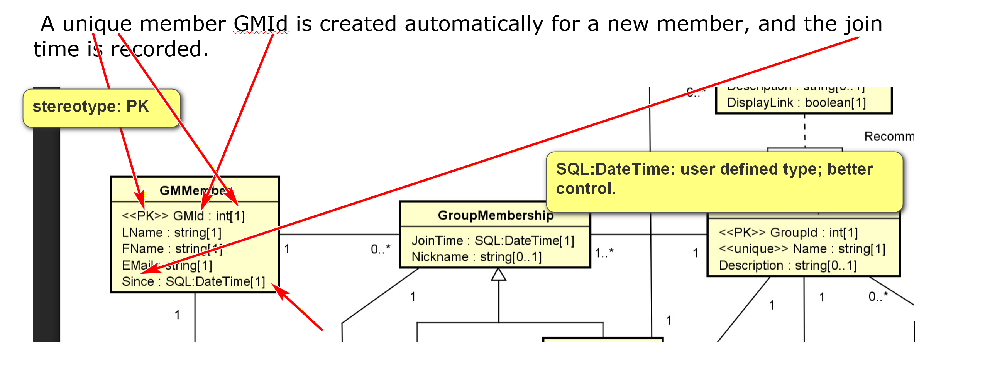
Use user-defined types to be more specific.
Members can form groups. A group has a unique id and a unique name. There may be a description for a group.
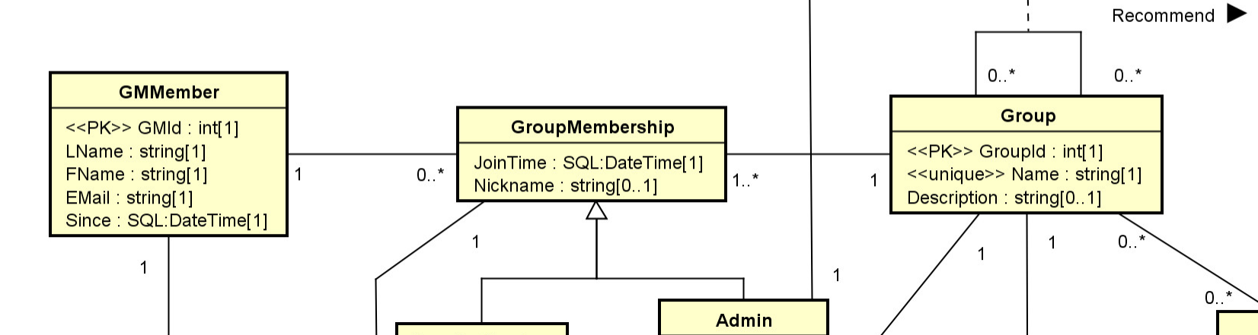

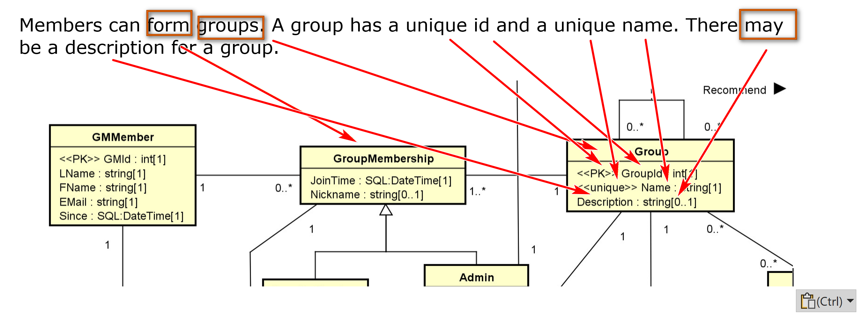

GM members can be a regular member or an admin in a group. If a GM member is an admin, a phone number must be stored. Note that the phone number of an admin in one group may be different from the phone number of the same GM member serving as an admin in a different group.
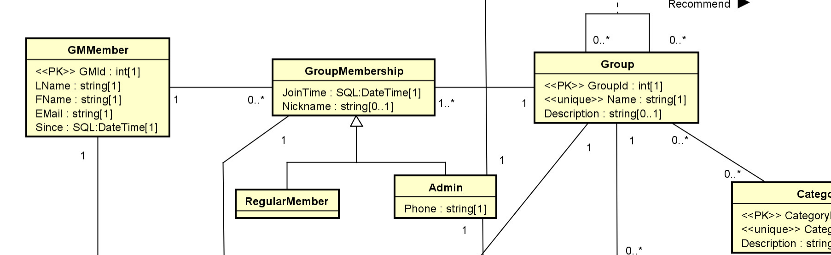
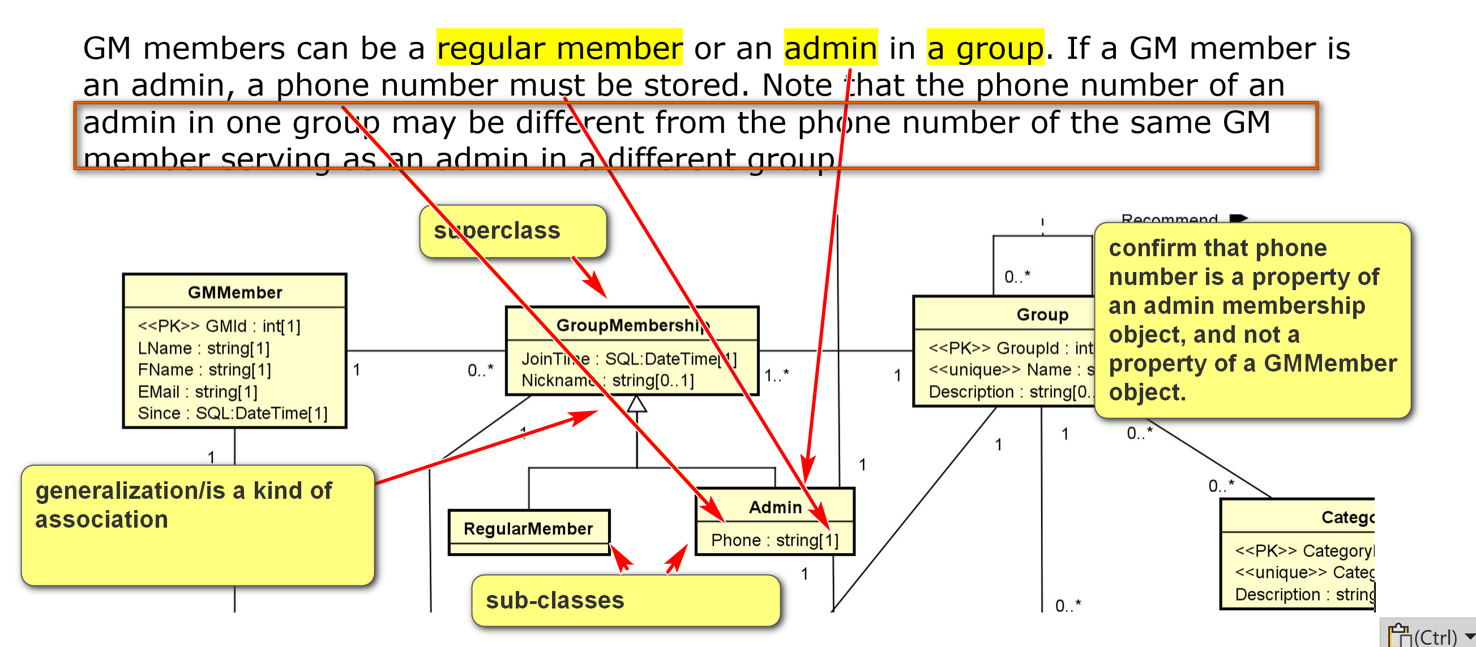

When a GM member joins a group, a nickname may be recorded. A GM member can join any number of groups.
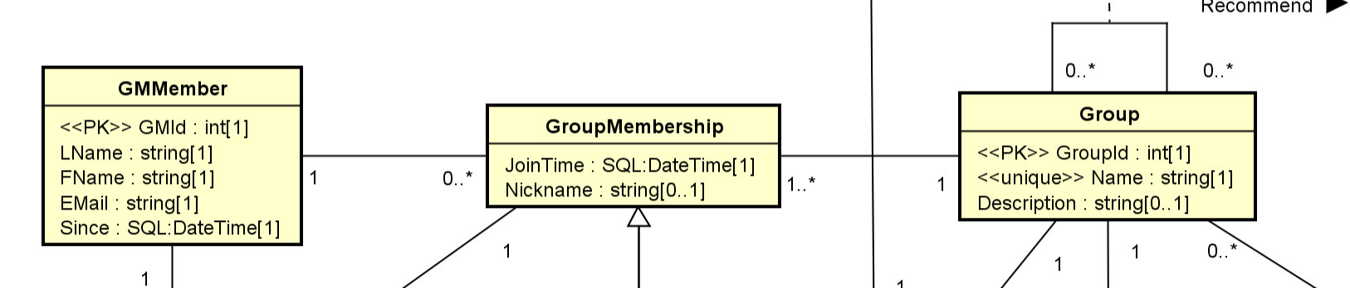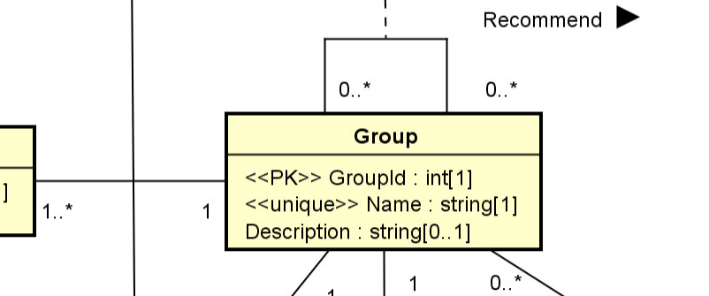
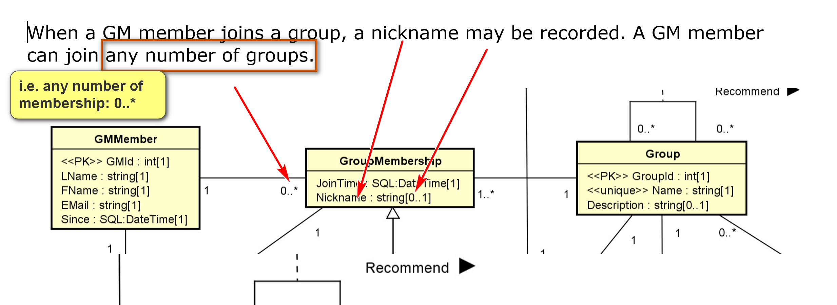

A group may belong to multiple categories, such as 'dessert', 'sport' and 'computer science'. For example, the group ‘Clear Lake Coffee-Fueled Database Developers' may belong to both 'drink' and 'computer science'. A category has a unique id, for examples, 103:'drink', 87:'computer science', etc. A category may have a description.
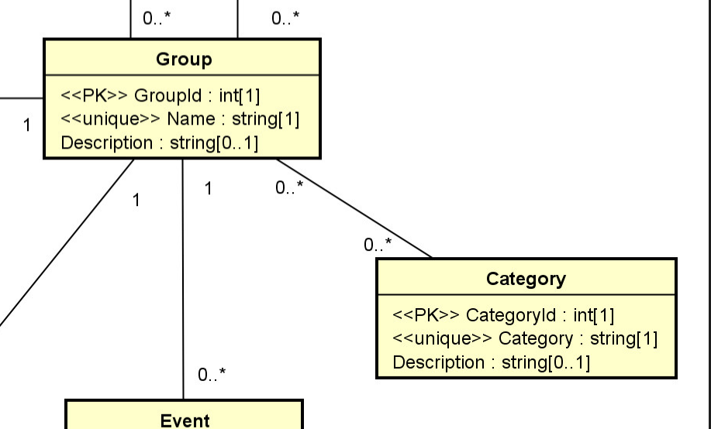
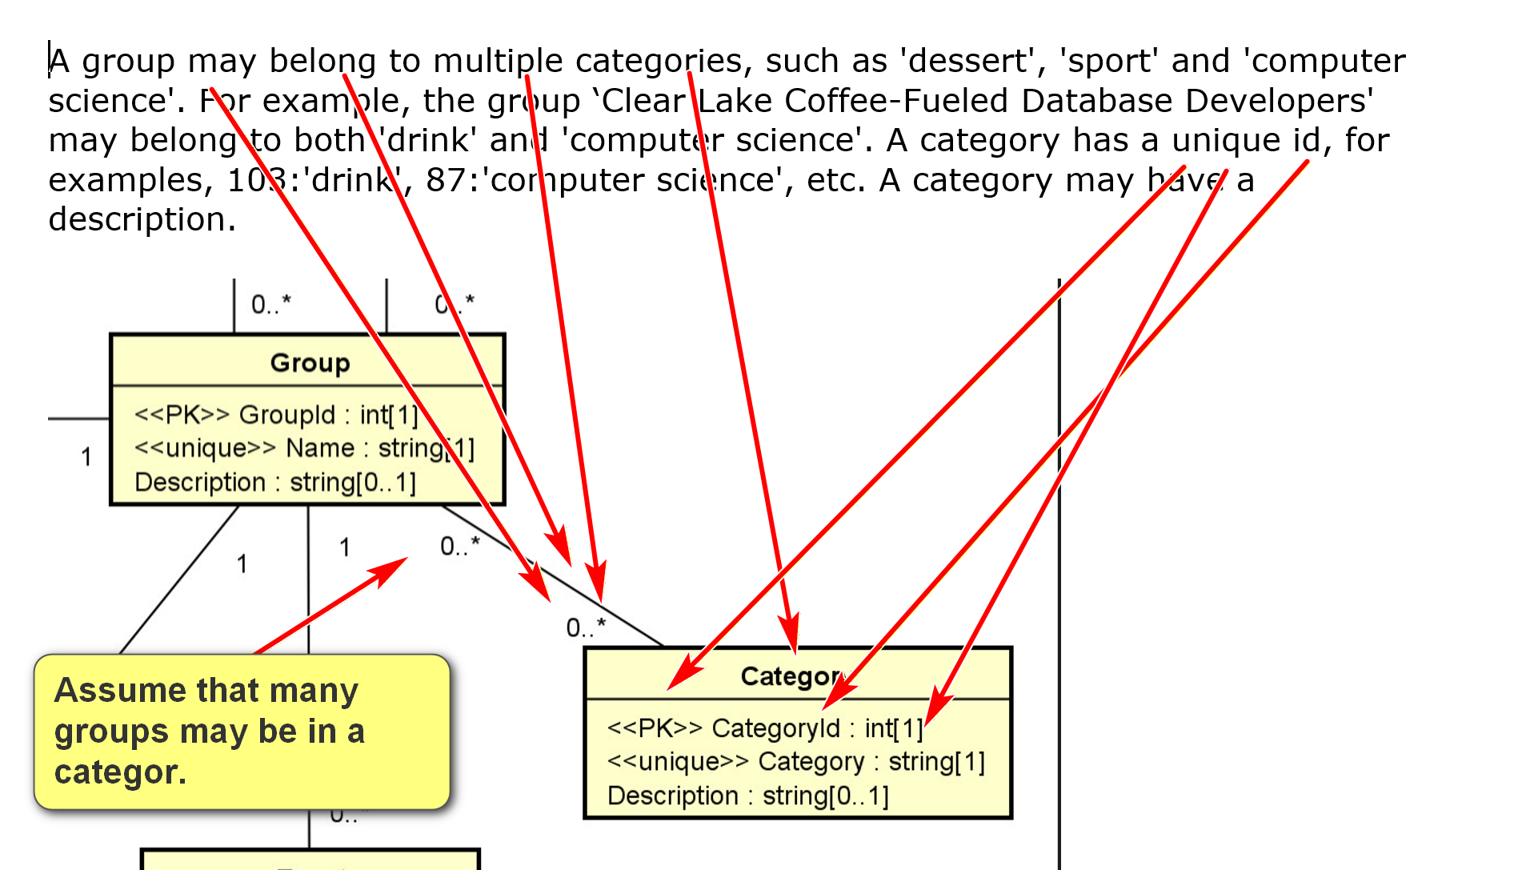

A group can recommend any number of other groups, A description may be stored for a recommendation. For example, the 'Clear Lake Coffee-Fueled Database Developers' group may recommend two other groups: 'Clear Lake Computer Science Faculty' and 'Houston Cafe." Only an admin of a group can add a recommendation by the group. The admin who adds a recommendation should be recorded in GM. When group A recommends group B, it can select whether a link to group B will be displayed in the page for group A or not.
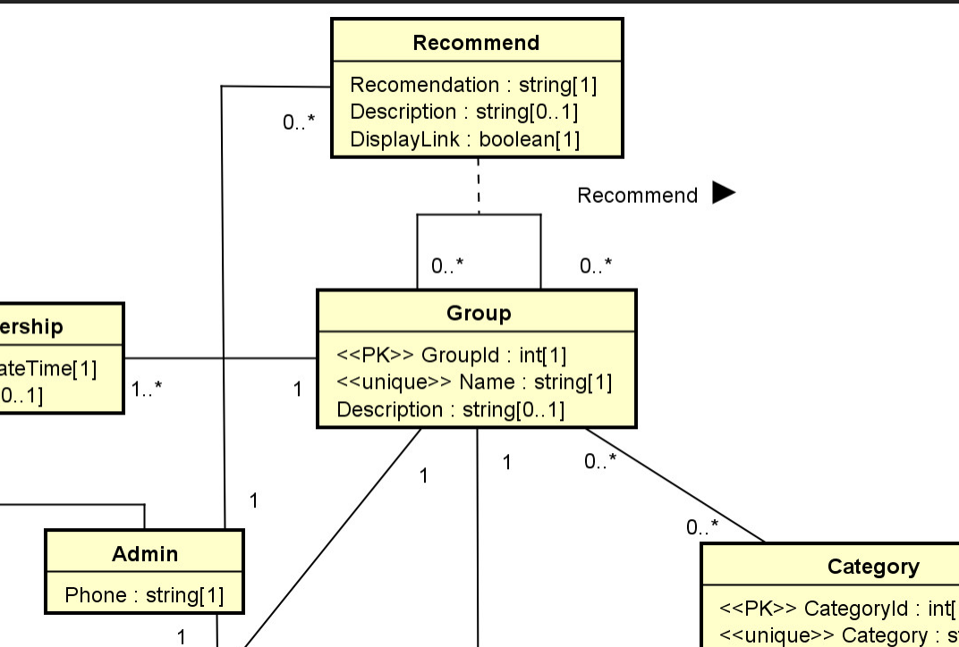

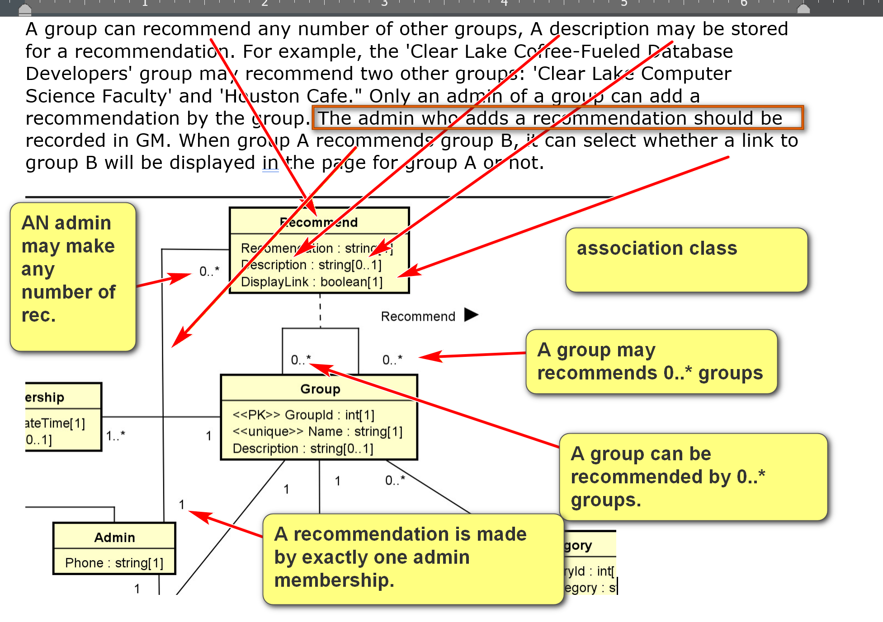
A group can set up any number of events. An event has a unique id, an event name, and meeting place, date, and time. There may be a description.
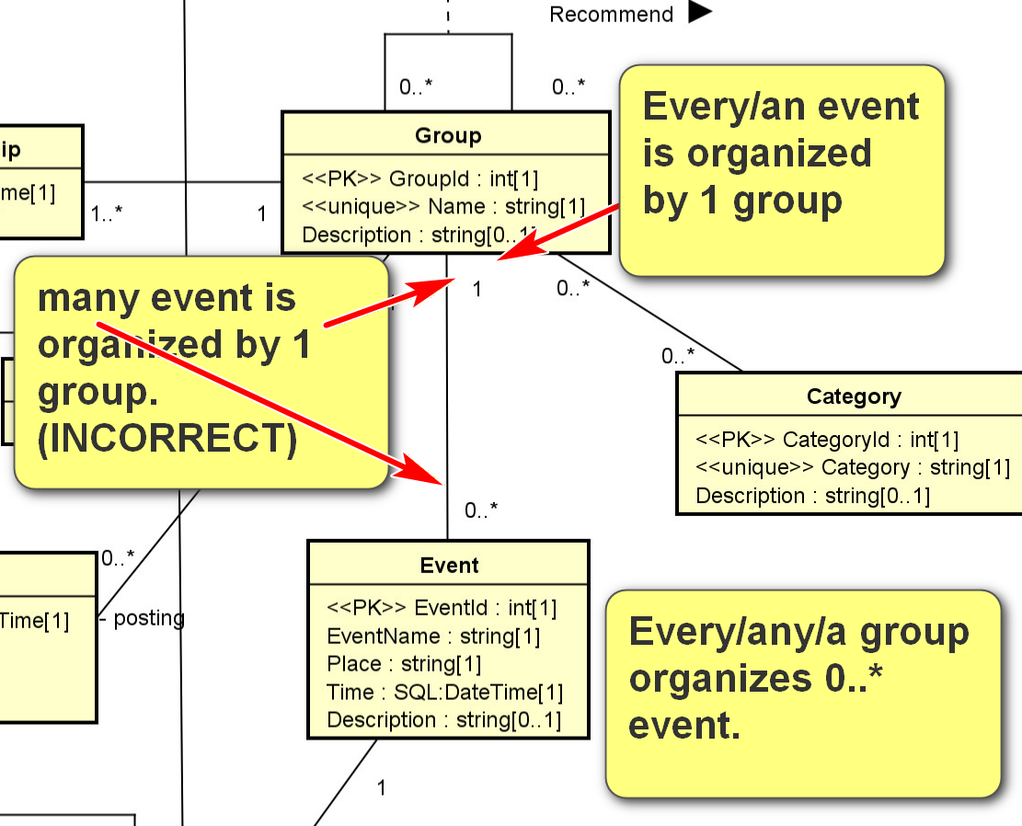

Group members can post on the group's web pages. A posting in the group's page must have a post time, subject, body, and priority. There are two kinds of postings. An event posting is associated with a specific event. Only a group administrator can add event postings. Event postings are displayed differently than regular postings in the group page as they are more important. A regular group member can add postings (called regular postings) to the group, but not event postings. An administrator can add both kinds of postings. A GM member that is not a member of a group cannot add a posting on the group. An event posting must have a posting type, selected from a predefined list, such as 'initial announcement', 'update', 'cancellation', 'completion', ‘miscellaneous’, etc.
Any GM member can post a comment on any group's postings and comments. The time and text of the comments are displayed in the group web pages in some ways. A comment may be made on a posting, which is at the top level of the group's page, or it can be on another comment.

