CSCI 4333.1
Annotation
2/16/26
Transforming UML Class Diagrams to Relational Models
by K. Yue
1. Transforming OO Model to the Relational Model
- Once a conceptual OO data model is constructed, it needs to be mapped for implementation in the selected logical database model. See IntroDataModeling.html.
- If a relational DB is used, the mapping will be from OO (classes, attributes, associations, etc.) to relational schema (relations, attributes, keys, etc.)
- Note that the relational model and the OO model are very different, even though diagrams representing the two models look similar (there are only a finite number of common suitable shapes).
- Computer-Aided Software Engineering (CASE) tools or DB modeling tools may provide varying degrees of facilities for automatic generating relational schema and corresponding SQL statements, mostly CREATE TABLE.
- However, it is important to understand the mechanism that a tool uses to generate the relational schema and make adjustment if needed.
1.1 Model Transformation

The problem is: Source Model --> Target Model.
- Source Model: UML OO
  - Basic elements:
    - Class
    - Attribute: can be multi-valued.
    - Association
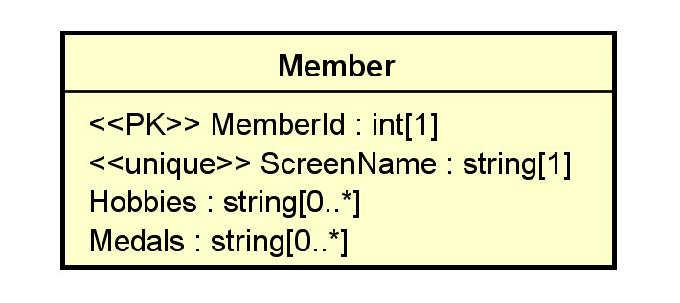
DB stores 0..* hobbies and 0..* medals of a member.
M1 has hobbies “running, eating, thinking”.
  - Secondary elements:
    - Object
    - Multiplicity
    - Data type
    - Default value
    - Constraint
    - Stereotype for RDB extensions: e.g., candidate keys, primary keys, unique, derived, nullability, etc.
    - ...
- Target Model: Relational Model
  - Basic elements:
    - Relation/table
    - Attribute (column/field): It should be single-valued (atomic: cannot be broken into smaller units with individual meaning). Otherwise, first normal form (1NF) is not satisfied.
  - Secondary elements:
    - Row (tuple)
    - Data type
    - Nullability
    - Constraint
    - Candidate key
    - Primary key
    - Foreign key
    - Index
    - ...
- There are only two basic elements in the targeted model to consider. Data in the relational model can be stored only in two ways:
  - relation:
    - more flexible,
    - can hold attributes to store a collection of logically related data
    - more complex.
  - attribute:
    - should be single-valued (if good design, i.e., the first normal form, is to be assured.)
    - Simple, possibly faster
    - Thus, if attributes are sufficient in model transformation, they are preferred.
- Different RDBMS provide different features.
    - Thus, the targeted RDB model is not universal.
    - It is necessary to define vendor-specific transformation rules.
2. Transformation Rules
- We present a set of mapping rules below. It is not meant to be complete or universal.
- Examples of comparable transformation rules:
  - A relative simple one: http://web.fe.up.pt/~ssn/2010/lbaw/slides/lbaw-uml2rel.eng.pdf a
  - A more elaborated one based on agile methodology: http://www.agiledata.org/essays/mappingObjects.html.
- Do not mechanically follow these rules. Instead, understand the rationale behind the rules and adapt.
- All OO model details should be implemented in the targeted model in some ways.
  - database level: preferred.
  - middle layer level
  - application level
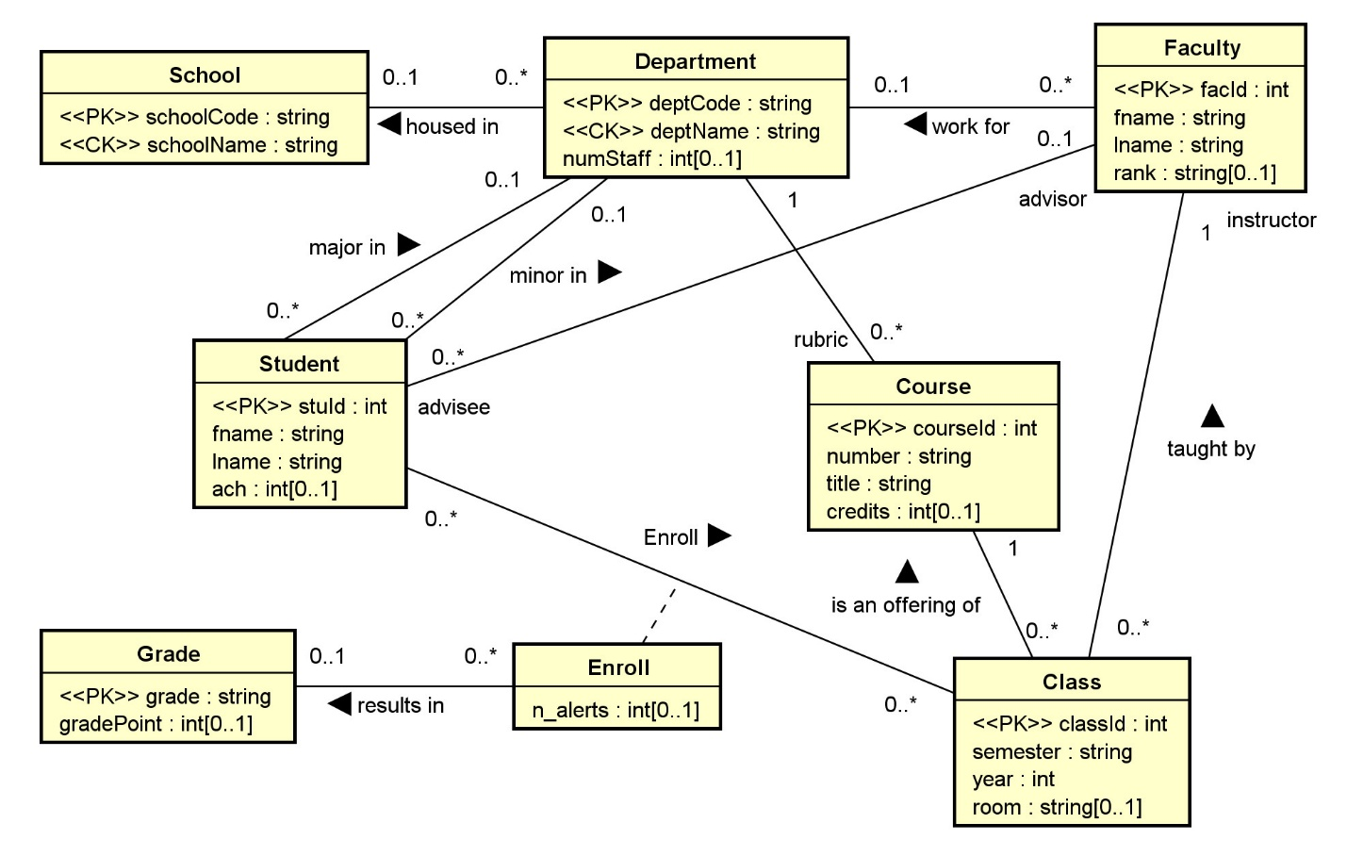
2.1 Classes
C1. A class C is mapped or transformed to a relation RC.
- Relations may later be merged and/or reorganized in design refinement and performance tuning.
- The relation may use the same name as the class.
- As a result, all infomration of an object of class C is stored as a row in RC.
In toyu: every class -> table (e.g. student, course, class, enroll,..)
Rationale:
- A class is a logical unit for encapsulating related data and a relation has the same property.
2.2 Attributes
Basic:
ATT1. Single-Valued Attributes. Map all single-valued attributes (with simple data types) of a class C as attributes of RC, the relation for the class C.

In toyu UML, every attribute is single-valued. They become attributes in the corresponding table.
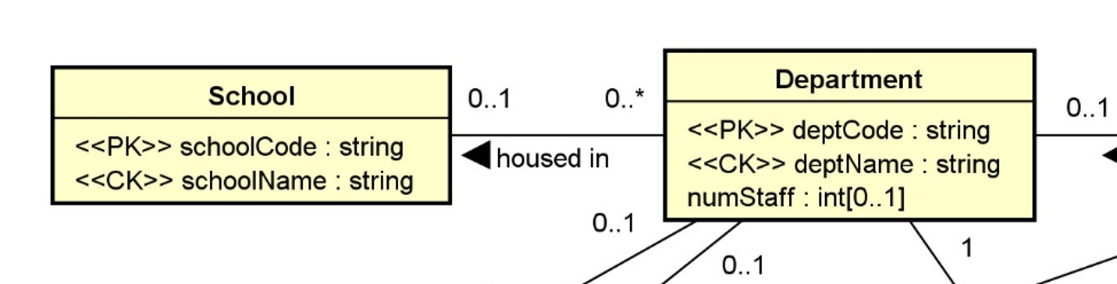

CREATE TABLE IF NOT EXISTS School (
schoolCode CHAR(3) NOT NULL,
schoolName VARCHAR(30) NOT NULL,
CONSTRAINT School_schoolCode_pk PRIMARY KEY (schoolCode),
-- alternate keys: [1] schoolName
CONSTRAINT School_name_ck UNIQUE (schoolName)
);

CREATE TABLE IF NOT EXISTS Department (
deptCode CHAR(4) NOT NULL,
deptName VARCHAR(30) NOT NULL,
schoolCode CHAR(3) NULL,
numStaff TINYINT NULL,
CONSTRAINT Department_deptCode_pk PRIMARY KEY (deptCode),
-- alternate keys: [1] deptName
CONSTRAINT Department_name_ck UNIQUE (deptName),
CONSTRAINT Department_schoolCode_fk FOREIGN KEY (schoolCode)
REFERENCES School(schoolCode)
);
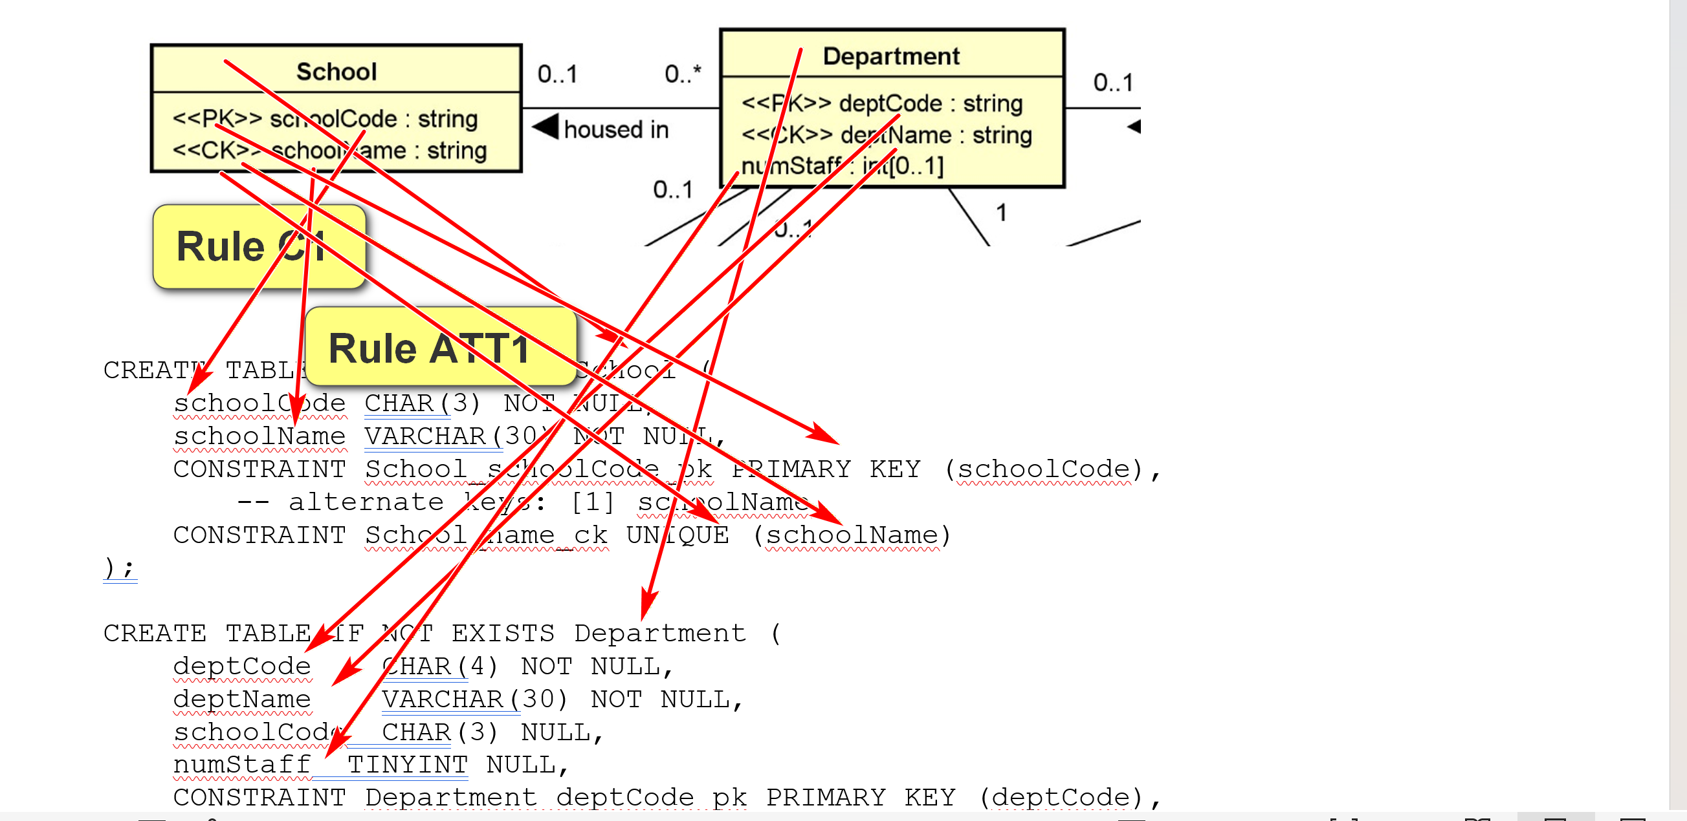

ATT2. Multi-Valued Attributes. For each multi-valued attribute A of the class C, create a new relation RCA containing the attribute A and the primary key, RCId, of the relation RC (which implements the class C).
- (RCId, A) is a composite candidate key.
- RCId is a foreign key referencing RC(RCId)
- A surrogate key, such as RCA_Id, may be created to serve as the simple primary key.
- The name of RCA should be meaningfully selected.
Secondary:
ATT3. Zero in Multiplicity. If the multiplicity of an attribute is specified, to handle the case of 0:
- If 0 is allowed in the UML model (e.g., 0..1, 0..* in the UML class diagram), the attribute is nullable. Add the NULL specifier in the column definition in the RDBMS. (NULL is usually the default)
- If 0 is not allowed, add the NOT NULL specifier in the column definition.
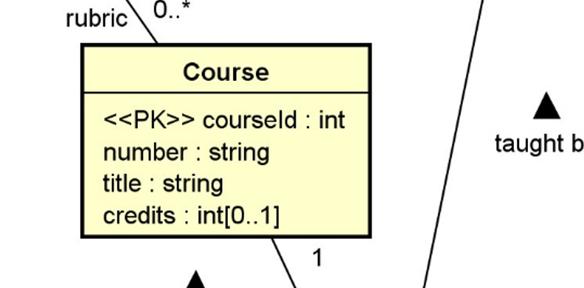
CREATE TABLE IF NOT EXISTS Course (
courseId INT NOT NULL,
rubric CHAR(4) NOT NULL,
number CHAR(4) NOT NULL,
title VARCHAR(80) NOT NULL,
credits TINYINT NULL,
CONSTRAINT Course_courseId_pk PRIMARY KEY (courseId),
CONSTRAINT Course_deptCode_fk FOREIGN KEY (rubric)
REFERENCES Department(deptCode));
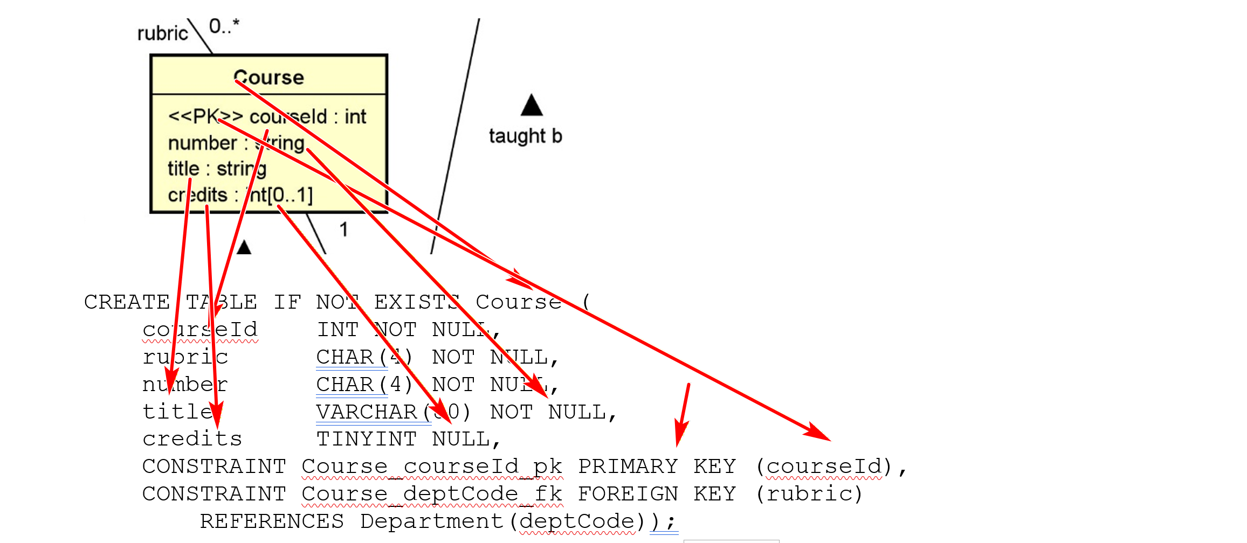
ATT4. Default Values. The default value of an attribute can be directly implemented in SQL DDL.
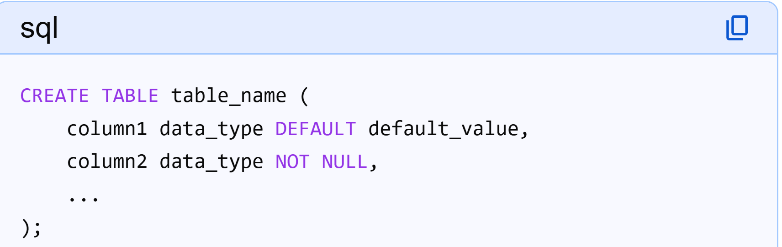
ATT5. Data Types. Data type mapping should be handled adequately, effectively, and consistently.
- In later modeling phases, one may use SQL data types of the targeted DBMS in the class diagram.
- If available, consider using user-defined data types in the targeted DBMS.
E.g. int in UML may be mapped to MySQL:
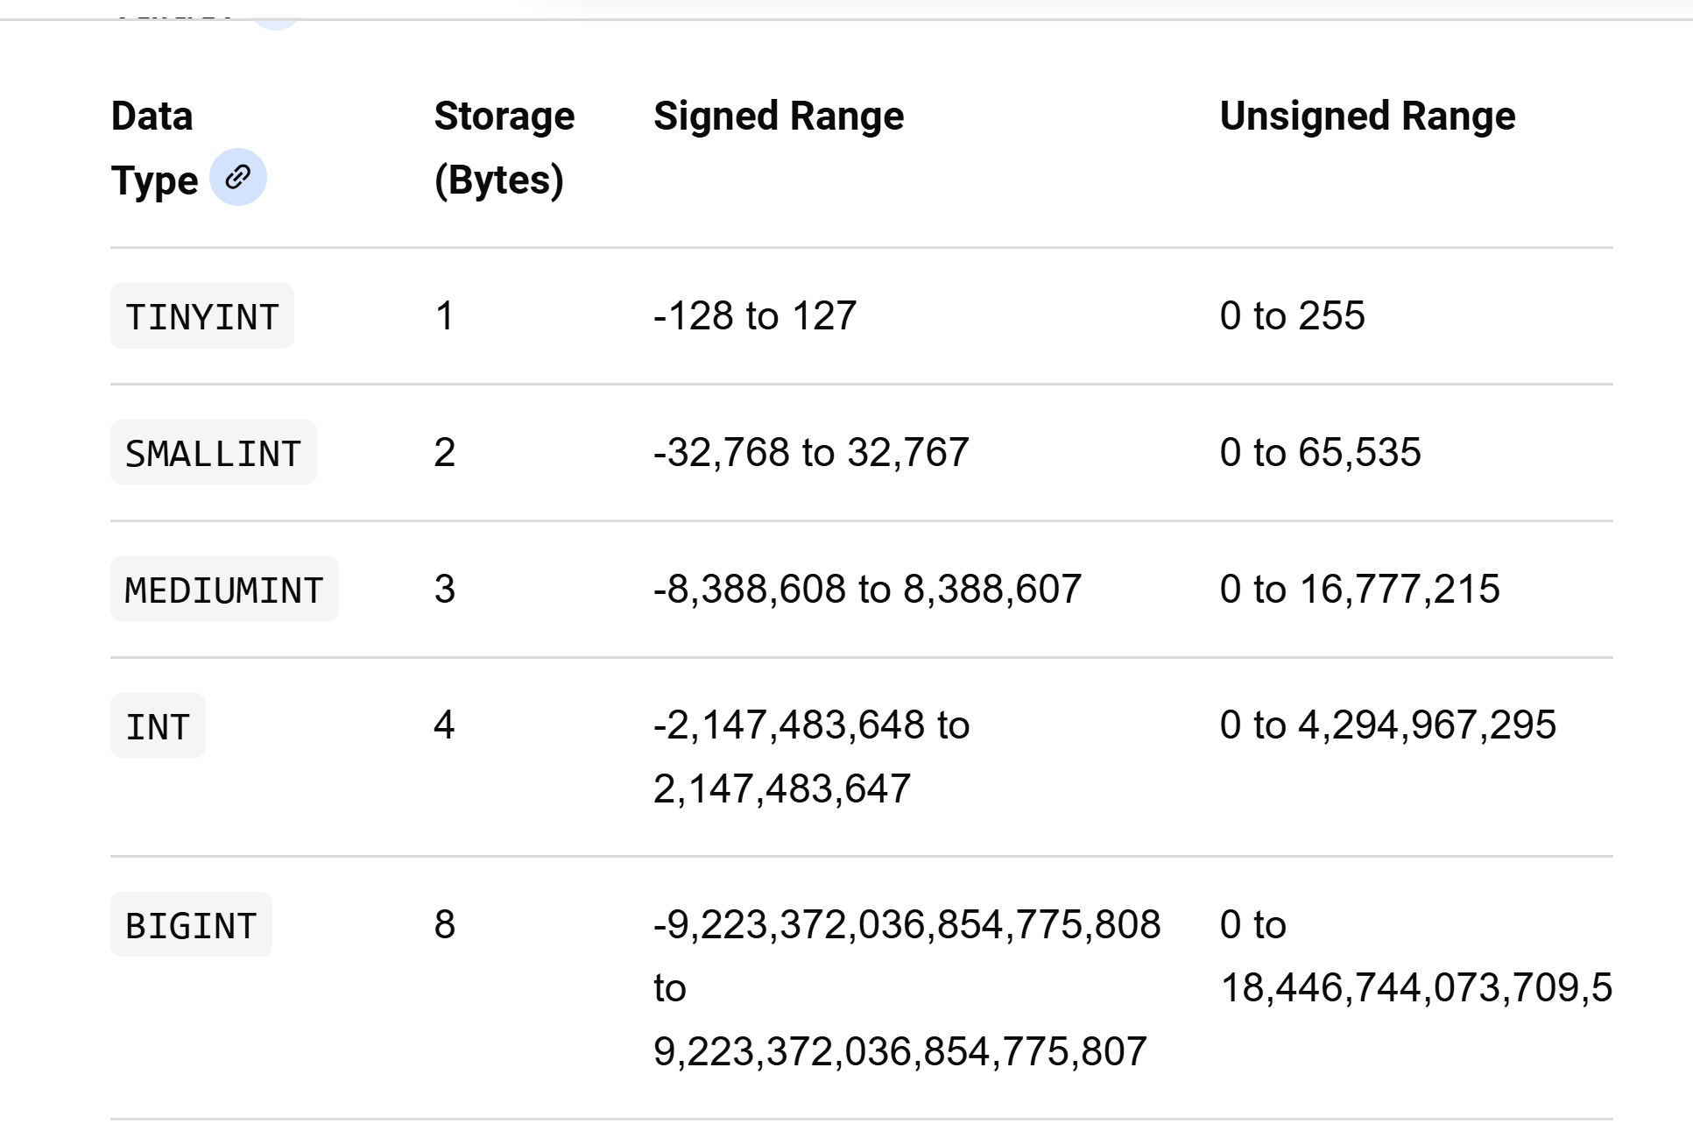
Example:
UML for toyu.student:
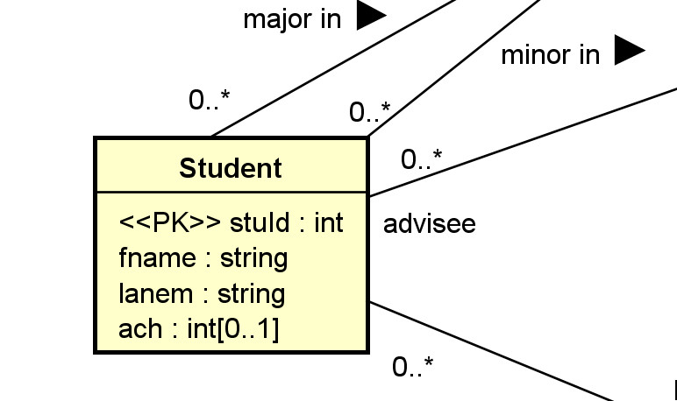
Relational schema (in HW assignment format):
Relation | Student(StuId, fname, lname, major, minor, ach, advisor)
Candidate Keys | [1] StuId
Foreign Keys | [1] major references department(deptCode), [2] minor references department(deptCode), [3] advisor references faculty(facId)
Nullable Attributes | major, minor, advisor, ach
Non-nullable Attributes | stuId, fname, lname
Notes
Relational schema in SQL (with more implementation details):
CREATE TABLE IF NOT EXISTS Student (
stuId INT NOT NULL,
fname VARCHAR(30) NOT NULL,
lname VARCHAR(30) NOT NULL,
major CHAR(4) NULL,
minor CHAR(4) NULL,
-- ach: accumulated credit hours, including transferred credits.
ach INTEGER(3) NULL DEFAULT 0,
advisor INT NULL,
CONSTRAINT Student_stuId_pk PRIMARY KEY(stuId),
-- an artificial example of a CHECK constraint.
CONSTRAINT Student_ach_cc CHECK ((ach>=0) AND (ach < 250)),
CONSTRAINT Student_major_fk FOREIGN KEY (major)
REFERENCES Department(deptCode) ON DELETE CASCADE,
CONSTRAINT Student_minor_fk FOREIGN KEY (minor)
REFERENCES Department(deptCode) ON DELETE CASCADE,
CONSTRAINT Student_advisor_fk FOREIGN KEY (advisor)
REFERENCES Faculty(facId)
);
Example:
Multi-valued attributes: consider the class Member with the following attributes:
- Member_Id: <<PK>>
- Screen_Name <<unique>>
- Hobbies[0..*]
- Medals[0..*]
Example object
- MemberId: <<PK>>: M1
- Screen_Name <<unique>>: SN10
- Hobbies[0..*]: eating, sleeping, daydreaming
- Medals[0..*]: IEEE, ACM, ACIS
Member(MemberId, ScreenName,…)
MemberId (PK) | ScreenName | Hobbies? No  (not atomic) | Hobby2 | Hobby3
M1 | SN10 | Eating, sleeping, daydreaming
Hobby
MemberId (Foreign key) | Hobby | HobbyId (PK: simple)
M1 | Eating | 1
M1 | Sleeping | 2
M1 | Daydreaming | 3
M2 | Daydreaming | 4
Hobby1, Hobby2, Hobby3 columns are only good for Hobbies[0..3].
- Hobby(HobbyId, MemberId, Hobby):
  - CK: [1] HobbyId (simple PK: 1 attribute), [2] MemberId, Hobby (composite key: key with more than one column/attribute)
  - FK: [1] MemberId references Member(MemberId)
Reasonable relation schema: three relations used
- Member(MemberId, ScreenName):
  - CK: [1] MemberId, [2] ScreenName
- Hobby(HobbyId, MemberId, Hobby):
  - CK: [1] HobbyId, [2] MemberId, Hobby
  - FK: [1] MemberId references Member(MemberId)
  - A surrogate key, HobbyId, is created as the simple primary key. (may be auto-increment value)
- Medal(MedalId, MemberId, Medal):
  - CK: [1] MedalId, [2] MemberId, Medal.
  - FK: [1] MemberId references Member(MemberId)
  - A surrogate key, MedalId, is created as the primary key.
All columns in the tables above are not nullable.
ATT6. Single-Valued Composite Data Types. A single-valued attribute of a composite data type (such as set, list, array) can be mapped in various ways.
- If there is a comparable composite data type in the targeted DBMS, it can be implemented as an attribute of that data type in the relation.
  - The relation will no longer be in the first normal form.
  - Care should be taken in handling the difference in data type mapping.
- Otherwise, regard the attribute as a multi-valued attribute and apply rule ATT2.
ATT7. Derived Attributes. For a derived attribute A: not independent data (computed)
Person(…, Age, ….., DoB,..)
Student(…, GPA, ….): if derived data is stored physically, may save computation.
- It can be implemented and stored as an attribute of the relation.
  - Mechanisms, such as triggers or stored procedures, should be used to ensure data consistency. The derived column should be consistent with the data that derives its value.
- It may not be stored as a column directly in any relation.
  - Mechanisms, such as virtual columns, views or stored functions, may be used to provide standard access to the derived attributes.
Example:
A class Rectangle has three attributes:
- Length
- Width
- \Area or <<derived>>: derived.
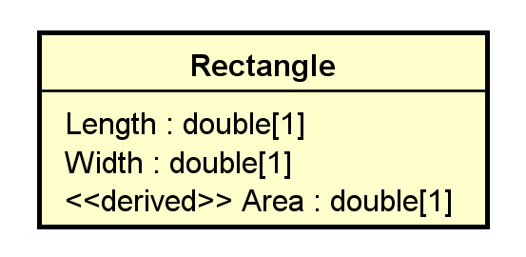
Width=10, Length = 5; area = 25 (inconsistent)
What may the relational schema look like?
One solution:
Rectangle(RectangleId, Length, Width)
with a view Rect define as
SELECT DISTINCT RectangleId, Length, Width, Length * Width as Area
FROM Rectangle;
Alternatively, use virtual columns: a column that is computed in real-time by an expression and not stored.
CREATE or replace TABLE rectangle (
width DOUBLE,
height DOUBLE,
area DOUBLE AS (width * height) virtual
);
Rectangle: width of 10; length of 5. Area is not stored (virtual): it is computed.
2.3 Keys and Constraints
KC1. Primary Key Identified. If a relation R implements a class C or an association (class) AC, and C or AC has identified the PK, set it as the primary key of R.
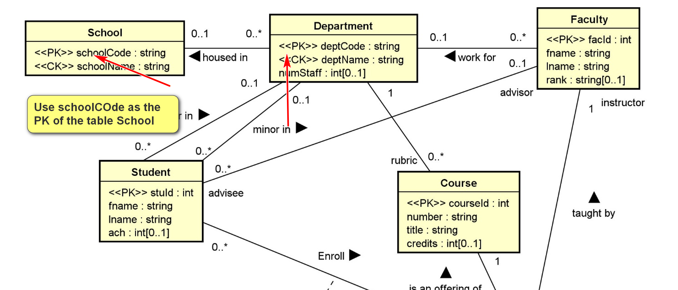

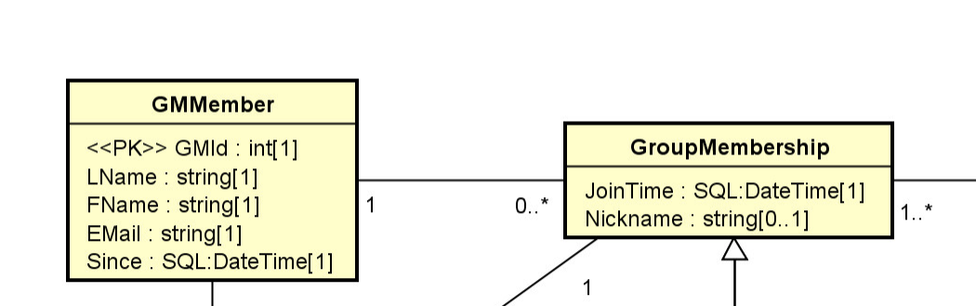
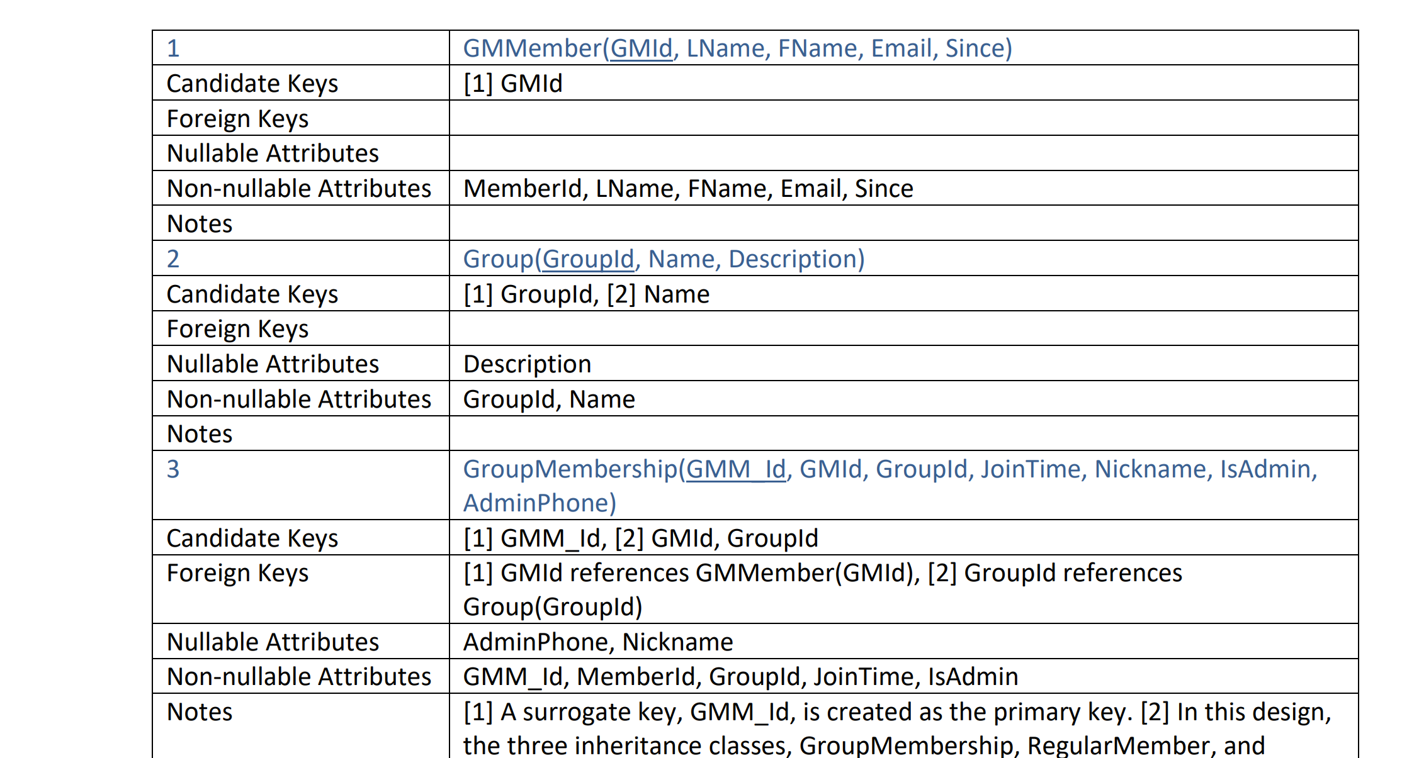
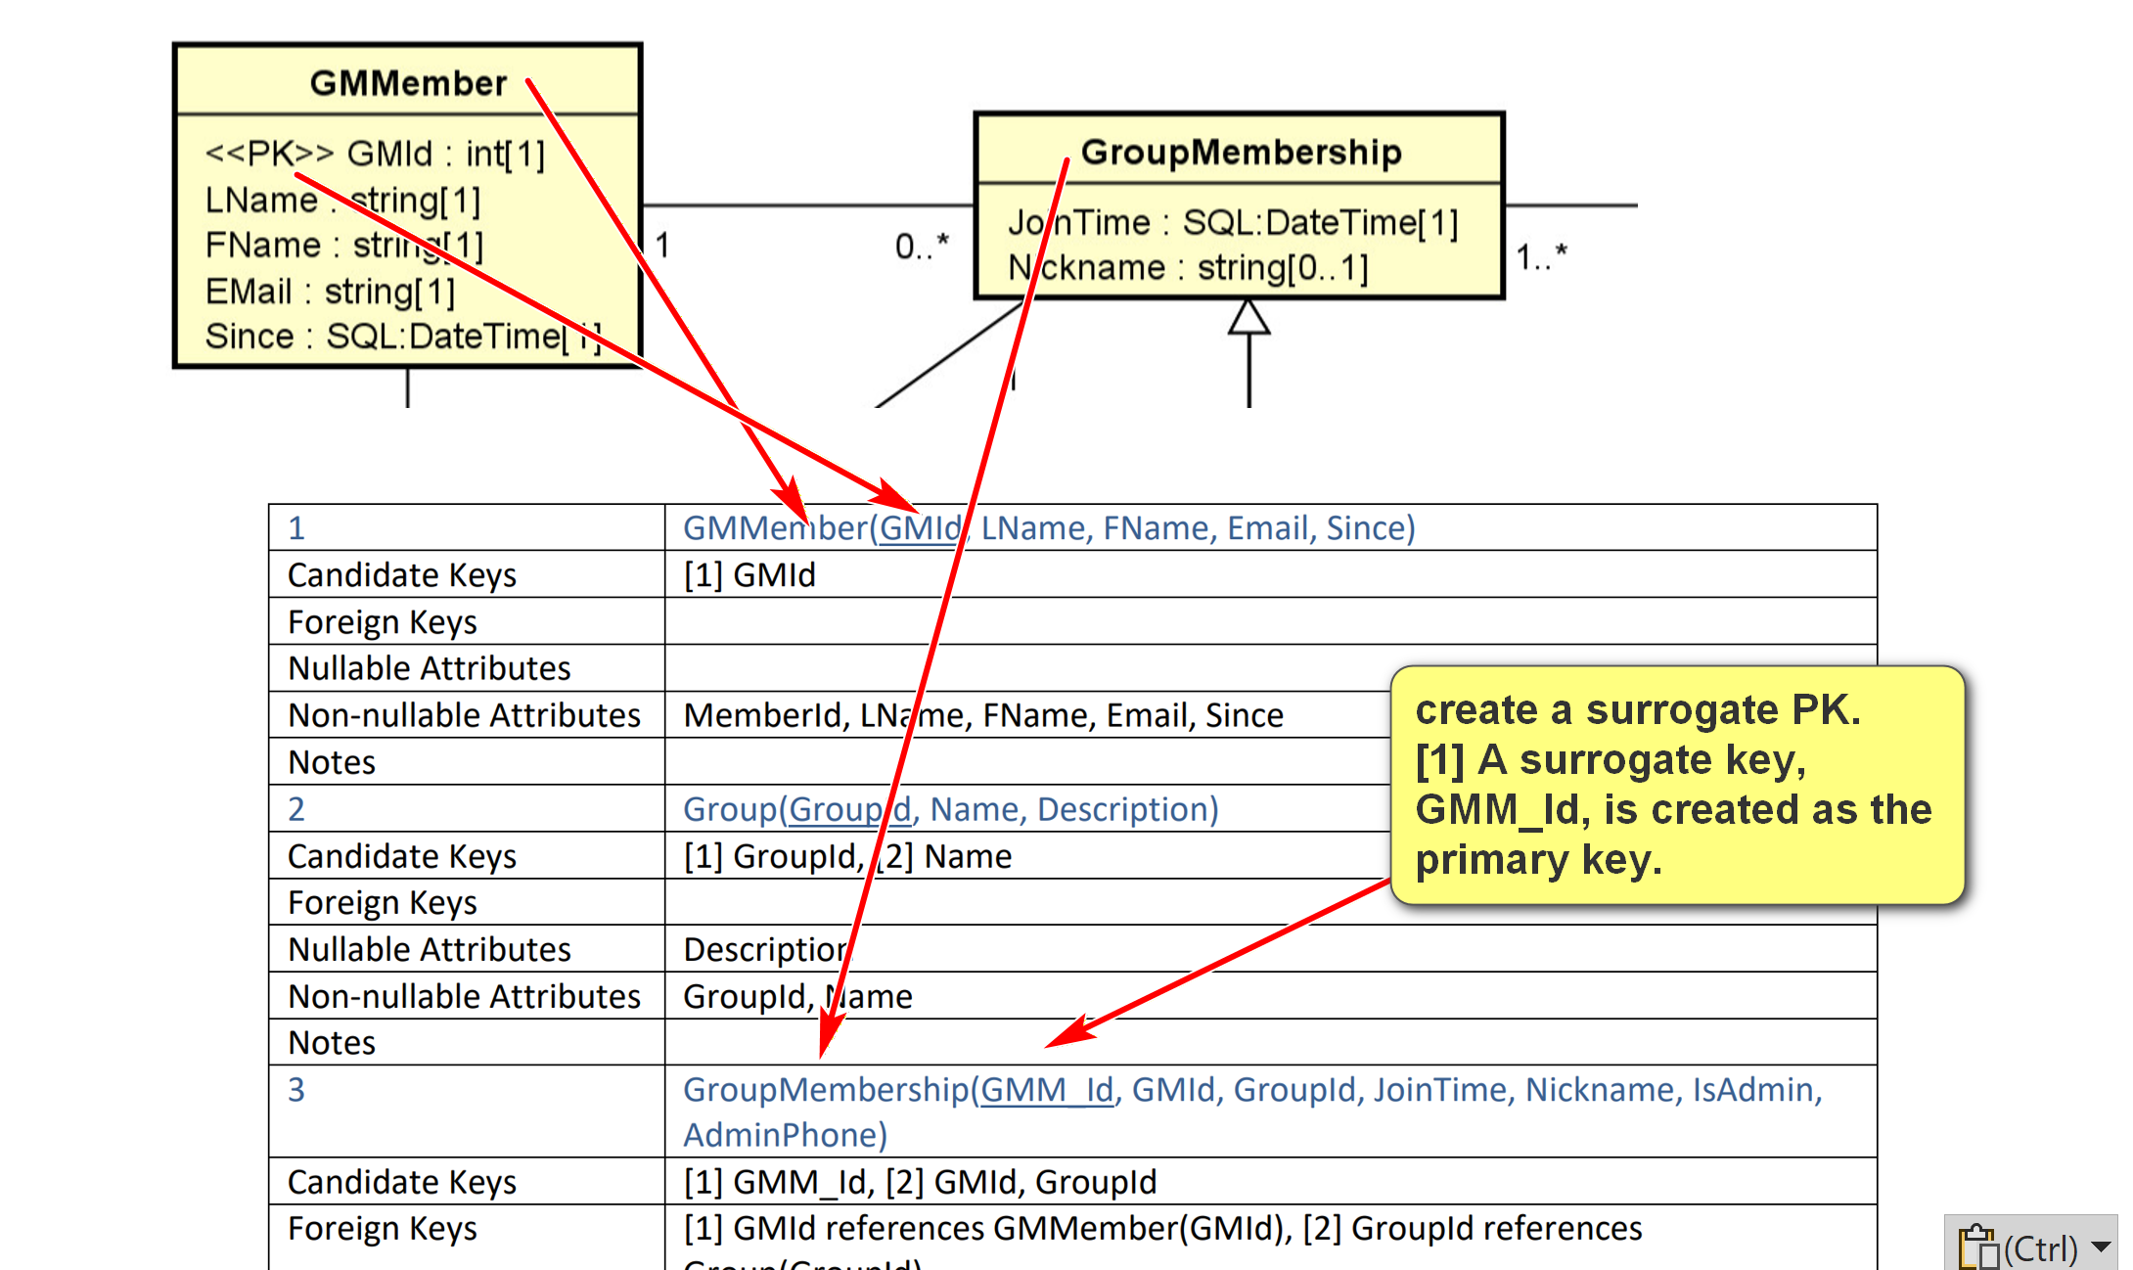
KC2. Candidate Keys. If a relation R implements a class C or an association (class) AC, and C or AC has candidate keys K's, set all K's as candidate keys of R.
- If no primary key has been identified, select a CK to serve as the primary key, and apply KC1.
- A candidate key can be implemented by using the 'unique' and non-null constraint together in SQL.
KC3. No Primary Key Identified. If a relation R implements a class C or an association (class) A, and C or AC has no candidate key, create a surrogate primary key K for R.
- This is needed as every relation must have at least one candidate key.
Example:
for the class Department in toyu:
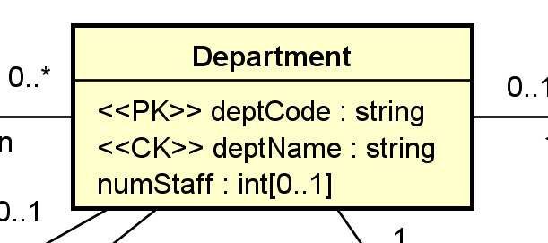
Relational schema (in HW assignment format):
3 | Department(deptCode, deptName, schoolCode, numStaff)
Candidate Keys | [1] deptCode, [2] deptName
Foreign Keys | [1] schoolCode references School(schoolCode)
Nullable Attributes | schoolCode, numStaff
Non-nullable Attributes | deptCode, deptName
Notes
Relational schema in SQL (with more implementation details):
CREATE TABLE IF NOT EXISTS Department (
deptCode CHAR(4) NOT NULL,
deptName VARCHAR(30) NOT NULL,
schoolCode CHAR(3) NULL,
numStaff TINYINT NULL,
CONSTRAINT Department_deptCode_pk PRIMARY KEY (deptCode),
-- alternate keys: [1] deptName
CONSTRAINT Department_name_ck UNIQUE (deptName),
CONSTRAINT Department_schoolCode_fk FOREIGN KEY (schoolCode)
REFERENCES School(schoolCode)
);
KC4. For a stereotype:
- Some may be directly implemented in SQL DDL, e.g., PK, CK, unique, etc.
- Otherwise, it is necessary to consider where and how it is implemented.
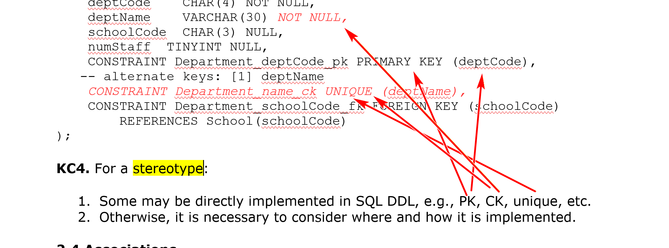

2.4 Associations
A1. Many-to-one Association. For a many to one association A between C1 (the class with the one multiplicity) and Cm, add a column R1_Id into the relation Rm (which implements Cm).
- Assume that R1_Id is the primary key of the relation R1 (which implements C1).
- R1_Id is a foreign key in Rm referencing R1(R1_Id).
- The name R1_Id may be renamed.
- R1_Id is not null in Rm iff (if and only if) 0 is not allowed (i.e., 1..1) for C1.
- Any single-valued attribute of the association is mapped to a column in Rm.
- If the association A is an association class, single-valued attributes of A can be stored as attributes of R1.
- If you have composite or multi-valued attributes of the relationship, you should consider promoting the association to a regular class in your UML class diagram.
Example:
For:
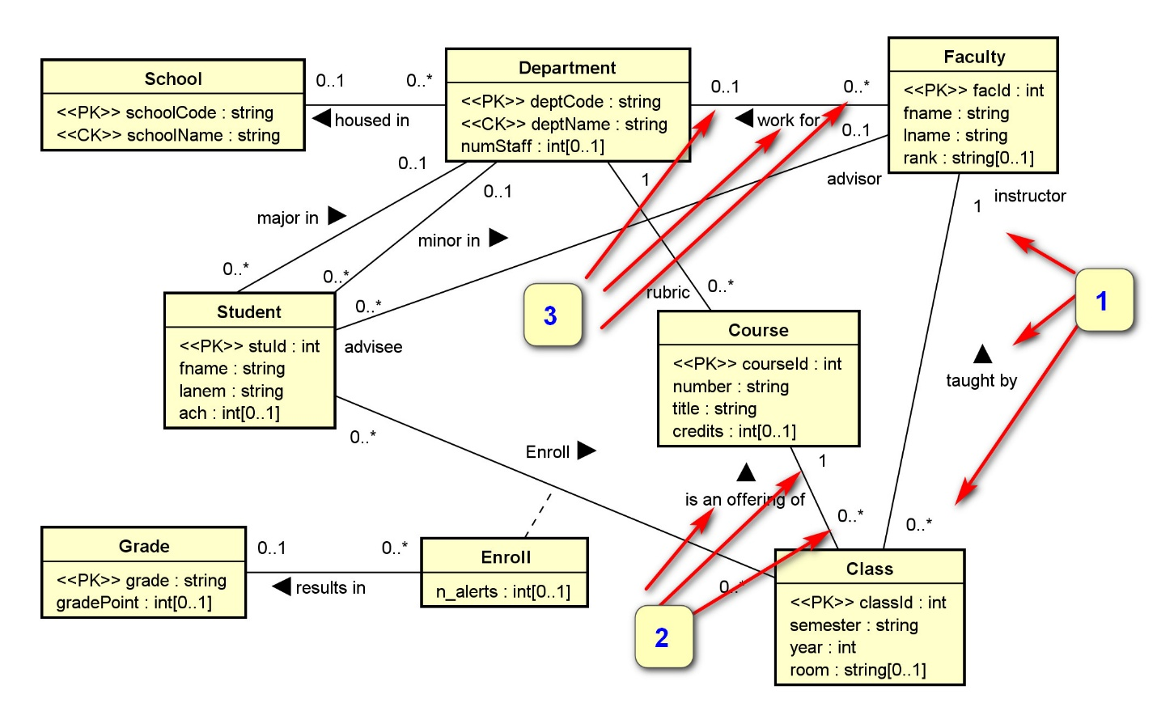
We have the three numbered associations implemented by the three foreign keys below.
4 | Faculty(facId, fname, lname, deptCode, rank)
Candidate Keys | [1] facId
Foreign Keys | [1] deptCode references Department(deptCode)
Nullable Attributes | rank, deptCode
Non-nullable Attributes | facId, fname, lname
Notes
6 | Class(classId, courseId, semester, year, facId, room)
Candidate Keys | [1] classId
Foreign Keys | [1] courseId references Course(courseId), [2] facId references Faculty(facId)
Nullable Attributes | room
Non-nullable Attributes | classId, courseId, semester, year, facId
Notes
Class(ClassId, …
ClassID | CourseId | FacId (FK)
11004 | … | 1018
Art Allister taught class 11004
Faculty(FacId, ….)
FacId | FName
1018 (PK) | Art | ..
A1. Many-to-one Association. For a many to one association A between C1, Faculty (the class with the one multiplicity) and Cm, add a column R1_Id into the relation Class, Rm (which implements Cm).
- that R1_Id is te phrimary key of the relation R1, Faculty (which implements C1).Assume
- R1_Id (FacId) is a foreign key in Rm (Class) referencing R1(R1_Id): Faculty(FacId)
- The name R1_Id may be renamed.
- R1_Id is not null in Rm iff (if and only if) 0 is not allowed (i.e., 1..1) for C1.
- Any single-valued attribute of the association is mapped to a column in Rm.
- If the association A is an association class, single-valued attributes of A can be stored as attributes of R1.
- If you have composite or multi-valued attributes of the relationship, you should consider promoting the association to a regular class in your UML class diagram.

A2. Many-to-many Association. For a many-to-many association (including association classes) between classes CA and CB, create a new relation RAB(RA_Id, RB_Id).
- (RA_Id, RB_Id) is a candidate key.
- RA_Id references RA(RA_Id) as a foreign key.
- RB_Id references RB(RB_Id) as a foreign key.
- An additional surrogate key, such as RAB_Id, can be created.
Example:
For:
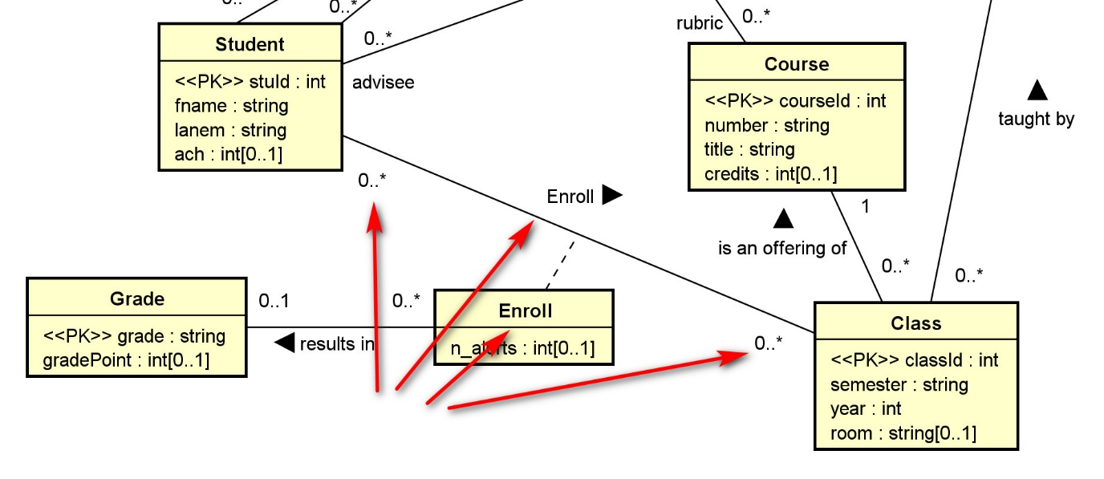
We have:
8 | Enroll(stuId, classId, grade, n_alerts)
Candidate Keys | [1] stuId, classId
Foreign Keys | [1] stuId references Student(stuId), [2] classId references Class(classId), [3] grade references Grade(grade)
Nullable Attributes | grade, n_alerts
Non-nullable Attributes | stuId, classId

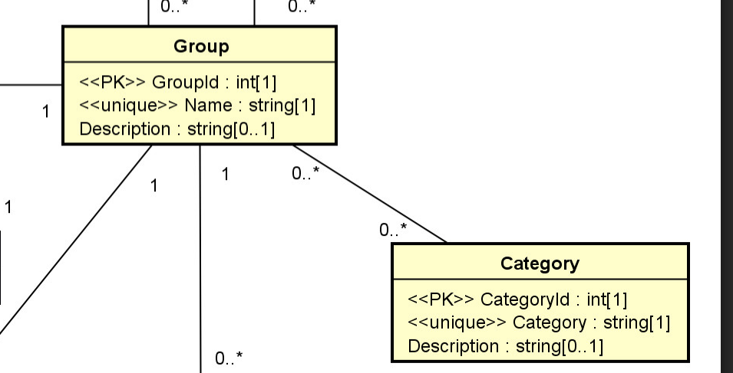
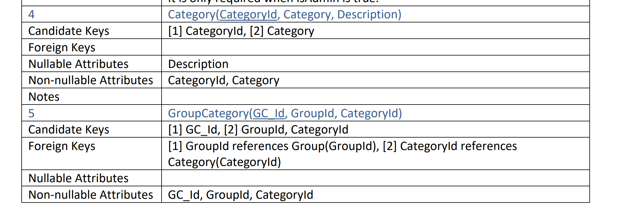
Group g1 in categories c1, c2, c3
Group g2 in categories c1, c4

A3. One-to-one Association. For a one to one association between classes CA and CB, there are several options:
- Treat CA as C1 and CB as Cm and apply A1.
- Treat CA as Cm and CB as C1 and apply A1.
- Merge the two relations RA and RB into one. (In this case, you may want to refactor the class diagram.)
A4. N-ary Associations. For any n-ary association (n>2), a new relation is needed. Do not use them.
- You should consider using binary associations instead.
- A ternary association can be modeled as a regular class with three binary associations with the participating classes in the ternary association.
Example:
Consider the ternary association between the classes Supplier, Part, and Warehouse with an association attribute quantity.
It can reasonably be replaced by a new class and three binary associations.
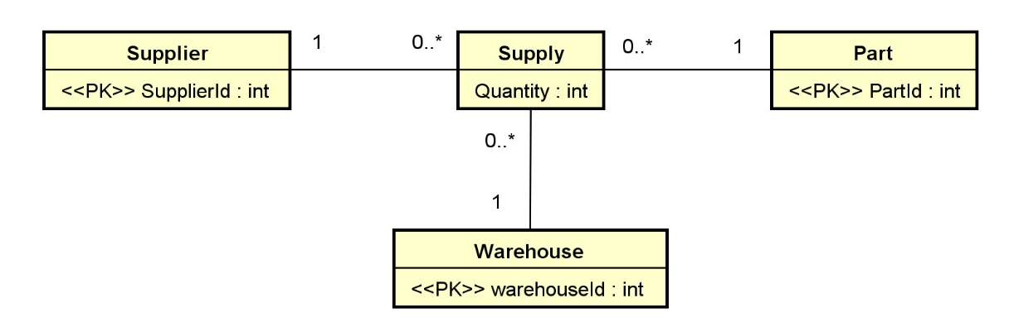
Supply(SupplyId, SupplierId, PartId, WarehouseId, Quantity):
- CK: [1] SupplyId, [2] SupplierId, PartId, WarehouseId
- FK: [1] SupplierId references Supplier(SupplierId), [2] PartId references Part(PartId), [3] WarehouseId references Warehouse(WarehouseId).
- All attributes in Supply is not nullable.
Example:
Checkout the UML diagram and relation schema for toyu and swim.

The Relational Model
by K. Yue
1. Introduction
1.1 Data Model
- There are many data models used by database systems.
- The data models of database systems define how data is organized, structured, connected, processed, and queried in the databases.
- It is important to recognize the basic data structures used by these models.
- Examples:
Is Excel table the same as a relation model’s table?
Relationals unordered, no duplicate. {1,2} = {2,1} = {1,1,2,2,1}
Excel table: 2d array; ordered, may have duplicate.

  - Relational model: set-theoretic relation/table (defined by sets)
  - Excel: table, and to be more exact, a two-dimensional array
  - Object-oriented model: directed graphs
  - XML: trees with many different types of nodes, plus sets of attributes.
  - Cassandra: columnar or wild column model
  - MongoDB: document model
  - Neo4J: graph model
1.2 The Relational Model: an introduction
- The basic relational data model in layman terms:
  - A database is composed of a collection of tables (relations).
  - A table contains many rows (tuples) and columns (attributes/fields).
  - Each row contains many column values.
  - Every row of a table has the same set of columns.
  - Values of the same column have the same data type.
  - Keys are sets of columns.
  - A candidate key of a table is a minimal unique identifier of a row in the table.
  - A primary key is a selected candidate key (for storing the table).
  - Alternative/secondary keys are candidate keys not selected as the primary key.
  - A foreign key of a relation references a primary key of another relation (known as the parent or referenced table).
More theoretically:
- The (theoretical) relational model is based on the concept of a relation.
- It is a set-theoretic model: the definitions are based on mathematical sets.
- If you are not familar with set theory, read about it. This is a basic, short, good, and good-enough introduction: https://www.ucl.ac.uk/~ucahmto/0005_2021/Ch2.S1.html (note that in the set builder form, the author used ":" to represent "such that". We usually use "|" instead.)
- Note that practical DBMS do not implement the pure relational model.
- In the theoretical relational model:
  - An attribute (column/field) is a name.
  - A domain is a set of values an attribute can take.
    - It is the set of values of the data type of the attribute.
    - The value of an attribute should be atomic (cannot be divided into smaller components with individual meanings):
      - If all attributes of a relation are atomic, the relation is said to be in First Normal Form.
    - Null may or may not be an acceptable value for an attribute. It depends on problem requirements.
  - A relation schema, R, is a set of attributes A₁, A₂,…,A_{n} with their domains D₁, D₂,…, D_{n}. E.g., faculty:
A₁, A₂,…,A_{n} = facId, fname, lname..
D₁, D₂,…, D_{n}. = INT, VARCHAR(30), VARCHAR(30),
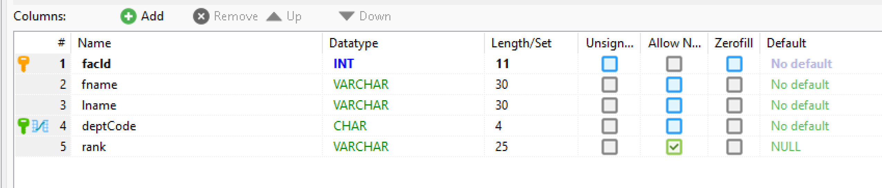
  - A tuple (row) is a set of mapping of a set of attributes to a set of values: A_{i} -> d_{i} where d_{i} ∈ D_{i}, for i = 1 to n (∈: belongs to)
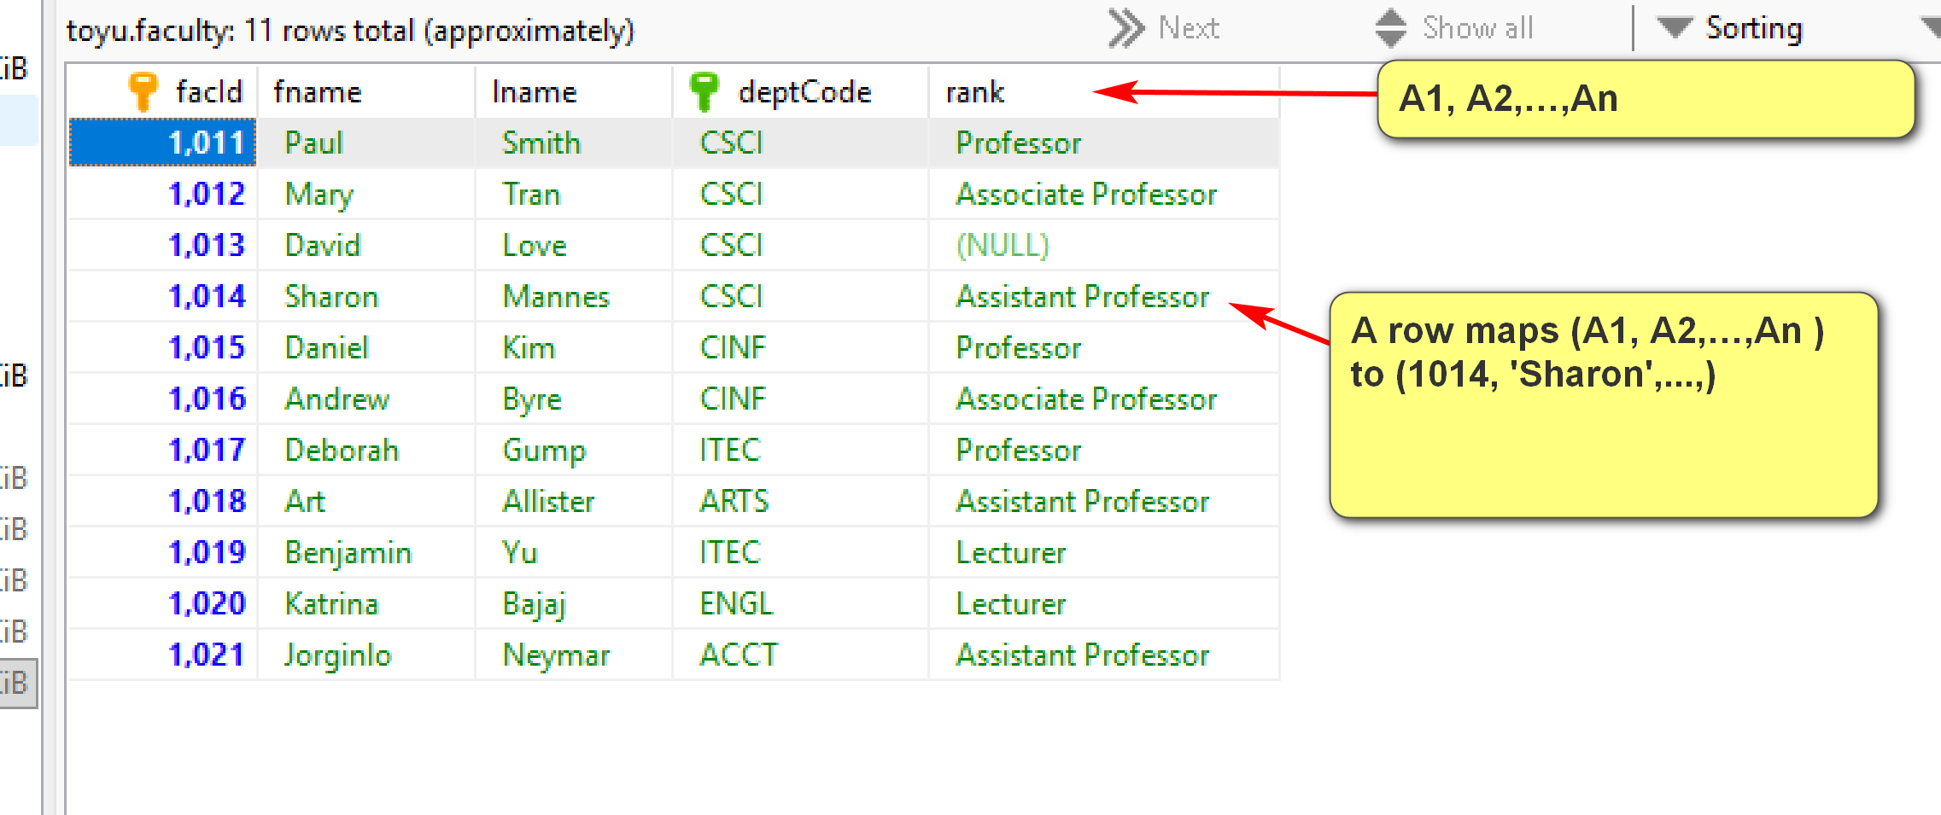
  - A relation (instance) is a set of tuples.
  - The degree (or arity) of a relation is the number of attributes in its schema.
- Some advantages of the relational model and relational DBMS (as compared to other databases):
  - Strong mathematical foundation
  - Simple
  - Strong design theory
  - Strong support of data integrity and consistency
  - Strong support of transactions
  - Strong industrial support and community
  - High popularity
- Some disadvantages of the relational model and relational DBMS:
  - The data model may not match the problem requirements well.
  - Impedance mismatch with object-oriented models.
  - Do not scale well.
  - Structured data may be too restrictive for specific problems.
1.3 Toyu Example
Toyu: A drastically simplified university
SQL statement: SELECT * FROM class;
Select every column from the table class.
MariaDB [toyu]> SELECT * FROM class;
+---------+----------+----------+------+-------+------+
| classId | courseId | semester | year | facId | room |
+---------+----------+----------+------+-------+------+
| 10000 | 2000 | Fall | 2019 | 1011 | D241 |
| 10001 | 2001 | Fall | 2019 | 1011 | D242 |
| 10002 | 2002 | Fall | 2019 | 1012 | D136 |
| 10003 | 2020 | Fall | 2019 | 1014 | D241 |
| 10004 | 2021 | Fall | 2019 | 1014 | D241 |
| 10005 | 2040 | Fall | 2019 | 1015 | D237 |
| 10006 | 2041 | Fall | 2019 | 1019 | D217 |
| 10007 | 2060 | Fall | 2019 | 1020 | B101 |
| 10008 | 2080 | Fall | 2019 | 1018 | D241 |
| 11000 | 2000 | Spring | 2020 | 1011 | D241 |
| 11001 | 2001 | Spring | 2020 | 1012 | D242 |
| 11002 | 2002 | Spring | 2020 | 1013 | D136 |
| 11003 | 2020 | Spring | 2020 | 1016 | D217 |
| 11004 | 2061 | Spring | 2020 | 1018 | B101 |
+---------+----------+----------+------+-------+------+
14 rows in set (0.005 sec)
A tuple/row: {classId: 10004, courseId: 2021, semester: 'Fall', year: 2019, facId: 1014, room: 'D241'}. Note that it is a set of mappings from attribute names to attribute values.
It can also be represented as:
{classId: 10004, facId: 1014, room: 'D241', semester: 'Fall', year: 2019, courseId: 2021}
or
{10004, 2021, 'Fall', 2019, 1014, 'D241'} if the attribute names are assumed in be in the right order.
or using a more computer science-style notation.
(10004, 2021, 'Fall', 2019, 1014, 'D241')
Identify some examples of the database terms in the class table above as much as possible.
- Some important properties of a relation:
  - There is no duplicate tuple.
    - Because a relation is a set.
    - Consequence: the relational model does not support 'object identity' directly.
  - The relational model is known to be 'value-oriented':
    - A row is a set of attribute values.
    - Two rows with the same values in all attributes are the same row.
    - Cannot store two duplicate rows in a table.
  - The terms tables and relations are not exactly the same. "Table" is a more generic term.
- Tuples within a relation are unordered.
  - Changing the order of displaying the tuples does not change (the meaning of) the relation.
- Attributes within a relation schema are unordered.
  - Changing the order of the attributes within a relation schema does not change the information stored in the relation.
Example:
+---------+----------+----------+------+-------+------+
| classId | courseId | semester | year | facId | room |
+---------+----------+----------+------+-------+------+
| 10000 | 2000 | Fall | 2019 | 1011 | D241 |
| 10001 | 2001 | Fall | 2019 | 1011 | D242 |
| 10002 | 2002 | Fall | 2019 | 1012 | D136 |
| 10003 | 2020 | Fall | 2019 | 1014 | D241 |
| 10004 | 2021 | Fall | 2019 | 1014 | D241 |
| 10005 | 2040 | Fall | 2019 | 1015 | D237 |
| 10006 | 2041 | Fall | 2019 | 1019 | D217 |
| 10007 | 2060 | Fall | 2019 | 1020 | B101 |
| 10008 | 2080 | Fall | 2019 | 1018 | D241 |
| 11000 | 2000 | Spring | 2020 | 1011 | D241 |
| 11001 | 2001 | Spring | 2020 | 1013 | D242 |
| 11002 | 2002 | Spring | 2020 | 1013 | D136 |
| 11003 | 2020 | Spring | 2020 | 1016 | D217 |
| 11004 | 2061 | Spring | 2020 | 1018 | B101 |
+---------+----------+----------+------+-------+------+
and
+---------+------+----------+----------+------+-------+
| classId | year | semester | courseId | room | facId |
+---------+------+----------+----------+------+-------+
| 11004 | 2020 | Spring | 2061 | B101 | 1018 |
| 10007 | 2019 | Fall | 2060 | B101 | 1020 |
| 10002 | 2019 | Fall | 2002 | D136 | 1012 |
| 11002 | 2020 | Spring | 2002 | D136 | 1013 |
| 11003 | 2020 | Spring | 2020 | D217 | 1016 |
| 10006 | 2019 | Fall | 2041 | D217 | 1019 |
| 10005 | 2019 | Fall | 2040 | D237 | 1015 |
| 10000 | 2019 | Fall | 2000 | D241 | 1011 |
| 11000 | 2020 | Spring | 2000 | D241 | 1011 |
| 10003 | 2019 | Fall | 2020 | D241 | 1014 |
| 10004 | 2019 | Fall | 2021 | D241 | 1014 |
| 10008 | 2019 | Fall | 2080 | D241 | 1018 |
| 10001 | 2019 | Fall | 2001 | D242 | 1011 |
| 11001 | 2020 | Spring | 2001 | D242 | 1013 |
+---------+------+----------+----------+------+-------+
store the same information.
The second table can be obtained in SQL by:
SELECT classId, year, semester, courseId, room, facId
FROM class
ORDER BY room, facId;
2. Keys
- A set of attributes K is a candidate key (CK) of a relation R if it minimally identifies a tuple at any time:
  - Uniqueness: No two tuples of R have the same value of K.
  - Minimality: No proper subset of K has the uniqueness property.
- A candidate key is a property of the semantic (meaning) of a relation.
- In other words, being a candidate key is the result of the requirements of an application.
- A relation always has at least one candidate keys. Why?
  - Because a relation instance r is a set of rows, no two rows will have the exact same values.
  - Thus, the relation schema R by itself satisfies the uniqueness property.
  - R or one of its proper subsets will satisfy the minimal property as extraneous attributes are removed.
- A set of attributes may be a candidate key of a relation R but not a candidate key of another relation S.
- For any relation instance, the candidate key of a tuple must have an unique value.
- A primary key is a selected candidate key for a relation in the DBMS. It is used for practical purpose (of how the relation is stored physically) and does not have a special meaning in the theory of the relational model.
- Some criteria for selecting a primary key:
  - Stable and relative immutable.
  - Simple: contains one attribute
  - Concise: short storage space and faster comparison.
- An alternate/secondary key is a candidate key that is not the primary key.
- Questions people may ask:
  - What is the key of the database toyu? Wrong question.
  - What is the primary key of the database toyu? more precise but still wrong question.
  - What is the key of the school table of the toyu database? good question but a bit ambiguous. Answer: schoolCode.
  - What is the primary key of the school table of the toyu database? schoolCode.
  - What are the candidate keys of the school table of the toyu database? [1] schoolCode, [2] schoolName.
  - What are the secondary/alternative keys of the school table of the toyu database? schoolName.
Example:
Consider:
MariaDB [toyu]> SELECT * FROM faculty;
+-------+----------+----------+----------+---------------------+
| facId | fname | lname | deptCode | rank |
+-------+----------+----------+----------+---------------------+
| 1011 | Paul | Smith | CSCI | Professor |
| 1012 | Mary | Tran | CSCI | Associate Professor |
| 1013 | David | Love | CSCI | NULL |
| 1014 | Sharon | Mannes | CSCI | Assistant Professor |
| 1015 | Daniel | Kim | CINF | Professor |
| 1016 | Andrew | Byre | CINF | Associate Professor |
| 1017 | Deborah | Gump | ITEC | Professor |
| 1018 | Art | Allister | ARTS | Assistant Professor |
| 1019 | Benjamin | Yu | ITEC | Lecturer |
| 1020 | Katrina | Bajaj | ENGL | Lecturer |
| 1021 | Jorginlo | Neymar | ACCT | Assistant Professor |
+-------+----------+----------+----------+---------------------+
11 rows in set (0.001 sec)
MariaDB [toyu]> SELECT * FROM department;
+----------+------------------------------+------------+----------+
| deptCode | deptName | schoolCode | numStaff |
+----------+------------------------------+------------+----------+
| ACCT | Accounting | BUS | 10 |
| ARTS | Arts | HSH | 5 |
| CINF | Computer Information Systems | CSE | 5 |
| CSCI | Computer Science | CSE | 12 |
| ENGL | English | HSH | 12 |
| ITEC | Information Technology | CSE | 4 |
| MATH | Mathematics | CSE | 7 |
+----------+------------------------------+------------+----------+
7 rows in set (0.001 sec)
- deptCode is a candidate key of the relation department. Assumptions made:
  - Each tuple in the department relation represents an unique department.
  - Each department has an unique code. No two departments can have the same code.
- deptName is also a candidate key of the relation department. Assumptions made:
  - Each tuple in the department relation represents an unique department.
  - Each department has an unique name. No two departments can have the same name.
- deptCode is selected as the primary key of the relation department since it is concise and more stable.
- deptCode is not a candidate key of the relation faculty. Assumptions made:
  - Each tuple in the faculty relation represents a faculty member.
  - Each faculty serves only one department.
  - A department may have many faculty members.
Consider the tables student and enroll:
- stuid is a candidate key of the relation student. Assumptions made:
  - Each tuple in the student relation represents an unique student.
  - Each student has an unique student id, or no two students can have the same stuid.
- stuid is not a candidate key of the relation enroll. Assumptions made:
  - Each tuple in the Enroll relation represents the enrollment of a student in a class, ending up with a grade.
  - A student can take many classes.
  - A class can have many students.
- Note again that a candidate key is a property of a relation.
2.1 More about keys:
- A key is simple if it has only one attribute.
- A key is a composite key if it has more than one attributes.
- A key is a compound key if it is a composite and each attribute in the key is a foreign key.
- Every relation has at least one candidate key.
- A foreign key of a relation is a set of attributes that is a candidate key in another relation. The other relation is sometimes called the parent (or referenced) table of the foreign key.
- A foreign key may or may not have null value. It depends on the problem requirements.
- For uses in normalization theory:
  - An attribute that appears in one or more candidate keys is a prime attribute (or key attribute).
  - An attribute that does not appears in any candidate key is a non-prime (non-key) attribute.
  - A superkey of a relation is a set of attributes that uniquely identify a row (uniqueness). It may not be minimal. (A Superkey may have extraneous attributes not needed for unique identification.)
Consider the example above. The attribute deptCode is a foreign key in the relation faculty, referencing department(deptCode)
- A deptCode in the department relation must be referring to a department in the database, identified by deptCode in the relation department (referential integrity).
- In relational DB, rows (data) from different tables are linked together using foreign keys.
- A foreign key of a child table links to a primary key of the parent table.
Likewise, stuid is a foreign key in the relation Enroll: stuid references student(stuid)
Note that the student table has three foreign keys.
Example: In the department table in toyu:
Department(deptCode, deptName, schoolCode, numStaff)
Candidate keys:
- deptCode (i.e. {deptCode})
- deptName
Primary key: deptCode
Alternate key:
- deptName
Prime attributes:
- deptCode
- deptName
Non-prime attributes:
- schoolCode
- numStaff
Superkeys:
- deptCode
- deptName
- deptCode, deptName (i.e. {deptCode, deptName})
- deptCode, schoolCode
- deptCode, numStaff
- deptCode, deptName, SchoolCode
- deptCode, deptName, numStaff
- deptCode, SchoolCode, numStaff
- deptCode, deptName, SchoolCode, numStaff
- deptName, SchoolCode
- deptName, numStaff
- deptName, SchoolCode, numStaff
Example:
Study the list of all foreign keys in toyu:
- The INNER JOIN operation can be used to join tables through foreign keys.
Example:
-- INNER JOIN
SELECT * FROM faculty;
SELECT * FROM department;
SELECT s.fname, s.lname, s.advisor, f.`rank`
FROM student AS s INNER JOIN faculty AS f
ON (s.advisor = f.facId);
Result:
MariaDB [toyu]> SELECT * FROM faculty;
+-------+----------+----------+----------+---------------------+
| facId | fname | lname | deptCode | rank |
+-------+----------+----------+----------+---------------------+
| 1011 | Paul | Smith | CSCI | Professor |
| 1012 | Mary | Tran | CSCI | Associate Professor |
| 1013 | David | Love | CSCI | NULL |
| 1014 | Sharon | Mannes | CSCI | Assistant Professor |
| 1015 | Daniel | Kim | CINF | Professor |
| 1016 | Andrew | Byre | CINF | Associate Professor |
| 1017 | Deborah | Gump | ITEC | Professor |
| 1018 | Art | Allister | ARTS | Assistant Professor |
| 1019 | Benjamin | Yu | ITEC | Lecturer |
| 1020 | Katrina | Bajaj | ENGL | Lecturer |
| 1021 | Jorginlo | Neymar | ACCT | Assistant Professor |
+-------+----------+----------+----------+---------------------+
11 rows in set (0.000 sec)
MariaDB [toyu]> SELECT * FROM department;
+----------+------------------------------+------------+----------+
| deptCode | deptName | schoolCode | numStaff |
+----------+------------------------------+------------+----------+
| ACCT | Accounting | BUS | 10 |
| ARTS | Arts | HSH | 5 |
| CINF | Computer Information Systems | CSE | 5 |
| CSCI | Computer Science | CSE | 12 |
| ENGL | English | HSH | 12 |
| ITEC | Information Technology | CSE | 4 |
| MATH | Mathematics | CSE | 7 |
+----------+------------------------------+------------+----------+
7 rows in set (0.000 sec)
MariaDB [toyu]> SELECT s.fname, s.lname, s.advisor, f.`rank`
-> FROM student AS s INNER JOIN faculty AS f
-> ON (s.advisor = f.facId);
+---------+----------+---------+---------------------+
| fname | lname | advisor | rank |
+---------+----------+---------+---------------------+
| Tony | Hawk | 1011 | Professor |
| Mary | Hawk | 1011 | Professor |
| David | Hawk | 1012 | Associate Professor |
| Larry | Johnson | 1017 | Professor |
| Linda | Johnson | 1015 | Professor |
| Lillian | Johnson | 1016 | Associate Professor |
| Linda | King | 1018 | Assistant Professor |
| Cathy | Johanson | 1018 | Assistant Professor |
+---------+----------+---------+---------------------+
8 rows in set (0.000 sec)
Classroom Exercise:
(1) Give a realistic example of a relation with two candidate keys. State the assumptions you have made.
(2) A relation R has an arity of 4. What are the possible minimum and maximum number of superkeys of R? What are the possible minimum and maximum number of candidate keys of R?
What about the general case?

