CSCI 4333.1
1/21/2026
(annotation)

Previously:
SQL, MongoDB, Python
MySQL: XAMPP.
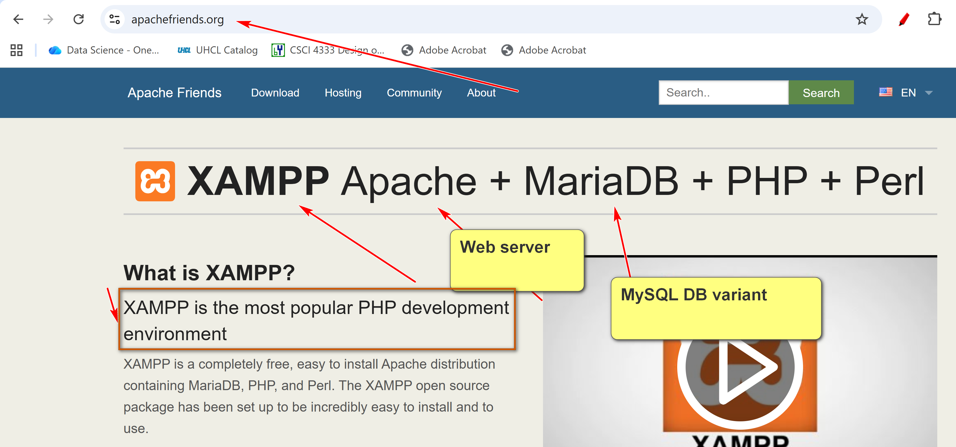
Install XAMPP in top level of C drive.
5. A Simple Introduction to the Relational Model
- Relational databases are the most popular databases: https://db-engines.com/en/ranking. It is based on the relational model.
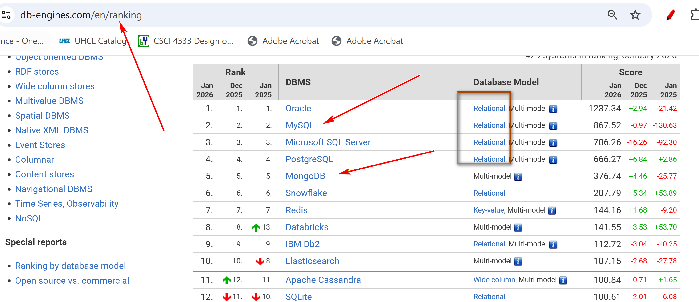
- There are many other data models. E.g. wide-column, document, key-value,…
- In layman's term: A table (relation) is the basic unit of a relational database.
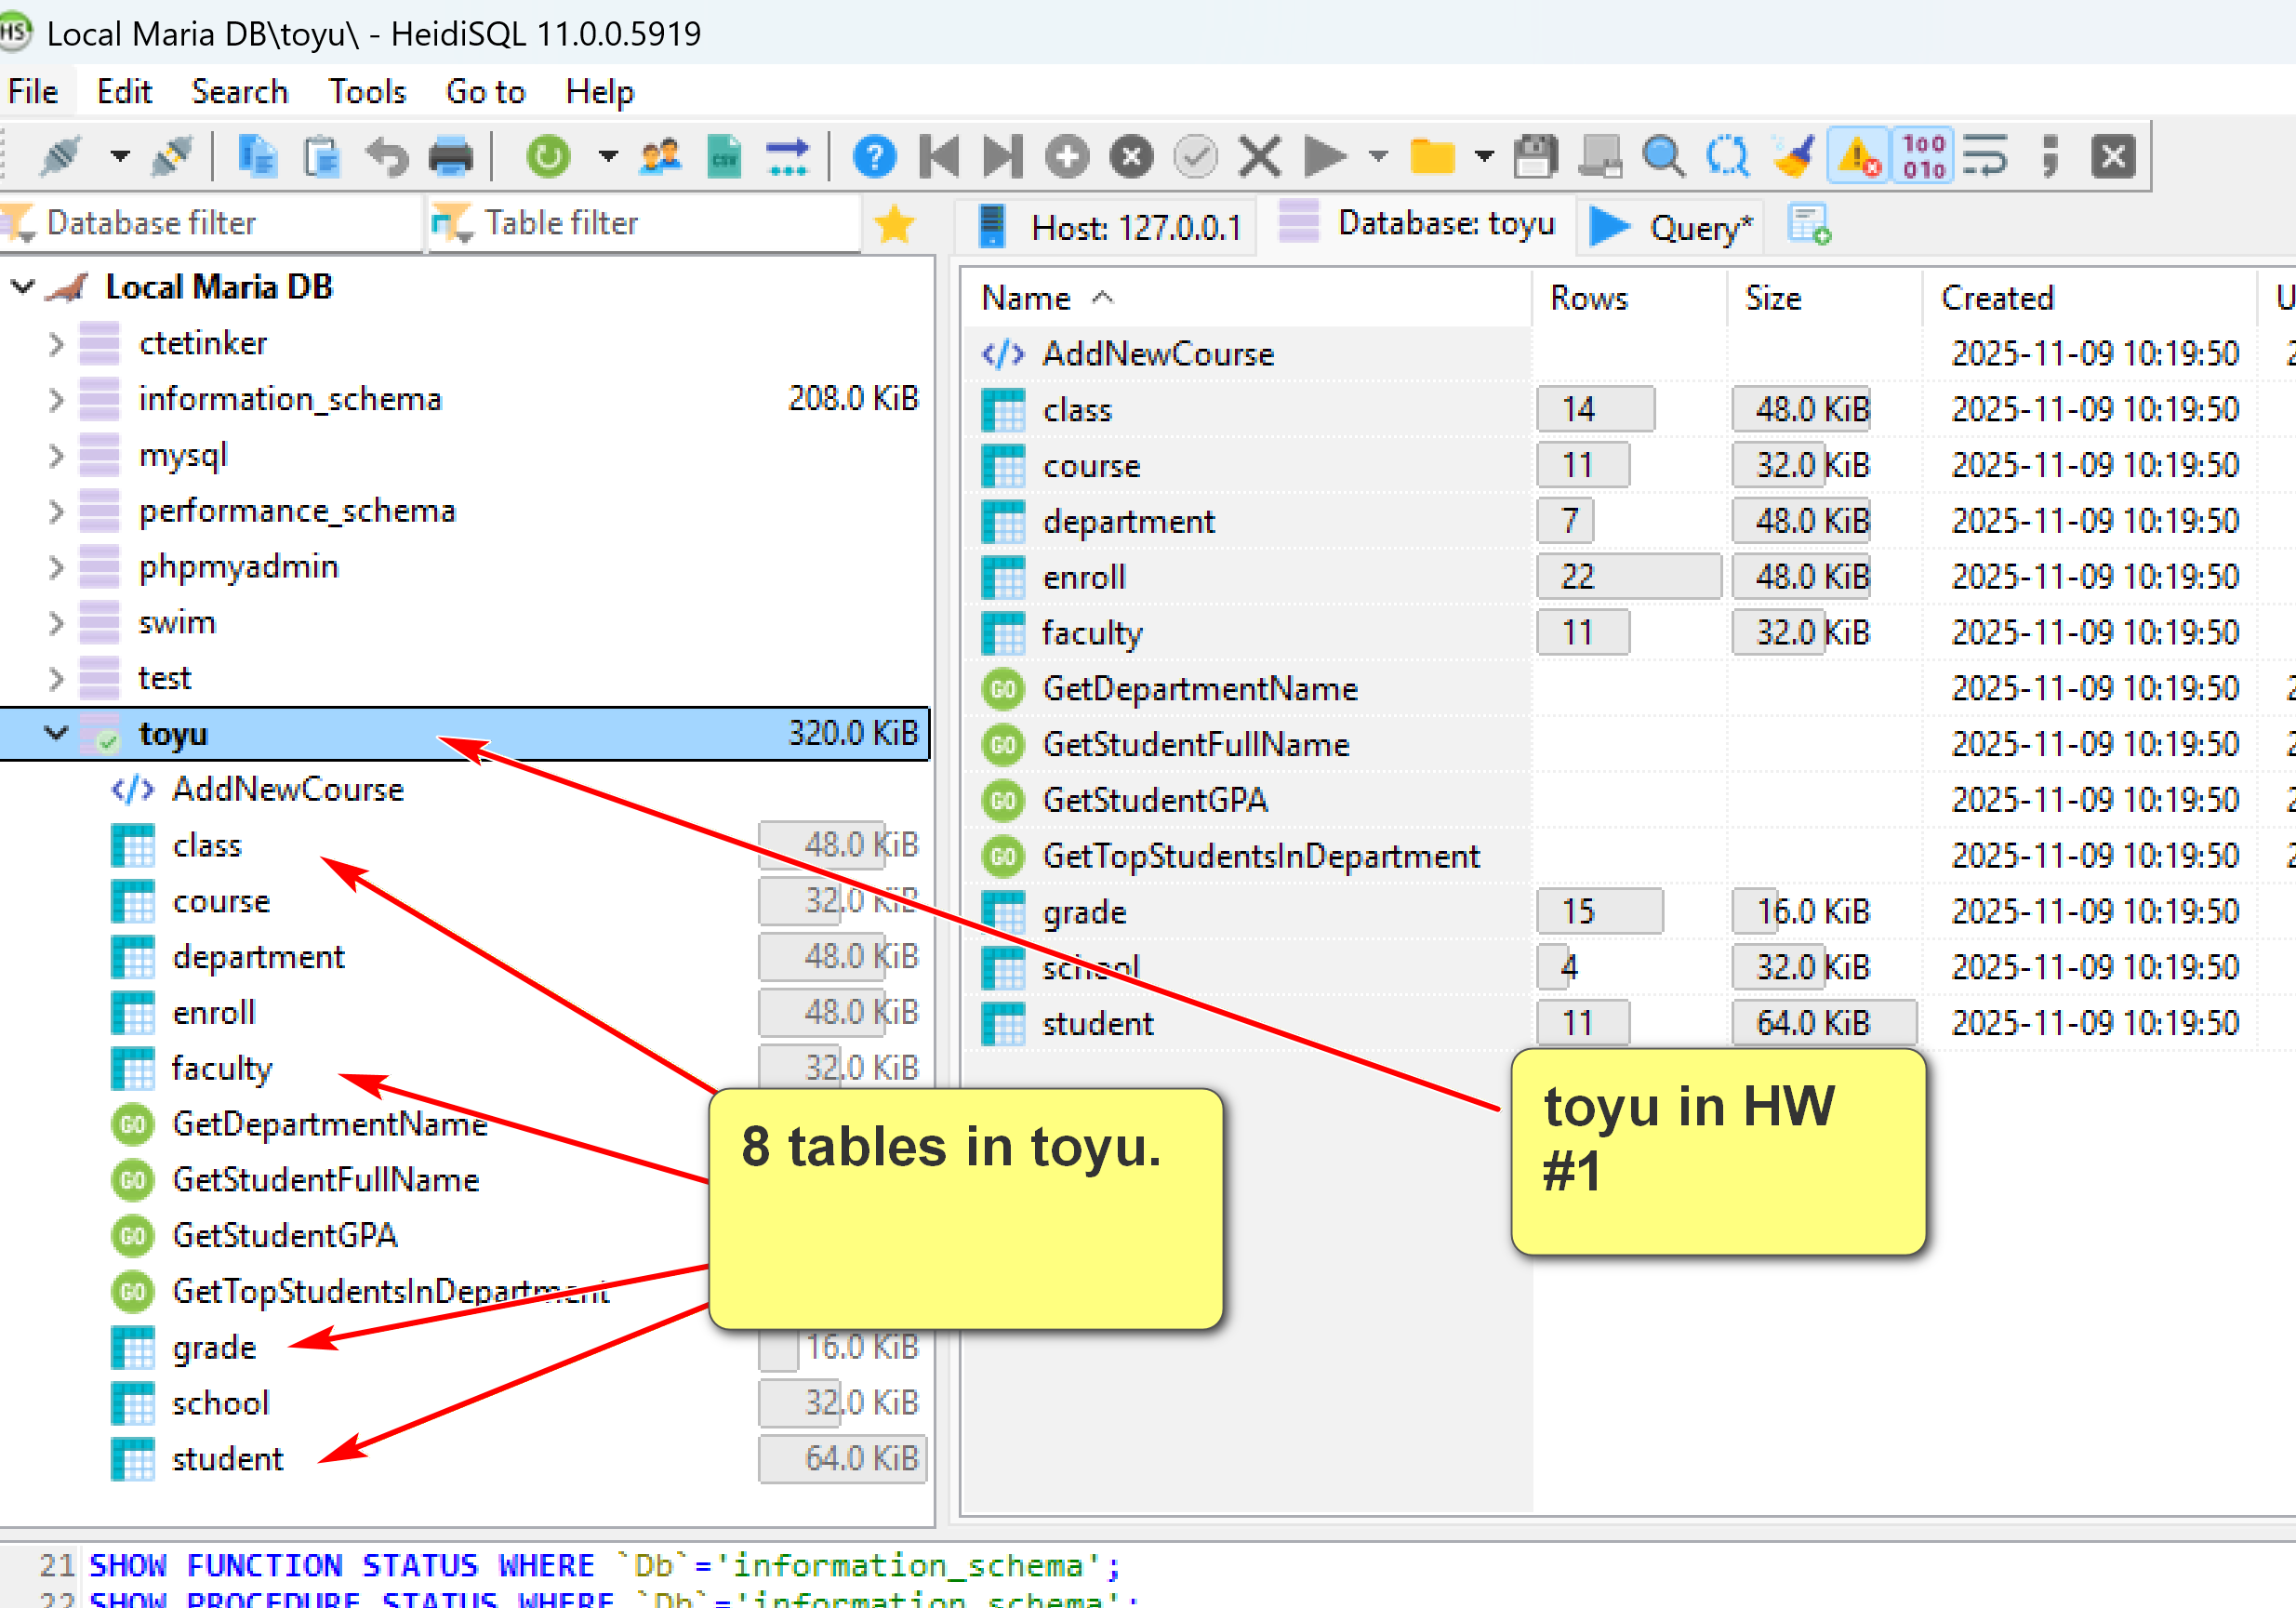
- A table is composed of many rows (tuples).
- Each row has many column (attribute) values.
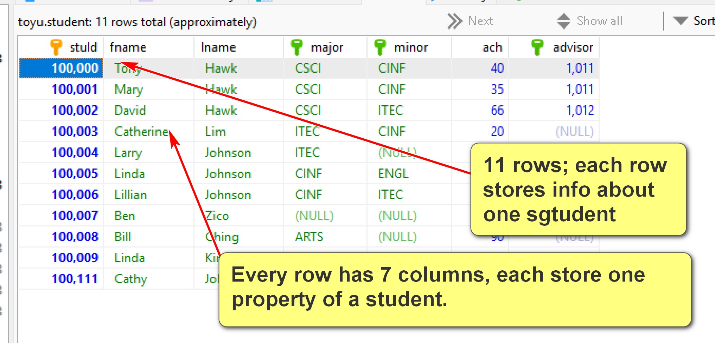
In TOyu:
A class is an offering of a course in a semester taught by an instructor in a room:
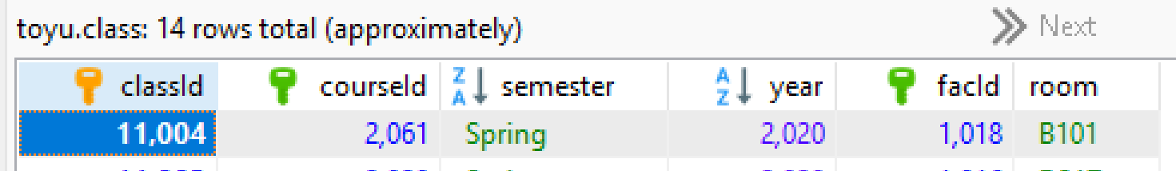

- A primary key is roughly a minimal set of columns in a table that uniquely identify a row.
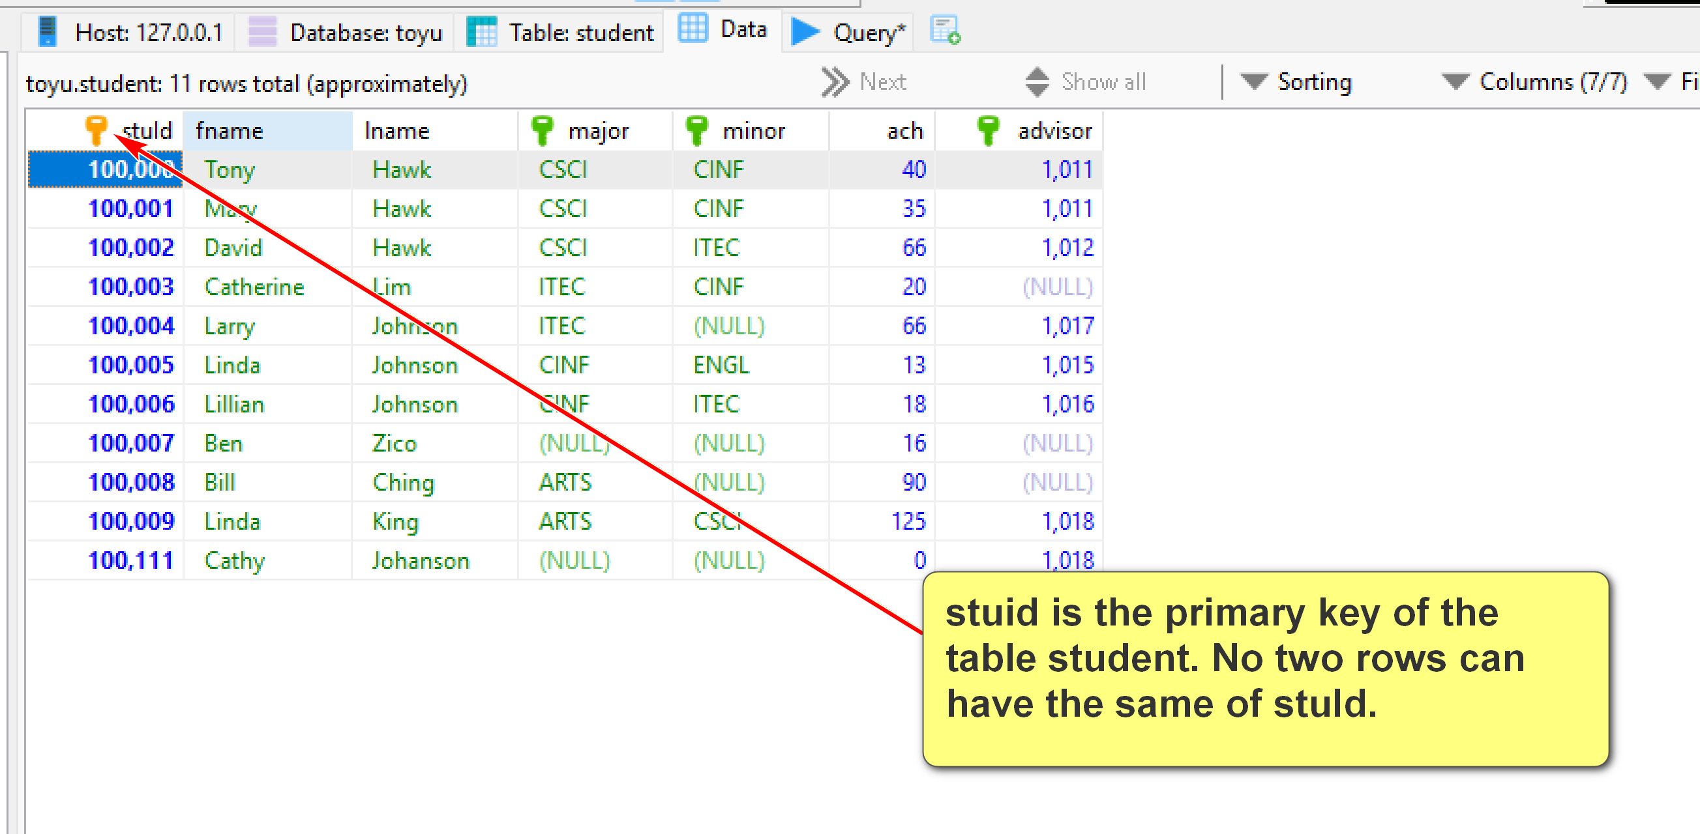
- Two tables can be related to each other by foreign keys. A foreign key is roughly a column in a table in which its value must be equal to the referenced value of the primary key in another table (called the parent or referenced table).
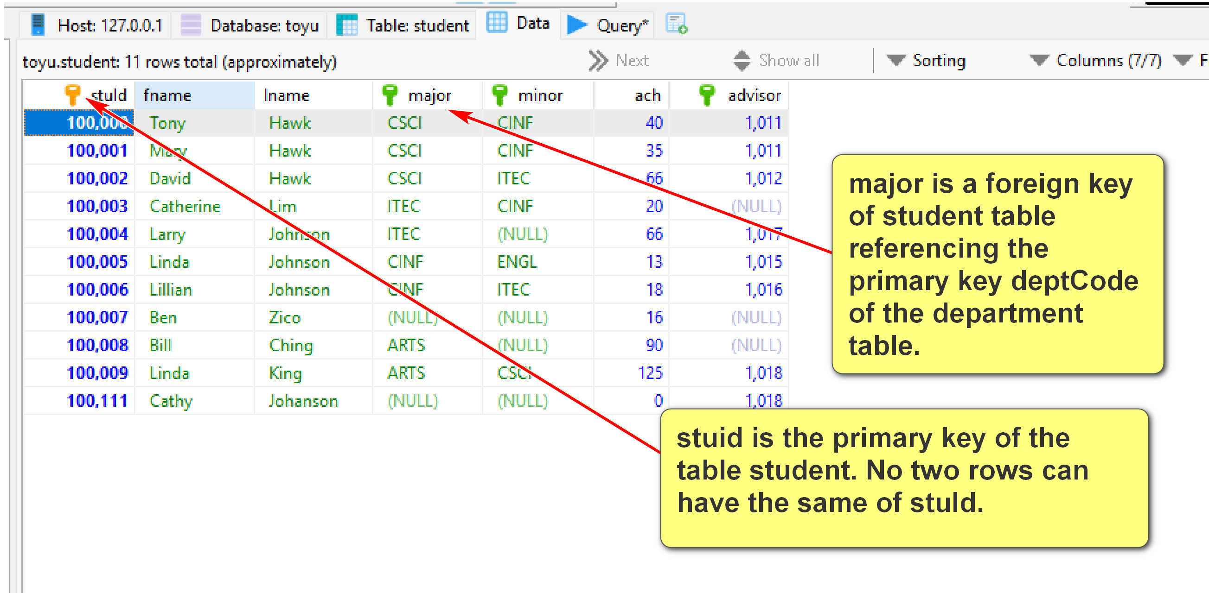
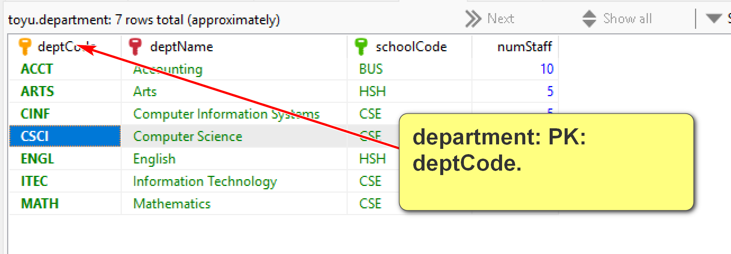
Join date from student (major) and department:
Student.major = department.deptCode
Table1.FK (foreign key) = parent table.PK (primary key)
Enroll table: a row is a student (identified by stuId) enrolled in a class (identified by classId) with a grade and a n_alerts:
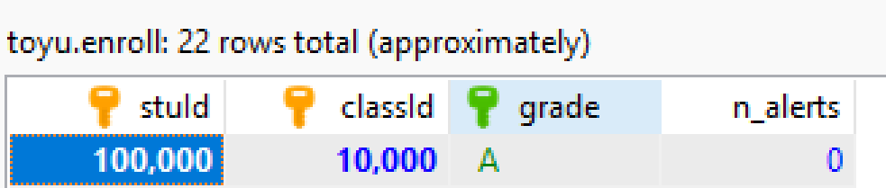
Relations/tables (primary key underscored):
Grade(grade, gradePoint)
School(schoolCode, schoolName)
Department(deptCode, deptName, schoolCode, numStaff)
Faculty(facId, fname, lname, deptCode, rank)
Course(courseId, rubric, number, title, credits)
Class(classId, courseId, semester, year, facId, room)
Student(StuId, fname, lname, major, minor, ach, advisor)
Enroll(stuId, classId, grade, n_alerts)
Foreign keys:
1. Student(advisor) references Faculty(facId)
2. Student(major) references Department(deptCode)
3. Student(minor) references Department(deptCode)
4. Faculty(deptCode) references Department(deptCode)
5. Department(schoolCode) references School(schoolCode)
6. Enroll(stuId) references Student(stuId)
7. Enroll(classId) references Class(classId)
8. Enroll(grade) references Grade(grade)
9. Class(courseId) references Course(courseId)
10. Class(facId) references Faculty(facId)
11. Course(Rubric) references Department(deptCode)

- Relational DBMS is the most popular DBMS. Examples:
  - DB-engine ranking: https://db-engines.com/en/ranking
  - Top 10 DBMS in Data Science: https://towardsdatascience.com/top-10-databases-to-use-in-2021-d7e6a85402ba
- SQL is the 'glue' in many DB systems.
Classroom discussion
Please ask questions about the toy University DB (toyu)
DBMS mostly uses a client-server architecture.
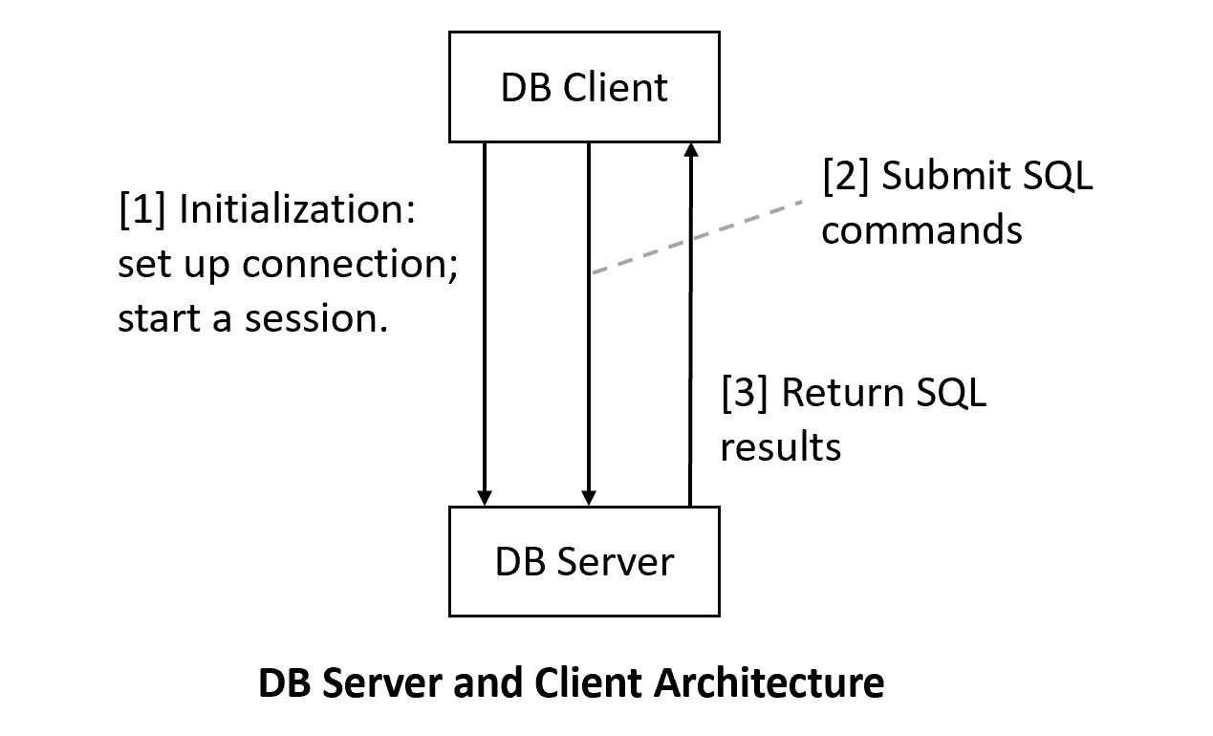

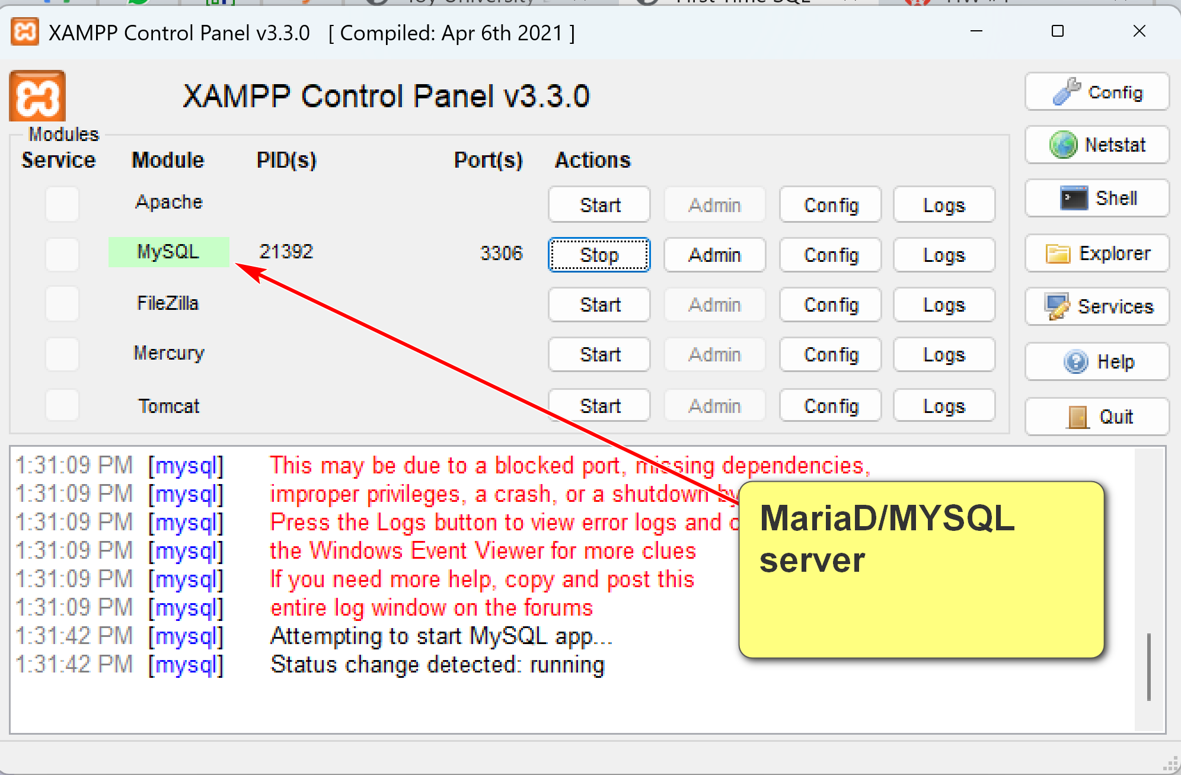

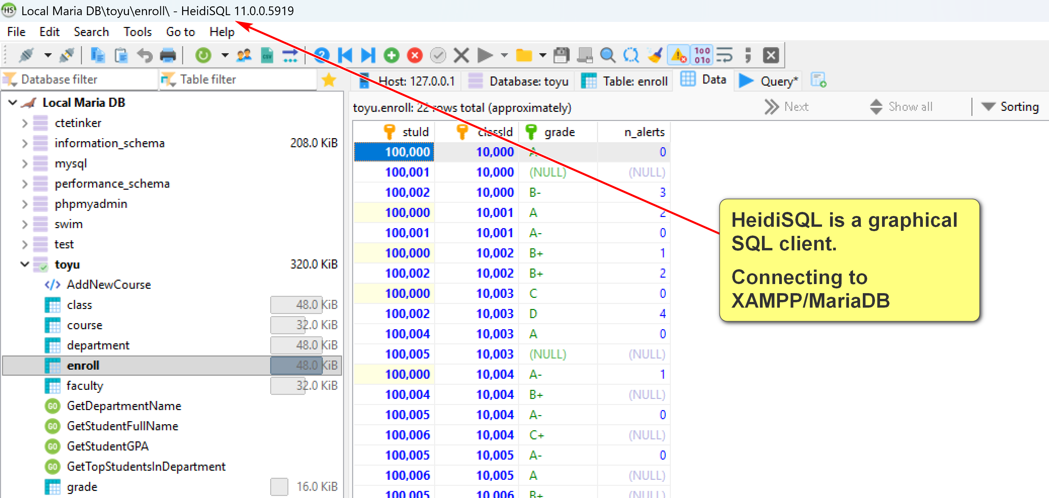

Use PhpMyAdmin to create accounts:
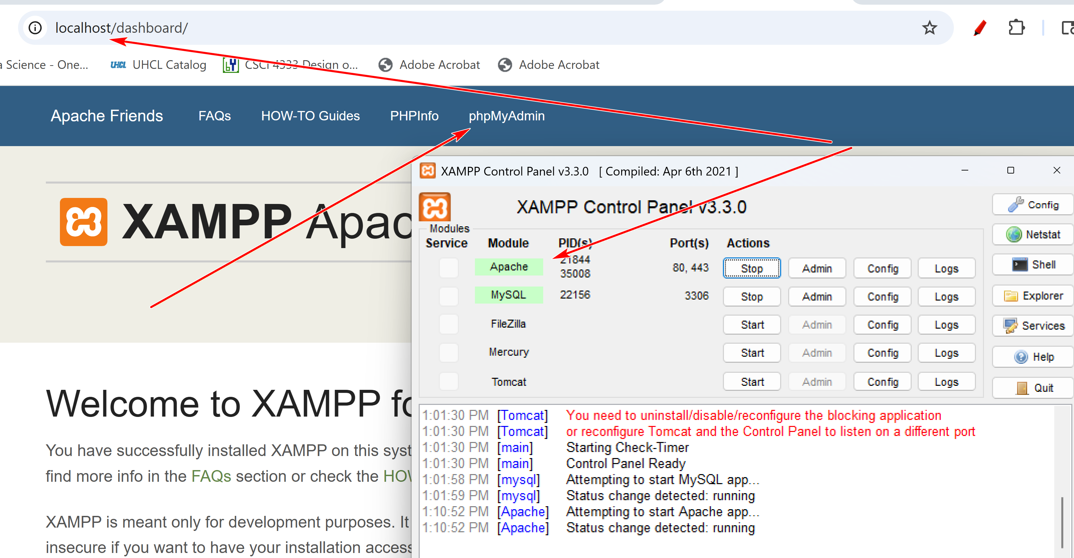

SELECT stuId, fname, lname -- columns in the table student
FROM student;

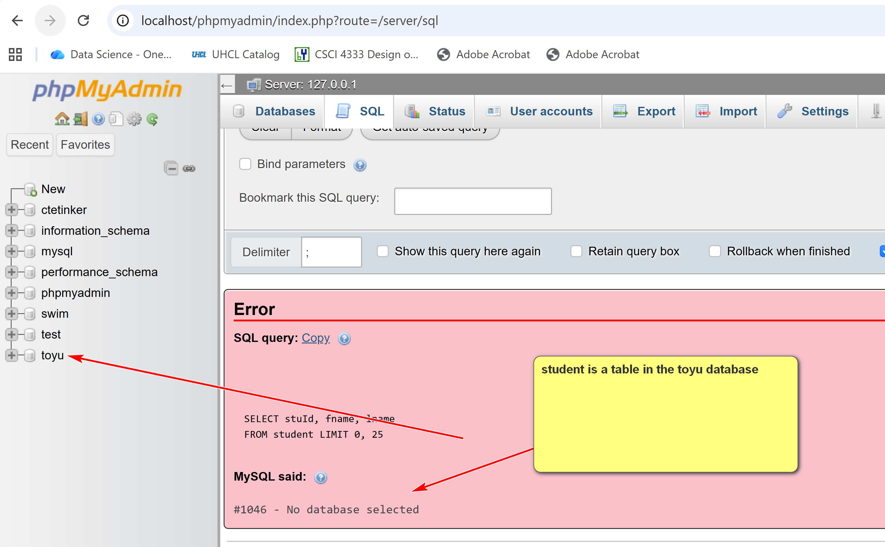

Create two accounts:
S1@localhost
s1@% (wild card matching and ipaddress)

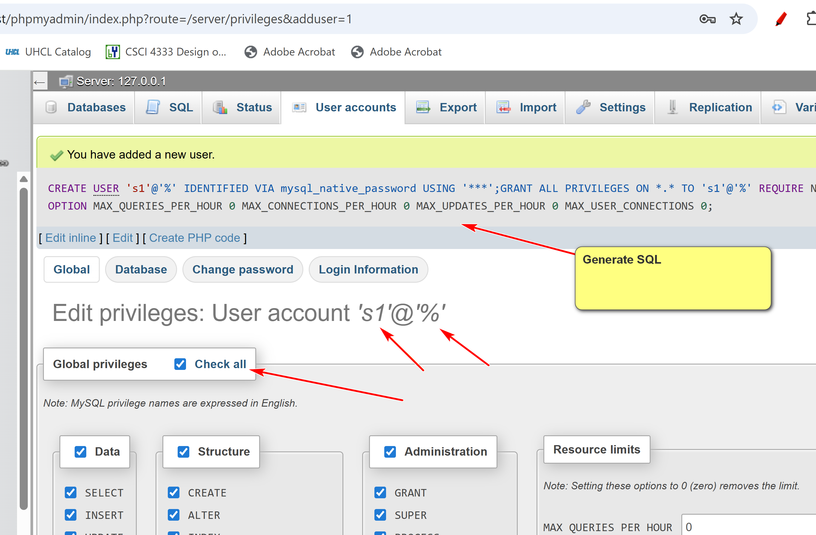
AN example of a section variable (client session):
MariaDB [toyu]> set @x = 1;
Query OK, 0 rows affected (0.000 sec)

MariaDB [toyu]> SELECT @x;
+------+
| @x |
+------+
| 1 |
+------+
1 row in set (0.000 sec)

4. SQL
- Note that different DBMS support different versions of SQL. They may not fully support the standards and may include extensions.
- For example, older versions of MySQL do not support EXCEPT, which is in ANSI SQL 92.
- When developing databases in a given DBMS, portability and backward compatibility issues are a consideration for your choice of SQL statements.
- MySQL is not based on a pure relational model. For example:
  - Query results may contain duplicate rows.
  - Order may be important.
- SQL is easy to start with. Not so easy to become an expert.
- SQL is a rich and essentially declarative but with some procedural constructs.
- For the time being, we only need to know the basic form of the SELECT statement to get some tastes of SQL and RDBMS.
SELECT DISTINCT <<result_columns>>
FROM <<source_tables>> -- conceptually joined to form a large table
WHERE <<conditions_for_inclusion>>
Declarative Analysis
- <<source_tables>>: the source tables to gather the result data
- <<conditions_for_inclusion>>: the conditions to be satisfied for results to be included and the conditions the tables should be connected together.
- <<result_columns>>: the result columns or expressions desired to be displayed.
Generate errors to play around:
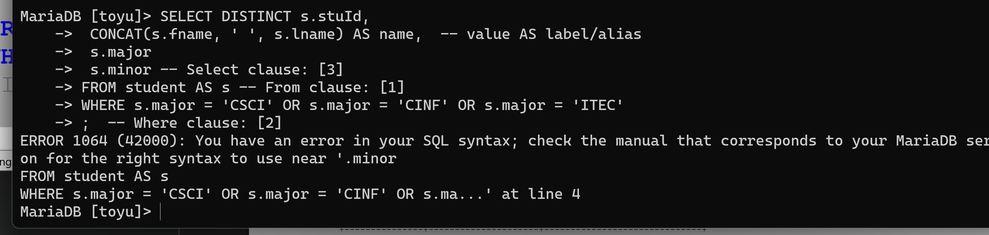
Examples:
Using toyu, executing the SQL:
-- Department codes and their names
SELECT DISTINCT deptCode, deptName
FROM department;
-- Faculty information from the department 'CSCI'
SELECT DISTINCT *
FROM faculty
WHERE deptCode = 'CSCI';
-- Faculty names from the department 'CSCI'
SELECT DISTINCT fname, lname
FROM faculty
WHERE deptCode = 'CSCI';
-- Associate professor names from the department 'CSCI'.
SELECT DISTINCT fname, lname
FROM faculty
WHERE deptCode = 'CSCI'
AND `rank` = 'Associate Professor';
-- Department names and numbers of faculty with the numbers
SELECT DISTINCT deptName, numStaff
FROM department
WHERE numStaff >= 10;
-- Names of all faculty members and their
-- department names and ranks.
SELECT DISTINCT faculty.fName, faculty.lname,
department.deptName, faculty.`rank`
FROM department, faculty
WHERE faculty.deptCode = department.deptCode;
SELECT DISTINCT faculty.fName, faculty.lname,
department.deptName, faculty.`rank`
FROM department INNER JOIN faculty ON (faculty.deptCode = department.deptCode);
Result:
MariaDB [toyu]> -- Department codes and their names
MariaDB [toyu]> SELECT DISTINCT deptCode, deptName
-> FROM department;
+----------+------------------------------+
| deptCode | deptName |
+----------+------------------------------+
| ACCT | Accounting |
| ARTS | Arts |
| CINF | Computer Information Systems |
| CSCI | Computer Science |
| ENGL | English |
| ITEC | Information Technology |
| MATH | Mathematics |
+----------+------------------------------+
7 rows in set (0.000 sec)
MariaDB [toyu]>
MariaDB [toyu]> -- Faculty information from the department 'CSCI'
MariaDB [toyu]> SELECT DISTINCT *
-> FROM faculty
-> WHERE deptCode = 'CSCI';
+-------+--------+--------+----------+---------------------+
| facId | fname | lname | deptCode | rank |
+-------+--------+--------+----------+---------------------+
| 1011 | Paul | Smith | CSCI | Professor |
| 1012 | Mary | Tran | CSCI | Associate Professor |
| 1013 | David | Love | CSCI | NULL |
| 1014 | Sharon | Mannes | CSCI | Assistant Professor |
+-------+--------+--------+----------+---------------------+
4 rows in set (0.000 sec)
MariaDB [toyu]>
MariaDB [toyu]> -- Faculty names from the department 'CSCI'
MariaDB [toyu]> SELECT DISTINCT fname, lname
-> FROM faculty
-> WHERE deptCode = 'CSCI';
+--------+--------+
| fname | lname |
+--------+--------+
| Paul | Smith |
| Mary | Tran |
| David | Love |
| Sharon | Mannes |
+--------+--------+
4 rows in set (0.000 sec)
MariaDB [toyu]>
MariaDB [toyu]> -- Associate professor names from the department 'CSCI'
MariaDB [toyu]> SELECT DISTINCT fname, lname
-> FROM faculty
-> WHERE deptCode = 'CSCI'
-> AND `rank` = 'Associate Professor';
+-------+-------+
| fname | lname |
+-------+-------+
| Mary | Tran |
+-------+-------+
1 row in set (0.000 sec)
MariaDB [toyu]>
MariaDB [toyu]> -- Department names and numbers of faculty with the numbers
MariaDB [toyu]> SELECT DISTINCT deptName, numStaff
-> FROM department
-> WHERE numStaff >= 10;
+------------------+----------+
| deptName | numStaff |
+------------------+----------+
| Accounting | 10 |
| Computer Science | 12 |
| English | 12 |
+------------------+----------+
3 rows in set (0.002 sec)
MariaDB [toyu]>
MariaDB [toyu]> -- Names of all faculty members and their
MariaDB [toyu]> -- department names and ranks.
MariaDB [toyu]> SELECT DISTINCT faculty.fName, faculty.lname,
-> department.deptName, faculty.`rank`
-> FROM department, faculty
-> WHERE faculty.deptCode = department.deptCode;
+----------+----------+------------------------------+---------------------+
| fName | lname | deptName | rank |
+----------+----------+------------------------------+---------------------+
| Paul | Smith | Computer Science | Professor |
| Mary | Tran | Computer Science | Associate Professor |
| David | Love | Computer Science | NULL |
| Sharon | Mannes | Computer Science | Assistant Professor |
| Daniel | Kim | Computer Information Systems | Professor |
| Andrew | Byre | Computer Information Systems | Associate Professor |
| Deborah | Gump | Information Technology | Professor |
| Art | Allister | Arts | Assistant Professor |
| Benjamin | Yu | Information Technology | Lecturer |
| Katrina | Bajaj | English | Lecturer |
| Jorginlo | Neymar | Accounting | Assistant Professor |
+----------+----------+------------------------------+---------------------+
11 rows in set (0.000 sec)
MariaDB [toyu]>
MariaDB [toyu]> SELECT DISTINCT faculty.fName, faculty.lname,
-> department.deptName, faculty.`rank`
-> FROM department INNER JOIN faculty ON (faculty.deptCode = department.deptCode);
+----------+----------+------------------------------+---------------------+
| fName | lname | deptName | rank |
+----------+----------+------------------------------+---------------------+
| Paul | Smith | Computer Science | Professor |
| Mary | Tran | Computer Science | Associate Professor |
| David | Love | Computer Science | NULL |
| Sharon | Mannes | Computer Science | Assistant Professor |
| Daniel | Kim | Computer Information Systems | Professor |
| Andrew | Byre | Computer Information Systems | Associate Professor |
| Deborah | Gump | Information Technology | Professor |
| Art | Allister | Arts | Assistant Professor |
| Benjamin | Yu | Information Technology | Lecturer |
| Katrina | Bajaj | English | Lecturer |
| Jorginlo | Neymar | Accounting | Assistant Professor |
+----------+----------+------------------------------+---------------------+
11 rows in set (0.000 sec)
Classroom Demonstration and Exercises:
Example. Show all student names.
Expected Result:
+---------+-----------+
| lname | fname |
+---------+-----------+
| Hawk | Tony |
| Hawk | Mary |
| Hawk | David |
| Lim | Catherine |
| Johnson | Larry |
| Johnson | Linda |
| Johnson | Lillian |
| Zico | Ben |
| Ching | Bill |
| King | Linda |
+---------+-----------+
10 rows in set (0.00 sec)
Declarative Analysis:
[1] Sources: student
[2] Conditions: none
[3] Output fields: lname, fname
SELECT DISTINCT s.fname, s.lname
FROM student AS s -- s is the alias of student
- Using alias in generally is considered good style.
- Conceptually "FROM student AS s " may be conceptually understood as that s is a row in the table student.
Example. List the last names and first names of students minoring in CINF and having 1011 as faculty advisor.
+-------+-------+
| lname | fname |
+-------+-------+
| Hawk | Tony |
| Hawk | Mary |
+-------+-------+
2 rows in set (0.001 sec)
[Analysis]
[1] Source tables: student
[2] Conditions:
- minor = 'CINF'
- advisor = 1011
[3] Output columns:
- lname
- fname
[suggested solution of sample question]
SELECT DISTINCT s.fname, s.lname
FROM student AS s -- s is the alias of student
WHERE s.minor = 'CINF'
AND s.advisor = 1011;
Classroom examples:
1. All student names and the major codes.
2. All student names and the major department names.
3. All student names enrolled in the class with id 10003.
4. Show all information of students majoring in ‘MATH’.
5. Show the names and credits of students majoring in 'CSCI'.
6. Show the names and credits of students majoring in 'CSCI' and having 40 or more ach credits.
7. Show the id of students enrolled in the course CSCI 4333.
8. Show the code of departments with faculty in the rank of 'Professor'.
9. Show the names of departments with faculty in the rank of 'Professor'.
10. Show the names of students who have enrolled in the course CSCI 4333.
11. Show the names and major names of every student.
12. Show the names, major names, and advisor names of every student.
13. Show the student names and their major names for all students who have received a grade A in a class offered by a faculty from the CSCI department.
14. Show the student names who have enrolled in at least two classes.
Will work on past SQL assignments.

