CSCI 4333.1
1/14/2026
(annotation)

SQL, MongoDB, Python
MySQL: XAMPP.
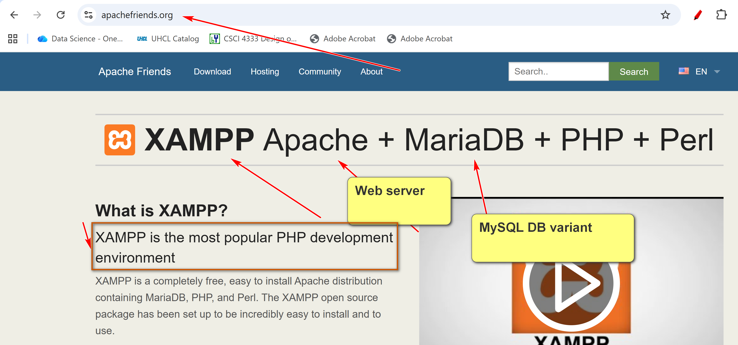
Install XAMPP in top level of C drive.

Introduction to the course
CSCI 4333
by K. Yue
1. Promotion
- This course is (hopefully) one of the more useful CS/DS courses for students.
- World data is estimated to double every two years.
- Question: still true? Source?
2. How to be successful in the course
General Course Suggestions:
- Course expectation is demanding.
- Please consider forming the habit of listening carefully and asking a lot of questions.
General Professionalism:
- Attitude
- Be considerate.
- Be helpful and useful to others.
- Be a good listener.
- Be responsive.
- Hardworking
- Attention to details.
- Focus: uni-tasking
Some general tips:
- Engagement: Participate. Ask questions, a lot of them. Help others. Plan ahead.
- Preparation: start as early as possible and do not fall behind.
- Don’t copy and paste. Instead, copy, integrate, and apply.
- SEE-I: State, Elaborate, Exemplify and illustrate. Gauge/assess your understanding.
  - State: the concept in your own words
  - Elaborate: elaborate the concepts by supplementary and supporting sub-concepts.
  - Exemplify: provide concrete examples

- Form good habits.
Some good traits of Computer and Data Scientists:
- Habits of trying to make sense of stuff.
- Intellectual curiosity.
- Tinkering and experimentation.
- Open-minded, not dogmatic.
- A large tool set.
3. Resources
- Companion materials of our textbook: please consult the course page in Canvas for additional resources related to the textbook.
- Contents of the course will be based mostly on
  - Lecture notes posted in the course website: ../../index.html.
  - Classroom demonstrations.
  - Assignments.
- Please read the appropriate pages in the textbook and lecture notes in this site before coming to the class.
- Document your learning. Bring a notebook to the class. Otherwise, it may be a good idea to print out the notes and bring them to the class so you can make notes during the class.
4. Introduction
- Persistent data is the backbone of many applications.
- Three main choices of storing persistent data:
  - Files
  - Databases: focus of this course.
  - Cloud-based storage and database.
- Some advantages of DBMS (according to Ricardo, the optional textbook of this class):
  - Sharing of data
  - Control of redundancy
  - Data consistency
  - Improved data standards: standards used to store data.
  - Better data security:
    - Manage data to allow access to selected by permitted groups.
      - Elaborate: Accurate and nuanced access controls to fine grained data.
      - Examples:
        - Windows File Systems: define groups and users to provide access control to individual files (R, W, E)
        - DBMS:
          - More flexible definition of groups and users.
          - More access features, R, W, E.,…
          - Fine grained: table, row (record), database
          - Other security mechanisms…
          - SQL can be used to set up access control (privilege)
  - Improved data integrity: data should be consistent with each other
  - Balance of conflicting requirements
  - Faster development of new applications
  - Better data accessibility
  - Economy of scale
  - More control over concurrency
  - Better backup and recovery procedures
- How do we make sense of these 12 different advantages?
  - Different textbooks may have different collections of the advantages of DBMS because of different classifications.
  - No need to memorize them.
  - Better to assimilate them and construct your own list.
  - Make your own notes. Use SEE-I (In your own words, state, elaborate, and exemplify with examples, and illustrate the concept.)
    - However, do not overuse metaphors.
  - Learning through documentation, communications, and teaching.
- What are some disadvantages of DBMS?
  - Complexity
  - Cost
  - Learning curve
  - Possible single points of failure and bottleneck
5. A Simple Introduction to the Relational Model
- Relational databases are the most popular databases: https://db-engines.com/en/ranking. It is based on the relational model.
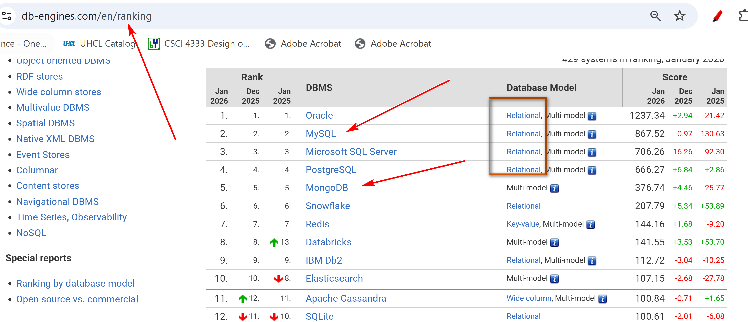
- There are many other data models. E.g. wide-column, document, key-value,…
- In layman's term: A table (relation) is the basic unit of a relational database.
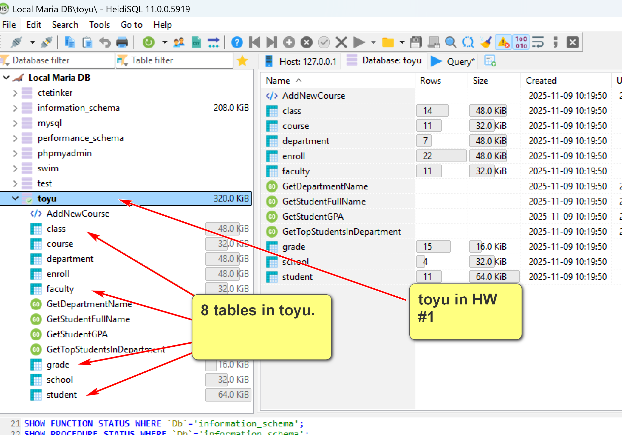
- A table is composed of many rows (tuples).
- Each row has many column (attribute) values.
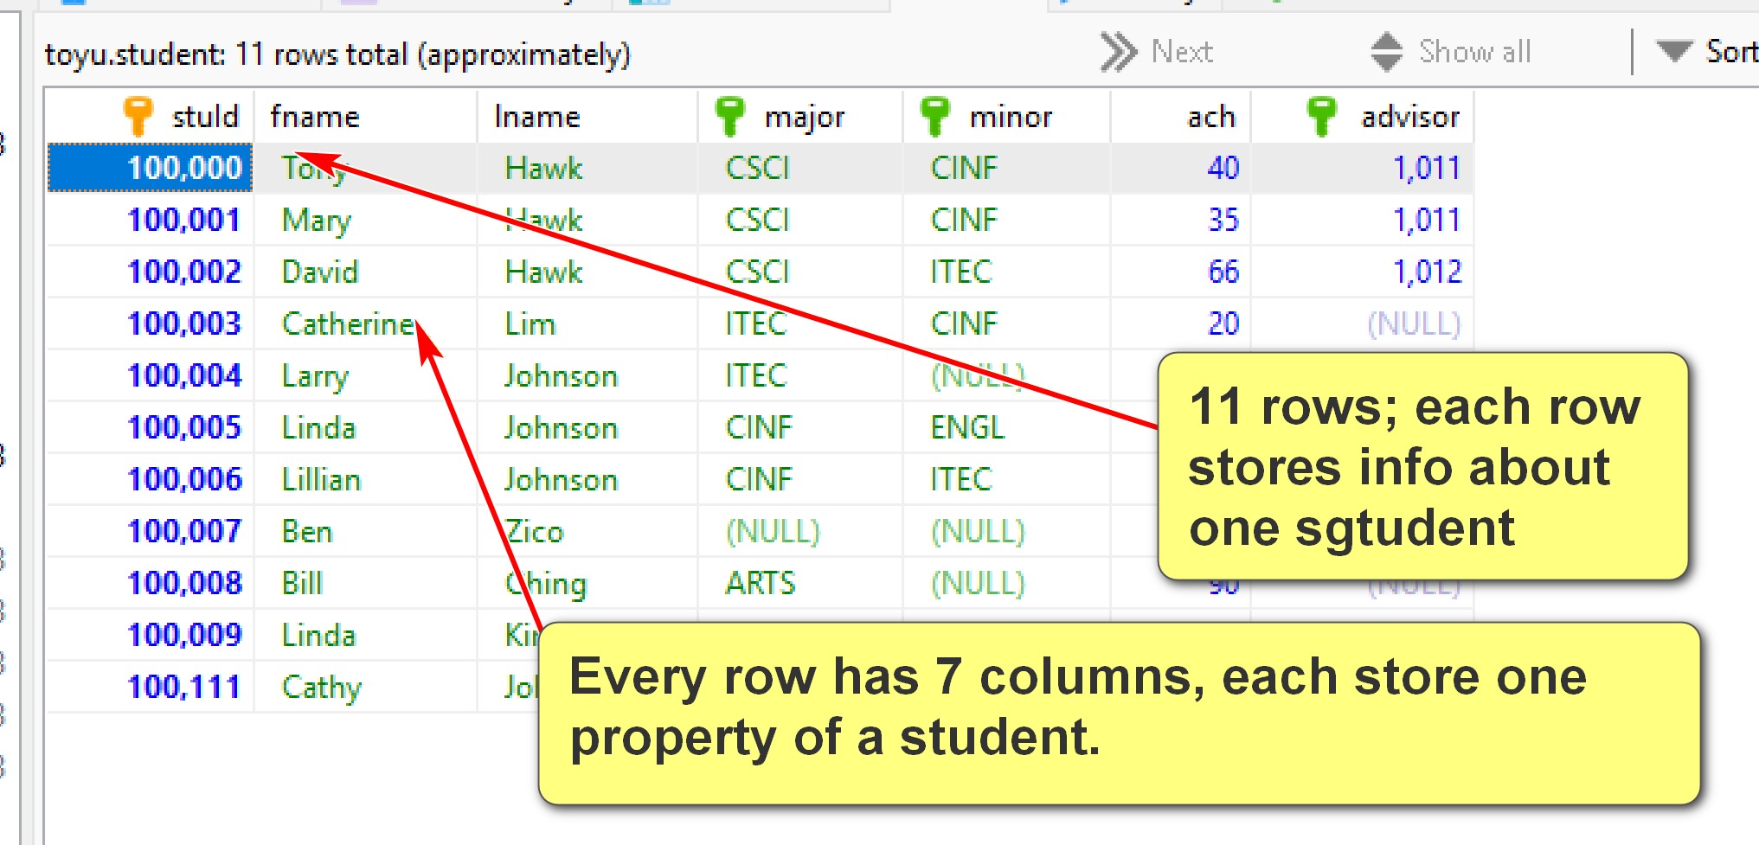
In TOyu:
A class is an offering of a course in a semester taught by an instructor in a room:
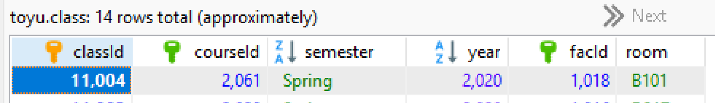

- A primary key is roughly a minimal set of columns in a table that uniquely identify a row.
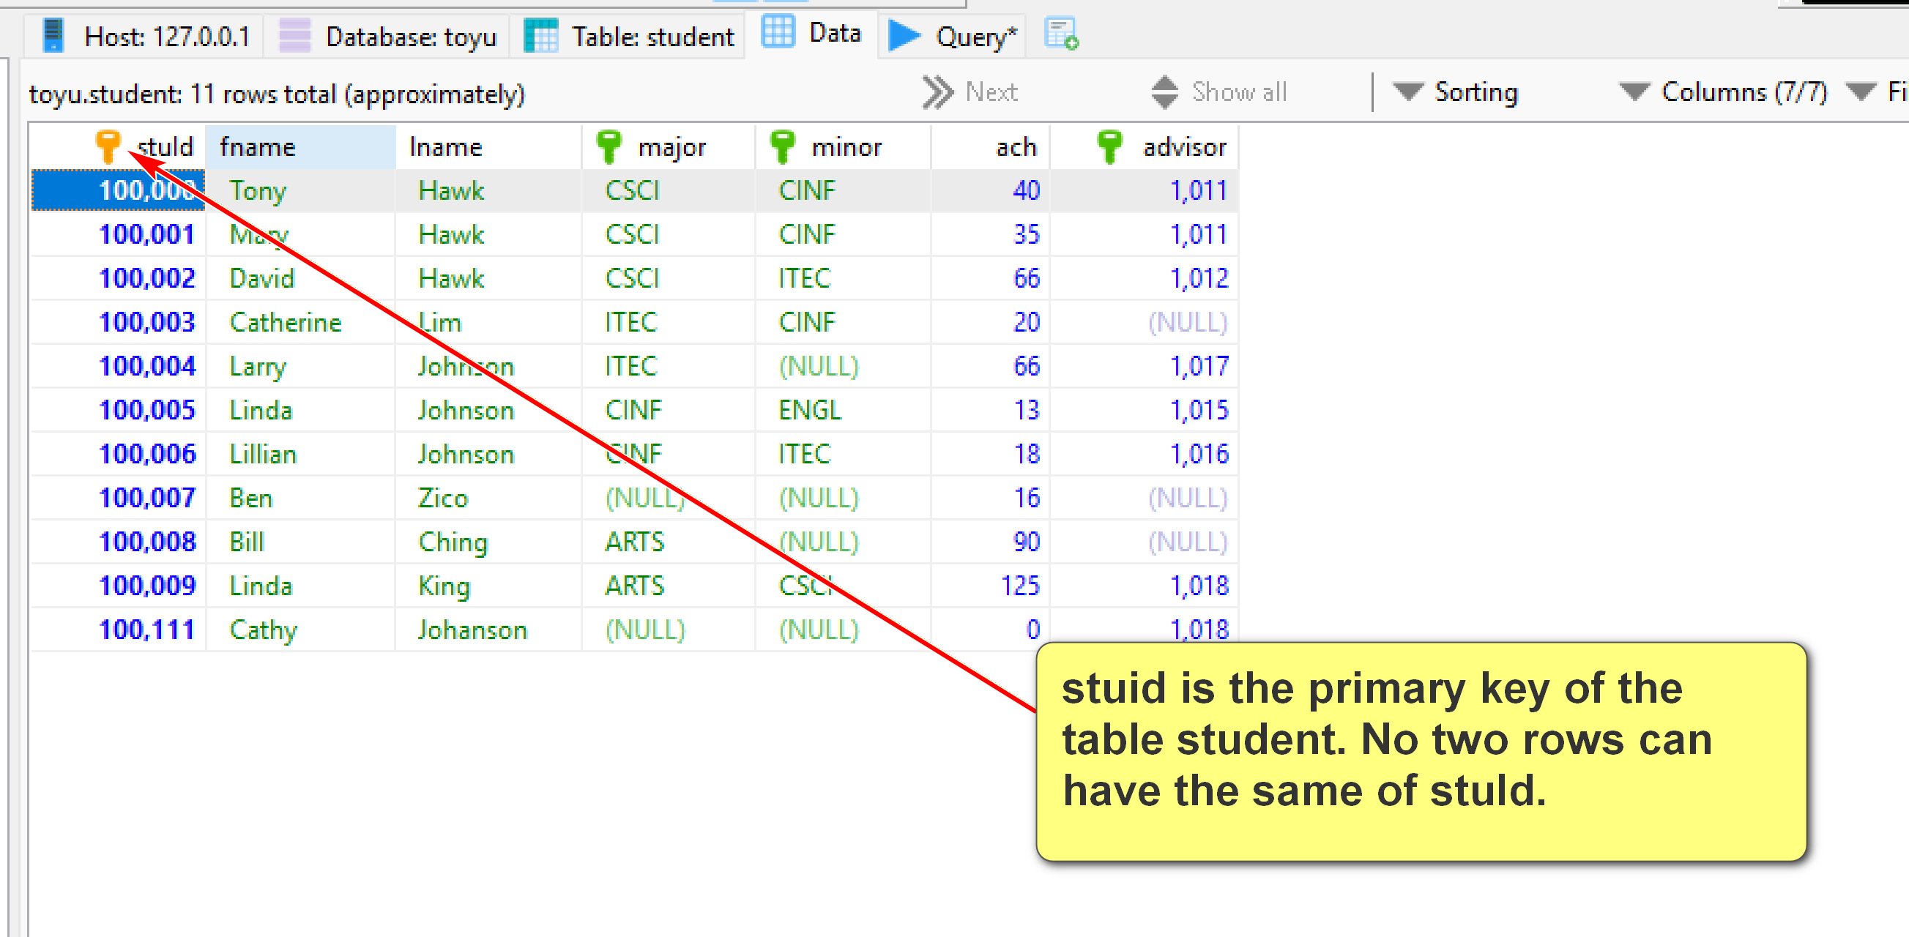
- Two tables can be related to each other by foreign keys. A foreign key is roughly a column in a table in which its value must be equal to the referenced value of the primary key in another table (called the parent or referenced table).
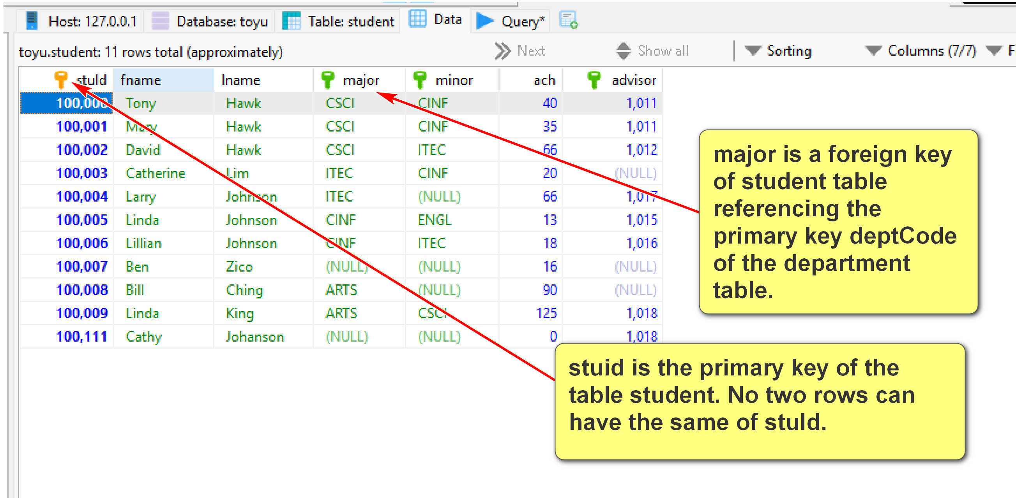
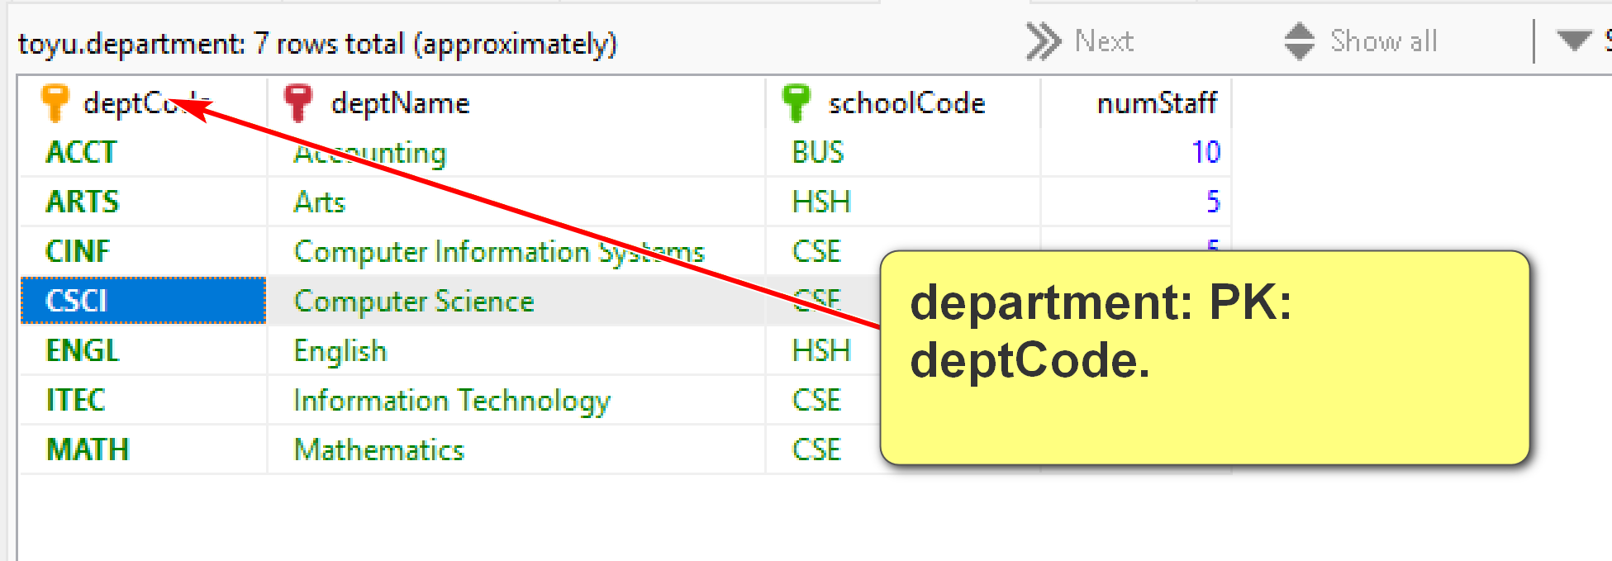
Join date from student (major) and department:
Student.major = department.deptCode
Table1.FK (foreign key) = parent table.PK (primary key)
Enroll table: a row is a student (identified by stuId) enrolled in a class (identified by classId) with a grade and a n_alerts:
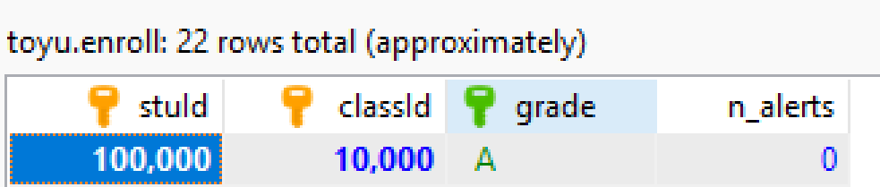
Relations/tables (primary key underscored):
Grade(grade, gradePoint)
School(schoolCode, schoolName)
Department(deptCode, deptName, schoolCode, numStaff)
Faculty(facId, fname, lname, deptCode, rank)
Course(courseId, rubric, number, title, credits)
Class(classId, courseId, semester, year, facId, room)
Student(StuId, fname, lname, major, minor, ach, advisor)
Enroll(stuId, classId, grade, n_alerts)
Foreign keys:
1. Student(advisor) references Faculty(facId)
2. Student(major) references Department(deptCode)
3. Student(minor) references Department(deptCode)
4. Faculty(deptCode) references Department(deptCode)
5. Department(schoolCode) references School(schoolCode)
6. Enroll(stuId) references Student(stuId)
7. Enroll(classId) references Class(classId)
8. Enroll(grade) references Grade(grade)
9. Class(courseId) references Course(courseId)
10. Class(facId) references Faculty(facId)
11. Course(Rubric) references Department(deptCode)

- Relational DBMS is the most popular DBMS. Examples:
  - DB-engine ranking: https://db-engines.com/en/ranking
  - Top 10 DBMS in Data Science: https://towardsdatascience.com/top-10-databases-to-use-in-2021-d7e6a85402ba
- SQL is the 'glue' in many DB systems.
Classroom discussion
Please ask questions about the toy University DB (toyu)
DBMS mostly uses a client-server architecture.
