DASC 5333 Database Systems for Data Science
CSCI 4333 Design of Database Systems
Spring 2025
Homework #2 UML Modeling
Download and install the student version of Astah's UML Editor: http://astah.net/download. Astah provides it free for students. This is one of the best free UML editors available. It has some restrictions but should be more than sufficient for our class. Another good alternative is to use Visual Paradigm’s community version. This is free but may leave a watermark when you export your model diagram to images or PDF. Instead, you may just take a screenshot of the model.
The homework assignment is to model a drastically simplified database application described below.
Multiplicities for attributes and associations should be as specific as possible. You may or may not explicitly specify the attribute multiplicity of 1..1 (or just 1), which is assumed to be the default. Attribute and association documentation are optional, but they are encouraged when not trivial. For example, the roles or the names of associations may be displayed when appropriate. Operations for classes are not necessary. You may create user-defined types, such as SQL::Id, SQL::DateTime, SQL::Boolean, etc.
Save your files as h2.asta (Astah's file format) and h2_documentation.docx (optional; for additional information if needed). You may also include a PDF version of your class diagram: h2.pdf, especially if you are not using Astah.
Submit your homework through Canvas, including .asta and/or .pdf files. If you are not using Astah, you must submit a PDF file.
Restaurant Management System (RMS)
Create a data model using an UML class diagram to support a portion of a drastically simplified restaurant management system (RMS). It only supports a very limited set of functions. Make reasonable simplifying assumptions.
There are menu items in RMS for customers to order. A unique Id of a menu item should be kept with the item name. An item name is also unique.
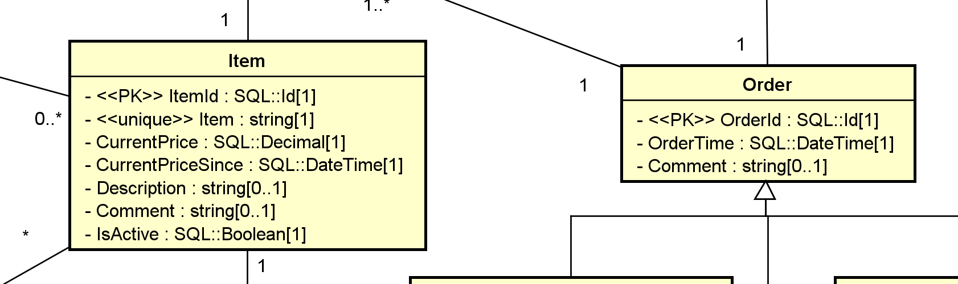
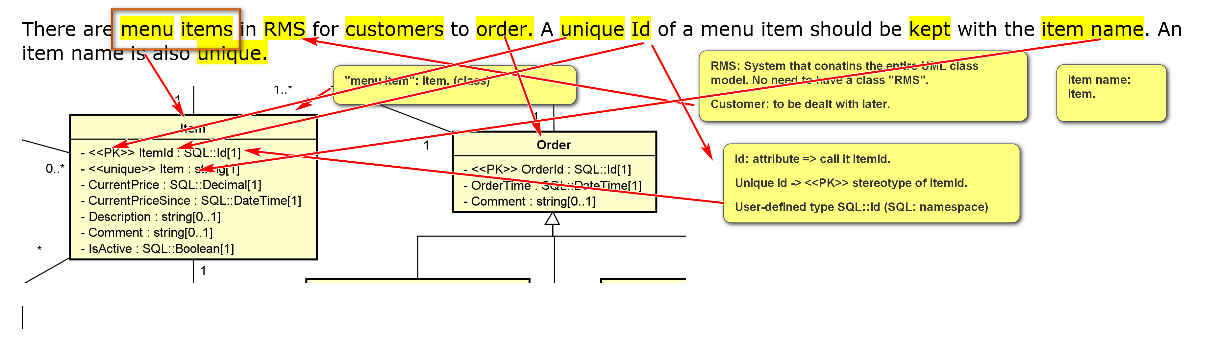
The current price of the item and when it became effective should be recorded. There may be a description and a comment on a menu item. An item can be active, which means that it is currently offered. It may also be inactive, meaning that it is not currently available.
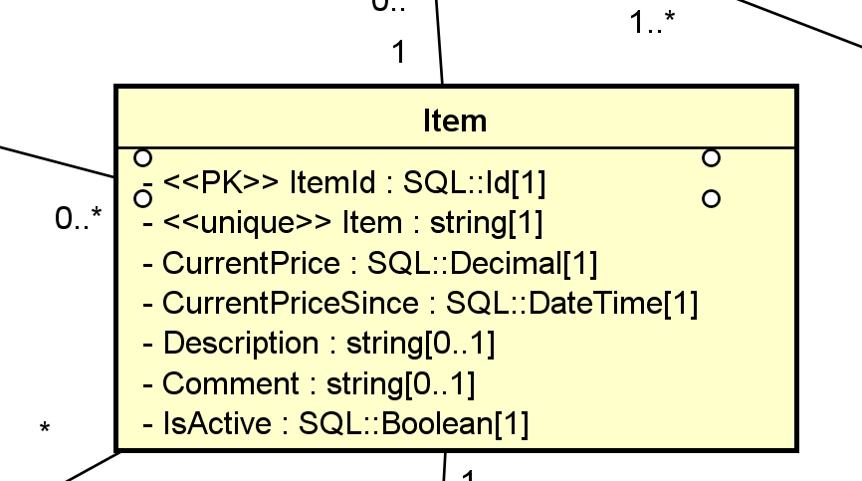

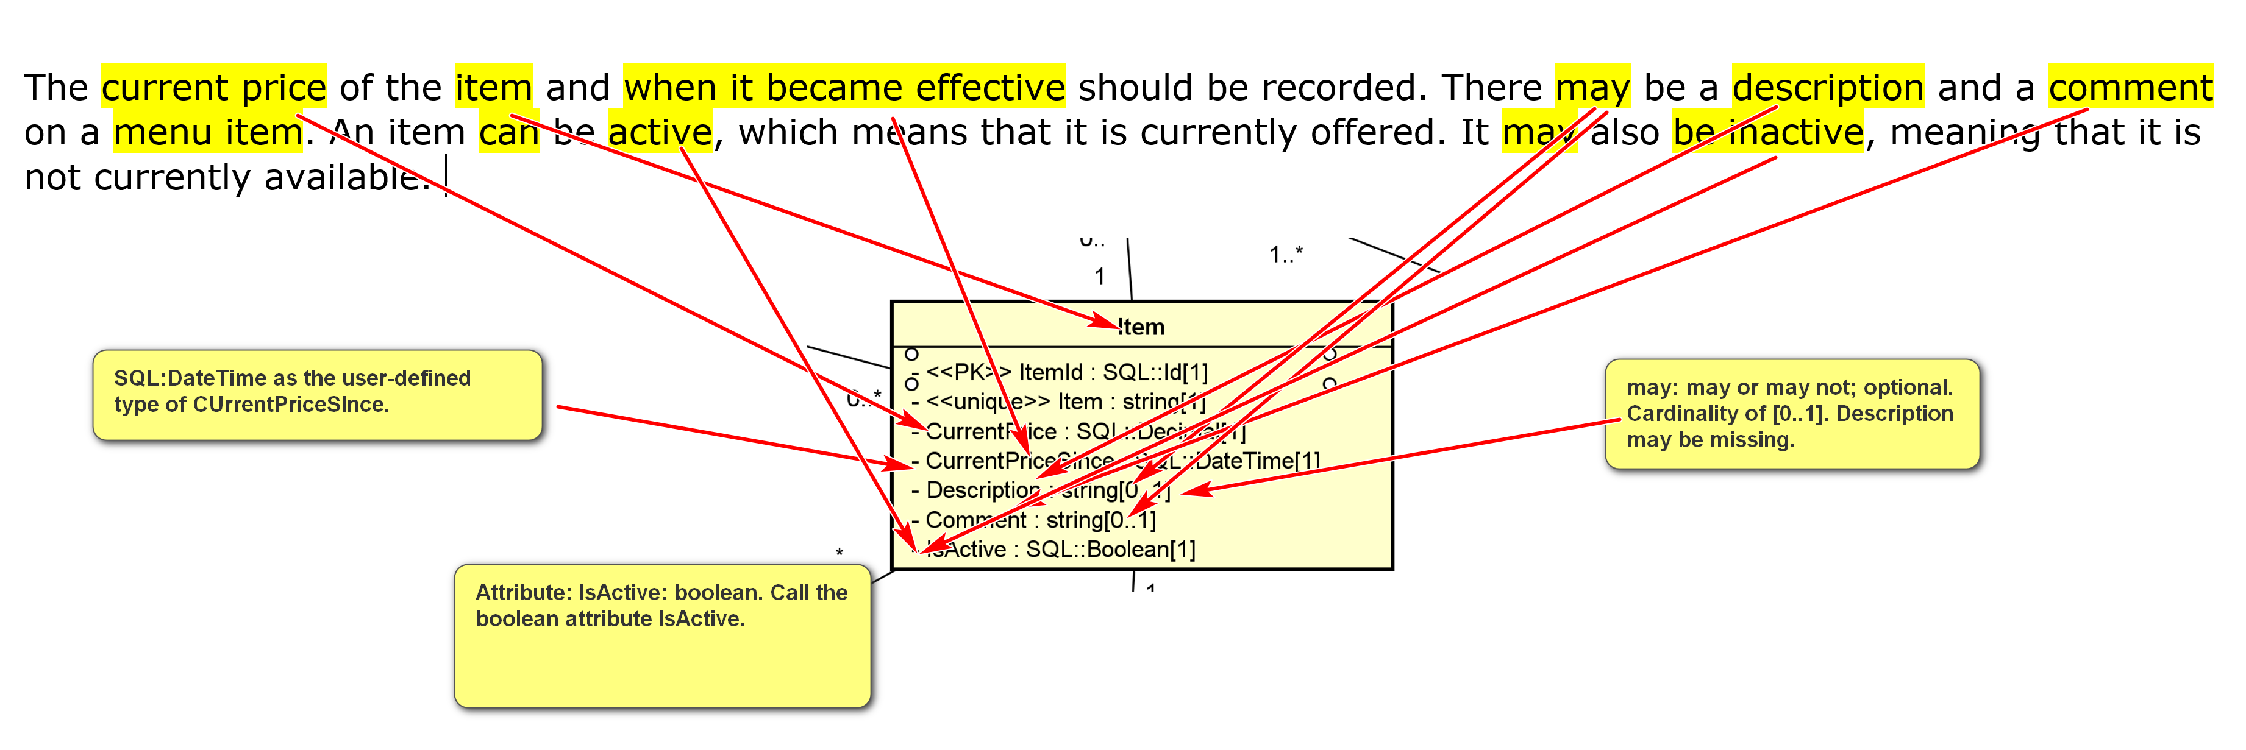

Every item belongs to a tax category. A restaurant needs to collect sale tax. Each tax category has a unique name and a tax rate.

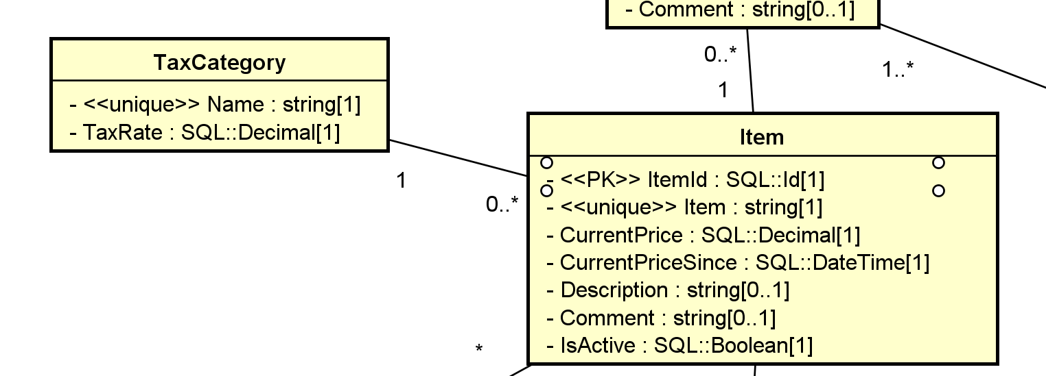
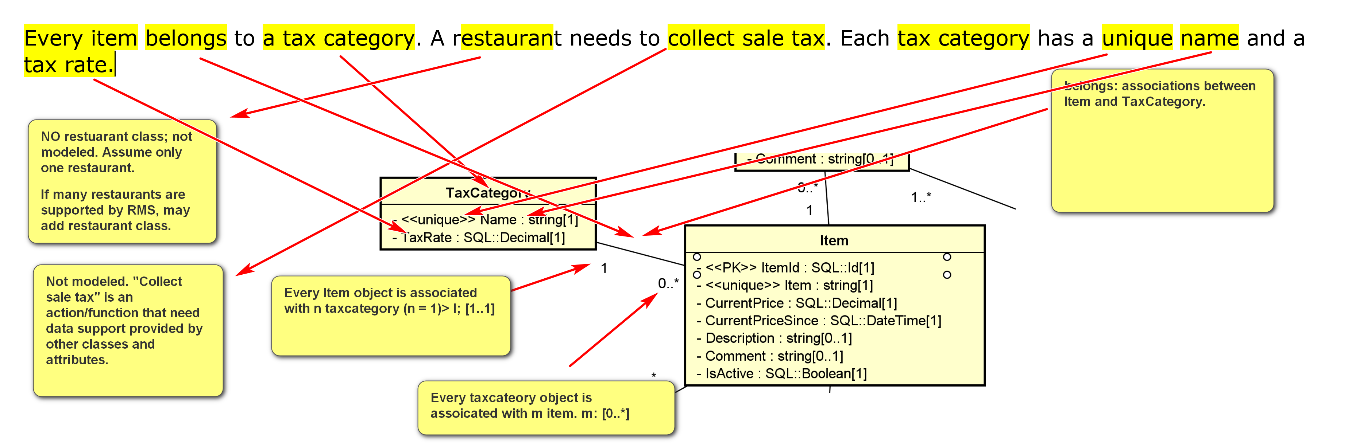
Coke (an item object) belongs (verb: association) to TC1 (tax category).
We need to make assumptions and check with the stakeholders.
If we need to store the date an item belonging a tax category:
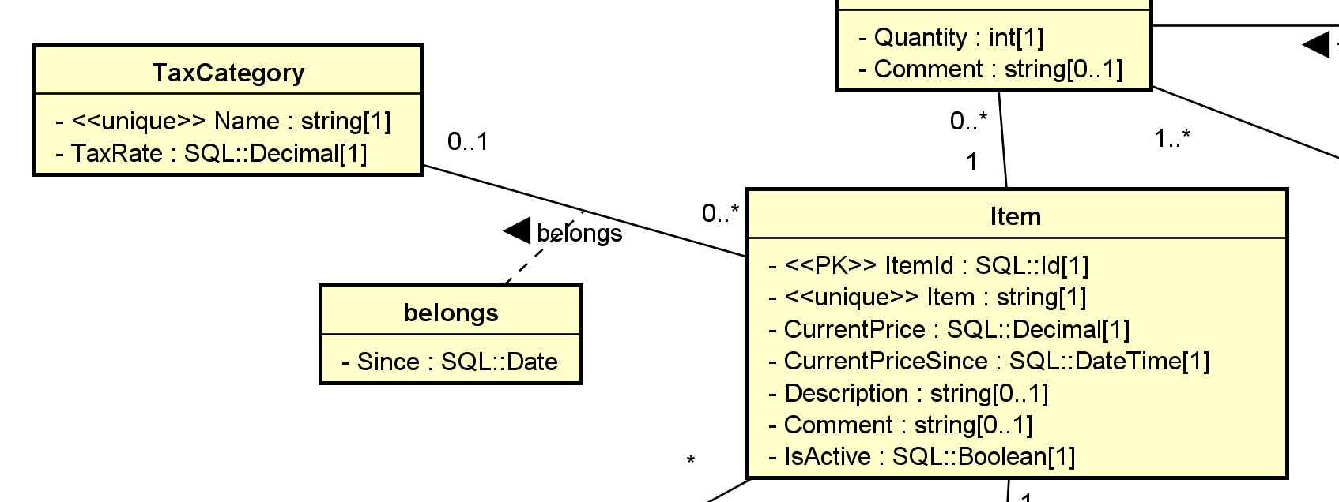
Coke (an item object) belongs (verb: association) to TC1 (tax category) since 7/1/25 (property of belongs). Thus, promote belongs from an association to an association class.
A menu item may also belong to a menu category, such as 'dessert', 'appetizer', 'seafood', 'entree', 'pasta', etc (examples of cateogries). In fact, a menu item may belong (association) to multiple categories. For example, 'clam pasta' may belong to both 'seafood' and 'pasta'. A menu’s category may have a description.
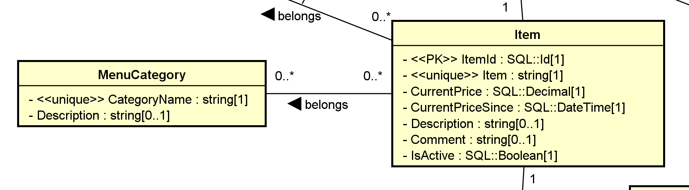

Note that the price of an item can be $0 (e.g. water). For example, for the menu item ‘clam pasta’, we may have:
- Item: clam pasta
- Current price: $16.99
- Price since: 12/1/2024 14:05:00
- Description: class pasta with Alfredo sauce and almond and peanut springle.
- Comment: Possible peanut allergy.
‘Clam Pasta’ is an object of the class item.
The change history of menu items should be kept. Currently, the changes can be price changes or availability changes. The effective start time of a change should be recorded with an optional comment.
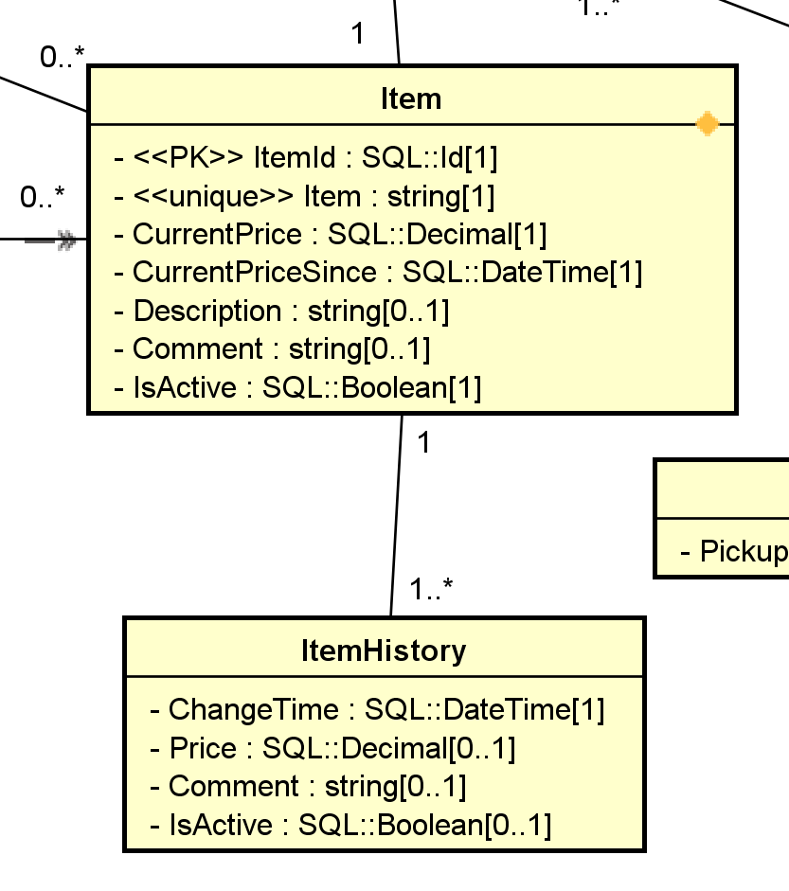
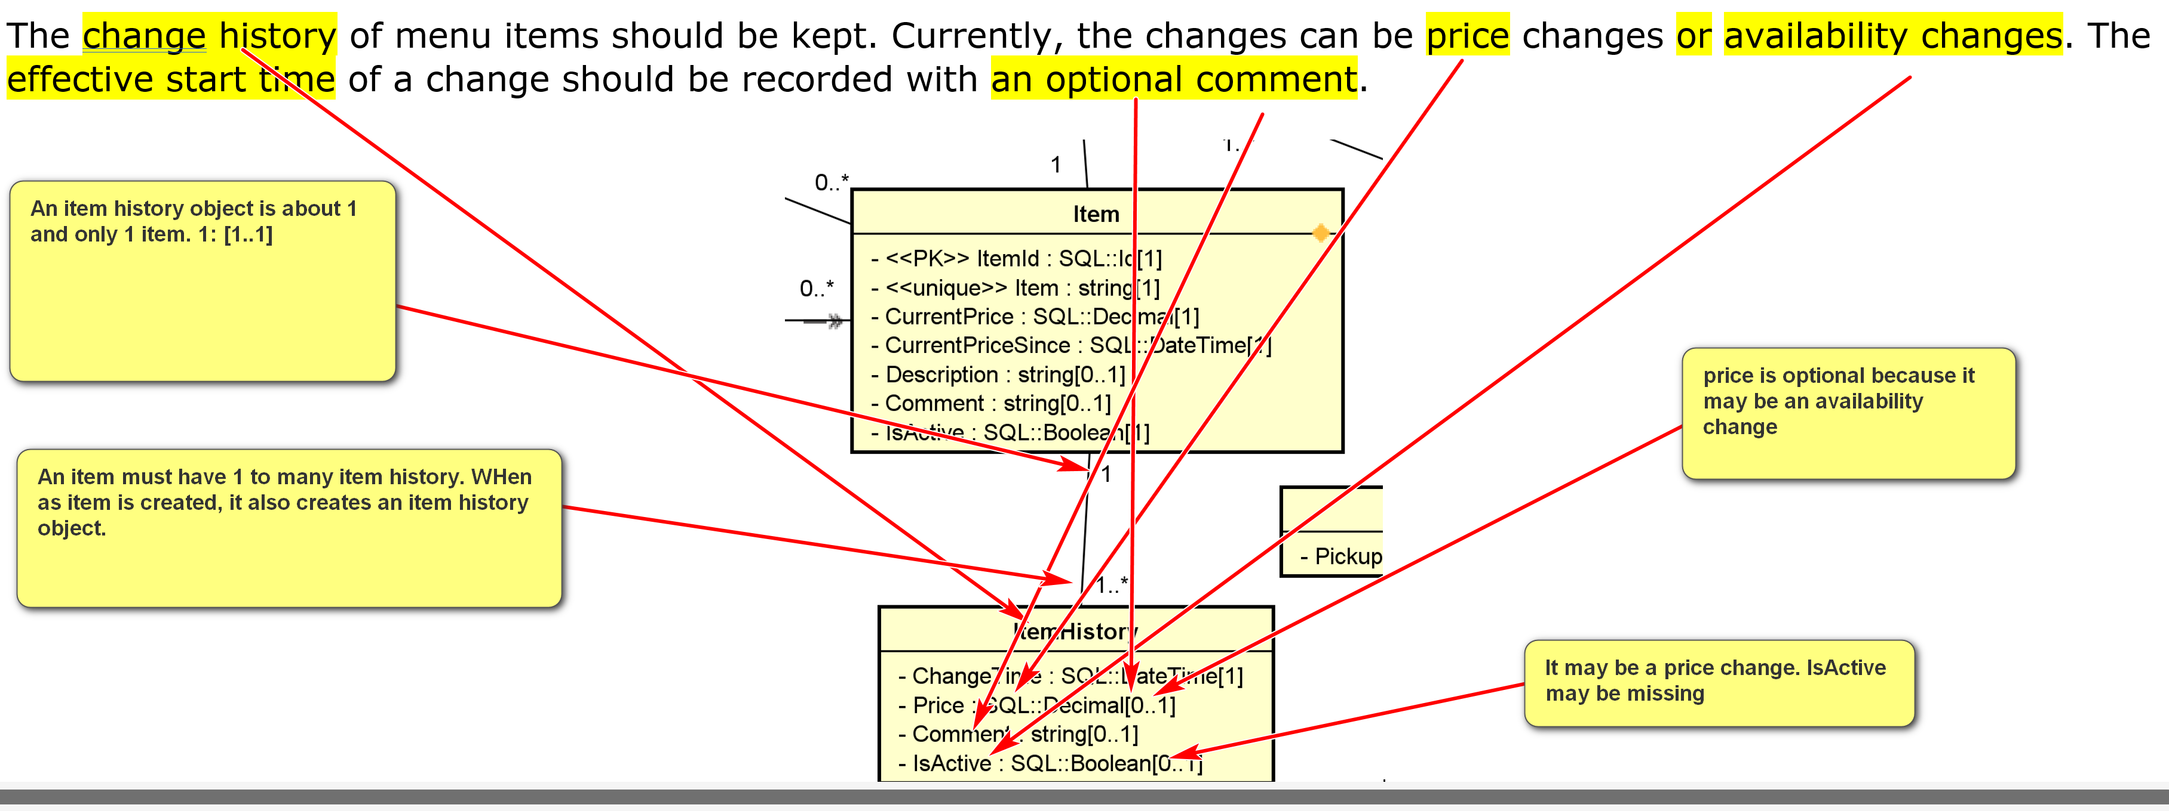
Object diagrams are useful to constructing class diagrams.
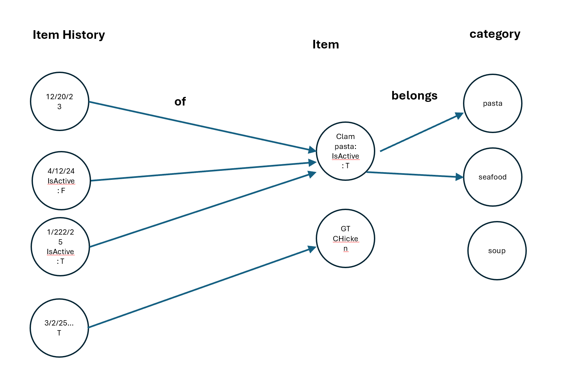
An order has a unique id as an identifier. The order time must be stored. An optional comment can be made by the person taking the order. An order can have any number of items on the menu. For example: order id 13247:
3 (order of) Clam Pasta
4 Garlic Bread
5 Tandoori Chicken
2 Coke
3 Water
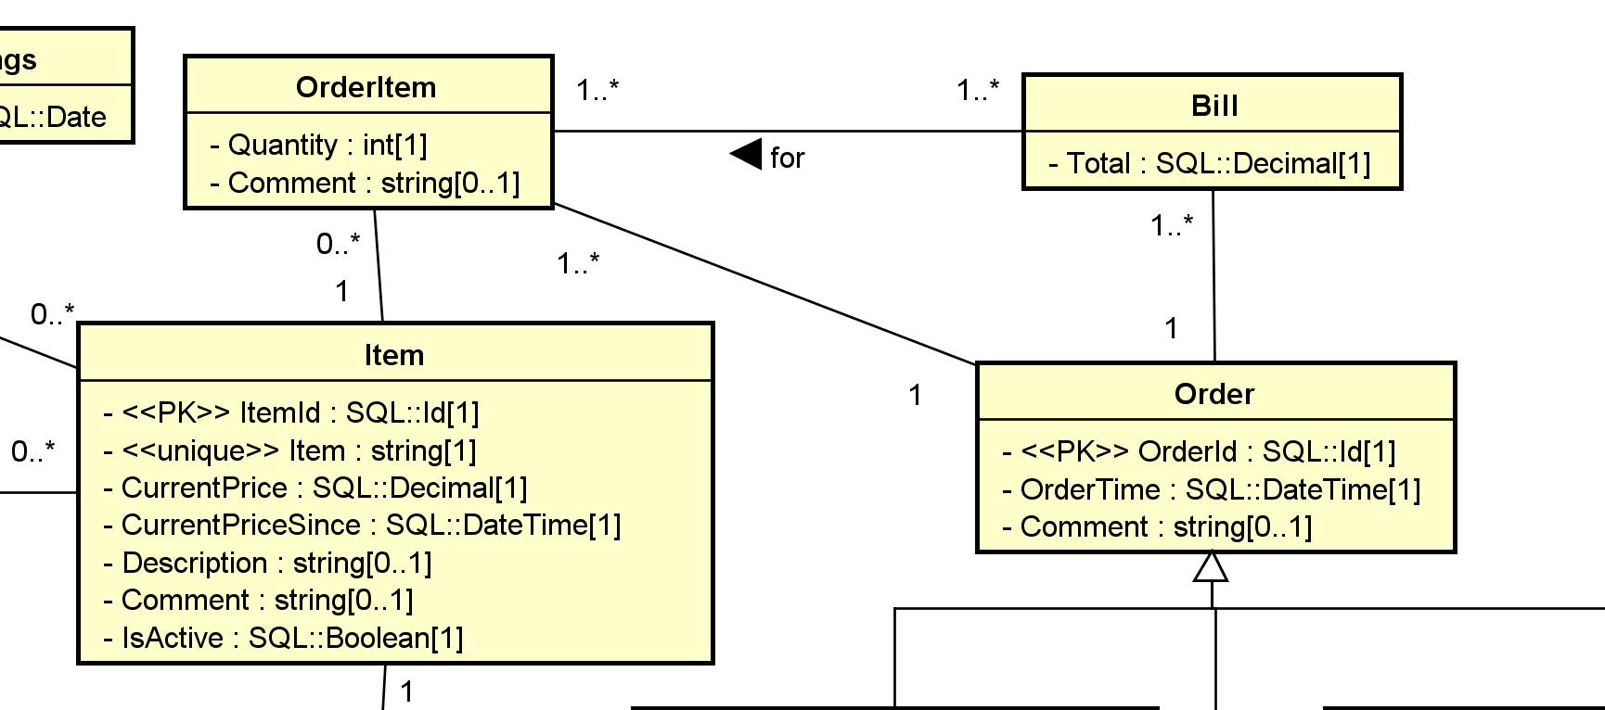
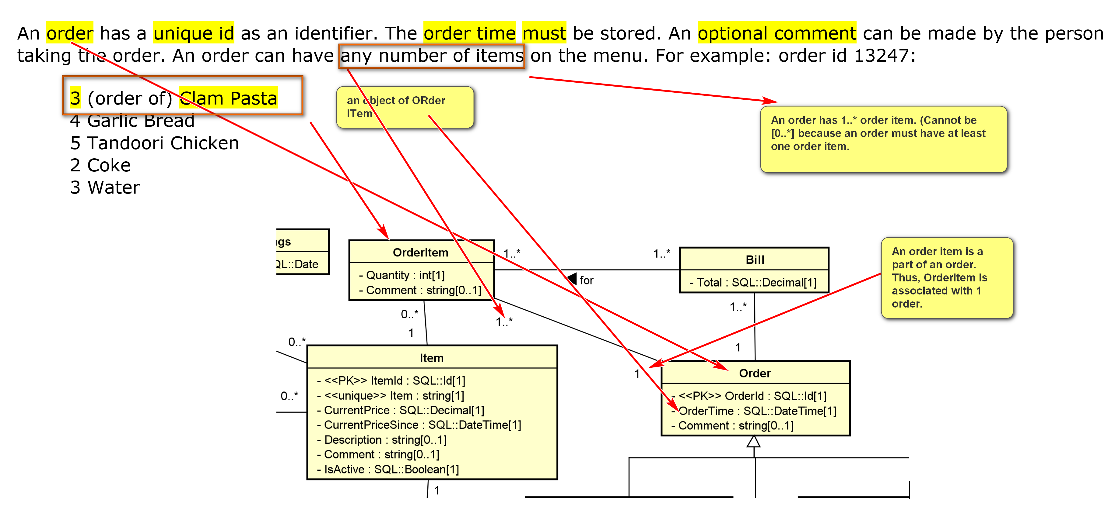

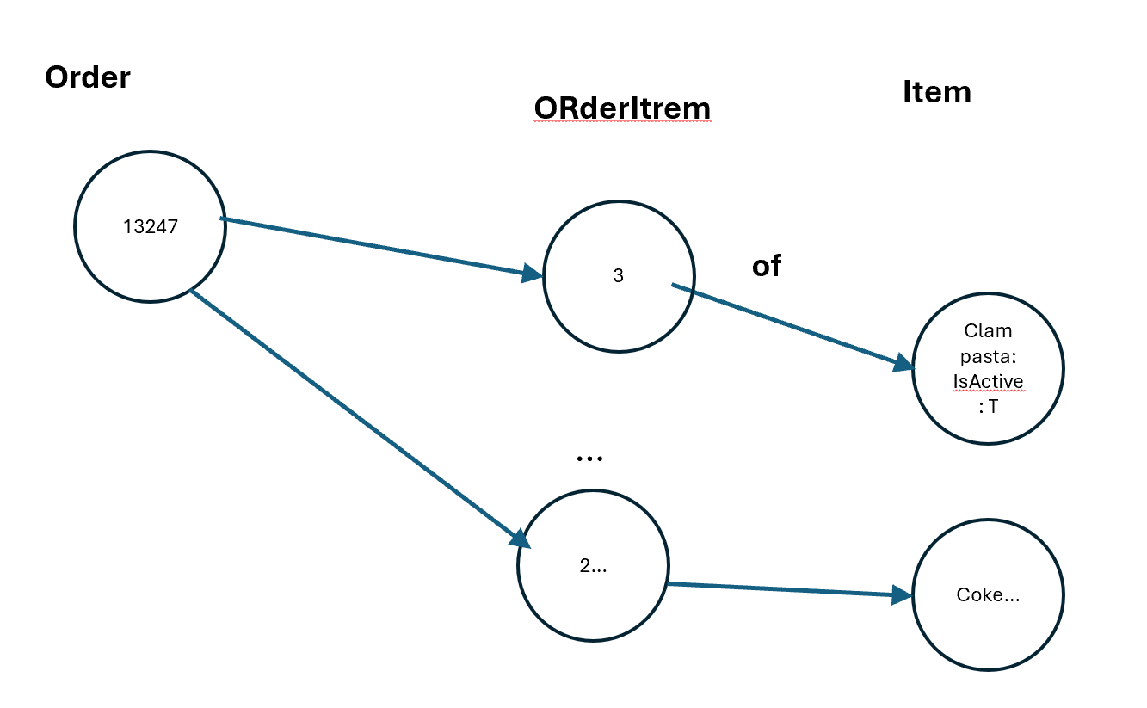
There are three kinds of orders.
A take-out order may include pick-up time.
A delivery order must have customer information: name, phone, address, city, state, and zip code. Note that the customer’s name is optional as it may be a one-time order. For repeating customers, the customer names are usually stored. There may be a promised time of delivery.
An in-house order is for a party dining in the restaurant. The number of guests in a party should be recorded. Each order is served by a waiter. A waiter has a unique id and a name. There are tables in the restaurant with a unique table id and a unique table number. There may be a description for each table. For example:
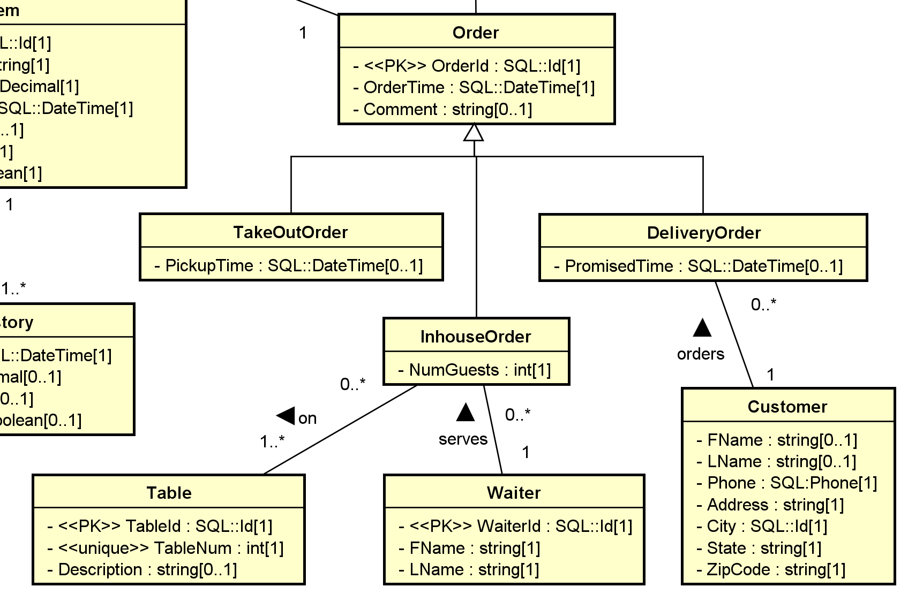
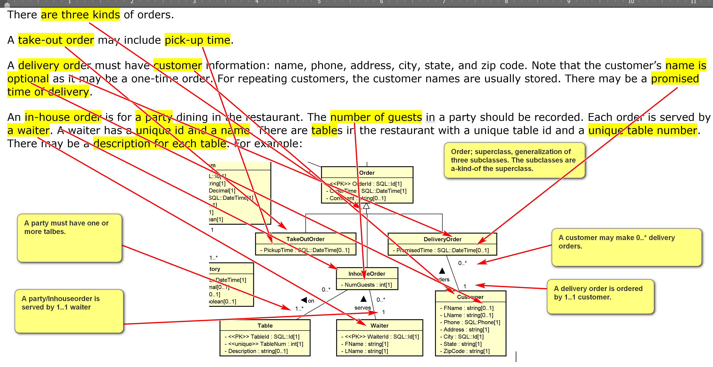

Table id 1: num: 101, 'Prime 1'
Table id 2: num: 102, 'Prime 2'
Table id 3: num: 201
Table id 4: num: 202
...
A party is usually seated at one table, but it is also possible that several tables are used for a large party.
An order usually has a single bill. The total amount of a bill should be stored explicitly. However, for in-house dining, the bills of an order may be split. For example, for order 13247, there may be three bills:
3 Clam Pasta
4 Garlic Bread
5 Tandoori Chicken
2 Coke
3 Water
Bill #1: $78.94
3 Clam Pasta
2 Garlic Bread
1 Tandoori Chicken
2 Water
Bill #2: $26.97
1 Garlic Bread
1 Tandoori Chicken
1 Coke
Bill #3: $66.95
1 Garlic Bread
3 Tandoori Chicken
1 Coke
1 water
This information should be recorded.

