**CSCI 4333.2 Classroom Notes and Demonstrations**

8/25/2025

1. **A Simple Introduction to the Relational Model**

**Installing XAMPP: for development.**

* Relational databases are the most popular databases: <https://db-engines.com/en/ranking>. It is based on the relational model.
* There are many other data models.
* In layman's term: A *table* (relation) is the basic unit of a relational database.
* A table is composed of many *rows* (tuples).
* Each row has many *column* (attribute) values.

* A primary key is roughly a *minimal* set of columns in a table that*uniquely identify* a row.
* Two tables can be related to each other by *foreign keys*. A foreign key is roughly a column in a table in which its value must be equal to the referenced value of the primary key in another table (called the paren or referenced table).
* Relational DBMS is the most popular DBMS. Examples:
  + DB-engine ranking: <https://db-engines.com/en/ranking>
  + Top 10 DBMS in Data Science: <https://towardsdatascience.com/top-10-databases-to-use-in-2021-d7e6a85402ba>
* SQL is the 'glue' in many DB systems.

***Classroom discussion***

Please ask questions about the toy University DB ([toyu](https://dcm.uhcl.edu/yue/courses/joinDB/Fall2025/notes/toyu/toyu.html))

**3. MySQL**

* The standard query language for RDBMS is Structured Query Language (SQL).
* We use MySQL (or MariaDB) in this class.

DBMS mostly uses a client-server architecture.

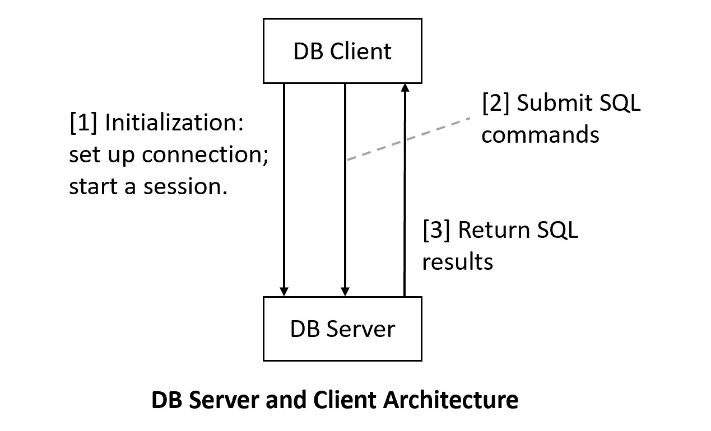

Stateful because of connected protocol.

As a comparsions, Web server and client (HTTP) is connectionless.

**3.1 MySQL Server Setup**

We will use MariaDB that is a part of XAMPP. Do not recommend installing standalone MySQL.

[1] Install XAMPP, which contains many server software configured to work together for development purposes. For XAMPP, we will use MySQL/Maria DB and Apache (Web server).

1. Recommended to install XAMPP in the*top* level: c:\xampp (likely the default).
2. Set up development accounts immediately using *phpMyAdmin* after installation.
3. Change the root password (optional but recommended): a secure step that requires tinkering.
4. To ensure that PHPMyAdmin will work on a new admin account (optional):
   1. Use PHPMyAdmin to create a new admin account, e.g., "frog_ad", with the password "a_new_prince" for both hostname '%' and 'localhost'
   2. PhpMyAdmin uses the default root account (with no initial password) via localhost.
   3. Thus, you will need to supply the new username and password to start up PhpMyAdmin by editing the file c:\xampp\phpMyAdmin\config.inc.php, search change the line to, for example:
      1. $cfg['Servers'][$i]['user'] = 'frog_ad';
      2. $cfg['Servers'][$i]['password'] = 'a_new_prince';

**3.2 MySQL Clients Setup:**

It is common to use multiple clients to connect to a backend database server. In this course, we will use three clients in our classes. You may use your own favorite clients (e.g., MySQL Workbench). However, I may not be as helpful in these clients.

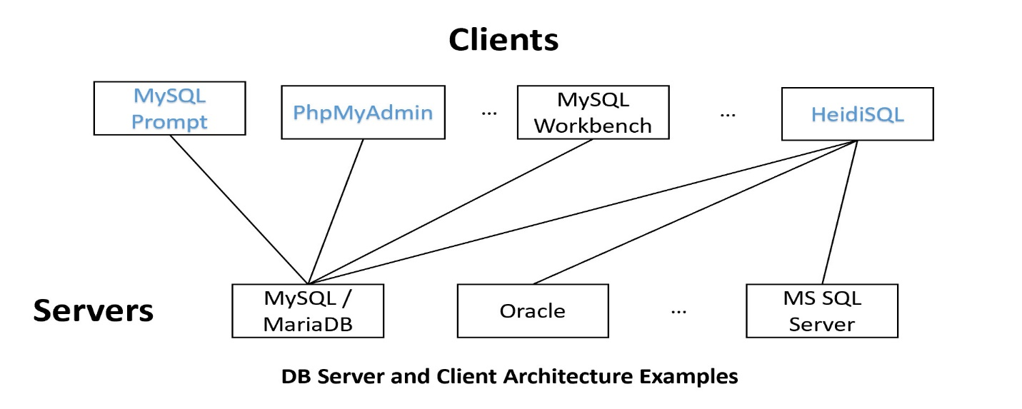

XAMMP Maria/DB is the DB server.

[1] MySQL Command-Line Prompt: will be used in this class.

1. Come with (1) XAMPP/MariaDB or (2) MySQL 8.x. (Note that the two versions of mysql prompt are somewhat different.)
   1. MariaDB mysql: <https://mariadb.com/kb/en/mysql-command-line-client/>
   2. MySQL 8.x mysql: <https://dev.mysql.com/doc/refman/8.0/en/mysql.html>
2. A command line text-based MySQL-specific client.
3. You may set the PATH variable so you can call mysql prompt anywhere, such as by adding "c:\xampp\mysql\bin" in the PATH system environment variable.

***Example:***

**mysql –h *host* -u *user* -p**

or

**mysql –h *host* -u *user* -p -P port_number**

[2] PhPMyAdmin

In a browser: localhost: request sent to the local web server (in the same computer).

MySQL account: username @ host

* S2@%: accept login from any ip address (first)
* S2@localhost: accept localhost request

MySQL default: root/

(with empty string as password)

1. A Web-based GUI client focused on DB administration.
2. After starting both MySQL and Apache in XAMPP, go to localhost in your browser.
3. MySQL specific.

[3] HeidiSQL: will be used in this class

1. A general Windows GUI SQL client

[4] MySQL Workbench:

1. A GUI MySQL client that comes with MySQL 8.x (but not XAMPP)

**Creating and populating toyu:**

MySQL creation script for creating toyu: [Createtoyu.sql.txt](https://dcm.uhcl.edu/yue/courses/joinDB/Fall2025/notes/toyu/Createtoyu.sql.txt) (remove .txt while saving). You can execute it with the source command in MySQL command line prompt:

1. Save the script file as createtoyu.sql in your working directory for this class.
2. Open a command line terminal in your working directory.
3. Start mysql command prompt: "mysql -u your_local_mysql_account -p"
4. Run "source createtoyu.sql" within mysql command prompt.

-- delete the toyu database. MySQL: schema = database

DROP SCHEMA IF EXISTS toyu;