CSCI 4333.2 Classroom Notes and Demonstrations
8/20/2025
Introduction to the course
CSCI 4333
by K. Yue
1. Promotion
- This course is (hopefully) one of the more useful CS/DS courses for students.
- World data is estimated to double every two years.
2. How to be successful in the course
General Course Suggestions:
- Course expectation is demanding.
- Please consider forming the habit of listening carefully and asking a lot of questions.
General Professionalism:
- Attitude
- Be considerate.
- Be helpful and useful to others.
- Be a good listener.
- Be responsive.
- Hardworking
- Attention to details.
- Focus: uni-tasking
Some general tips:
- Engagement: Participate. Ask questions, a lot of them. Help others. Plan ahead.
- Preparation: start as early as possible and do not fall behind.
- Don’t copy and paste. Instead, copy, integrate, and apply.
- SEE-I: State, Elaborate, Exemplify and illustrate.
- Form good habits.
Some good traits of Computer and Data Scientists:
- Habits of trying to make sense of stuff.
- Intellectual curiosity.
- Tinkering and experimentation.
- Open-minded, not dogmatic.
- A large tool set.
3. Resources
- Companion materials of our textbook: please consult the course page in Canvas for additional resources related to the textbook.
- Contents of the course will be based mostly on
  - Lecture notes posted in the course website: ../../index.html.
  - Classroom demonstrations.
  - Assignments.
- Please read the appropriate pages in the textbook and lecture notes in this site before coming to the class.
- Document your learning. Bring a notebook to the class. Otherwise, it may be a good idea to print out the notes and bring them to the class so you can make notes during the class.
4. Introduction
- Persistent data is the backbone of many applications.
  - Data remains after software closes.
  - Examples: profiles in social media, Instagram. In cloud, in files, in DBMS.
  - Examples of non-persistent (transient) data: stored in RAM, registers, … variable values in Java prorams.
- Three main choices of storing persistent data:
  - Files
  - Databases: focus of this course.
  - Cloud-based storage and database.
- Some advantages of DBMS (according to Ricardo, the optional textbook of this class):
  - Sharing of data
  - Control of redundancy
  - Data consistency
  - Improved data standards
  - Better data security
  - Improved data integrity
  - Balance of conflicting requirements: DBMS allows the specification of problem requirements much better than file systems.
Requirements:
Bun Yue’s Bday is 6/14/1995
2/30/1988?
8/abc/hkd
1/4/1780
  - Faster development of new applications
  - Better data accessibility
  - Economy of scale: larger scales implies better efficiency.
    - USA better than smaller countries in certain things.
  - Scaling well:
    - Size of problem get bigger, solution is still effective.
  - More control over concurrency:
    - File systems allow very little concurrency to preserve data integrity.
    - DBMS allows more concurrency with nuanced access control.
  - Better backup and recovery procedures
- How do we make sense of these 12 different advantages?
  - Different textbooks may have different collections of the advantages of DBMS because of different classifications.
  - No need to memorize them.
  - Better to assimilate them and construct your own list.
  - Make your own notes. Use SEE-I (In your own words, state, elaborate, and exemplify with examples, and illustrate the concept.)
    - However, do not overuse metaphors.
  - Learning through documentation, communications, and teaching.
- What are some disadvantages of DBMS?
  - Complexity
  - Cost
  - Learning curve
  - Possible single points of failure and bottleneck
- A Simple Introduction to the Relational Model
Installing XAMPP: for development.
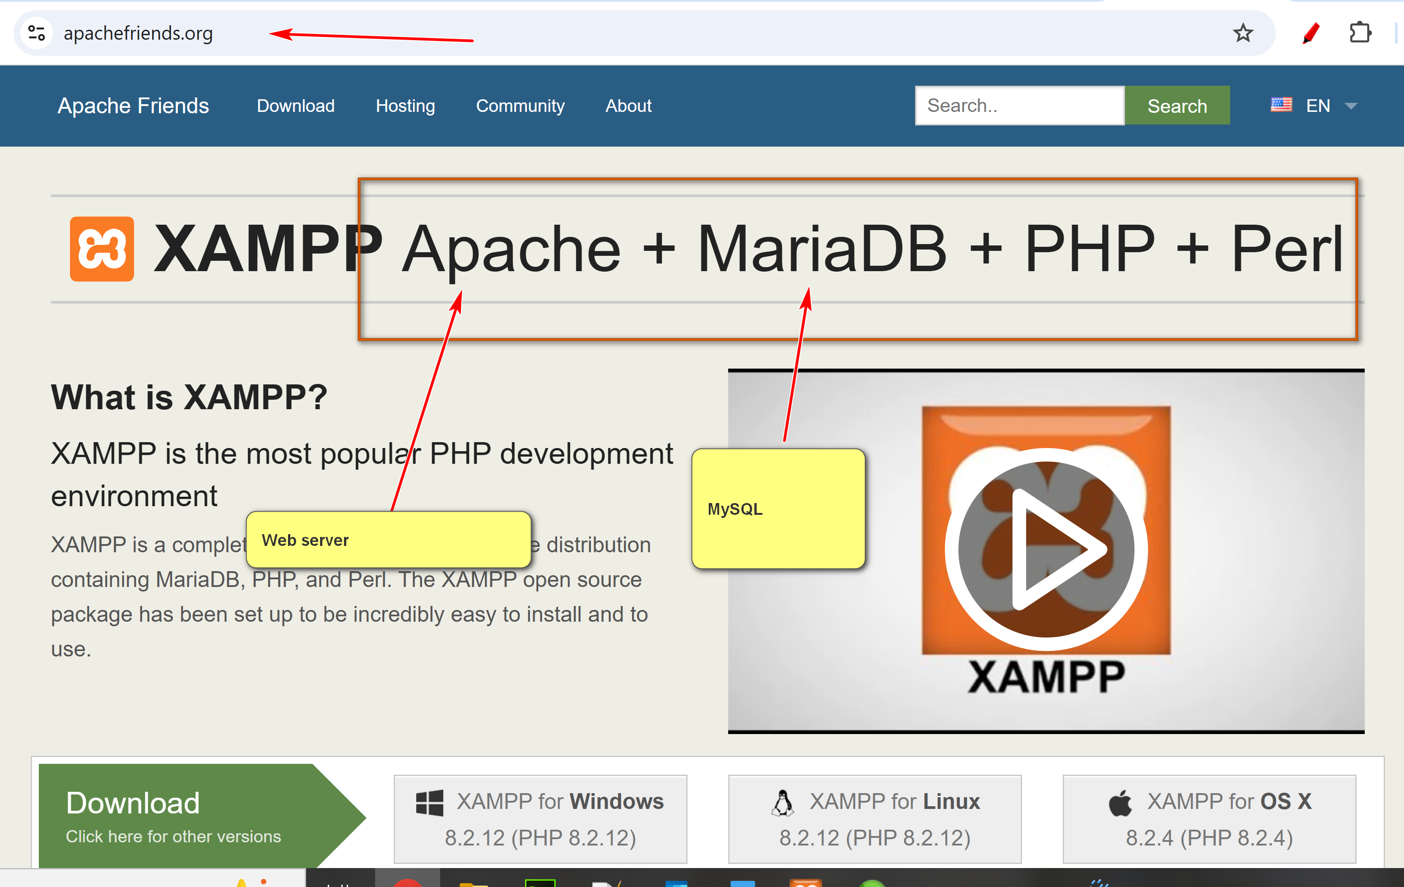
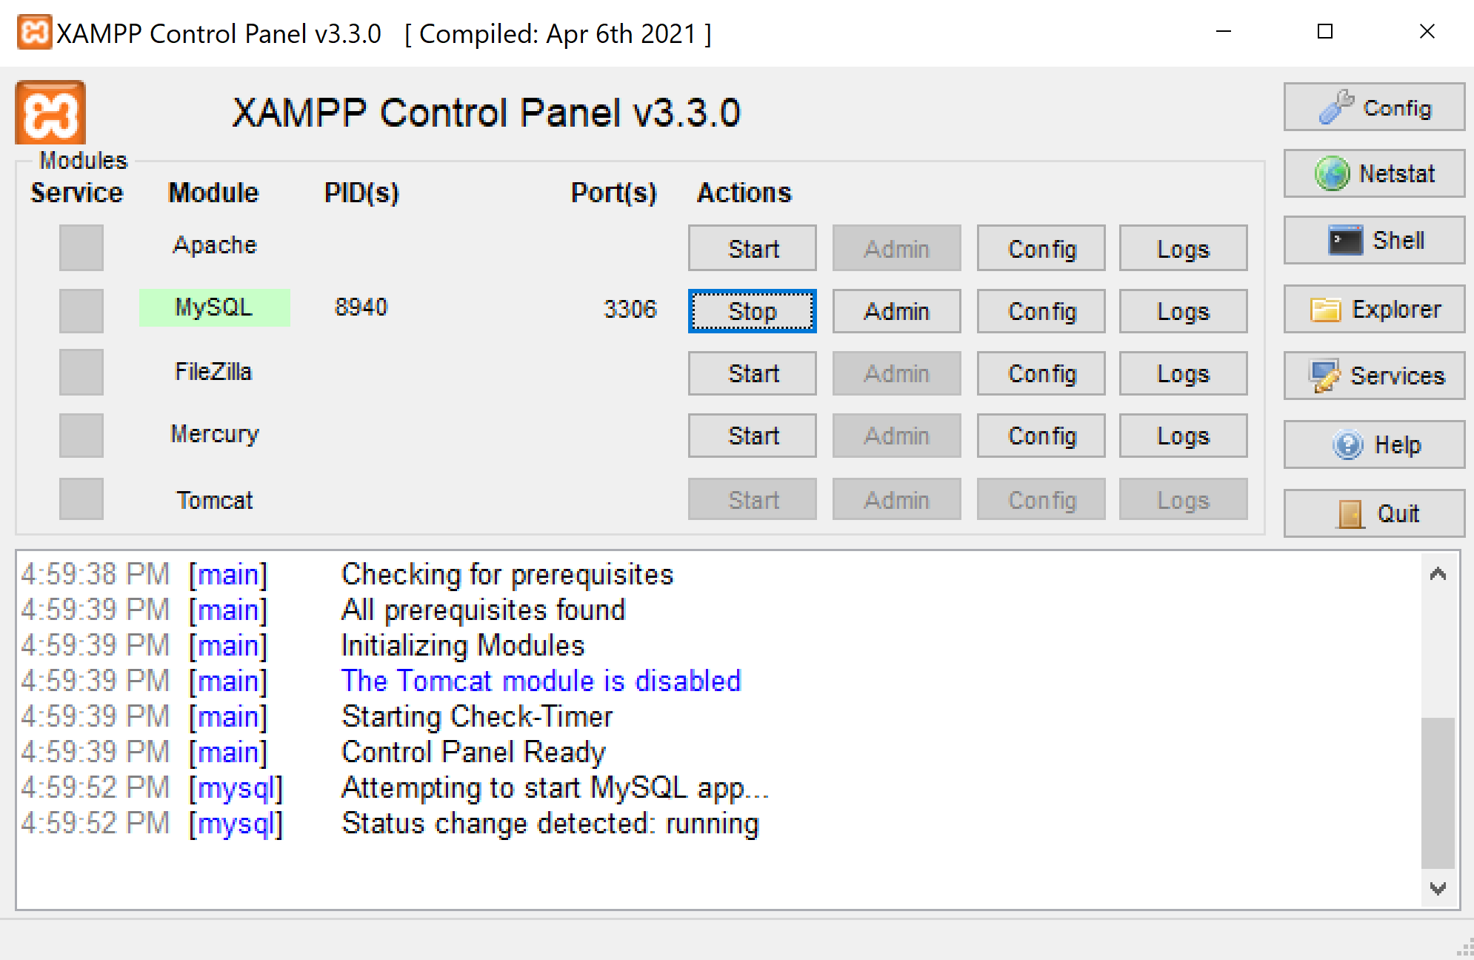

- Relational databases are the most popular databases: https://db-engines.com/en/ranking. It is based on the relational model.
- There are many other data models.
- In layman's term: A table (relation) is the basic unit of a relational database.
- A table is composed of many rows (tuples).
- Each row has many column (attribute) values.
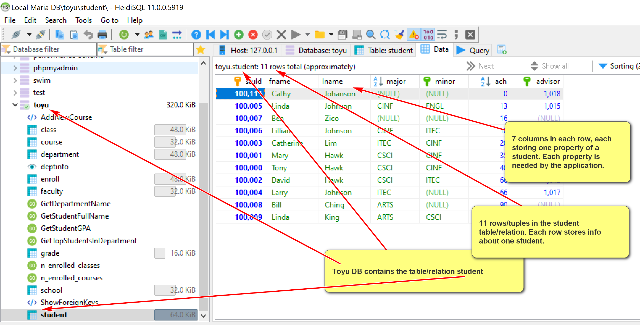
- A primary key is roughly a minimal set of columns in a table that uniquely identify a row.
- Two tables can be related to each other by foreign keys. A foreign key is roughly a column in a table in which its value must be equal to the referenced value of the primary key in another table (called the paren or referenced table).
- Relational DBMS is the most popular DBMS. Examples:
  - DB-engine ranking: https://db-engines.com/en/ranking
  - Top 10 DBMS in Data Science: https://towardsdatascience.com/top-10-databases-to-use-in-2021-d7e6a85402ba
- SQL is the 'glue' in many DB systems.
Classroom discussion
Please ask questions about the toy University DB (toyu)

