CSCI 4333.2 Classroom Notes and Demonstrations
10/27/202

MySQL Programming in Python
by K. Yue
1. MySQL Drivers for Python
- There are many MySQL drivers for Python. Some examples:
  - MySQLDB Python: http://sourceforge.net/projects/mysql-python/
  - MySQL Connector Python: https://dev.mysql.com/downloads/connector/python/: written with pure Python.
  - MySQL Connector Python's Developer Guides: http://dev.mysql.com/doc/connector-python/en/index.html
- Selecting the right driver is important and not straightforward. Examples:
  - An example comparing driver performance: https://gist.github.com/methane/90ec97dda7fa9c7c4ef1
  - PyMySQL evaluation: https://wiki.openstack.org/wiki/PyMySQL_evaluation
- Because of some problems of MySQL Connector in Python 3, we use PyMySQL.
- Two kinds of drivers:
  - General purpose drivers: JDBC, ODBC, .. (multiple DB servers): portable, low learning cost, simpler, …
  - Vendor-specific drivers: connect only to one DBMS: e.g. PYMySQL: performance, rich features.
2. PyMySQL:
- Installation:
  - Install pip (Package Installer for Python), if necessary: https://pip.pypa.io/en/stable/installing/.
  - Command: "pip install PyMySQL"
- Documentation: http://pymysql.readthedocs.io/en/latest/
- Compliant with Python Database API Specification v2.0: https://www.python.org/dev/peps/pep-0249/#module-interface.
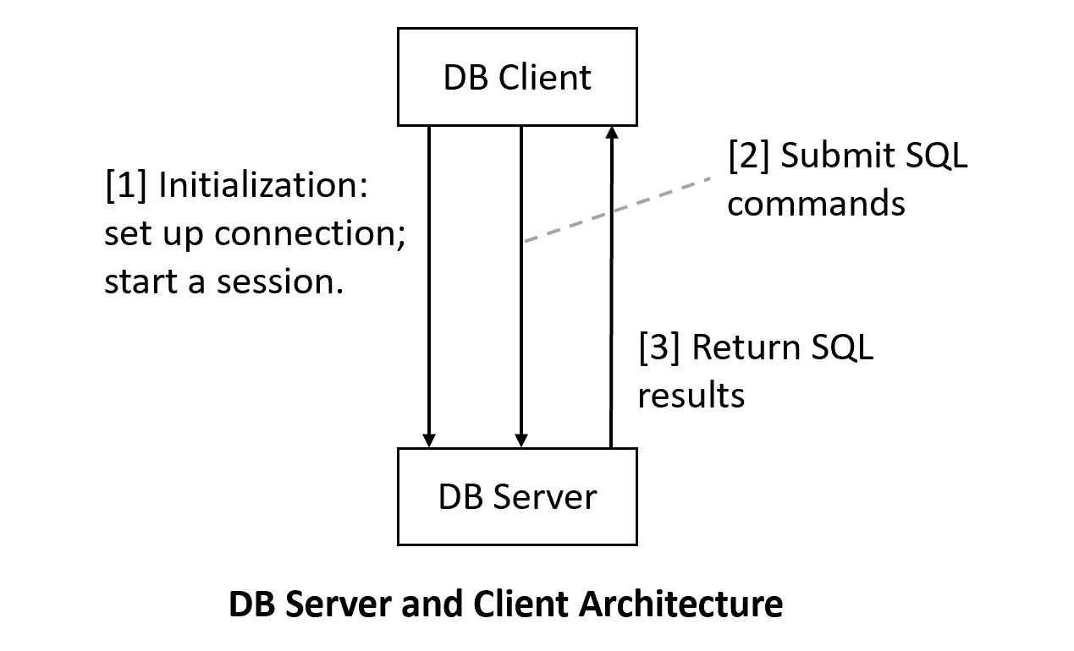
Additional Materials: MySQL Connector Python (not used in this course, but it is a good resource)
- API reference: http://dev.mysql.com/doc/connector-python/en/connector-python-reference.html
- Read MySQL Connector Python's Guideline for developer: http://dev.mysql.com/doc/connector-python/en/connector-python-coding.htm
- Examples of good tips and insight:
  - "Use config.py module to store database connection information."
  - "Any application that accepts input must expect to handle bad data."
  - "Data that you choose to store in MySQL instead is likely to have special characteristics."
  - "you can use Python's triple-quoting mechanism to enclose the entire statement."
  - "Oracle recommends the ENGINE=INNODB clause for most tables, and makes InnoDB the default storage engine in MySQL 5.5 and up."
3. Python Programming with MySQL
- Embedded SQL: embedding SQL in a host language.
- SQL is a DB language, not a general purpose language.
- Host languages:
  - general purpose languages
  - usually have vast libraries and tools.
  - usually have a good community in a specific application area.
- Examples of popular host languages: Java, JavaScript, ts, GOLANG, C#, C, C++, PHP, Perl, Python, Ruby, etc.
- Preparation: create a MySQL account in your computer for development if you have not already done so. (You may use PHPMyAdmin or MySQL Workbench)
3.1 Basic steps
- Basic steps of embedded SQL programming.
  - Create connections to the database.
  - Prepare and execute SQL statements in the connections by using a cursor: develop and debug your SQL statements that provide all the needed data.
  - Use the results of SQL statements.
  - Perform house cleaning and close connections.
- Step (2) => learn your SQL well.
- Some issues in step (3):
  - Data type mismatch (impedance mismatch): relations/tables are usually not supported natively in the host languages.
  - Performance consideration: DB operations are usually much more expensive (take longer time) than CPU operations. Examples:
    - Minimize DB connections, especially active ones.
    - Optimize the numbers of SQL statements and their efficiencies.
  - Security consideration: DB breaches are serious.
3.2 Connection and Cursor Objects
- To solve the data type mismatch problem, the concept of cursor is usually used.
- A cursor allows the programmer to iterate through the result set, one row at a time.
- Cursor reference of PyMySQL: http://pymysql.readthedocs.io/en/latest/modules/cursors.html
- There may be different cursor types for performance, security, and access method considerations.
- PyMySQL's cursor types:
  - SSCursor: unbuffered cursor
  - DictCursor: return a dictionary
  - SDictCursor: an unbuffered cursor returning a dictionary
Example:
student1.py: (All .py and .ini files have an extra extension, .txt, which should be removed when downloading).
import pymysql
# [1] Making connection to the MySQL server
cnx = pymysql.connect(user='demo', password='abcdef',
host='localhost',
database='toyu')
# Create a cursor using the connection.
cursor = cnx.cursor()
# [2] Prepare a SQL query for the problem
query = '''
SELECT CONCAT (s.fname, ' ', s.lname) AS student,
d.deptName,
CONCAT(f.fname, ' ', f.lname) as advisor
FROM student AS s LEFT JOIN department AS d
ON (s.major = d.deptCode)
LEFT JOIN faculty AS f
ON (s.advisor = f.facId);
'''
# Execute the query
cursor.execute(query)
# [3] Use the result in the query
for (student, major, advisor) in cursor:
print("{}: major={}; advisor={}".format(student, major, advisor))
# [4] Housekeeping
cursor.close()
cnx.close()
The output of running this program:
C:\...>python student1.py
Tony Hawk: major=Computer Science; advisor=Paul Smith
Mary Hawk: major=Computer Science; advisor=Paul Smith
David Hawk: major=Computer Science; advisor=Mary Tran
Catherine Lim: major=Information Technology; advisor=None
Larry Johnson: major=Information Technology; advisor=Deborah Gump
Linda Johnson: major=Computer Information Systems; advisor=Daniel Kim
Lillian Johnson: major=Computer Information Systems; advisor=Andrew Byre
Ben Zico: major=None; advisor=None
Bill Ching: major=Arts; advisor=None
Linda King: major=Arts; advisor=Art Allister
Cathy Johanson: major=None; advisor=Art Allister
- Some tips:
  - Test your SQL statements thoroughly first.
  - Use typical input parameters for testing.
  - Be mindful of:
    - security, especially SQL injection
    - special characters of the languages involved
    - performance
3.3 Configuration files
- It is better to use configuration module and data ini file (e.g. dbconfig.py and dbconfig.ini). Why?
  - Separation of data and program: separation of concerns
  - Reuse and maintenance
  - Security
- In general, using a configuration data file is a good programming practice.
dbconfig.py:
import configparser
# simplistic and no error handling.
def get_mysql_param(filename='dbconfig.ini', section='mysql'):
config = configparser.ConfigParser()
config.read(filename)
return config[section]
If running in Windows IIS (such as in the dcm server):
import configparser
from pathlib import Path
# simplistic and no error handling.
def get_mysql_param(filename='dbconfig.ini', section='mysql'):
config = configparser.ConfigParser()
file_path = (Path(__file__).parent / filename).resolve()
config.read(file_path)
return config[section]
dbconfig.ini:
[mysql]
host = localhost
port = 3306
database = toyu
user = your_account
password = your_password
In your Python program:
from dbconfig import *
import pymysql
db = get_mysql_param()
cnx = pymysql.connect(user=db['user'],
password=db['password'],
host=db['host'],
database=db['database'],
port=int(db['port']))
cursor = cnx.cursor()
If you use the default port (i.e., 3306), you may adjust by
- remove the line "port=3306" in dbconfig.ini, and
- remove the argument "port" in the call of pymysql.connect() in the main program.
In your Python program,
student2.py:
from dbconfig import *
import pymysql
db = get_mysql_param()
print (db)
cnx = pymysql.connect(user=db['user'], password=db['password'],
host=db['host'],
database=db['database'],
port=int(db['port']))
cursor = cnx.cursor()
# [2] Prepare a SQL query for the problem
query = '''
SELECT CONCAT (s.fname, ' ', s.lname) AS student,
d.deptName,
CONCAT(f.fname, ' ', f.lname) as advisor
FROM student AS s LEFT JOIN department AS d
ON (s.major = d.deptCode)
LEFT JOIN faculty AS f
ON (s.advisor = f.facId);
'''
# Execute the query
cursor.execute(query)
# [3] Use the result in the query
for (student, major, advisor) in cursor:
print(f"{student}: major={major}; advisor={advisor}")
# [4] Housekeeping
cursor.close()
cnx.close()
- See Format Specification Mini-Language: https://docs.python.org/3.11/library/string.html#formatspec
- Your SQL statement may use placeholder parameters: %s.
- Parametrized statements are preferred.
Example from http://dev.mysql.com/doc/connector-python/en/connector-python-api-mysqlcursor-execute.html:
insert_stmt = (
"INSERT INTO employees (emp_no, first_name, last_name, hire_date) "
"VALUES (%s, %s, %s, %s)"
)
data = (2, 'Jane', 'Doe', datetime.date(2012, 3, 23))
cursor.execute(insert_stmt, data)
select_stmt = "SELECT * FROM employees WHERE emp_no = %(emp_no)s"
cursor.execute(select_stmt, {'emp_no': 2})
Example:
Get the school code as the command line argument.
student3.py
from dbconfig import *
import pymysql
import sys
# Use the school code in command line arguments
# to list all students majoring in a department
# in the school.
# [1] Making connection to the MySQL server
db = get_mysql_param()
cnx = pymysql.connect(user=db['user'], password=db['password'],
host=db['host'],
database=db['database'],
port=int(db['port']))
cursor = cnx.cursor()
# [2] Prepare a SQL query for the problem
query = '''
SELECT CONCAT (s.fname, ' ', s.lname) AS student,
d.deptName,
CONCAT(f.fname, ' ', f.lname) as advisor
FROM student AS s LEFT JOIN department AS d
ON (s.major = d.deptCode)
LEFT JOIN faculty AS f
ON (s.advisor = f.facId)
WHERE d.schoolCode = %s;
'''
# [2b] Get input values
school_code = 'CSE'
if len(sys.argv) > 1:
school_code = sys.argv[1]
# Execute the query
cursor.execute(query, school_code)
# [3] Use the result in the query
for (student, major, advisor) in cursor:
print(f"{student}: major={major}; advisor={advisor}")
# [4] Housekeeping
cursor.close()
cnx.close()
Result:
C:\...>python student3.py CSE
Linda Johnson: major=Computer Information Systems; advisor=Daniel Kim
Lillian Johnson: major=Computer Information Systems; advisor=Andrew Byre
Tony Hawk: major=Computer Science; advisor=Paul Smith
Mary Hawk: major=Computer Science; advisor=Paul Smith
David Hawk: major=Computer Science; advisor=Mary Tran
Catherine Lim: major=Information Technology; advisor=None
Larry Johnson: major=Information Technology; advisor=Deborah Gump
Notes:
- %s is used as a placeholder.

