CSCI 4333.1 Classroom Notes and Demonstrations
9/24/2025
Transforming UML Class Diagrams to Relational Models
by K. Yue
1. Transforming OO Model to the Relational Model
- Once a conceptual OO data model is constructed, it needs to be mapped for implementation in the selected logical database model. See IntroDataModeling.html.
- If a relational DB is used, the mapping will be from OO (classes, attributes, associations, etc.) to relational schema (relations, attributes, keys, etc.)
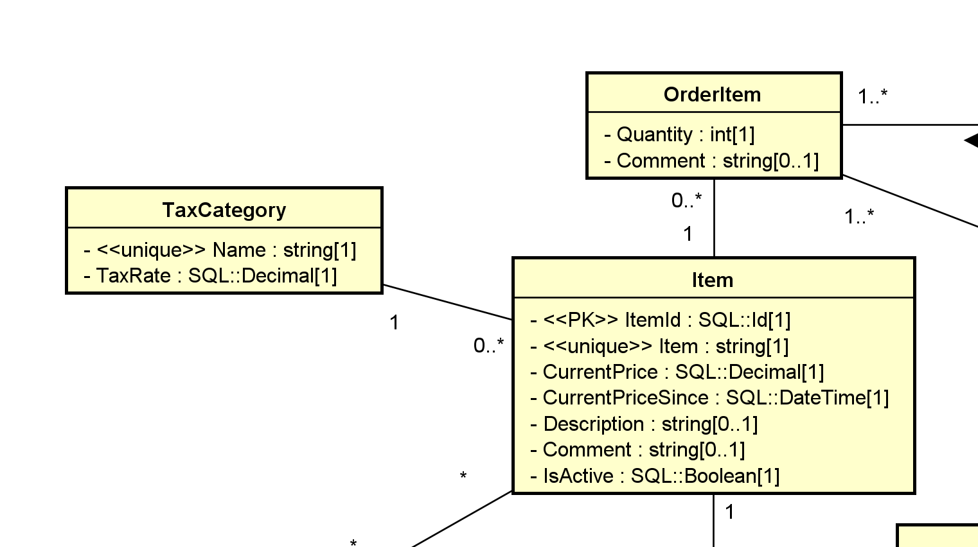
Map to target model:
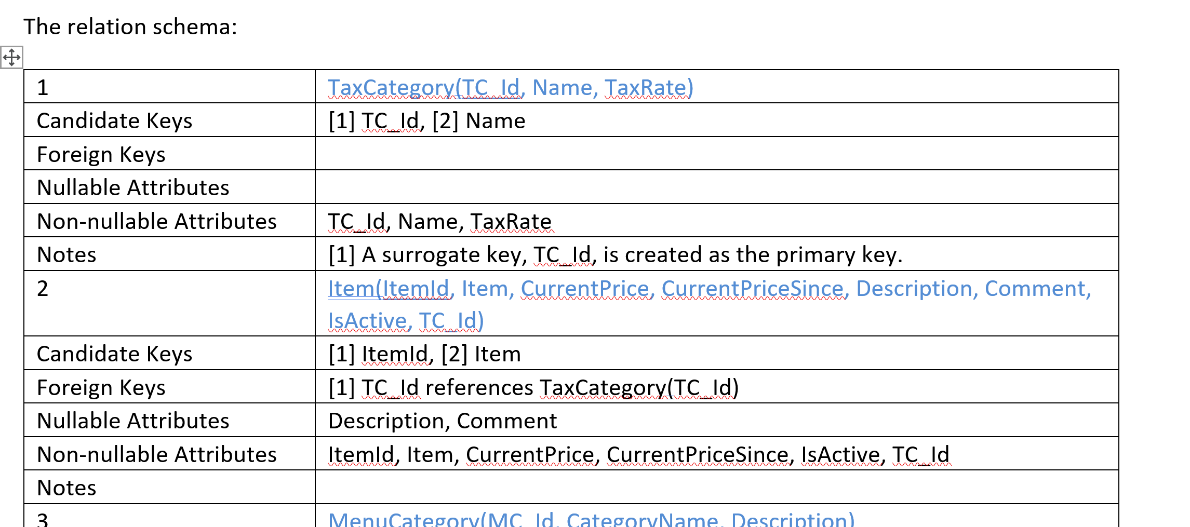
- Note that the relational model and the OO model are very different, even though diagrams representing the two models look similar (there are only a finite number of common suitable shapes).
A rectangle is a class in UML, but it is a relation in a relation-relationship diagram.
- Computer-Aided Software Engineering (CASE) tools or DB modeling tools may provide varying degrees of facilities for automatic generating relational schema and corresponding SQL statements.
- However, it is important to understand the mechanism that a tool uses to generate the relational schema and make adjustment if needed.
1.1 Model Transformation
The problem is: Source Model --> Target Model.
- Source Model: UML
  - Basic elements:
    - Class
    - Attribute: can be multi-valued.
- 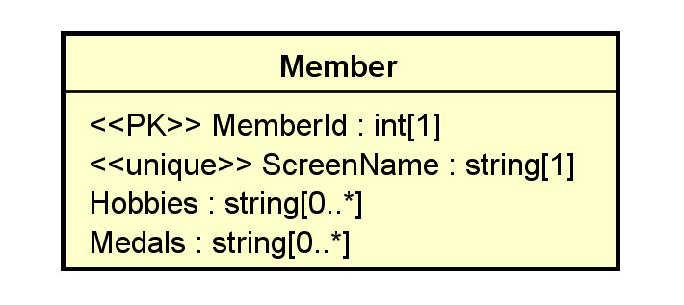
    - Association
Association can be multi-valued:
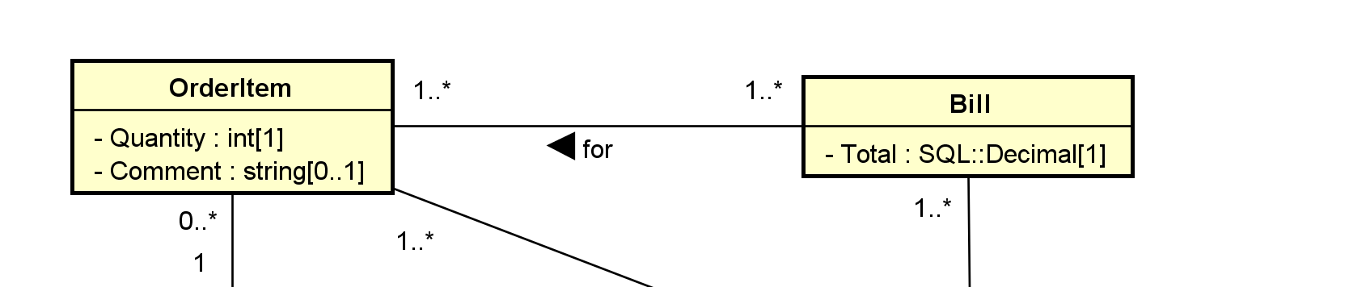

  - Secondary elements:
    - Object
    - Multiplicity
    - Data type
    - Default value
    - Constraint
    - Stereotype for RDB extensions: e.g., candidate keys, primary keys, unique, derived, nullability, etc.
    - ...
- Target Model: Relational Model
  - Basic elements:
    - Relation
- Relation is related to another relation by FY-PK linke (one to one)

    - Attribute (column/field): It should be single-valued (atomic). Otherwise, first normal form (1NF) is not satisfied.
  - Secondary elements:
    - Row (tuple)
    - Data type
    - Nullability
    - Constraint
    - Candidate key
    - Primary key
    - Foreign key
    - Index
    - ...
- There are only two basic elements in the targeted model to consider. Data in the relational model can be stored only in two ways:
  - relation:
    - more flexible,
    - can hold attributes to store a collection of logically related data
    - more complex.
  - attribute:
    - should be single-valued (if good design, i.e., the first normal form, is to be assured.)
    - Simple
    - Thus, if attributes are sufficient in model transformation, they are preferred.
- Different RDBMS provide different features.
    - Thus, the targeted RDB model is not universal.
    - It is necessary to define vendor-specific transformation rules.
2. Transformation Rules
- We present a set of mapping rules below. It is not meant to be complete or universal.
- Examples of comparable transformation rules:
  - A relative simple one: http://web.fe.up.pt/~ssn/2010/lbaw/slides/lbaw-uml2rel.eng.pdf a
  - A more elaborated one based on agile methodology: http://www.agiledata.org/essays/mappingObjects.html.
- Do not mechanically follow these rules. Instead, understand the rationale behind the rules and adapt.
- All OO model details should be implemented in the targeted model in some ways.
  - database level: preferred.
  - middle layer level
  - application level
2.1 Classes
C1. A class C is mapped or transformed to a relation RC.
- Relations may later be merged and/or reorganized in design refinement and performance tuning.
- The relation may use the same name as the class.
- As a result, all infomration of an object of class C is stored as a row in RC.
Rationale:
- A class is a logical unit for encapsulating related data and a relation has the same property.
2.2 Attributes
Basic:
ATT1. Single-Valued Attributes. Map all single-valued attributes (with simple data types) of a class C as attributes of RC, the relation for the class C.
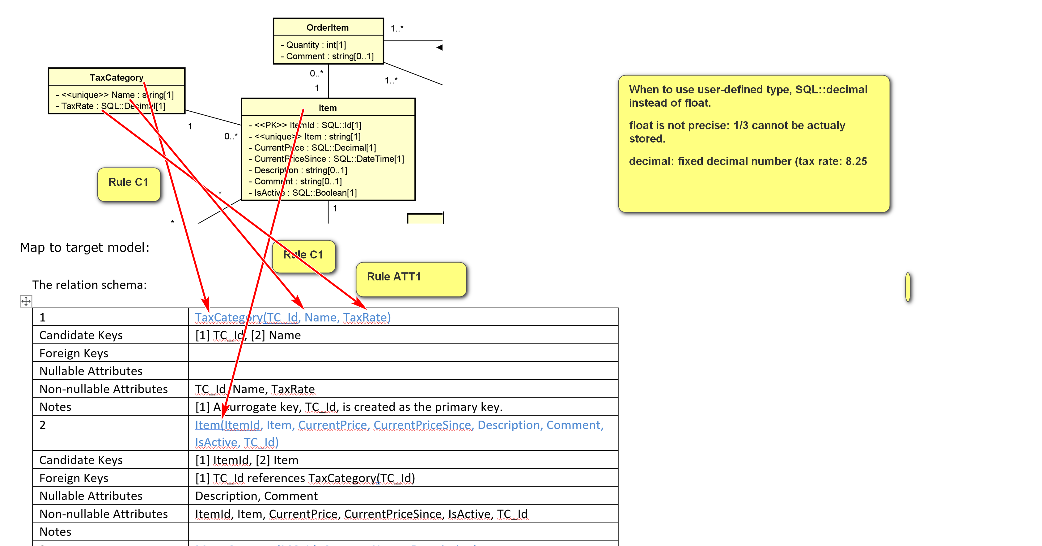
ATT2. Multi-Valued Attributes. For each multi-valued attribute A of the class C, create a new relation RCA containing the attribute A and the primary key, RCId, of the relation RC (which implements the class C).
- (RCId, A) is a composite candidate key.
- RCId is a foreign key referencing RC(RCId)
- A surrogate key, such as RCA_Id, may be created to serve as the simple primary key.
- The name of RCA should be meaningfully selected.
E.g. Class C: Member; multiple-valued attribute: A
Member object: M1 (one object’s information is stored in one row.)
- MemberId: M1
- ScreenName: Bun
- Hobbies: eating, daydreaming, sleeping
- Medals: ACM, IEEE, SS
Member table:
MemberId (PK): RCId | ScreenName | Hobbies? No | Hobby1? | Hobby2 | Hobby3? Probably
M1 | Bun | eating, daydreaming, sleeping  (multi-valued) | eating | sleeping | daydreaming
M2 | Jane | Eating, studying
If it were Hobbies[0..3], then ok to use Hobby1, Hobby2, Hobby3.
MemberHobby (new table RCA): Ck: (RCId, A): (MemberId, Hobby); MemberHobby(MemberId) references Member(MemberId) (RCId is a foreign key referencing RC(RCId)
MHIdN(surrogate PK) | MemberId (RCid): FK | Hobby (A)
1 | M1 (for Bun) | Eating
2 | M1 | sleeping
3 | M1 | daydreaming
4 | M2 | Eating
5 | M2 | Studying
- RCId is a foreign key referencing RC(RCId)
- Name change to MemberHobby.
Secondary:
ATT3. Zero in Multiplicity. If the multiplicity of an attribute is specified, to handle the case of 0:
- If 0 is allowed in the UML model (e.g., 0..1, 0..* in the UML class diagram), the attribute is nullable. Add the NULL specifier in the column definition in the RDBMS. (NULL is usually the default)
- If 0 is not allowed, add the NOT NULL specifier in the column definition.
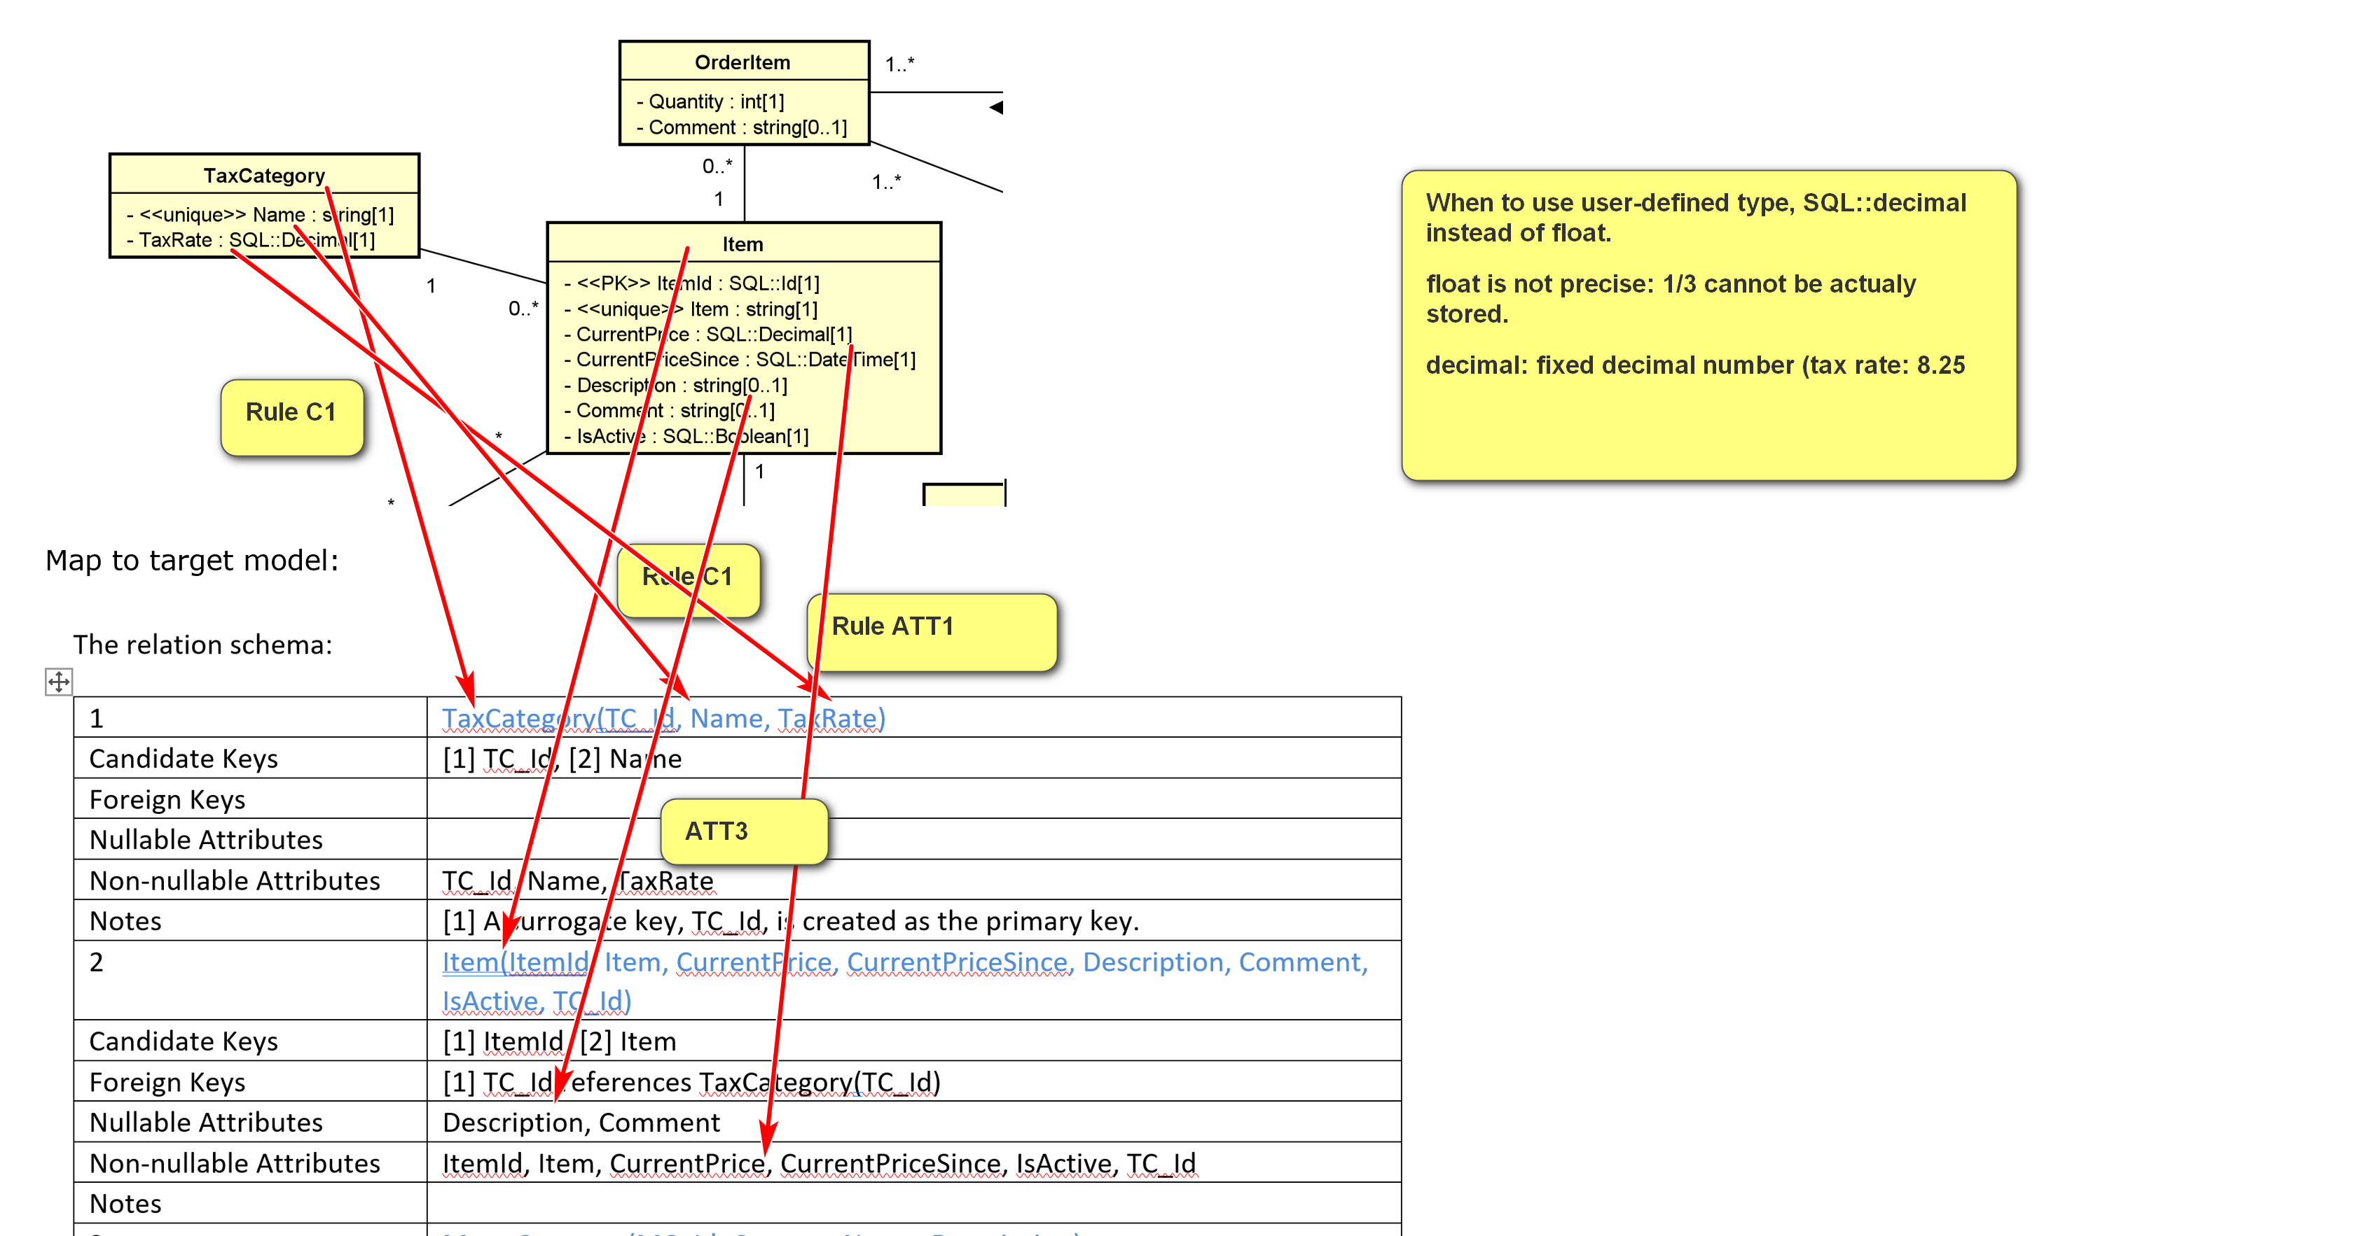
ATT4. Default Values. The default value of an attribute can be directly implemented in SQL DDL.
ATT5. Data Types. Data type mapping should be handled adequately, effectively, and consistently.
- In later modeling phases, one may use SQL data types of the targeted DBMS in the class diagram.
- If available, consider using user-defined data types in the targeted DBMS.
Example:
UML for toyu.student:
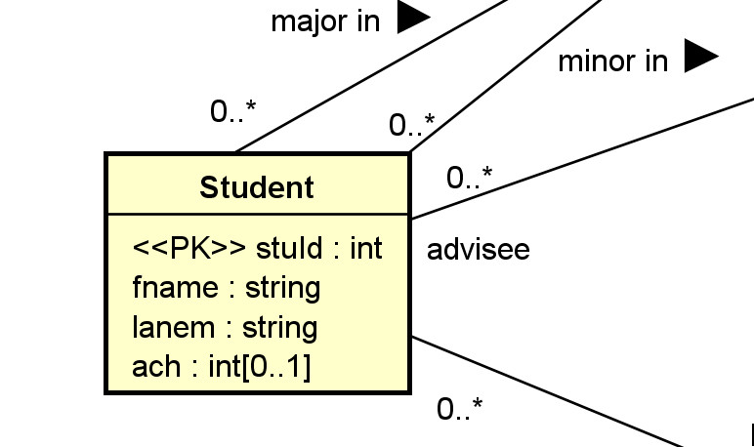
Relational schema (in HW assignment format):
Relation | Student(StuId, fname, lname, major, minor, ach, advisor)
Candidate Keys | [1] StuId
Foreign Keys | [1] major references department(deptCode), [2] minor references department(deptCode), [3] advisor references faculty(facId)
Nullable Attributes | major, minor, advisor, ach
Non-nullable Attributes | stuId, fname, lname
Notes
Relational schema in SQL (with more implementation details):
CREATE TABLE IF NOT EXISTS Student (
stuId INT NOT NULL,
fname VARCHAR(30) NOT NULL,
lname VARCHAR(30) NOT NULL,
major CHAR(4) NULL,
minor CHAR(4) NULL,
-- ach: accumulated credit hours, including transferred credits.
ach INTEGER(3) NULL DEFAULT 0,
advisor INT NULL,
CONSTRAINT Student_stuId_pk PRIMARY KEY(stuId),
-- an artificial example of a CHECK constraint.
CONSTRAINT Student_ach_cc CHECK ((ach>=0) AND (ach < 250)),
CONSTRAINT Student_major_fk FOREIGN KEY (major)
REFERENCES Department(deptCode) ON DELETE CASCADE,
CONSTRAINT Student_minor_fk FOREIGN KEY (minor)
REFERENCES Department(deptCode) ON DELETE CASCADE,
CONSTRAINT Student_advisor_fk FOREIGN KEY (advisor)
REFERENCES Faculty(facId)
);
Example:
Multi-valued attributes: consider the class Member with the following attributes:
- Member_Id: <<PK>>
- Screen_Name <<unique>>
- Hobbies[0..*]
- Medals[0..*]
Reasonable relation schema: three relations used
- Member(MemberId, ScreenName):
  - CK: [1] MemberId, [2] ScreenName
- Hobby(HobbyId, MemberId, Hobby):
  - CK: [1] HobbyId, [2] MemberId, Hobby
  - FK: [1] MemberId references Member(MemberId)
  - A surrogate key, HobbyId, is created as the primary key.
- Medal(MedalId, MemberId, Medal):
  - CK: [1] MedalId, [2] MemberId, Medal.
  - FK: [1] MemberId references Member(MemberId)
  - A surrogate key, MedalId, is created as the primary key.
All columns in the tables above are not nullable.
ATT6. Single-Valued Composite Data Types. A single-valued attribute of a composite data type (such as set, list, array) can be mapped in various ways. (e.g. JSON, Geocode)
- If there is a comparable composite data type in the targeted DBMS, it can be implemented as an attribute of that data type in the relation.
  - The relation will no longer be in the first normal form.
  - Care should be taken in handling the difference in data type mapping.
- Otherwise, regard the attribute as a multi-valued attribute and apply rule ATT2.
ATT7. Derived Attributes. For a derived attribute A: no independent value, value is computed. (v. good for write-once data storage)
E.g. Age, GPA
- It can be implemented and stored as an attribute of the relation.
  - Mechanisms, such as triggers or stored procedures, should be used to ensure data consistency. The derived column should be consistent with the data that derives its value.
- It may not be stored as a column directly in any relation.
  - Mechanisms, such as virtual columns, views or stored functions, may be used to provide standard access to the derived attributes.
Example:
A class Rectangle has three attributes:
- Length
- Width
- \Area or <<derived>>: derived.
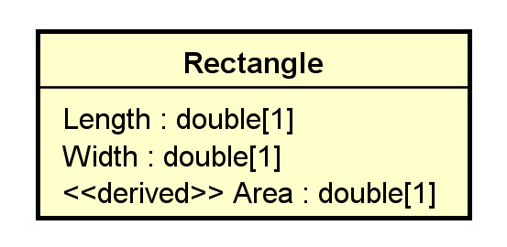
What may the relational schema look like?
One solution:
Rectangle(RectangleId, Length, Width)
with a view Rect define as
SELECT DISTINCT RectangleId, Length, Width, Length * Width as Area
FROM Rectangle;
Alternatively, use virtual columns: a column that is computed in real-time by an expression and not stored.
CREATE or replace TABLE rectangle (
width DOUBLE,
height DOUBLE,
area DOUBLE AS (width * height) virtual
);
2.3 Keys and Constraints
KC1. Primary Key Identified. If a relation R implements a class C or an association (class) AC, and C or AC has identified the PK, set it as the primary key of R.
KC2. Candidate Keys. <<CK>> If a relation R implements a class C or an association (class) AC, and C or AC has candidate keys K's, set all K's as candidate keys of R.
- If no primary key has been identified, select a CK to serve as the primary key, and apply KC1.
- A candidate key can be implemented by using the 'unique' and non-null constraint together in SQL.
KC3. No Primary Key Identified. If a relation R implements a class C or an association (class) A, and C or AC has no candidate key, create a surrogate primary key K for R.
- This is needed as every relation must have at least one candidate key.
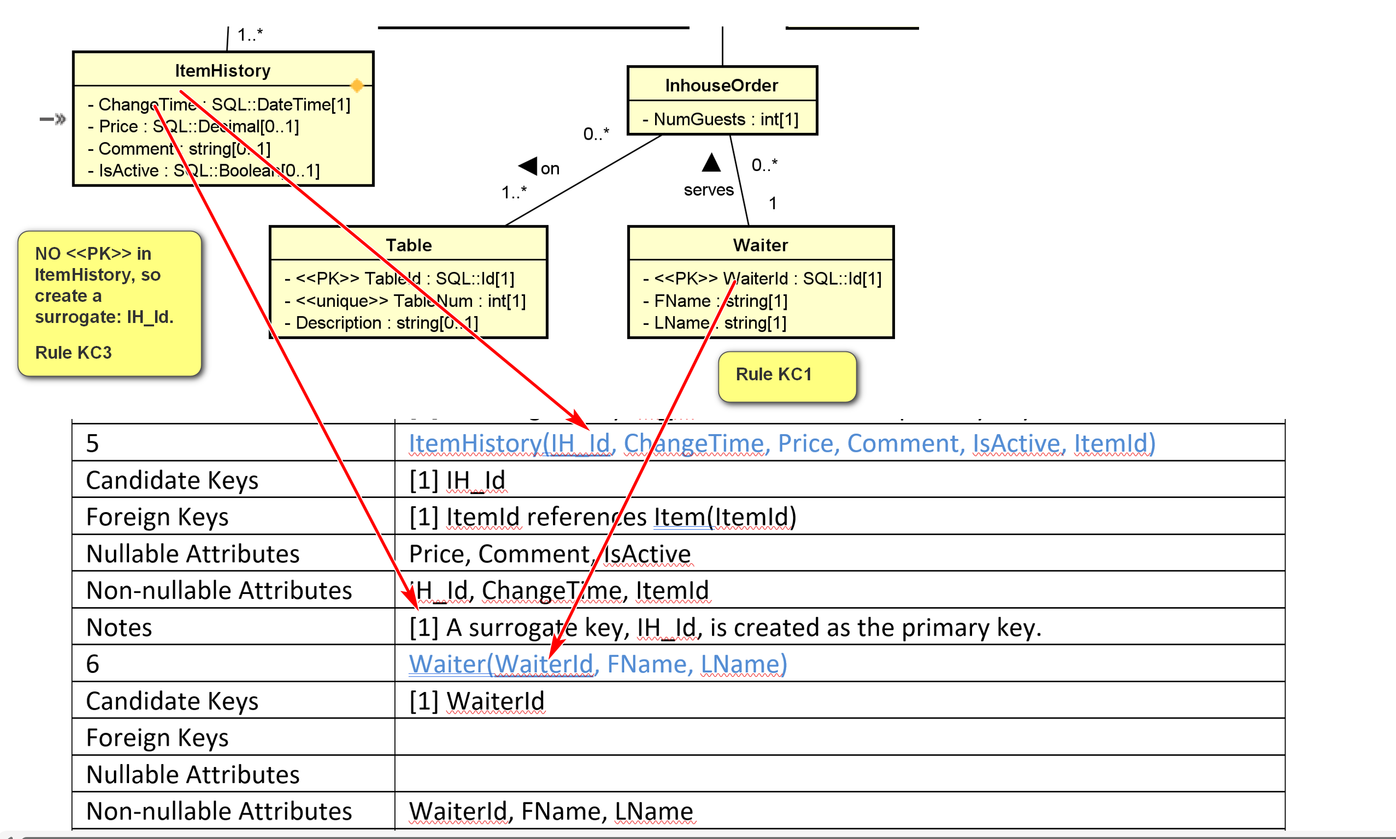
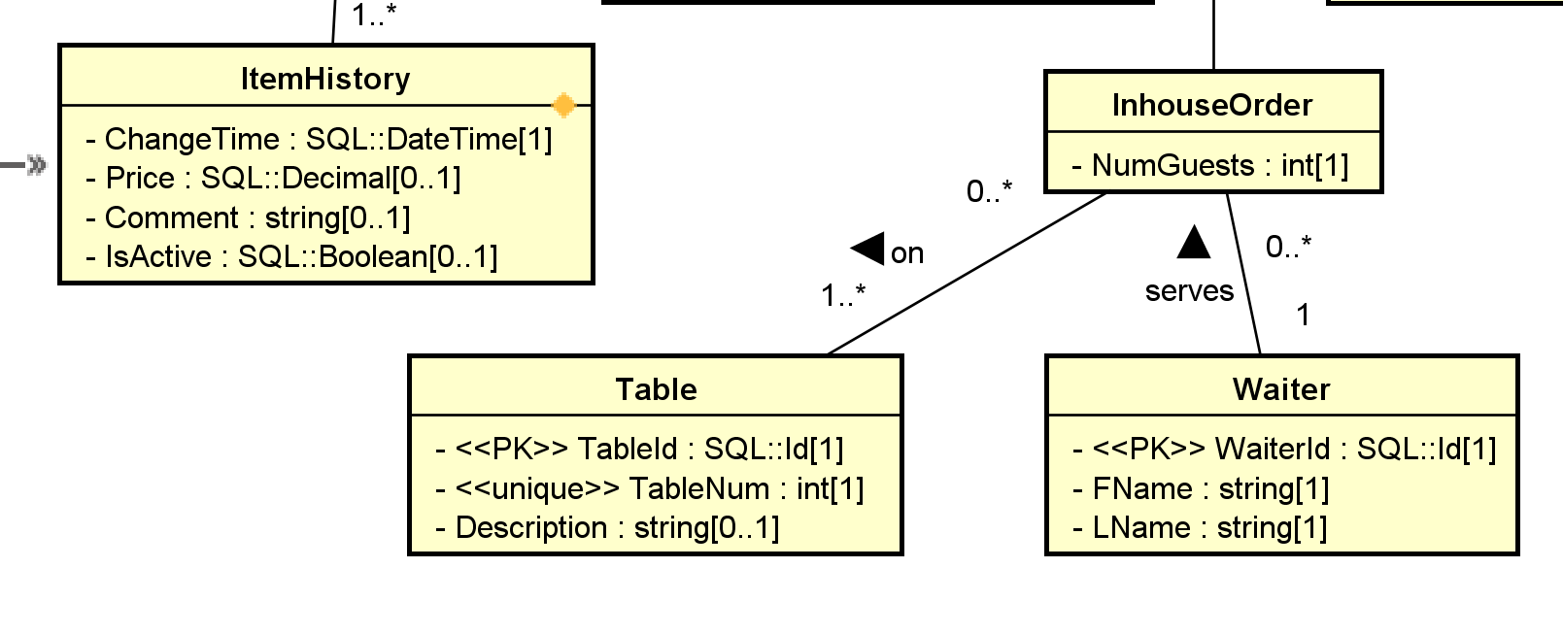
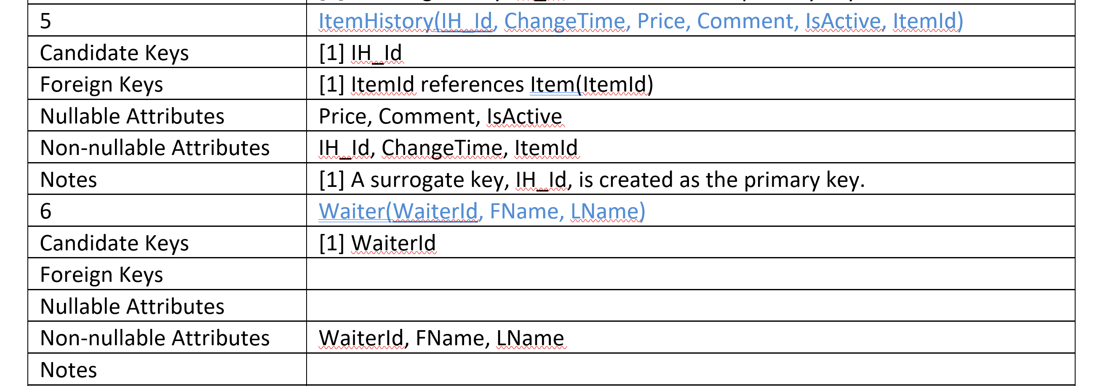

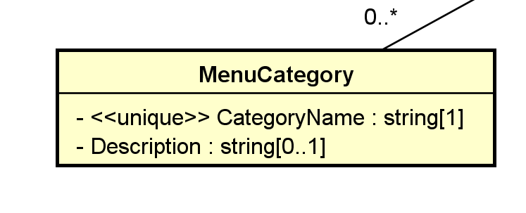
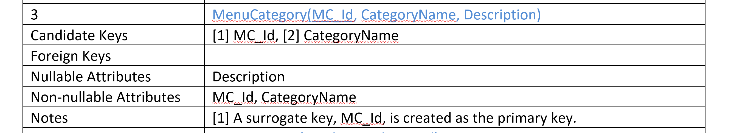
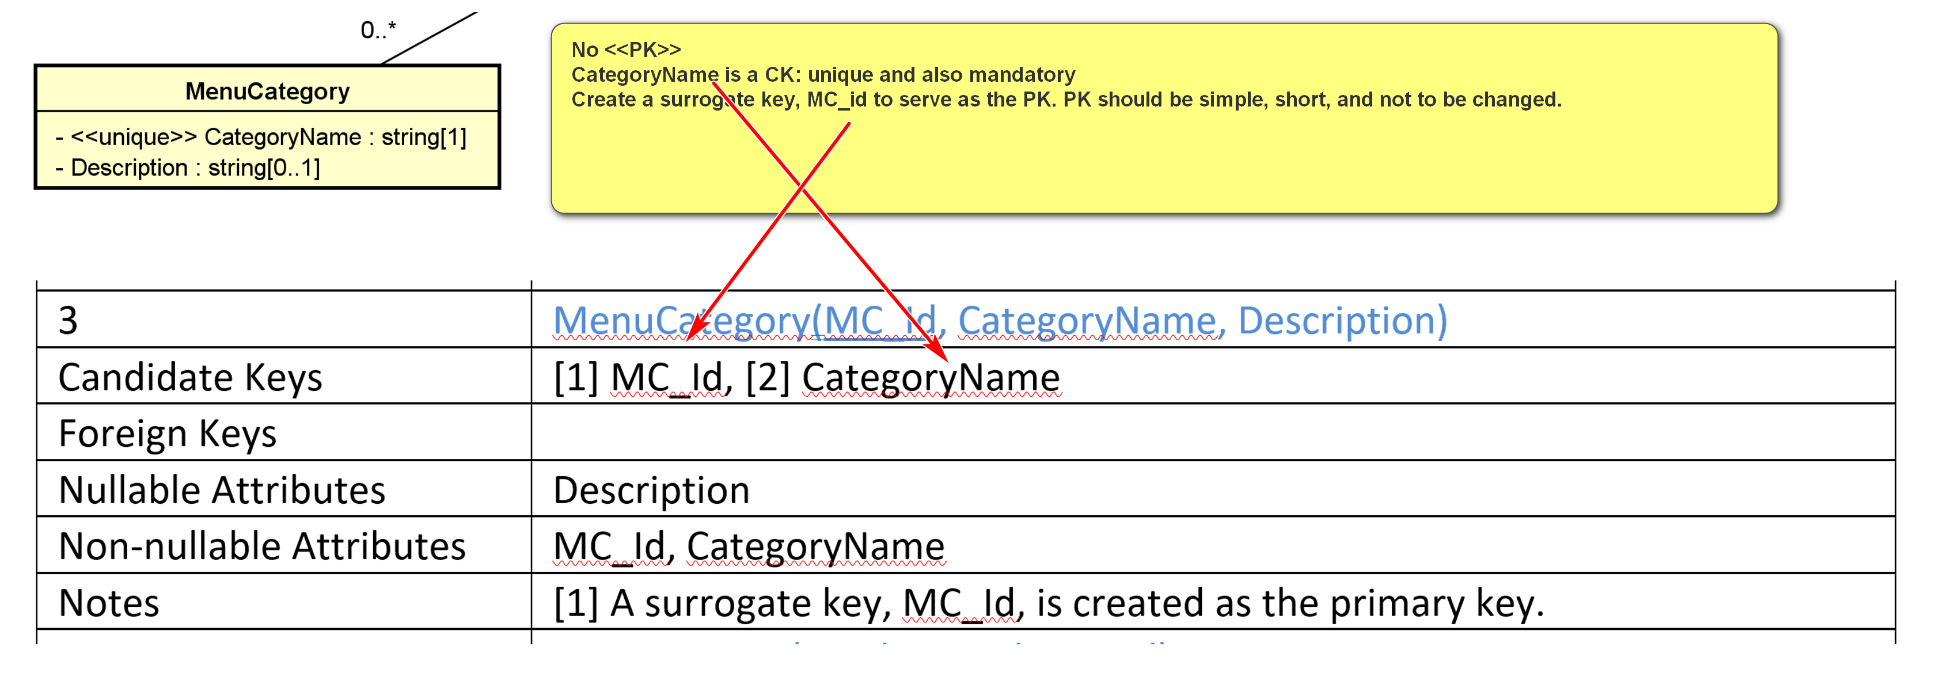
Example:
for the class Department in toyu:
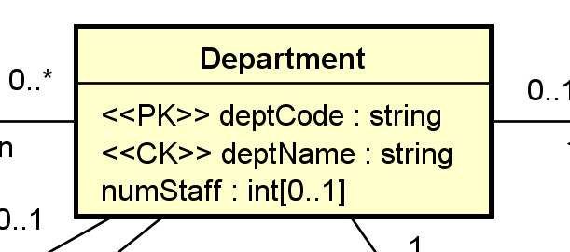
Relational schema (in HW assignment format):
3 | Department(deptCode, deptName, schoolCode, numStaff)
Candidate Keys | [1] deptCode, [2] deptName
Foreign Keys | [1] schoolCode references School(schoolCode)
Nullable Attributes | schoolCode, numStaff
Non-nullable Attributes | deptCode, deptName
Notes
Relational schema in SQL (with more implementation details):
CREATE TABLE IF NOT EXISTS Department (
deptCode CHAR(4) NOT NULL,
deptName VARCHAR(30) NOT NULL,
schoolCode CHAR(3) NULL,
numStaff TINYINT NULL,
CONSTRAINT Department_deptCode_pk PRIMARY KEY (deptCode),
-- alternate keys: [1] deptName
CONSTRAINT Department_name_ck UNIQUE (deptName),
CONSTRAINT Department_schoolCode_fk FOREIGN KEY (schoolCode)
REFERENCES School(schoolCode)
);
KC4. For a stereotype, constraints, or property lists, etc:
- Some may be directly implemented in SQL DDL, e.g., PK, CK, unique, etc.
- Otherwise, it is necessary to consider where and how it is implemented.
2.4 Associations
A1. Many-to-one Association. For a many to one association A between C1 (the class with the one multiplicity) and Cm, add a column R1_Id into the relation Rm (which implements Cm).
- Assume that R1_Id is the primary key of the relation R1 (which implements C1).
- R1_Id is a foreign key in Rm referencing R1(R1_Id).
- The name R1_Id may be renamed.
- R1_Id is not null in Rm iff (if and only if) 0 is not allowed (i.e., 1..1) for C1.
- Any single-valued attribute of the association is mapped to a column in Rm.
- If the association A is an association class, single-valued attributes of A can be stored as attributes of R1.
- If you have composite or multi-valued attributes of the relationship, you should consider promoting the association to a regular class in your UML class diagram.
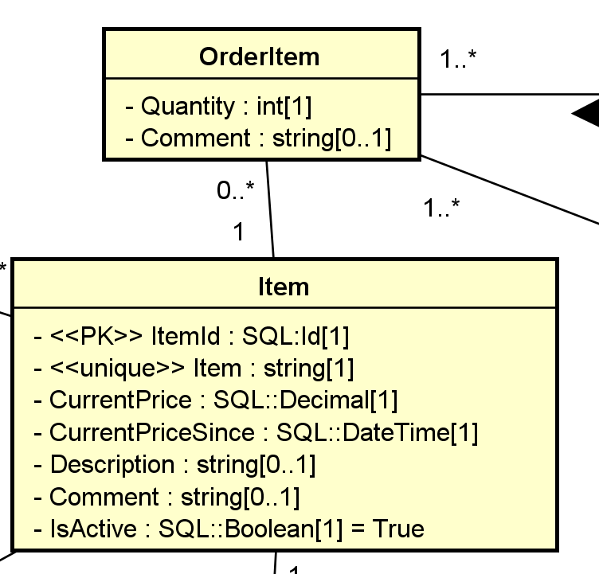Order Item: 3 (order of) Clam Pasta (item)
Item:
ITemId | Item | ..
24 | Clam Pasta
OrderItem:

OOITemId | ItemId (FK) | Quantity | …
101 | 24 | 3
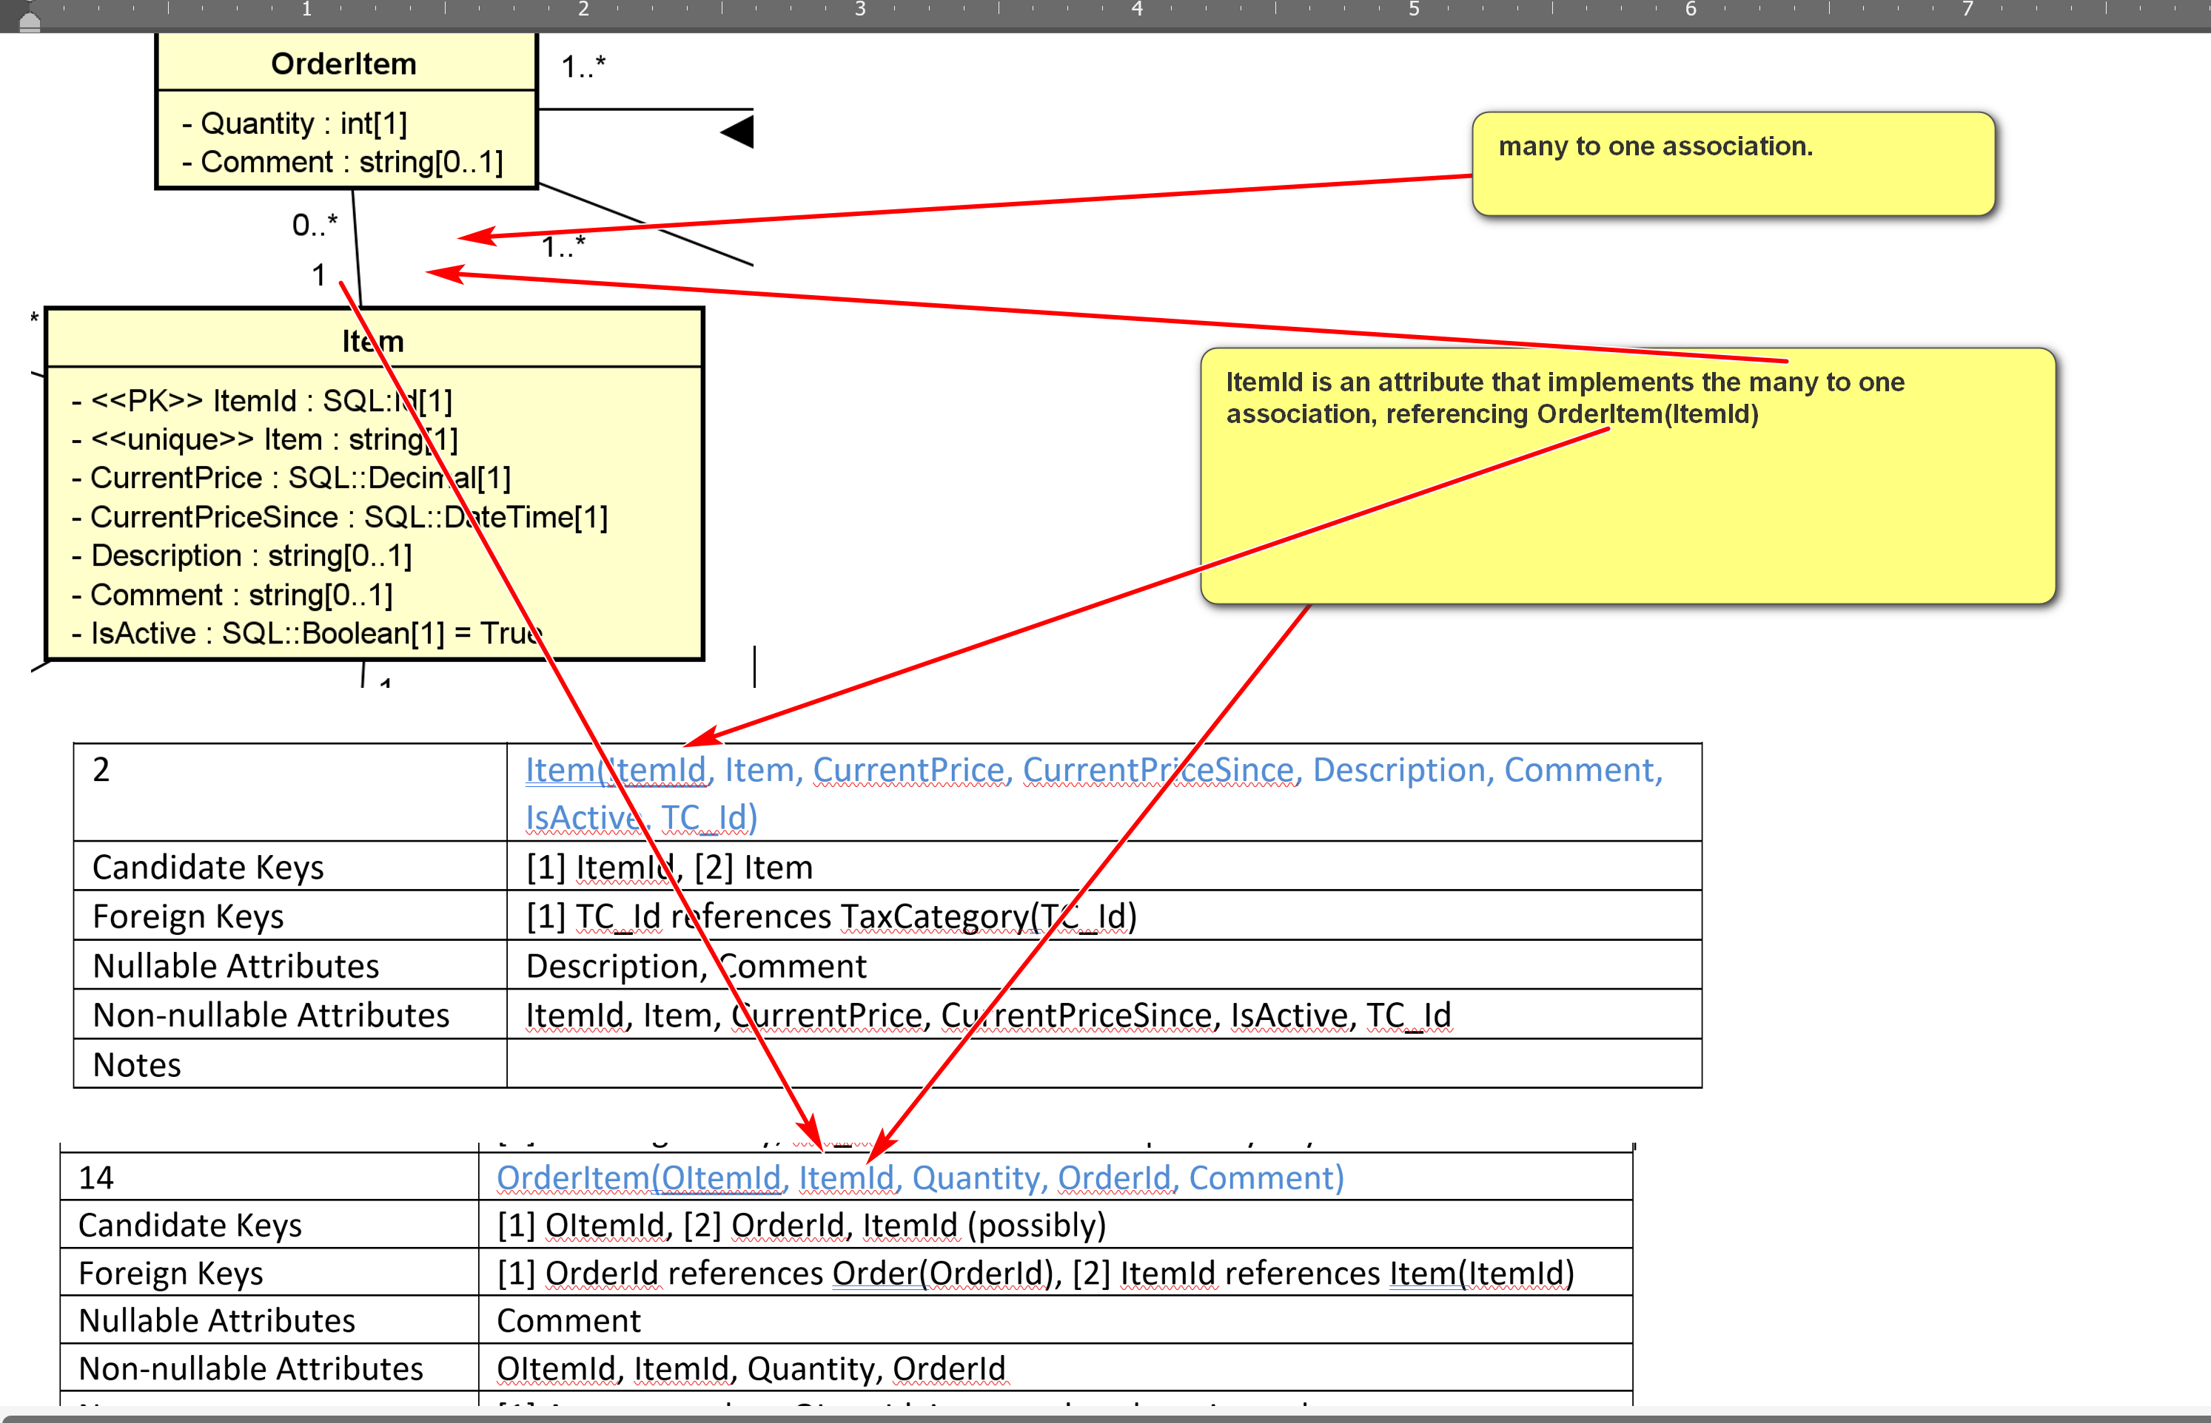
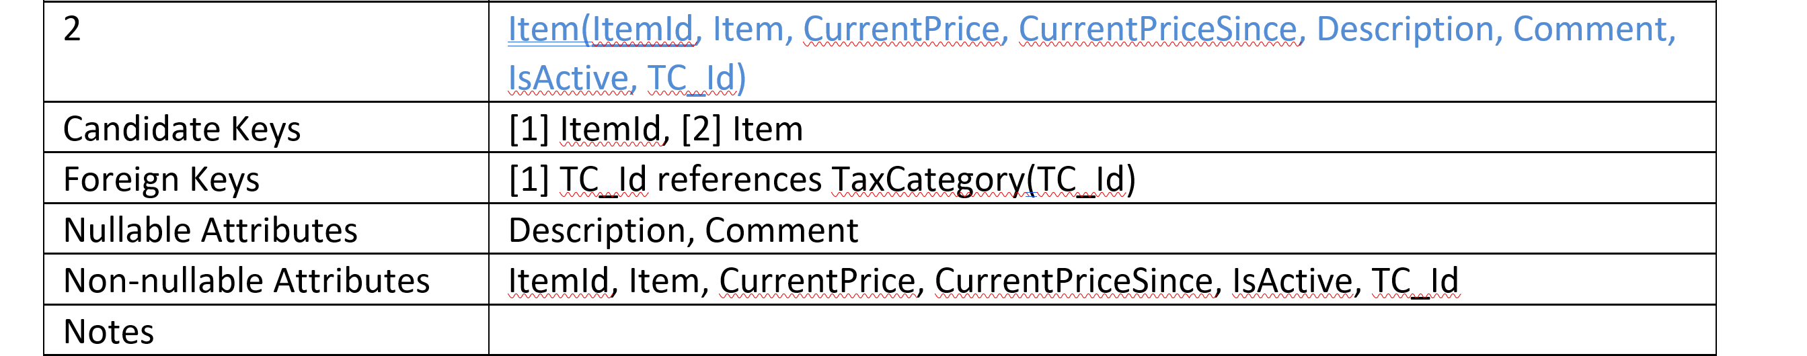
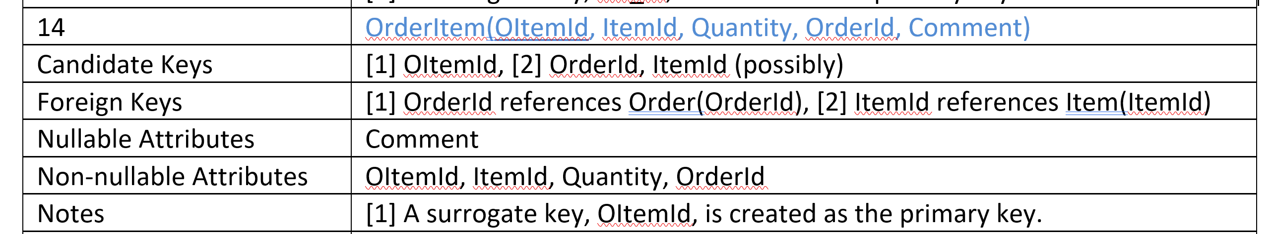

Example:
For:
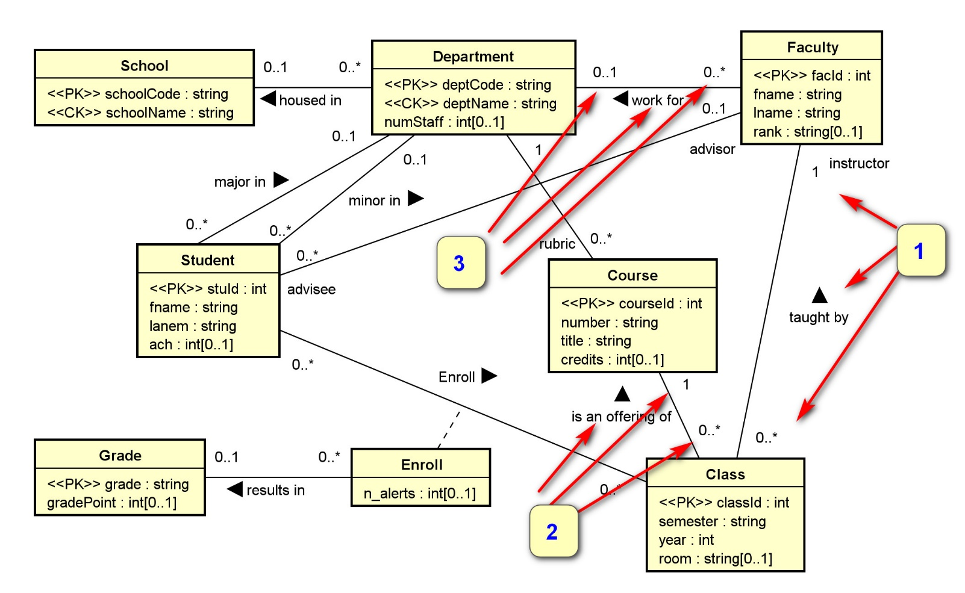
We have the three numbered associations implemented by the three foreign keys below.
4 | Faculty(facId, fname, lname, deptCode, rank)
Candidate Keys | [1] facId
Foreign Keys | [1] deptCode references Department(deptCode)
Nullable Attributes | rank, deptCode
Non-nullable Attributes | facId, fname, lname
Notes
6 | Class(classId, courseId, semester, year, facId, room)
Candidate Keys | [1] classId
Foreign Keys | [1] courseId references Course(courseId), [2] facId references Faculty(facId)
Nullable Attributes | room
Non-nullable Attributes | classId, courseId, semester, year, facId
Notes
A2. Many-to-many Association. For a many-to-many association (including association classes) between classes CA and CB, create a new relation RAB(RA_Id, RB_Id).
- (RA_Id, RB_Id) is a candidate key.
- RA_Id references RA(RA_Id) as a foreign key.
- RB_Id references RB(RB_Id) as a foreign key.
- An additional surrogate key, such as RAB_Id, can be created.

- 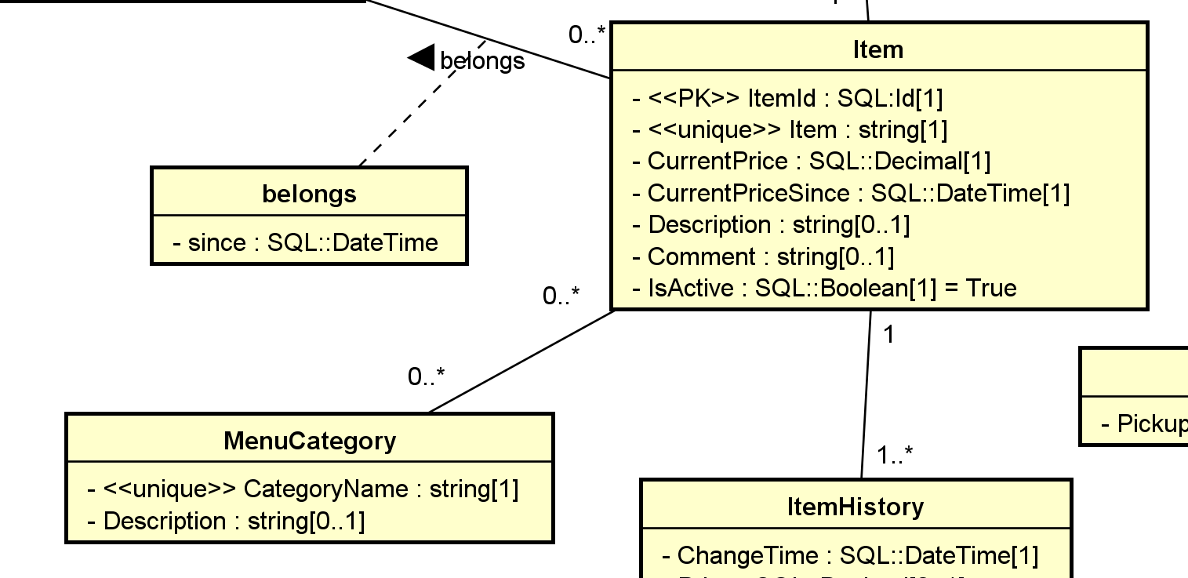
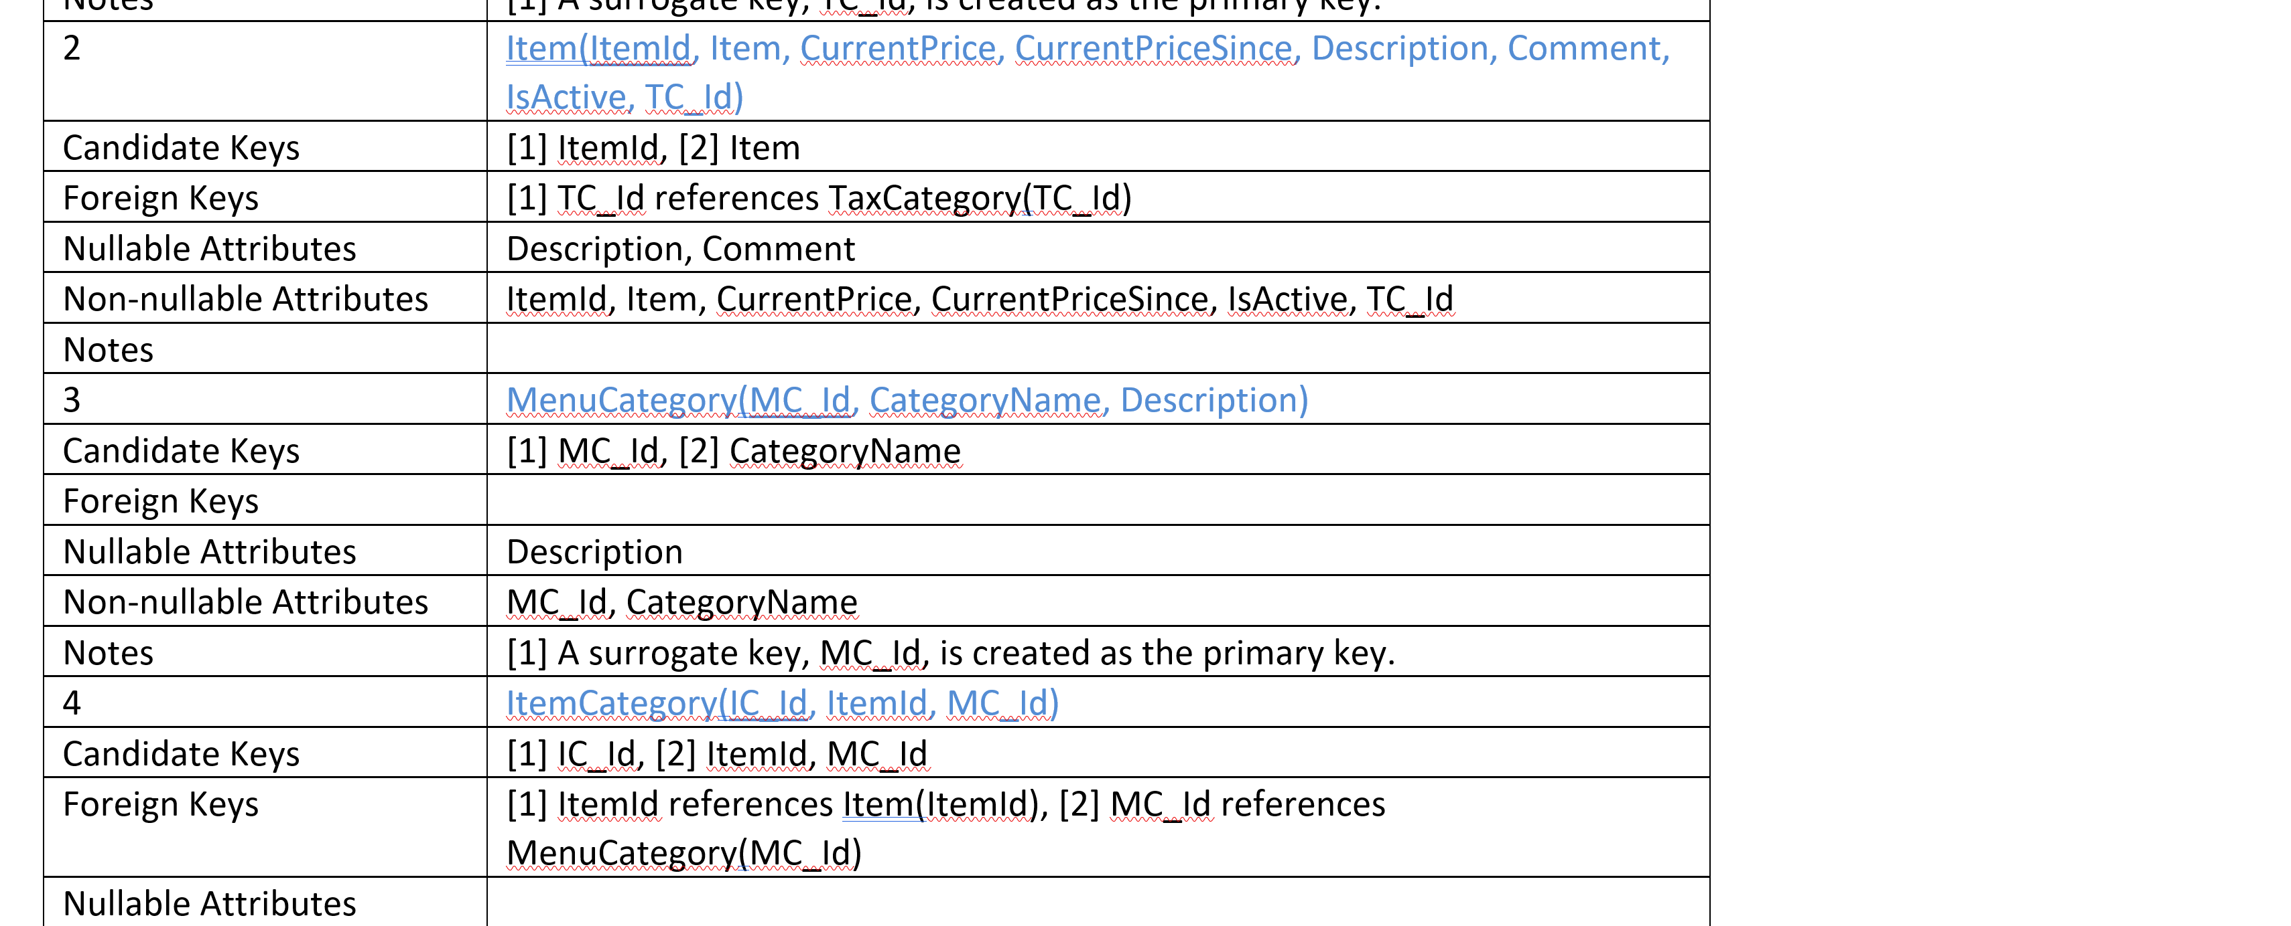
clam chowder (Item): soup, seafood, comfy (menu category) (3 associations)
tomato soup (item): soup, vegetable. (2 associations
Item:
ItemId | Item | MCIds? Not single-valued
IId10 | Clam chowder | 12,20,35
IId20 | Tomato soup | 12,40
MenuCategory:
MCId | CategoryName | ItemIds?
12 | Soup | IId10, IId20, …
20 | seafood
35 | Comfy
40 | vegetable
ITemCategory
ICID (PK) | MCId (FK) | ITemId
 | 12 | IId10
 | 12 | IId20
 | 30 | IId10
 | 35 | IId10
 | 40 | IID20
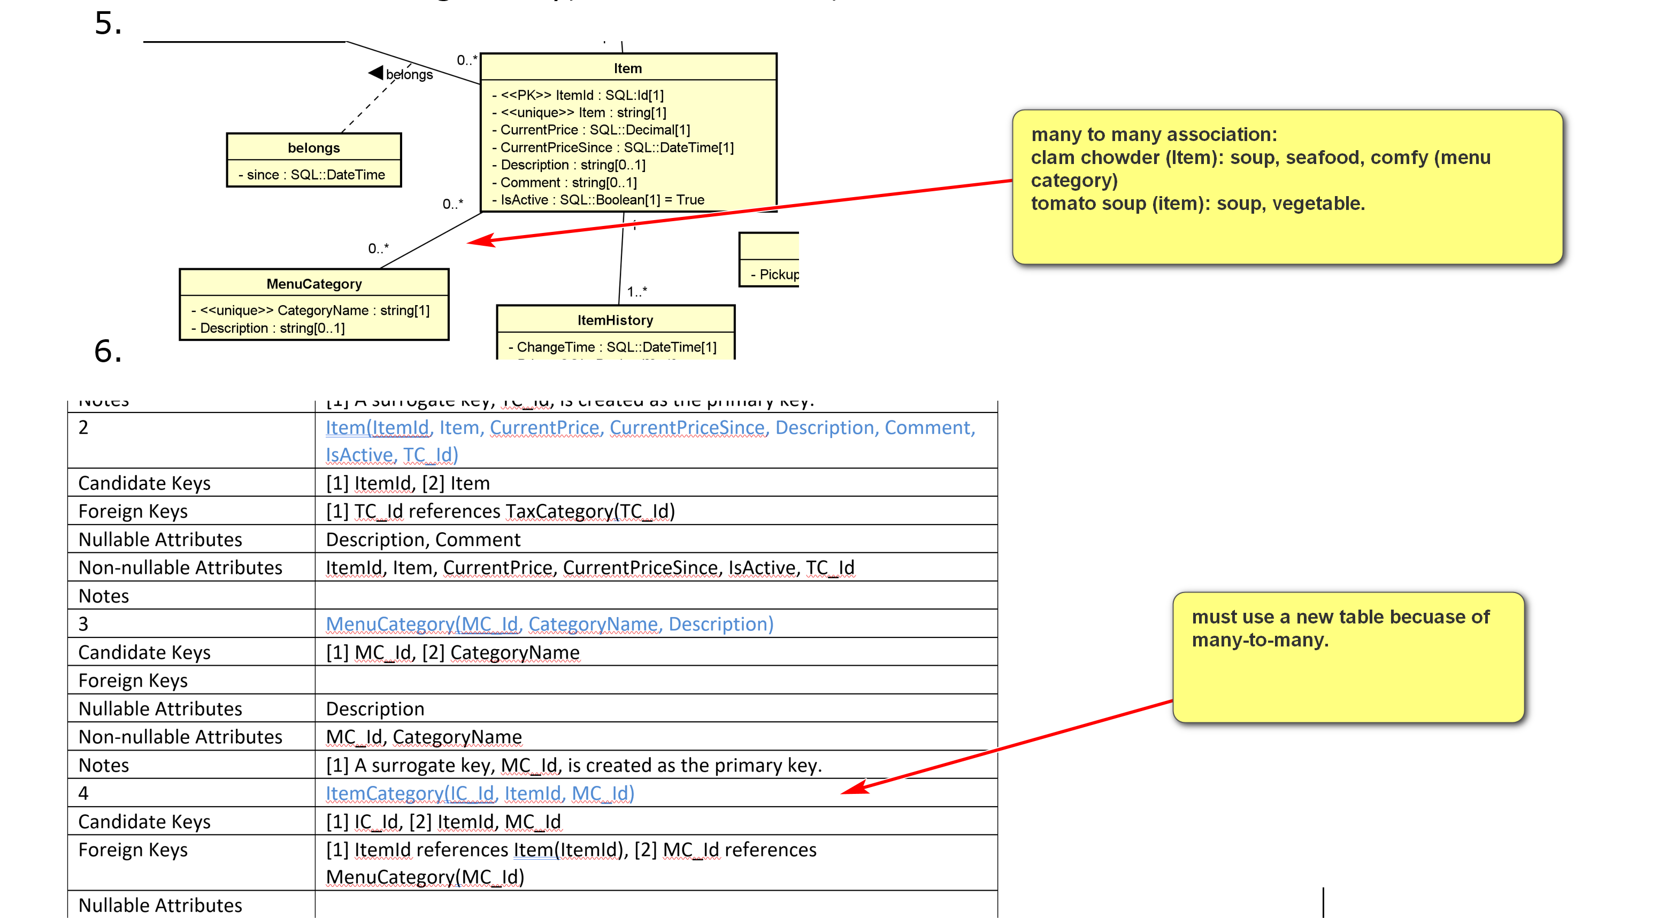

Example:
For:
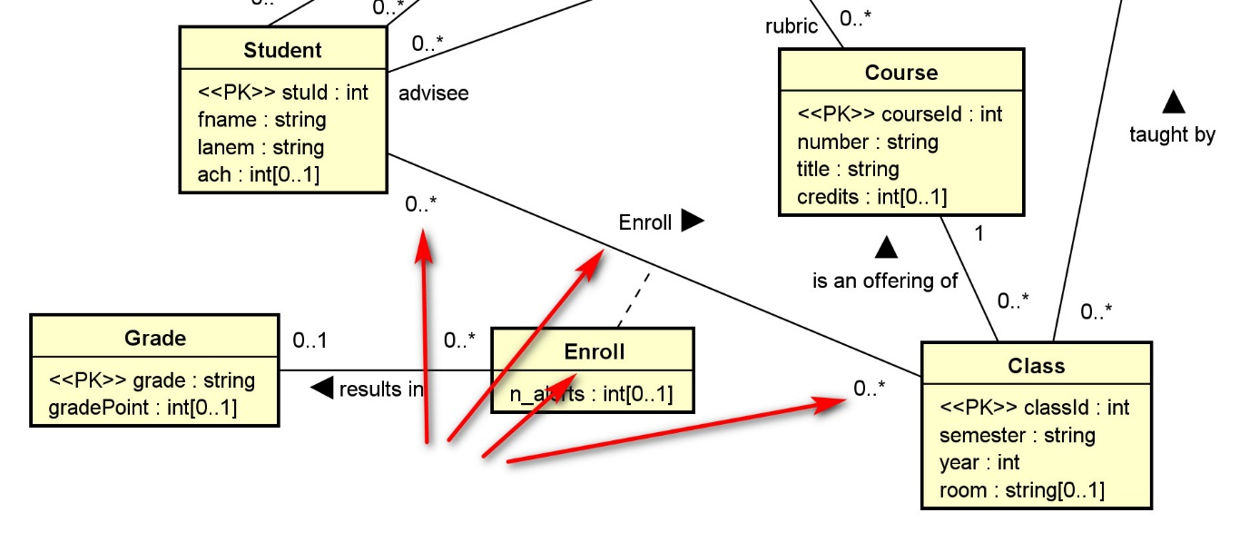
We have:
8 | Enroll(stuId, classId, grade, n_alerts)
Candidate Keys | [1] stuId, classId
Foreign Keys | [1] stuId references Student(stuId), [2] classId references Class(classId), [3] grade references Grade(grade)
Nullable Attributes | grade, n_alerts
Non-nullable Attributes | stuId, classId
A3. One-to-one Association. For a one to one association between classes CA and CB, there are several options:
- Treat CA as C1 and CB as Cm and apply A1.
- Treat CA as Cm and CB as C1 and apply A1.
- Merge the two relations RA and RB into one. (In this case, you may want to refactor the class diagram.)
A4. N-ary Associations. For any n-ary association (n>2), a new relation is needed.
- You should consider using binary associations instead.
- A ternary association can be modeled as a regular class with three binary associations with the participating classes in the ternary association.
Example:
Consider the ternary association between the classes Supplier, Part, and Warehouse with an association attribute quantity.
It can reasonably be replaced by a new class and three binary associations.
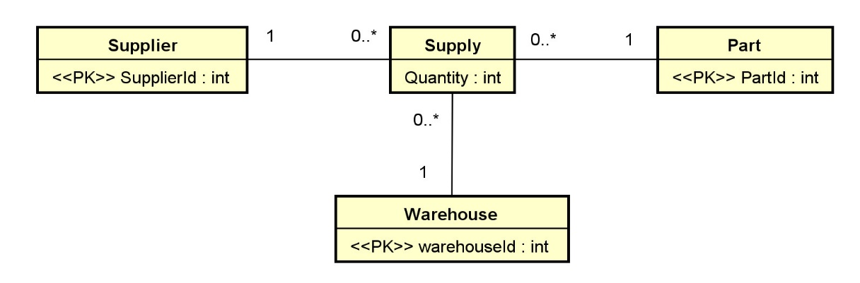
Supply(SupplyId, SupplierId, PartId, WarehouseId, Quantity):
- CK: [1] SupplyId, [2] SupplierId, PartId, WarehouseId
- FK: [1] SupplierId references Supplier(SupplierId), [2] PartId references Part(PartId), [3] WarehouseId references Warehouse(WarehouseId).
- All attributes in Supply is not nullable.
Example:
Checkout the UML diagram and relation schema for toyu and swim.

