ITEC 3335 Database Development
Fall 2018
Examination #1

Last Name: ________________ First Name: ____________ Student Id: ________

Number: _________

Time allowed: one hour 15 minutes. Total score: 100 points. Closed book examination.

Answer all questions. Turn in both question and answer sheets (if needed).

Academic honesty policy will be followed strictly. Cheating will be pursued vigorously and will result in a failing grade of D or below, a permanent academic record, and possibly other more serious penalty!

(1) [30 points] The goal is to build a highly simplified toy prototype database to partially support storing of information about students and organizations. Provide an ER diagram to capture and model the partial requirements below. You should list the entities, their attributes, and relationships (with names and cardinalities). Identify the primary keys of the entities when appropriate. Since this is only a highly simplified part of the application, model your design in a flexible way.

In this application, students (entity) can join organizations (entity) supervised by faculty members. A student has a unique id, last name, first name, and email.

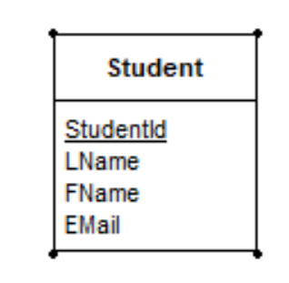

An organization has a unique id, name, start date, and an optional mission statement.

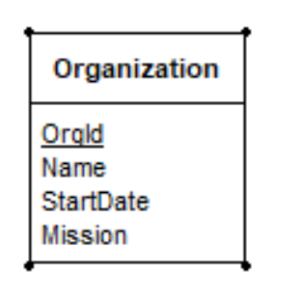

A student (entity) can join (relationship) an organization (entity) as a member (same as student? No, a member is a role of a student in an organization).

Every organization (entity) has a student (entity) as its president. It may also has another student as its vice president.

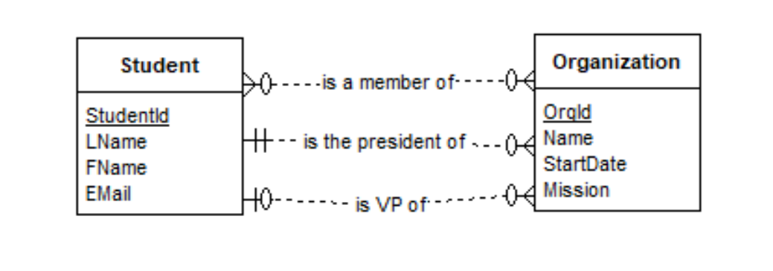
An organization may be categorized by kinds, such as ‘social’, ‘political’, ‘study’, ‘recreational’ (examples of the names of kinds), etc. An organization kind (entity: name and descirption) may have a description.

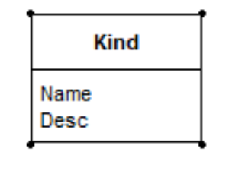
An organization (entity) may be classified into (relationship) many kinds (entity). For example, the organization ‘ITEC 3335 Club’ can be classified as both ‘study’ and ‘social.’

An organization (entity) must have a faculty (entity) as its primary supervisor (relationship). It may have any number of additional supervisors. All supervisors must be faculty members. A unique faculty id, name and email should be stored for every faculty member.

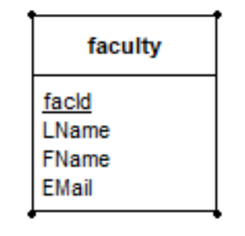
Please answer your question in the next page.

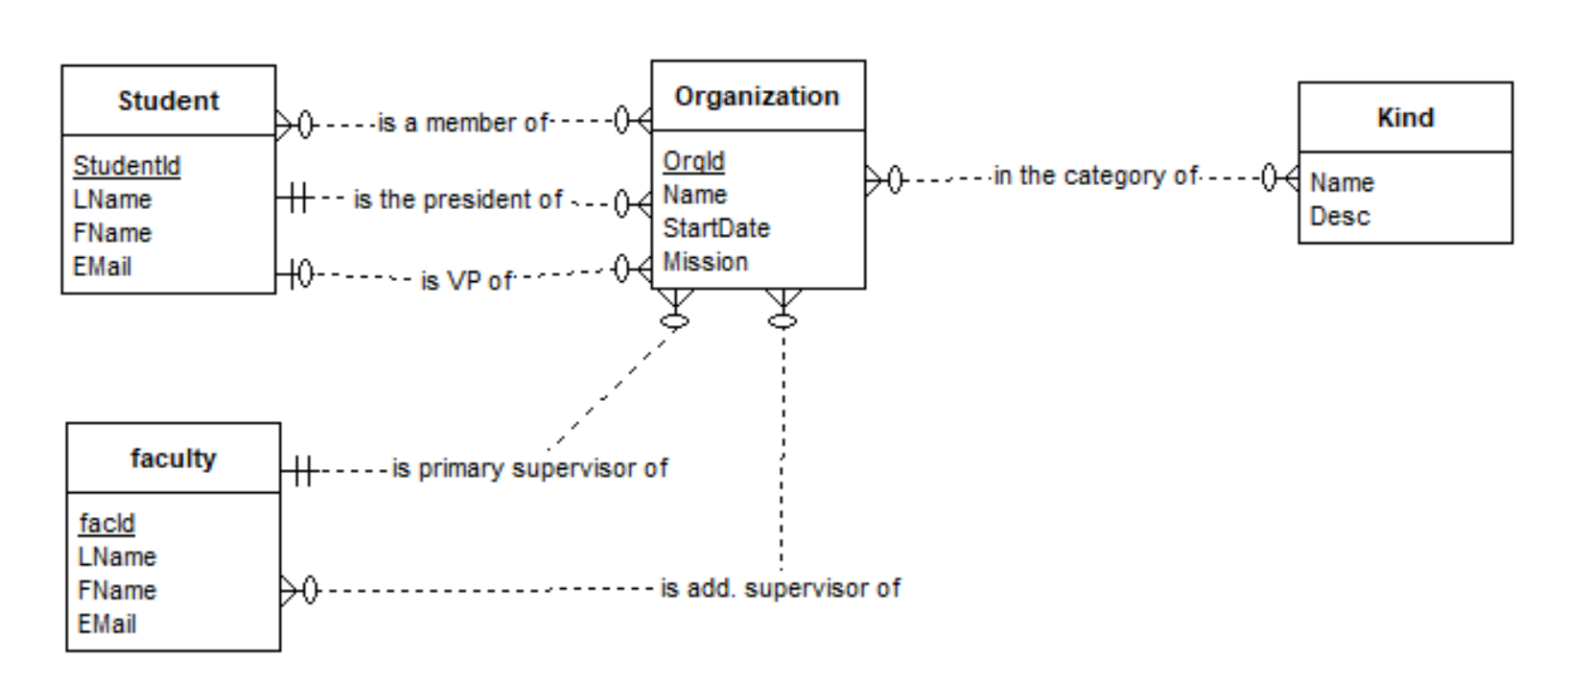
(1) Your answer here:
(2) [30 points] Use the Toy University (toyu) to answer the following queries with SQL. The detail of toyu is provided in a separate sheet.

(a) Show the ids and names of students not majoring in ITEC and have 40 or more credits. For example:

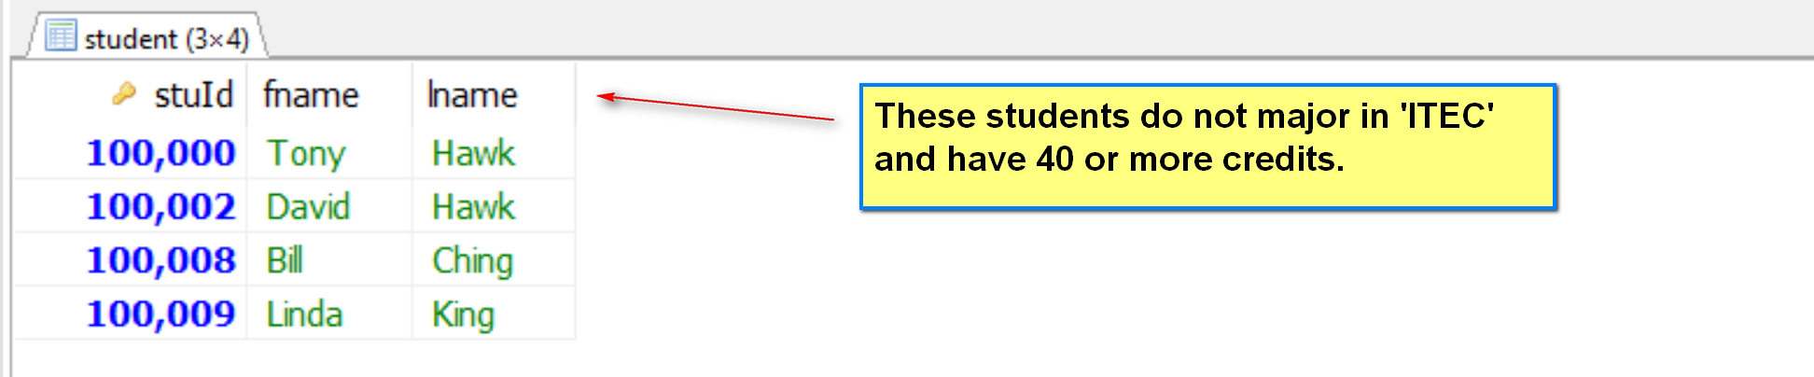

[1] Output: stuId, fname, lname
[2] Source: student
[3] Conditions: major <> ‘ITEC’, credits >= 40
SELECT DISTINCT stuId, fname, lname
FROM student
WHERE major <> ‘ITEC’ AND credits >= 40;

(b) All enrollments of classes in 2017 of courses with the rubric ITEC, including classid, course name, stuid of student and grade. For example:

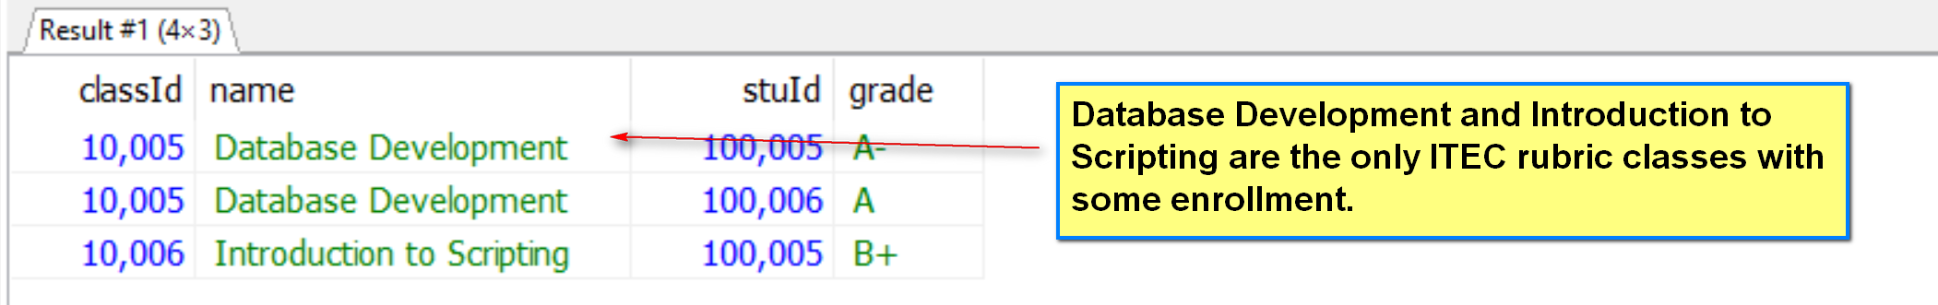

ITEC courses: 2041, 2040 (courseId)
Classes: classId of 2040, 2041: 10005, 10006.
Enrollment:
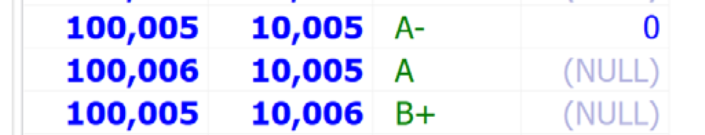

[1] Output: class:classId, name: course:name, enroll:stuId, enroll:grade
[2] Source: class, course, enroll
[3] Conditions:
Join conditions: class.courseId = course.courseId; enroll.classId = class.classId
Problem conditions: course.rubric = ‘ITEC’

SELECT DISTINCT c.classId, co.name, e.stuId, e.grade
FROM class AS c INNER JOIN course AS co USING (c.courseId = co.courseId)
JOIN enroll AS e USING (e.classId = c.classId)
WHERE co.rubric = ‘ITEC’;

SELECT DISTINCT c.classId, co.name, e.stuId, e.grade
FROM class AS c, course AS co, enroll AS e
WHERE (c.courseId = co.courseId
AND e.classId = c.classId
AND co.rubric = ‘ITEC’;
(c) All classes taught by the faculty 'Paul Smith' with the information and format shown below. Note the name of the third column. It should be ordered by course rubric and number.

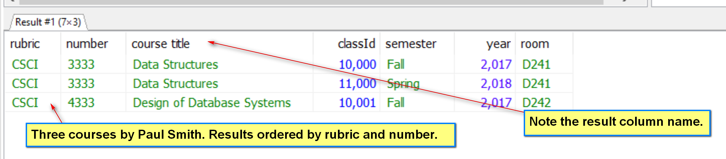

(d) List the student names and their major department names of all students who have taken a course from a faculty of the department CSCI in the following manner.

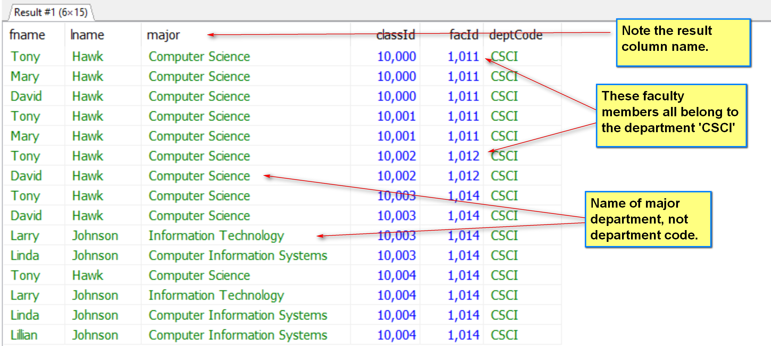

(3) [30 points]

(a) [T or F] In MS Access, after a query is designed with the design view or design wizard successfully, a corresponding SQL statement will be generated.

(b) [T or F] In MS Access, the query design view allows users to select which foreign key should be used to join two tables.

(c) [T or F] In MS Access, it is possible to define a query for the user to input a value for a table column to be satisfied in the result, but only when the table column is also shown in the result.

(d) [T or F] Comparing to a file processing system, a DBMS improves concurrent access to data.

(e) [T or F] The definition of relation schema is usually implemented in SQL by its Data Manipulation Language.

(f) [T or F] In the relational model, R(A,B,C) may not have more than 6 superkeys.

(g) [T or F] In the relational model, a table may have no foreign key.

(h) [T or F] In an ER diagram, an entity type may not have a relationship with itself.

(i) [T or F] In the relational database process, constructing the relational schema is usually the first activity.

(j) [T or F] The Entity-Relationship model is object-based.

(k) [T or F] A primary key in a relation is also a candidate key.

(l) [T or F] Creating DB accounts and assigning privileges are usually a part of the job of a database developer.

(m) [T or F] A foreign key cannot have a null value.

(n) [T or F] Once defined by SQL, a relation schema cannot be changed.

(o) [T or F] In the relational model, it is possible that a set of attributes, such as AB, to serve as the primary key of two relations.

[4] (10 points) Short Questions.

(a) It is known that R(A,B,C,D) has two candidate keys: AB and AC. What are the prime attributes?

A, B and C.

(b) Refering to toyu, correct the syntax error(s) in the following SQL statement.

select distinct c.classId, co.name
from class c, course AS co
where c.classId = co.classId
and co.rubric = 'CSCI';

Correct:

select distinct c.classId, co.name
from class c, course co
where c.courseId = co.courseId
and co.rubric = 'CSCI';

(c) R(A,B,C,D) has two candidate keys AB and AC. List all superkeys.

Student(StuId, LName, FName, EMail)

R: Student
A: stuId

F18 Exam 2:

(2) [15 points] Consider the following ER diagram. Construct a reasonable set of relation schema to implement it. For each relation, list its candidate keys, foreign keys, and all attributes you know for sure that are not nullable. If you create a surrogate key for a relation, indicate so. Note that the attributes a, c, and f have been identified as the primary keys for the entities A, C and D respectively.

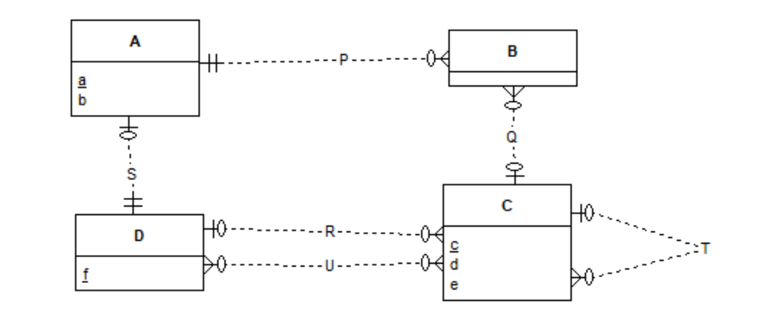
Answer: fill in the table below.

Relation | A(a,b) | Relation | B(B_Id, a
[CK] (1) a  [FK]  [Nullable]  [Note] |  | [CK] B_Id  [FK] (1) a references A(a)  [Nullable]  [Note] B_Id is created as a surrogate PK.
Relation | C(c,d,e ) | Relation | D(f,a)
[CK] (1) c  [FK]  [Nullable]  [Note] |  | [CK] (1) f  [FK] a references A(a)  [Nullable] a  [Note]
Relation | U(c,f) | Relation
[CK] (1) c,f  [FK] (1) c references C(c), [2] f references D(f).  [Nullable]  [Note] |  | [CK]  [FK]  [Nullable]  [Note]

