9/9/2019
Data Problem:
List all students (Names in one column call Student) and their major names (e.g. Computer Science) and their minor names (e.g. Computer Information Systems). List students who have both major and minors.
[1] Expected Results: 8 rows
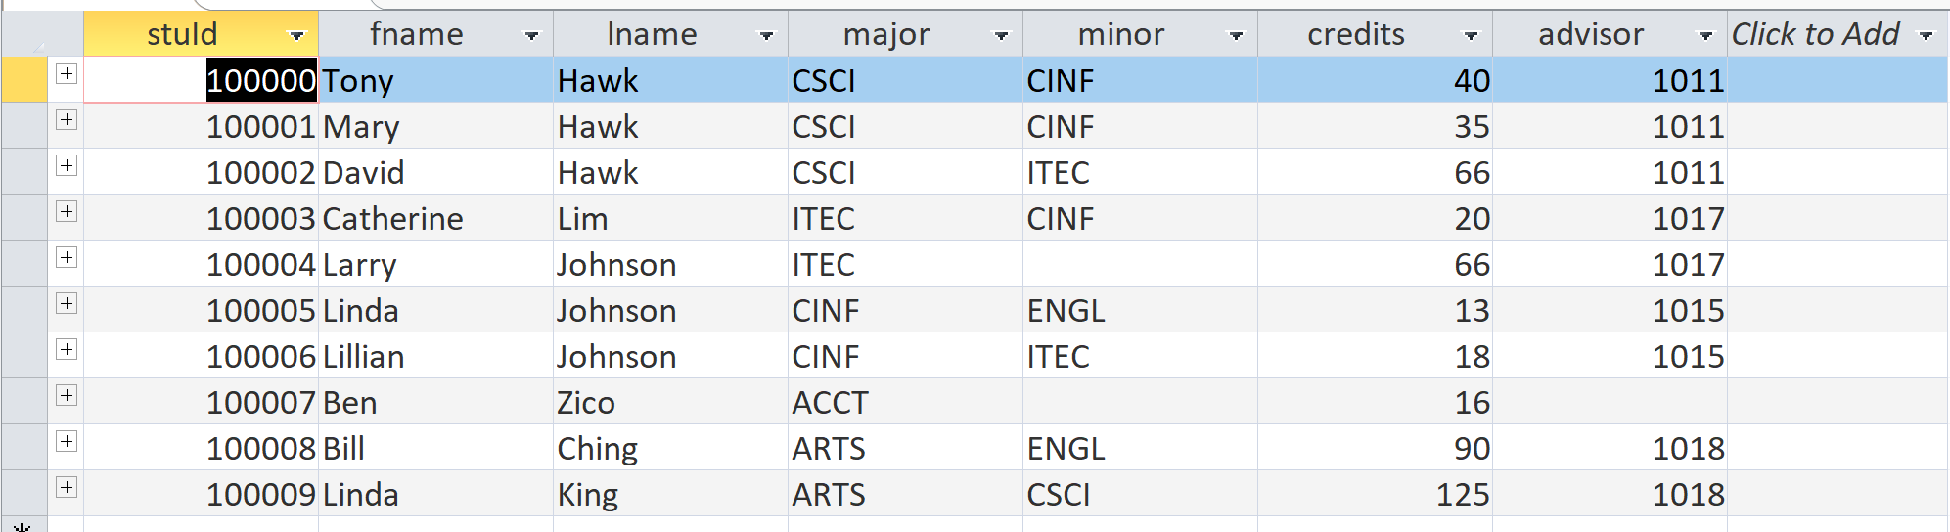

Student | Major | Minor
Tony Hawk | Computer Science | Computer Information Systems
Mary Hawk | Computer Science | Computer Information Systems
…
Linda Johnson | Computer Information Systems | English

student
stuId | fname | lname | major | minor | credits | advisor
100000 | Tony | Hawk | CSCI | CINF | 40 | 1011
100001 | Mary | Hawk | CSCI | CINF | 35 | 1011
100002 | David | Hawk | CSCI | ITEC | 66 | 1011
100003 | Catherine | Lim | ITEC | CINF | 20 | 1017
100004 | Larry | Johnson | ITEC |  | 66 | 1017
100005 | Linda | Johnson | CINF | ENGL | 13 | 1015
100006 | Lillian | Johnson | CINF | ITEC | 18 | 1015
100007 | Ben | Zico | ACCT |  | 16
100008 | Bill | Ching | ARTS | ENGL | 90 | 1018
100009 | Linda | King | ARTS | CSCI | 125 | 1018

department
deptCode | deptName | schoolCode | numFaculty
ACCT | Accounting | BUS | 10
ARTS | Arts | HSH | 5
CINF | Computer Information Systems | CSE | 5
CSCI | Computer Science | CSE | 12
ENGL | English | HSH | 12
ITEC | Information Technology | CSE | 4
MATH | Mathematics | CSE | 7

[2] Analysis
1. Output columns:
- Name, value: Student: student.fname, ‘ ‘, student.lname (e.g. ‘Tony’, ‘ ‘, ‘Hawk’)
- Major: department.deptName
- Minor: department.deptName
2. Sources:
- Student
- Department
3. Conditions:
- Problem conditions: none
- Join conditions:
  - Student.major (FK in Student) = Department.deptCode (PK in Department)
[3] Implementation:
2. Sources:
- Student
- Department
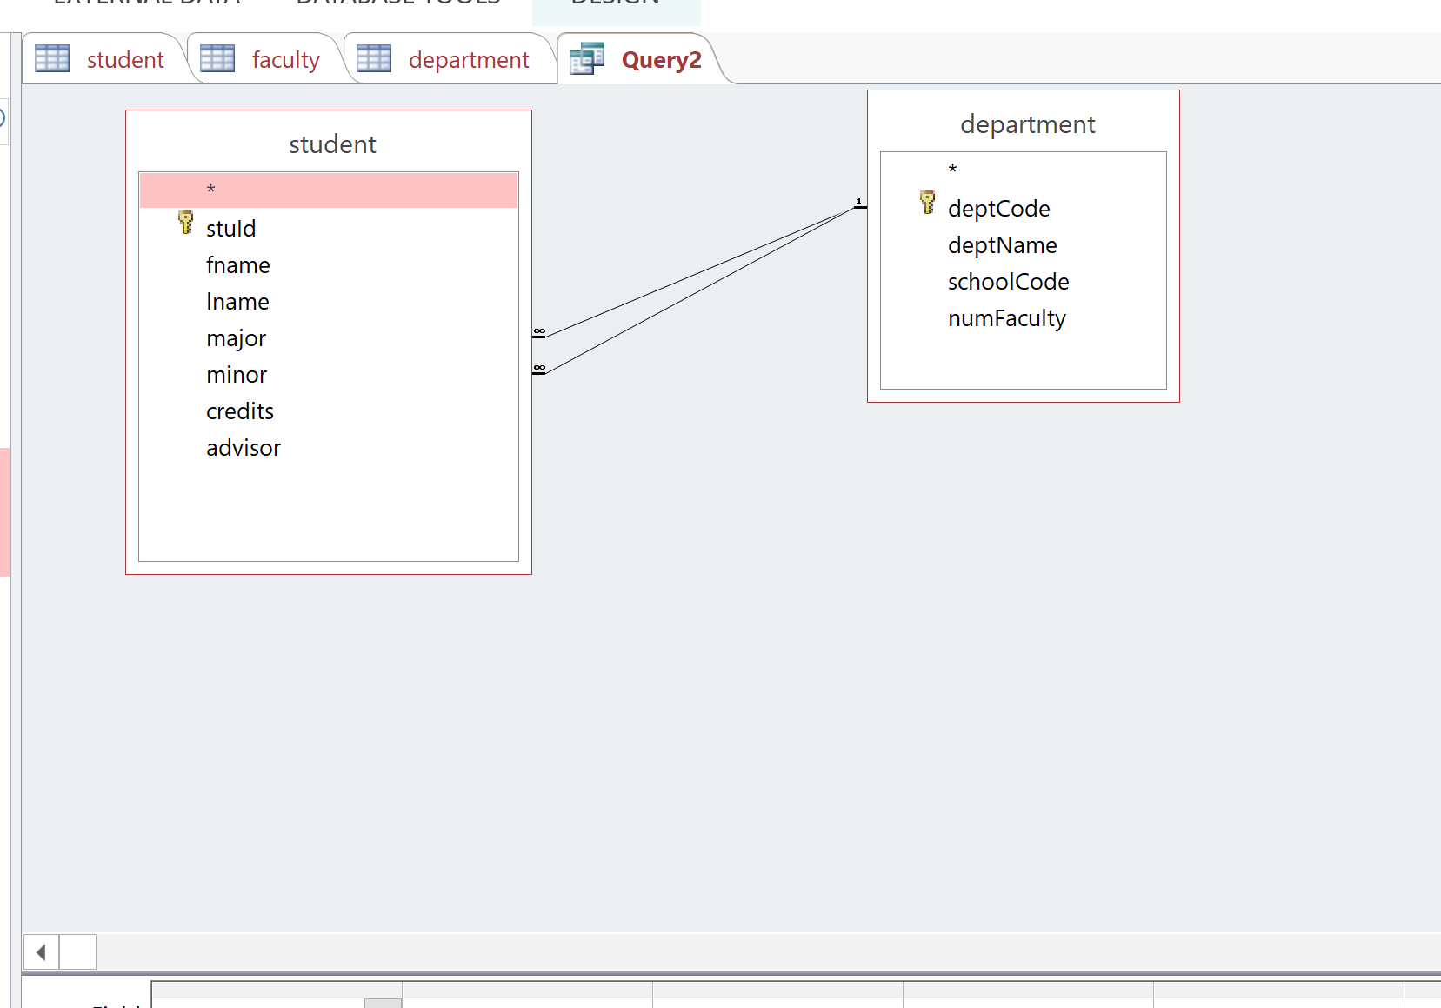
1. Output columns:
- Name, value: Student: student.fname, ‘ ‘, student.lname (e.g. ‘Tony’, ‘ ‘, ‘Hawk’)
- Major: department.deptName
- Minor: department.deptName
Q: relabel your column name?
- “Place the cursor in front of the first letter of the field name (in this case, P).
- Enter the new field name Insured followed by a colon (:).”

major:deptName
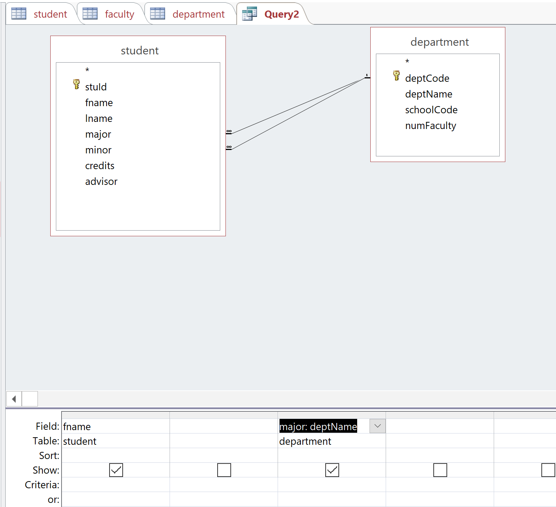
Access enforces two FK-PK relationships.
Student.major = Department.deptCode
Student.minor = Department.deptCode
- Student.major = Student.minor
Return empty result.
Generated SQL:
SELECT student.fname, department.deptName AS major
FROM department INNER JOIN student ON (department.deptCode = student.minor) AND (department.deptCode = student.major);

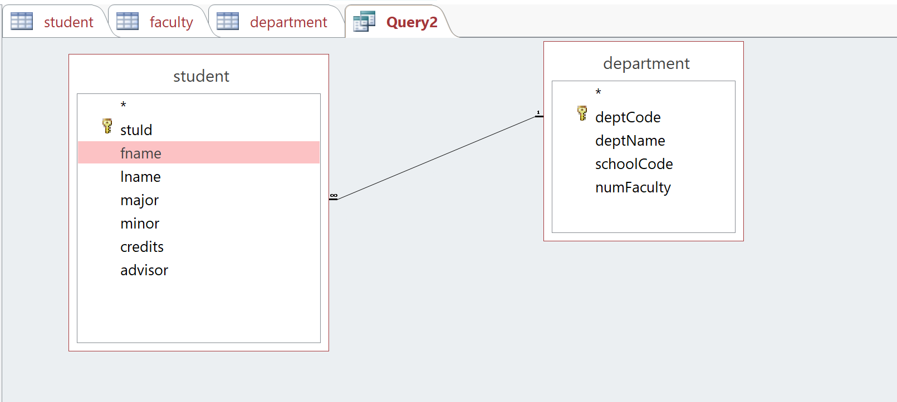
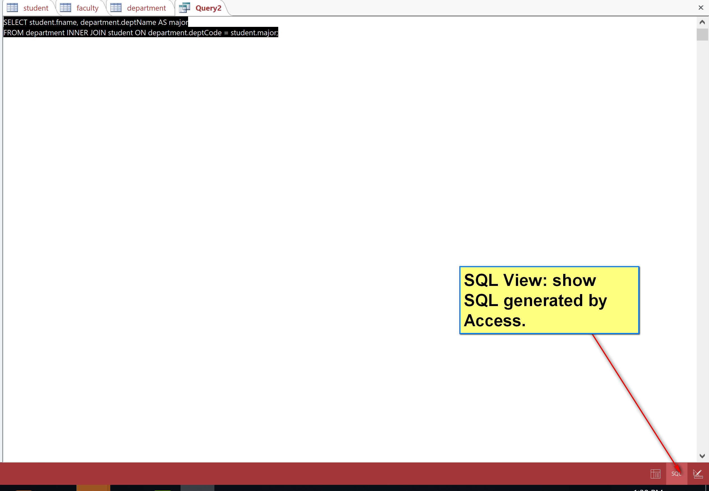
Generated SQL:
SELECT student.fname, department.deptName AS major
FROM department INNER JOIN student ON department.deptCode = student.major;
Output:
Query2
fname | major
Ben | Accounting
Bill | Arts
Linda | Arts
Linda | Computer Information Systems
Lillian | Computer Information Systems
Tony | Computer Science
Mary | Computer Science
David | Computer Science
Catherine | Information Technology
Larry | Information Technology

3. Conditions:
- Problem conditions: none
- Join conditions:
  - Student.major (FK in Student) = Department.deptCode (PK in Department)

Automatic done by Access.

Q: How to construct the output values from multiple columns
Expression: concatenate three strings
student.fname, ‘ ‘, student.lname
string_1 & string_2 & string_n
value: student.fname & ‘ ‘ & student.lname
student: student.fname & ‘ ‘ & student.lname
1. Output columns:
- Name, value: Student: student.fname, ‘ ‘, student.lname (e.g. ‘Tony’, ‘ ‘, ‘Hawk’)
- Major: department.deptName
- Minor: department.deptName
2. Sources:
- Student
- Department d1
- Department d2
3. Conditions:
- Problem conditions: none
- Join conditions:
  - Student.major (FK in Student) = d1.deptCode (PK in Department)
  - Student.minor (FK in Student) = d2.deptCode (PK in Department)
Student instance
student
stuId | fname | lname | major | minor | credits | advisor
100000 | Tony | Hawk | CSCI | CINF | 40 | 1011

Department instance d1
department
deptCode | deptName | schoolCode | numFaculty
ACCT | Accounting | BUS | 10
ARTS | Arts | HSH | 5
CINF | Computer Information Systems | CSE | 5
CSCI | Computer Science | CSE | 12
ENGL | English | HSH | 12
ITEC | Information Technology | CSE | 4
MATH | Mathematics | CSE | 7

Department instance d2

department
deptCode | deptName | schoolCode | numFaculty
ACCT | Accounting | BUS | 10
ARTS | Arts | HSH | 5
CINF | Computer Information Systems | CSE | 5
CSCI | Computer Science | CSE | 12
ENGL | English | HSH | 12
ITEC | Information Technology | CSE | 4
MATH | Mathematics | CSE | 7

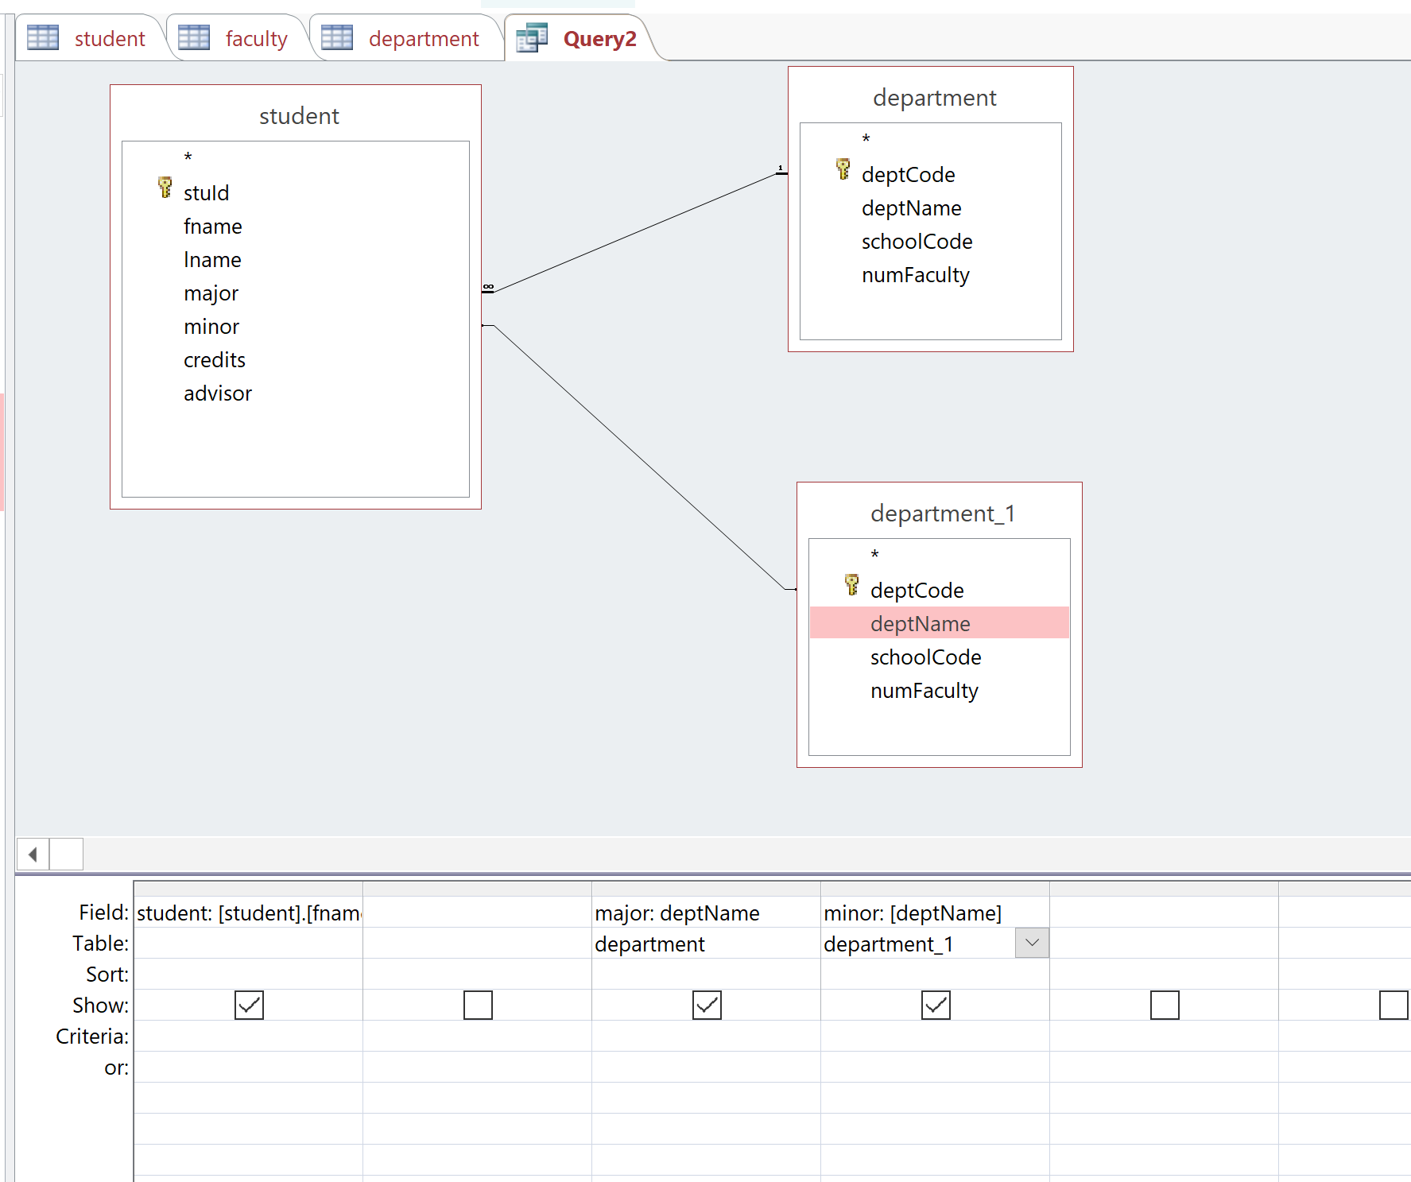
Query2
student | major | minor
Tony Hawk | Computer Science | Computer Information Systems
Mary Hawk | Computer Science | Computer Information Systems
David Hawk | Computer Science | Information Technology
Catherine Lim | Information Technology | Computer Information Systems
Linda Johnson | Computer Information Systems | English
Lillian Johnson | Computer Information Systems | Information Technology
Bill Ching | Arts | English
Linda King | Arts | Computer Science
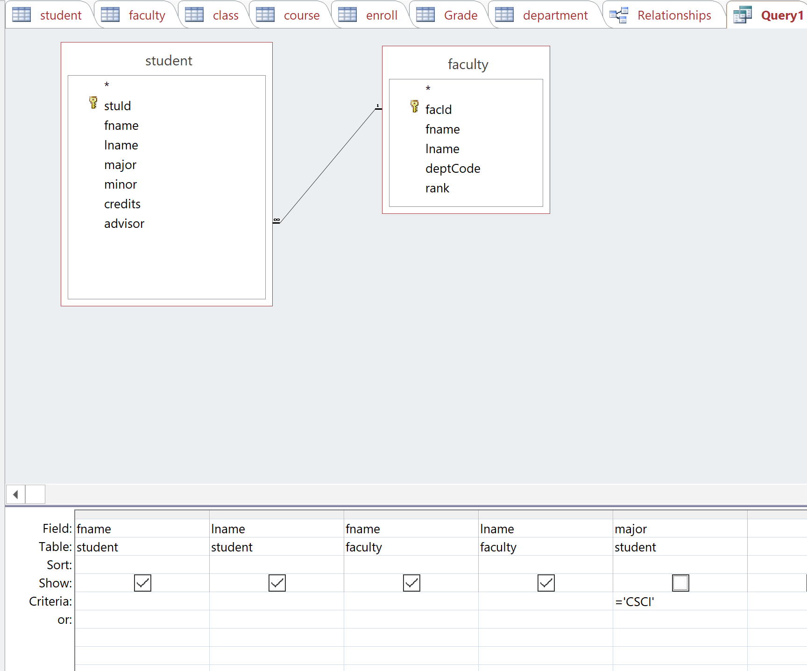

Data Problem:
List me the student, major, minor of major code entered by the user.
Expected output:
User input: CSCI:
Query2
student | major | minor
Tony Hawk | Computer Science | Computer Information Systems
Mary Hawk | Computer Science | Computer Information Systems
David Hawk | Computer Science | Information Technology

Same:
Problem condition: student.major = user input value
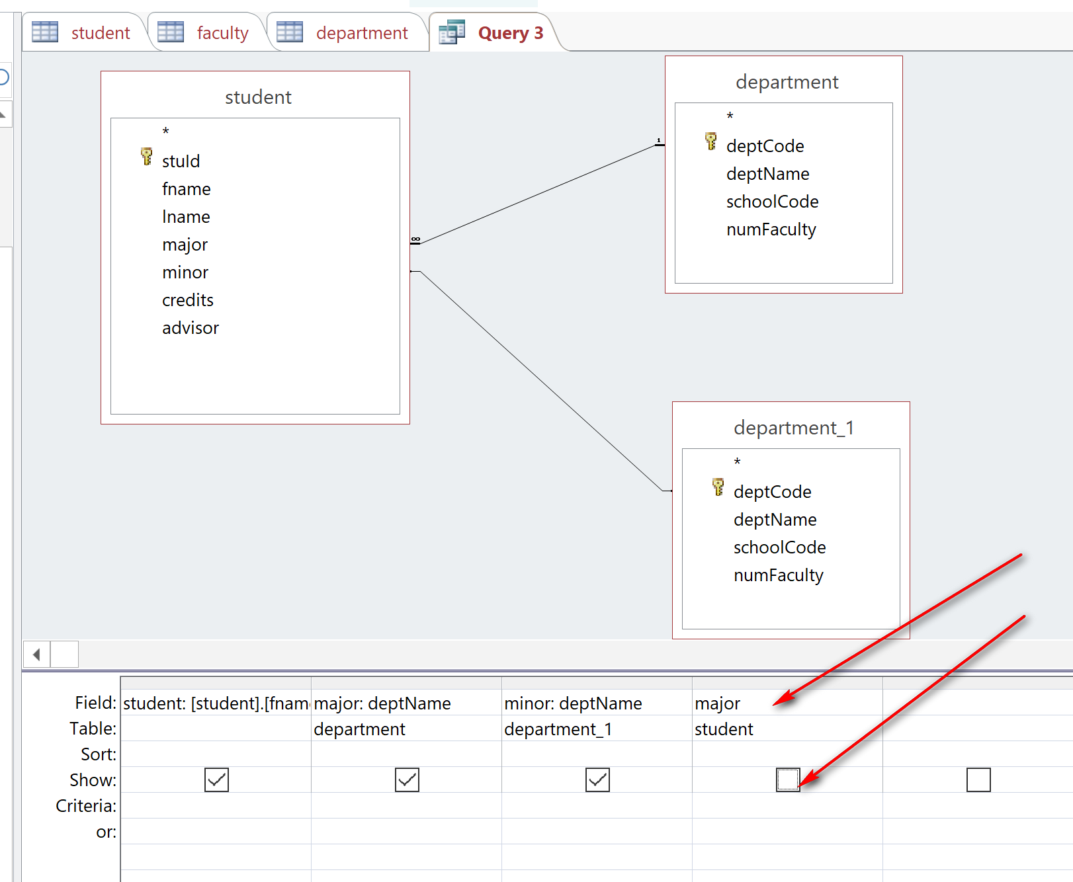
https://datatofish.com/how-to-create-an-input-box-in-access/

[Please input the dept code] allows Access to get user input value
