9/4/2019

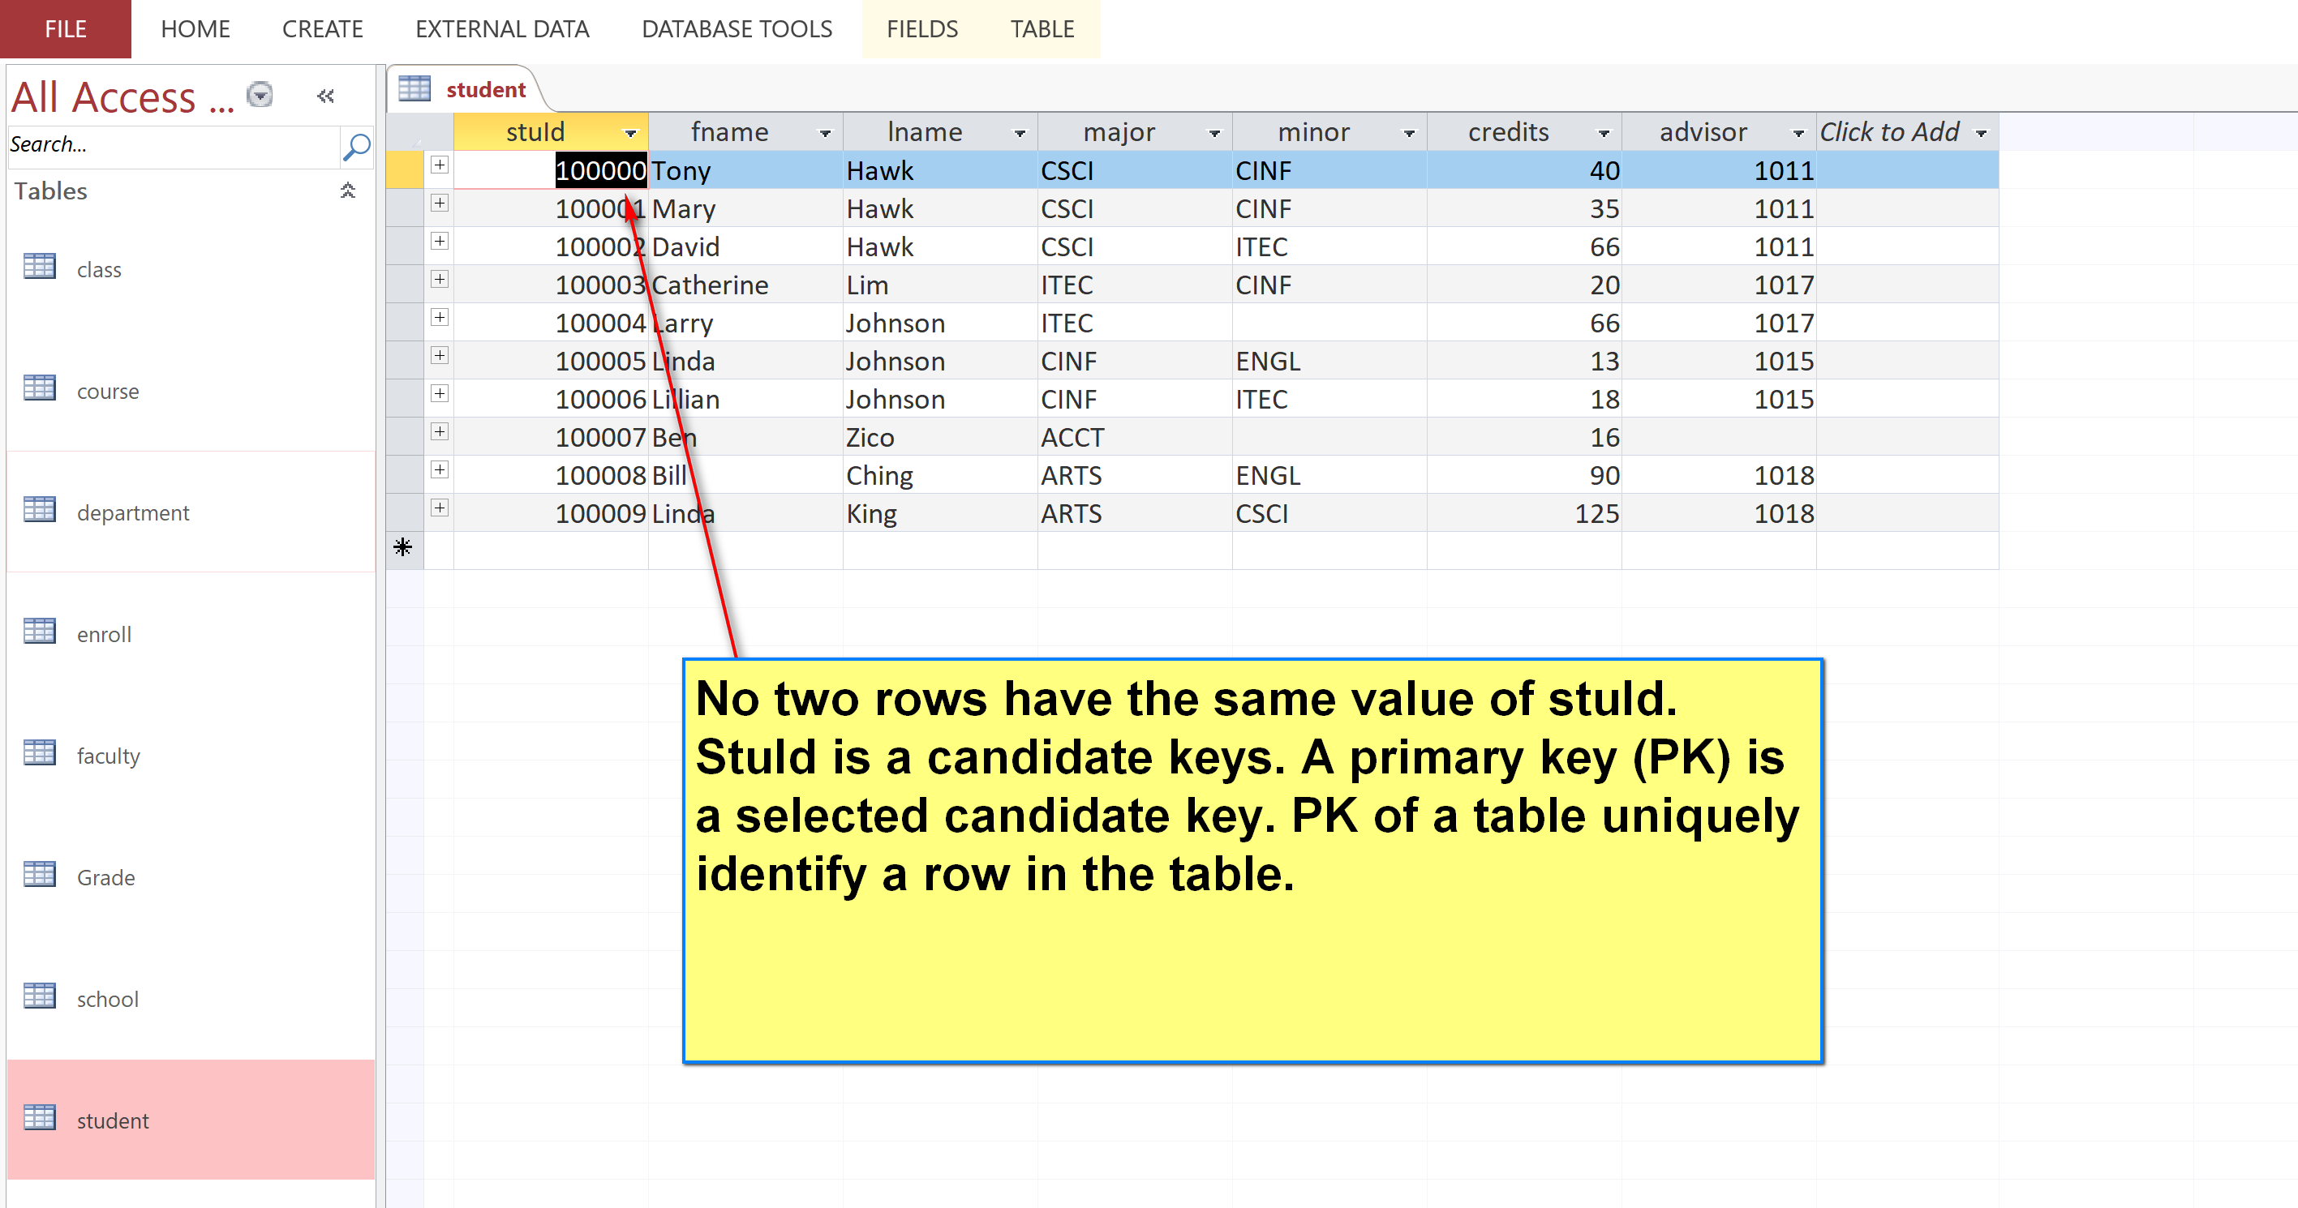

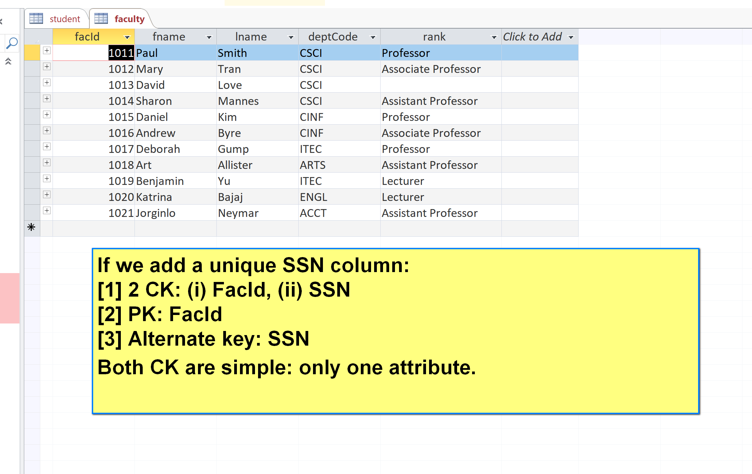
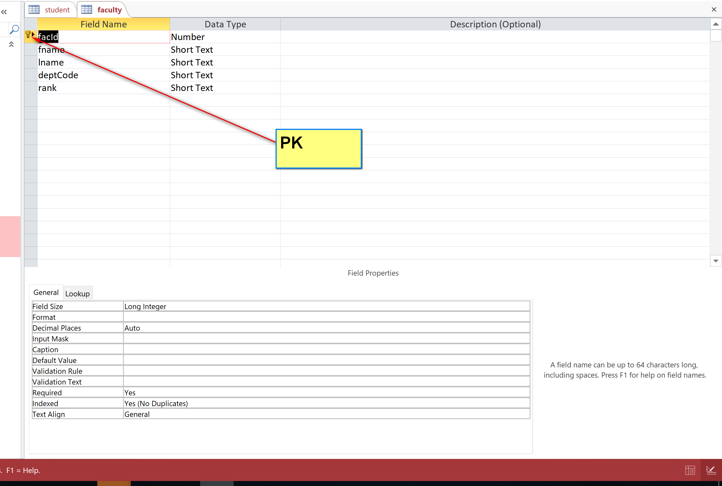
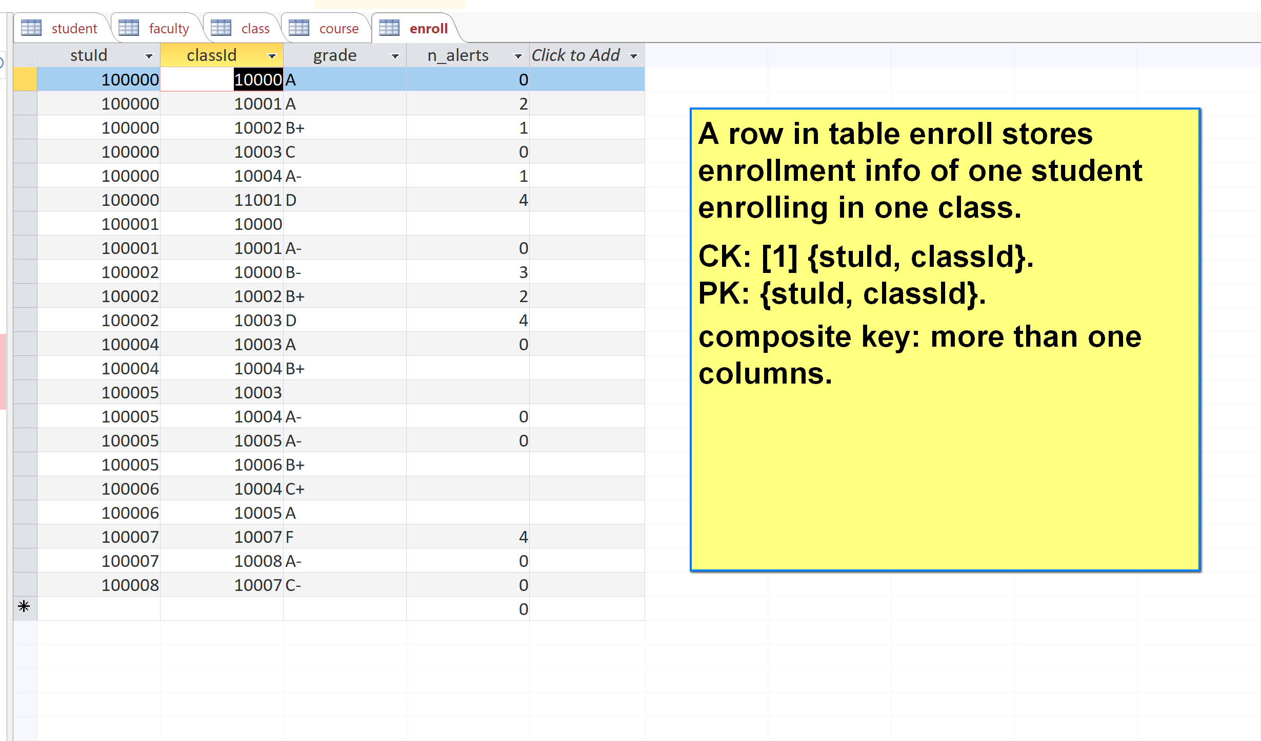

In student:
student
stuId | fname | lname | major | minor | credits | advisor
100000 | Tony | Hawk | CSCI | CINF | 40 | 1011

Tony Hawk has advisor 1011.
In faculty:
faculty
facId | fname | lname | deptCode | rank
1011 | Paul | Smith | CSCI | Professor

1011 (facId) is Paul Smith.
Name of student and advisor (data problem):
Tony Hawk: Paul Smith.
Faculty: facId is PK.
Student(Advisor: foreign key, FK) references faculty(facId) (parent table: PK)

FK links table together.

Relationship:
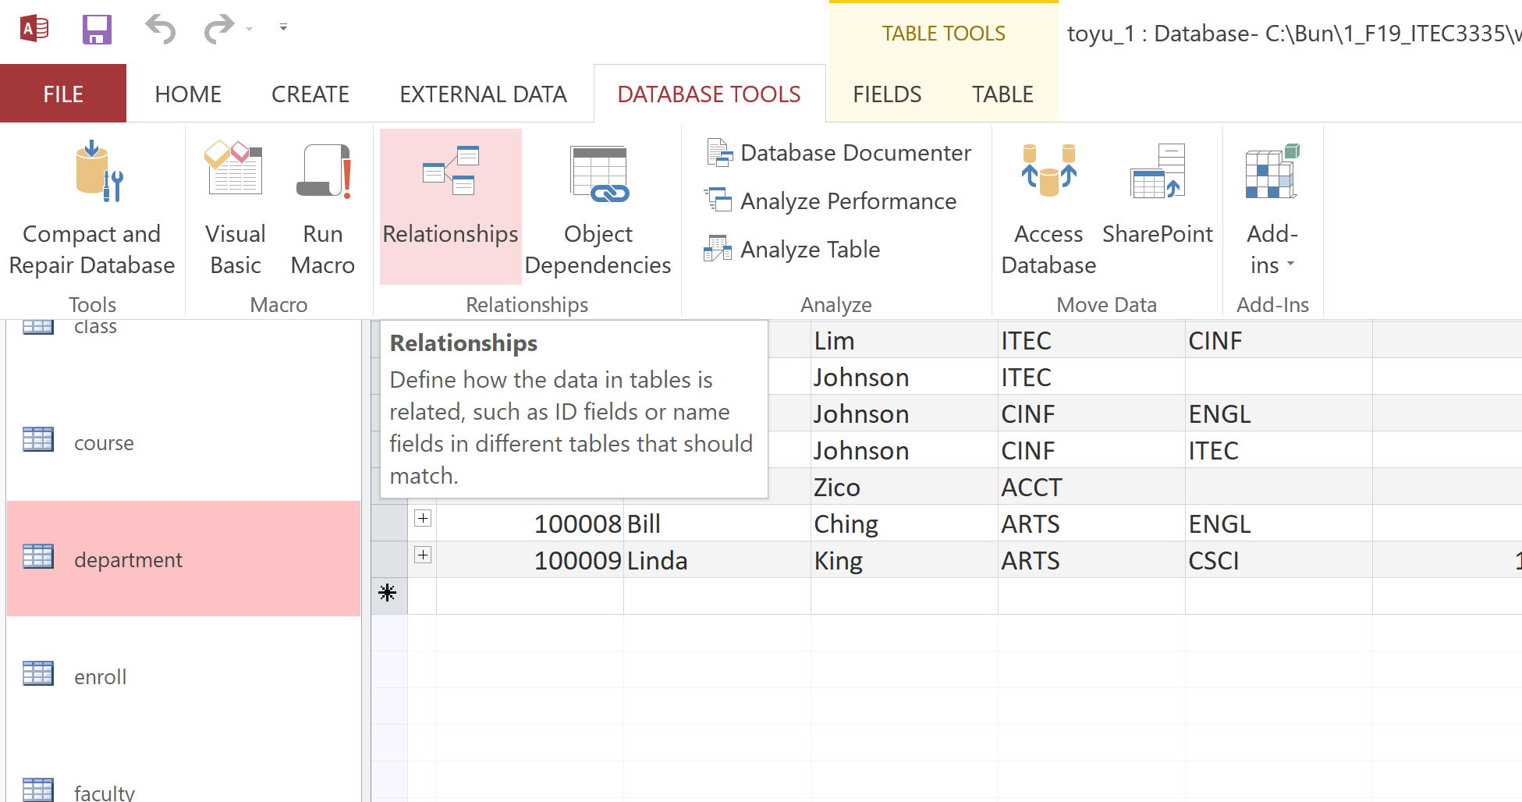
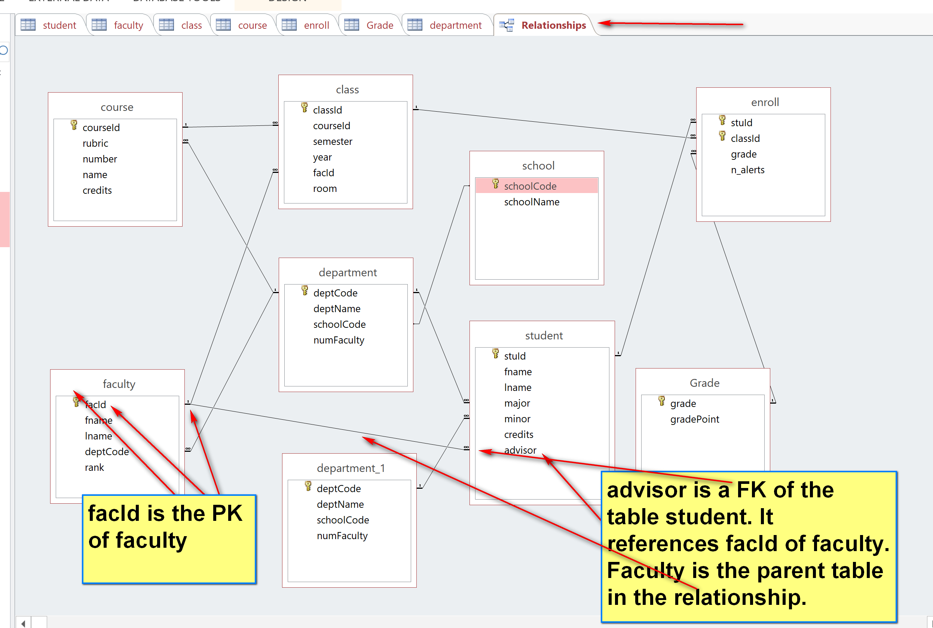

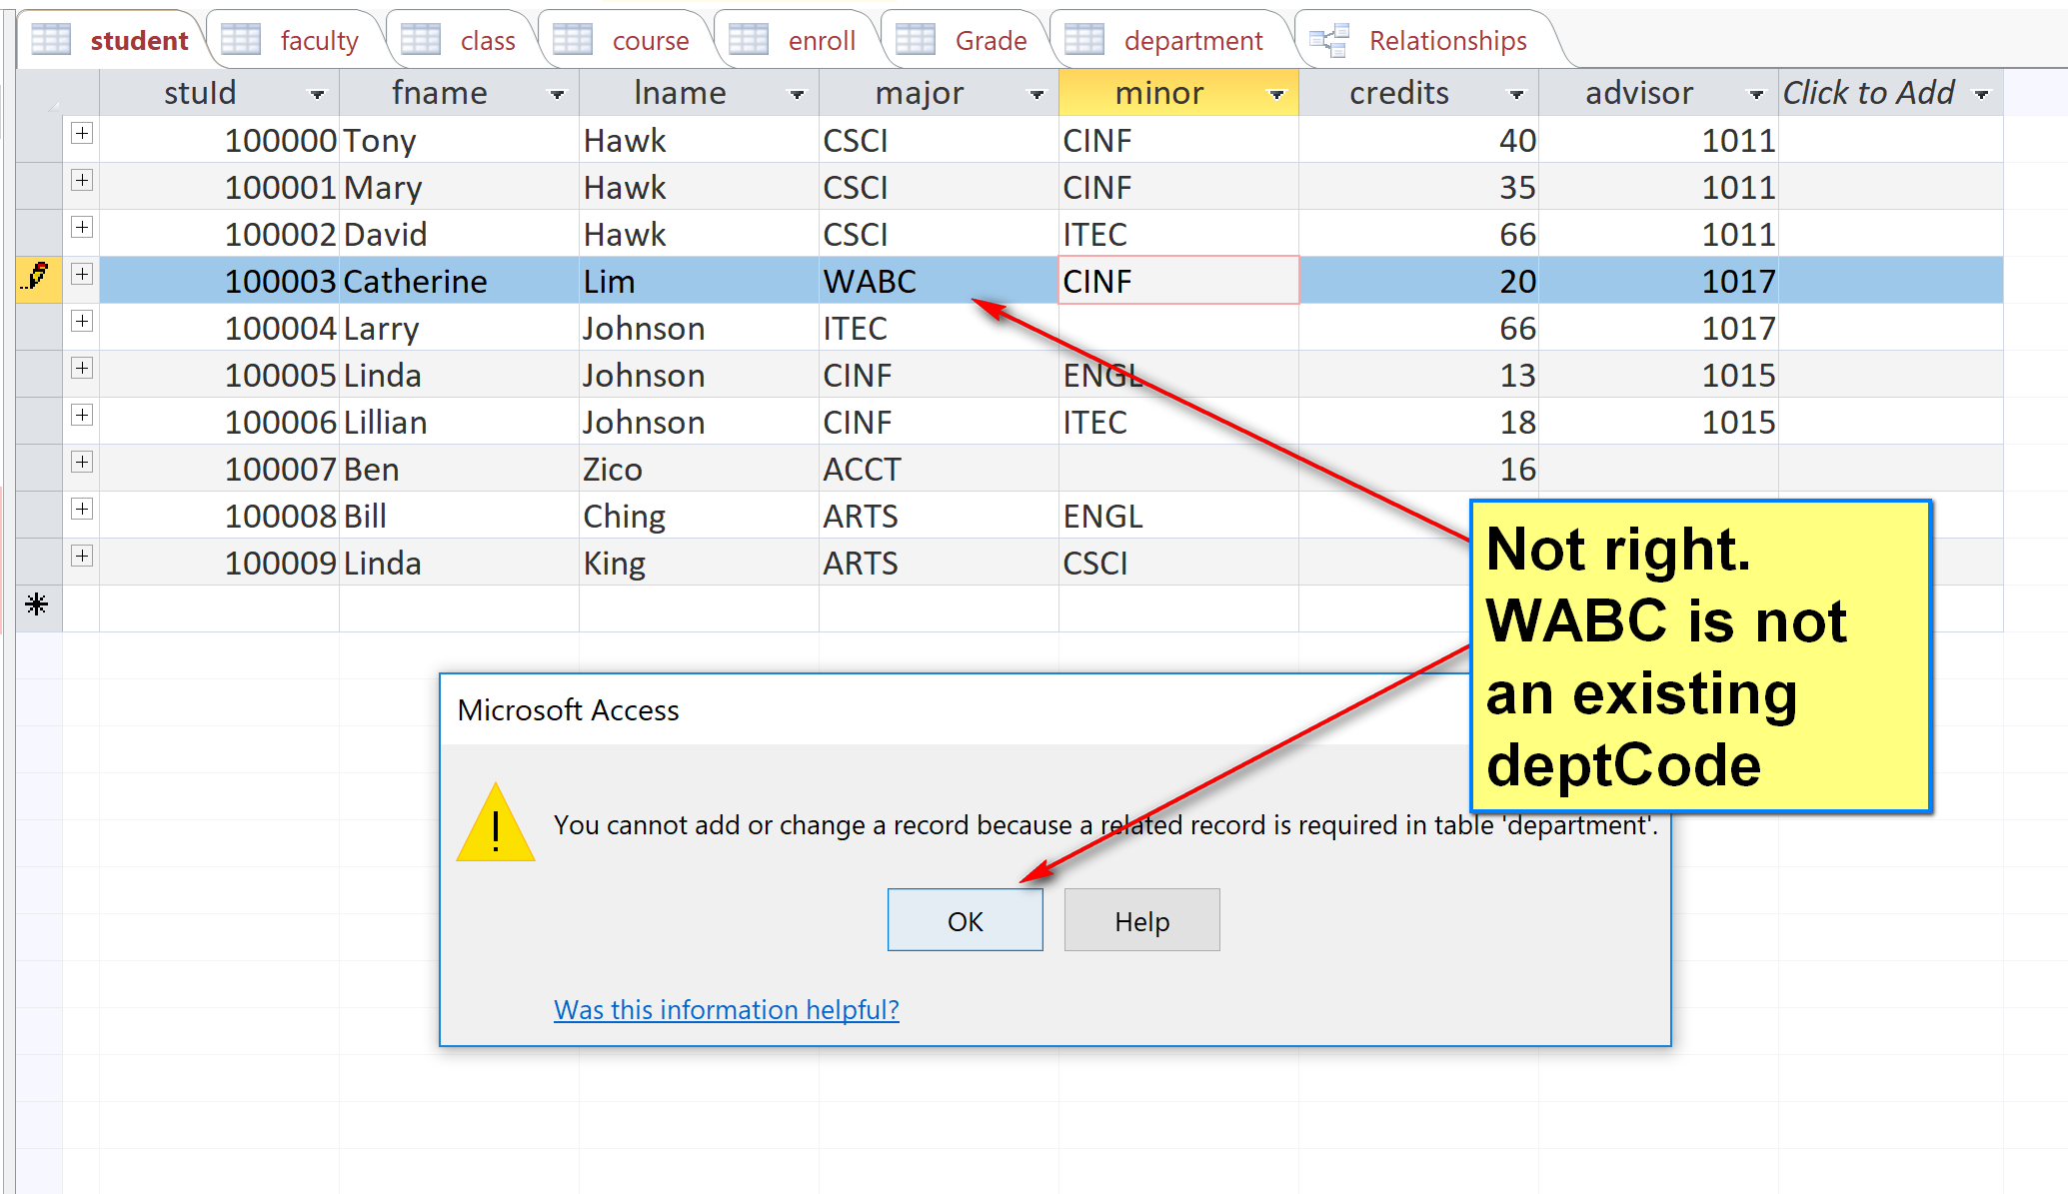
Referential integrity: DBMS mostly support it.

Data problem:
Query (SQL) -> Data to solve problem
Ex. Data Problem: Names of students and their advisor names of all CSCI major.
Step #1: Expected Results:
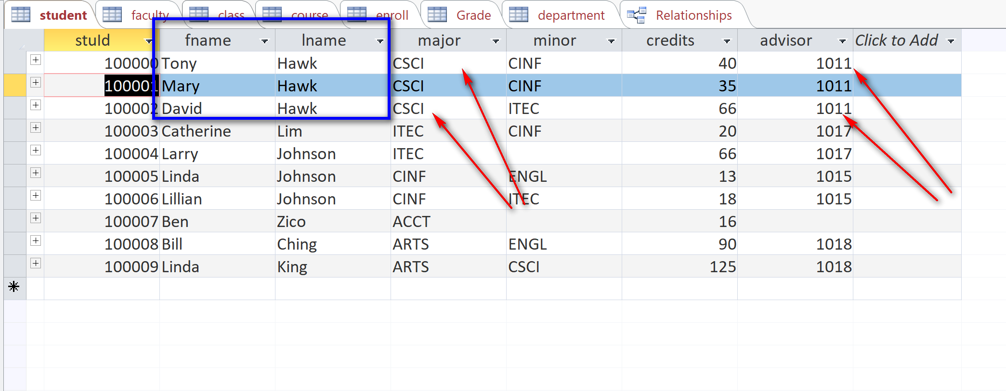
Facid = 1011
Three rows:
Step 2: Analysis:
[1] Output columns:
- Student: fname, lname.
- Faculty: fname, lname.
[2] Sources: Student, Faculty.
[3] Conditions:
- Problem condition: student.major = ‘CSCI’
- Join condition: student.advisor (FK in student) = faculty.facId (PK in the parent faculty table)
Step 3: implementation
[2] Sources: Student, Faculty.
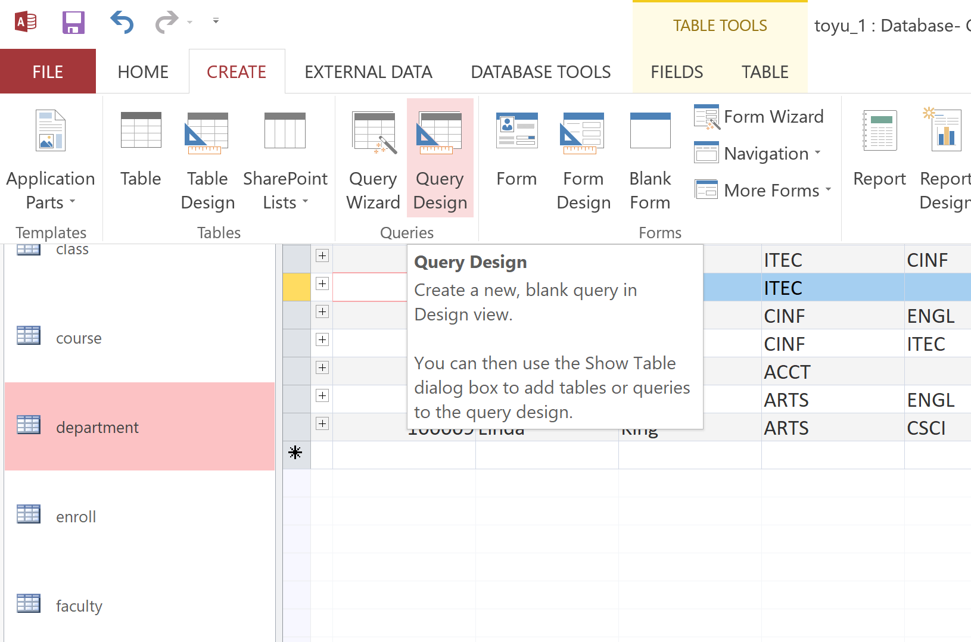
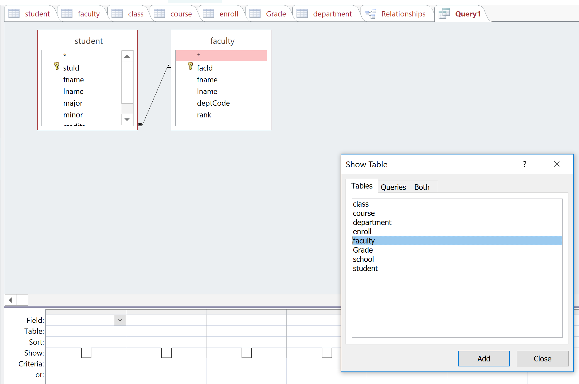
[1] Output columns:
- Student: fname, lname.
- Faculty: fname, lname.
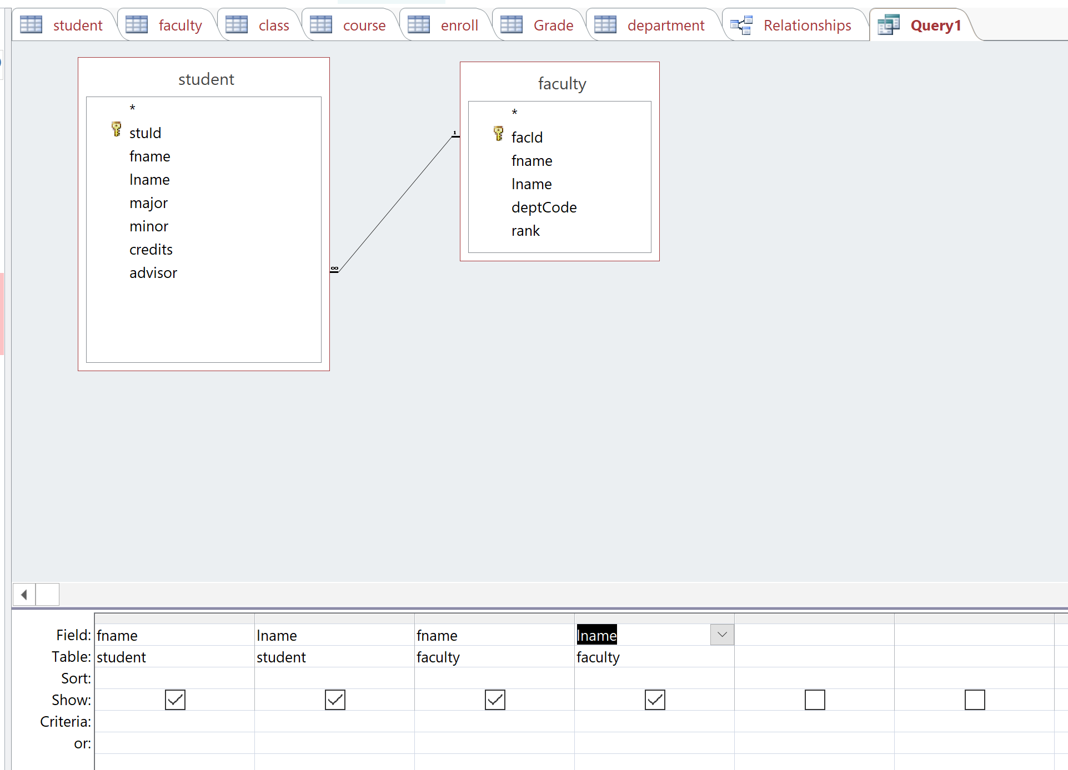
[3] Conditions:
- Problem condition: student.major = ‘CSCI’
- Join condition: student.advisor (FK in student) = faculty.facId (PK in the parent faculty table)
3.1:
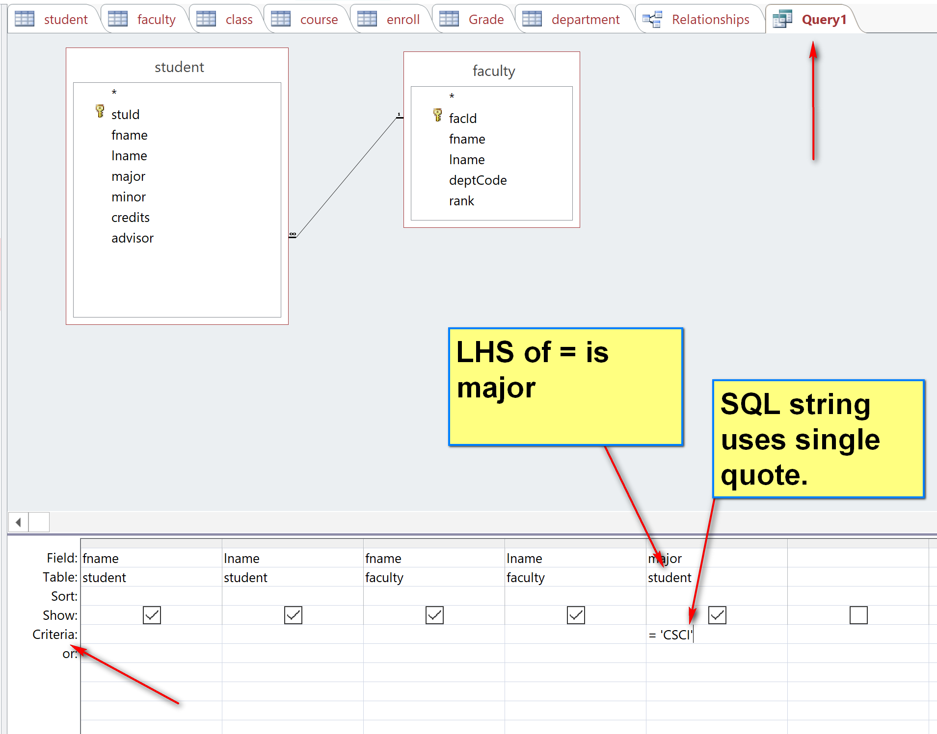
3.2 Join condition: student.advisor (FK in student) = faculty.facId (PK in the parent faculty table)
Automatically done by MS Access.
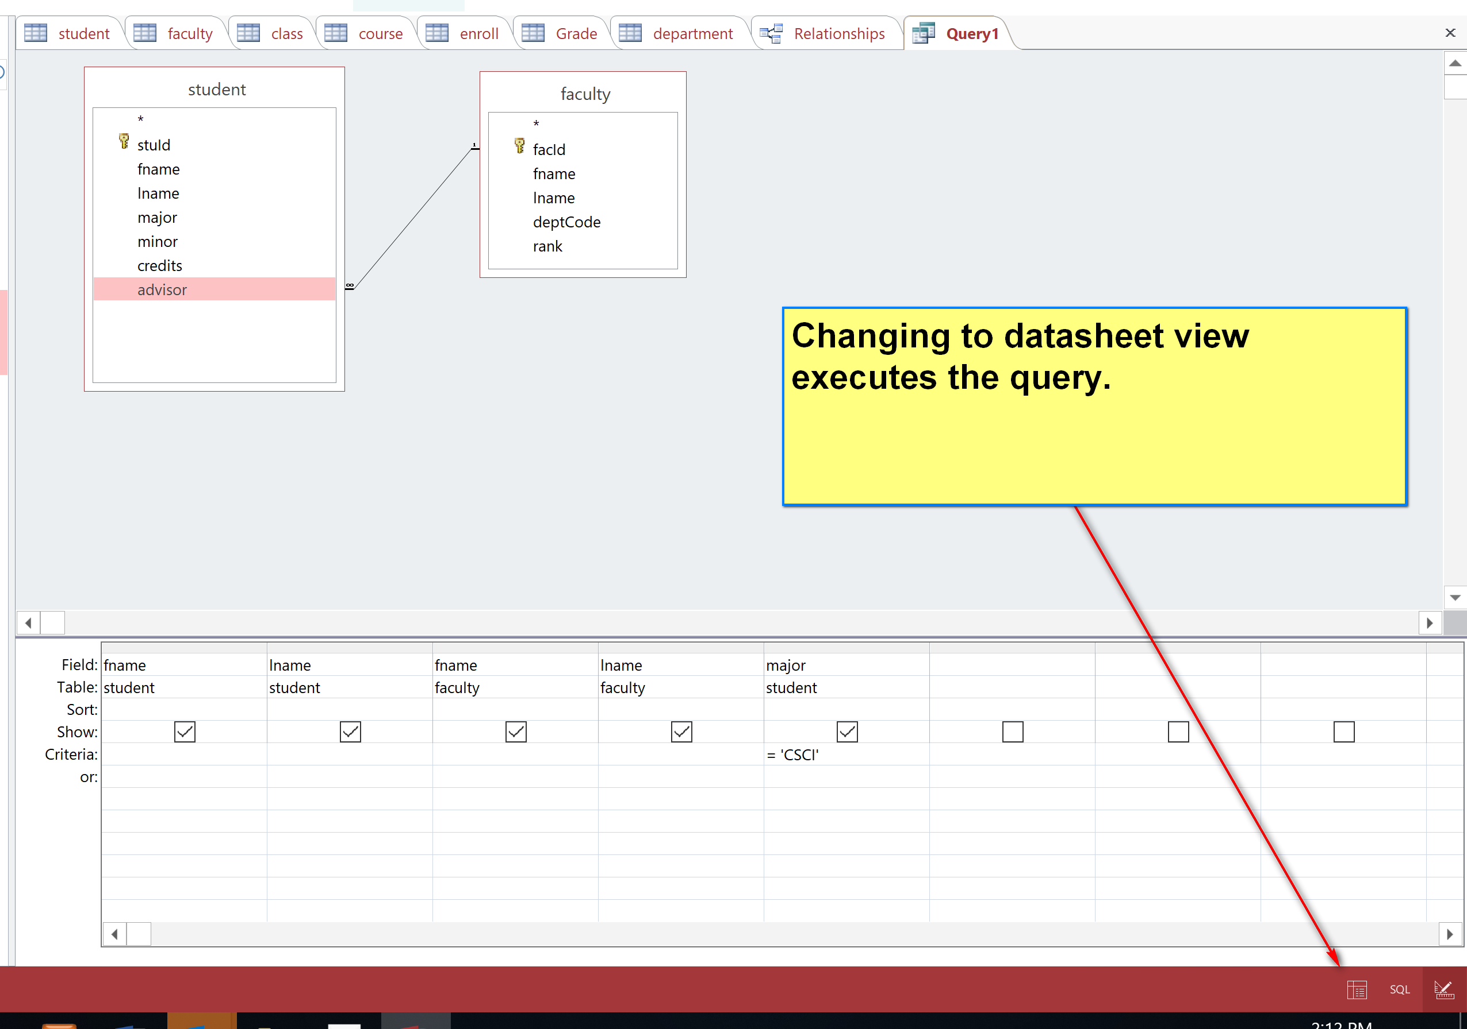

Actual result has an extra column: major.
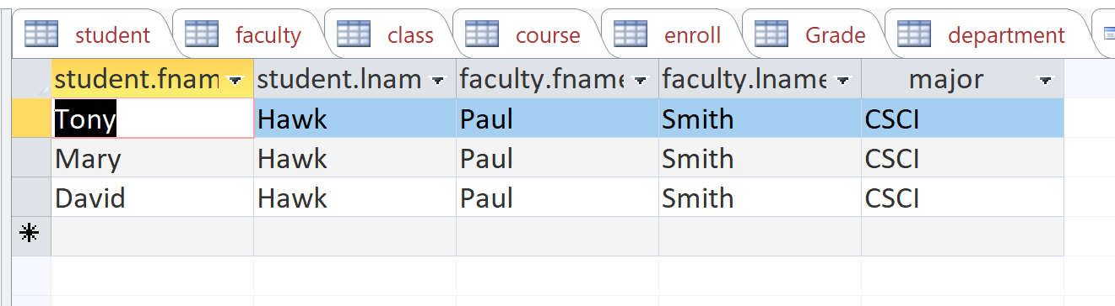
Uncheck show box for major:
