9/18/2019
Executing MySQL client in command line prompt: (more flexibility)
Mysql8.bat:
"C:\Program Files\MySQL\MySQL Server 8.0\bin\mysql.exe" -P 3308 %*
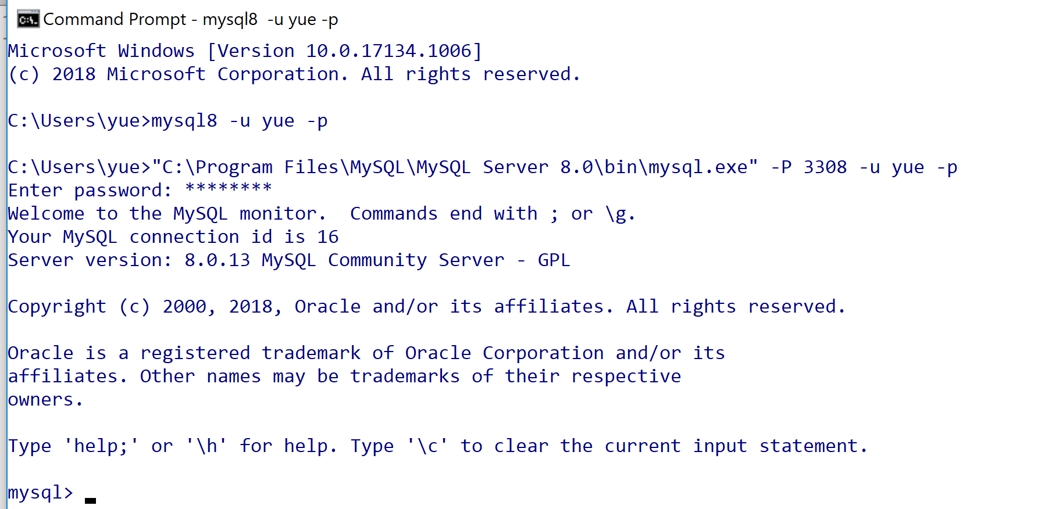
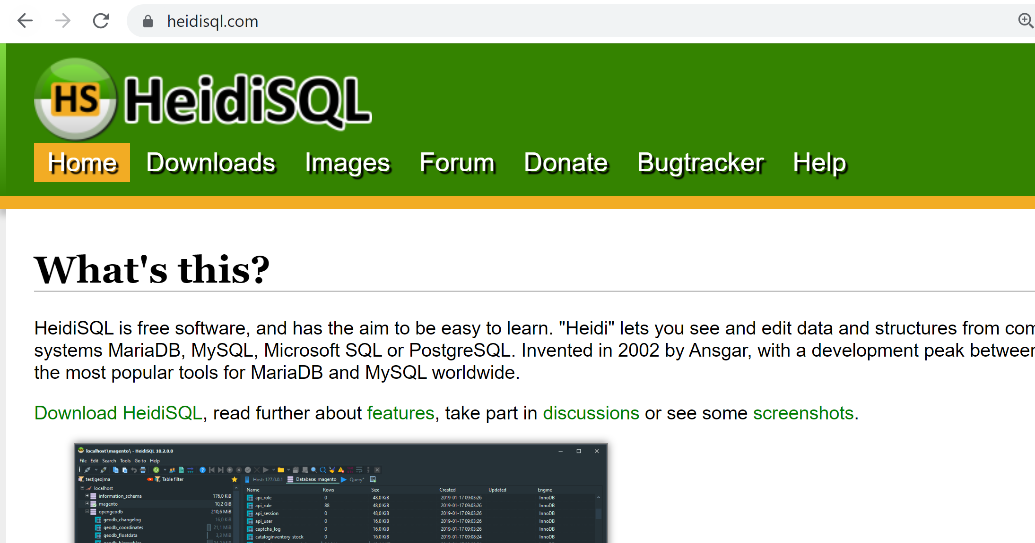\
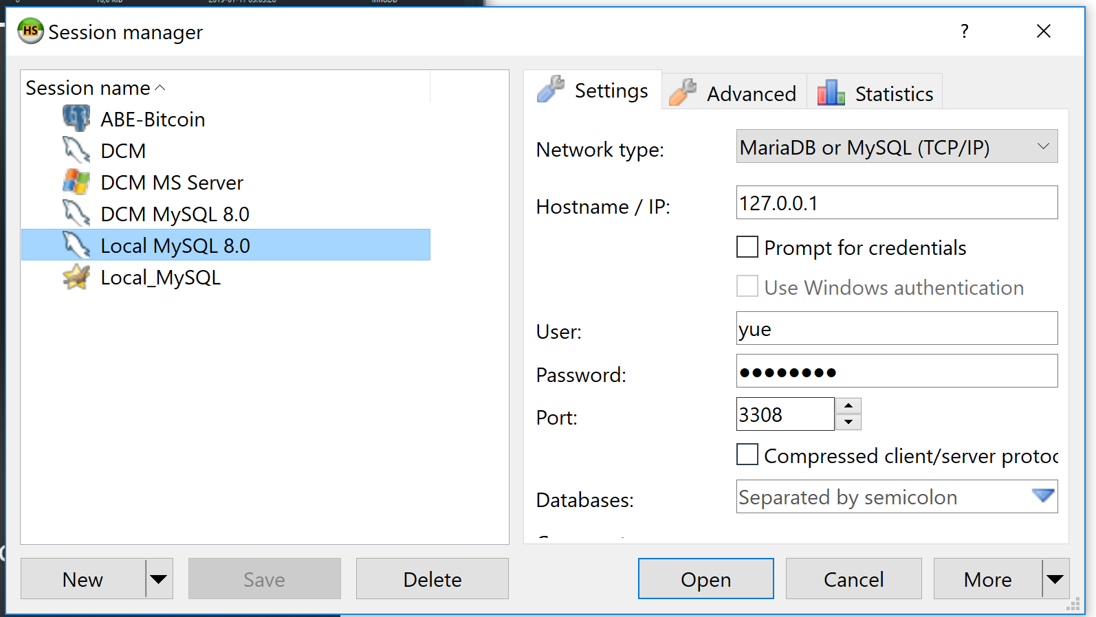
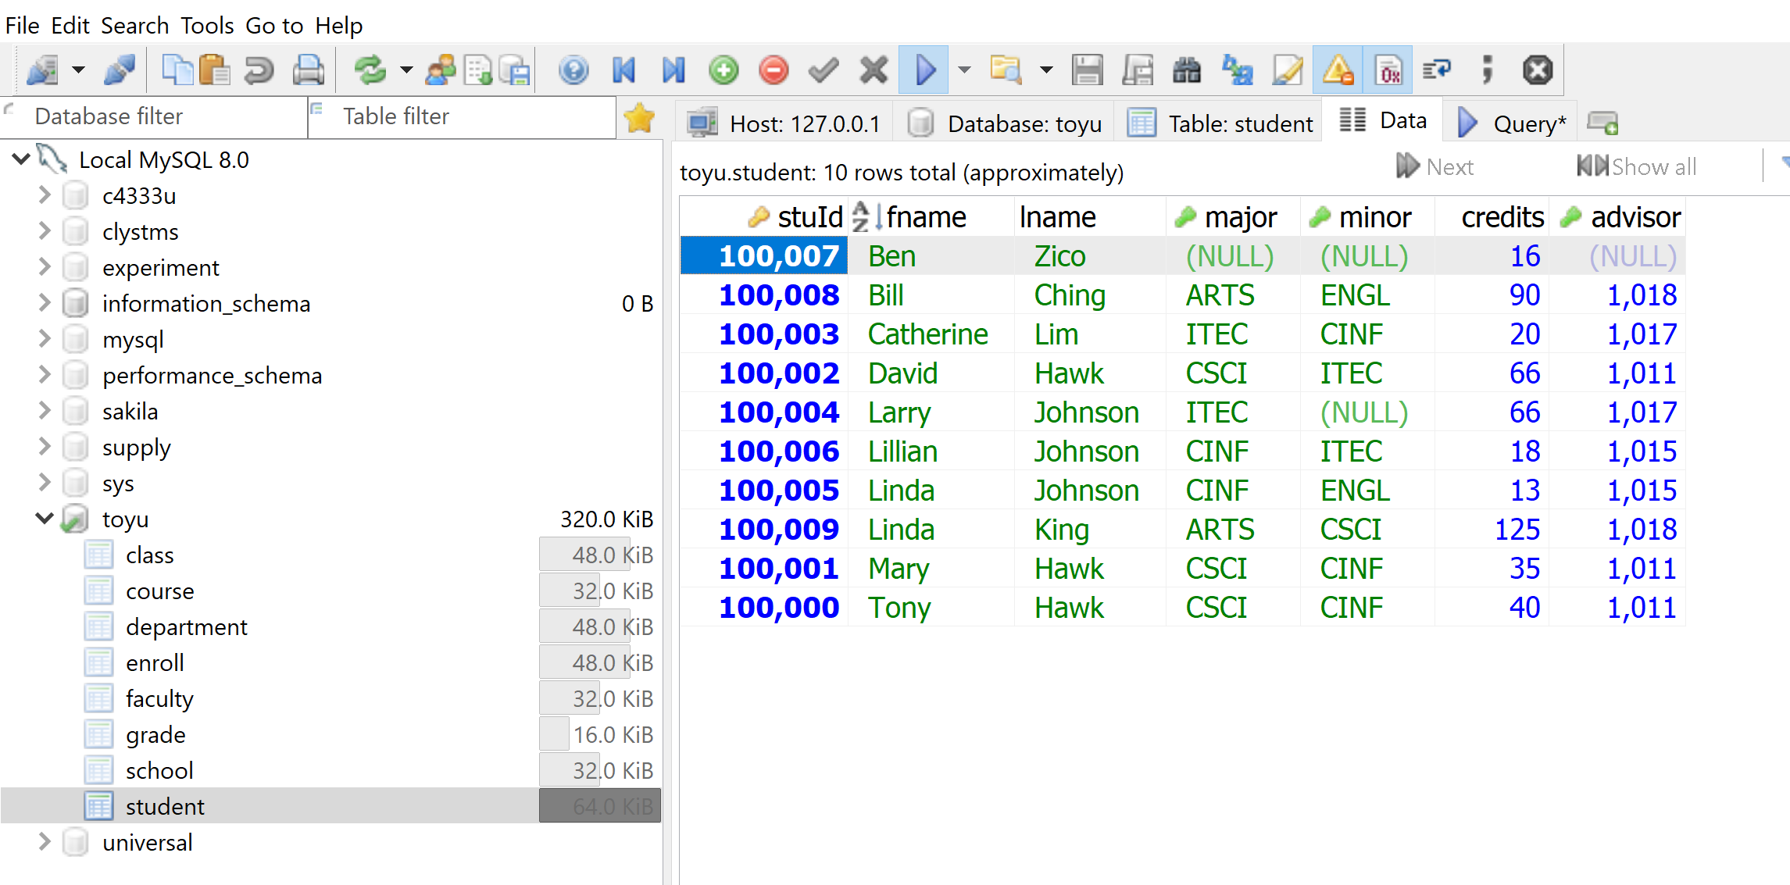
Q7 Fall 2018.
(7) Show the student ids, names, minor department names, and faculty advisor names of all students majoring in CSCI.
+--------+-------+-------+------------------------------+------------+------------+
| stuId | fname | lname | deptName | adv. fname | adv. lname |
+--------+-------+-------+------------------------------+------------+------------+
| 100000 | Tony | Hawk | Computer Information Systems | Paul | Smith |
| 100001 | Mary | Hawk | Computer Information Systems | Paul | Smith |
| 100002 | David | Hawk | Information Technology | Paul | Smith |
+--------+-------+-------+------------------------------+------------+------------+
3 rows in set (0.00 sec)

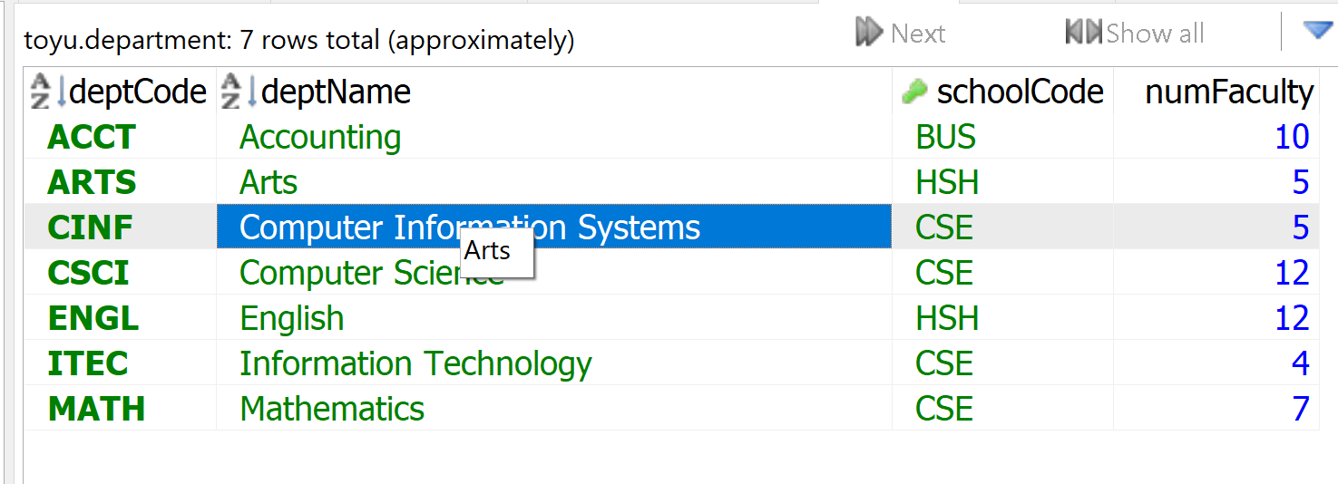
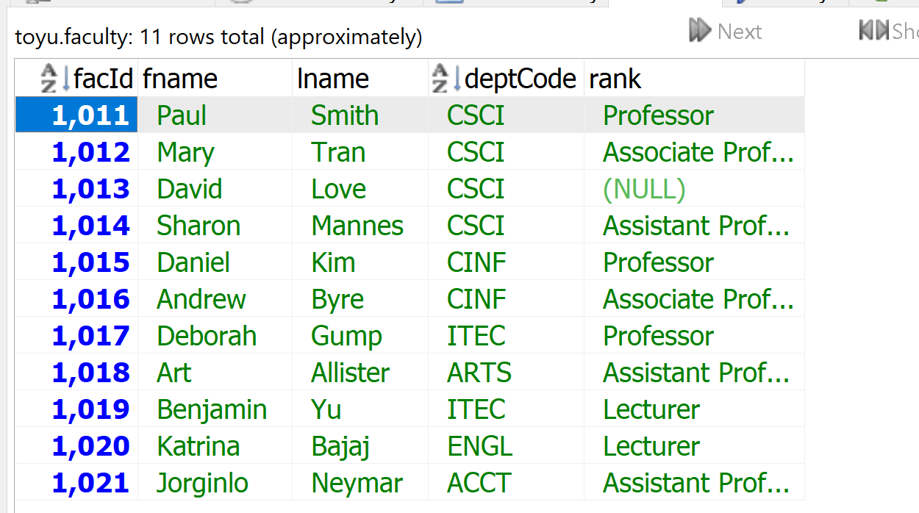
Data Analysis
[1] Output columns:
- stuId: student.stuId
- fname: student.fname
- lname: student.lname
- deptName: department.deptName
- adv. fname: faculty.fname
- adv. lname: faculty.lname

mysql> select * from student;
+--------+-----------+---------+-------+-------+---------+---------+
| stuId | fname | lname | major | minor | credits | advisor |
+--------+-----------+---------+-------+-------+---------+---------+
| 100000 | Tony | Hawk | CSCI | CINF | 40 | 1011 |
| 100001 | Mary | Hawk | CSCI | CINF | 35 | 1011 |
| 100002 | David | Hawk | CSCI | ITEC | 66 | 1011 |
| 100003 | Catherine | Lim | ITEC | CINF | 20 | 1017 |
| 100004 | Larry | Johnson | ITEC | NULL | 66 | 1017 |
| 100005 | Linda | Johnson | CINF | ENGL | 13 | 1015 |
| 100006 | Lillian | Johnson | CINF | ITEC | 18 | 1015 |
| 100007 | Ben | Zico | NULL | NULL | 16 | NULL |
| 100008 | Bill | Ching | ARTS | ENGL | 90 | 1018 |
| 100009 | Linda | King | ARTS | CSCI | 125 | 1018 |
+--------+-----------+---------+-------+-------+---------+---------+
10 rows in set (0.00 sec)

[2] Source table instances:
- student
- department
- faculty
[3] Conditions:
- Join conditions:
  - Student.minor = department.deptCode (e.g. Tony Hawk: CINF)
  - Stduent.advisor = faculty.facId
- Problem conditions:
  - majoring in CSCI: student.major = ‘CSCI’
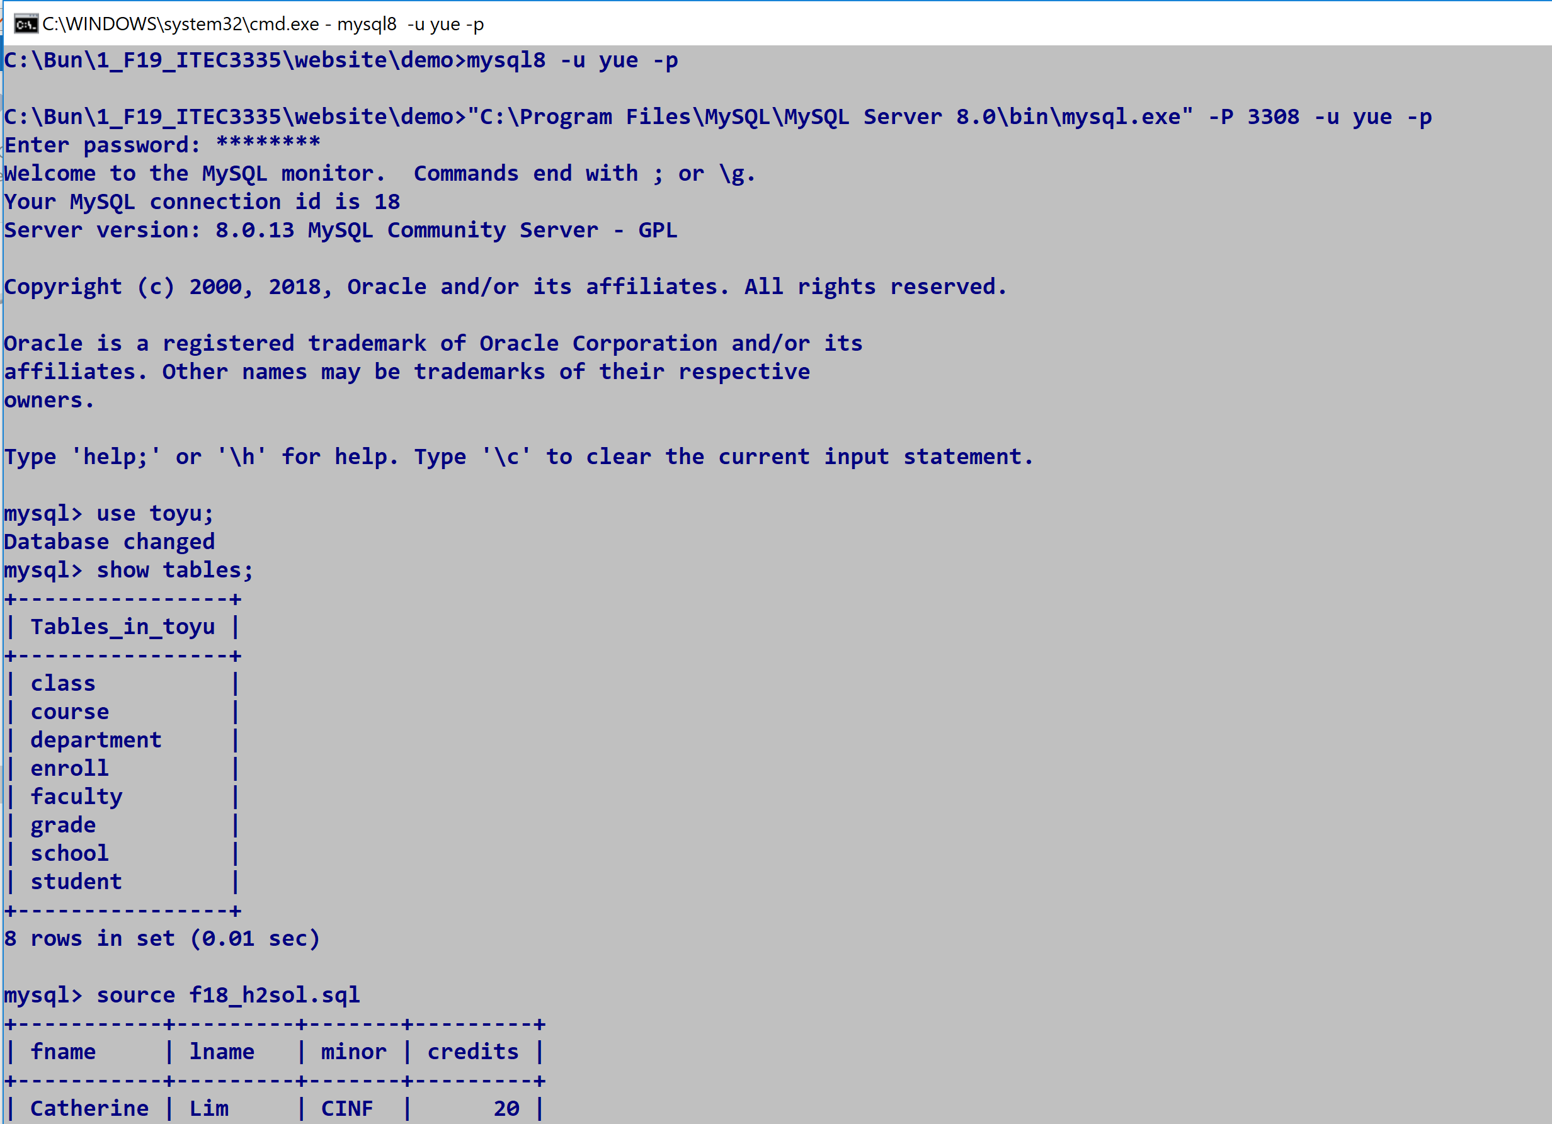
Table/Relation: student
Column names: stuId , fname | lname | major | minor | credits | advisor
Domain for stuId: int(11).
Atomic: stuId: 100000 cannot be broken into 100 and 000.
relation schema: R, is a set of attributes A₁, A₂,…,A_{n} with their domains D₁, D₂,…, D_{n}.
R: student:
- A_{1:}stuId: D₁ int(11)
- A₂ Fname: D₂ varchar(20)
- …| lname | major | minor | credits | advisor
A tuple (row) is a set of mapping of a set of attributes to a set of values: A_{i} -> d_{i} where d_{i} belongs to D_{i}.
+--------+-----------+---------+-------+-------+---------+---------+
| stuId | fname | lname | major | minor | credits | advisor |
+--------+-----------+---------+-------+-------+---------+---------+
| 100000 | Tony | Hawk | CSCI | CINF | 40 | 1011 |

One tuple: one row.
A_{i} (stuId ) -> d_{i} (100000) in D_{i} (int(11))

mysql> SELECT * FROM student;
+--------+-----------+---------+-------+-------+---------+---------+
| stuId | fname | lname | major | minor | credits | advisor |
+--------+-----------+---------+-------+-------+---------+---------+
| 100000 | Tony | Hawk | CSCI | CINF | 40 | 1011 |
| 100001 | Mary | Hawk | CSCI | CINF | 35 | 1011 |
| 100002 | David | Hawk | CSCI | ITEC | 66 | 1011 |
| 100003 | Catherine | Lim | ITEC | CINF | 20 | 1017 |
| 100004 | Larry | Johnson | ITEC | NULL | 66 | 1017 |
| 100005 | Linda | Johnson | CINF | ENGL | 13 | 1015 |
| 100006 | Lillian | Johnson | CINF | ITEC | 18 | 1015 |
| 100007 | Ben | Zico | NULL | NULL | 16 | NULL |
| 100008 | Bill | Ching | ARTS | ENGL | 90 | 1018 |
| 100009 | Linda | King | ARTS | CSCI | 125 | 1018 |
+--------+-----------+---------+-------+-------+---------+---------+
10 rows in set (0.00 sec)
This row:
| 100000 | Tony | Hawk | CSCI | CINF | 40 | 1011
For
{stuID -> 100000, fname -> ‘Tony’,lname -> ‘Hawk’, major -> ‘CSCI’, minor -> ‘CINF’, credits -> 40, advisor -> 1011}
{ major -> ‘CSCI’, minor -> ‘CINF’, stuID -> 100000, fname -> ‘Tony’,lname -> ‘Hawk’, credits -> 40, advisor -> 1011}
Same

mysql> SELECT * FROM student;
+--------+-----------+---------+-------+-------+---------+---------+
| stuId | fname | lname | major | minor | credits | advisor |
+--------+-----------+---------+-------+-------+---------+---------+
| 100000 | Tony | Hawk | CSCI | CINF | 40 | 1011 |
| 100004 | Larry | Johnson | ITEC | NULL | 66 | 1017 |
| 100005 | Linda | Johnson | CINF | ENGL | 13 | 1015 |
| 100006 | Lillian | Johnson | CINF | ITEC | 18 | 1015 |
| 100007 | Ben | Zico | NULL | NULL | 16 | NULL |
| 100001 | Mary | Hawk | CSCI | CINF | 35 | 1011 |
| 100002 | David | Hawk | CSCI | ITEC | 66 | 1011 |
| 100003 | Catherine | Lim | ITEC | CINF | 20 | 1017 |
| 100008 | Bill | Ching | ARTS | ENGL | 90 | 1018 |
| 100009 | Linda | King | ARTS | CSCI | 125 | 1018 |
+--------+-----------+---------+-------+-------+---------+---------+
same

