9/16/2019
MySQL creation script: Createtoyu.sql.txt.
Download and save as .sql file and open with a text editor.
CREATE TABLE IF NOT EXISTS grade (
grade VARCHAR(2),
gradePoint DECIMAL(5,4),
CONSTRAINT Grade_grade_pk PRIMARY KEY (grade)
);
Command line:
Show databases;
Use toyu;
Use toyu as the detault db during the session.

Full name: toyu.student
Partial name: student
Show tables;

CREATE TABLE IF NOT EXISTS grade (
grade VARCHAR(2),
gradePoint DECIMAL(5,4),
CONSTRAINT Grade_grade_pk PRIMARY KEY (grade)
);
Example of Data Definition Language (DDL): structure/schema definition.
-- population by insertion. Data manipulation language
INSERT INTO Grade VALUES
('A',4),('A-',3.6667),('B+',3.3333),('B',3),('B-',2.6667),
('C+',2.3333),('C',2),('C-',1.6667),
('D+',1.3333),('D',1),('D-',0.6667),('F',0),
('WX', NULL);
mysql> SELECT * from school;
+------------+-------------------------------+
| schoolCode | schoolName |
+------------+-------------------------------+
| BUS | Business |
| LAW | College of Law |
| EDU | Education |
| HSH | Human Sciences and Humanities |
| CSE | Science and Engineering |
+------------+-------------------------------+
5 rows in set (0.00 sec)

mysql> INSERT INTO school VALUES ('BUS', 'College of Busy People');
ERROR 1062 (23000): Duplicate entry 'BUS' for key 'PRIMARY'
mysql>

Data Problem:
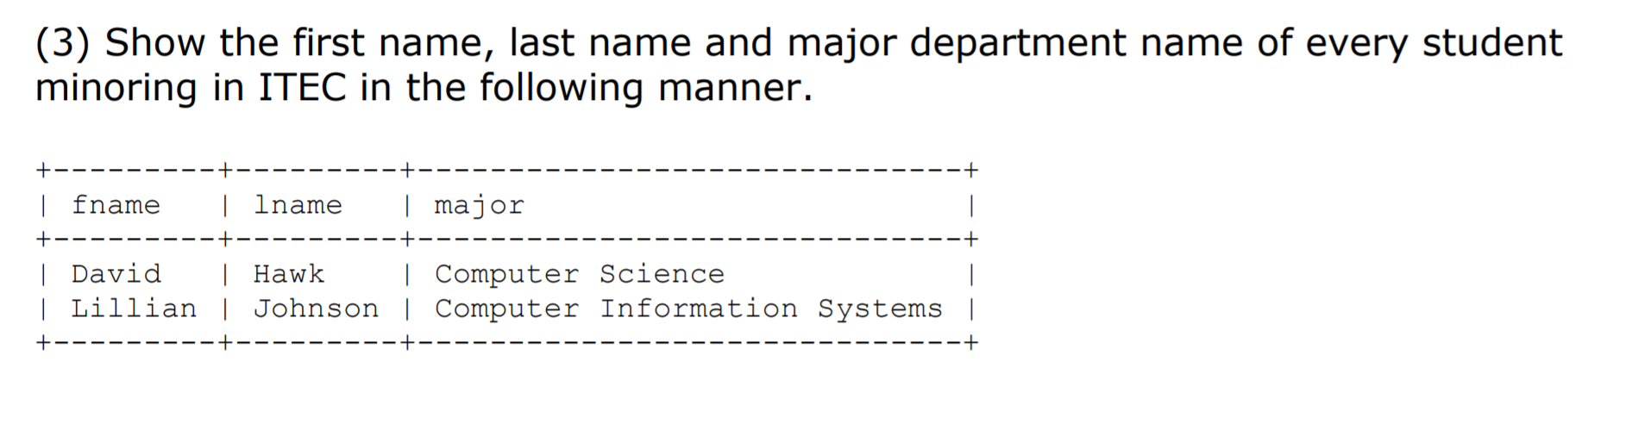
Analysis:
[1] Output:
- Fname: student.fname
- LName: student.lname
- Major: department.deptName
[2] Source instances:
- Student
- Department
[3] Conditions:
- Join conditions: student.major = department.deptCode
- Problem condition: minor in ITEC
  - Student.minor = ‘ITEC’
SELECT DISTINCT – 2. output column
FROM – 1. source
WHERE -- 3. conditions

