9/11/2019
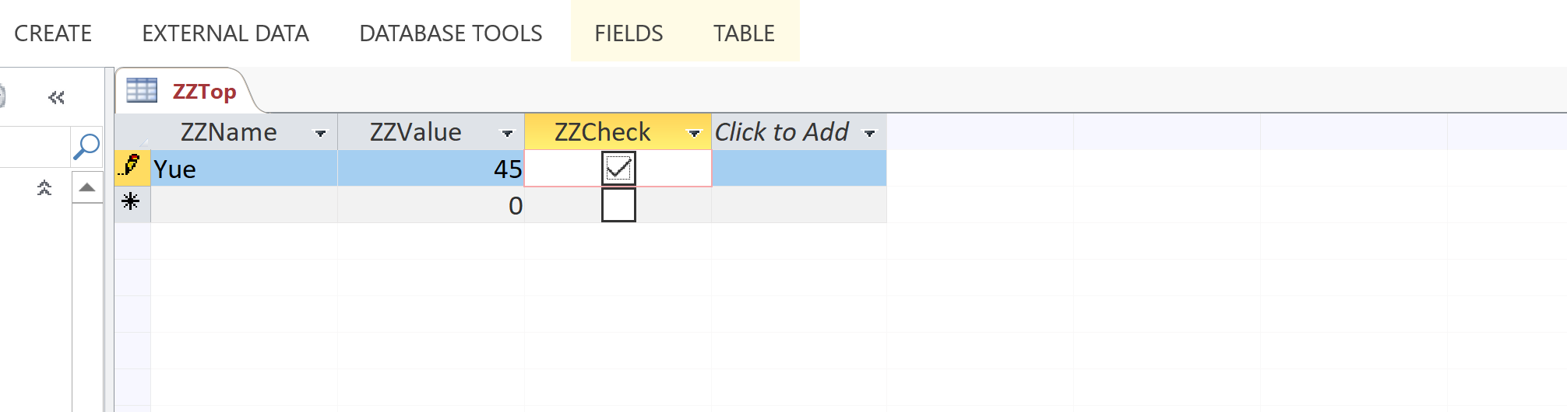
For:
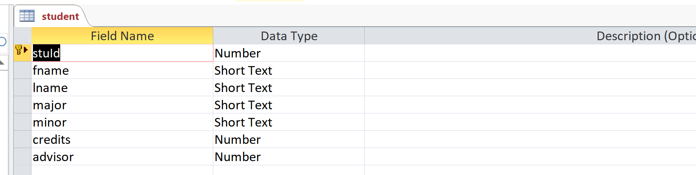
Structure of table student: relational schema
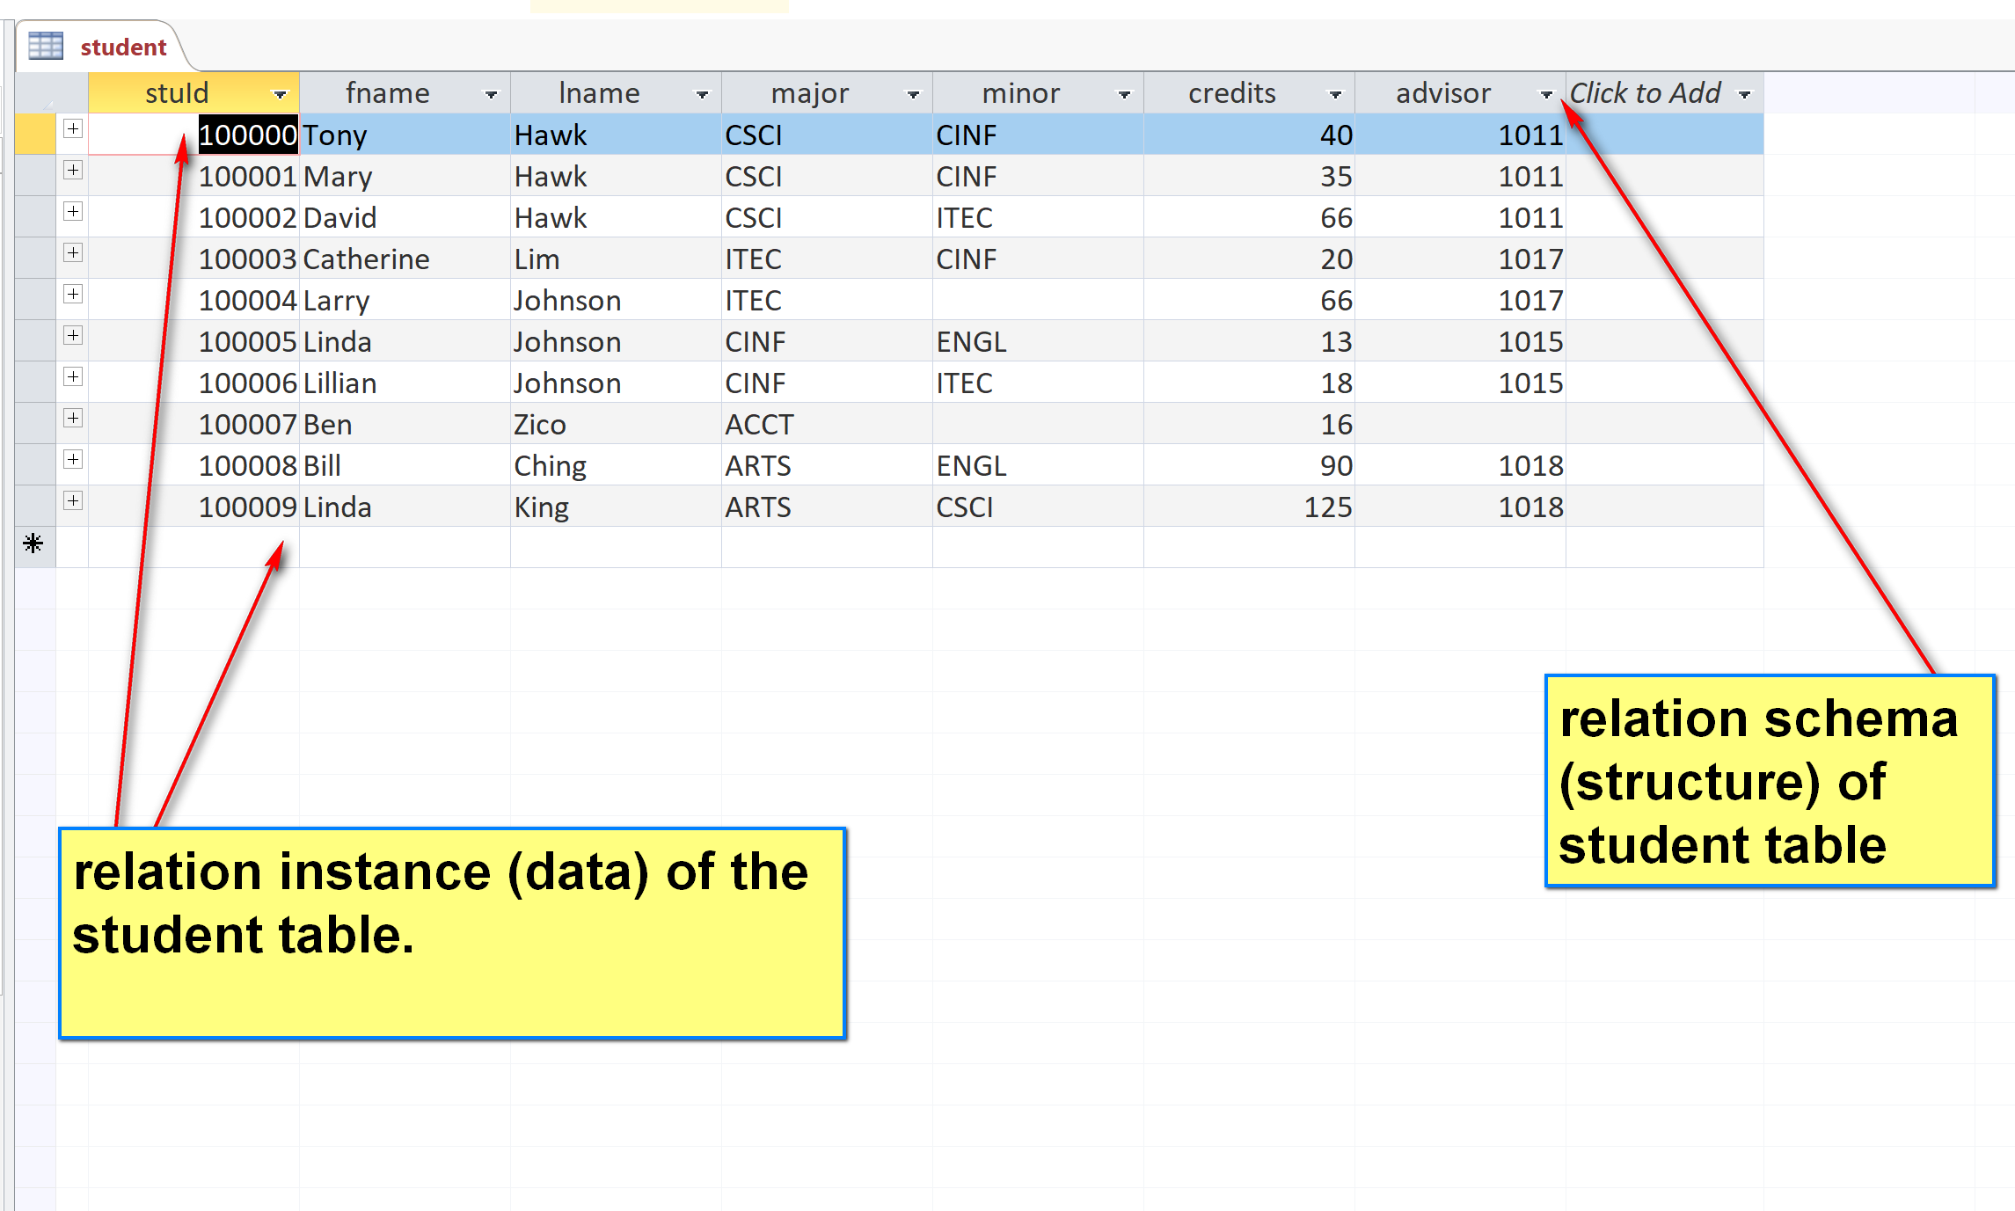
Install the latest version (8.0) from https://www.mysql.com/.
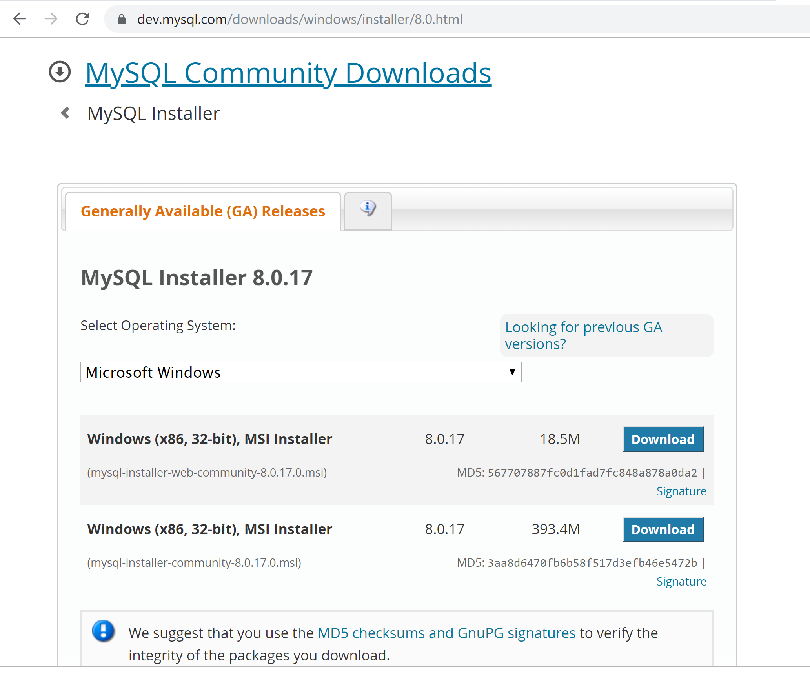
MySQL server runs usually as a OS service.
GUI client:
Command Line Client
Create toyu:

DROP SCHEMA IF EXISTS toyu;
CREATE SCHEMA toyu;
USE toyu;
DDL: Data Definition Language
CREATE TABLE IF NOT EXISTS grade (
grade VARCHAR(2),
gradePoint DECIMAL(5,4),
CONSTRAINT Grade_grade_pk PRIMARY KEY (grade)
);
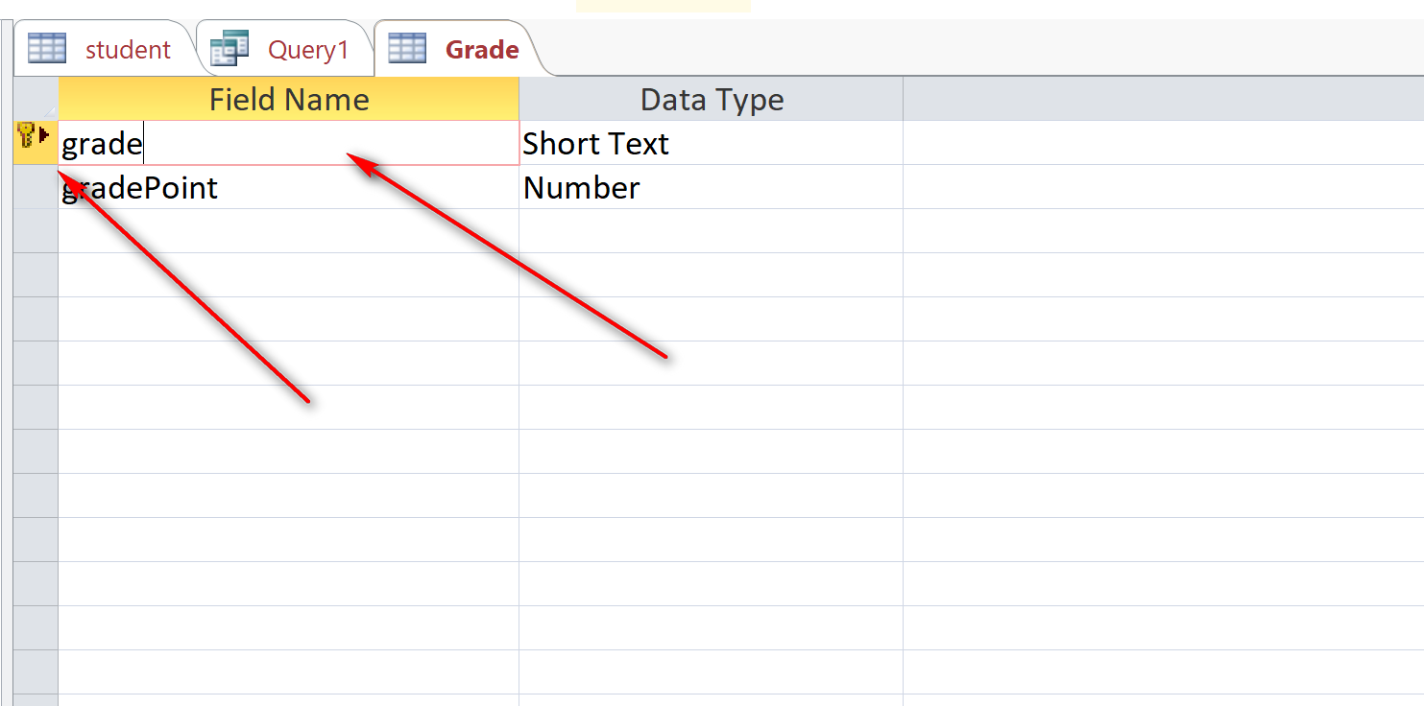
Data type: more precise in DB.
- VARCHAR(2): string up to 2 characters.
- CHAR(2): string that always has 2 characters.
Grade_grade_pk : name of constraints.

VARCHAR(1000): Up to 1000 characters in the actual storage.
CHAR(1000): always 1000 characters in the actual storage.
DECIMAL(5,4):
