12/4/2019

-- columns in table toyu.student

SELECT DISTINCT c.*
FROM information_schema.COLUMNS c
WHERE c.TABLE_SCHEMA = 'toyu'
AND c.TABLE_NAME = 'student';

the table student of the database toyu into a CSV file h9exp.csv.

Step #1. Right click on the table student and select “Table Data Export Wizard”:

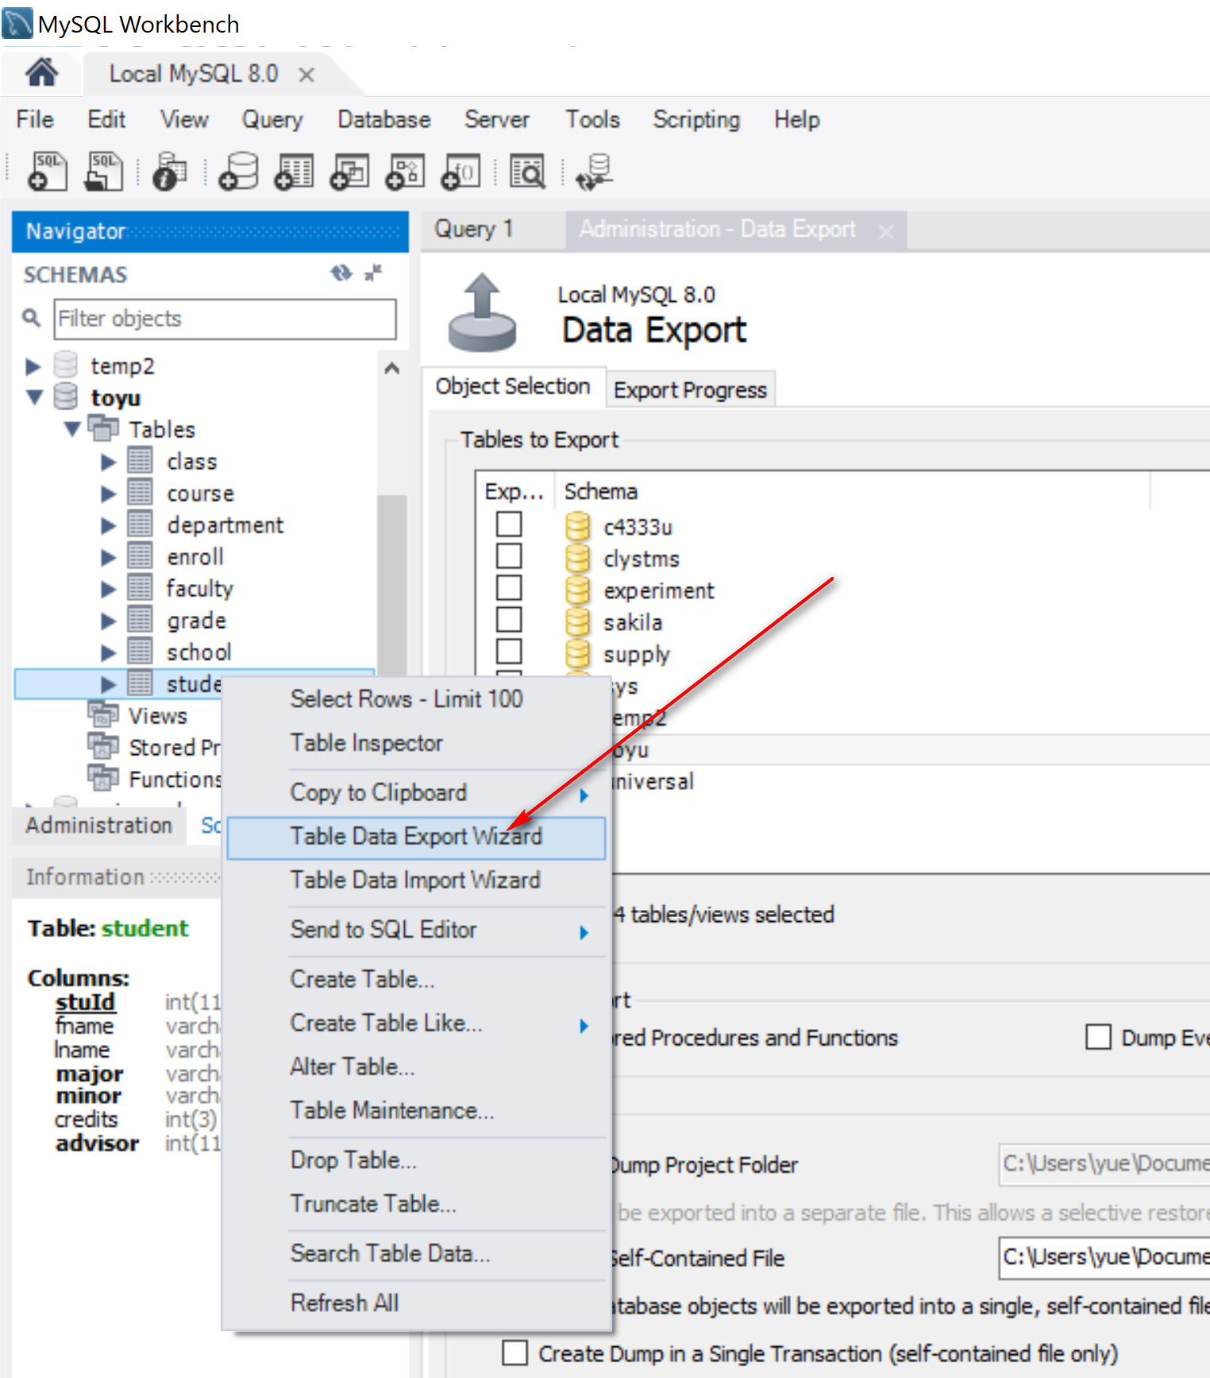

Step 2. Keep all columns and click ‘Next’
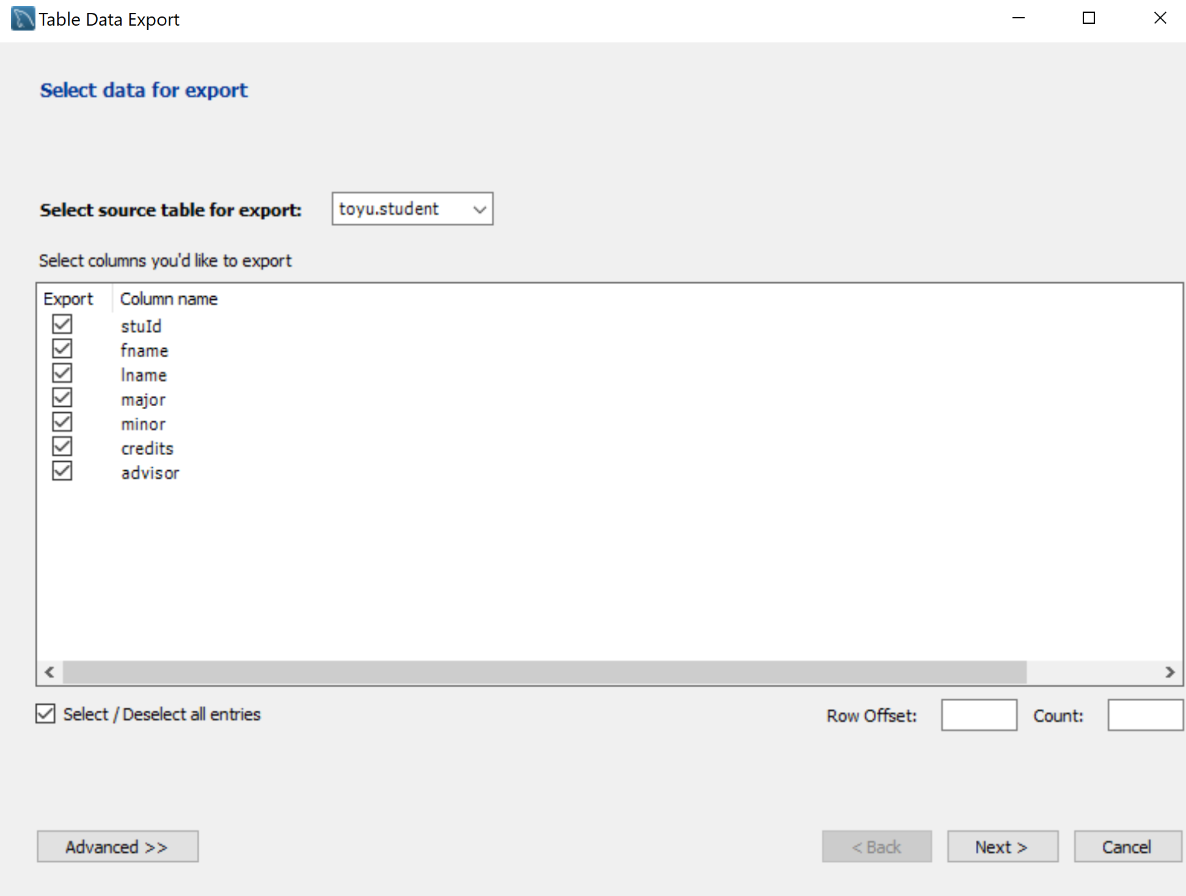
Step 3: Ensure CSV option is selected, the target file name is set probably and click ‘Next’:
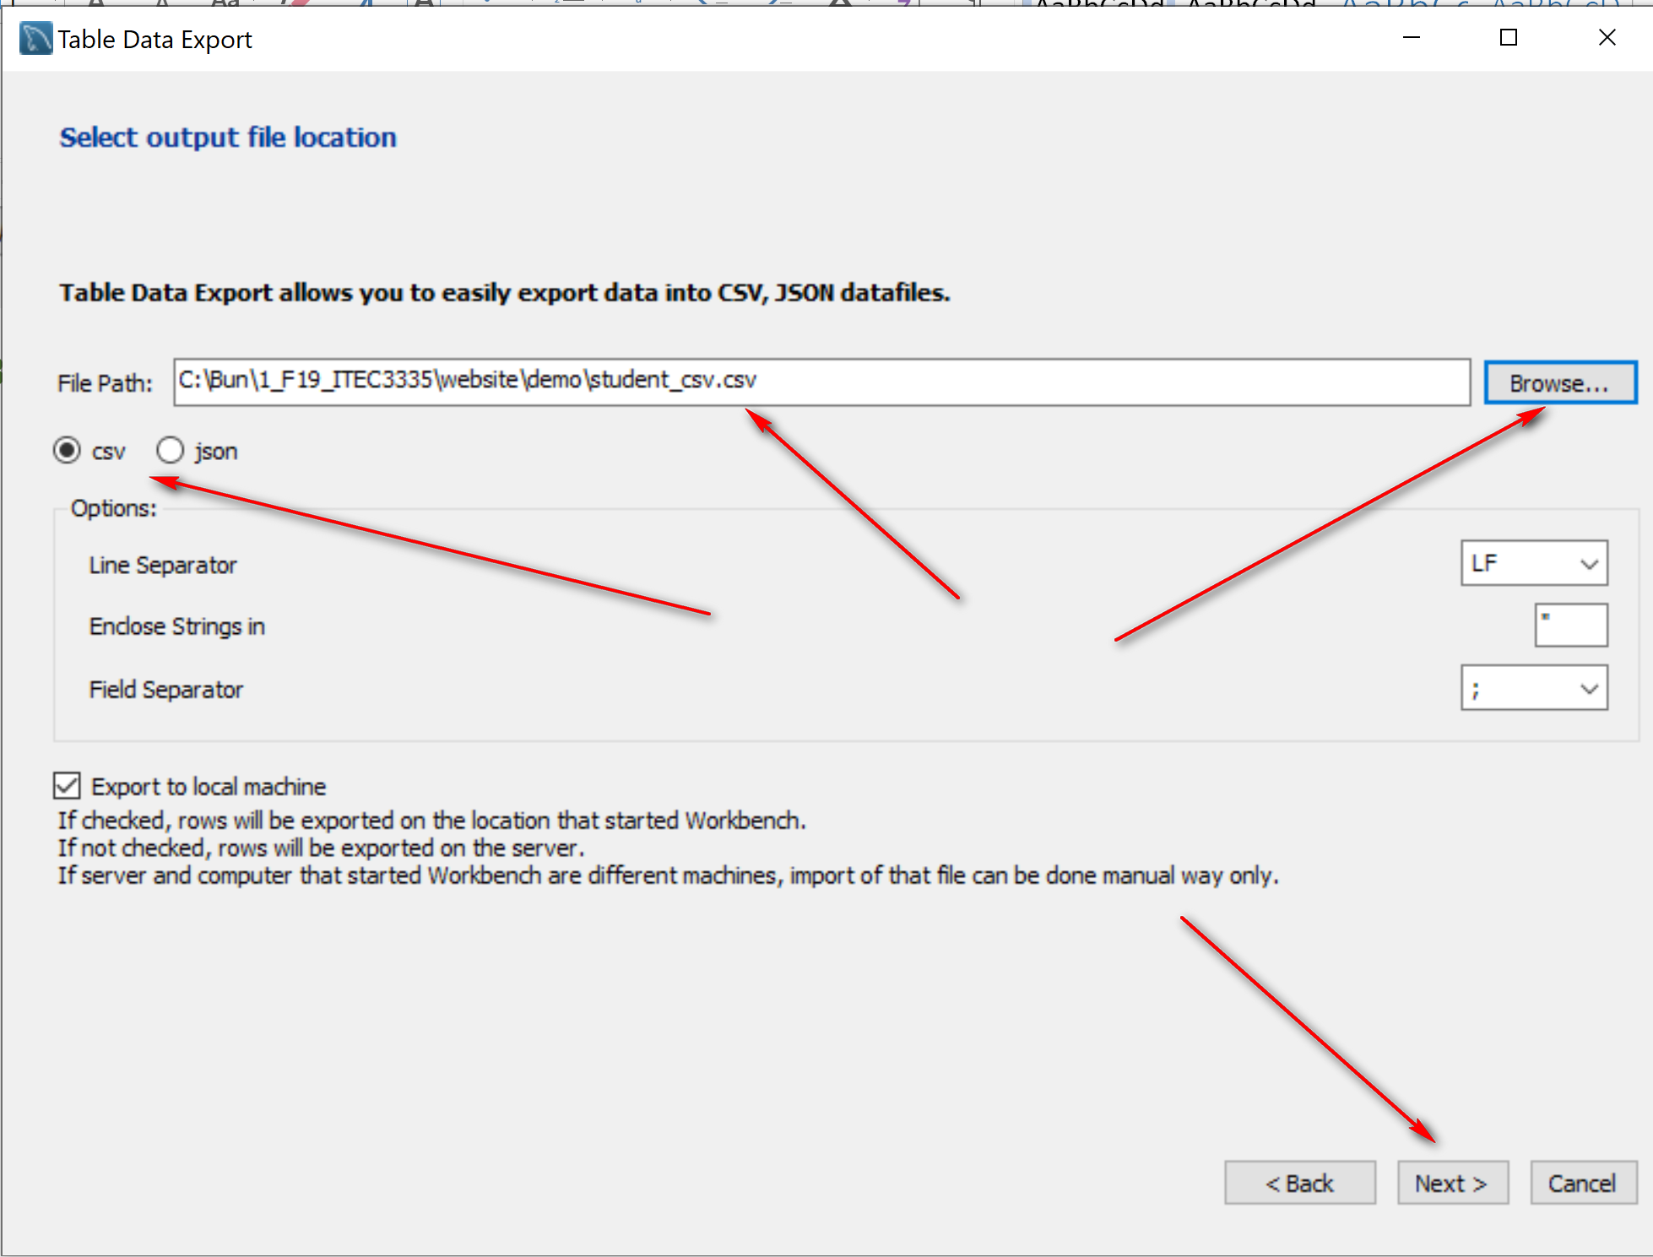
…

Transfer $200 from account 1234 to 2345
http://en.wikipedia.org/wiki/SQL#Transaction_controls
Task t1:
-- Assume: account 1234 = $1,000, account 2345: $500; total of two accounts: $1,500
UPDATE Account SET amount=amount-200 WHERE account_number=1234; -- (1) inconsistent state at this point. Total: $1,300
UPDATE Account SET amount=amount+200 WHERE account_number=2345; -- (2)
Sequence #1:
(1) Task t1 step (1): inconsistent $1,300
(2) Task t1 step (2): consistent $1,500

Sequence #2: read-write anomaly
(1) Task t1 step (1)
(2) Task t2 account reports: account 1234 = $800, account 2345: $500 (another task access the data in its inconsistent state.)
(3) Task t1 step (2)
Sequence #3: System crashes and recovery
(1) Task t1 step (1)
(2) System crashes; task t1 aborted after step (1)

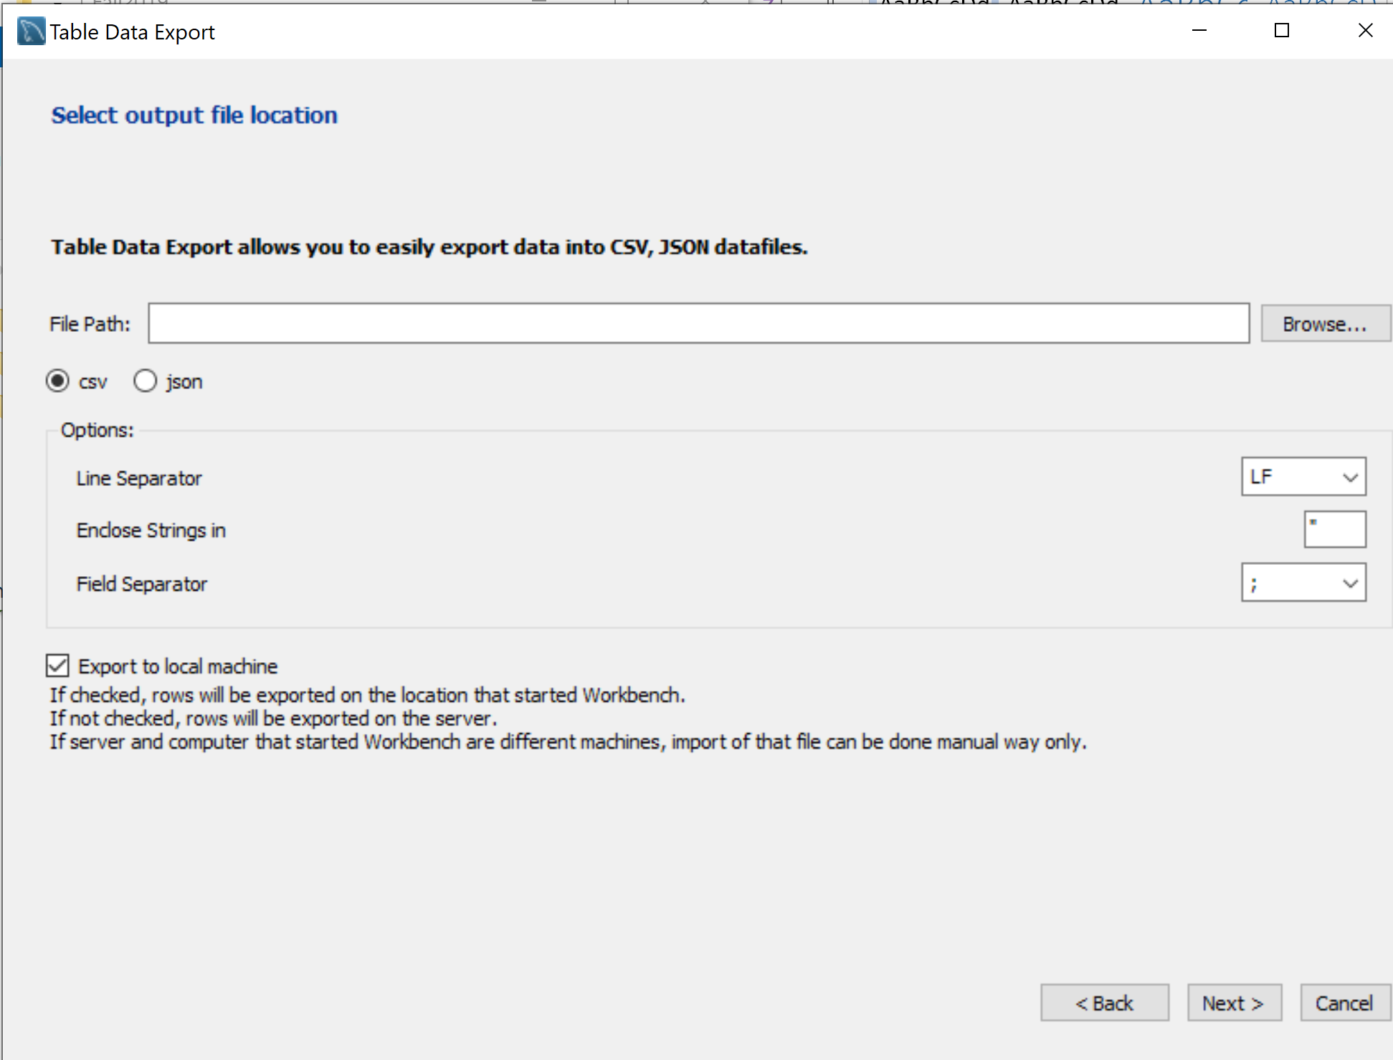

System Catalog Examples:

SELECT t.*
FROM Information_schema.TABLES t
WHERE t.TABLE_SCHEMA = 'toyu';

-- number of tables in toyu
SELECT COUNT(t.TABLE_NAME)
FROM Information_schema.TABLES t
WHERE t.TABLE_SCHEMA = 'toyu';

-- all schema and their number of tables.
SELECT t.TABLE_SCHEMA, COUNT(t.TABLE_NAME)
FROM Information_schema.TABLES t
GROUP BY t.TABLE_SCHEMA;

