12/2/2019
H8 F2019:
Embedded SQL in Python
Write a simple Python program, h8q1.py, to connect to the database toyu in dcm.uhcl.edu server to print out product information about a product line with number provided as the only command line argument. You must use PyMySQL driver for this assignment. For example:
…>python h8q1.py ITEC
Classes enrolled by students majoring in dept ITEC:
----------------------------------------------------
Catherine Lim: 0.
Larry Johnson: 2.
…>python h8q1.py CSCI
Classes enrolled by students majoring in dept CSCI:
----------------------------------------------------
David Hawk: 3.
Mary Hawk: 2.
Tony Hawk: 5.

…>python h8q1.py CINF
Classes enrolled by students majoring in dept CINF:
----------------------------------------------------
Lillian Johnson: 2.
Linda Johnson: 4.
Analysis:
Input: ITEC
Output:
Classes enrolled by students majoring in dept ITEC:
----------------------------------------------------
Catherine Lim: 0.
Larry Johnson: 2.
Dynamic content: from input or MySQL.
Not highlight: static content.
ITEC: from input
Catherine Lim: 0.
Larry Johnson: 2.
From MySQL
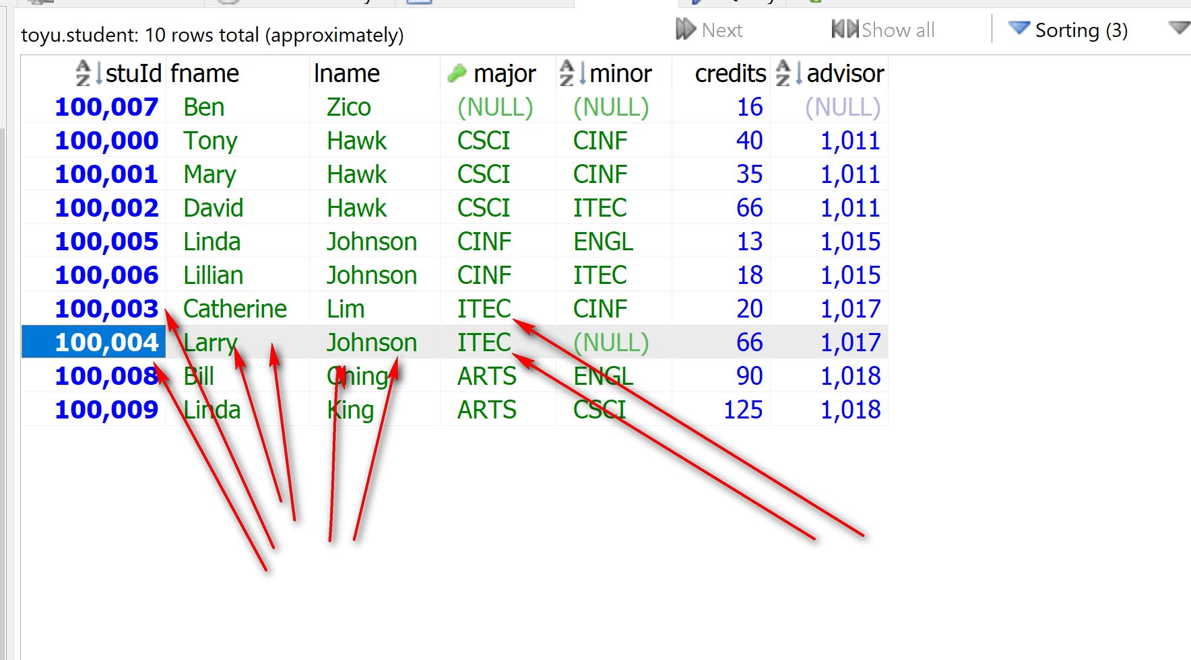
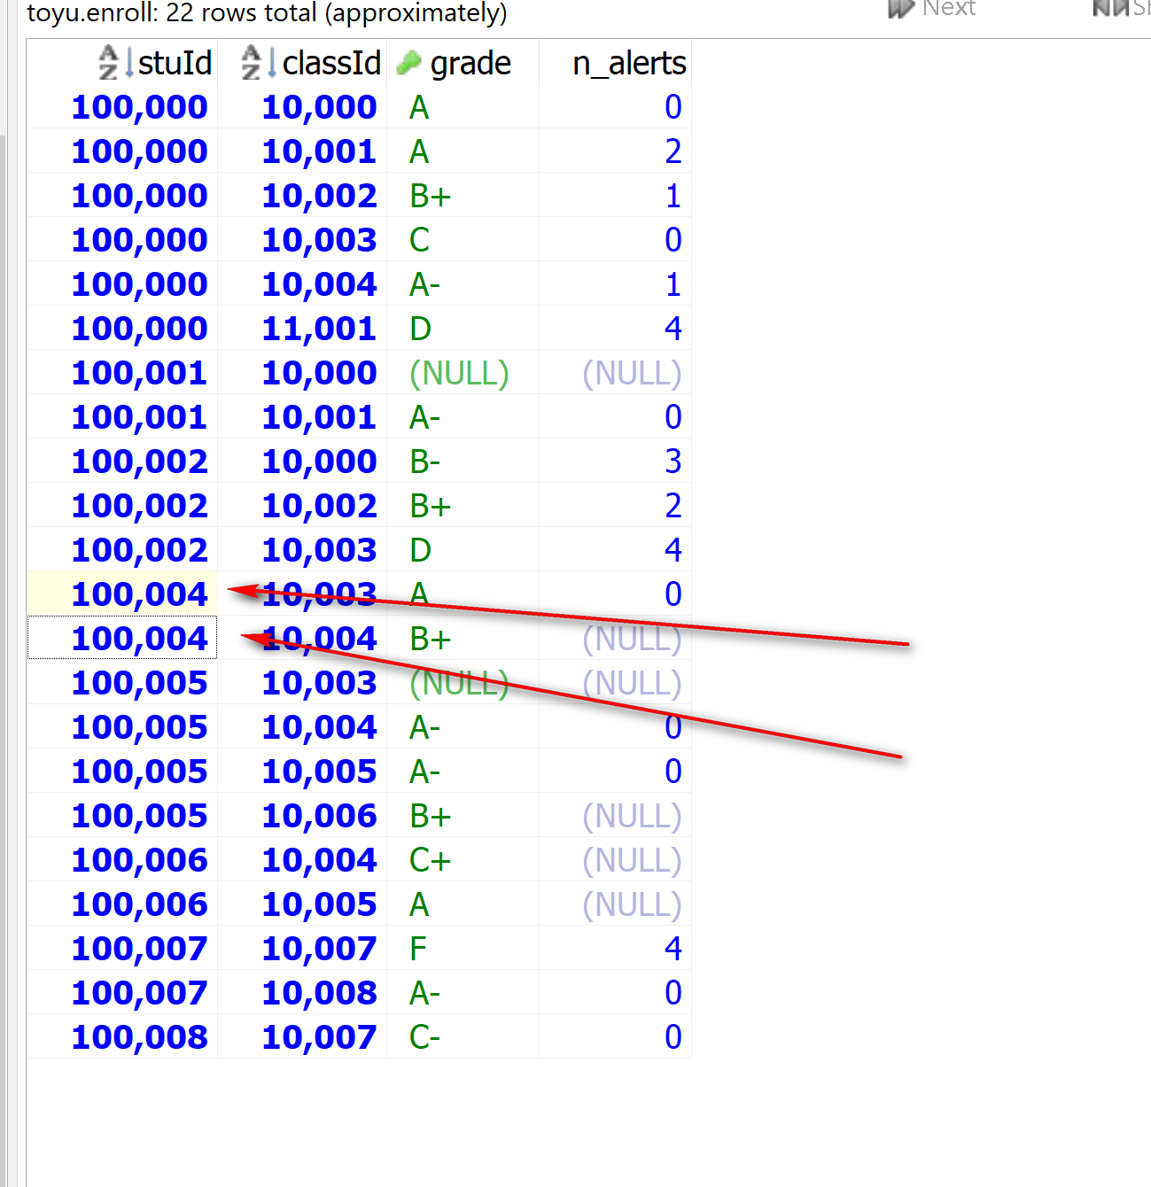
SELECT DISTINCT s.stuId, s.fname, s.lname, e.classsId
FROM Student s INNER JOIN Enroll e ON (s.stuId = e.stuId)
WHERE s.Major = 'ITEC';

SELECT DISTINCT s.stuId, s.fname, s.lname, e.classId
FROM Student s LEFT JOIN Enroll e ON (s.stuId = e.stuId)
WHERE s.Major = 'ITEC';

SELECT DISTINCT s.stuId, s.fname, s.lname, COUNT(e.classId) as n_classes
FROM Student s LEFT JOIN Enroll e ON (s.stuId = e.stuId)
WHERE s.Major = 'ITEC'
GROUP BY s.stuId;

SELECT DISTINCT s.stuId, s.fname, s.lname, COUNT(e.classId) as n_classes
FROM Student s LEFT JOIN Enroll e ON (s.stuId = e.stuId)
WHERE s.Major = 'CSCI' -- 'CSCI' replaced by input
GROUP BY s.stuId;

Solution:

from dbconfig import *
import pymysql
import sys
# import sys object

# Get command line argument of product line id.
# For python h8q1.py ITEC
# sys.argv[1] = ‘ITEC’
# sys.argv[0] = ‘h8q1.py’
if len(sys.argv) > 1:
dept = sys.argv[1]
else:
dept = 'ITEC'

# Connect to big_pvfc of the MySQL server and
# set up SQL statement to obtain product information
# in the product line: quite standard for config.py and config.ini
db = get_mysql_param()
cnx = pymysql.connect(user=db['user'], password=db['password'],
host=db['host'],
database=db['database'])
cursor = cnx.cursor()

# Parametrized query: %s: placeholder
query = '''
select concat(s.fname, ' ', s.lname) as student,
count(e.classId) as num_classes
from department d join student s on (d.deptCode = s.major)
left join enroll e on (s.stuId = e.stuId)
where d.deptCode = %s
group by student
order by student
'''
# (dept): one variable, the same as dept
# (dept,): a list with one element, dept
cursor.execute(query,(dept,))

# Print product report.
print('Classes enrolled by students majoring in dept ' + dept + ':')
print('----------------------------------------------------')
for (student, num_classes) in cursor:
print(student + ': ' + str(num_classes) + '.')

# housekeeping
cursor.close()
cnx.close()

https://pymysql.readthedocs.io/en/latest/modules/cursors.html:

execute(query, args=None)
Execute a query
Parameters: | - query (str) – Query to execute.  - args (tuple, list or dict) – parameters used with query. (optional)
Returns: | Number of affected rows
Return type: | int
If args is a list or tuple, %s can be used as a placeholder in the query. If args is a dict, %(name)s can be used as a placeholder in the query.

System Catalog Examples:

SELECT t.*
FROM Information_schema.TABLES t
WHERE t.TABLE_SCHEMA = 'toyu';

-- number of tables in toyu
SELECT COUNT(t.TABLE_NAME)
FROM Information_schema.TABLES t
WHERE t.TABLE_SCHEMA = 'toyu';

-- all schema and their number of tables.
SELECT t.TABLE_SCHEMA, COUNT(t.TABLE_NAME)
FROM Information_schema.TABLES t
GROUP BY t.TABLE_SCHEMA;

