9/21/2019
…

CONCAT:

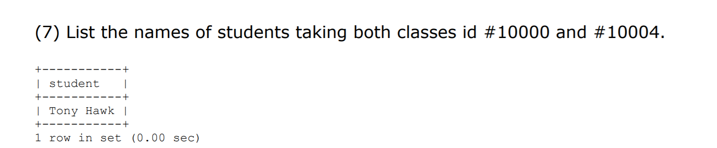
Output: student: s.fname, ‘ ‘, s.lname
Source: student s, Enroll e
Condition: classid in enroll #10000 and #10004.

100,000 -> Tony Hawk
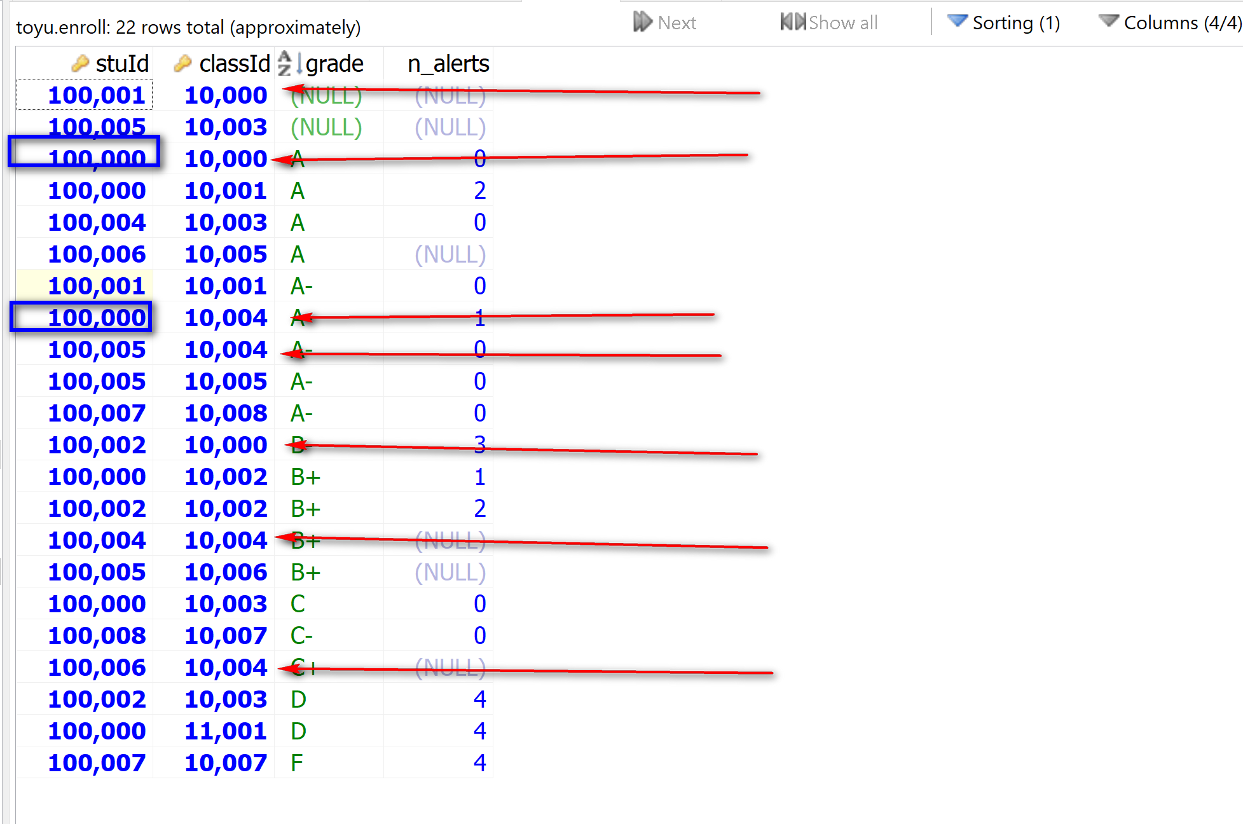

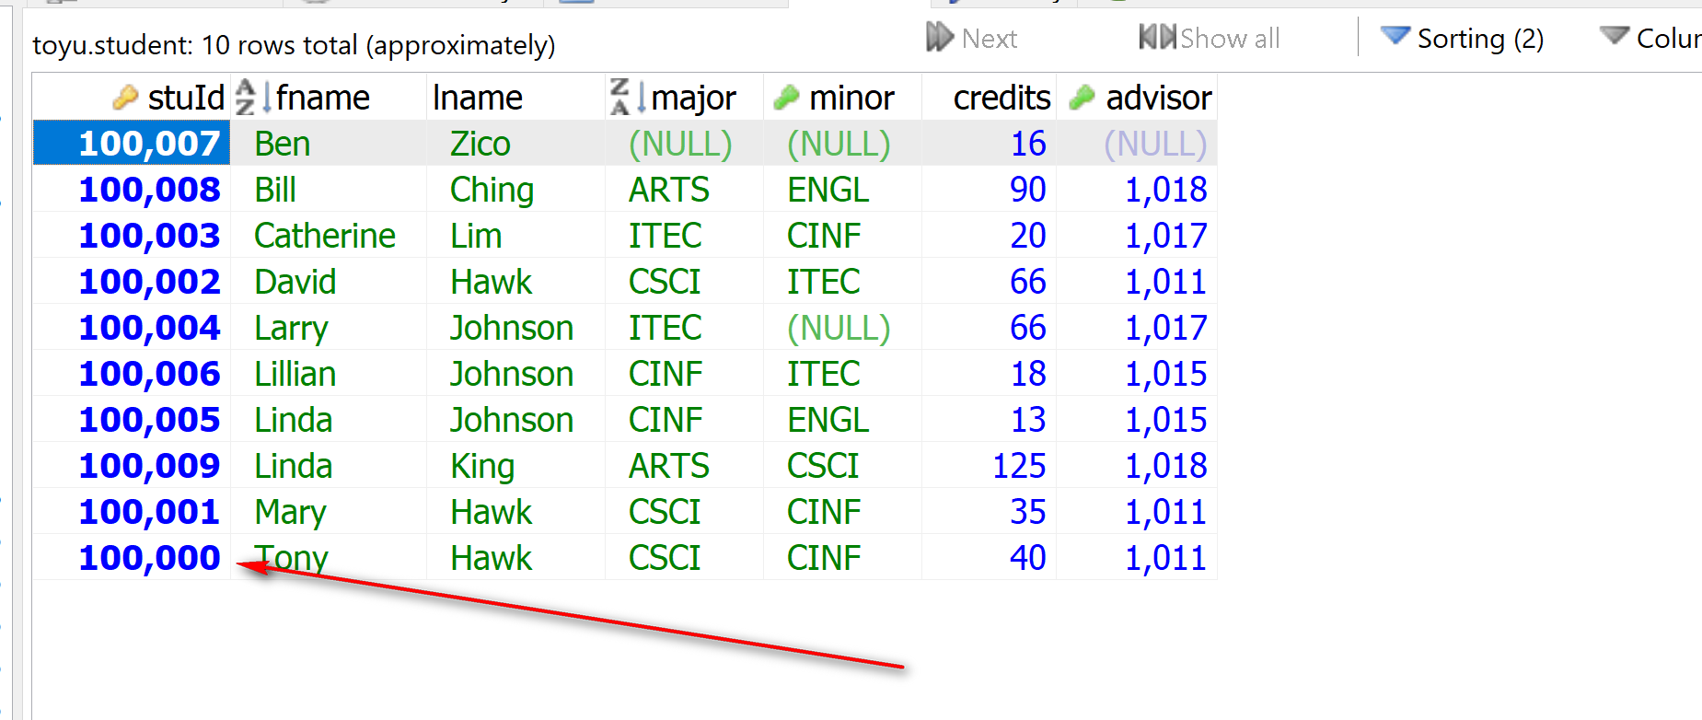

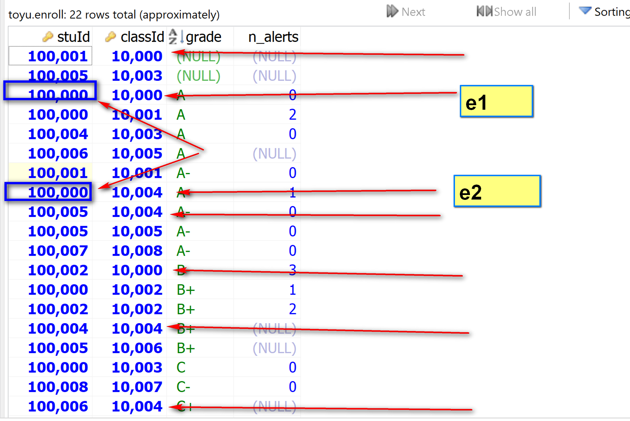
Output: student: s.fname, ‘ ‘, s.lname
Source: student s, Enroll e1, Enroll e2
Condition:
- E1.classId = 10000
- E2.classId = 10004

