10/14/2019
CREATE TABLE IF NOT EXISTS Department (
deptCode VARCHAR(4),
deptName VARCHAR(30) NOT NULL, --
schoolCode VARCHAR(3),
numFaculty TINYINT,
CONSTRAINT Department_deptCode_pk PRIMARY KEY (deptCode),
CONSTRAINT Department_name_ck UNIQUE (deptName), -- CK: unique not null
CONSTRAINT Department_schoolCode_fk FOREIGN KEY (schoolCode)
REFERENCES School(schoolCode)
);

https://dev.mysql.com/doc/refman/8.0/en/integer-types.html
Table 11.1 Required Storage and Range for Integer Types Supported by MySQL
Type | Storage (Bytes) | Minimum Value Signed | Minimum Value Unsigned | Maximum Value Signed | Maximum Value Unsigned
TINYINT | 1 | -128 | 0 | 127 | 255
SMALLINT | 2 | -32768 | 0 | 32767 | 65535
MEDIUMINT | 3 | -8388608 | 0 | 8388607 | 16777215
INT | 4 | -2147483648 | 0 | 2147483647 | 4294967295
BIGINT | 8 | -2⁶³ | 0 | 2⁶³-1 | 2⁶⁴-1

mysql> desc department;
+------------+-------------+------+-----+---------+-------+
| Field | Type | Null | Key | Default | Extra |
+------------+-------------+------+-----+---------+-------+
| deptCode | varchar(4) | NO | PRI | NULL | |
| deptName | varchar(30) | YES | UNI | NULL | |
| schoolCode | varchar(3) | YES | MUL | NULL | |
| numFaculty | tinyint(4) | YES | | NULL | |
+------------+-------------+------+-----+---------+-------+
4 rows in set (0.02 sec)

PRI: primary
UNI: Unique
MUL: Multivalued

- DDL:
  - CREATE TABLE
  - CREATE DATABASE: a database contains a collection of related tables for an application.
  - CREATE VIEW
  - CREATE INDEX
  - CREATE PROCEDURE
  - CREATE FUNCTION
  - CREATE TRIGGER
  - ALTER (No ALTER TRIGGER and ALTER INDEX)
  - DROP
- Constraint: to implement certain constraints in your data model.
  - NOT NULL: attributes cannot have an null value.
  - UNIQUE: KEY; the set of attributes must be unique for each row:
  - PRIMARY KEY: unique, not null, and used for the physical structure of the relation.
  - FOREIGN KEY
  - CHECK: for a Boolean conditions on the columns.
  - DEFAULT: insert a default.
Fall 2018:

(1) The student with id 100001 has received a new grade of A in the class with id 10000.

1.1 The student with id 100001, classId = 10000

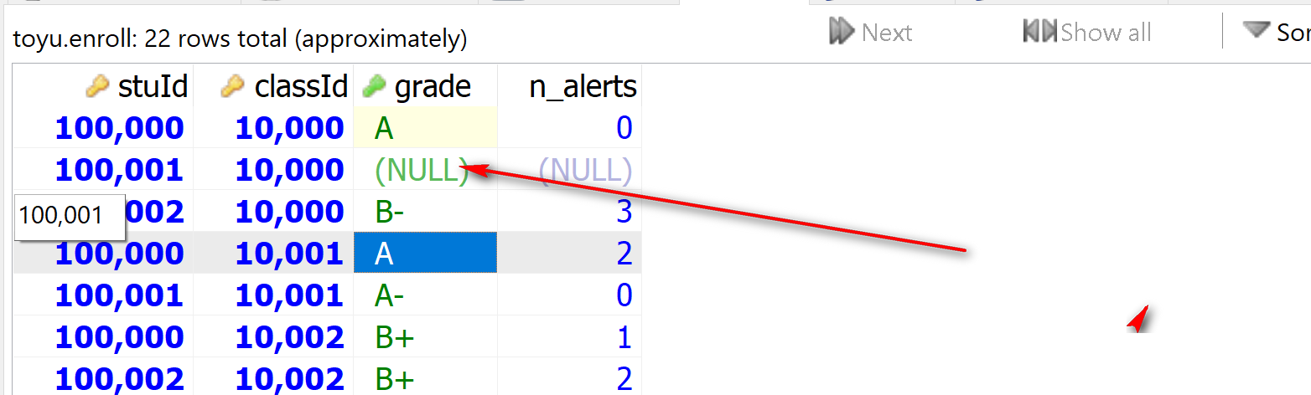

stuId = 100001, classId = 10000

UPDATE [LOW_PRIORITY] [IGNORE] table_name
SET
column_name1 = expr1,
column_name2 = expr2,
...
[WHERE
condition];

UPDATE Enroll
SET grade = ‘A’
WHERE stuId = 100001
AND classId = 10000;

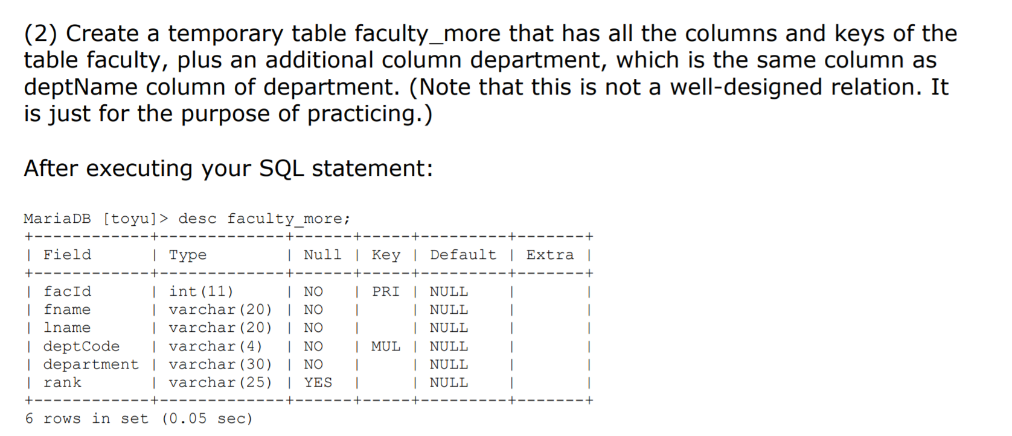

mysql> desc faculty; +----------+-------------+------+-----+---------+-------+ | Field | Type | Null | Key | Default | Extra | +----------+-------------+------+-----+---------+-------+ | facId | int(11) | NO | PRI | NULL | | | fname | varchar(20) | NO | | NULL | | | lname | varchar(20) | NO | | NULL | | | deptCode | varchar(4) | NO | MUL | NULL | | | rank | varchar(25) | YES | | NULL | | +----------+-------------+------+-----+---------+-------+ 5 rows in set (0.00 sec)

CREATE TABLE IF NOT EXISTS Faculty (
facId INT NOT NULL,
fname VARCHAR(20) NOT NULL,
lname VARCHAR(20) NOT NULL,
deptCode VARCHAR(4) NOT NULL,
`rank` VARCHAR(25),
CONSTRAINT Faculty_facId_pk PRIMARY KEY (facId),
CONSTRAINT Faculty_deptCode_fk FOREIGN KEY (deptCode)
REFERENCES Department(deptCode));

CREATE TABLE IF NOT EXISTS Department (
deptCode VARCHAR(4),
deptName VARCHAR(30),
schoolCode VARCHAR(3),
numFaculty TINYINT,
CONSTRAINT Department_deptCode_pk PRIMARY KEY (deptCode),
CONSTRAINT Department_name_ck UNIQUE (deptName),
CONSTRAINT Department_schoolCode_fk FOREIGN KEY (schoolCode)
REFERENCES School(schoolCode)
);

