CSCI 5333 DBMS Classroom Notes
11/2/2021

URL: http://dcm.uhcl.edu/yue/ -> IP address (Domain Name ServerL DNS)

2. PHP
- PHP is the acronym for PHP: Hypertext Preprocessor.
  - Open source
  - Multiple platforms
  - Active community
  - Scripting language
- http://www.php.net/: PHP is a widely-used general-purpose scripting language that is especially suitable for Web development and can be embedded into HTML.
- The general idea is the separation of program script code and (static) data.
- It looks a little like a mix between Perl and ASP.NET.
  - Perl-like syntax as a scripting language.
  - <?PHP ... ?> for inserting PHP script within HTML page.
- The PHP script section provides dynamic content for the Web pages.
- Some resources:
  - w3schools: http://www.w3schools.com/php/
  - I like: https://learnxinyminutes.com/docs/php/
PHP Language Basics
- Variables start with $.
- Important data types: http://php.net/manual/en/language.types.php
  - Scalar: Boolean, number, strings
  - Array: ordered map (of name value pairs)
  - Object
- Comments: // or /* */
URL Mapping:
Web application in PHP:
- Hello.php is saved in a Web account of the Web server
- When a PHP page is requested through HTTP Request:
  - URL Mapping: the Web server identifies the local location of hello.php.
  - The Web server invokes the PHP interpreter.
  - The PHP interpreter runs hello.php.
  - Output of hello.php is sent to the Web server (STDOUT is the Web server.)
  - The Web server uses the output of hello.php to prepare the HTTP response.
- Steps 2 to 4 are governed by Common Gateway Interface (CGI).
URL:
http://dcm.uhcl.edu/yue/courses/csci5333/current/notes/php/SQL_PHP.html
DCM:
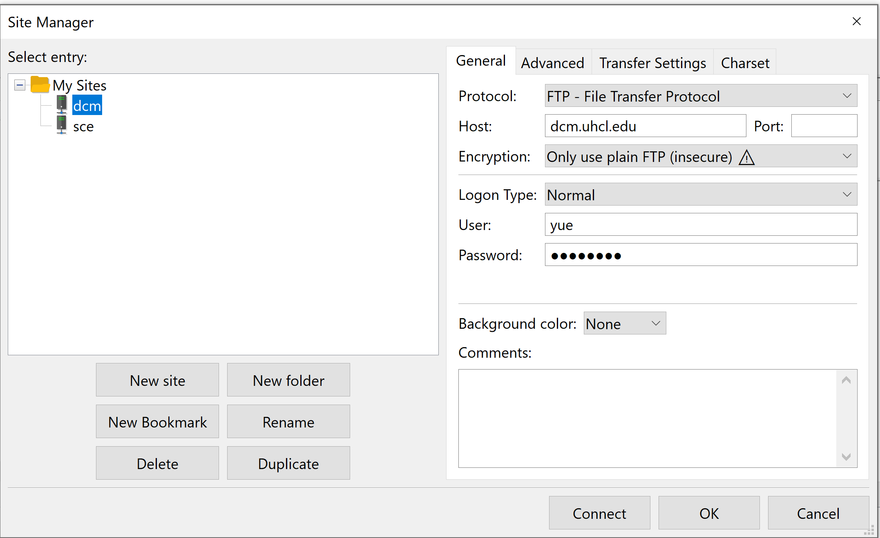
http://dcm.uhcl.edu/yue -> /yue/pages (root directory for the account yue)
http://dcm.uhcl.edu/yue/courses/csci5333/current/notes/php/SQL_PHP.html ->
/yue/pages/ courses/csci5333/current/notes/php/SQL_PHP.html

http://dcm.uhcl.edu/yue/hello2.html ->
DCM: /yue/pages/hello2.html
Apache: default root directory: C:\xampp\htdocs

URL: localhost/php/csci5333/Fall2021/hello2.html
Local: C:\xampp\htdocs\php\csci5333\Fall2021\hello2.html

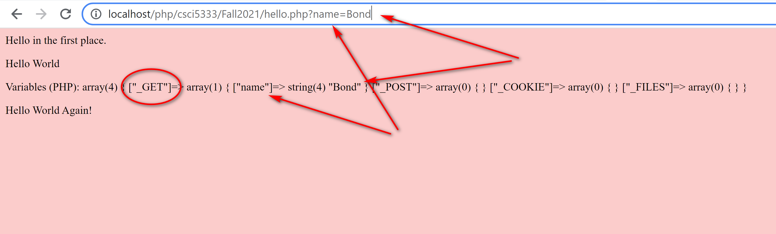
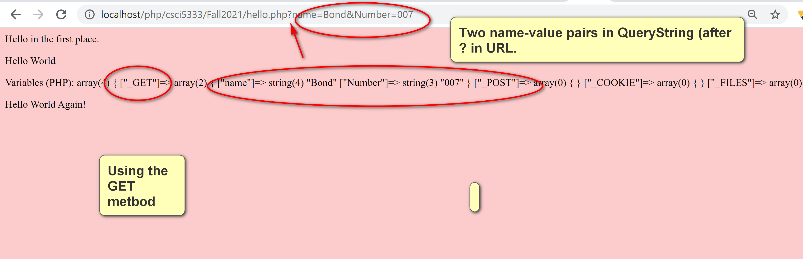

- The string using double quotes allow for variable interpretation. Special characters, such as $ and \ need to be escaped using \.
phpinfo.php: list php info. Use with care.
<?php
phpinfo();
?>
Server2.php:
<table border="1">
<tr><td>Server variables</td><td>Values</td></tr>
<?php
foreach($_SERVER as $key => $value) {
echo "<tr><td>$key</td><td>$value</td></tr>\n";
// the same.
echo "<tr><td>” . $key . “</td><td>” . $value . “</td></tr>\n";
}
?>
</table>
- GET:
  - The parameters are a part of the URL after '?', known as the query string.
  - Parameters are name=value pairs, separated by the symbol '&'.
  - The HTTP request body is empty.
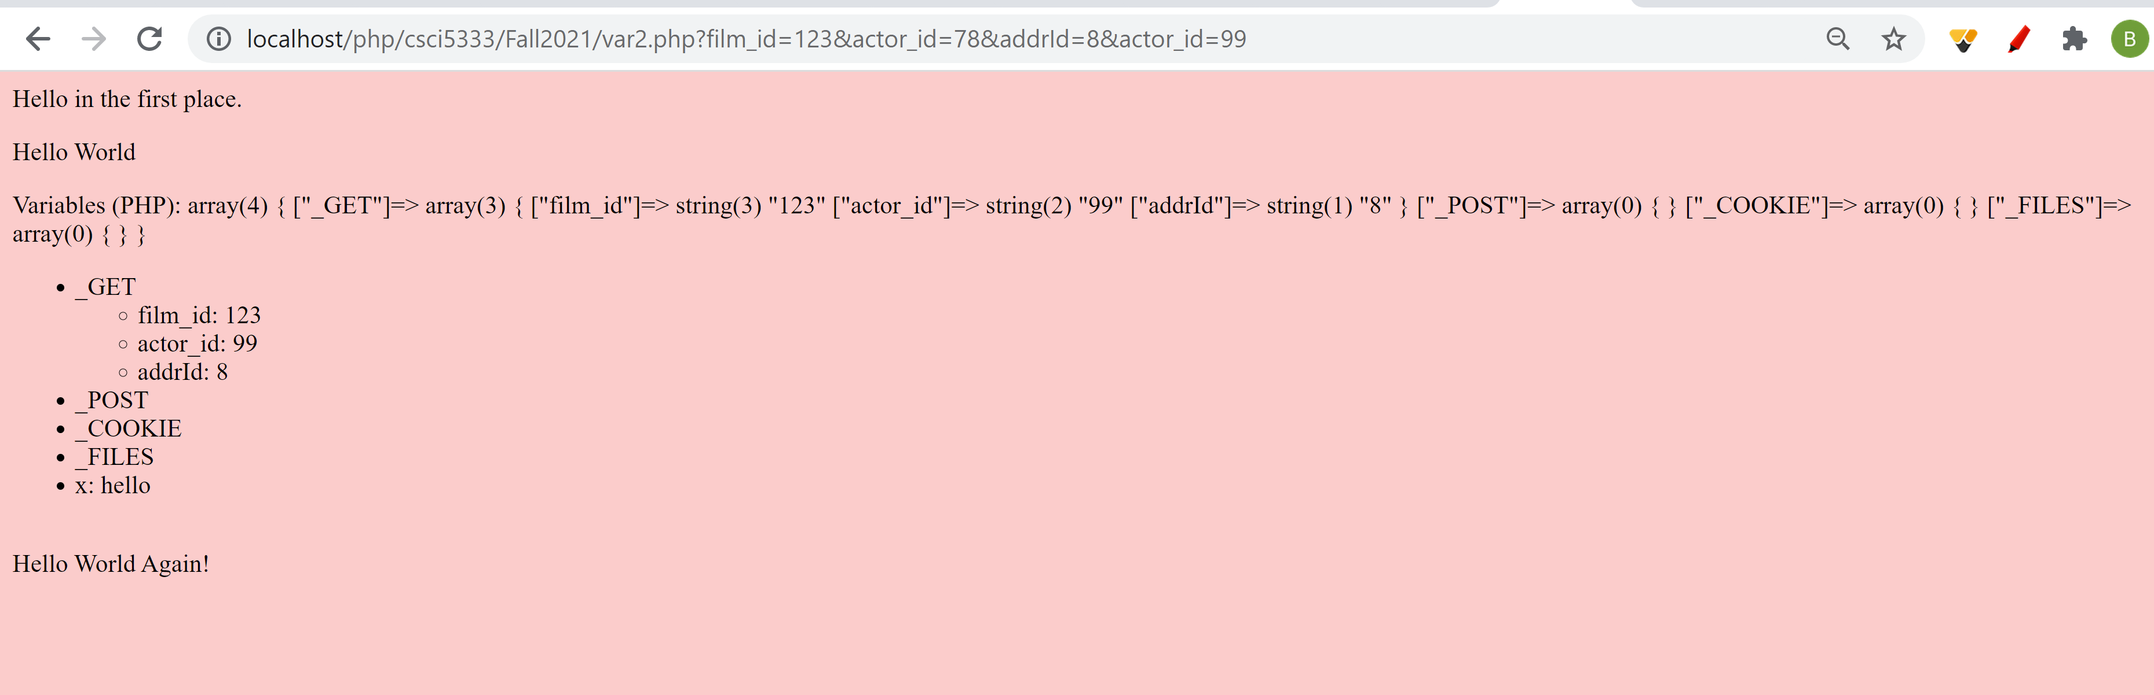

Example HTTP Get Header:
- Request URL:
http://dcm.uhcl.edu/yue/courses/csci5333/current/index.html
- Request Method:
GET
- Status Code:
200 OK
- Remote Address:
129.7.84.135:80
- Referrer Policy:
strict-origin-when-cross-or
GET: simplicity.
- HTTP Header: QUerystring: name=Yue
- NO HTTP body.
POST:
- HTTP Header:
- Empty line
- HTTP Body: query string (e.g. name=yue)
Multi-part requests: multiple files; binary file; slightly more security.

3. PHP Database Programming
- PHP provides both Database Abstraction Layer (e.g. ODBC, JDBC: portability, diverse DB, flexibility) and Vendor-Specific Database Extensions (functionality, performance).
- Examples of Database Abstraction Layers: (DB-independent)
  - PDO: PHP use PDO MYSQL driver to connect to a MySQL database.
  - ODBC
  - Pear DB: used by the text book, deprecated.
  - Pear MDB2: http://pear.php.net/package/MDB2, newer version of Pear DB.
- Examples of vendor specific extensions:
  - IBM DB2
  - MySQL: original PHP extension for older versions; procedural interface.
  - MySQLi: improved PHP extension for version 4.1.3 or later. Benefits from http://php.net/manual/en/mysqli.overview.php:
    - Object-oriented interface
    - Support for Prepared Statements
    - Support for Multiple Statements
    - Support for Transactions
    - Enhanced debugging capabilities
    - Embedded server support
  - OCI8: Oracle OCI8
  - PostgreSQL
  - MS SQL Server
- MySQLi will be used in this class. Do not use other MySQL API for PHP.
- If you still want to use MySQL in other projects for whatever reasons: PHP MySQL function: http://us.php.net/manual/en/ref.mysql.php.
URL:
http://localhost/php/csci5333/Fall2021/supply2.php?city=Houston&status=4

- GET:
  - The parameters are a part of the URL after '?', known as the query string.
  - Parameters are name=value pairs, separated by the symbol '&'.
  - The HTTP request body is empty.
- POST:
  - The parameters are not a part of the URL.
  - The HTTP request body stores the parameters.
GET: RESTFul API
http://localhost/php/csci5333/Fall2021/get1.php?x=1&y=2

heredoc: multiple line string literal
Variable interpretation

E.g. System Catalog: MySQL INformationSchema
SELECT COUNT(*)
FROM TABLES
WHERE TABLE_SCHEMA = 'Sakila'
AND TABLE_TYPE = 'BASE TABLE';

E>g.
SELECT t.TABLE_SCHEMA, COUNT(*) AS `Num tables`
FROM Information_schema.TABLES AS t
WHERE TABLE_TYPE = 'BASE TABLE'
GROUP BY t.TABLE_SCHEMA
ORDER BY `Num tables` DESC;

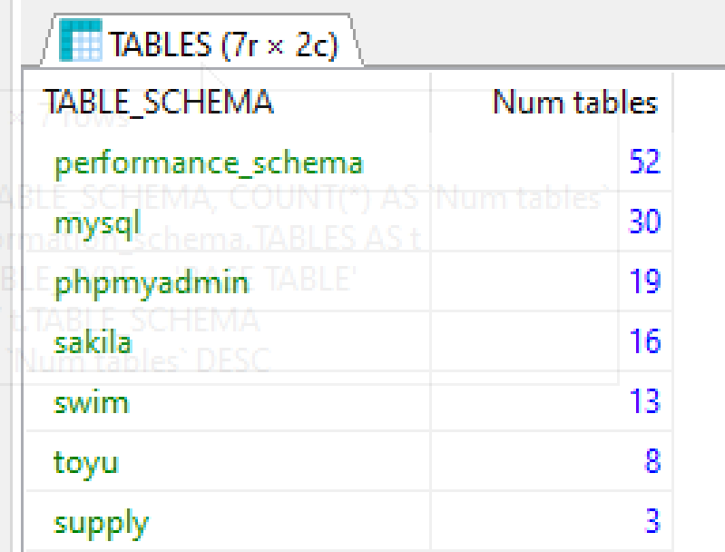
3. Views
- Views are virtual table derived from other tables.
- Some advantages of using views:
  - Better data abstraction
  - Logical data independence
  - Better consistency
  - Possible centralized security control
  - Can be more efficient
- Some disadvantages:
  - More work.
  - Can be inefficient.
  - Complicated especially when views are updated.
- MySQL Create View Manual: search for "mysql view manual"

